Patient Satisfaction and Service Quality as Drivers of Competitive Advantage in UK Private Healthcare Providers

Student Name:
Ramim Ahmed
Student ID:
2516509
Module Code:
BMMB7028
Module Name:
Business Research
Programme:
Master of Business Administration (MBA)

Executive summary
The proposed study investigates the importance of service quality and patient satisfaction in developing a competitive advantage in the UK private healthcare industry. As the National Health Service faces pressure and the needs of patients are rising (along with demands for the services of private healthcare providers), the experiences of patients have gained more and more significance. The research will focus on understanding the role of various dimensions of service quality in patient satisfaction as well as its role in organisational performance and positioning.
The study assumes an interpretivist philosophy and qualitative methodology, and the semi-structured interview with patients who had a personal experience with private healthcare services. The thematic analysis will be used to analyse the data in order to determine the important patterns and insights. The results will give meaningful implications to private healthcare providers and add to the scholarly knowledge of the quality of services and patient satisfaction in the UK healthcare background.

Table of Contents
Executive summary 2
1. Introduction 5
1.1 Background of the Study 5
1.2 Problem Statement 5
1.3 Research Aim 6
1.4 Research Objectives 6
1.5 Research Questions 6
2. Literature Review 7
2.1 Service Quality in Healthcare 7
2.2 Patient Satisfaction Theory 8
2.3 Relationship Between Service Quality and Patient Satisfaction 9
2.4 Patient Satisfaction and Competitive Advantage 10
2.5 UK Healthcare Context 11
2.6 Research Gap 12
3. Methodology 12
3.1 Research Philosophy 12
3.2 Research Approach 13
3.3 Research Strategy 13
3.4 Research Method 14
3.5 Data Collection 14
3.6 Sampling 15
3.7 Data Analysis 15
3.8 Justification of Methodology 16
3.9 Ethical Considerations 16
3.10 Limitations 17
4. Expected Outcomes & Timeline 17
4.1 Expected Outcomes 17
4.2 Proposed Timeline (Gantt Overview) 18
References 20

1. Introduction

1.1 Background of the Study
The UK healthcare system is based on a system of two practices, which include publicly funded services of the National Health Service and the increasing private healthcare industry. Although the NHS provides universal access to healthcare, a rise in demand and a workforce deficit, and longer waiting times have resulted in a gradual increase in the number of private healthcare providers (Goodair and Reeves, 2024; Guy and Newcombe, 2025). This has led to the rising number of patients consulting a private provider to get more personalised care, get quick access, and better experiences with service quality (Brindley et al., 2024).
Increased competition among the providers due to the growth of the private healthcare industry has shifted the emphasis to providing better quality of service as a form of differentiation. Service quality, which is relevant in healthcare, entails clinical outcomes, as well as responsiveness, communication, environment, and overall patient experience (Al-Assaf, Bahroun and Ahmed, 2024; Ferreira et al., 2023). Quality service is thus critical towards increasing patient satisfaction, bolstering organisational reputation, and making organisations sustainable in the long run (Perals, Rambaud, and Garcia, 2024). It has been noted that patients are becoming more critical when assessing medical professionals by considering their perceived quality of care and general experience of the service rather than just the medical outcomes (Zehra, Ranjan, and Shukla, 2025; Sukmawati, Ramadania, and Pebrianti, 2024).
Moreover, patient satisfaction is now one of the performance indicators that are crucial in contemporary healthcare systems. It is a measure of how well healthcare services are satisfying and surpassing the expectations of patients, and it is critical in determining patient loyalty and retention (Ahmed, Khan, and Lawal, 2024; Hung et al., 2025). A direct relationship exists between competitive positioning and market success, with the aspect of patient satisfaction in the framework of a competitive environment where patients are the consumer variable (Almulhim and AlMulhim, 2024).

1.2 Problem Statement
The increasing role of service quality in private healthcare is still a burden, with a lot of challenges. There is an increased competition among the private providers, thus resulting in increased patient expectations and a higher challenge in maintaining overall high-quality services (Bawuah, Appleton, and Li, 2024; Doubova et al., 2024). Simultaneously, there is an indication that the quality of services in healthcare facilities is usually uneven, in particular, regarding such areas as communication, responsiveness, and patient-centred care (Al‐Hammouri et al., 2024; Owusu et al., 2024).
Even in the private healthcare environment, the problem of patient dissatisfaction remains persistent, despite the fact that high standards of quality of the offered services are anticipated. As has been shown, the problem of dissatisfaction can frequently occur when the discrepancies between the expectations and the real experiences of the patients happen, which is also known as the service quality gap (Adongo et al., 2025; Karume et al., 2025). This gap shows that a more profound insight is sought into the ways service quality dimensions attain patient perceptions and satisfaction outcomes.
Despite the past research on service quality and patient satisfaction conducted separately, little research has been conducted to determine the relationships among these themes to generate a competitive advantage in the UK private healthcare market. Such disunified knowledge amounts to a major gap, especially in a market where patient choice and experience are becoming central to organisational success.

1.3 Research Aim
To examine how service quality influences patient satisfaction and contributes to competitive advantage in UK private healthcare providers.

1.4 Research Objectives
- To analyse service quality dimensions in private healthcare
- To evaluate the impact of service quality on patient satisfaction
- To examine the relationship between patient satisfaction and competitive advantage
- To explore patient perceptions of private healthcare services in the UK

1.5 Research Questions
- How does service quality influence patient satisfaction?
- What factors shape patient perceptions in private healthcare?
- How does patient satisfaction contribute to competitive advantage?

2. Literature Review

2.1 Service Quality in Healthcare
The concept of quality of service in healthcare denotes the level at which the services offered in healthcare facilities either satisfy or surpass the expectations of the patients, both in the clinical and non-clinical aspects of healthcare. Contrary to other service industries, the level of healthcare quality is multidimensional in embracing the elements of technical competence, interpersonal interactions, and environmental factors (Al-Assaf, Bahroun and Ahmed, 2024; Zehra, Ranjan and Shukla, 2025). With the shift to patient-centred models of healthcare systems, in which patient perceptions and experiences become the key performance indicators (PIs), the quality of service has gained greater importance (Ferreira et al., 2023; Endalamaw et al., 2024).
One of the most popular models to measure service quality is the SERVQUAL model, which measures the discrepancy between the expectations of customers and the perceived delivery of the service (Adongo et al., 2025; Alfatafta et al., 2025). The model has come up with five fundamental dimensions: reliability, responsiveness, assurance, empathy and tangibles. Reliability can be described as the capability to perform promised services correctly and consistently, whereas responsiveness can be perceived as the desire of healthcare staff to provide timely help (Karume et al., 2025). Assurance involves the role of knowledge, competency, and trustworthiness of healthcare professionals, which is essential in high-risk service settings like healthcare (Shaikh and Sarkar, 2023).
Empathy is associated with the delivery of individualised care and emotional support, which are critical factors in how patients perceive the quality of care (Çakmak and Uğurluoğlu, 2024). The tangibles refer to physical plants, equipment, and a certain number of the staff, which factor into the entire service experience (Rauf et al., 2024b). The research regularly emphasises that the combination of these dimensions determines patient ratings of the healthcare services and is closely related to satisfaction outcomes (Alsubahi et al., 2024).
Nevertheless, according to other researchers, SERVQUAL can reduce the complexity of healthcare by mostly concentrating on subjective perceptions but not clinical results (Sukmawati, Ramadania and Pebrianti, 2024; Abu-Hasheesh et al., 2024). Notwithstanding such a shortcoming, it is still a leading framework because of its practical application and description of the experiences of patients in healthcare environments of different prices and uses (Yang et al., 2024).
Table 1: Service Quality in Healthcare - Key Dimensions (Self-Made)
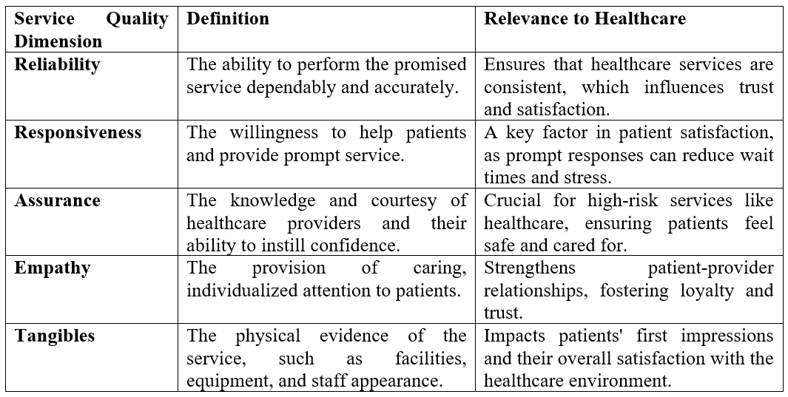
It represents the most significant dimensions of service quality which are reliability, responsiveness, assurance, empathy, and tangibles and applies them to healthcare, as indicated in this table. Each of the dimensions plays an instrumental role to establish the patient satisfaction, loyalty and the entire healthcare experience. These dimensions are significant in the sense that when the healthcare providers are concerned to them, this means that they will be able to meet or even surpass the patient expectations that would result into development of trust and a competitive edge. These aspects of service quality are essential and must be studied and improved in the UK crucially since they have direct impact directly on perceptions, satisfaction and effective long-term performance of the patients in the competitive healthcare industry.

2.2 Patient Satisfaction Theory
The level of satisfaction of patients is expressed as the extent to which the healthcare services can meet or even surpass the expectations of patients, so it is an important measure of the quality of the services and the performance of healthcare (Ahmed, Khan and Lawal, 2024; Akin, 2025). It is a summary of the general perception of patients about their healthcare experience, such as the experience during medical services, waiting queues, communication, and treatment outcomes (Hung et al., 2025).
The expectation-perception theory is one of the core patient satisfaction theories based on the assumption that the expected and actual service performance difference defines customer satisfaction (Karume et al., 2025). In case the perceived performance is better than the expectations, satisfaction will be attained, whereas in the opposite case of the failure in an expectation, a result will be satisfaction (Bhatt, Ghimire and Khanal, 2024). This model applies specifically in healthcare settings where expectations tend to be subject to prior experiences, social-demographic aspects, and value of care (Ali et al., 2025a; Cha, 2025).
Patient-centred care continues this idea because it focuses on the need to customise healthcare services to the needs, preferences, and values of a specific patient (Chen, Guan and Zhuang, 2024). A study proves that patient-centred care may improve communication, trust, and engagement and eventually result in an increase in the level of satisfaction (Jameel et al., 2025; Smerat et al., 2025). Besides, the quality of nursing services and human interaction are also found to be decisive factors of satisfaction, emphasising the role of human factors in health care delivery (Al‐Hammouri et al., 2024; Alhussin et al., 2024).
Although it is an important metric, patient satisfaction is a subjective and multi-layered measure that can be affected by factors other than the quality of service, including cultural expectations and personal perceptions (Ali et al., 2025a; Hussain, Nikoloski and Gjebrea, 2024). This complexity also requires a complex method in comprehending satisfaction within the healthcare setup.
Table 2: Patient Satisfaction Theory - Key Theories and Concepts (Self-Made)
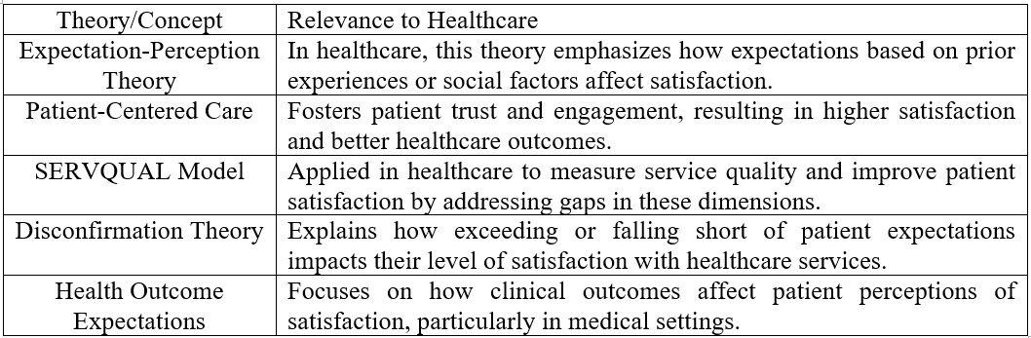

2.3 Relationship Between Service Quality and Patient Satisfaction
There is a considerable amount of empirical evidence that shows that there is a positive correlation between patient satisfaction and the quality of services. Research suggests that the increase in service quality dimensions, especially in the areas of reliability, responsiveness, and empathy, is a significant factor that can be used to raise the levels of patient satisfaction (Rauf et al., 2024a; Rao et al., 2025). On the same note, studies within various healthcare settings affirm that perceived quality of service is an effective indicator of patient satisfaction and their entire experience in healthcare (Owusu et al., 2024; Wei et al., 2026).
The connection is usually theorised as a causal route, with service quality serving as a predisposing variable ahead of satisfaction (Chaanine and Sleilati, 2024). As an illustration, communication, shorter waiting period, and individualised care have proven to enhance patient perception and improve patient satisfaction (Abu-Hasheesh et al., 2024; Cui et al., 2025). Moreover, service quality has been described as the crucial factor in defining satisfaction because patient-centred communication has been associated with increased engagement and quality-of-life outcomes (Çakmak and Uğurluoğlu, 2024).
Nevertheless, there is no total agreement on the strength or consistency of this relationship in the studies. There are indications that the organisational culture and the structure of the healthcare system could moderate the correlation between service quality and satisfaction (Hoxha et al., 2024). Moreover, the research has discovered that perceived value and expectations can also affect patient satisfaction and not the quality of the service alone (Hendy et al., 2025; Rao et al., 2025).
Besides, this relationship is also complicated by differences between the environments of public and private healthcare. There is some research that shows that although private healthcare tends to provide greater perceived service quality, this does not necessarily translate into a significantly higher level of satisfaction because of the higher expectations of a patient (Ali et al., 2025b; Doubova et al., 2024). These results indicate the necessity to have a more detailed perspective on the role of service quality in affecting satisfaction in various healthcare settings.
Much more recent literature also reveals the fact that patient satisfaction is not simply predetermined by direct interactions with the service, but its perspective and perception of value and trust in the healthcare systems. The study has found that perceived fairness, transparency, and comfort are significant factors in patient ratings with respect to quality of care (Rao et al., 2025; Hussain et al., 2025). The expectation in a private health care setting is normally quite tough, in the sense that the patients often pay a premium price, thus this will make the patients sensitive to errors in service delivery. This confirms the assumption that healthcare providers should not only deliver efficient services to their customers but also make sure that the services they offer are interconnected and experience-based to make sure that the satisfaction rates they achieve are high (Sukmawati, Ramadania and Pebrianti, 2024).
Furthermore, there exists some emerging evidence that technological integration and innovation of services are becoming a critical concern in enhancing the satisfaction of patients. The access, responsiveness, and continuity of care are achieved with the help of digital technologies, such as telehealth and electronic communication devices, thereby positively influencing patient perceptions (Hendy et al., 2025; Szewczyk and Hoque, 2026). However, the innovations can be placed under their congruence with the anticipation of patients, and their usability. It implies that the healthcare organisations will have to strategically implement the use of technology without sacrificing a patient-centred approach towards competitive advantage and maintenance of service quality.

2.4 Patient Satisfaction and Competitive Advantage
Customer satisfaction is critical towards the creation of competitive advantage within healthcare organisations, especially in the private healthcare market, where patients are more choice-based. Happy patients will be more loyal, revisit services in future, and refer others to services, which will boost the organisational reputation and market presence (Almulhim and AlMulhim, 2024; Hussain et al., 2025).
One of the primary results of patient satisfaction is loyalty because it shows that patients are ready to develop lasting relationships with providers of healthcare services (Gün and Söyük, 2025). Satisfaction at high levels leads to positive word-of-mouth, which is the most vital in the healthcare sector since a high level of trust is entailed in service selection (Widiastuti, Indartono and Sa'adah, 2024). Moreover, loyal customers would have fewer switching experiences, which would increase retention rates and decrease the ability to advertise at a lower cost (Alodhialah, Almutairi and Almutairi, 2024).
Strategically, patient satisfaction supports the reputation and the brand image of organisations, which are also essential elements of competitive advantage (Perals, Rambaud and Garcia, 2024). It is research-proven that the higher the satisfaction rating of the healthcare provision, the more reliable and trustworthy they appear, as a result of which they gain new patients and stabilise the position in the market (Yeboah and Amponsah, 2025).
Nevertheless, other researchers claim that other elements, like pricing, availability, and patient outcomes, might be crucial in maintaining a competitive advantage since satisfaction alone could not be considered adequate (Goodair and Reeves, 2024). It is an indication that although satisfaction is an important driver, it should be incorporated with wider strategic issues in order to succeed in the long term.

2.5 UK Healthcare Context
The UK healthcare system provides a distinct environment in which the service quality and patient satisfaction can be analysed because of the existence of both public and private systems (Alhawajreh, Jackson and Paterson, 2025). Universal access to healthcare services is offered by the National Health Service, and the alternative options are provided by the companies that are characterised by shorter waiting lines and better service experiences (Guy and Newcombe, 2025).
There is also a growing pressure on the healthcare sector in the UK with an increasing number of users relying on the services provided by local healthcare providers, especially those related to elective treatments and services (Brindley et al., 2024). The perceived quality, convenience and personalised care continue to form a strong influence on the decision made by patients between the public and the private options (Bawuah, Appleton and Li, 2024).
Regardless of these benefits, there are difficulties in the consistent delivery of a high level of services provided by the private healthcare providers, especially in ensuring patient satisfaction among various types of patients (Wu et al., 2025; Harazni, Malak and Dasan, 2025). Moreover, when comparing the results of the public and private sectors, it can be stated that, on the one hand, private providers usually have better scores on the dimension of satisfaction, whereas, on the other hand, expectations are elevated, and the conditions of providing their services become more demanding (Ali et al., 2025b).

2.6 Research Gap
Despite the abundance of studies on service quality and patient satisfaction in the healthcare sector, there are multiple gaps. To begin with, a significant proportion of the available literature is oriented towards the general healthcare systems, or at a minimum, to a situation in a particular sector, namely the UK market of the private healthcare, but specifically (Doubova et al., 2024; Goodair and Reeves, 2024). This gives rise to an opportunity for contextual research that embodies the definite dynamics of UK private healthcare markets (Hammoud et al., 2024).
Second, although the connection between service quality and patient satisfaction has been researched extensively, the few studies analysing the relationship have not extensively examined the contribution of the two variables together to competitive advantage. The association between satisfaction outcomes and strategic organisational benefits is not well-researched (Perals, Rambaud and Garcia, 2024).
Lastly, studies that emphasise patient concerns and experiences as being the primary part of healthcare assessment are deficient. Available literature is mostly based on numerical variables, which restricts the insight into patient experiences and expectations (Niraula et al., 2026).
The proposed research is expected to fill these holes by determining the impact of service quality on patient satisfaction and as a competitive advantage in the UK private healthcare market, with particular emphasis on patient perceptions and experiences.

3. Methodology

3.1 Research Philosophy
The interpretivist approach is the research philosophy adopted in the study, which is very effective in studying a subjective aspect of the human experience and the social realities of society. The focus of interpretivism is on how people form some meaning themselves through their interactions and experiences, but not through their measurement (Saunders et al., 2019). Patient satisfaction is a subjective phenomenon; in other words, under a healthcare environment, patient satisfaction depends on their own experiences and expectations of healthcare services.
Since this study is aimed at studying the perceptions of patients regarding the quality of services offered by the private healthcare providers in the UK, the interpretivist approach will help to explore that further (Eissa et al., 2025). It also acknowledges the fact that the rise of perception of patients could never be universal and will have to be adjusted to a particular patient based on their background, past experiences, and expectations (Bryman, 2016). At the top of this, interpretivism also justifies the gathering of specific information, which is necessary in the articulation of the intricacy of the relationship between patient satisfaction and quality of service.

3.2 Research Approach
A research method used in this study involves an inductive research approach, as it enables themes and insights to be obtained from the data instead of being overly constrained through the use of existing theories. Induction is especially used where the research seeks to address perceptions and experiences in the more context-focused areas where understanding is paramount (Easterby-Smith, Jackson and Thorpe, 2012).
Instead of having predetermined concepts that the researcher aims to prove, the methodology allows the researcher to construct conceptual knowledge from the views of the participants. These investigations can be done under the inductive approach established in this research because it is necessary to identify the way patients influence the understanding of the service quality and how such perceptions can distort the satisfaction and perceptions of value. The fact that it brings out unexpected themes also renders this flexibility vital, offering a richer insight into the research issue (Leavy, 2020).

3.3 Research Strategy
The study takes an exploratory case study approach in an effort to explore the experiences of patients in the UK private healthcare industry. The case study approach is suitable where the focus is made on complex phenomena in real-life scenarios, especially in situations where there are no clear lines between the phenomenon and the context (Flyvbjerg, 2006).
The descriptive character of the study provides the opportunity to thoroughly examine the quality of the services and patient satisfaction without having strict assumptions. The study addresses in-depth information about the impact of service delivery on satisfaction outcomes by targeting patients who have received private healthcare services (Eissa et al., 2025). The case study research is especially effective in a healthcare context, where contextual variables like the organisational practices, expectations of the patients and environments in which the services are provided are critical influences on the creation of experiences (Gorman et al., 2005).

3.4 Research Method
The in-depth perception of the patient perception and experience is aimed at by a qualitative research method. Qualitative research methods are especially suitable when investigating a complicated social phenomenon and helping to identify the meanings that people attribute to their experience (Leavy, 2020).
Compared to the quantitative method, which dwells on the numerical measure, the qualitative method enables enrichment of descriptive data that is quite descriptive of the multifaceted nature of patient satisfaction. This is particularly significant in healthcare research, whereby the role of emotions, psychological, and interpersonal aspects of research has the capacity to contribute hugely in regard to perceptions of service quality. The interpretivist approach is also consistent with the qualitative approach, as it allows the researcher to get a meaningful in-depth insight into subjective experiences (Bryman, 2016).

3.5 Data Collection
Semi-structured interviews will be used to collect data to be used in this study. This approach gives a balance between structure and flexibility and gives the researcher a chance to provide guidance to the conversation, and at the same time, leave the participants to share their experiences with each other freely. One of the popular examples of qualitative research methods is semi-structured interviews because of the possibility to produce more comprehensive and context-based data (Saunders et al., 2019).
The sample will include people who have utilised the services of private healthcare in the UK. This will be to make sure that the data gathered will be directly pertinent to the research goals. The main themes that will be prioritised in the interviews are the quality of the offered services, communication, waiting time, and the overall experience of a patient.
Semi-structured interviews also provide an opportunity to dig deeper into the answers of the participants, providing the ability to explore the underlying reasons for their viewpoint. Such polymorphism is especially crucial in medical research in which personal experience can differ considerably (Gorman et al., 2005). Interviews will take about 30-60 minutes and can be face-to-face or online, taking place when the participants are available.

3.6 Sampling
To obtain the purposive sample, the study will rely on participants with relevant experience in using the services of private healthcare. Purposive sampling is a type of non-probability sampling method that is widely applied to a qualitative study in order to select the participants who can give abundant and pertinent information (Bryman, 2016).
The number of participants will amount to 10 to 20. This scope is thought to be suitable for qualitative research, since it is capable of having enough depth of analysis and at the same time, is manageable within the framework of the study. There will be a data saturation concept that will inform the final sample size, such that data collection will go on until no new themes are received (Morse et al., 2002).
The study will capture and include relevant and insightful information by picking the participants who have had direct experiences with the private healthcare services. Moreover, there will be an attempt to make participants of various backgrounds in order to record a variety of perspectives.

3.7 Data Analysis
The interviews that will be carried out will be analysed through thematic analysis. This is a process of recognising, examining and reporting patterns or themes when considering qualitative data. The thematic analysis is also known to be flexible and applicable to research studies focused on interpretivism (Fereday and Muir-Coohrane, 2006).
The systematic process that will be followed in the analysis will comprise familiarisation with the data, coding, development and elaboration of themes and their interpretation. By using this method, the researcher can systematise more complicated data and fit it under meaningful categories that will enable them to gain a better insight into patient experiences.
Thematic analysis is also suitable in this study because it will help to determine the common trends among patients in the perception of the quality of their services and their overall satisfaction. It further promotes the generation of insights which have their basis in participant experience and are not forced by the way things are structured (Leavy, 2020).

3.8 Justification of Methodology
The research objectives are quite consistent with the methodology used and the study's nature. A qualitative approach is suitable since the research is aimed at getting subjective experiences as opposed to quantifying the variables. The concept of patient satisfaction is complex because it depends on the perception, feelings and personal expectations, and therefore qualitative techniques are more appropriate (Easterby-Smith et al., 2012).
Semi-structured interviews will be most suitable in this research since the participants will have time to formulate their position using their own words, besides giving the researcher space to discuss the themes that may arise. It is a process that also makes interacting with the participants deeper, and therefore provides more data (Saunders et al., 2019).
The purposive sampling applied also makes sure that the respondents have pertinent experience and increases the validity of the results. Besides, thematic analysis offers a structured and yet flexible method of analysing qualitative data, allowing for the finding of significant patterns.
On the whole, the research methodology will enable the overall picture of the role of service quality in the patient satisfaction scale and its competitive advantage in UK privatised healthcare.

3.9 Ethical Considerations
Moral concerns are a very important part of this study. The objective of the study will be explained to the participants, and informed consent shall be ensured before data collection. This will make participants willingly decide to contribute to the research (Saunders et al., 2019).
The study will observe confidentiality and anonymity. No personal disclosures will be made, and the participants will be given pseudonyms to hide their identities (Hammoud et al., 2024). Data will be saved safely within the data protection requirements, such as the General Data Protection Regulation (GDPR).
The respondents will also be at liberty to pull out of the study at any time without any repercussions. The study will be carried out in a way that would cause minimal harm or pain to the respondents, and there will be no violation of any ethical principles in the research process (Bryman, 2016).

3.10 Limitations
The study has a number of limitations, though there are strong sides. First, it is likely that the sample size represents a relatively small sample and thus restricts the generalisability of the findings. Nonetheless, the intention of the qualitative research is to offer insight as opposed to generalisation (Flyvbjerg, 2006).
Second, qualitative research is subjective, which can create the possibility of bias by the research participants and the researcher. The respondents can give socially desirable answers, and the analysis can also be affected by the interpretation done by the researcher. This will be curtailed by ensuring that there will be transparency and reflexivity in the process of conducting the research (Morse et al., 2002).
Last but not least, the research is narrowly specific to the UK setting of private healthcare, and this could prevent the extrapolation of the study to other settings. Regardless of the limitations, the study offers implications for the perceptions of the patients and adds to a more comprehensive knowledge about service quality and satisfaction in healthcare.

4. Expected Outcomes & Timeline

4.1 Expected Outcomes
This research is likely to produce a more profound insight into the major sources of patient satisfaction in the UK private healthcare industry. The research will determine the influence of various dimensions of service quality (communication, responsiveness, and personalised care) on the results of the satisfaction process by examining how they are perceived by patients and experienced. Past research points to the fact that patient satisfaction highly depends on the perceived quality of the service and the quality of the experience of being under care, but not on clinical results alone (Ferreira et al., 2023; Zehra, Ranjan and Shukla, 2025).
Besides, the results are likely to offer a practical contribution to the study by individual healthcare providers. Knowing what patients appreciate the most can assist organisations to become better service-givers, deliver better patient experiences, and react better to the growing competition (Perals, Rambaud and Garcia, 2024). To illustrate, interpersonal communication enhancement and waiting time reduction have been defined as the most vital factors that affect satisfaction and service review (Rao et al., 2025; Jameel et al., 2025).
Strategically, the research is set to support the contribution of patient satisfaction to the competitive advantage. Patients who are satisfied will be more loyal, reuse services, and refer other patients to the providers, which improves the organisational reputation and positioning in the market (Almulhim and AlMulhim, 2024; Hussain et al., 2025). This endorses the role of patient satisfaction as a strategic resource as opposed to a performance indicator.
Besides, the research will also serve as a contribution to the academic community by filling the gaps reported in the other studies. Although service quality and patient satisfaction have been focused on in the body of research, the two variables have received very minimal coverage on their role in generating a competitive advantage, especially in the UK private healthcare market (Doubova et al., 2024; Goodair and Reeves, 2024). This study can be viewed as a qualitative contribution to the body of literature, as it will shed more light on the evaluation of healthcare services by the patients (Niraula et al., 2026; Szewczyk and Hoque, 2026).

4.2 Proposed Timeline
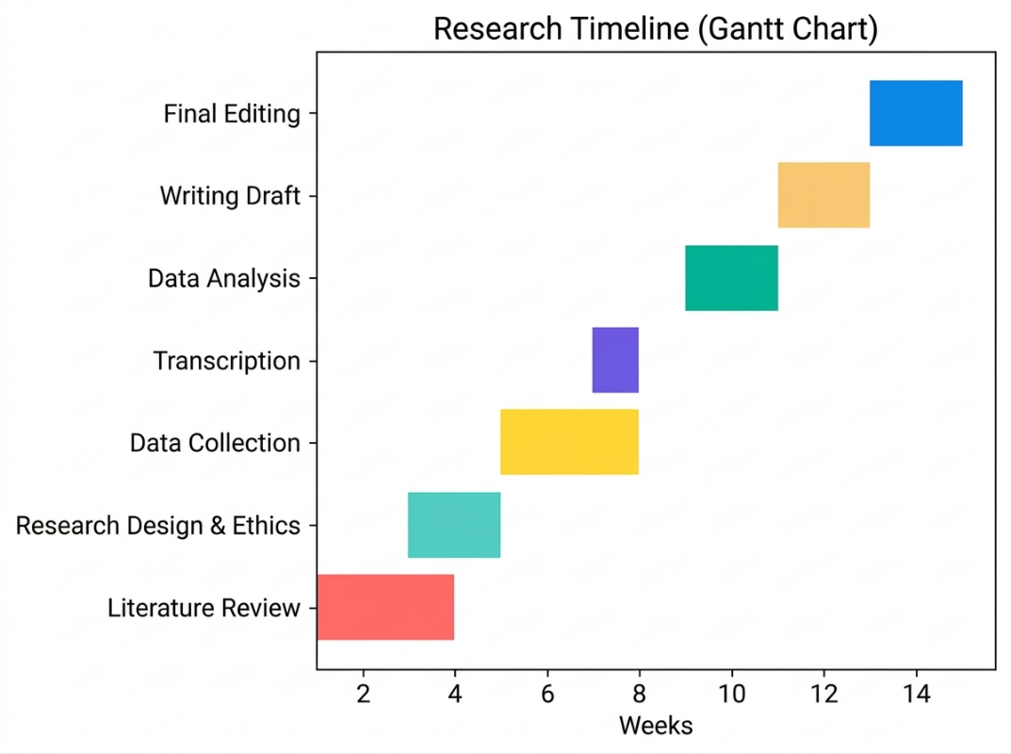
The Gantt chart offers a non-random visual presentation of the research plan, illustrating the chronological flow of important activities of the literature review to the final submission in a period of 14 weeks. The process allows good planning and time management as each part of the research process will be assigned a certain time period, making sure everything is done in a well-organised manner and meets the due dates (Saunders et al., 2019). The interrelated nature of activities like data collection and transcription assists effective utilisation of resources and time, which is critical during qualitative research studies (Bryman, 2016). Moreover, the timeline allows tracking the progress and referring to possible delays in time to make the required corrections (Easterby-Smith, Jackson and Thorpe, 2012). Altogether, the Gantt chart improves the organisation of the project and leads to the successful achievement of the research within the given timeframe.

References
Abu-Hasheesh, S.J., Dandis, A.O., Al, M., Alzyoud, S. and Khasawneh, M.A. (2024). The influence of service quality and marketing ethics on relationship marketing outcome in private hospitals. Journal of marketing communications, pp.1–28. doi:https://doi.org/10.1080/13527266.2024.2376256.
Adongo, A.A., Mokulogo, R.K., Bodpii, D.N., Akazili, J. and Yar, D.D. (2025). A patient-centred comparison of the public and private healthcare service quality: insights from the SERVQUAL model. Discover Health Systems, 4(1). doi:https://doi.org/10.1007/s44250-025-00317-4.
Ahmed, A., Khan, H.T.A. and Lawal, M. (2024). Patients’ Satisfaction with Healthcare Services Among Older People with Multimorbidity: Subnational Gender Perspective. Journal of population ageing. doi:https://doi.org/10.1007/s12062-024-09455-8.
Akin, T. (2025). Assessing quality of health care in the context of patient satisfaction from patients’ perspective among a physical therapy and rehabilitation unit. BMC Health Services Research, 25(1). doi:https://doi.org/10.1186/s12913-025-12214-w.
Al-Assaf, K., Bahroun, Z. and Ahmed, V. (2024). Transforming Service Quality in Healthcare: A Comprehensive Review of Healthcare 4.0 and Its Impact on Healthcare Service Quality. Informatics, 11(4), p.96. doi:https://doi.org/10.3390/informatics11040096.
Alfatafta, M., Alsubahi, N., Alfatafta, H., Alshawabka, A., McGarry, A., Ahmad, A., Derkacs, E., Varga, D. and Molics, B. (2025). Assessing service quality and its impact on patient experience and satisfaction in prosthetics and orthotics: a SERVQUAL-based cross-sectional study. BMC Health Services Research, 25(1). doi:https://doi.org/10.1186/s12913-025-13172-z.
Al‐Hammouri, F., Hamdan, K.M., Haymour, A.M., Ibrahim, M.O., Malkawi, A., Al‐Hiary, S.S., Albqoor, M.A. and Shaheen, A.M. (2024). Quality of nursing care: Predictors of patient satisfaction in a national sample. Nursing Open, 11(8). doi:https://doi.org/10.1002/nop2.2252.
Alhawajreh, M.J., Jackson, W.J. and Paterson, A.S. (2025). Healthcare professionals’ perceptions about implementing accreditation as a strategy to improve healthcare quality and organisational performance: a cross-sectional survey study. PLOS ONE, [online] 20(3), p.e0320664. doi:https://doi.org/10.1371/journal.pone.0320664.
Alhussin, E.M., Mohamed, S.A., Hassan, A.A., Al-Qudimat, A.R. and Doaib, A.M. (2024). Patients’ satisfaction with the quality of nursing care: A cross-section study. International Journal of Africa Nursing Sciences, 20, pp.100690–100690. doi:https://doi.org/10.1016/j.ijans.2024.100690.
Ali, Holland, E.M., Tauseef, A., Noor, A., Zafar, M., Mirza, M., Klaus, T., Frederickson, T. and Mirza, M. (2025a). Patient satisfaction: A feature of quality metrics within the inpatient healthcare system – A narrative review. Journal of Family Medicine and Primary Care, 14(6), pp.2099–2105. doi:https://doi.org/10.4103/jfmpc.jfmpc_1717_24.
Ali, Z.H., AL-Fayyadh, S., Isam, S.R., Hussein, S.M., Al-Ganmi, A.H.A. and AL-Hadrawi, H. (2025b). Private versus Public Hospitals: Patient Satisfaction of Nursing Care Quality in Orthopaedic Wards. Nigerian Postgraduate Medical Journal, 32(3), pp.197–203. doi:https://doi.org/10.4103/npmj.npmj_84_25.
Almulhim, A. and AlMulhim, A. (2024). Ophthalmology Practice-Related Factors and Patient Loyalty: Mediating Role of Patient Satisfaction. Patient Preference and Adherence, Volume 18, pp.1675–1689. doi:https://doi.org/10.2147/ppa.s461314.
Alodhialah, A.M., Almutairi, A.A. and Almutairi, M. (2024). Key Predictors of Patient Satisfaction and Loyalty in Saudi Healthcare Facilities: A Cross-Sectional Analysis. Healthcare, [online] 12(20), pp.2050–2050. doi:https://doi.org/10.3390/healthcare12202050.
Alsubahi, N., Pavlova, M., Alzahrani, A.A., Ahmad, A. and Groot, W. (2024). Healthcare Quality from the Perspective of Patients in Gulf Cooperation Council Countries: A Systematic Literature Review. Healthcare, [online] 12(3), p.315. doi:https://doi.org/10.3390/healthcare12030315.
Bawuah, A., Appleton, S. and Li, Y. (2024). The effect of health facility ownership on perceived healthcare quality: evidence from Ghana. International Journal of Health Economics and Management, 24(4), pp.571–593. doi:https://doi.org/10.1007/s10754-024-09385-0.
Bhatt, L.D., Ghimire, S. and Khanal, K. (2024). Patient satisfaction and their determinants in outpatient department of a tertiary public hospital in Nepal: a cross-sectional study. Journal of Patient-Reported Outcomes, [online] 8(1), p.26. doi:https://doi.org/10.1186/s41687-024-00696-x.
Brindley, C., Wijemunige, N., Bom, J., Meessen, B. and Bonfrer, I. (2024). Health seeking behaviours and private sector delivery of care for non-communicable diseases in low- and middle-income countries: a systematic review. BMC Health Services Research, 24(1). doi:https://doi.org/10.1186/s12913-023-10464-0.
Bryman, A. (2016) Social Research Methods. 5th edn. Oxford: Oxford University Press.
Çakmak, C. and Uğurluoğlu, Ö. (2024). The Effects of Patient-Centered Communication on Patient Engagement, Health-Related Quality of Life, Service Quality Perception and Patient Satisfaction in Patients with Cancer: A Cross-Sectional Study in Türkiye. Cancer Control, 31(1). doi:https://doi.org/10.1177/10732748241236327.
Cha, Y.-J. (2025). Key Factors Influencing Outpatient Satisfaction in Chronic Disease Care: Insights from the 2023 Korea HSES. Healthcare, 13(6), p.655. doi:https://doi.org/10.3390/healthcare13060655.
Chaanine, J. and Sleilati, E.B. (2024). The Moderating Impact of Employee Job Satisfaction on the Service Quality–Customer Satisfaction Relationship: The Case of the Lebanese Healthcare Institutions. SAGE Open, [online] 14(4). doi:https://doi.org/10.1177/21582440241295473.
Chen, M., Guan, Q. and Zhuang, J. (2024). Patient-centered lean healthcare management from a humanistic perspective. BMC Health Services Research, 24(1), pp.1–15. doi:https://doi.org/10.1186/s12913-024-11755-w.
Cui, J., Du, J., Zhang, N. and Liang, Z. (2025). National Patient Satisfaction Survey as a Predictor for Quality of Care and Quality Improvement – Experience and Practice. Patient Preference and Adherence, Volume 19, pp.193–206. doi:https://doi.org/10.2147/ppa.s496684.
Doubova, S.V., Leslie, H.H., Pérez-Cuevas, R., Kruk, M.E. and Arsenault, C. (2024). Users’ perception of quality as a driver of private healthcare use in Mexico: Insights from the People’s Voice Survey. PLoS ONE, 19(6), pp.e0306179–e0306179. doi:https://doi.org/10.1371/journal.pone.0306179.
Easterby-Smith, M., Jackson, P.R. and Thorpe, R. (2012) Management Research. 4th edn. London: SAGE Publications.
Eissa, A., Al-Tarrab, F., Kasem, E., Zaim, Y.A., Hmidoush, A., Salloum, J. and Ataya, J. (2025). A comparative study of total quality management in healthcare from provider and patient perspectives at Al-Mouwasat University Hospital. Scientific Reports, 15(1). doi:https://doi.org/10.1038/s41598-025-08512-2.
Endalamaw, A., Khatri, R.B., Mengistu, T.S., Erku, D., Wolka, E., Zewdie, A. and Assefa, Y. (2024). A scoping review of continuous quality improvement in healthcare system: Conceptualization, models and tools, barriers and facilitators, and impact. BioMed Central health services research, [online] 24(1), p.487. doi:https://doi.org/10.1186/s12913-024-10828-0.
Fereday, J. and Muir-Cochrane, E. (2006) ‘Demonstrating rigour using thematic analysis: A hybrid approach of inductive and deductive coding and theme development’, International Journal of Qualitative Methods, 5(1), pp. 80–92.
Ferreira, D.C., Vieira, I., Pedro, M.I., Caldas, P. and Varela, M. (2023). Patient satisfaction with healthcare services and the techniques used for its assessment: A systematic literature review and a bibliometric analysis. Healthcare, 11(5). doi:https://doi.org/10.3390/healthcare11050639.
Flyvbjerg, B. (2006) ‘Five misunderstandings about case-study research’, Qualitative Inquiry, 12(2), pp. 219–245.
Goodair, B. and Reeves, A. (2024). The effect of health-care privatisation on the quality of care. The Lancet. Public Health, [online] 9(3), pp.199–206. doi:https://doi.org/10.1016/S2468-2667(24)00003-3.
Gorman, G.E., Clayton, P., Shep, S.J. and Clayton, A. (2005) Qualitative Research for the Information Professional: A Practical Handbook. 2nd edn. London: Facet Publishing.
Gün, İ. and Söyük, S. (2025). The serial mediation effect of perceived quality and customer satisfaction on the relationship between trust and repurchase intention: a research on private health insurance owners. BMC Health Services Research, 25(1). doi:https://doi.org/10.1186/s12913-025-12269-9.
Guy, M. and Newcombe, L. (2025). NHS Patient Choice Policy in England: What Mapping the Private Healthcare Market for NHS Patients Can Tell Us. Liverpool Law Review. doi:https://doi.org/10.1007/s10991-025-09395-z.
Hammoud, S., Alsabek, L., Rogers, L. and McAuliffe, E. (2024). Systematic review on the frequency and quality of reporting patient and public involvement in patient safety research. BMC health services research, 24(1). doi:https://doi.org/10.1186/s12913-024-11021-z.
Harazni, L., Malak, M.Z. and Dasan, M. (2025). A comparative study of Palestinian patient satisfaction with service quality in accredited government and private hospitals in the West bank. BMC Nursing, 24(1). doi:https://doi.org/10.1186/s12912-025-03232-4.
Hendy, A., Farghaly Abdelaliem, S.M., Zaher, A., Sadek, B.N., Nashwan, A.J., Al-Jabri, M.M.A., Ahmeda, A., Hendy, A., Alabdullah, A.A.S. and Sinnokrot, S.M. (2025). Telehealth satisfaction among patients with chronic diseases: a cross-sectional analysis. PeerJ, [online] 13, p.e19245. doi:https://doi.org/10.7717/peerj.19245.
Hoxha, G., Simeli, I., Theocharis, D., Vasileiou, A., Vasileiou, A. and Tsekouropoulos, G. (2024). Sustainable Healthcare Quality and Job Satisfaction through Organizational Culture: Approaches and Outcomes. Sustainability, 16(9), pp.3603–3603. doi:https://doi.org/10.3390/su16093603.
Hung, M., Vu, S., Hon, E.S., Reese, L., Gardner, J. and Lipsky, M.S. (2025). Unveiling the drivers of patient satisfaction in the United States hospitals: Assessing quality indicators across regions. PLOS One, 20(6), p.e0324737. doi:https://doi.org/10.1371/journal.pone.0324737.
Hussain, A., Kanwel, S., Khan, S., Alonazi, W., Malik, A. and Khan, A.A. (2025). Antecedents of Patient Loyalty: Exploring Mediating and Moderating Paradigms in Public Hospitals. Patient Preference and Adherence, Volume 19, pp.527–542. doi:https://doi.org/10.2147/ppa.s492710.
Hussain, M., Nikoloski, Z. and Gjebrea, O. (2024). Trends and inequalities in health system satisfaction: results from the latest nationally representative surveys in Qatar. International Journal for Equity in Health, 23(1). doi:https://doi.org/10.1186/s12939-024-02317-x.
Jameel, A., Sahito, N., Guo, W. and Khan, S. (2025). Assessing patient satisfaction with practitioner communication: patient-centered care, hospital environment and patient trust in the public hospitals. Frontiers in Medicine, 12. doi:https://doi.org/10.3389/fmed.2025.1544498.
Karume, A.K., Nyongesa, K., Okutoyi, L. and Kinuthia, J. (2025). Patient’s expectations and perceptions on quality of care; An evaluation using SERVQUAL gap in Kenya. PLoS ONE, 20(3), pp.e0315910–e0315910. doi:https://doi.org/10.1371/journal.pone.0315910.
Leavy, P. (2020) The Oxford Handbook of Qualitative Research. 2nd edn. Oxford: Oxford University Press.
Morse, J.M., Barrett, M., Mayan, M., Olson, K. and Spiers, J. (2002) ‘Verification strategies for establishing reliability and validity in qualitative research’, International Journal of Qualitative Methods, 1(2), pp. 13–22.
Niraula, S.R., Niraula, T.P., Rizwan, A.A.M. and Kafle, R.C. (2026). Health management services and patient satisfaction – institutional and patient perspective: a qualitative study in Eastern Nepal. BMC Health Services Research, [online] 26(1). doi:https://doi.org/10.1186/s12913-025-13963-4.
Owusu, A.A., Boakye, K., Boateng, D., Osei-Mensah, C. and Agyei-Baffour, P. (2024). Patient satisfaction with quality of care at out-patient departments in selected health facilities in Kumasi, Ghana. BMC Health Services Research, 24(1). doi:https://doi.org/10.1186/s12913-024-11399-w.
Perals, P.O., Rambaud, S.C. and García, J.S. (2024). Quality of care and patient satisfaction: Future trends and economic implications for the healthcare system. Journal of Economic Surveys. doi:https://doi.org/10.1111/joes.12657.
Rao, X., Luo, L., Xiang, J. and Wang, X. (2025). The impact of perceived value, customer expectations, and patient experience on the satisfaction of contracted patients in hospitals. BMC Health Services Research, 25(1). doi:https://doi.org/10.1186/s12913-024-12118-1.
Rauf, A., Muhammad, N., Mahmood, H. and Yen, Y.Y. (2024a). The Influence of Healthcare Service Quality on Patients’ Satisfaction in Urban Areas: The Case of Pakistan. Heliyon, [online] 10(18), pp.e37506–e37506. doi:https://doi.org/10.1016/j.heliyon.2024.e37506.
Rauf, A., Muhammad, N., Mahmood, H., Yen, Y.Y., Rashid, M.H. and Naseem, W. (2024b). Role of servicescape in patients’ clinic care waiting experience: Evidence from developing countries. PLoS ONE, 19(10), pp.e0311542–e0311542. doi:https://doi.org/10.1371/journal.pone.0311542.
Saunders, M., Lewis, P. and Thornhill, A. (2019) Research Methods for Business Students. 8th edn. Harlow: Pearson Education Limited.
Shaikh, M.I. and Sarkar, A. (2023). A comparison of patients’ satisfaction treated at public and private healthcare institutions under the health scheme using the HEALTHQUAL model. Journal of Integrative Medicine and Public Health, 2(2), pp.75–81. doi:https://doi.org/10.4103/jimph.jimph_22_23.
Smerat, H., Abu Ejheisheh, M., Ayed, A., Aqtam, I. and Batran, A. (2025). Patient satisfaction with the quality of nursing care in critical care units and medical wards in West Bank Hospitals, Palestine: A cross-sectional study. PLOS One, [online] 20(4), p.e0322804. doi:https://doi.org/10.1371/journal.pone.0322804.
Sukmawati, T., Ramadania and Pebrianti, W. (2024). Enhancing Patient Satisfaction by Healthcare Service Providers: A Systematic Literature Review. Asian Journal of Economics, Business and Accounting, 24(12), pp.342–356. doi:https://doi.org/10.9734/ajeba/2024/v24i121613.
Szewczyk, T. and Hoque, F. (2026). Improving Patient Experience in Healthcare. Journal of Brown Hospital Medicine, [online] 5(1). doi:https://doi.org/10.56305/001c.147405.
Wei, Y., Xu, Y., Chen, D., Fang, Y., Liang, K., Deng, B., Ma, L., Yang, Y. and Cao, Q. (2026). An evaluation of outpatient satisfaction in Chinese tertiary hospitals from a patient-centered perspective: a cross-sectional study. Frontiers in Public Health, 13. doi:https://doi.org/10.3389/fpubh.2025.1698875.
Widiastuti, W., Indartono, S. and Sa’adah, N. (2024). Islamic Service Quality and Patient Loyalty: Investigating the Role of Satisfaction in Healthcare Contexts. Society, 12(2), pp.538–555. doi:https://doi.org/10.33019/society.v12i2.723.
Wu, S., Lei, Z., Liu, T., Chen, L. and Qin, Y. (2025). The analysis of factors influencing patient choice of healthcare providers between tertiary hospitals and community clinics. Frontiers in Public Health, 13. doi:https://doi.org/10.3389/fpubh.2025.1510311.
Yang, Z., Alveyn, E., Dey, M., Arumalla, N., Russell, M.D., Norton, S. and Galloway, J.B. (2024). Impact of visualising healthcare quality performance: a systematic review. BMJ Open, 14(11), pp.e083620–e083620. doi:https://doi.org/10.1136/bmjopen-2023-083620.
Yeboah, J.G. and Amponsah, K.T. (2025). The mediating role of service innovation in the relationship between customer orientation and patient satisfaction. BMC Health Services Research, 25(1). doi:https://doi.org/10.1186/s12913-025-12794-7.
Zehra, S., Ranjan, J. and Shukla, M. (2025). Service quality in healthcare: understanding the relationship between patient experience and healthcare outcomes. PubMed, pp.1–18. doi:https://doi.org/10.1108/ijhcqa-09-2024-0090.

Appendices

Appendix A: Interview Guide
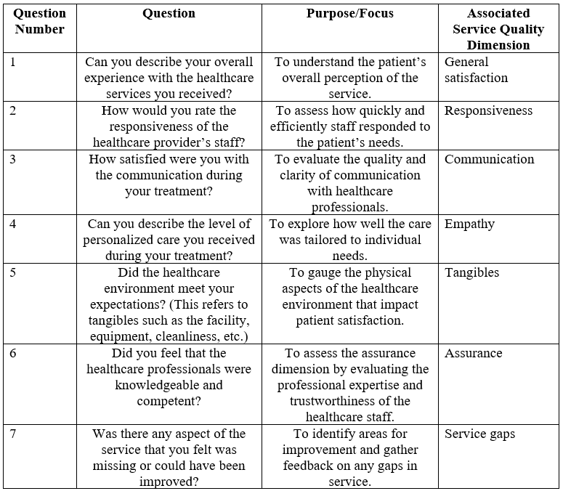

Appendix B: Data Analysis Codebook
A codebook would be created for thematic analysis, outlining the themes and sub-themes used to analyze the interview data.
Example:
- Theme 1: Service Quality
  - Sub-theme 1.1: Responsiveness
  - Sub-theme 1.2: Communication
  - Sub-theme 1.3: Assurance
- Theme 2: Patient Satisfaction
  - Sub-theme 2.1: Overall Experience
  - Sub-theme 2.2: Perceived Service Quality vs. Expectations
- Theme 3: Competitive Advantage
  - Sub-theme 3.1: Loyalty
  - Sub-theme 3.2: Word-of-mouth Promotion

