Data Findings and Initial Analysis (Primary Research)
The whole purpose of the research was to question the views of the practitioners and then to then critically analyse those results with existing doctrine. Seventy-five officers responded in what provides a strong basis to argue credibility in terms of the primary research and the first four questions provide demographic information about the profile and background of the respondents.
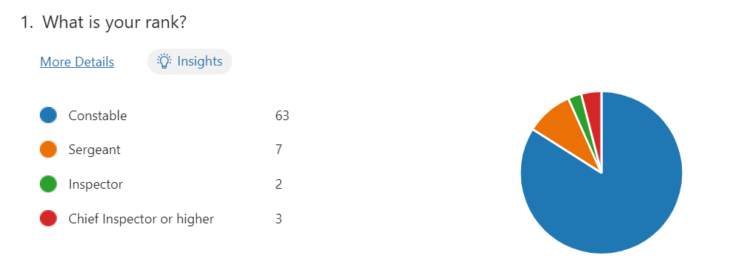

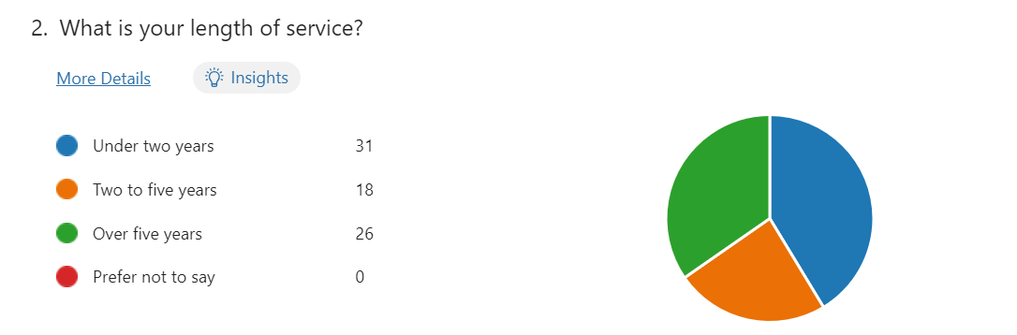

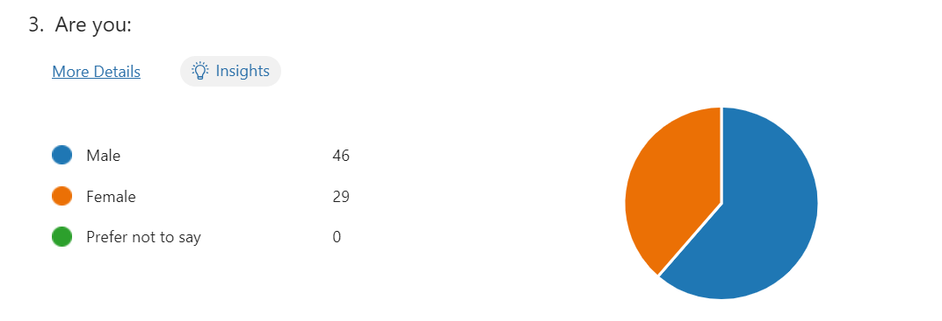
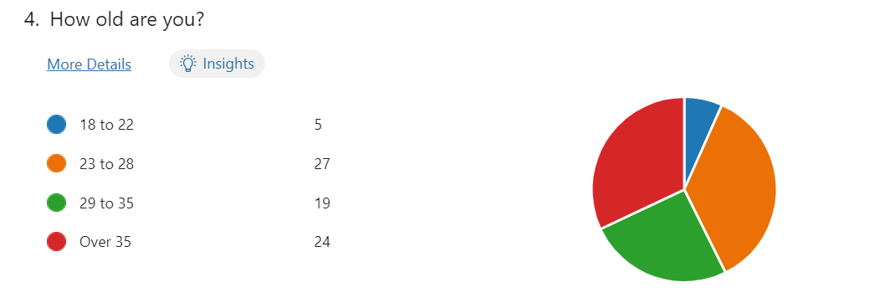

The above showed participants of all ranks from Police Constable up to and including Chief Superintendent. It showed a variety of service levels reflective of the sample group with a large number of respondents who were relatively young in service – again reflective of the wider response policing profile. Encouragingly, thirty-eight per cent of respondents were female officers (far in excess of the widely accepted representative level of one-in-four) with the vast majority in their twenties and early thirties – which again added to the reliability of the data obtained.

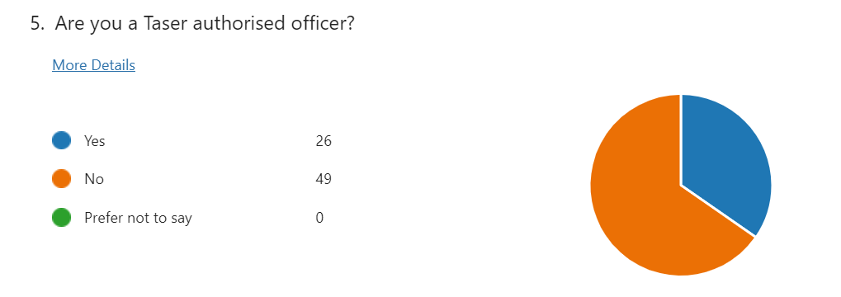
This diagram suggests that a far higher number of respondents were not Taser trained, typically 65%, which provided a result that could be argued or negated in any suggestion of a pre-formed bias in favour of those who were trained beforehand, adding further to the impartiality of the research.

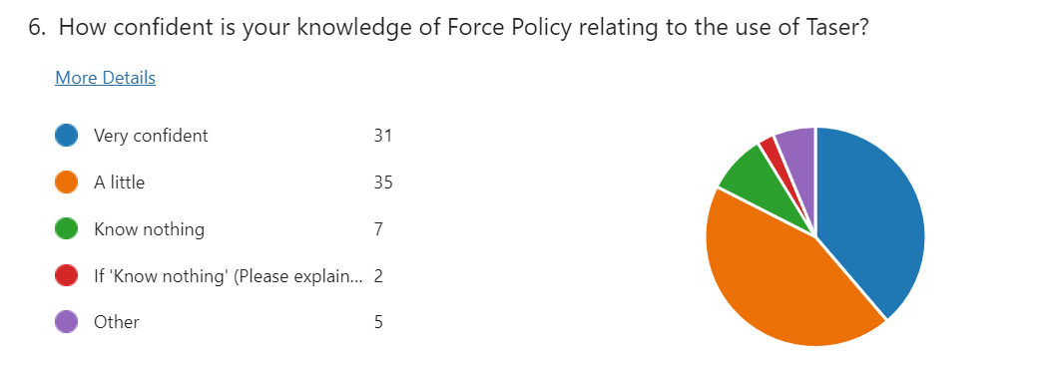
In what was considered a very open and honest response, 46% or just under half of respondents (but the largest group of those who expressed an opinion) admitted to only a little knowledge of the related Force Policy with comments like, “as I am not authorised to use Taser, I have not read up on anything…” or “not Taser trained so very limited knowledge" were typical of such responses.
This could tend to support an existing suggestion of malaise over policy access and awareness generally - but encouragingly, responses to the next question threw doubt on that assertion.

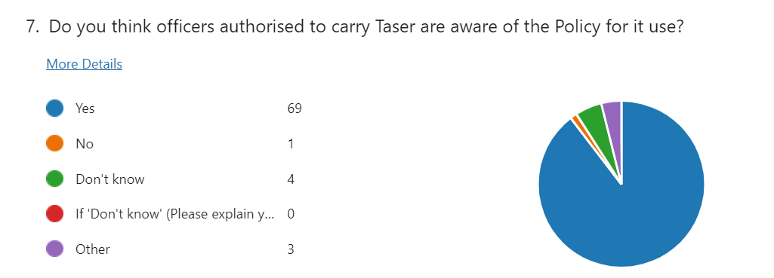
This was because 92% of all responders suggested that Taser users should be aware of its policy. This demonstrates a very strong suggestion that such authorised officers ought to be aware of the rules that govern its use - with one respondent offering that at the very least, “I would like to think Taser carrying officers have a basic knowledge of Policy.”

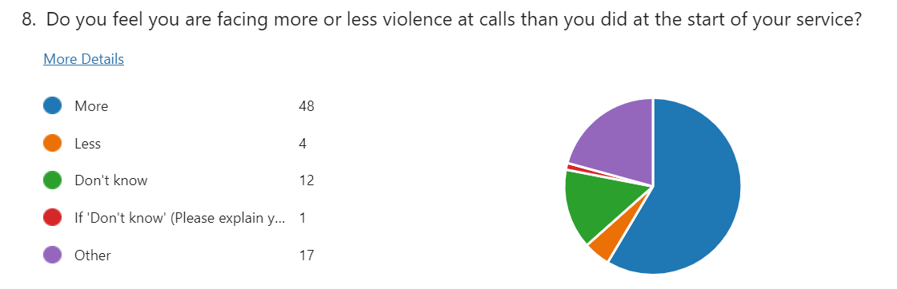
Designed to tease out the perception of violence faced by the police and whether it had changed relative to service or experience, in order to perhaps justify or negate the need for Taser, over half agreed that they now faced more of it. One respondent suggested that having been promoted, they faced less but acknowledged those “in front line roles faced far more.”
Interestingly, those with less than two years’ service suggested they were facing the same amount, whilst another even offered a differing ‘type’ with “the level or methods of violence” having increased.
In spite of such increases, it was also encouraging to note one respondent who suggested violence had increased, by clarifying further that, “it depends on how well you communicate and whether you are able to de-escalate the situation you are facing."

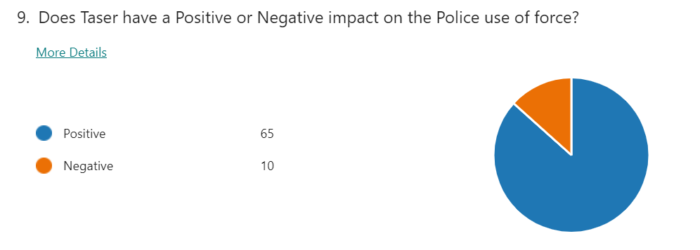

In what is a clear link to the previous question, 86% demonstrated very clear finding that the presence of Taser has a very positive impact on the use of force. One respondent suggesting, “members of the public will see the Taser and tend to comply better than without the presence of Taser.”
Others suggested it de-escalated situations when people saw its carriage to produce “less physical altercations” with overwhelming comments as to its deterrent capabilities.

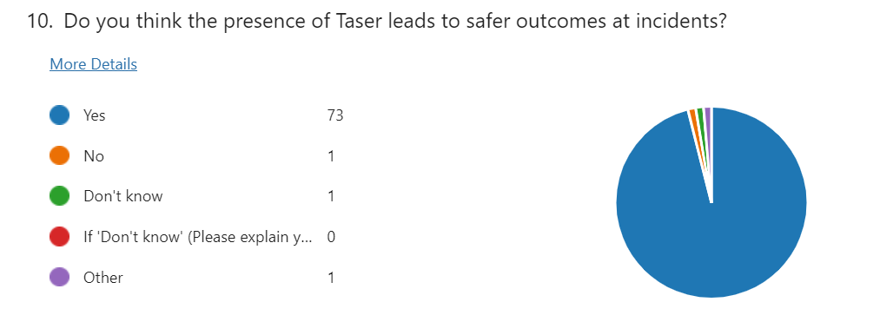
Here, one of the strongest endorsements with over 97% of respondents in agreement that Taser delivered safer outcomes with one slightly dissenting view offering that such safer outcomes depended “upon the nature of the incident.”

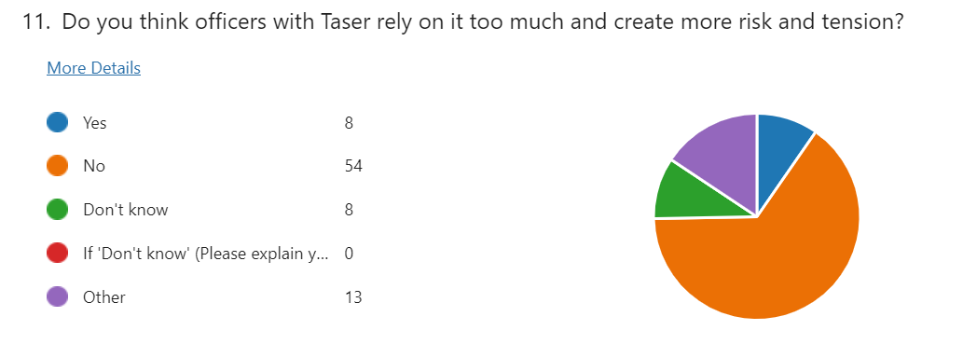
Keeping in touch with the questions that had gone before and noting the positivity reported in the presence of Taser, there was the clear need to then delve deeper to establish whether Taser was relied upon too much.
Interestingly, in an environment where a strong response suggested there was no such over-reliance, a theme did tend to emerge that suggested some did with suggestions a minority were “over reliant” especially with “those who can’t speak to people” or “rely on it as an early intervention rather than tactical communications.”
Explaining further, another responder clarified further on the ‘danger’ of an officer who will “try to get a swift resolution by deploying Taser before exhausting all opportunities to de-escalate."

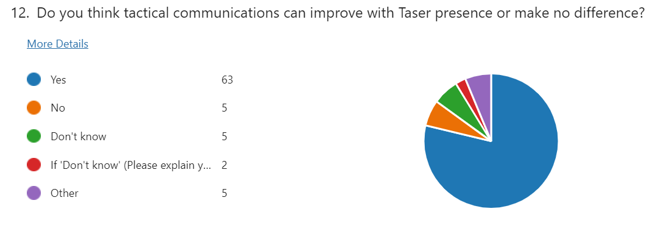
Following on that theme of tactical communications, was the next question, that suggested again by an overwhelming majority of 84%, that tactical communications could improve when Taser was present.
Even those that supported it, suggested that these communications were “hugely important” where officers without Taser had to develop and rely on such communications even more.
Again though, the emerging theme was once again touched upon where those who offered an opposing view were more verbal with their rationale suggesting that again within those few officers, that “Taser is usually accompanied by shouting/dominant instructions which can escalate” issues at incidents.

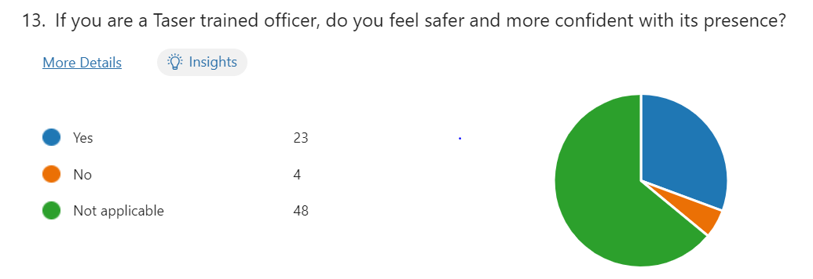
In a question clearly aimed at the Taser practitioner and also reflecting on the data provided again in question 5, a very strong preference of 92% responded that Taser had no bearing on their safety and confidence.

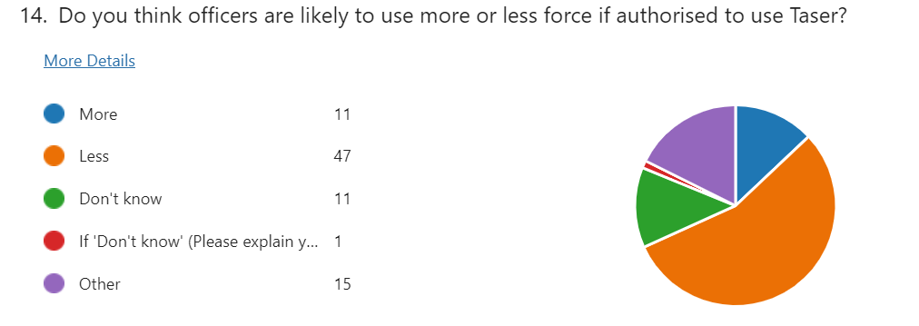
Another interesting result where 62% suggested less force was likely to be used where Taser was present. Far more variance here where some offered, “officers with Taser will use it, officers without Taser will use other tactics.” Others suggested “presence of Taser should give additional tactical options that can de-escalate.”
Of interest was one respondent within those that couldn’t express a clear opinion with a mature view suggesting it was “hard to say because there are (sic) so many differing tolerance levels and subjective opinions between officers.”

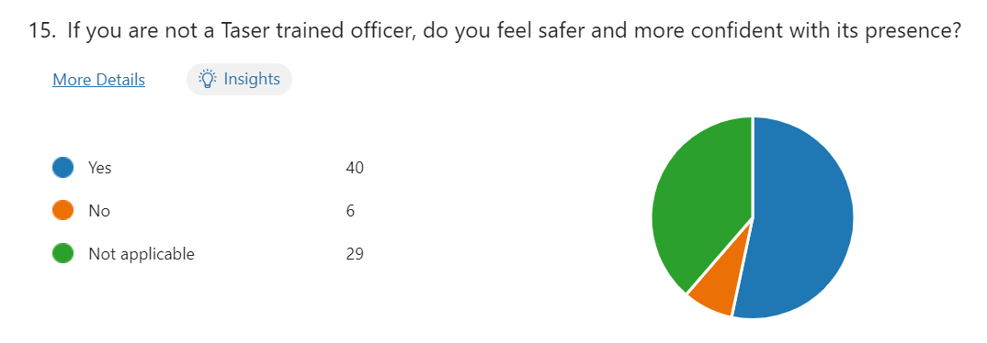
Again, reflecting on question 5 data to take away those trained in its use, a very strong suggestion was again found that those not trained in its use who felt far safer and more confident when it was present.
Another sister question to number 13, this was a straightforward request that again failed to realise any narrative – just clear support of greater safety and confidence with Taser presence.

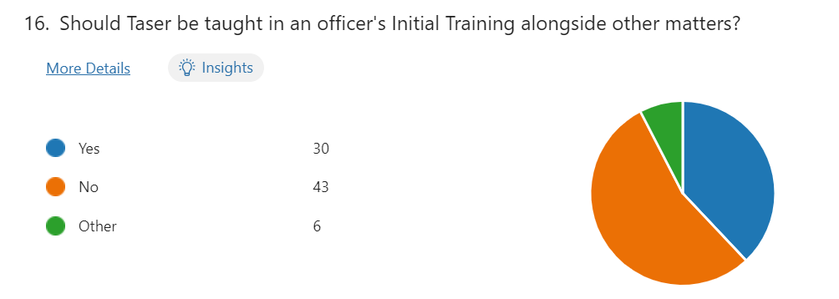

Drawing the data harvest to a conclusion, matters started to become more pointed now with a more non-committal environment where nearly 60% suggested Taser use should not feature in initial police training.
With no narrative offered supporting an inclusion in such training, comments instead suggested officers should “wait for a period of three to six months after tutorship for officers to gain confidence in dealing with confrontation.”
Additionally, another respondent offered more thought with, “No, I believe if after an officer has shown they are competent in use of force and able to deal with confrontation appropriately, they should be allowed to put themselves forward for the training.” This was supported by another offering a far longer wait of three years, “to allow (sic) a student officer to experience a range of different incidents” first before being better “able to gauge best when to use Taser accordingly.”

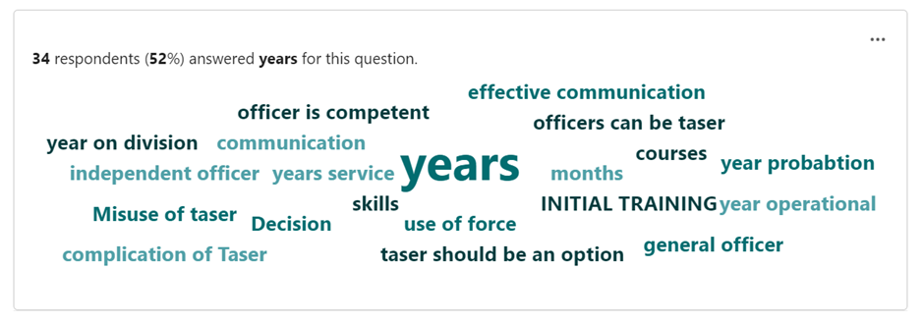

The natural consequence was then to consider how long should any period be before such training could therefore take place, where only a handful offered an immediacy of training with “Initial Training,” or “as soon as possible” being typical of that group.
However, in support of the above tag cloud and where 52 of the 65 responders actually offered a quantifiable figure, a consequential average of those figures was taken which offered a period in the region of around one and a half years of service was found to be appropriate before consideration of such training being offered.
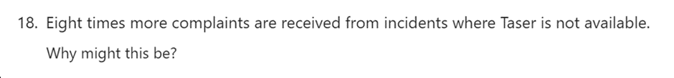

Concluding the data search with a question that invited only written responses, hopefully to build upon the themes offered above, officer comments around having to get “hands on” when Taser wasn’t available, increases risk and “looks messy” to an uninformed public, received widespread commentary with one respondent suggesting “without having Taser, the impact of the public seeing physical force being used may present officers in a bad light.”
Another regular feature again suggested the inability of officers to communicate effectively, whilst another supported its presence by suggesting a person’s “behaviour changes upon seeing Taser and can lead to less force being required by police.”
Adding further value to the position, another respondent offered that “when Taser is not present, members of the public feel they are able to become more violent and aggressive as there is no risk of being tasered.”
Conversely, and with a more positive view, another officer suggested the lower levels of injury from Taser compared to an officer physically striking a person were beneficial, adding the device had become the normality “for knife/weapon incidents” and where “unarmed skills could be seen as harder to justify” when injury has resulted.
This last question was one which was also offered to two expert witnesses by way of a separate questionnaire, where Herbert (2024) a serving senior police officer and experienced Hostage and Crisis Negotiator, suggested the reason was because “a large proportion of our patrol teams still do not carry Taser” whilst supporting the above assumptions of its de-escalating effects.

That view was also supported by Davies (2024), a retired police firearms officer and trainer, now employed by Taser who offered that “in excess of 80% of Taser ‘uses’, the situation is resolved without the device being discharged” and that “as a result of the de-escalation benefits…complaints will inevitably be lower.”

Asked as to when training ought to be provided, he declined to comment but instead offered that “an organisation is duty bound to provide that individual with equipment to allow them maximum safety.”

Delving deeper into the suggestion that Taser training should be offered during initial training, Herbert (2024) clearly stated it was “far too soon” suggesting officers should first learn to de-escalate through speech before relying on a device that “isn’t perfect” and can fail.

Davies (2024) surprisingly declined to give an opinion on what should be included in training, but put forward the strong argument that, “if an officer is trained and trusted to attend violent calls, then the organisation is duty bound to provide…them maximum safety.”

Probed further as to whether a trial period could be considered where all are so trained, Herbert (2024) provided the present organisational position and clarity that all officers with at least twelve months service could apply for it, but that it ought not to be mandated. He also offered concerns over the intrusion of inquiries when matters go wrong. Davies (2024) however was clearer in voicing support for such a pilot as “very few he had met, di not want to carry” before once again acceding the decision ought to be organisational and not corporate by a provider.

Both cited tactical awareness as promoting the most effective use (or not) of the Taser device and indeed vouched for the positive impacts upon local communities in improving confidence in policing – backing that up with high levels of training, scrutiny and training in terms of the standards for any such use.

To conclude this primary research, a brief critical analysis of both primary and secondary findings is prudent. In summary, the most glaring of findings and a central theme arose in an environment where 64% stated they faced more violence than at the start of their service, was that not all respondents wanted training in the device in the same manner that (White 2021) Amnesty International had suggested.

Notwithstanding the above, an overwhelming majority emphasised that Taser had a very positive effect on the use of force tending to compliment (White 2024) findings of increased officer safety and which clearly questioned the perception of the ‘weapon effect’ (Ariel 2018) of more hostility, where conversely, the opposite was found to be commented upon.

Research also challenged the findings of complacency (Dymond 2019) by resorting to the Taser device, but yet there was also clear support in the view that suggested officers were more confident with its presence. Much in the same way, there was no appetite nor evidence found that supported ‘trigger happy officers’ (Adams and Jennison 2007).

However, that aside, a theme clearly emerged around poor conversation skills which did find traction where support was found, albeit in a limited number of officers who may be more reliant on Taser. Notwithstanding that, a very clear majority preferred the assertion that Taser trained officers simply did not rely upon it. This also challenged such over reliance in other (Miller 2023) findings, which interestingly also supported the position of first learning the ability to talk to people.

Reassuringly, respondents also spoke of the need for the reassuring and safer presence of Taser as well as the need for better tactical communications, which was the case mentioned in earlier (Somers et al 2020) doctrine as the best ‘combination’ offered by way of deterrent.

Finally, adapting and adopting that best form of deterrent in an environment where it’s presence tends to yield eight times less complaints, that public confidence gap as demonstrated in earlier reviews (Independent Office for Police Conduct 2021) is surely narrowed where a clear consensus offered that’s its presence actually led to less force being used.
Word count 2182

Conclusions and Findings
In drawing matters to a conclusion, the whole purpose of the research was to consider whether student police officers should undergo Taser training as part of their initial studies, or not.
Daily media coverage bears testimony to the view that violence towards officers is increasing and the researcher will make no further comment on the political argument and counter argument over the reduction of officer numbers and the consequential loss of experience therein.
Instead, having asked questions, the responses were examined and analysed in pursuit of answers as well as any themes or trends that may have merged together would tend to confirm the position offered by previous texts, or offer an alternative view – either way with a desire to better inform the decision-makers of the future with the benefit of evidence-led recommendations fashioned from research undertaken of those perhaps best positioned to offer a learned opinion.
Comment has already been offered by the researcher as to the credibility of that primary research undertaken in search of such solutions. That all said, it was a reasonable and accurate profile of the type of target audience that the researcher sought – where the majority were not trained in the use of Taser, which always carried the risk of an unnatural response in simply agreeing to request something that the peer group didn’t presently have.
Instead, the researcher found honesty in an acceptance of limited knowledge of the rules and regulations relating to its use, but yet an expectation of exactly the opposite in those charge with Taser use. There is surely a need to improve on the former.
Having fully considered all responses thereafter, where it is accepted that Taser as a device that is not likely to be replaced or removed as a less than lethal temporary incapacitant. This is demonstrated by its latest iteration being rolled-out to existing authorised Taser officers to receive additional training in a new device that features significant improvements such as greater accuracy over more distance and consequently more time in which to de-escalate and resolve conflict, as well as the ability to deploy up to ten individually targeted probes without the need to reload.
These advancements come at a time of never previously experienced scrutiny over the police use of force – and in an era where increased violence is offered, whether the question has remained as to whether these existing technologies should be offered to all officers to keep them and those they engage with, safer.
Compare that with the opposing view that not all may actually want the device, that those who have it are over-reliant upon it, trigger-happy and as a consequence create more of a risk than it looks to mitigate and you have the classic two-sided debate.
Returning, therefore, to the original research proposals, the researcher found the clearest of opinion that rejected the concept of Taser being delivered as part of initial police training, instead preferring period of time not dissimilar to that presently administered to pass first, whilst other basics of policing are learned first – specifically the ability to speak to people in times of conflict, violence or threat.
That said, there was also strong support as to the presence of Taser at such incidents and carried by authorised officers trained to use it, as the benefits of such ‘presence’ far outweighed any negative perceptions offered under the above headings. Of particular interest was the almost unanimous approval from non-trained officers that they felt more confident when it was present at incidents when carried by others. Research also suggested respondents found themselves feeling safer due to its presence, that less violence and aggression was consequently offered, not more and there was less likelihood of resorting to the physical use of force. Comment was also found that suggested there was less risk of violence being offered towards them by others - one opinion, already cited, suggested eight-times less violence to be exact.
And yet having accepted such responses, still further credibility was evidenced where additional commentary was also then offered in respect of small numbers of officers who lacked the ability to deliver better tactical communications in such circumstances and perhaps tended to rely on Taser in support of clumsier, failed verbal attempts at reasoning which had the effect of increasing and not decreasing tensions.
To better achieve such outcomes, whilst it is accepted that there is no need to proceed with Taser training to all staff and especially those undergoing their initial training, the researcher found that there appeared to be a need to amend such training so as to focus on both the improved delivery of tactical communications as well as a move towards the inclusion of technologies to include the notional presence of Taser officers at training incidents, to better reflect reality of the threats and behavioural changes likely to be encountered. This would include policy awareness to improve knowledge of the subject at hand, its capabilities and indeed it's limits.
It has also been shown that it is vital that authority needs to despatch such trained officers to more types of incidents where violence is offered, to be reviewed in order to provide a greater clarity and equality of response in mitigating such threats.
To illustrate further acceptance of this status quo, the currently practice of firstly completing a period of twelve months of service before the offer of additional Taser training, should continue unchanged.
Additionally, in terms of a greater training requirement identified through research, a strategic review of Taser training should be considered to reflect the significant increase in training need anticipated from within an ever younger and inexperienced workforce. Specifically, as current demand sees initial courses fully-booked for well over the next twelve months as supply is swamped by significant increases in demand, plus the rollout of updated training to existing officers, arrangements need to be considered to best meet and deliver the needs of both streams if the benefits offered within this research are to be fully realised.
With greater training comes increased visibility and another consideration ought to be an accompanying media strategy that explains the rational for such increased use and visibility to inform what could be the more vulnerable or indeed those most opposed to such tactics within a wider reassurance and awareness-led campaign.
The above is therefore offered as a potential framework to be considered to assist in the potential training delivery of tomorrow.
Word count 1067

