

Module: International Business Concepts
Module Code: LCMB7034
Lecturer: Gladius Kulothungan

STRATEGIC MARKET ENTRY ANALYSIS: SPOTIFY'S EXPANSION INTO CHINA
Word Count: 5289
Student Name: Shahbuddin aliahmad shah
Student ID: 2519349

Table of Contents
Introduction 3
Section 1: International Market Entry Report – Spotify into China 3
1. Organisational Classification and Global Strategy 3
1.1 Strategic Categorisation: Bartlett and Ghoshal Analysis 3
1.2 Critical Analysis: Strengths and Limitations 4
1.3 Global Configuration and Geographic Footprint 5
1.4 Competitive Advantage and Value Creation 6
2. Macro-Environmental Appraisal and Market Attractiveness 7
2.1 Host Country Analysis: China 7
2.2 Market Entry Analysis Using Dunning's Eclectic (OLI) Paradigm 15
2.3 Identify Key Factors Influencing Success 20
2.4 Critical Evaluation of the Chosen Market's Attractiveness 20
3. Entry Mode Strategy and Strategic Synthesis 22
3.1 Historical Pattern Recognition: Spotify's Dominant Entry Modes 22
3.2 Strategic Fit and Justification for China 24
3.3 Conclusion and Recommendations 26
Section 2: Reflective Account 27
Introduction to the model 27
Model Application 28
Description 28
Feelings 28
Evaluation 28
Analysis 29
Conclusion 29
Action Plan 29
Reference List 31

Introduction
Spotify has 761 million monthly active users in 184 markets by Q1 2026 but the one of the biggest music market in the world in monetary terms is mainland China, with a 2025 value of $3.4 billion, which has been completely undervalued. This report uses the Bartlett and Ghoshal framework to categorize the international posture of the firm, PECL Analysis of the host environment, the OLI paradigm of Dunning to determine the attractiveness of the market and a final evaluation of the entry mode to justify the final recommendation to enter China by Spotify. A Gibbs reflective account is at the end of the report.

Section 1: International Market Entry Report – Spotify into China

1. Organisational Classification and Global Strategy

1.1 Strategic Categorisation: Bartlett and Ghoshal Analysis
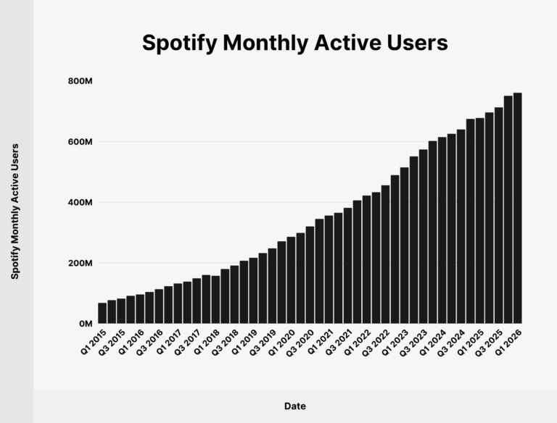
Figure 1: Spotify Monthly Active Users
(Source: Dean, 2026)
Spotify tends to lay nearest to the global-transnational point of aid in the Bartlett and Ghoshal model, nevertheless, its de facto stance tends strongly global. The headquartered company has a highly centralized product platform and algorithmic engine with 761 million monthly active users spread across 184 markets as of the end of Q1 2026 (Dean, 2026). There is some localisation (localized editorial selection in Hindi, Portuguese and Bahasa, different pricing, which differs fourfold between Copenhagen and Jakarta, and local artist relations in Latin America and Southeast Asia) but the discovery algorithm, product roadmap and Premium tier architecture are all tightly centralized (Shyam Future Tech, 2025). That local stretch of modest central coordination and tightness is Spotify transnational.

1.2 Critical Analysis: Strengths and Limitations
Strengths: The typology encloses the truth of Spotify: a single recommendation system, a single Freemium infrastructure, a single artist onboarding funnel - stratified by local content customization in 184 markets. This dual call can be used to explain the 12% year on year increase in MAUs to 761 million in Q1 2026 and the 23 to 37% lift of Rest of World by Spotify in comparison to four years ago (Spangler, 2026).
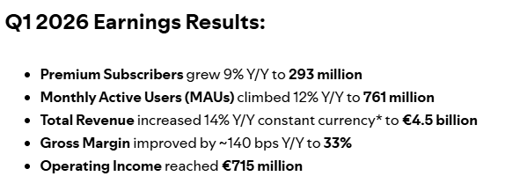
Figure 2: Q1 2026 Earnings Results
(Source: Spotify, 2026)
Limitations: The weakness is the fact that Spotify is not necessarily transnational, in practice. Stockholm retains the roadmap, algorithm logic and pricing the January 2026 US Premium increase to $12.99 (was 11.99) implemented top down following comparable increases all over the UK and Switzerland. The 293 million paid subscribers are still disproportionately provided by Europe and North America even though these regions only host 41% of the MAUs, revealing a structural bias to prefer the developed-market monetisation, to the true local autonomy (Spotify, 2026).

1.3 Global Configuration and Geographic Footprint
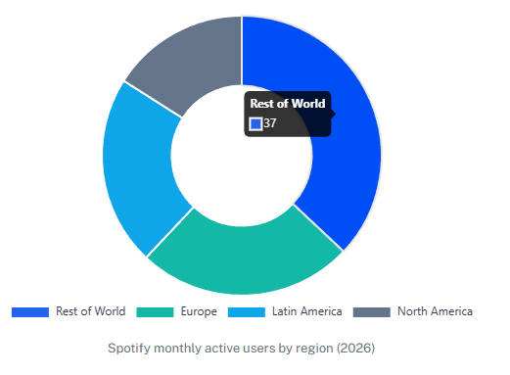
Figure 3: Spotify Target Market and Segmentation
(Source: Darius, 2026)
The 761 million MAUs of Spotify as at Q1 2026 are disproportionately represented - Rest of World 37%, Europe 25%, Latin America 22%, North America 16%. The number of paid subscribers (293 million) was clustered in Europe 36%, North America 25%, Latin America 24%, Rest of World 15% (Darius, 2026). India, Indonesia and Sub-Saharan Africa lead the growth, but it is important to note that mainland China, the 5th largest ever recorded music market of 1.45 billion, is set to grow to 8.39 billion by 2030 and is a blank slate . By applying the concept of adaptive leadership, this gap is no longer a timing issue, but an organizational issue that involves positioning technical work which it has tried that it is familiar with and adaptive work which it has never had to confront (ChinaAlbums, 2026).

1.4 Competitive Advantage and Value Creation
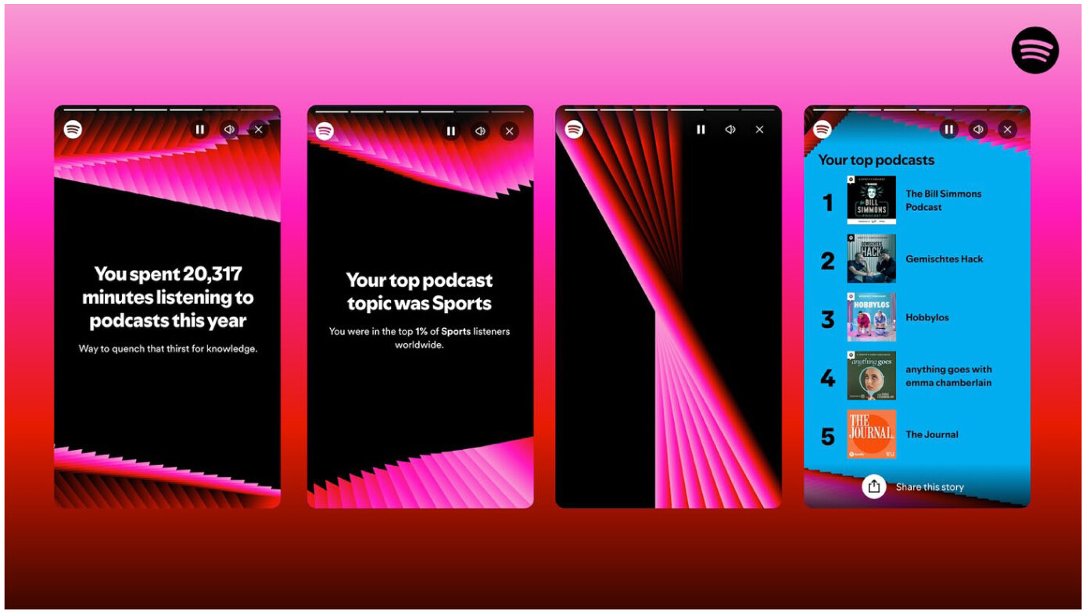
Figure 4: Screenshots of the Spotify Wrapped in-app experience
(Source: Annabell and Rasmussen, 2025)
There are three engines in value creation. Algorithmic personalisation Wrapped is new and has attracted 300 million engaged users and 630 million social shares in 56 languages in December 2025, the highest single day of subscriber intake in the history of the company (Spotify, 2026b). Two sided marketplace connecting 12 million creators and 761 million listeners and paying 11 billion of royalties in the year 2025. And the funnel to the freemium and the 483 million ad-supported users-293 million Premium subscribers. Adaptive leadership elucidates that these engines are designed to target markets that Spotify can dominate technically; China insists on ceding operational dominance to a collaborator who realizes a setting that none other in the world has penetrated quite this manner (Sridharan, 2025).

2. Macro-Environmental Appraisal and Market Attractiveness

2.1 Host Country Analysis: China

2.1.1 Political Environment

Xi Jinping's Third-Term Governance and Party Control
After Xi Jinping was re-elected CCP General Secretary in October 2022, China has been operating under the leadership of a single man, marking the first time that this two-term norm had been broken since Deng. A crossway foreign platform. There is no lurching by policy with elections, five-year plans are in fact implemented and the Party is able to cut through roadblocks like no Western regulator (Krishnan, 2023).

Regulatory Crackdowns and Tech Sector Oversight
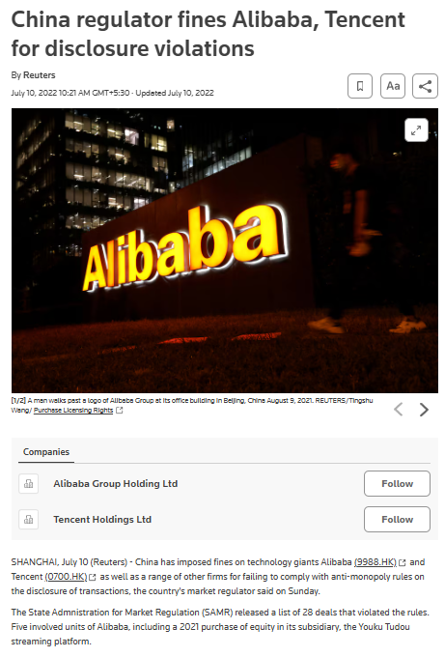
Figure 5: China Regulators Finest Tencent and Alibaba
(Source: Reuters, 2022)
The 2020–2023 clampdown showed what that looks like in practice. In July 2021 the market regulator fined Alibaba, ordered Tencent to relinquish its exclusive music rights in 30 days and pulled the IPO of Ant Group after it declared having discovered that it held more than 80% of the exclusive music library in China (Reuters, 2022). Cyberspace Administration and MIIT continue to screen all platforms of content by issuing licenses, filing algorithms and security checks. The tone has since 2025 been more relaxed, as the Negative List has been reduced to 106 restricted items, across 21 industries, and 13 foreign telecom companies by 2025, effectively had permission to set up under the wholly foreign-owned pilot, but nothing has been dismantled (Xinhua, 2025).

Stability and Foreign Investor Sentiment
Investors have taken the signal at that. FDI declined 27.1% in 2024, the biggest decline in the history of the flights and tumbled again by 5.7% year-on-year to RMB161.45 billion in the first two months of 2026. The combination of the mix narrates more of an exciting story than the headline (Joaquim, 2025). Inflows (New foreign) enterprises increased by 25.5% compared with the previous period and high-technology inflows increased by 20.4% to RMB63.21 billion, which constitute 39.2% of the total. The money is continuing to flow in smaller and better hedged increments of foreign capital (Nan, 2026).

2.1.2 Economic Environment

Growth and GDP Base
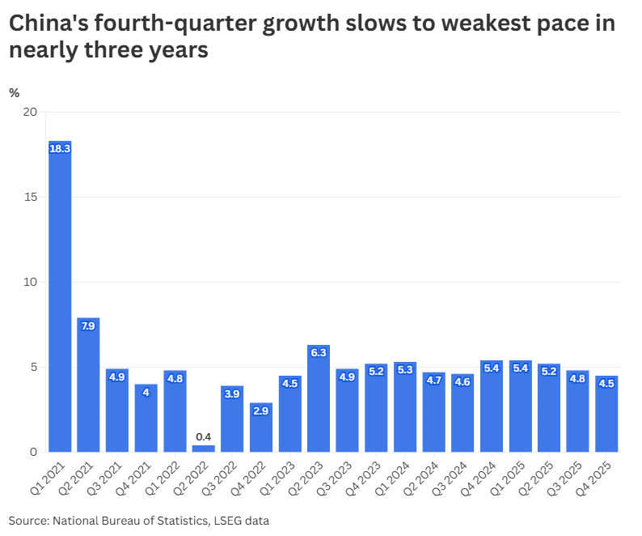
Figure 6: China GDP slow Growth
(Source: Bao and Cheng, 2026)
By 2025, China had an economic figure of RMB140.19 trillion of approximately 20 trillion, which was equivalent to the official figure of around 5%. The momentum slowed over the year - the growth in the fourth quarter was at 4.5% and the IMF projects a growth of circa 4.2% in 2026 (Bao and Cheng, 2026). The composition is more relevant than the number of the headline. Services increased by 5.4% and now they contribute the best proportion of production while fixed investment was stuck and property remained a liability. Changing to a household consumption-led growth instead of the export-led growth is precisely the transformation that a subscription business would wish to witness in Beijing (Reuters Staff, 2026).

Inflation, Currency, and Rates
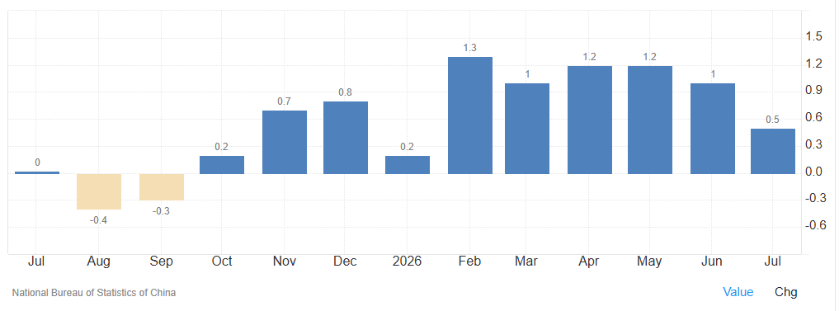
Figure 7: China Inflation Rate
(Source: Trading Economics, 2026)
The odd one is the prices. In 2025, inflation had an average of 0.0% which shifted to negative in early 2026 and went back to 0.5% in July. Deflation is no fringe benefit to a streaming service. It implies that incumbents would be able to keep the nominal prices flat over years without reducing real revenue, and limit how high a new entrant would be able to charge without seeming like they are out to make a quick buck (Trading Economics, 2026). A gradual response by the PBOC has been to keep on reducing the policy rate by 0.1% point in May 2025 and also injecting liquidity. A low yuan increases the expense ofRepatriations of profits as well as the expenses of paying label royalties that will be paid in dollars using RMB receipts (Xinhua, 2025b).

Consumer Purchasing Power
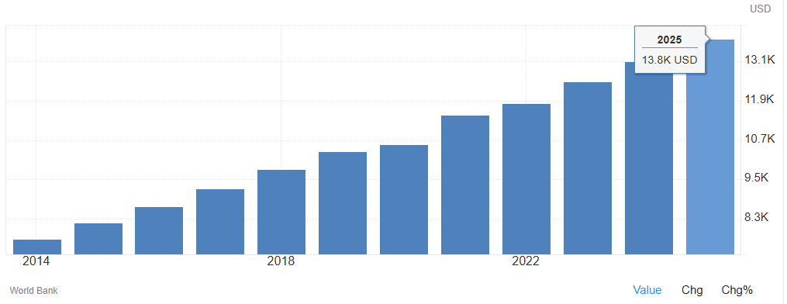
Figure 8: Gross Domestic Product per capita in China
(Source: Trading Economics, 2026a)
The household capacity exists but is not evenly distributed. Disposable income per capita grew 5.0 to reach RMB43,377 in 2025, with urban residents on RMB56,502 versus rural residents on RMB24,456 - the literally defining base. GDP per capita stood at $13,968 and is tracking toward $14,874 in 2026, while urbanisation hit 67.89% (Trading Economics, 2026a). Video, Gaming, and music memberships have already been included in the Tier 1 household payments in Beijing, Shanghai, Shenzhen and Guangzhou. In the cities of Tier 3 it is not the desire to spend that is the limit but the competition over a smaller entertainment budget.

2.1.3 Legal Environment

Foreign Ownership and Investment Rules
The first wall is foreign ownership. Music streaming is classified as a value-added telecoms service, with the Negative List (maximum foreign equity of 49% not subject to any specific free trade zone). An internet content service in China is not run by a foreign company without an ICP licence and it is the Chinese controlled organizations that were licensed with the ICP licence (China Briefing, 2026). The latter single need excludes a wholly-owned launch despite the amount of capital that Spotify would actually be ready to spend or the market appeal it might have. A joint venture or licensing with a domestic holder is not desirable in this case - it is the only legal way out (Moreau et al., 2024).

Intellectual Property and Content Licensing
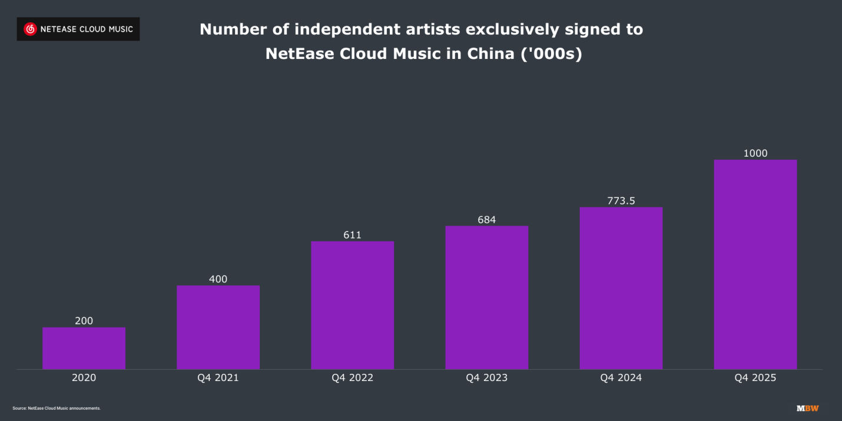
Figure 9: NetEase Cloud Music now counts over 1 million registered indie artists
(Source: Stassen, 2026)
There has been an increase in the enforcement of copyright and much of this has been through the coercion of regulators. The win in the 2021 antitrust case, which allowed lifting the exclusive-licensing lock that Tencent imposed supported by a RMB500,000 fine, and the catalogue market was immediately available to all platforms (BRICS, 2025). NetEase Cloud Music has over 1 million independent artists with 5.6 million tracks, which would not have been possible in the old regime. This could not be more favourable to an entrant working in the law than a development in a decade (Stassen, 2026).

Tax, Labour, and Sector-Specific Rules
Corporate income tax is 25% and 15% is offered to high-tech certified enterprises and VAT on digital services stands at 6%. Data is more difficult to comply with. The Cybersecurity Law as well as PIPL means that the personal data of the Chinese user has to be domestically stored (PWC, 2026). The cross-border transfer is open to security analysis, i.e., listening history is the raw material of the recommendation engine used by Spotify.

2.1.4 Cultural Environment

Digital Entertainment and Consumption Norms
The digital life in China is based on super-apps, as opposed to individual services. WeChat has over 1.4 billion monthly users and is concurrently a messenger, payment rail, mini-programme host and identity layer (WeChat Team, 2026). Instant messaging targets 1.093 billion individuals, or 97.3% of netizens, and Douyin has 907 million individuals monthly by October 2025. Music is not isolated from this ecosystem. It is ingrained in short-video soundtracks, livestream gifting and karaoke (Stassen, 2026b). WeSing created a business on singing, not listening. To a Chinese user an interface such as a pure audio-player would look incomplete.

Music Market and Streaming Behaviour
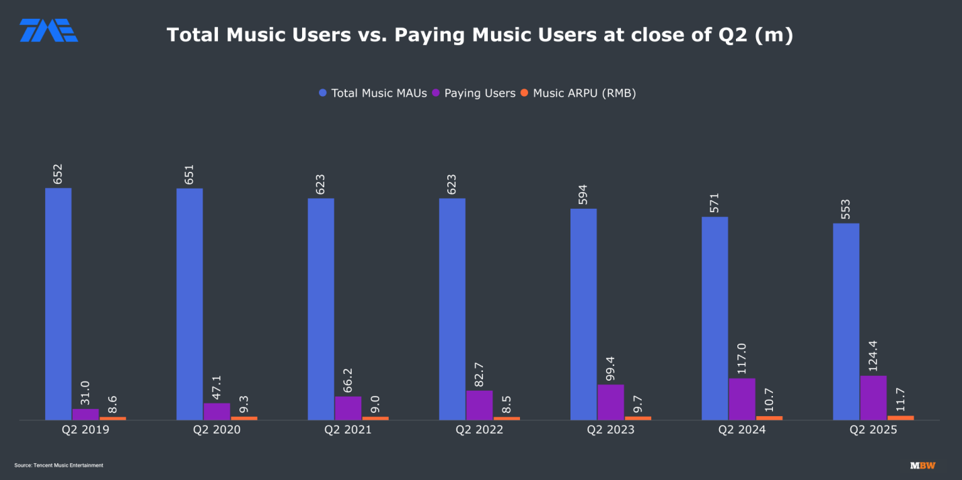
Figure 10: Tencent Music now has 15 million ‘Super VIP’ subscribers
(Source: Ingham, 2025)
The most rapidly expanding tale in music worldwide is its own market. In 2025, China passed Germany to be the fourth biggest music market ever at a revenue of 7.4 billion, with a growth rate of 20.1%, the fastest growth in the global top 20 (Ayodeji, 2026). Tencent Music generated revenues of RMB32.9 billion in the year, 15.8% higher with the SVIP level exceeding 20 million subscribers and its ARPPU of RMB11.9 each month (Ingham, 2025). NetEase Cloud Music increased the subscription revenue by 13.3% to be RMB5.1 billion. Mandopop and Cantopop are the most popular in playlists, but Western catalogue interest is increasing fast, as well as K-pop licensing.

Hofstede and Gen-Z Digital Natives
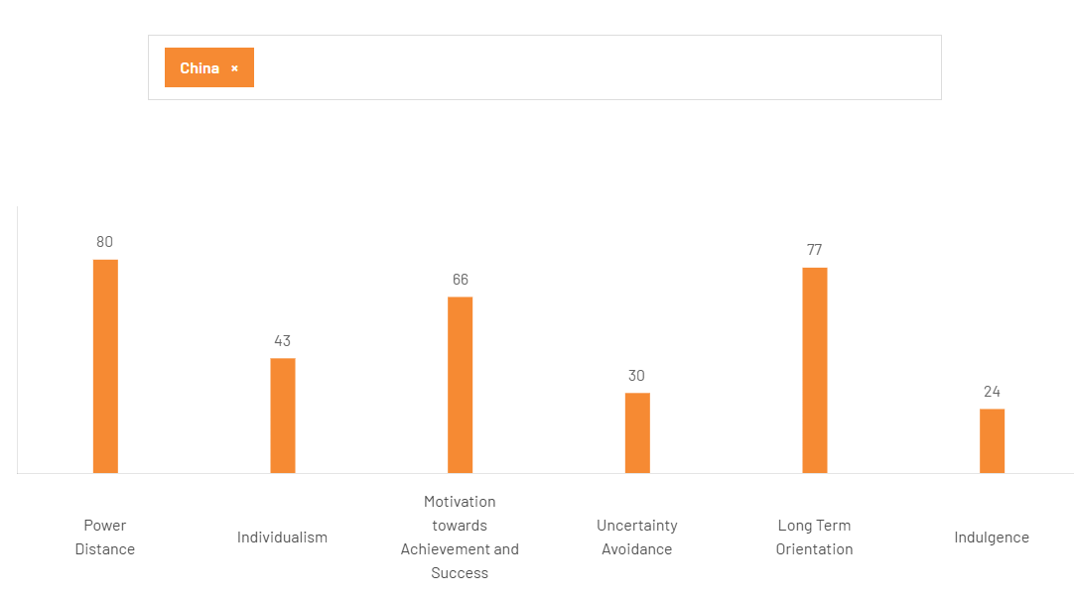
Figure 11: China Hofstede Insights
(Source: The Culture Factor Group, 2025)
The picture is brought into focus by the readings by Hofstede. A 80 power distance combined with a 20 individualism suggests consumption that is influenced by peer groups and social validation instead of individual uncovering - playlists are communally shared, rated and discussed in group chats. The long-term orientation of 87 implies not being in a hurry to work with a brand that becomes an investment one can see in years, or in a hurry to work with a brand that approaches China as a quarterly experiment (The Culture Factor Group, 2025). The target group is anyone under 35: someone who is digitally native and already spends about RMB12 a month on music and will be willing to read about a foreign premium subscription as associated with a sense of taste.

2.2 Market Entry Analysis Using Dunning's Eclectic (OLI) Paradigm

2.2.1 Ownership Advantages
Recommendation Engine: This is the crown asset which is the recommendation engine. Discover Weekly, Daily Mixes and the annual Wrapped campaign are aspects that have not been replicated by competitors. One on one resulted in 300 million including users and 630 million social shares in 56 languages in December 2025 and generated the largest single day of subscriber acquisition in company history (Spotify, 2025). There is no Chinese platform which has created a product of discovery with anything resembling that cultural pull and discovery is the axis where the incumbents are indeed weak.
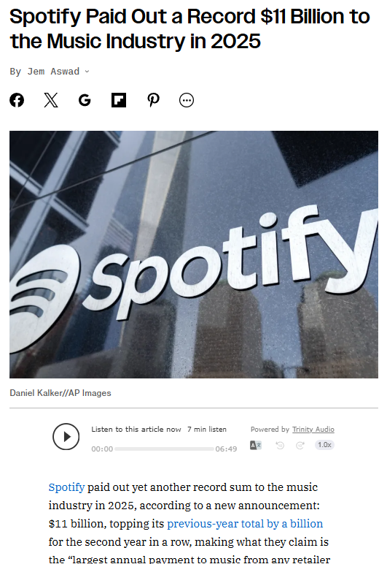
Figure 12: Spotify Paid Out a Record $11 Billion to the Music Industry
(Source: Aswad, 2026)
Catalogue and Creator Tooling: Despite the 22 markets, overlapping over 100 million tracks, 7 million podcast titles and 700,000 audiobooks which are served by roughly 12 million artists and creators behind a single interface. Spotify for Artists provides rights holders with the analytics which Chinese platforms traditionally have closed. The $11 billion that they will spend to the music industry in 2025 not only buys bargaining skill with Universal, Sony and Warner but three of them already have a stake in Chinese platforms and will be happy to have an antagonist to Tencent (Aswad, 2026).
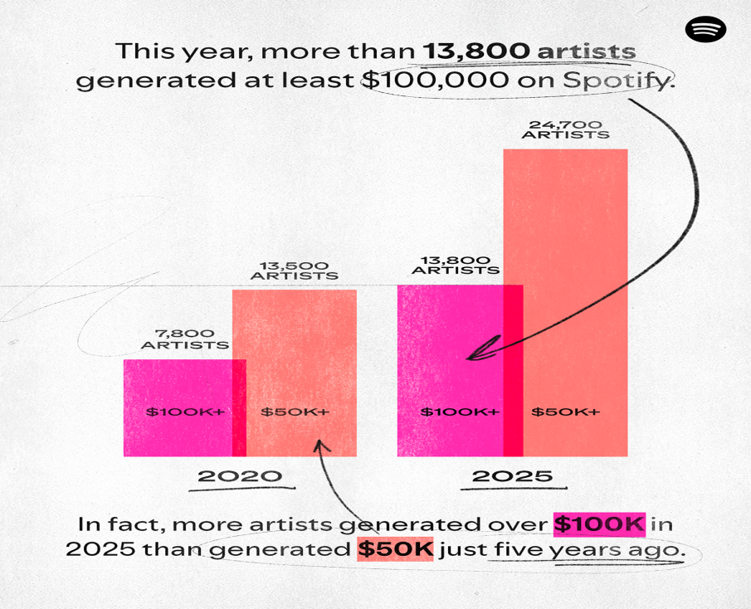
Figure 13: Revenue Generation by Spotify
(Source: Spotify, 2026a)
Network Effects and Financial Capacity: Network effects multiplies on both sides of the market. Sharpening the algorithm is done by more listeners, recommendations are improved by more creators, and a richer catalogue attracts more listeners.In 2025, more than 13,800 artists generated at least $100,000 from Spotify alone (nearly 1,400 more than the prior year) (Spotify, 2026a). This reflects the fact that it can afford to build in China over a multi-year period without the need to break even in the initial years of its operation, something that few players have ever had in the history of this market. Neither Tencent Music nor NetEase has such a combination of catalogue depth, creator tooling and discovery software on a single product.

2.2.2 Location Advantages
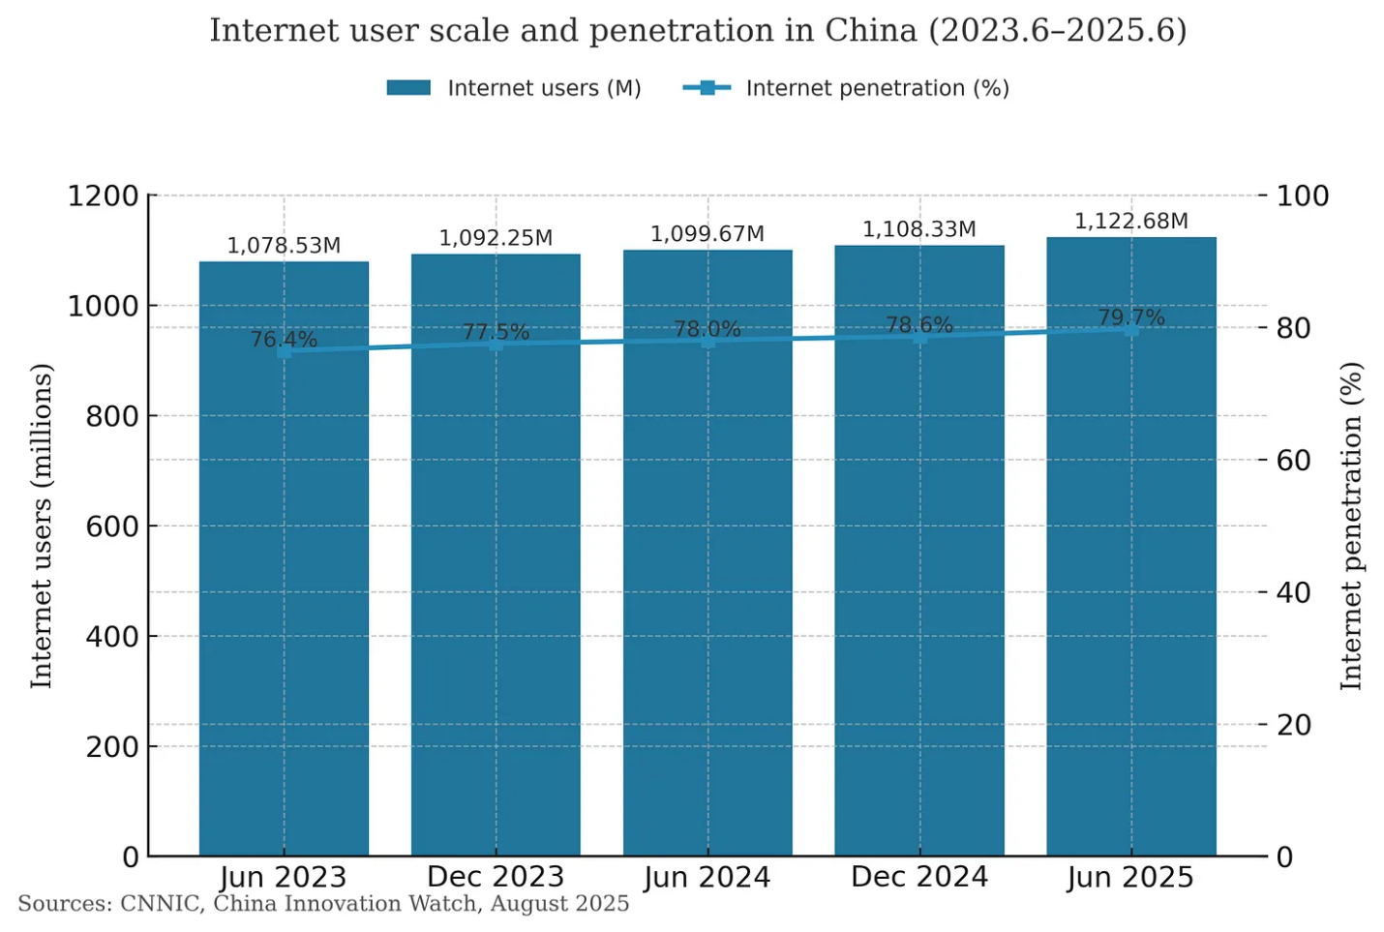
Figure 14: China Internet Penetration Rate
(Source: CIW, 2026)
Market Size and Demographics: This is the self-evident attraction of a demand base. China possesses the 1.4 billion population, 1.123 billion internet users and 79.7% penetration as of the mid of 2025 with the music revenues in the country increasing approximately four times the rate of the economy (Wu and Qiu, 2026). The paid market is not even close to becoming saturated. Tencent Music had an estimated 123 million paid users compared to a national number of 9 times those on the internet and the world has 837 million paid accounts with subscriptions. The conversion headroom in China alone is more than all the subscribers of most Western markets (Dredge, 2026).
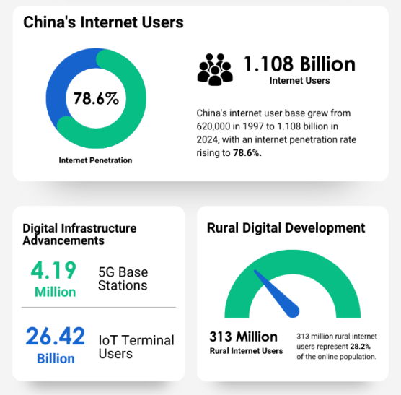
Figure 15: China Internet Users
(Source: China Marketing Corp, 2025)
Digital Infrastructure and Cost Structure: Infrastructure eliminates the vast majority of barriers that impede entry in other areas. By June 2025, 4.19 million 5G base stations and 1.108 billion Internet users who pay online through mobile devices had been registered in China, 91.0% of whom are netizens (China Marketing Corp, 2025). Recurring billing is painless with Alipay and WeChat Pay in a market where credit-card adoption is low, the issue that it took Spotify years to overcome in India and Indonesia just does not exist in this country. The Alibaba Cloud or Tencent Cloud provides server capacity at low prices, in large quantities, and the services are already familiar with the domestic hosting regulations (Alex, 2024).
Regional Positioning: China fills the final significant gap in the Spotify coverage in Asia-Pacific, right next to existing offerings in Japan, South Korea, India and Southeast Asia. There is flow in regional contents in both directions. Spotify can serve a large diaspora in Singapore, Malaysia and Taiwan currently served by C-pop and Mandopop, and licensing of K-pop catalogue relationships operate in the same label relationships (Boonen, 2025). Presence of an operation in China would strengthen the network in the region and not be alien to it.

2.2.3 Internalisation Advantages
Risks of Pure Licensing: Pure licensing puts a Chinese operator into the brand and does not receive anything permanent with Spotify. The recommendation engine would need to be opened up to work efficiently and it is precisely in the environment of technology-transfer that China has been criticised to have been saturated with algorithm IP.
Risks of Wholly Owned Entry: Wholly owned entry is not available. The equity limit of 49% of value-added telecommunication service and the ICP limit render it legally unfeasible, and even in case the regulations would be relaxed, Spotify would have no governmental interactions, capacity to comply with censorship or the domestic label contacts to operate independently. The solution can be hybrid: equity control over product, algorithm, local control over licensing, compliance and government interface and surrounding the recommendation stack contractual firewalls (Demócrata, 2026).

2.3 Identify Key Factors Influencing Success
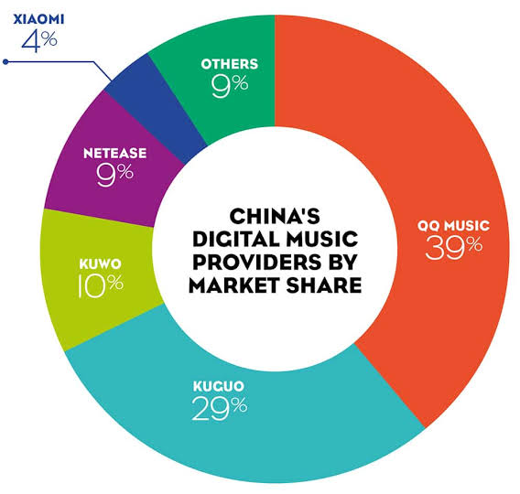
Figure 16: Chinese Music Streaming Industry
(Source: CBBC, 2025)
Things are determined by four things. First, quality of partners - a Chinese operator having a current ICP licence, standing label relationships and regulatory credibility condenses the build by a number of years (Zhou, 2024). Second, navigating regulations: Localisation of data, filing algorithm and content approvals of CACs are not a one-time event and entry barriers, but a continuous requirement that must be staffed permanently with local personnel. Third, localisation of the catalogue, as most of the listening is driven by Mandopop and a Western-bias library will not convert. Fourth, diversification to market leaders which are already market owners. Competitors such as QQ Music, Kugou, Kuwo and NetEase Cloud Music compete on social ones as well as karaoke features, which leaves Spotify with no choice but to prevail on discovery instead (CBBC, 2025).

2.4 Critical Evaluation of the Chosen Market's Attractiveness
The case is drawn a-two directions. On the one hand as shown by Dyson (2026), China is a music market in the 4th biggest in the world, expanding 20.1% per annum, a billion plus connected consumers, friction-free recurrent payments and a copyright law that regulators had forced into the brooms. As per Khurana And Khurana (2026), across the way is a 49% equity ceiling, mandatory data localisation, content review without appeal, and two established platforms that boast a decade of licensing associations. The magnitude is unparalleled to where Spotify has not ventured yet. So is the friction. It is its appeal and adoptability to the level that Spotify seems unable to enter on its own terms that makes China appealing.

3. Entry Mode Strategy and Strategic Synthesis

3.1 Historical Pattern Recognition: Spotify's Dominant Entry Modes

3.1.1 Review of Historical Entry Modes
Spotify has almost always walked in alone. The table below sets out its principal entries and the structure used in each.
Market | Year | Entry Mode | Structure / Notes
Sweden | 2008 | Direct launch | Home market; freemium model originated here
UK | 2008 | Direct launch | Wholly owned subsidiary (Spotify, 2022)
USA | 2011 | Direct launch | Followed two years of major-label licensing talks
Japan | 2016 | Direct launch | Wholly owned; entered a physical-dominant market
MENA | 2018 | Direct with telco partnerships | Partnerships for billing and distribution only
Sub-Saharan Africa | 2018 | Direct with carrier billing | Mobile-money and telco integration (Spotify.com, 2026)
India | 2019 | Direct launch | Aggressive free tier; local-currency pricing
Russia | 2020 | Direct launch | Exited market in 2022
South Korea | 2021 | Direct launch | Entered against entrenched incumbent Melon

3.1.2 Strategic Implications
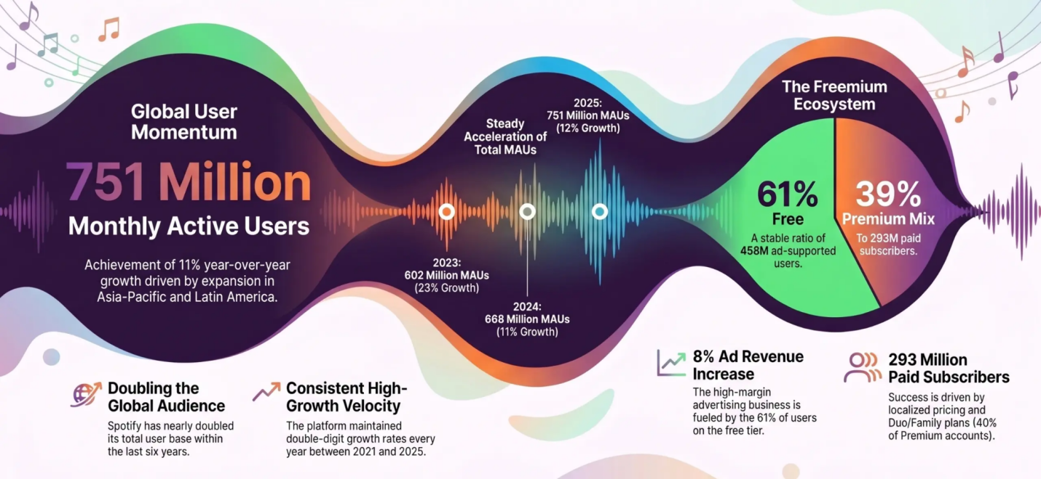
Figure 17: Spotify Statistical Highlights
(Source: Lal, 2026)
The trend is simple. In a market where legislation is made permissible, Spotify establishes its own subsidiary and retains the entire margin. In areas where distribution or payment is a challenge, it only collaborates on those functions and never on the product itself. Never has it been an acquirer of a minority equity in a foreign operating company and never has it surrendered algorithm control to a third party. China is an exception to the rule (Hayes, 2025). The 49% cap and ICP stipulation render the direct-entry playbook not available, and the partnership-lite model employed throughout the MENA addresses a distribution issue, rather than a licensing one. All previous templates collapse (Lal, 2026).

3.2 Strategic Fit and Justification for China

3.2.1 Assessing the Suitability
The sole form that meets the Negative List and at the same time the need of product control by Spotify is a joint venture with a Chinese technology group. The preplanning has already been done. The 2017 equity swap placed Spotify with an approximate of 9% of Tencent Music, with Tencent and its affiliates holding a similar share in Spotify and the 282.8 million TME Class A shares of Spotify AB are under a standing voting structure (Leo Miller, 2026). They both are not strangers. Turning a passive cross-holding into a venture of the same nature is quite a short step compared with a cold approach to a new partner.

3.2.2 Risk and Resource Commitment
Risk Assessment
Risk Category | Exposure | Mitigation via 50:50 JV
Political | Regulatory crackdown cycles; sector directives with no appeal route | Partner absorbs government interface; staged capital release
Intellectual property | Algorithm and data exposure to JV partner | Contractual firewall around recommendation stack; Spotify-appointed product director
Currency | Soft yuan raises repatriation and dollar royalty costs | RMB-denominated cost base; profit reinvested locally in early years
Operational | Great Firewall latency, PIPL localisation, content censorship | Domestic hosting via partner; partner-run content review function (Crusell, 2025)
Competitive | Two incumbents with a decade of licensing relationships | Partner's existing label agreements transfer into the venture
Resource Commitment
The exposure of Spotify is limited to about a half built on a 50:50 joint. The domestic label deal, server infrastructure, and government relations: the domestic partner provides ICP licence, domain label deal, and server infrastructure The ICP licence is a five-year asset that would require a significant amount of capital should Spotify have managed to get it together in five years, assuming it did. Spotify brings along the platform relationships, brand and catalogue relationships with the majors (BROCENT CLOUD SERVICE CO.,LIMITED, 2025). Localisation engineering, RMB-denominated marketing, and expatriate deployment, all lie in the venture envelope and do not show up on the balance sheet of Spotify. That framework cushions the quarterly operating profit to support expansion in other areas and ring-fences the cash flows in China in case of a regulatory mid-rollout environment (Sellmann, 2026).

3.2.3 Control versus Flexibility
A standards agreement allows the board parity, and brand and product decisions with Spotify, with a Product director appointed by Spotify in an owner position of the recommendation stack. This local affiliate operates all that Spotify is unable to: making it ICP compliant, reviewing its content, negotiating with local labels and integrating payment with Alipay and WeChat Pay (Spotify, 2025b). That segment purchases the leeway in which the environment changes the quickest and has control in which the competitive advantage truly looms. The escalation paths should be included in the shareholders agreement as opposed to goodwill.

3.2.4 Long-Term Strategic Fit
The final big blank in the Spotify map is China. Ability to close it makes it covered across 184 markets worldwide and implements the fastest-growing top 20 market to the portfolio. With Chinese listening moving toward subscription norms and to up ARPPU, the economics of venture is enhanced with no additional capital. It must be structured in such a way that a gradual transition to majority ownership is possible in case of the relaxation of the equity cap (Dyson, 2025).

3.3 Conclusion and Recommendations

3.3.1 Summary Judgement
China does not qualify as a clean entry. There is a limit to foreign equity, no information can exit the country through listening, content is subject to unlimited review and two licensed incumbents have ten years of licensing relationships. However there is no alternative to the scale, the fourth-largest music market, which is growing faster than any other with a billion connected consumers and payments already resolved. The 2017 cross-hold provides Spotify with a connection unattainable by any other Western platform. The window is open, but very slenderly.

3.3.2 Recommended Approach
Go through a 50/50 joint venture with Tencent Music, transforming the existing cross-holding into an operating structure. Initially rolled out in Beijing, Shanghai, Shenzhen and Guangzhou on a freemium basis, with the free offering handling the acquisition but the Premium priced level on existing subscription levels, as opposed to a higher price level. Re-train recommendation engine on Mandopop and Cantopop prior to start; a Western-weighted algorithm will not work on day one. Keep all user data within the country to comply with PIPL, and regulate content with the help of the control of the partners. Patent registers and algorithms and keep them confidential until publicly announced (Tezeract, 2023). Add a 5 year review clause a set of majority ownership in case of an increase in the equity cap. Staff compliance functions locally at the very beginning as opposed to making it a post-launch reception.

Section 2: Reflective Account

Introduction to the model
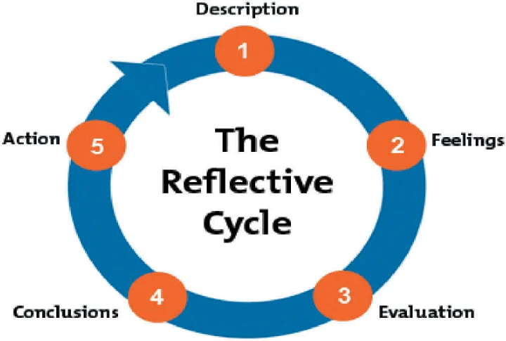
Figure 18: Gibbs Reflection Cycle
(Source: Ahmed, 2019)
The Reflective Cycle created by Gibbs has been used to take me through the experience of creating this report. The six stages namely description, feelings, evaluation, analysis, conclusion and action plan compel a division between what has occurred and what I have constructed out of it; that is precisely where my personal reflection often crumbles down into synopsis. I want to question in this part how I did the research, and how I arrived at the reason, rather than repeat the results. In the doubtful points, where I have been found wanting, I have made it plain instead of cleaning up anything afterwards (Galli and New, 2022).

Model Application

Description
I was requested to prepare an international market entry report of a multinational that is branching out into a country where it does not operate yet. I selected Spotify and mainland China. The potential combination, as the difference is odd, Spotify is the most ubiquitous streaming platform globally, and its absence in China is no accident but an aspect of the structure. I divided the work into three blocks during a period of about two weeks. The initial selection of covered framework and that of Spotify as a strategic profile. The second analysis was the China one which was by far the most time-consuming. The third combined the OLI synthesis, the decision on the entry mode and this reflection.

Feelings
My initial thoughts about Spotify were of optimism and that I knew virtually nothing regarding the regulatory landscape in China. I had thought that being familiar with a product was a source of knowledge of a business and it is not. I was in the company section in a flash, and it gave me a false impression of how the remainder was going to be. I had got stuck on the middle block. This took days to work out, reading as it seemed to be going nowhere, that music streaming is within the value added telecom services, and that the ICP requirement barred a fully owned launch. Part of the frustration was access - most of the core Chinese content appears behind the Great Firewall or is only in Mandarin and not something I was reading about but into it (Bonini and Treré, 2024).

Evaluation
The integration of the framework was successful. As soon as I ceased to consider Bartlett and Ghoshal as three dissimilar workouts, the argument began to construct itself - the internalisation logic, to be more exact, that was leveled directly at the joint venture recommendation, rather than having to be shoved upon me. There were two shortcomings. I was over relying on the English-language coverage at initial stages, with which I got a Western interpretation of Chinese regulation that I needed to adjust on later days (Chen and Xu, 2025). And my would tally discipline was leaky. The legal environment piece passed almost twice its allotment on the first test and reducing it without the ICP argument had been briefly shortened twice.

Analysis
This strategy proved successful since I anchored all my strategic assertions in the way in which Spotify has been acting as opposed to what an idealised entrant is supposed to act. The sequence of its market entries made the pattern quite clear: direct entry whenever the law permits, only partnership (without payment and distribution) otherwise. (Dinçkol, Ozcan and Zachariadis, 2023) As soon as I perceived that the China conclusion came with almost equal force as robots, since China is where that trend cannot be true. Cross referencing was more effective than any one framework. It was presented to me by Bartlett and Ghoshal why Spotify is experiencing an unstable global-transnational straddle in practice, using language. Cynefin helped me to distinguish technical issues of regulation which are solvable and genuinely complex ones - localisation of data is a compliance issue, government relations in a one-party country are not (Strand et al., 2024). The adaptive leadership content disclosed the rationale of having a polycentric partner where the Stockholm model would be ineffective in exporting.

Conclusion
I learn many lessons about this, how schemes are interrogating instruments and not templates. They get their place when they create a query that I would not ask on my own - that is to say, the internalisation stage in an opposition to unadulterated licensing is the most obvious here. They are used only as headings to fill in and create a report that describes and not one that determines anything. In a re-running of this I would use the reverse order and begin with the question of the entry mode and reverse into the country analysis. The mode question reveals to you what the real factors affecting the environment are. In general , without the mode question I did waste time on economic data which did not have any influence on the recommendation.

Action Plan
Three variations to the next song. To begin with, I will have allocated the number of words to use in each subsection during the outline stage instead of finding out the overrun during the first draft and comparing it to it as I write (Dwivedi, 2023). Second, to have provided the statistic, its source, and date of retrieval, I will maintain a running list of sources to which I have already read the entries, and waste half a day here to search for one figure again. In the long run, I desire depth in a single market area instead of superficial coverage of a number of areas (ATAS, 2023). China was rewarding sustained reading in such a manner that the skimming up four countries never would have been rewarded. I will continue to work using live entry cases as well, as the pattern recognition in the historical section proved to be the most helpful step that I took in this case.

Reference List
Ahmed, A.M. (2019) “Students’ reflective journaling: An impactful strategy that informs instructional practices in an EFL writing university context in Qatar,” Reflective Practice, 20(4), pp. 1–18. Available at: https://doi.org/10.1080/14623943.2019.1638246.
Alex (2024) Getting started with Alibaba cloud: Pros, cons, and key differences., Medium. Available at: https://alexmarket.medium.com/getting-started-with-alibaba-cloud-pros-cons-and-key-differences-95e570e52a2c
Annabell, T. and Rasmussen, N.V. (2025) “An algorithmic event: The celebration and critique of Spotify Wrapped,” New Media &amp; Society [Preprint]. Available at: https://doi.org/10.1177/14614448251391301.
Aswad, J. (2026) Spotify paid out a record $11 billion to the music industry in 2025, Variety. Available at: https://variety.com/2026/digital/news/spotify-paid-out-11-billion-to-music-industry-2025-1236642550/
ATAS (2023) What does the depth of market indicator show? | ATAS, ATAS. Available at: https://atas.net/blog/depth-of-market/
Ayodeji, D. (2026) China just became the world’s 4th-Largest music market. Its streaming runs on apps most distributors skip., The InterSpace Daily. Available at: https://interspacemusic.com/blog/china-just-became-the-worlds-4th-largest-music-market-its-streaming-runs-on-apps-most-distributors-skip/
Bao, A. and Cheng, E. (2026) China fourth-quarter growth slows to 4.5%, weakest in nearly three years as consumption misses forecasts, CNBC. Available at: https://www.cnbc.com/2026/01/19/china-q4-gdp-growth-2025-target-retail-sales-industrial-output-investment-income-employment.html
Bonini, T. and Treré, E. (2024) Algorithms of resistance, The MIT Press eBooks. The MIT Press. Available at: https://doi.org/10.7551/mitpress/14329.001.0001.
Boonen, I. (2025) Spotify’s localization and international expansion, Nimdzi. Available at: https://www.nimdzi.com/lessons-in-localization-spotify-expanded/
BRICS (2025) Tencent ordered to give up exclusive contracts for music licensing - BRICS competition, Bricscompetition.org. Available at: https://bricscompetition.org/news/tencent-ordered-to-give-up-exclusive-contracts-for-music-licensing
BROCENT CLOUD SERVICE CO.,LIMITED (2025) ICP license in China: A 2026 guide for foreign companies, Brocent — IT Support & Managed Services. BROCENT CLOUD SERVICE CO.,LIMITED. Available at: https://www.brocent.com/blog/posts/5
CBBC (2025) The Chinese music industry is about to become the fastest growing in the world, Focus - China Britain Business Council. Available at: https://focus.cbbc.org/the-chinese-music-industry-is-about-to-become-the-fastest-growing-in-the-world/
Chen, X. and Xu, L. (2025) “State, society, and market: Interpreting the norms and dynamics of China’s AI governance,” Computer Law & Security Review, 59, pp. 106206–106206. Available at: https://doi.org/10.1016/j.clsr.2025.106206.
China Briefing (2026) China’s foreign investment negative list - A guide for investors, China Briefing News. Available at: https://www.china-briefing.com/news/chinas-foreign-investment-negative-list-guide/
China Marketing Corp (2025) 2025 China internet users data | China Marketing Corp, China Marketing Corp. Available at: https://chinamarketingcorp.com/blog/2025-china-internet-users-data/
ChinaAlbums (2026) Chinese music industry 2026: Streaming data and trends, ChinaAlbums. Available at: https://chinaalbums.com/chinese-music-industry-2026/
CIW (2026) China internet overview, Ciw.news. China Innovation Watch. Available at: https://www.ciw.news/p/china-internet-overview
Crusell, C. (2025) Breaking through the great firewall: Ensuring website performance in China | comprend, Comprend.com. Available at: https://www.comprend.com/news-and-insights/insights/2025/breaking-through-the-great-firewall-ensuring-website-performance-in-china/
Darius (2026) Spotify target market 2026: User demographics, listener segments and brand positioning, Companies History. CompaniesHistory.com. Available at: https://www.companieshistory.com/spotify-target-market/
Dean, B. (2026) Spotify user stats, Backlinko. Available at: https://backlinko.com/spotify-users
Demócrata (2026) Spotify will label artists created with artificial intelligence and will limit their presence in recommendations., Demócrata. Available at: https://www.democrata.es/en/current-events/spotify-will-label-artists-created-with-artificial-intelligence-and-will-limit-their-presence-in-recommendations/
Dinçkol, D., Ozcan, P. and Zachariadis, M. (2023) “Regulatory standards and consequences for industry architecture: The case of UK open banking,” Research Policy, 52(6), p. 104760. Available at: https://doi.org/10.1016/j.respol.2023.104760.
Dredge, S. (2026) Tencent Music reveals 11% growth in its music-related revenues, Music Ally. Available at: https://musically.com/2026/08/12/tencent-music-reveals-11-growth-in-its-music-related-revenues/
Dwivedi, Y.K. (2023) “‘So what if ChatGPT wrote it?’ Multidisciplinary perspectives on opportunities, challenges and implications of Generative Conversational AI for Research, practice and policy,” International Journal of Information Management, 71(0268–4012), p. 102642. Available at: https://doi.org/https://doi.org/10.1016/j.ijinfomgt.2023.102642.
Dyson, S. (2025) China Music Industry Update, february 2025, Omdia. Available at: https://omdia.tech.informa.com/om127798/china-music-industry-update-february-2025
Dyson, S. (2026) China Music Industry Update, february 2026, Omdia. Available at: https://omdia.tech.informa.com/om143472/china-music-industry-update-february-2026
Galli, F. and New, C. (2022) “Gibbs’ cycle review. Emotions as a part of the cycle,” e-Motion: Revista de Educación, Motricidad e Investigación, 19(19), pp. 92–101. Available at: https://doi.org/10.33776/remo.vi19.7224.
Hayes, C. (2025) How do spotify payments work for artists?, Soundon.global. Available at: https://www.soundon.global/forum/spotify-artist-pay?lang=en
Ingham, T. (2025) Tencent music now has 15 million ‘super VIP’ subscribers. They helped drive music subs revenue up, Music Business Worldwide. Available at: https://www.musicbusinessworldwide.com/tencent-music-now-has-15-million-super-vip-subscribers/
Joaquim, A. (2025) China FDI plunges to record low in 2024, Tradingeconomics.com. TRADING ECONOMICS. Available at: https://tradingeconomics.com/china/foreign-direct-investment-yoy/news/444485
Khurana And Khurana (2026) The spotify clause: Streaming royalty disputes and the future of copyright law in India, Khurana And Khurana. Available at: https://www.khuranaandkhurana.com/the-spotify-clause-how-streaming-royalty-disputes-are-exposing-the-fault-lines-in-india-s-copyright
Krishnan, A. (2023) Xi Jinping begins third five-year term in firmer control, The Hindu. Available at: https://www.thehindu.com/news/international/chinese-parliament-endorses-president-xi-jinpings-leadership-for-rare-3rd-five-year-term/article66602376.ece
Lal, R. (2026) Spotify - statistics, trends, and facts 2026, Idea Usher. Available at: https://ideausher.com/blog/spotify-statistics/
Leo Miller, M. (2026) The “spotify of China” just got a whole lot cheaper, Yahoo Finance. Yahoo! Finance. Available at: https://finance.yahoo.com/markets/stocks/articles/spotify-china-just-got-whole-124000412.html
Moreau, F., Patrik Wikström, Haampland, O. and Johannessen, R. (2024) “Alternative payment models in the music streaming market: A comparative approach based on stream-level data,” Information Economics and Policy, pp. 101103–101103. Available at: https://doi.org/10.1016/j.infoecopol.2024.101103.
Nan, Z. (2026) Foreign investment increases as innovation drive deepens, Chinadaily.com.cn. Available at: https://www.chinadaily.com.cn/a/202604/23/WS69ea33e5a310d6866eb45339.html
PWC (2026) China, People’s Republic of - Corporate - Taxes on corporate income, taxsummaries.pwc.com. Available at: https://taxsummaries.pwc.com/peoples-republic-of-china/corporate/taxes-on-corporate-income
Reuters (2022) “China regulator fines Alibaba, Tencent for disclosure violations,” Reuters, 10 July. Available at: https://www.reuters.com/world/china/china-regulator-fines-alibaba-tencent-disclosure-violations-2022-07-10/
Reuters Staff (2026) “China targets 100 trillion yuan services sector By 2030 in upgrade push,” Reuters, 21 April. Available at: https://www.reuters.com/world/china/china-targets-100-trillion-yuan-services-sector-by-2030-upgrade-push-2026-04-21/
Sellmann, R. (2026) Quick pitch: Tencent Music Entertainment Group ($TME), Compoundwithrene.com. Compound with René. Available at: https://www.compoundwithrene.com/p/quick-pitch-tencent-music-entertainment
Shyam Future Tech (2025) How spotify used data-driven campaign & regional curation to expand in India, Shyam Future Tech. Available at: https://shyamfuture.com/how-spotify-used-data-driven-campaign-regional-curation-to-expand-in-india/?srsltid=AfmBOoro89nTMu1SLkgkOWwyw1aBPCX82Xopk4aqjsYpAI7KdeaLu85l
Spangler, T. (2026) Spotify Q1 2026 earnings: Revenue rises 8%, premium subs decline in North America, Variety. Available at: https://variety.com/2026/music/news/spotify-q1-2026-earnings-revenue-total-premium-subscribers-1236731842/
Spotify (2022) 424B4, www.sec.gov. Available at: https://www.sec.gov/Archives/edgar/data/1639920/000119312518105231/d494294d424b4.htm
Spotify (2025a) About spotify, Spotify. Spotify. Available at: https://newsroom.spotify.com/company-info/
Spotify (2025b) Spotify and NMPA announce agreement to expand direct-licensing audiovisual opportunities for independent publishers — Spotify, Spotify. Available at: https://newsroom.spotify.com/2025-11-11/spotify-nmpa-independent-publisher-licensing/
Spotify (2026a) As Spotify turns 20, the most global and diverse music industry in history has taken shape — Spotify, Spotify. Available at: https://newsroom.spotify.com/2026-03-11/loud-and-clear-music-economics-highlights/
Spotify (2026b) Spotify reports first quarter 2026 earnings — Spotify, Spotify. Available at: https://newsroom.spotify.com/2026-04-28/spotify-q1-2026-earnings/
Spotify (2026c) Spotify Reports Fourth Quarter 2025 Earnings, Spotify.com. Available at: https://newsroom.spotify.com/2026-02-10/spotify-q4-2025-earnings/
Spotify.com (2026) [All platforms][subscription] add direct carrier billing (ooredoo, djezzy, mobilis) in Algeria, Spotify.com. Available at: https://community.spotify.com/t5/Closed-Ideas/All-Platforms-Subscription-Add-Direct-Carrier-Billing-Ooredoo/idi-p/7459943
Sridharan, M.A. (2025) How spotify makes money, Think Insights. Available at: https://thinkinsights.net/strategy/how-spotify-makes-money
Stassen, M. (2026a) NetEase Cloud Music now counts over 1 million registered indie artists, Music Business Worldwide. Available at: https://www.musicbusinessworldwide.com/netease-cloud-music-now-counts-over-1-million-registered-indie-artists/
Stassen, M. (2026b) Tencent Music investors see ByteDance’s Soda as a major threat. What is it, and why are they so worried?, Music Business Worldwide. Available at: https://www.musicbusinessworldwide.com/tencent-music-investors-see-bytedances-soda-as-a-major-threat-what-is-it-and-why-are-they-so-worried/
Strand, R., Kovacic, Z., Silvio Funtowicz, Voelker, T. and Jesus, A. (2024) Governance in complexity: Sustainability governance under highly uncertain and complex conditions. Available at: https://doi.org/10.2800/597121.
Tezeract (2023) Konnect AI social recommendation engine case study, Tezeract. Available at: https://tezeract.ai/ai-case-studies/konnect-ai-powered-recommendation-engine/
The Culture Factor Group (2025) Country comparison tool. Available at: https://www.theculturefactor.com/country-comparison-tool?countries=china
Trading Economics (2026a) China GDP per capita, Tradingeconomics.com. TRADING ECONOMICS. Available at: https://tradingeconomics.com/china/gdp-per-capita
Trading Economics (2026b) China inflation rate, Tradingeconomics.com. TRADING ECONOMICS. Available at: https://tradingeconomics.com/china/inflation-cpi
WeChat Team (2026) Celebrating 15 years of Weixin and WeChat, Wechat.com. Available at: https://newsroom.wechat.com/newsRooms/NewsDetails/Celebrating15YearsofWeixinandWeChat
Wu, C. and Qiu, Y. (2026) “Trends in internet infrastructure development and online health use in China: 10-Year descriptive longitudinal study,” JMIR Formative Research, 10, p. e86714. Available at: https://doi.org/10.2196/86714.
Xinhua (2025a) China further shortens market access negative list to boost business vitality, Www.gov.cn. Available at: https://english.www.gov.cn/news/202504/24/content_WS6809c130c6d0868f4e8f2085.html
Xinhua (2025b) China to cut policy rate By 0.1 percentage points from thursday, english.scio.gov.cn. Available at: http://english.scio.gov.cn/m/pressroom/2025-05/07/content_117861957.html
Zhou, D. (2024) How to register an ICP license in China in 7 steps, MSA. Available at: https://msadvisory.com/icp-license-china/

