

Dissertation Proposal
The Impact of Advertising on Consumer’s Buying Behaviour: A case study of Zara’s Loyalty Programs

Student Name: Antonella Gaeta
Student ID: 2217962
Supervisor: Jia Miao
Pathway General Management

Table of Contents
1. Introduction 3
2. Justification of the Research 5
3. Problem Discussion 5
4. Research Question 6
5. Research Aim and Objectives 6
6. Research Purpose 7
7. Significance of the Study 7
8. Scope 8
9. Literature Review 9
9.1 Advertising Approaches in Fashion Retailing 9
9.2 Consumer Behaviour and the Advertising Impact 9
9.3 Effect of Loyalty Programs on Consumer Retention in Fashion Business 9
10. Research Method 10
10.1 Data Collection and Sampling 11
10.2 Ethical Consideration 11
11. Resources and Planning 12
11.1 Research Timeline 12
Explanation of the Gantt chart 13
11.2 Budget 14
References 15
Appendix 1: Expected Budget of the Research 18

1. Introduction
People have become mindful about how advertising affects what customers buy in the retail industry (Bonagas and Vu Dang, 2022). Companies want to have a strong place in the market and keep customers loyal. Knowing how advertising plans connect with how people buy is now extremely important. This research looks at the greater picture of how ads, especially when it comes to Zara's rewards programs. They are important in deciding what people prefer and demand (Kalsi, 2022). The world advertising business is where it is learned how major an effect ads can have on people's buying habits. According to Statista (2023), the UK is a major player in the world advertising market. In the last few years, UK businesses have invested heavily into advertising. As figure 1 shows, they spent about 34.77 billion British pounds on this type of spending (Statista, 2023). This number, showing a nearly 9% growth compared to earlier years, shows how important advertising is in making markets more competitive and brands more visible.

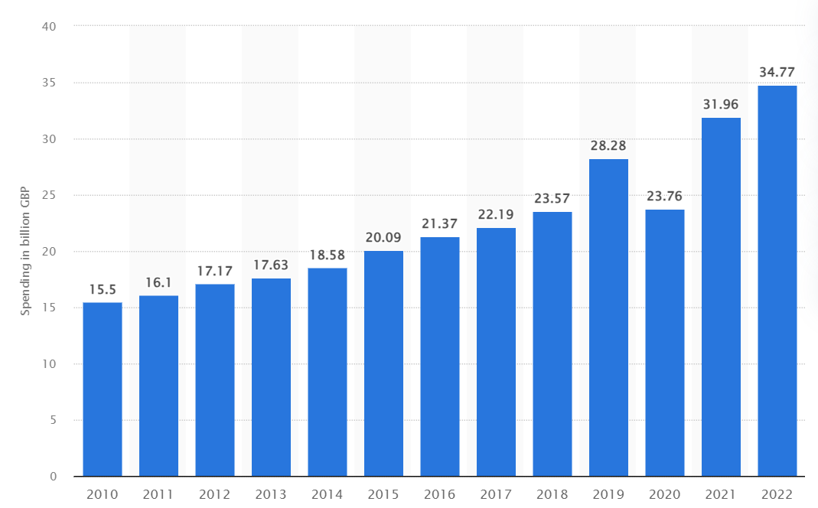
Figure 1: UK advertisement Expenditure
(Statista, 2023)

The trend of people buying items has changed because of worldwide trends and local market movements. This makes it harder for advertising to connect with consumers. The COVID-19 pandemic has made more people shop online. Data from Zhou (2023) shows that about 9 out of 10 customers liked buying items online during difficult times like the pandemic. This is a major change away from usual shopping in stores. Zara, a well-known name in the fashion world, has not been left out by changing how people buy. The business had problems during the pandemic time, a decrease of sales.
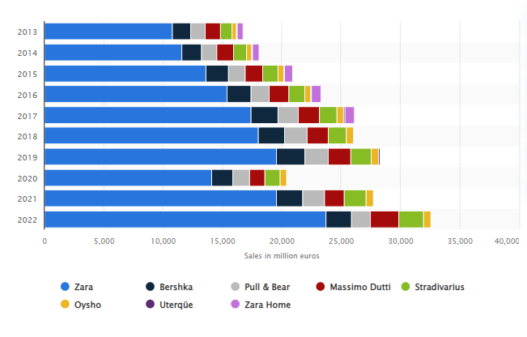
Figure 2: Revenue of Zara
(Source: Smith, 2023)
Zara introduced reward programs in its ad campaigns and promotions to meet changes and customer preferences (Bonagas and Vu Dang, 2022). As Figure 2 suggests Zara accumulated 23 billion Euros in 2023 as its net sales (Smith, 2023). Businesses, especially retail stores, have started using customer loyalty programs to keep customers coming back and staying involved (Jawaid and Rajadurai, 2021). Zara, seeing the need to change as people's demands grow. Added loyalty programs into its advertisement tools, these programs do more than simple ads (Koivulehto, 2017). They give real advantages to buyers, like discounts, special offers and unique deals. Knowing this helps examining the detail how advertising tactics impact consumer actions when it comes to a worldwide famous fashion brand. This study attempts to analyse advertising affects buying habits, mainly looking closely at Zara's special customer clubs

2. Justification of the Research
This study is important and makes sense in today's world of marketing and customer actions. This study is highly important because it has several key parts. First, the shops are seeing a major change in how people buy items. This is caused by new technology use and changing market situations after events like COVID-19 pandemic worldwide (Moreira, 2020). Zara is a major company in the fashion business. It shows how advertising, especially with loyalty programs, can change to match what customers want these days (Jiang, 2020). Second, Zara's addition of loyalty programs shows they have a plan to deal with market competition and keep customers (Rapantova, 2021). Loyalty programs are fast becoming more common, especially in stores. However top end fashion retailing experts continue to study how well they work. This study works to help with this topic. It will look into how Zara's rewards programs work and their effect on customer wanting to buy again.
Third, the world advertising scene shows that putting greater investment into UK ads is important for keeping brands seen and ahead in business (Do Le Phuong, 2022). Learning how Zara does advertising helps to understand better. This is effective for students and workers in the fashion business looking to use strong ideas about selling clothes via ads (Silva and Duarte, 2021). In addition, the study fills a hole in what has been written before. It looks at how important loyalty programs are for high-end fashion stores. Old ideas about how loyalty programs fit with luxury brands are being questioned (Jiang, 2020). Zara's situation is a good example for this discussion to focus on.

3. Problem Discussion
This study looks at how effectively Zara's rewards programs work in comparison with advertising. It attempts to understand if these programs change the way customers buy items and dig deeper into delicate details of that effect. Zara, which is in the dynamic clothing business, has smartly put loyalty plans into their ad approach (Dewi et al., 2022). However, it is not known exactly how these programs affect what customers decide to buy and make them want to keep buying. This is an area of study that has not been looked into enough yet.
Presently, Zara is working in a really tough area where other clothing companies are fighting to get the focus of buyers (Hutama and Ekawati, 2020). Zara has to decide if their customer reward programs help keep customers coming back and build strong connections (Noh and Johnson, 2019). This is the major issue in this tough situation they are dealing with. The question moves from only getting customers with sales to creating a lasting bond that goes beyond the one-time buying part (Valenzuela et al., 2023). The changing way people buy items makes the research problem harder. People's likes have changed a lot because of world stuff and local market aspects. The COVID-19 disease helped to speed up these changes even more. The growth of online shopping and changes in old buying ways make people ask important questions about how Zara's advertising schemes adjust to these new buyer actions (Liu and Zhang, 2019). It is highly important for Zara to learn a lot about these major changes. This will help them make their plans work well and stay close with many kinds of customers.
Moreover, it gets challenging to do research because there is not enough information in the current literature. Many studies look at how different ways of advertising affect customer behavior Phochatan (2016) and Kent and Bernarto (2022), but there is a major gap when it comes to studying the importance and effectiveness of loyalty programs in luxury fashion stores. This study aims to explain how Zara's reward programs affect a person's desire to buy again. It gives helpful information for school researchers and business people who want to learn about how customer actions are changing in the fashion retail industry.

4. Research Question
- What is the consumer perception about Zara’s loyalty program?
- How does Zara’s loyalty program affect customer purchase intention?
- What is the impact of Zara’s loyalty program on the repurchase intention?

5. Research Aim and Objectives
The purpose of this research is to investigate the impact of Zara’s loyalty programs on the customer repurchase intention. The specific objectives of the research are as follows;
- To evaluate the Zara’s loyalty program and its perception among consumers.
- To identify how Zara’s loyalty program affect customer purchase intention.
- To identify the impact of Zara’s loyalty program on the repurchase intention.

6. Research Purpose
The aim of this study is to look at how advertising affects buying habits, mainly looking closely at Zara's special customer clubs. In the fast-changing fashion world, knowing how advertising plans, especially those included in reward programs - affect what customers buy is highly important for talks among experts and real use of retail. The goal is not only to look at if there are programs that reward loyalty. It is also about seeing how well they work and their complex parts, thinking of the tough competition in business places and changes happening with how people behave as customers.
This study looks at Zara, a famous clothing company. It wants to find out how rewards programs affect customers wanting to buy again from the same brand. The goal is to move past simple checks and explore the complicated connection between adverts, loyalty schemes, and making strong customer-brand connections. Also, the goal is to look at missing parts in what people have written so far. This focuses on how well loyalty programs work for expensive fashion shops. By doing this study, more about Zara's business plans will be learned. It can help improve ideas in studies on how people buy stuff and give useful tips for companies dealing with the challenges of today's shopping world.

7. Significance of the Study
The importance of this study is that it might give helpful information to schools and the fashion business. It can help in understanding how ads, like loyalty programs at Zara impact customers' actions better. Knowing this change is important to deal with shifting likes of buyers, new technology and markets that have competition. First, in the world of learning, this study is important because it fills gaps in current literature. Many studies have been done on how different advertising methods change what customers do. Yet the strength and details of loyalty programs, especially for high-end fashion shops are unknown. This research on Zara's story helps in improving theories about how reward programs affect what people buy and if they will return to shop. It also gives a detailed view on how loyalty programs work with luxury brands, which is an area that has not been paid much attention in the past.
Secondly, the results from this study can give useful suggestions for people who work in businesses. This especially helps those involved with fashion stores. Zara, a well-known brand all over the world, is an important example for other shops to follow. They can learn how to keep their customers happy and get them coming back again by studying it. Looking at Zara's reward programs can teach businesses how to change the way they market goods based on what customers want and changes in markets. This is highly important in a time when factors like the COVID-19 pandemic and online shopping are changing regular ways of buying. Moreover, the importance of this study is also for Zara as a brand. Because the business works in a highly tough market, knowing how its advertising plans influence aspects like rewards program becomes really important. The findings can help Zara improve how they talk to customers, make reward programs better and be stronger in the business of clothes shops.

8. Scope
The research has a large scope, with the attempt of showing how many aspects affect what people buy in places where they sell luxury clothes. The study looks at how Zara uses special methods for its loyalty programs. The goal is to learn how these programs can get, keep and hold customers in a tough market. The study wants to know in detail how Zara uses their rewards programs. This includes giving out points, offering personalized deals and special VIP memberships. The study looks at Zara's activities all over the world, understanding its wide influence and different customers. The study looks at how customers behave in different places to find out what they like and do not. This will help make Zara's ads better, while keeping the whole world in mind.
Also, the study looks into how long Zara's loyalty programs last and what their lasting effects are. This means looking at old records, patterns and changes in how people buy items. This helps to understand over time how Zara's ways of getting customers have changed better with changing market situations. Then, the range must cover doing a detailed study by comparing to industry standards and best ways. The study wants to look at Zara's ways of rewarding customers compared with other luxury clothes brands. This will help find special aspects about Zara's methods and test if they really work well in making people stay as loyal clients.

9. Literature Review

9.1 Advertising Approaches in Fashion Retailing
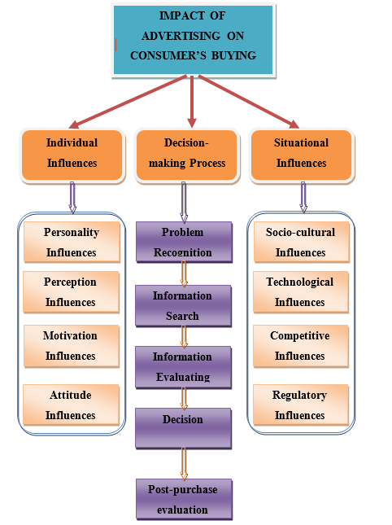
The studies about advertising tactics in the luxury fashion shop business help us to understand how customer behavior is changing. Kalsi (2022) talks about the old worries if loyalty programs can be really mixed in with luxury brands. Their research gives important information about how effective reward programs are in the high-end fashion store business. They show a shift from only thinking about effective rewards to looking at practical, fun and meaningful benefits more fully (Koivulehto, 2017). This study uses a theory to look at how Zara's reward programs impact customers buying again in the fancy fashion shopping area.
Figure 3: Advertising and Consumer Behaviour

9.2 Consumer Behaviour and the Advertising Impact
The research on how people buy items, focused especially for ads (figure 3), gives a way to perceive Zara's rewards schemes. It helps understand their loyalty programmes better. Moreira (2020) stresses the very big role of good advertising ways in making customers decide what to buy. This study is about looking at how Zara's ads, especially through loyal programs, affect what people buy and why it changes them. Moreover, the studies show how important it is to understand changing ways people buy. This is a big issue looked at when studying what Zara does in response to fast changes caused by COVID-19 (Jiang, 2020).

9.3 Effect of Loyalty Programs on Consumer Retention in Fashion Business
It looks at studies that find out how loyalty programs can keep customers returning to fashion stores. Bonagas' research in 2022 gives us helpful details about how important loyalty programs are for getting new customers and building long-lasting love. When you try to see what this study is saying, it's very important that you know how reward programs help keep business customers coming back. This study wants to check if Zara's reward programs make people buy more. In 2022, Do Le Phuong studied about how big companies buy items differently because of changing world markets and new likes from their customers. Silva and Duarte (2021) has pointed out the increase in people buying things online. This look at important papers talks about what Zara does when the market changes. It highlights how good ads are now more than ever, because digital ways make a big difference on where people choose to spend their money today. Understanding the main trends helps to judge if Zara's loyalty programs match with what customers want now. It also makes assessing these more accurate too.

10. Research Method
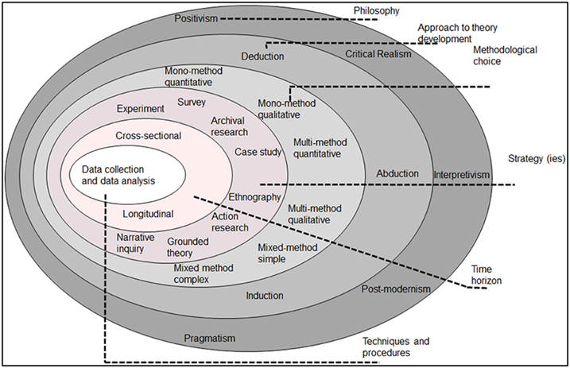
Figure 4: Research Onion
(Source: Melnikovas, 2018)
Research methodology explains how researchers intend to carry out the entire research. The research strategy has referred to a particular process that would be followed for conducting the entire research. Relevant to the research onion (figure 4), the philosophy has been segmented into the group of “point of view” and “positions” (Moon et al. 2019). This would be involved in three major variants such as interpretivism, positivism, and realism philosophy. Moreover, the research will follow the positivism philosophy. “Positivism research philosophy” is an effective approach for supporting various dimensions of the research based on consumer buying behaviour. However, among the inductive and deductive approaches, this research will follow the deductive approach to complete the research properly. The deductive approach is a significant skill that could help logically and make proper decisions in the workplace (Tsai, 2019). However, this research will follow both quantitative and qualitative data approaches as this will be conducted by helping with interviews and surveys. This research will follow the descriptive design with assisting of the quantitative approach.

10.1 Data Collection and Sampling
The primary data will be collected through an online survey. As commented by Nayak and Narayan (2019), online surveys are effective in the preparation of questionnaires, data collection, data storage and visualization of data. The sampling method is instrumental in research as it helps a researcher in gaining relevant information. According to Bhardwaj (2019), sampling is one of the determinant factors which define the success of a study. Sampling methods can be segmented into random sampling, clustered sampling, and systematic sampling and stratified sampling. The present study would include random sampling to gain a comprehensive grasp of the data collected.

Data Analysis
The statistical analysis will follow here for this research and for the qualitative analysis there will be graphs and charts. All crucial analysis tools will be used to conduct the research such as MS Excel and the Google Form.

10.2 Ethical Consideration
In the primary research, all respondents will be subject to confidentiality and anonymity to conduct interviews and surveys. Copyright act will follow properly of each participant in the survey. Hence, the entire research will work and as well abided by “The Copyright, Designs, and Patents Act 1988 (c. 48)” and “Data Protection Act 2018 (c.12)”.

11. Resources and Planning

11.1 Research Timeline

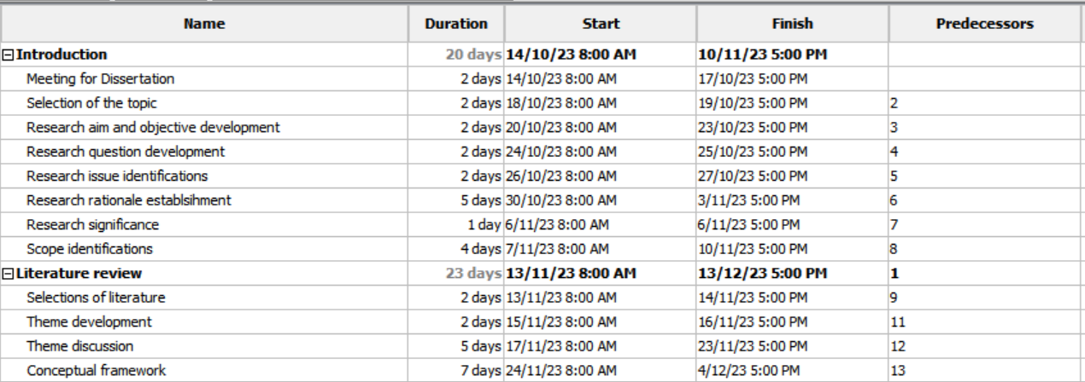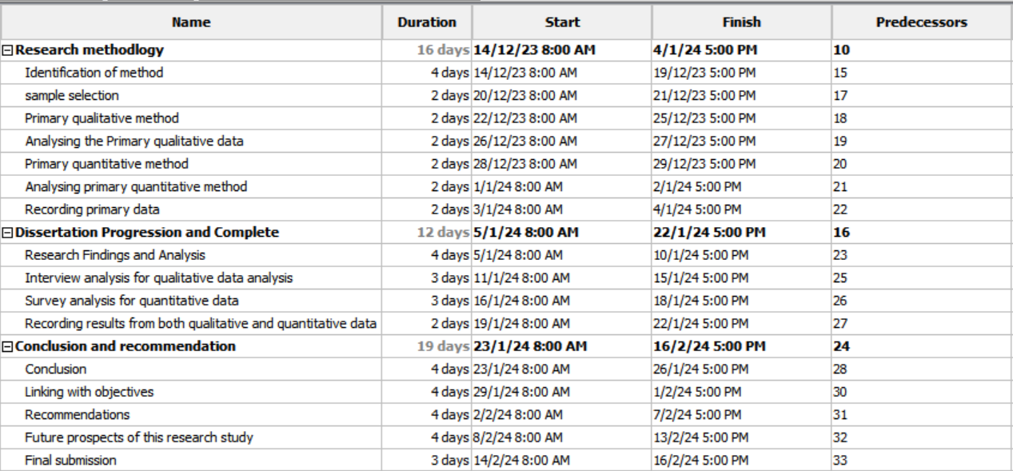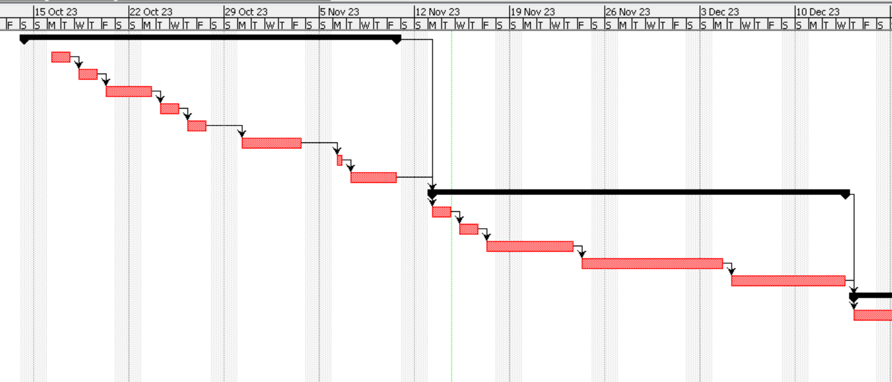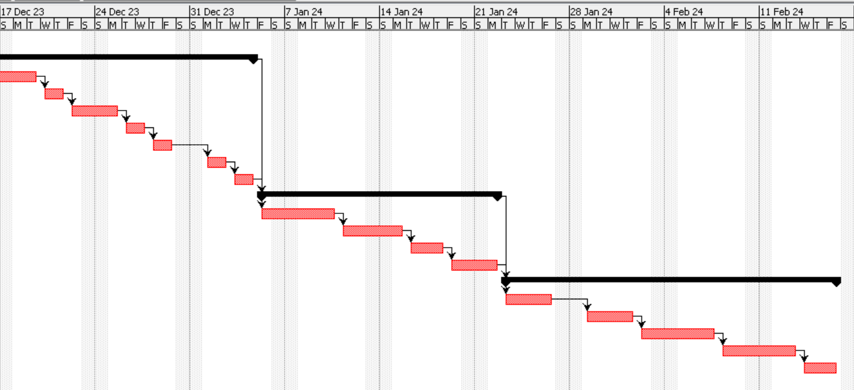
Figure 5: Timeline

Explanation of the Gantt chart
The Introduction chapter takes 20 days to complete and it starts from 14/10/23 and ends on 16/02/24. After the completion of this chapter, the literature review chapter will begin and will span from 13/11/23 to 13/12/23, in explanation 23 days. After the completion of this chapter, the development of the research methodology will start from 14/12/23 to 4/1/24. In this chapter, the chosen research methods, data collection and data analysis methods will be discussed. Dissertation Progression and Complete will then begin from 5/1/24 to 22/1/24. After recording both kinds of data and discussing them, this chapter will end. The last chapter, namely the conclusion and recommendations will begin from 23/1/24 to 16/2/24, in explanation of 19 days.

11.2 Budget
(Refer to Appendix 1)

References
Bhardwaj, P., (2019). Types of sampling in research. Journal of the Practice of Cardiovascular Sciences, 5(3), p.157.
Bonagas, K., & Vu Dang, T. G. (2022). Consumers’ Perspective on Loyalty Programmes and its Influence on Purchasing Decisions: A study on fast-fashion retailers’ consumers in the Swedish market.
Dewi, N. L. P. T., Suryaputra, R., & Sondakh, O. (2022). Analysis of the Effect of Product Quality Factors, Product Style, Product Price, Brand Image, Service Quality and Store Environment against Brand Loyalty of Zara Customers in Surabaya. Zenodo (CERN European Organization for Nuclear Research).
Do Le Phuong, V. (2022). The effects of fashion marketing in the buying behaviour of Z generation: Case study: Ader Error brand.
Hutama, K. Y., & Ekawati, N. W. (2020). The influence of price fairness and corporate image on customer loyalty towards trust. American Journal of Humanities and Social Sciences Research, 4(8), 209-214.
Jawaid, M., & Rajadurai, K. G. (2021). The Effect of Social Media Marketing on Customer Loyalty amongst University Students: Evidence from the Fashion Industry in Kuala Lumpur. Journal of Content, Community & Communication, 13(1), 66-81.
Jiang, S. (2020). A Comparative Analysis of Chinese and British Consumers’ Consumption Behaviours and Attitudes Toward Fast-Fashion Brand as Zara and H&M. Asian Journal of Social Science Studies, 5(2), 17.
Kalsi, A. R. (2022). Investigating the impacts of digital marketing on consumer buying behavior in the fast fashion industry of Ireland–a case study of ZARA (Doctoral dissertation, Dublin, National College of Ireland).
Kent, Y. D., & Bernarto, I. (2022). The Effect Of Perceived Product Quality, Brand Image, And Promotion On Customer Purchase Intention (Case Of Zara Customers In Grand Indonesia, Jakarta). Indonesian Marketing Journal, 1(1), 26-37.
Koivulehto, E. I. (2017). Do social media marketing activities enhance customer equity? A case study of fast-fashion brand Zara.
Liu, Y., & Zhang, T. (2019, June). Research on digital marketing strategies of fast fashion clothing brands based on big data. In 2019 34rd Youth Academic Annual Conference of Chinese Association of Automation (YAC) (pp. 552-556). IEEE.
Luisa Zhou. (2023). Online Review Statistics: The Definitive List (2023 Data). Available at: https://www.luisazhou.com/blog/online-review-statistics/ [Accessed on December 2023]
Melnikovas, A. (2018). Towards an Explicit Research Methodology: Adapting Research Onion Model for Futures Studies. Journal of futures Studies, 23(2).
Moon, K., Blackman, D.A., Adams, V.M., Colvin, R.M., Davila, F., Evans, M.C., Januchowski‐Hartley, S.R., Bennett, N.J., Dickinson, H., Sandbrook, C. and Sherren, K., (2019). Expanding the role of social science in conservation through an engagement with philosophy, methodology, and methods. Methods in Ecology and Evolution, 10(3), pp.294-302.
Moreira, R. D. M. (2020). Fast fashion retailer’s marketing strategies: brand awareness and customer brand engagement (Doctoral dissertation).
Nayak, M.S.D.P. and Narayan, K.A., (2019). Strengths and weaknesses of online surveys. technology, 6(7), pp.0837-2405053138.
Noh, M., & Johnson, K. K. (2019). Effect of apparel brands’ sustainability efforts on consumers’ brand loyalty. Journal of Global Fashion Marketing, 10(1), 1-17.
Phochatan, K. (2016). A Study of Key Influencing Factors on Customer's Brand Choice Decision of Fast Fashion Category in Bangkok Focusing on Top Three Brands: Zara, H&M and Uniqlo.
Rapantova, L. (2021). Perceived Benefits of Loyalty Programs for Apparel Consumers (Doctoral dissertation, Webster University).
Silva, A. M. A., & Duarte, V. (2021). Online Shopping Behaviours during quarantine: Zara case study (Doctoral dissertation).
Smith, P. (2023) Inditex: net sales worldwide by brand 2022, Statista. Available at: https://www.statista.com/statistics/456505/sales-inditex-group-worldwide-by-format/ (Accessed: 12 December 2023).
Statista. (2023). Advertising expenditure in the United Kingdom from 2010 to 2022. Available at: https://www.statista.com/statistics/262754/advertising-revenue-in-the-uk/ [Accessed on December 2023]
Tsai, K.J., (2019). Corpora and dictionaries as learning aids: inductive versus deductive approaches to constructing vocabulary knowledge. Computer Assisted Language Learning, 32(8), pp.805-826.
Valenzuela Quintero, A. R., & Bellon Álvarez, L. A. (2023). Trademark Influence and Brand Experience on Consumer's Loyalty to Fast Fashion Brands. Mercados y negocios, 24(50), 71-94.

Appendix 1: Expected Budget of the Research
Resources | Expected Expense (in £)
Survey
Telephonic and Email Conversations | £3,400
Preparing Google Forms | £1,450
Internet Access | £1,600
Research for Question Designing | £1,100
Excel Analysis | £800
Interview
Telephonic and Email Conversations | £1,500
Meeting through Zoom or Google Meet | £1,200
Total Expenses for conducting a Survey and Interview = £10,950

