Web Development: ASP.NET
  - Lecture 8 Lab Tutorial Exercise

Completing a Booking

Objectives
In today’s exercise, you will finally add the code for completing a booking. You will also do some tidying up – updating the links and add an admin area.

Exercise 1: Restricting Access to a Controller to Logged In Users
You can restrict access to all controller methods to only users that are logged in. It is very easy to implement. In this exercise, you will restrict access to the Bookings controller to only users logged in to the application.
- Open up your Bookings Controller file.
- All you need to do is to specify that access to this controller and all its action methods must be authorised by adding the Authorise attribute as shown below.
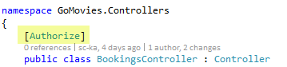
- Save your changes.
- Run your application. If you are currently logged in, log out. Now go to the following address. If you are not logged in, it should automatically redirect you to the log in page.
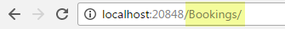

Exercise 2: Retrieving the Current User’s Details
- Open up the Utility class in the Helpers folder. Recall that we use this class to define the data for the Booking view model.
- Import the Microsoft Identity library.

Get Booking View Model Method
- Now locate the GetBookingViewModel method.
- The following steps to retrieve the current user should be added just before you create the new booking view model object.
  - First retrieve the logged in user’s ID.
// Get the user ID of the currently logged in user
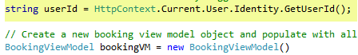
  - Now retrieve the full user details of the logged in user.
// Get the full application user details of the logged in user
- Next update the required booking view model customer properties. See example below:
Note: that I am setting the CustomerId to a fixed string. This is because for security reasons I do not want to pass the real customer id to the view page, but I need a value or the model will not validate. Even if you make it a hidden field, you can still see it using view page source.
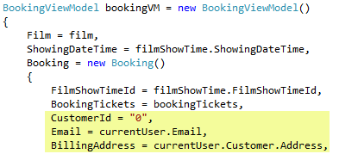
- Complete the entries for:
  - Billing City
  - Billing Postcode
- Save your changes and test your page.
- Now when you get to the Booking page, the entries should be prepopulated.

Exercise 3: Adding Display Labels and Error Messages to the Booking View Model
- Last week, you added display labels and validation error messages to the Customer and AccountView Models using data annotations.
- Open up the Booking class model and add similar data annotations for the labels and error messages. Note: you only need to do this for the fields that are going to be displayed in the view.
Below is an example of restricting the number of wheelchairs to a maximum of two per booking. I am not discriminating, I just want to show you how the Range attribute works.
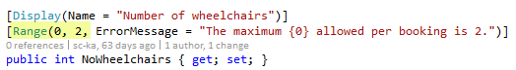
- Save your changes and test to see if your annotations have worked – do not submit the form yet.

Exercise 4: Updating the View to Display Only Necessary Fields
- Open up the Bookings editor template in the Bookings\EditorTemplates folder.
- Make the following changes to the Booking view:
  - Delete the following fields as they will be set programmatically or are not needed to complete the booking.
    - Purchase Date
    - Discount
    - IsCancelled
    - Refund Amount
  - Change the following fields to hidden fields
    - CustomerId
    - FilmShowTimeId
Note: Look at the Booking Ticket editor template if you have forgotten how to do this. Also, the fields do not need their own <div class=”form-group”>…</div>, you can add to one of the others or just somewhere on the page.
- Save your changes and preview the changes to the page.

Exercise 5: Some more JavaScript
In this exercise, you will make changes to the existing JavaScript function, calcTotal, to also calculate the grand total. You will also create another function to check that the user has selected at least one ticket to purchase before submitting the form.
- Open up the Create view in the View\Bookings folder.

Calc Total Function
To calculate the grand total, you need to find all the subtotal cells in the table and use their values to calculate the grand total.
- Go to the calcTotal JavaScript function at the end of the page.

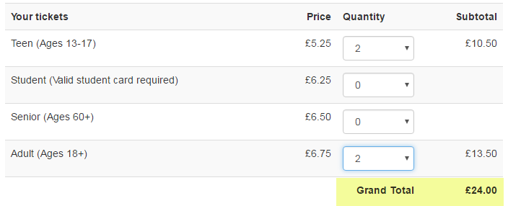
- Add a new variable that will be used to sum up the running grand total. You can
// initialise the grand total variable that will be used to sum the totals
- Next you need to find all the subtotal cells.
  - A table cell in HTML is created using the <td> element.
  - All the subtotal cells also have an ID that starts with the text “bookingTicket_Total” – you can go to the booking ticket editor template to have a look.
  - Thus: you will use JavaScript’s CSS Query selector method (querySelectorAll) to find all td HTML elements, with an id starting with “bookingTicket_Total”. The ^= symbol indicates to match the start.
// find all td elements that have an id that starts with bookingTicket_Total
// number of subtotal elements found
- BEGIN FOR: Now you need to loop through each of the subtotal elements.
// Loop through all the subtotal elements found
  - Read the value of the current subtotal value but get rid of the £ symbol so you can convert to a number
// Read the value and get rid of the £ symbol, so we can parse the string to a number
  - Convert (parse) the string to a number
// parse the string to a float (decimal) number
  - BEGIN IF: Check that the conversion was successful using JavaScript’s isNaN (Is Not a Number) function.
// check that the conversion was successful
// If it was not, JavaScript will return IsNaN - Is Not a Number
    - Increase the grandTotal variable by the value of total i.e. add total to grandTotal’s current value. If you are stuck, you can ask me.
}
  - END IF.
}
- END FOR.
- Finally, set the value of the grand total table cell. The cell has an id attribute = grand-total
// display the calculated grand total in the grand-total HTML element
- Save your changes. You can test if you want.

Validate Form function
In this function, you will only allow the user to submit the form if the user has selected at least one ticket to purchase.
- Locate the beginning of the tickets table in the HTML code above (still within the Create view) and add the following highlighted validation error message field to it.
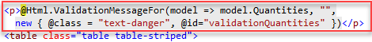
- Go back to the scripts block at the end of the page.
- Create a new function in the script block called validateForm. No parameters needed.
- Create a variable to store a reference to the validation error message field you just created.
// Get the error message field
- Reset the error message to blank
// reset the error message to blank
- Next you need to find all the quantities drop down fields.
  - Drop down fields are <select> elements in HTML
  - This time we need to find drop down fields with the ID attribute ending ($=) in Quantity. If you run the page and inspect the quantity elements you will find out that the id is of the form: Booking_BookingTickets_0__Quantity
// Get all the quantities select (drop down) elements
- BEGIN FOR: Now you need to loop through each of the quantities elements – look at what you did in the last exercise.
  - As soon as you find a quantity that is greater than zero, you can let the booking go through.
// As soon as you find the first match where the quantity is greater than zero,
// you can return true as it means at least one ticket is being booked
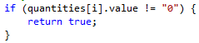
- END FOR.
- If the code gets here, it means it has looped through all the quantities and none was greater than zero. Set an error message and stop the form being submitted (return false).
// if it gets here, it means no tickets have been booked, all quantities are zero, display an error message
- Now go back to the HTML in the view and locate the @using (Html.BeginForm(…) { … } block of code. Modify it as shown to call the validate form function you just created when the user tries to submit the form.
- Save your changes. You can test if you want.

Exercise 6: Updating the Controller
In this exercise, you will update the controller to finally complete the booking!!
- Open up the Bookings Controller class
- First, import the Microsoft Identity library, so you can get access to the current user’s details.

Book Post Action Method
- Next, locate the Book POST action method.
- When creating a POST method, for security reasons, specify the fields allowed in the post submission.
- Modify the method’s definition as shown to remove the fields we are not submitting with the view. That is remove the PurchaseDate, Discount, IsCancelled and RefundAmount
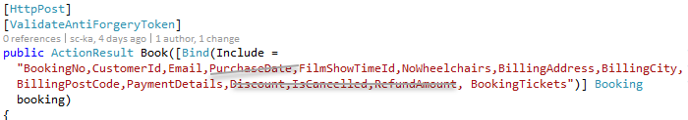
- BEGIN IF: ASP.NET confirms the model data submitted is valid (ModelState.IsValid)
  - Now, you can set the other values required programmatically. You need to set the Customer ID and the Purchase Date:
// Set the other values required for the booking, which the user does not need to set
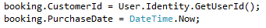
  - You also only want to submit the tickets where the quantity is greater than zero, as these are the tickets being bought. Using a lambda expression filter out the booking’s ticktets.
// Also, only submit the booking tickets with a quantity greater than zero
// Use a lambda expression to filter the booking’s tickets where the quantity > 0
  - Finally, send the submitted booking to the database – you can just uncomment the lines.
// Finally add the booking to the database and save the changes
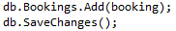
  - Redirect the user to the page listing the bookings.
- END IF.
- If the code gets here, it means the model state was not valid. Redirect the user back to creating the booking, replace the return View(); statement as follows:
// Model state not valid, send user back to create booking view
Note: if the code gets here, which is highly unlikely it will cause an error, but we will fix this next session.

Create (GET) Action Method
The controller currently contains a POST Create action method. You need to create a GET action method.
- Create a new a GET action method in the controller called Create – try and put it after/before the corresponding POST method.
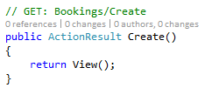
- At the moment, the action method is very simple, but you will fix this next session.

Index Action Method
- Locate the Index action method in the controller – it should be the first action method.
- At the moment, it will show the user ALL bookings in the database, including other people’s bookings. This is not right.
- Create a string variable in the Index action method called userId.
  - Initialise its value to the current user’s ID. If you have forgotten, look at what you did in the Book Post action method when you set the customer id for the booking.
- Now modify the return statement to only show the user’s bookings as shown below.
- Save your changes and test. Do you have a booking?

Exercise 7: Tidying Up a Bit
In this exercise, you will tidy up the links and add an Admin area.

Tidying Up Links
- Go to the Views\Shared folder and open up the _Layout.cshtml partial view.
- This partial view contains the common layout features for your website. Please see Lecture 3, slides 31 – end. I asked you to read these previously.
- Decide on a name for your web application.
- Locate the Application Link and change the name and also make it point to the Films index view.
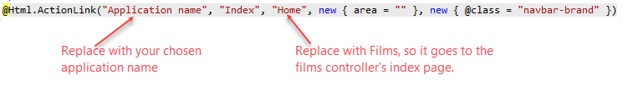
- Locate the other Home menu item and replace as shown below.
Replace above as follows (feel free to use your own preferred text for What’s On):
- Next you will create a link to the user’s account section, which will only display:
  - If the user is logged in
  - And the logged in user is a Member (i.e. customer, not admin)
Add the following highlighted code to the menu.
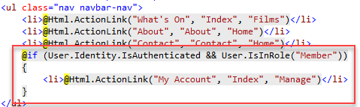
- Save and test your changes.
- If you want the “My Account” link to appear with the other account information on the menu bar:
  - Cut the code added in the last step
  - Open up the _LoginPartial.cshtml file and paste the copied code after the <li> element containing the Hello…

Creating an Admin Area
Areas are used to organise your application into functional units.
- From the solution explorer, right click on the project node and select Add Area… Type Admin as the area name to create.
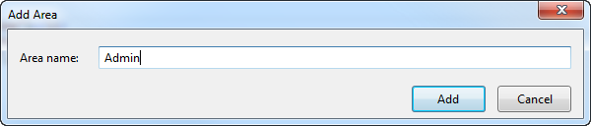
- It should create an Admin folder, with child folders for Controllers, Views and Models.
- First you need to update the routes to use the different namespaces for the different areas of the website.
- In the Admin folder, there is a file called AdminAreaRegistration.cs. Open this file.
- Make the following change, replacing the highlighted text with the name of your application. Don’t forget the separating comma.
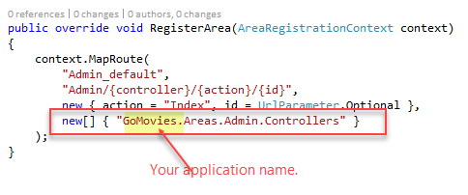
- Save your changes. You can close the file if you wish.
- Now go to the App_Start folder and open up the Route.Config.cs file.
- Make the following change, replacing the highlighted text with the name of your application. Donte forget the separating comma.
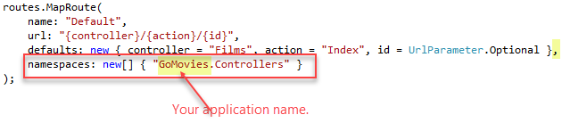
- Save your changes. You can close the file if you wish.
- Go to the normal Views folder and copy the Shared folder.
- Now go the Admin\Views folder and paste the copied folder.
- Right-click on the Admin\Controllers and use the Add New Scaffolded Item … to scaffold a controller and views for the Film model class.
- In the new Films controller created, set the authorisation to only users logged in as Admin as shown below.
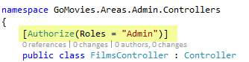
- Save your changes.
- Now run your application and try going to the following URL.
  - It is very likely that you are currently logged in as a member and you will be redirected to the log in page.
  - Log in as an administrator.
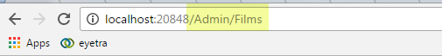
- Oops, we are back to the ugly layout!
- You can copy only the Films Index view from the main area and replace the ugly view if you wish.
  - Open up the main Views\Index.cshtml view page.
  - Copy everything below the <h2> … </h2> tag and close the view.
  - Now open the Areas\Admin\Films\Index.cshtml view page.
  - Locate the <table> … </table> element and delete/comment it out.
  - Now paste the copied code.
- You will also need to copy the search functionality you added to the Index action method in the Films controller.
  - Open up the main Controllers\FilmsController.cs file.
  - Locate the Index action method and copy it and close this file.
  - Now open the Areas\Admin\Controllers\FilmsController.cs file.
  - Locate the Index action method and replace it with the copied code.
- Save your changes and test. Is that better?
- Ideally you should now remove the edit views and corresponding action methods from the main public area as members of the public should not be allowed to edit films, film show times, etc.

Challenge Exercise
- Create an Admin area link that displays in the menu when the current user logged in is a member of the Admin role.
  - It should take the user to the Film’s index view.
- Can you think of how you can determine how many wheel chair spaces are still available for the show being booked in the GetBookingViewModel method in your utility class?
- Use a drop down list instead of a text field for the Number of Wheelchairs field. It will be very similar to what was done for the Quantities drop down – you will need to extend the BookingViewModel.
- Hide the Number of wheelchairs field in the Booking view if there are no wheelchair spaces available.
- That’s all for today

