Professional Career Development
Module Number: LCHS4005
Professional career development report and role play (interviewee and interviewer)
Lecturer: Lloyd Beharry
Student name: Julia Catia Gomes Dias da Silva
Student ID:2130195
Submission Date: 10th May 2023

Table of Contents
Introduction 3
The Employment Relationship 4
How is regulated 8
What are employer’s responsibilities 9
Employees responsibilities 10
The Recruitment Process 11
The Interview – reflection on role play…………………………………………………………………………………………15
Career Development…………………………………………………………………………………………………………………….16
Conclusion…………………………………………………………………………………………………………………………………20
References………………………………………………………………………………………………………………………………….21
. Appendix…………………………………………………………………………………………………………………………………...22

Introduction

The employment relationship will be covered in this paper, along with how it is governed. In the second section, the recruiting and selection procedures will be examined in light of the interview role-playing exercise that was conducted in week 9. finally. My personal position will be discussed, as well as career development.

The Employment Relationship
The English employment market is hotting up with multiple job openings available and one of the highest incomes in all of Europe. Immigrants from all over the world are drawn to this situation, but in order to be accepted, it is crucial to understand the UK employment application process.
People frequently conflate employment relationship with employment relationship when discussing labour rights, but these phrases have distinct legal meanings and are also used in quite different ways. To further illuminate each of these ideas and the significance of realising how they differ from one another, The interactions between employers and employees are referred to as "employee relations." Currently, the phrase "employee relations" refers to both interpersonal and collective relationships at work. The growth of employee rights is portrayed as making the working relationship increasingly more intimate. Different voice channels are essential.
However, using collective channels—which use union and/or non-union representatives—gives workers a collective voice that can support and complement individual channels. In the modern workplace, the term "employee relations" has largely taken the role of "industrial relations." Topics like working conditions are what they mainly focus on.
Pay, benefits, and compensation.
Health and safety at work and for the workforce.
Rewards and acknowledgement.
resolution of disputes.
Every firm should make it a top priority to inform and consult the workforce, which is a fundamental people management principle. When done correctly, it offers a useful framework for communication between workers' elected representatives and management.
In order to win support from the workforce, senior management can use this chance to communicate crucial information or plans. Employees, for their part, can use their collective voice to offer suggestions, pose questions, or voice concerns via an indirect channel through their representatives. It highlights how crucial it is to ensure that an organization's connection with its employees is managed through open procedures and appropriate legal frameworks.

The potential for improved company outcomes as well as improved employee health and wellbeing exists when there is a favourable work environment and high levels of employee engagement. According Alan Price, CEO, Bright HR” The success of any business starts and ends with your people. People practitioners bring management practice to managing people especially in professional areas such as employee relations."

Trade union influence, there has been a transformation in many aspects of UK employment relations over the past 40 years, none more profound than the changed role and influence of trade unions. The declining levels of union membership and density, combined with a huge fall in collective industrial action, are well charted. In the UK, there are numerous legal regulations that must be followed while managing employee relations and resolving potential issues. These can be roughly split into those that deal with individual relationships between employers and employees and those that deal with collective relationships.
Individual employee interactions are influenced by contract law and the conditions of the employment contract. Additionally, it's crucial that staff manuals and employer handbooks adhere at a minimum to the Acas Code of Practise on grievance and disciplinary procedures. Although handbooks differ, many aspects of work rights, including as holidays, sick days, parental and other types of leave, reporting fraud, communications, and equal opportunity, are governed by them.
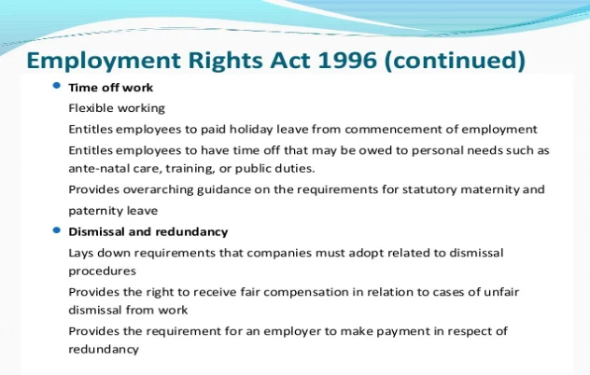
To supplement the law of contracts, certain mandatory statutory employment rights also apply. These rights have an impact on issues like termination, negotiation, mediation, and other methods of managing conflicts and disciplinary actions. The Employment Rights Act of 1996, which addresses when an employee can be fired fairly, and the Equality Act of 2010, which addresses discrimination and equal pay, are important examples of employment laws that have an impact on employee relations.

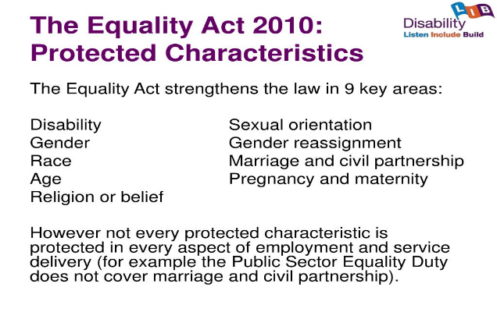

Arbitration, industrial action, information and consultation, collective bargaining, and other collective processes are all included in the collective dimension. When negotiating compensation and working conditions, or when informing and consulting employees about changes like layoffs or health and safety regulations, employers may partner with recognised unions. Examples include: Concerning consultation during redundancy and collective bargaining, the Trade Union and Labour Relations (Consolidation) Act of 1992
The Trade Union Act of 2016 comprises laws relating to voting, strikes, and the duties of the Certification Officer, who is in charge of statutory matters pertaining to trade unions and employers' associations, such as registration and recognition.
Conflict at work is still a reality of organisational life and must be handled constructively and effectively. Individual and "unorganised conflict," such as sickness absence, bullying or harassment, and employee turnover, can be just as detrimental and expensive to a company as collectively planned strike action. Organisations must create proactive methods for handling conflict and make sure that line managers are competent to settle disputes early on as part of a problem-solving strategy.
The term "partnership" between employers and unions is no longer generally emphasised as a paradigm for contemporary labour relations. However, its emphasis on teamwork, cooperation, and reciprocity is still relevant today. It basically involves "employers, unions, and employees working together and creating long-term positive relationships that focus on the future of business and improving working life for employees" (John Monks, TUC General Secretary, 2001).
Individual voice channels and people management techniques can both benefit from fostering an atmosphere of cooperative cooperation with recognised trade unions and employee representatives, whether union or non-union. The business as well as the personnel may gain from such an approach.
Organisations should create an efficient, all-encompassing employee relations structure, for instance:
Create a number of distinct and overlapping channels for employee voice, such as direct means through direct communication with people and indirect methods through employee representation for collective voice.
Create systems and procedures for interacting with employees at all organisational levels, both union and non-union representatives.
In order for managers to effectively support employee voice, it is important to educate and mentor them on the organization's information and consultation policies as well as its goals and practises.
Ensure that a culture of cooperative working permeates the entire company so that managers at all levels approach their working relationships with representatives in a good manner and foster trust.

How is regulated
The goal of the regulation, which is normative in nature, is to ensure that the law is applied correctly. The Executive Branch issues this rule whenever it is necessary to control (organise) how a specific legal activity is carried out. These Executive Norms are intended to fractionate a normative act immediately superior and are gifted with abstraction, generality, impersonality, imperativeness, and inventiveness.

What are employer’s responsibilities
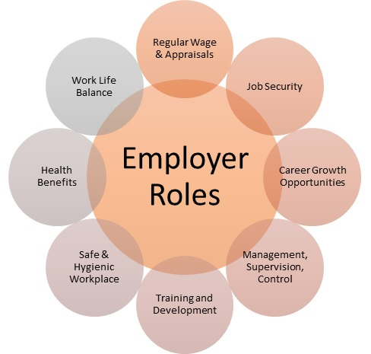
Without limiting the contractual flexibility possessed by the parties in establishing the employment contract, labour law, in particular the Labour Code, creates the following duties:

- Respect and sophistication: The employer are obligated to treat the employee with sophistication and probity, and any actions that violate worker dignity or are discriminatory, harmful, intimidating, harassing, or affect their self-worth are strictly prohibited.
- Punctual payment of compensation is one of the responsibilities of the employer, who must also pay the employee's salary on time and in a manner that is fair and commensurate with the work performed;
- decent working conditions: The employer is required to offer the employee decent working conditions, both morally and physically, and must do so by implementing measures derived from legal or collective labour control instruments relating to safety and health at work;
- Vocational training: Under labour law, employees have the right to ongoing training that will boost their productivity and employability;
- Employers also have a responsibility to respect and not interfere with the exercise of positions in organisations that represent workers.
- Employee registration: The employer is required to keep a current record of each employee, including their name, date of birth, date of hire, type of employment, category, promotions, pay, start and end dates of holidays, and any absences that could result in a reduction in pay or a loss of vacation time.

Employees responsibilities

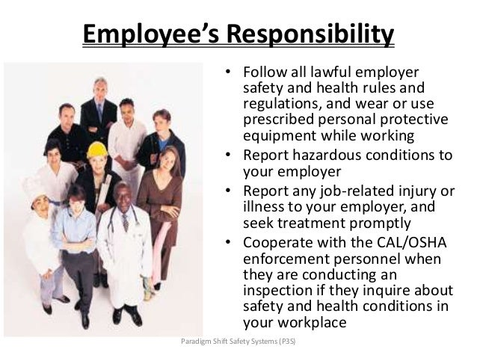
Employees are responsible for a variety of tasks at work. These comprise:
Loyalty nothing that could hurt the business must be done.
Honesty Your bosses, co-workers, and clients should all be able to trust you.
Observing deadlines and timing must be sure to accomplish each of your assignments on time and before the deadlines assigned to them.
protection of health You are responsible for ensuring both your own and others' safety.
Professionalism to produce excellent work, you need make a commitment.

The Recruitment Process

Searching for and attracting applicants are only one aspect of effective recruitment. It combines effective administrative, human resource, and people management techniques to find staff who are in line with the mission, values, and vision of the business. As a result, the process needs to be well organised and start with a thorough understanding of the organisational culture and the best profile for each opening.
The process of recruitment involves locating and luring particular candidates to an organisation. One of the most well-known authors in this field, Adalberto Chiavenato, writes in the book People Management: The New Role of Human Resources in Organisations that: "Recruitment is a set of techniques and procedures that seeks to draw candidates who may be qualified and capable of holding positions within the organisation."
In other words, the quality and talents of potential employees should be the main focus of a solid recruitment process because they can always be assessed. In other words, in businesses that want to stay competitive, this process is ongoing and not just carried out when there is a position that has to be filled.
This makes sense because the organisation will know where to start in the recruitment process thanks to the identification and supervision of trained specialists. In addition to watching potential employees who work for rival organisations, it is important to understand the internal team's competencies and provide a career plan that inspires personnel.

In conclusion, effective hiring necessitates ongoing market research on behalf of the business, taking into account both internal and external talent pools, and identifying experts who possess the technical and behavioural qualities necessary for an open position. These individuals may be employed by the business, by rival businesses, or by job seekers in the market.
In order to apply filters and suggest the most eligible candidates, the procedure seeks to draw in as many qualified individuals as it can. The selection process, which involves interviewing and vetting the hired applicants, doesn't start until after the recruitment stages are complete.
Professionals must demonstrate their qualifications for the open post throughout the selection rounds, which include technical knowledge assessments and interviews.
Unlike selection, which is typically handled by managers and HR experts of the organisation itself with the aid of consulting, recruitment is typically carried out by individuals or consultancies that specialise in human resources.
The hiring of the best candidate to fill a particular job in the organisation is the shared goal of both processes, recruiting and selection, thus it is important to keep in mind that both must be well adjusted.
So why should each corporation fund a hiring process?
Because it makes it possible to choose qualified applicants whose profiles match the position's requirements and the organization's organisational culture. Companies increase their human capital in this way, which improves their performance.
Recruitment became commonplace a few decades ago as a result of significant changes in society, much like other instruments for valuing people. If we consider, for instance, the Fordist model of manufacturing, these changes become extremely obvious. This method, which dates back to the early 20th century, is characterised by the standardisation of production, with assembly lines and moving walkways to shorten the time required for product manufacturing.
Workers at the time were considered as just another component of the production system and solely carried out the monotonous tasks for which they had been educated. The speed of innovation and discovery, however, has drastically altered that justification. Organisations must become more adaptable and flexible in order to stay up with this fast-paced environment, which calls for a workforce that places a high value on ongoing education.
Businesses that prosper in this scenario bank on a more horizontal structure, without strict hierarchies, where everyone may participate in accordance with their expertise. The value of education and training as essential conditions to enhance problem-solving abilities therefore becomes apparent, leading to creativity by exploring new avenues.
This is why it's important to take note of what Ieda Maria Vecchioni Carvalho writes in the article Recruitment and selection by competencies: "People have become one of the main assets of organisations in the age of learning organisations, where the competitiveness of organisations depends on a large scale on their ability to process information, create knowledge, and present innovative solutions to everyday impasses." Aware of the importance of their human resources, companies need to improve the way they attract and choose future employees, investing in quality recruitment. Recruitment can be divided into two categories: methods used and sources used to draw in candidates.
Recruitment in the first case can be done traditionally or digitally. Typical Recruitment, it is the one that collects information about job openings, resumes, and offline methods for disseminating it. In this kind of hiring, job openings are advertised by the employer through conventional media including newspapers, magazines, radio, and television. The HR department should receive printed copies of interested applicants' resumes, or applicants may mail their CVs and application forms.
Online Recruitment
From enticing candidates to filling the position, it makes use of digital resources throughout the hiring process. As it takes less time and money to discover qualified professionals, this method is becoming more popular. The company's website and specialised websites advertise job openings.
Professionals can send resumes and other material via email or these sites. Only a small portion of the selection processes will be done in person; the initial contacts are also made online. Recruitment can be classed as internal, external, or hybrid in terms of the sources used to draw candidates.
What Stages of The Recruitment Process Are There?
According on the urgency, complexity of the position, and corporate goals, the dynamics may vary
.1. Planning A successful recruitment takes planning because it is a process. The manager in charge must coordinate with consultants and HR specialists to create a schedule in addition to determining the details that will appear in the disclosure of the employment opportunity.
Consider the budget and the specialists' availability while establishing timeframes for each stage of the hiring process. The instruments that will be employed in the R&S, such as group dynamics, tests, and individual interviews, must also be chosen.
2. Announcement of the vacancy This step determines whether the recruitment will be conducted internally, externally, or through a combination of both. Following the announcement of the opening, the HR team starts to monitor the applications received through various sources.
3. Examining the curriculum
In the final round of hiring, consultants or HR experts review resumes and other needed materials, such as portfolios. Its objective is to identify candidates who fit the vacancy's profile and move them on to the selection stages. Candidates will probably be contacted remotely, over the phone, via video call, or through messaging services, before heading in for in-person interviews or dynamics.

The Interview – reflection on role play

The questions and answers in a job interview come in a variety of forms. In order to succeed in a job interview, you must be able to respond to the trickiest and most frequent questions. During the job interview, on the other hand, it's crucial to ask the recruiter pertinent questions. However, it is not need to be that way. Additionally, the candidate should and might ask in order to determine whether there is a framework between functions and business culture on the one hand, both the employer and the applicant candidate benefit from job interviews. As a result, it's crucial that you not only respond to the recruiter's inquiries but also explore any reservations you may have about the job and the organisation.
The process of reflection involves identifying how something is being thought about in a particular way. We have to understand something in order to comprehend it. Making sense becomes learning when we subsequently apply this knowledge to guide behaviour or activities.
The goal of this report is to create a self-study based on a hypothetical situation in which I can evaluate my strengths and weaknesses in relation to the theory and data surrounding the use of correspondence and relational skills, as well as how and when to integrate interchanges of compatibility, compassion, tuning in, and undivided attention.
In particular, I have succeeded in improving my knowledge and comprehension of the process of reflecting on a particular region while working on the role play. Along with improving my personal development abilities, I've learned the value of a strong work ethic, integrity, adaptability, and self-confidence in order to achieve any task. An individual can always do better overall in terms of personal development with comprehensive knowledge and abilities in communication, problem-solving, and organisation. I was taking part in this role-playing exercise at the same time with the aim of learning more about professional abilities that would be useful to me later.
It applies equally to me because I have grown in my comprehension of how to improve as a worker in a workplace setting. In tandem with controlling the entire process, the workplace atmosphere must also be addressed. I can only become a better entrepreneur in the future with the support of this strategy. To better the entire situation with reference to advancing my career, I have worked on my communication abilities and work procedures. Another aspect of the role play that has assisted me in improving myself through the process of self-knowledge and awareness is developing talents and strengths, which has been highlighted.

Career Development

I acknowledge that I possess a concealed set of skills that I also see as traits, as was just mentioned. I do consider myself to be dependable, confident, persistent, and precise in all I do (Sekarwinahyuet al. 2019). I acknowledge that I have exceptional interpersonal skills that I can employ to persuade any buyer to like our products. I have distinct critical thinking skills and operate effectively under pressure.

PERSONAL DEVELOPMENT PLAN

NAME | Julia catia Gomes Dias DA Silva | Target Job/career  Example: | General Nurse

TIME PERIOD | From:13-06-22 | To:13-06-26

What Skills do I need to achieve my goal?
SKILLS | How Will I get them | What resources or support will I need? | What can prevent me from achieving my goals: (unemployment, illness | How long should it take
knowledge and technical/technological performance;  scientific knowledge;  decision making  leadership; work  communication | focus on university studies  practise, instruction  experience coexistence  practise, instruction  experience coexistence | many books and confidential  patients, family, co-workers, and friends | Hospitals, GP clinics  University  Hospitality  Clinics  home | 3 years  3 years  for all my life

Conclusion
Knowing oneself is important, I said in this essay. I must hone my skills and develop my character if I am to accomplish all of my goals. In addition, I feel that the role play that we performed in class and that we discussed here has given me a better understanding of my skills, weaknesses, and potential. While carrying out the activity, there are a lot of difficulties and problems that must be handled properly in order to go beyond them. Based on the entire project, it can be inferred that careful preparation and strategy are crucial components of accomplishing a task.

References

BBC (2022). The recruitment process - Recruitment and selection - National 5 Business management Revision. [online] BBC Bitesize. Available at: https://www.bbc.co.uk/bitesize/guides/z3s9fcw/revision/2 (Access 5th Mat 2023)
Bowers, J. (1997). Bowers on Employment Law. Blackstone Press.
Britain, G. (2013). Trade union and labour relations (consolidation) act 1992 (amendment) order. Tso.
Gibson, J.W. and Hodgetts, R.M. (2013). Readings and Exercises in Organizational Behavior. Saint Louis: Elsevier Science.
GOV.UK (2012). Employment status. [online] GOV.UK. Available at: https://www.gov.uk/employment-status/worker. (Access 5th Mat 2023)
Jobsoid (2018). End to End Recruitment Process - The Ultimate Guide to Hiring Top Talent |... [online] Jobsoid. Available at: https://www.jobsoid.com/recruitment-process/.(Access 5th Mat 2023)
Kaponya, P.G. (1991). The human resource professional : tactics and strategies for career success. New York: Praeger.
Mccolgan, A. (2011). Equality Act 2010. Liverpool: The Institute Of Employment Rights.
NHS (2015). How to become a nurse. [online] Health Careers. Available at: https://www.healthcareers.nhs.uk/explore-roles/nursing/how-become-nurse. (Access 5th Mat 2023)
NiDirect (2019). Employers’ health and safety responsibilities | nidirect. [online] nidirect. Available at: https://www.nidirect.gov.uk/articles/employers-health-and-safety-responsibilities. (Access 5th Mat 2023)
Sciencedirect.com. (2011). Employment Relationship - an overview | ScienceDirect Topics. [online] Available at: https://www.sciencedirect.com/topics/social-sciences/employment-relationship. (Access 5th Mat 2023)

. Appendix

Job application form

Application for [Nurse] -

Your details

Name: Julia catia Gomes Dias da Silva

Education and training
Please give details:

First year successfully completed at university at university Trinity Saint David
Secondary school of Amora (Portugal)
Humanities Course

Qualifications
Please give details:

- Understanding of and commitment to the implementation of equal opportunities.
- Knowledge of health and safety issues.
- Developing customer services procedures, policies & standards.
- Experience of Microsoft software like Word, Excel, and PowerPoint.
- Producing written information for customers and reports for managers.

Employment history

Your current or most recent employer

Name of employer Olive Catering Service-Piccadilly

Work in a fast environment, work as a team, provide excellent customer service at all time by attending to customer needs in a prompt and friendly way.

Job title: Hospitality and barista

Length of time with employer: Feb 2018 –Jan 2023 Hospitality

Reason for leaving:

Duties:

Work in a fast environment, work as a team, provide excellent customer service at all time by attending to customer needs in a prompt and friendly way.

Previous employers
Please tell us about other jobs you have done and about the skills you used or learned in those jobs.

Miller and Carter restaurant – Newbury Park Jan 2014 – Feb 2018
Starters Chef
Being friendly and hardworking individual also a team player as this shop gets very busy always need to be fast and work under pressure.

Questions
Can You tell me about yourself?
Can you tell me why you won’t work with us?
Can you tell me about your strengths?
What are your Weaknesses?
Where do you see yourself in five years?

