

Assessment 1 – Reading Task Template
Upload your photo of your A3 in-class notes here:
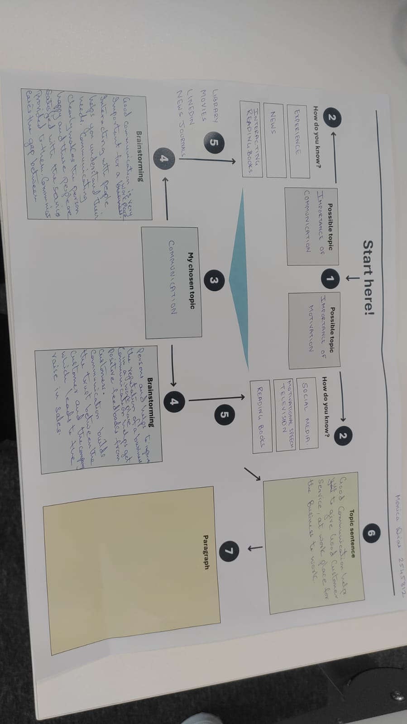

1. Answer these questions using the sentence starters below
a. What is the main idea of the text?
The main idea is the powerful role social media platforms like TikTok and Instagram play in helping small local businesses go viral, gain global awareness, attract customers from far and wide.
b. What are two key points?
One key point is that viral content and customer posts drive massive foot traffic to local shops, such as customers traveling three hours to Hony wood sandwich shop or driving four to five hours to visit Krystals boutique
Another key point is social media allows small traders to transform local side hustles. Or market stalls into full businesses with global reach, like Lindy Loo’s boutique shipping to Australia and Little Loves Pamper Bus getting inquiries from US and Bahamas.
c. What part of the text did you find most important? Why?
The most important part is marketing expert Faye Martins quote that brand awareness is at the heart of it. Social media explains how small businesses were able to grow so rapidly through online platform.
d. Was anything unclear or difficult to understand?
I was not sure about how a local mobile pamper bus based in Essex manages inquiries from places as far away as the Bahamas.
e. How did your group help you understand the text better?
My group helped me by making the hard words easy explaining it. Showing how social media impact various industries like food, fashion, and party services.
2. One sentence reflection
Question: What did you find challenging about this task?
The hardest part was 1. Summarizing the key details through the three pages of the article while following the sentence starters strictly.

