LCBB4004
Marketing Fundamentals
Assignment 2
The Effect of Globalisation on Unilever’s Marketing Strategy

Student ID: 2027510
The global marketing environment consists of all factors that emphasise inside or outside an organisation that impacts the marketing strategy to build and create a sustainable marketing relationship with the targeted customers. The global marketing environment benefits an organisation to market its products on a worldwide scale. According to Armstrong et al. (2014), most organisations focus on global marketing to reach global objectives. The global marketing environment allows enhancing effectiveness in the marketing function by stakeholders. The essay aims to identify the stakeholders within a global marketing environment and their impact on the worldwide marketing functions of Unilever. Unilever is one of the most leading British multinational companies in the world, headquartered in London. Unilever operates its business in over 190 countries globally with more than 400 brands. The sustainable global marketing environment helped Unilever make thirteen brands with over one billion euros sales (Reza, 2010). The essay will demonstrate various marketing functions of Unilever and how these functions are used to satisfy customer needs. The essential data are collected from the books, articles, journals, news, and Unilever's annual report to achieve the objectives correctly. In addition, the essay will explain everything in the context of Unilever and its various marketing functions that they use to fulfil the consumer's needs.
Stakeholders are defined as a group party interested in a specific organisation that may be affected or affected by this organisation. Keegan (2011) emphasises that Stakeholders are significant resources in an organisation because they invest money, effort, time, knowledge and help in decision making. For example, Unilever's global marketing environment has mainly two stakeholders – primary stockholders and secondary stockholders. The primary stakeholders define those groups of people directly engaged with the organisation and on whom the organisation depends for its survival and desired success (Maignan et al., 2005). For example, the primary stakeholders of Unilever consist of stockholders, customers, employees, creditors, and suppliers. In contrast, the secondary stakeholders include those not engaged with the organisation directly and haven't contractual obligation with the company. The secondary stakeholders of Unilever consist of competitors, communities, trade associations, governance, and social media (Doyle, 2009).
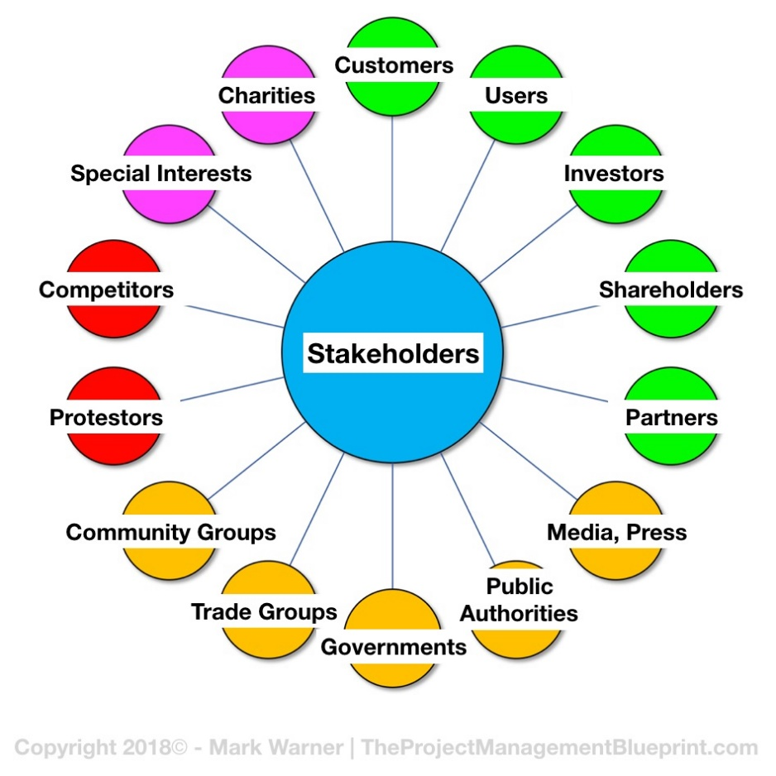
Figure 1: Stakeholders within Global Marketing Environment
Source: Blueprint (2018)
Global marketing functions involve collecting market information, planning, strategy making to reach targeted customers, and buying and selling products globally to develop the country's economy and increase industrial growth. Unilever's global marketing functions are planning, development, price, place, and promotion (Damian and Zowghi, 2002). Unilever uses these functions to choose the primary route for global marketing, identify the sustainable market and product, select feasible distribution channels, develop a pricing strategy, and prepare an international marketing strategy. According to Best (2006), global marketing functions facilitate an organisation to reach international customers and promote the brand globally. For example, a leading international company like Unilever operates its business in over 190 countries globally and increases its market share and customers by applying a sustainable global marketing strategy. However, Unilever's stakeholders have a significant impact on this entire procedure of global marketing functions as stakeholders help marketing functions work correctly.
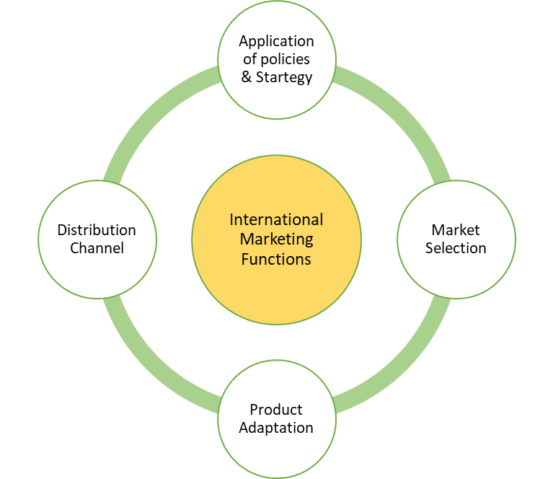
Figure 2: Global Marketing Functions
Source: Prezi (2013)
Shareholders are the crucial stakeholders of an organisation who invest money and expect a better return on investment without incurring any significant risk. That's why top management continuously focuses on sustainable marketing moves away to measure such as increasing sales growth and the value of the market share that will add value in the shareholder's wealth (Moorman and Rust, 1999). In Unilever's global marketing functions, shareholders have significant impacts to ensure the marketing accountability that leads to making out the best outcome to enhance the shareholder's wealth. According to the annual report 2019 of Unilever, ROI is 13.86% which is more significant than the minimum ROI of 7%. Maximum ROI encourages the shareholders to invest more in the company. To maximise the shareholder's wealth, Unilever introduces a new product to positively postlaunch effects on shareholders' returns (Payne et al., 2005). There has also impact on branding that creates new value for the shareholders and magnitude market benchmark.
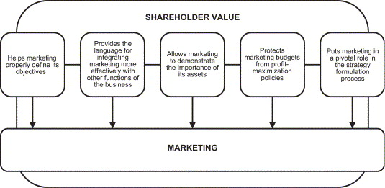
Figure 3: Shareholders Impact on Global Marketing Function
Source: Science Direct (2005)
Customers are the most significant and valuable stakeholders of every organisation. Keegan (2011) clarifies that The customer plays a vital role in the marketing function to select the best product and fair price. Before launching a new product, an organisation can get appropriate information by questioning the customers regarding the right price and marketing message that appeals to the consumers. According to Unilever's report, 2.5 billion people use their products and fulfil their needs every day. Unilever launched different brands in the same product that helps to increase sales growth and profitability(Girgenti et al., 2016). Unilever adopts a customer-focused sales campaign to make out the best outcome of global marketing functions.
In contrast, employees are called the source of success of an organisation that plays a vital role in implementing the all-marketing strategy and global marketing functions that ensure reaching the organisation's objectives. Sajid (2016) explains that Employees work to determine appropriate products for the customers, identify feasible distribution channels, and make a sustainable marketing plan for getting the customers. If employees don't put effort into implementing strategy, an organisation can never successfully reach its targeted customers. Unilever has 149k excellent employees leading from different places and combines the global marketing function to achieve the best outcome (Clow, 2013).
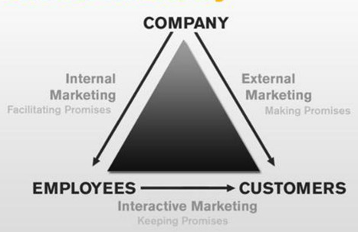
Figure 4: The Role of Employees on Global Marketing Function
Source: Quizlet (2021)
Suppliers are also significant stakeholders for an organisation to execute the function. Amoako and Akanyijuku (2012) illustrate that suppliers play a vital role in delivering the raw materials for producing products and help distributors deliver products to the customers at the right time by keeping the quality of goods and services. For example, Unilever has 60000 suppliers to supply their products to the consumers. If suppliers stop their delivery, many restrictions will be created to deliver the products to the customers. Suppliers also impact planning for the sustainable distribution strategy and innovating generation in supply chain relationships (Reza, 2010). In addition, suppliers can help an organisation to get competitive advantages by delivering quality goods and services at a low cost.
Creditors may be defined as an entity that extends credit and gives permission to another institution to borrow money that will be repaid on a specific future date. According to Haque et al. (2015), there are two types of creditors – loan and trade creditors. Creditors of Unilever significantly impact global marketing function by contributing required capital that will help the organisation produce its products without facing a liquidity shortage. Sometimes Unilever purchases on credit from trade creditors also impact marketing function.
Competitors are the secondary stakeholders of an organisation who are not directly connected. Still, their indirect roles impact global marketing function—competitors affect all of the worldwide marketing functions positively and negatively. According to Rao and Bharadwaj (2008), Every organisation follows the competitor’s products quality, pricing strategy, marketing strategy, and distribution channel to ensure the best product quality. Every organisation tries to deliver quality products, reach more customers by effective marketing strategy than its competitors (Jawahar and McLaughlin, 2001). Unilever is the most successful multinational company globally, but it also has competitors in the market. For a typical example, Reckitt Benckiser (RB) is the most significant competitor of Unilever. RB also sells consumer goods in the same market as Unilever. Most of the time, competitors' pricing strategy affects the organisation—for example, RB, when it sells its products at a lower price, negatively affects Unilever. Sometimes competitors launch an identical product with good quality in the market that can threaten an organisation. The company needs to increase the product quality or decrease its sales value to get competitive advantages (Clow, 2013). Unilever uses its feasible pricing strategy and expertise distribution channel to reach the nook and corner of the world and gain competitive advantages.
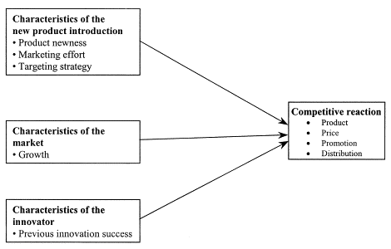
Figure 5: The impact of new product launch Strategy on Competitive Reaction
Source: Science Direct (2021)
Hindustan Unilever and Tata global Beverage are recognised as the largest competitors in the tea industry. According to Unilever (2020), Both are competitors, but they cooperate in developing the farming practices and the livelihood of thousands of small farmers. So, Unilever's competitors have been playing a positive role rather than a negative impact on the global marketing function (Reza, 2010). It proves that competitors always have adverse effects on the organisation and provide more positive and competitive advantages.
Regulators are also important stakeholders of an organisation that exert the external political and economic forces on an organisation. Wentzel (2009) emphasises that regulatory constraints significantly impact global marketing functions – the product's design, packaging of products, and advertising. Regulators protect the rights of the consumers and ensure the delivery of quality goods and services. Much research suggests that regulators have a significant influence on an organisation for environmental marketing (Selnes and Sallis, 2003). The forces of government agencies, regulations make an organisation sincere to achieve market success. Regulators play an essential role in Unilever for the customers and help them select whether the organisation is reputable or not.
At the same time, community members are also secondary stakeholders for an organisation that includes non-governmental institutions and communities. According to Wentzel (2009), Communities can mobilise public opinion regarding an organisation’s activities in favour of or opposition. Community members may impact enhancing the brand equity of an organisation (Vorhies and Morgan, 2005). Unilever does its marketing activities following communities' regulatory and social dimensions like donating to charities and CSR in social organisation. These activities enable Unilever to reach its marketing-oriented goals, build up brand equity, and enhance an organisation's public image (Girgenti et al., 2016). But there is a chance to have occurred risk in the boycott for disagreeing with community interests. A boycott will be decreased customers support and make a negative impact on the public image. So, giving attention to the community will bring out the positive result and provide competitive advantages, while poor relations may be threatening and negatively impact performance (Doyle, 2009). Community members facilitate an organisation from different sides and also can put an organisation at risk.
Social media is a secondary stakeholder that also has a significant impact on global marketing functions. Social media is the biggest platform for online promotion of this modern era (Reza, 2010). The majority of organisation uses this platform to create new customers and increase brand value. According to the research report, 4.48 billion people uses social media platform. According to Unilever (2021), their online sales grew by 38% than before. There was no opportunity to do the offline campaign and reach the customer physically in the pandemic situation. Social media played a significant role in promoting the brand online and getting the targeted customers as most of them were active on social media then. According to Wentzel (2009), Social media increases brand awareness, facilitates sustainable advertising, and engages customers at a low cost. Customers can frequently communicate with the company and get expected information about preference products through social media. Conclusion: There are many platforms in social media like Facebook, WhatsApp, Instagram, Twitter, E-mail, Website, LinkedIn, and more that helps to reach the targeted customer and engage new customers. However, there have also some risks in social media marketing. There was a chance to be hacked data by hackers and faced the rumour about the brand that can destroy the customer's trust in the brand in a matter of minutes (Girgenti et al., 2016). Whatever the significant benefit from social media for advertising at low cost increases its acceptability to everyone.
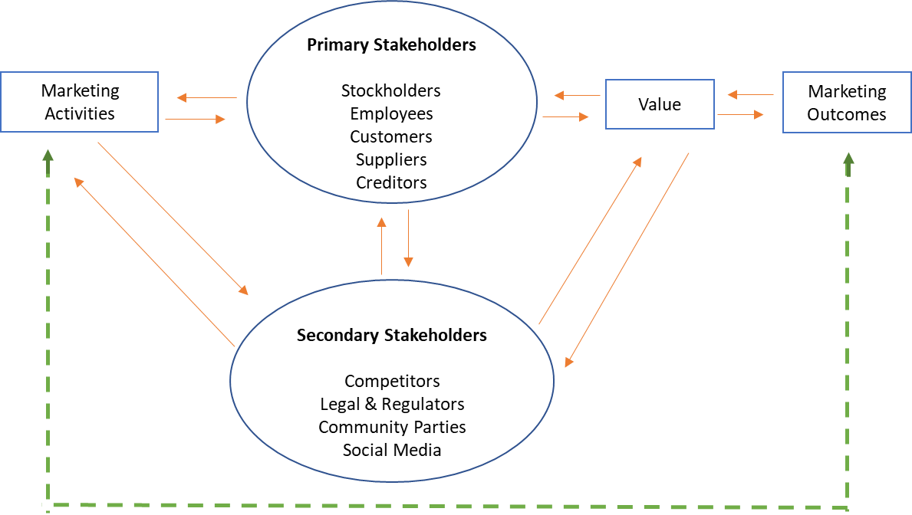
Figure 6: Stakeholders Impact on Global Marketing Functions
Source: Researchgate (2017)
Marketing functions within an organisation are essential to make sure the satisfaction level of customer needs. According to Haque et al. (2015), Large companies like Unilever's marketing functions are often separated into different segments and specialised departments. Marketing functions are related to reaching the targeted customer and fulfilling their needs (Wentzel, 2009). Therefore, the Unilever marketing functions is a very significant aspect for the business. Madden et al. (2006) state that several elements in the marketing functions are directly engaged with each other. These aspects are – assessing the current position of Unilever, determining the marketing objectives, developing marketing strategy and implementing that, measuring the performance, and revising the marketing strategies.
Identification of the current position of the organisation makes sure the strengths and weaknesses of presents marketing strategy. Armstrong et al. (2014) explained that Every year the marketing manager needs to assess the current situation of Unilever by situational analysis. By situational analysis, the marketing manager will determine the company s strengths and weaknesses and the efficiency of marketing strategy that will help make the next sustainable marketing strategy (Maignan et al., 2005). For example, Unilever sells its products in over 190 countries with 400 brands. There is a chance to be content with the global financial crisis for the subsequent economic uncertainty in some countries. At that time, customers are ready to spend more to buy their needed products rather than what they want. These kinds of research help Unilever in market development and increasing sales growth (Doyle, 2009). However, Unilever has 400 brands that customers feel necessities. So, Unilever can grow its sales by satisfying customer needs.
Determining marketing objectives is essential for ensuring the way an organisation wants to move on the market. According to Payne et al. (2005), Marketing objectives include the expected sales margin, targeted customers, probable product quality, level of innovation. Sustainable marketing objectives can fulfil customer needs. For example, Unilever's marketing objectives are to increase the awareness of the quality brand and create a sustainable relationship with customers. Marketing objectives help Unilever create a sustainable marketing strategy and understand how this strategy will satisfy customer needs (Jawahar and McLaughlin, 2001). If an organisation cannot determine the marketing objectives, it won’t make a sustainable marketing strategy and combine other marketing functions with meeting customer needs.
Product or service management is an essential function among marketing functions within an organisation. Sajid (2016) states that This function involves obtaining, determining, developing the product mix to get market opportunities. Product and service management functions enable an organisation to understand customer demand and produce quality products to satisfy customer needs (Selnes and Sallis, 2003). For example, Unilever provides high-quality products to its customers. SEAC works with Unilever to ensure product safety and environmental sustainability. For focusing on quality foods and refreshment sites, Unilever is certified to FSSC 22000 GFSI benchmarked standard. Product service management helps to ensure what kinds of product consumers want, what kinds of product packaging appeals to them, and how the product meets the standards with others product lines.
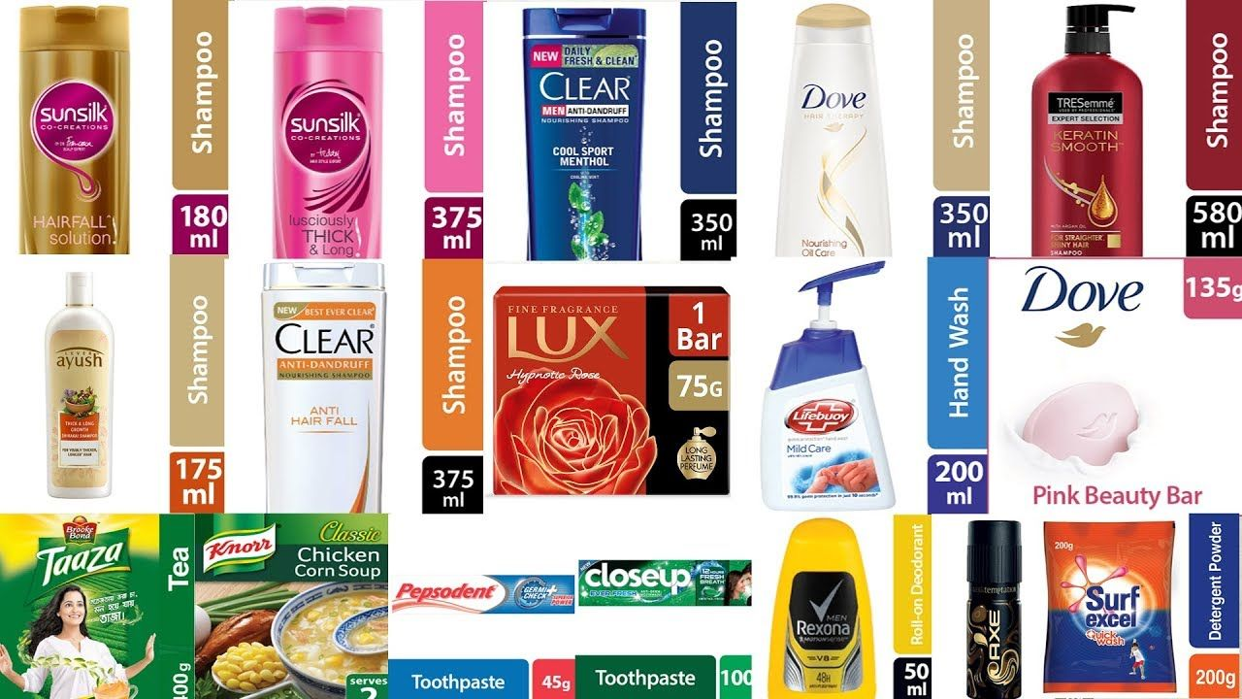
Figure 7: Unilever Brands with Products
Source: Pintrest (2017)
The twelve brands of Unilever among 400 brands leading in the market and satisfying the customer needs for their proper product management. The product function helps Unilever innovate new products to fulfil customer needs (Vorhies and Morgan, 2005). In 2010, Unilever launched its new innovative brands in over ten countries like Dove, Men + Care, Clear Anti Dandruff shampoo. Figure 7 shows that Sunsilk, Clear, All Clear Man, and Dove Shampoo are different brands of Unilever, but all are the same kind of product. Unilever diversified its products so that customer could satisfy their needs by their own choices. In this product or service management, stakeholders, employees, customers, competitors, suppliers, and other communities have a significant impact. According to (Luo and Bhattacharya, 2009), employees play an essential role in producing quality goods and services, and stakeholders help product design. Suppliers supply the raw materials to produce the products on time. Finally, competitors play a significant role as every organisation wants to get more customers by providing quality goods and services than its competitors (Girgenti et al., 2016). Like this way, the product or service management function satisfy customer needs.
The pricing function of marketing functions within an organisation involves setting the product's price, maximising the profit and meeting the customer’s perceived value. According to Best (2006), customers always want to get quality products at affordable prices. This function emphasises how much the price should be of a product so that customers are encouraged to buy it and meet their needs. For example, there are some alternative prices $10, $25 and 45$; the pricing function will help fix the best price, $33.33, so that customers can afford it and maximise the profitability. Unilever uses a flexible pricing strategy so that it can meet customer needs. There are different income level people, those who want to get the product at a lower price. Unilever diversified its products into different brands and sold at different prices to satisfy their needs with their choices. On the pricing function, competitors have a negative and positive impact. When an organisation launches a new product, there is already the same product in the competitors' market (Reza, 2010). Different organisations use different pricing strategies: skim pricing, premium pricing, bundle pricing, competitive pricing, and penetration pricing strategy. Wentzel (2009) explains that Unilever uses a penetration pricing strategy that indicates high quality at low prices. Unilever also uses a competitive pricing strategy to get competitive advantages. For example, Unilever sells its numerous personal care products in Vietnam, but the prices for local people are similar in Australia for people. Though the prices vary, the commensurate satisfy the customer needs.
The placing function enables an organisation to deliver its products to the customer by ensuring quality. According to Haque et al. (2015), The placing function indicates how an organisation makes its products everywhere and distributes them to the consumer market. The placing function facilitates the consumer to get their desired products from nearby shops and stores (Vorhies and Morgan, 2005). Unilever uses its placing function from its broader context and globally. Unilever focuses on a selective distribution strategy and delivers its products to various stores, supermarkets, grocery, and unique shops. The marketing functions of Unilever are included with moving and transferring the ownership of goods and services. The main goal of the placing function is to move the products from the producer to the consumer (Keegan, 2011). The primary places for the distribution channel of Unilever are retailers. For example, the world's biggest and most renowned retailer is Walmart, responsible for delivering the products to the customer. Occasionally, Unilever uses Kiosks to introduce their products to the customers and directly engage with different shops. In this way, consumers are introduced to Unilever products and have many options to get their desired products from nearby shops or supermarkets. Maignan et al. (2005) emphasise that Placing functions enable the customer to choose different brands based on the price, product features, and quality by comparing with other crucial products.
The promotion function is one of the broad and valuable functions among marketing functions within an organisation. Without promotion, an organisation can never reach its targeted customer and increase its sales growth. Promotion includes various tools used to attract customers and make an excellent sustainable relationship with them (Clow, 2013). The promotion tool informs the customers about a new product, new offer and new brand that encourages them to purchase it. Promotion involves advertising the product via television, newspaper, radio, mail, social media and billboards. Advertising helps an organisation reach its targeted customers and inform them about the products (Jawahar and McLaughlin, 2001). Publicity is also part of a promotion that includes news releases, press conferences, special events and regular features on the website. Advertising is the primary step of Unilever to promote its products. They also advertise their products through social media that is now a big platform. Facebook, Instagram, and YouTube users can quickly know Unilever’s new product and differentiate it from other competitors’ products. When Unilever brings out a new product in the market, they use sales promotion that indicates sales coupons and discounts. For example, the Dove soap of Unilever is sometimes offered at a bundle price to encourage the consumer to buy Unilever products. There has an impact of competitors on the promotion function of an organisation. Competitors aggressive promotion sometimes affects the market (Doyle, 2009). The company needs to change its promotion strategy and go for an alternative to ensure better reach. So, the promotion benefits both the company and consumers as the company can reach customers.
In this modern era, automation in the marketing function plays a tremendous job within an organisation. According to Keegan (2011), automation in marketing functions benefits both organisations and consumers. For example, customer can order their products online and get the products by home delivery. This automation in Unilever helps to increase its sales growth and online sales. Customers are now familiar with apps and websites, and also, they are not used to online shopping (Luo and Bhattacharya, 2009). The automaton in marketing function saves money and time, both of which add value to customer relationships. Unilever monitors its marketing function and takes feedback from the customers to improve its service.
The essay aimed to identify the stakeholders within a global marketing environment and their impact on the global marketing functions of an organisation. And also to discuss the various marketing functions of Unilever and how these functions satisfy the customers. So, after the above discussion, it can be said that this essay has been achieved successfully. In this entire essay, there have been identified the stakeholders within a global environment. Stakeholders, employees, customers, creditors and suppliers play very significant roles in the marketing function. In addition, competitors, regulators, other communities, and social media have both positive and negative impacts on the global marketing function. However, as a leading multinational company, Unilever successfully uses its marketing function product, price, place, and promotion. As a result, the use of marketing function in a sustainable way increased its online sales growth by 13.76%, and customers satisfied their needs. So, it can be said that the marketing function within an organisation plays a significant role in satisfying customer needs and increasing the sales growth.
References
Armstrong, G., Adam, S., Denize, S. and Kotler, P. (2014) Principles of Marketing. Pearson Australia.
Maignan, I., Ferrell, O.C. and Ferrell, L. (2005) A Stakeholder Model for Implementing Social Responsibility in Marketing. European journal of marketing.
Keegan, W.J. (2011) Global Marketing Management. Pearson Education India.
Doyle, P. (2009) Value-based marketing: Marketing Strategies for Corporate Growth and Shareholder Value. John Wiley & Sons.
Best, K. (2006) Design Management: Managing Design Strategy, Process and Implementation. AVA Publishing.
Damian, D.E. and Zowghi, D., (2002) September. The Impact of Stakeholders' Geographical Distribution on Managing Requirements in A Multi-Site Organization. In Proceedings IEEE Joint International Conference on Requirements Engineering (pp. 319-328). IEEE.
Payne, A., Ballantyne, D. and Christopher, M., (2005) A Stakeholder Approach to Relationship Marketing Strategy: The Development and Use of the “Six Markets” Model. European Journal of Marketing.
Moorman, C. and Rust, R.T., (1999) The Role of Marketing. Journal Of Marketing, 63(4_suppl1), pp.180-197.
Keegan, W.J. (2011) Global Marketing Management. Pearson Education India.
Girgenti, A., Pacifici, B., Ciappi, A. and Giorgetti, A. (2016) An Axiomatic Design Approach for Customer Satisfaction Through a Lean Start-Up Framework. Procedia CIRP, 53, pp.151-157.
Sajid, S.I., (2016) Social Media And Its Role In Marketing.
Clow, K.E. (2013) Integrated Advertising, Promotion and Marketing Communications, 4/e. Pearson Education India.
Amoako-Prempeh, J. and Akanyijuku, P. (2012) The Impact of Sales Promotion on Consumer Good (A Case Study Of Unilever Ghana Limited). Journal Of Business and Retail Management Research, 3(1).
Reza, M.H., (2010) Marketing Strategy and Sustainable Plan of Unilever.
Haque, S.U., Jahan, Y., Siddique, R., Tasnim, T. and Roy, S. (2015) Marketing Analysis of Unilever. Total Quality Management.
Jawahar, I. M., & McLaughlin, G. L. (2001) Toward A Descriptive Stakeholder Theory: An Organizational Life Cycle Approach. Academy of Management Review, 26(3), 397–414.
Rao, R. K. S., & Bharadwaj, N. (2008) Marketing Initiatives, Expected Cash Flows, And Shareholders’ Wealth. Journal of Marketing, 72(1), 16–26.
Selnes, F., & Sallis, J. (2003) Promoting Relationship Learning. Journal of Marketing, 67(3), 80–95.
Wentzel, D. (2009) The Effect of Employee Behavior on Brand Personality Impressions and Brand Attitudes. Journal of the Academy of Marketing Science, 37(3), 359–374.
Vorhies, D. W., & Morgan, N. A. (2005) Benchmarking Marketing Capabilities for Sustainable Competitive Advantage. Journal of Marketing, 69(1), 80–94.
Madden, T. J., Fehle, F., & Fournier, S. (2006) Brands Matter: An Empirical Demonstration of The Creation of Shareholder Value Through Branding. Journal of the Academy of Marketing Science, 34(2), 224–235.
Luo, X., & Bhattacharya, C. B. (2009) The Debate Over Doing Good: Corporate Social Performance, Strategic Marketing Levers, And Firm-Idiosyncratic Risk. Journal of Marketing, 73 (6), 198–213.
Blueprint (2018) Stakeholders within Global Marketing Environment [Online] Blueprint Available at https://www.theprojectmanagementblueprint.com/blog/stakeholder-management/definition-of-stakeholder [Accessed on November 11, 2021]
Prezi (2013) Global Marketing Functions [Online] Prezi Available at https://prezi.com/ddilt_bswcq3/unit-5-functions-of-international-marketing/ [Accessed on November 11, 2021]
Science Direct (2005) Shareholders Impact on Global Marketing Function [Online] Science Direct Available at https://www.sciencedirect.com/science/article/abs/pii/S014829630300136X [Accessed on November 12, 2021]
Quizlet (2021) The Role of Employees on Global Marketing Function [Online] Quizlet Available at https://quizlet.com/292441314/employee-roles-in-service-delivery-flash-cards/ [Accessed on November 12, 2021]
Science Direct (2021) The impact of new product launch Strategy on Competitive Reaction [Online] Science Direct Available at https://www.sciencedirect.com/science/article/abs/pii/S0737678201001357 [Accessed on November 11, 2021]
Pintrest (2017) Unilever Brands with Products [Online] Pinterest Available at https://www.pinterest.com/ideas/beauty/935541271955/ [Accessed on November 11, 2021]

