Melodic, Sensation, Recital.

Student Name: Lucy Woodrow-Johnstone
P Number: 1800315
Programme of Study: Fine Art Studio, Site and Context
Module: ADAD5004
Tutor Name: Alexander Duncan
Word Count: 2,465

Proposed question for Independent Inquiry

“Does performance art change the narrative and perception due to the audience’s involvement and the artist’s reflection?”

Melodic, Sensation, Recital.

“When I was a little girl, I remember standing, letting waves run over my scrapes. Mama said saltwater heals. And everything that pours, from your body’s releasing, is saltwater. And everything that heals creates saltwater. And everything that breaks us makes us saltwater” (Wiest, 2020).

From a young age, the awareness of loss was always apparent to me, I always knew about heartache and suffering without any explanation, it was natural. I always found insecurity in myself. I began to question whether performance was the right path as I was always insecure and anxious in front of others. I never figured out whether that was due to my awareness of heartache and did not want to face a situation similar again, or whether I didn’t have the right support. My practice is a collaboration of different emotions, actions and moments. Expressing numerous variations of my life in one performance. I find myself falling for the stains left on my skin once the performance is complete and the excess paint has been removed. The markings left on the performance platform and the body that was used creates a nostalgia that my practice craves.

Melodic

Music is important to me; it is something that controls my emotions and actions. When I was a child, I lived with my father, stepmother and half-sister. I would be locked in my room for numerous hours, hearing various music and laughter from downstairs. I grew up in a negative environment fully aware of how positive music can be. Being denied so much enjoyment at the beginning of my life, makes me so passionate and so inspired by it today.

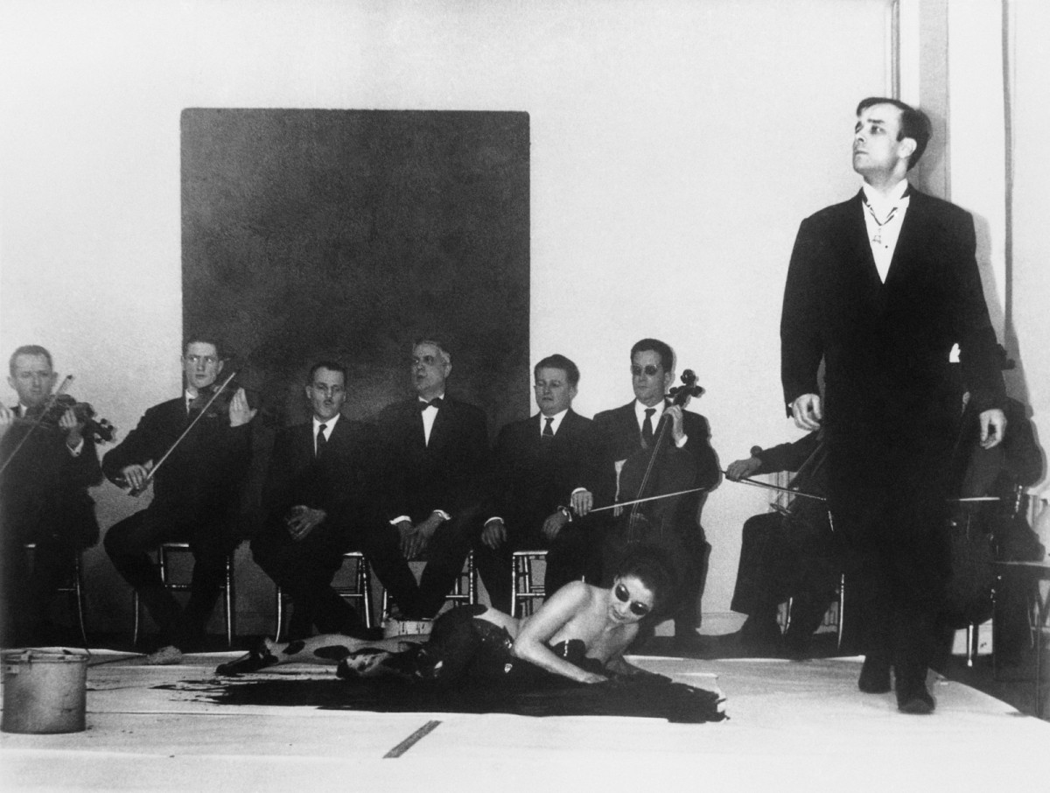
“Anthropometry of the Blue Period” (1960, Klein)

“Anthropometry of the Blue Period” is a performance from Yves Klein that inspired my practice. The inclusion of the female body, music and audience changed perceptions of performance art. During this performance we are introduced to three female models, or “living paintbrushes” (MoMA, 2008) was the terminology he preferred. I became curious of the audiences understanding of the performance. How they were feeling during this performance, whether they were aware of how important this piece will turn out to be.

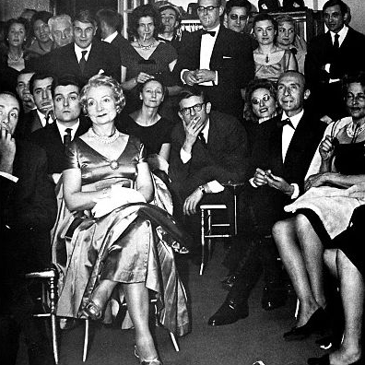
Image of the Audience during Yves Klein “Anthropometry of the Blue Period”

Looking further into this one performance, I was invested in the orchestra and Klein’s involvement with the music. Throughout the process of researching Klein and his practice, I learnt that Klein was creating symphonies at an early age. “While the monochrome floods us with its silence… radiance… Yves Klein’s Symphony plunges us into its own resonance.” (Prot, 2012). My practice highlights the importance of music and the importance it has.

I have a passion for rock music, and it empowers my practice, growing up I’d listen to Queen continuously. I always admired the passion and love they presented on stage and excitement my mother gained from them. Listening to Queen during my practice allows me to open up emotionally and physically, spending numerous amounts of minuets on a performance, I find connections to the lyrics and what they mean to myself, my story and my performance.

The band Queen on stage 1970

“Who Wants to Live Forever” (Queen, 1986) was played at my mother’s funeral, it is an emotional song for my family and it’s a song that I plan on bringing into my practice. “Dancing with Dad” (2003) by Jaan Toomik is a piece that demonstrates the loss of a parent with a connection of music. “It is a symbolic dance with my father who died in 1971 when I was 9 years old. In reality I never had the chance to dance with him” (Toomik, 2003).

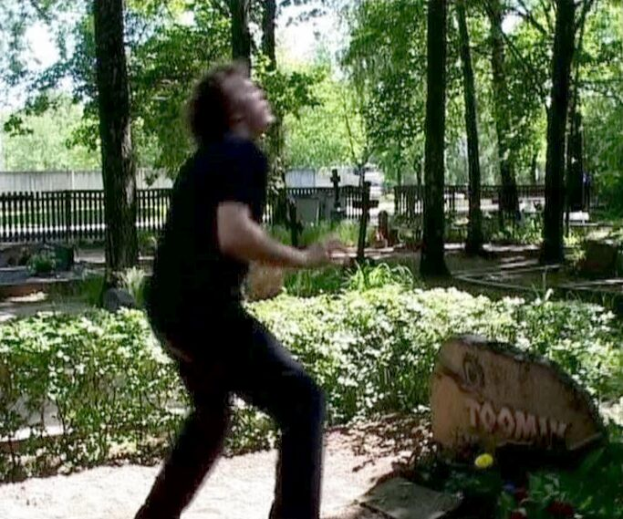
“Dancing with Dad”
(Toomik, 2003)

My practice and my story have a personal connection with Toomik’s piece, this connection is the biggest and the most aware of all performance pieces. Dedicating a performance to music and family is a relation both myself and Toomik have. Bringing my story and music into my performances creates a moment of nostalgia. Knowing my performances have and will be dedicated to music and my family, I plan on masking in beautiful movements and actions.

Music has changed my perspective on almost everything. It is important to bring music in my practice, as it is a major part of my story. I get lost in music, it heavily influences my emotions and actions, music can take over my mindset, change my ideas and make me question what is important. Music has created a relationship with someone who I only knew for a few months but think of every time I listen to a certain band, having that power to remind people of different moments, is incredibly important to my practice.

Sensation

Sensation is presented in my practice both physically and emotionally. The motion of undressing, the application of paint, the echoing of music bouncing off the walls. A collaboration of numerous memories and experiences all coming to light in the space of an eight-minute performance. Having numerous sensations during a performance, questions the existence of those sensations and how they can be seen as a performative gesture.

“[Feeling vulnerable] makes you face the experience fully and almost embrace it. Those moments can bring a lot of creativity and make ideas flourish” (Willer, 2018). When I start a performance, I get undressed. I become nervous, vulnerable and ashamed. Having an individual present, changes the perspective and my mindset, I start to become aware of what is happening and how it is changing someone’s opinion of me. In that moment I become ashamed of the way I look without certain barriers. I am almost stripped of an identity anyone outside of an intimate relationship is aware of.

Being aware that I am vulnerable and ashamed I start to wonder how individuals who present themselves as female are proud of their nude body. I panic as I am ashamed of who I am without my barriers, I begin to find flaws in myself that I am aware of but have tried to ignore. During a nude performance, I question why I am ashamed, my nude body is no different to the audience, but as I am vulnerable, I begin to remember aspects where I have been humiliated because my body. “Female sexuality is socially, culturally, politically, and economically debased in patriarchal society – even while seemingly worshipped aesthetically” (Schneider, 1997).

While I am experiencing numerous memories of where my body has let me down, I realise that it’s not only my body, but my story. I don’t enjoy sympathy and I don’t enjoy sorrow; I find discussing numerous situations of my life difficult, not because they’re hard to talk about, but because of the reaction. The discussion of my story has led to sympathy and aggression, a spectrum raging from an apology to being told that I need to get over it she’s dead move on. During a nude performance physically and emotionally I am faced with challenges, I am vulnerable.

A discussion about numerous outcomes appear in my practice and questioned the idea of the literal. Having an image and a description can change the viewers emotion and reality, but that can be temporary as something more shocking will come along. Discovering story telling began in my practice, how an individual can emotionally stick to a piece without it being literal.
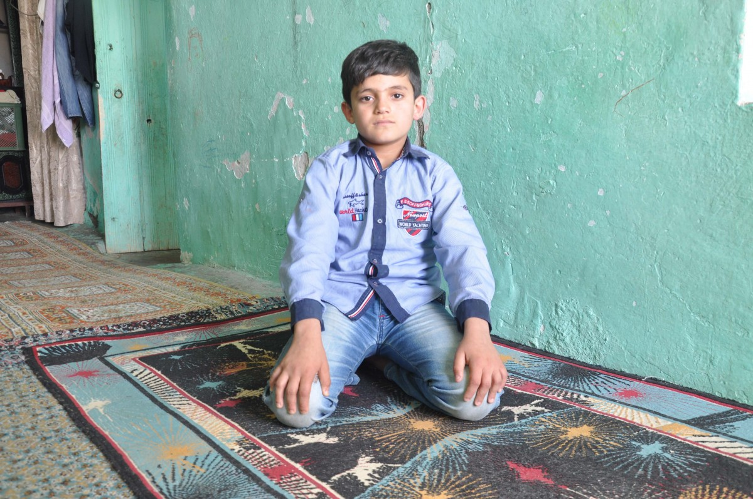
“Wonderland” (Ozgen, 2016)

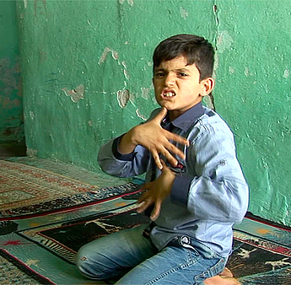
“Wonderland” (Ozgen, 2016)

“His performance electrocutes us. It leaves us viewers alone with our bare senses, puts us in the middle of a deep questioning on humanity” (Özgen, 2016). Wonderland is a performance piece that creates a moment dedicated to trauma. An awareness of struggle and torment, this performance is presenting vulnerability and despair through movements and personal interpretations. Viewing this performance, I start to question the impact it has on certain individuals. The variety of different cultures, numerous moments in one singular lifetime, how this singular performance has affected their lifestyle.

This performance piece questioned the literal. Having a performance film discussing traumatic experiences through movements and gestures is incredibly unique. “Wonderland” has brought a new perspective into my practice, changing my idea of the literal and what should be presented during a performance and what should be interpreted through dialogue. Understanding this particular performance changed the audience’s perspective, being aware of how unnecessary the literal is and realising how affective a story can be giving this piece a new meaning and perspective.

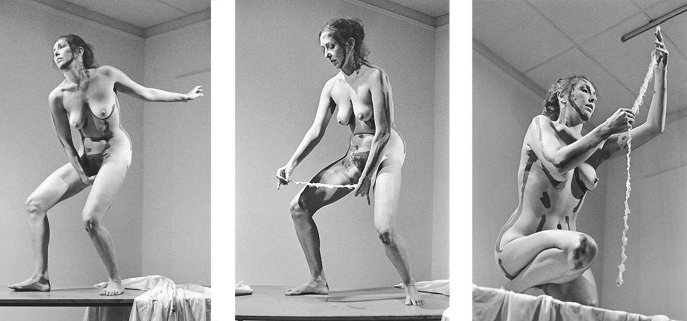
During numerous performances, certain aspects of my work is determined on what I am listening to. Performing to songs that have been a part of my life changes the effect it presents on me, both physically and emotionally. Through my movements it become apparent that I am pushing my performance to a new extreme.

“Interior Scroll” (Schneemann, 1975)
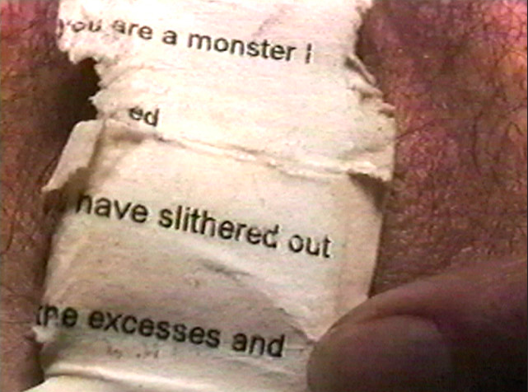
“Interior Scroll” (Schneemann, 1975)

“I can make something taboo so formally compelling the taboo becomes the after-effect, that makes it much more powerful” (Schneemann, n.d.). This performance piece has empowered my practice, it is a piece that has dedicated the physically aspect of my work. Performing under new emotions and new physically attributions, “Interior Scroll” questioned my performance and questioned whether I want to present a literal piece. Above has featured two pieces both discussing the literal and whether it’s important to feature bold statements.

Recital

My practice has always revolved around the body, memory and existence. At the beginning I found my practice was based around the audience’s opinion and their viewpoint of art and what pleased them. As my practice grew, I started to realise my desire for creating has vanished, I needed something new. A collaboration of blue paint, a plastic bag and music, caused a catastrophe of motions and actions changing my own perspective and observations of performance art.

Recently my practice has turned into a full body performance, what was once hands and arms, has turned into breasts and hips. Creating numerous pieces with just my hands and arms, became something I was proud of, the stains that were left my hands and clothes after one performance originated a thought about the rest of my body, leaving me to wonder whether I could go further. Pushing my own limitation’s and my own recognitions or my practice, I started to become aware of my body.

An appreciation for performance art, especially nude performative actions become aware when I found numerous pieces from Marina Abramović, Yves Klein, Deborah de Robertis, Tania Bruguera, Valie Export, Ana Mendieta and Leigh Bowery. A connection of importance and absurdity defined the idea that performance art is a collaboration of numerous ideas, aspects and stories.

As I started performing in the nude, I realised that my nude body was no longer hidden. It began to be clear that I decided what I could show to the viewer, I was in control of what I wanted to present and what to create. A recent thought of sextortion came to mind during a performance and how individual’s use the nude as a form of blackmail, but my practice always me, as the artist to decide what is put on display, I get to decide what the audience gets to see, which is empowering. My body is no longer a secret, the audience can see what my shape is and although I’m ashamed of my body, I appreciate how my body is acknowledged on certain mediums.
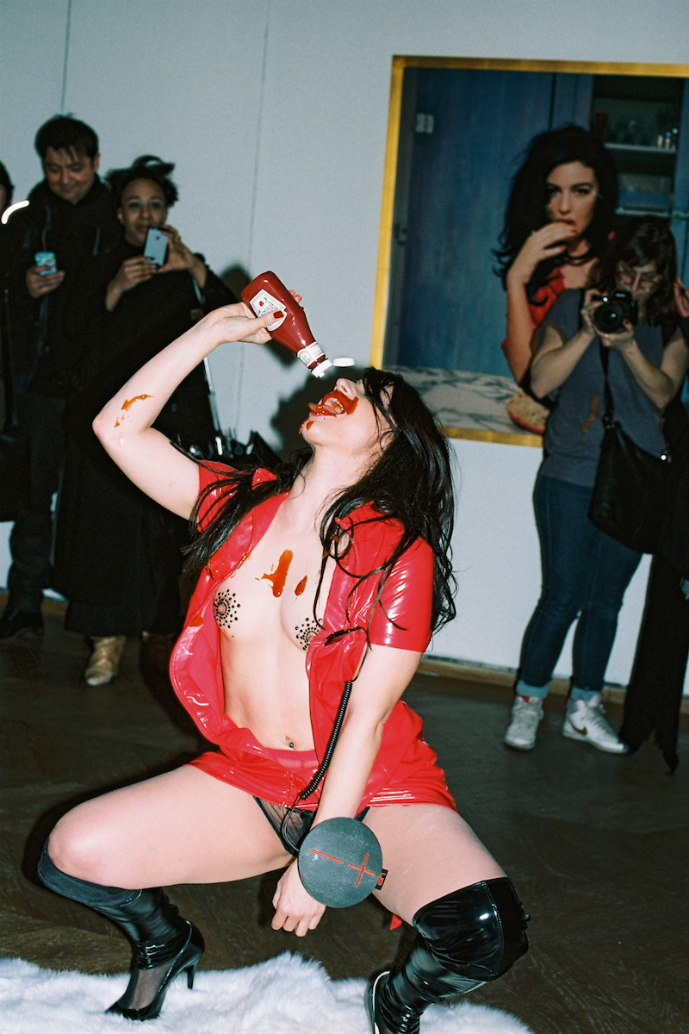
“Deborah de Robertis recreating a Bettina Rheims photograph of Monica Belucci at the Maison Européenne de la Photographie” (Robertis, 2016).

“When I exhibit my body, it’s not a private body anymore but a public body that reproduces a scene. My nudity is seen through the context of creation and image. I want my actions to be judged in the light of my work, my films, and my performances as an artist, whether I am naked or not” (Othen, 2016). This performance piece is bold and extreme, constructing activism in performance leading to the artists arrest. Throughout her practice de Robertis has exhibited her nude body, demonstrating the idea that her own nude can be portrayed as masterpieces.
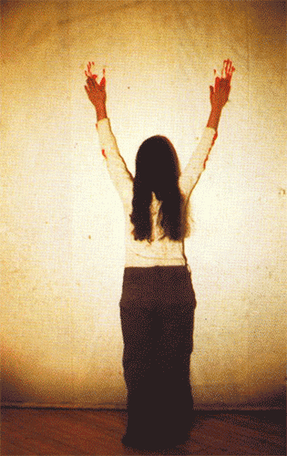
“Body Tracks” (Mendieta, 1982)

Ana Mendieta’s practice shares a context dedicated to feminist art practices of a certain time. “Body Tracks” is a performance film, presenting Mendieta leaving traces of blood dragged from her forearms, creating a downward motion. Once Mendieta has performed and stepped away from the medium, we are presented with marks created by the body, which reconstructed into text. Mendieta has a close connection to my practice as she has fought for women’s rights through her practice, pieces such as “Rape Scene” (1973) and “Untitled (Self-Portrait with Blood)” (1973).

“Her bodily presence demands the recognition of a subject as she makes visible the violent images that contribute to woman’s subjugation.” (Sesana, 2015). Recently my practice has been focused around the colour red, symbolising the body and my presence. Red is viewed as a violent colour and can be bold in an unspoken terminology. I believe my practice where it is at does not fall under a violent category due to colour.
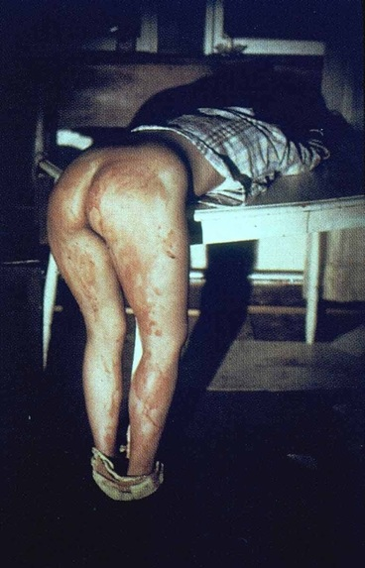
“Rape Scene” (Mendieta, 1973)

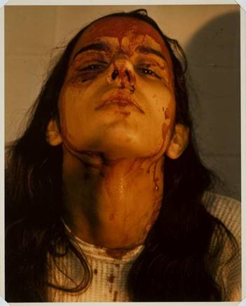
“Untitled (Self-Portrait with Blood)” (Mendieta, 1973)

Performative situations that depict traumatic experiences from a female perspective, in both pieces I have highlighted, it is very clearly an awareness of distress and upset. In relation to my practice, I have found myself in a vulnerable state, which brings an aspect of her work into my practice. “Rape Scene” is a piece displaying a woman who has been bent over, stripped from the waist and stained in blood. This performance was a dedicated action response to the rape and murder of Sara Ann Otten and student nurse. This piece was performed in front of an audience of individual’s she knew. Creating a moment which caused her to think about the situation and understand the impact it has taken on her as an artist and a female.

Conclusion

I find myself attracted to numerous words dedicated to my practice and narrowing them down to three words was difficult. Melodic, Sensation and Recital are words that best describe what my practice is about. My proposed question is, ‘Does performance art change the narrative and perception due to the audience’s involvement and the artist’s reflection?’. This question may be a starting point for the Independent Enquiry, as it may lead onto new questions that explore performance art, music, sensation and numerous moments. Has the notion of the female body been categorised into one factor changed the audience’s opinion, questioning the usage of the female body and the idea of the nude?

Understanding the use of the body, the story, the sounds, the application, the movement, changes a thought process of what my practice is. Thinking of numerous issues and tragedies in my story, changes my reality of performance art and what I expect from my practice.

Bibliography

Özgen, E. (2016). Front. Retrieved from Frontart: https://frontart.org/artists/erkan-ozgen/
Banai, N. (2005). Colour After Klein: Re-thinking Colour in Modern and Contemporary Art. Black Dog Publishing.
Goldberg, R. (2004). Performance Live Art Since the 60s. Thames & Hudson .
Koddenberg, M. (2016). Yves Klein: In/Out Studio. Acc Art Books.
McDonald, H. (2000). Erotic Ambiguites: The Female Nude in Art. Routledge.
Nead, L. (1992). The Female Nude: Art, Obscenity and Sexuality. Routledge.
Othen, S. (2016, December 14). Nude Performance Artist Deborag de robertis Defends Herself in French. Retrieved from Artistswork: http://artistswork.uk/nude-performance-artist-deborah-de-robertis-defends-herself-in-french-court/
Peyton-Jones, J. (2014). Marina Abramović: 512 Hourse. Verlag der Buchhandlung Walther Konig.
Prot, P. F. (2012). Monotone-Silence Symphony. Retrieved from Yves Klein: http://www.yvesklein.com/en/articles/view/3/monotone-silence-symphony/
Richards, M. (2009). Marina Abramović (Routledge Performance Practitioners). Routledge .
Schneemann, C. (n.d.). Carlee Schneemann (American, 1939-2019). Retrieved from Artnet: http://www.artnet.com/artists/carolee-schneemann/
Schneider, R. (1997). The Explicit Body in Performance . Routledge .
Sesana, M. (2015, May 16). Violence and the Body in Ana Mendieta and Chris Burden. Retrieved from Reusing Old Graves: http://reusingoldgraves.weebly.com/melissa-sesana/violence-and-the-body-in-ana-mendieta-and-chris-burden
Song, M. (1984). Art Theories of Charles Blanc, 1813-1882. UMI Research Press, U.S.
Toomik, J. (2003). Jaan Toomik Dancing with Dad 2003. Retrieved from Temnikova & Kasela: http://temnikova.ee/?c=gallery-artists&l=en&t=jaan-toomik&id=2&view=pics&pic=220
Vergine, L. (2000). Body Art and Performance: The Body as Language . Skira Editore.
Wetemeier, H. (2016). Yves Klein. Taschen Deutschland GmbH.
Wiest, B. (2020). Salt Water. Though Catalog Books.
Willer, M. (2018, February 20). It's Nice That. Retrieved from Its nice that: https://www.itsnicethat.com/features/creativity-vulnerability-brene-brown-marina-willer-advice-200218
Yves Klein Anthropometry: Princess Helena 1960. (2008). Retrieved from MoMA: https://www.moma.org/collection/works/80530

Figures

Figure 1 - “Anthropometry of the Blue Period” (1960, Klein)
Source - http://www.yvesklein.com/en/articles/view/3/monotone-silence-symphony/

Figure 2 - Image of the Audience during Yves Klein “Anthropometry of the Blue Period” (1960)
Source - https://www.pinterest.co.uk/pin/322992604495746849/

Figure 3 - The Band Queen on Stage

Source - https://www.bbc.co.uk/programmes/b09d5xpf

Figure 4 - “Dancing with Dad” (Toomik, 2003)
Source - http://temnikova.ee/?c=gallery-artists&l=en&t=jaan-toomik&id=2&view=pics&pic=220

Figure 4 - “Wonderland” (Ozgen, 2016)
Source - https://frontart.org/artists/erkan-ozgen/

Figure 5 - “Wonderland” (Ozgen, 2016)
Source - https://universes.art/en/specials/zilberman-gallery/the-red-gaze/erkan-ozgen

Figure 6 - “Interior Scroll” (Schneemann, 1975)
Source - https://fineartmultiple.com/blog/carolee-schneemann-interior-scroll-masterpiece/

Figure 7 - “Interior Scroll” (Schneemann, 1975)

Source - https://iffr.com/en/2020/films/interior-scroll

Figure 8 - “Deborah de Robertis recreating a Bettina Rheims photograph of Monica Belucci at the Maison Européenne de la Photographie” (Robertis, 2016).
Source - https://www.vice.com/en_us/article/3dxg35/stripping-naked-and-squirting-ketchup-on-tits-with-a-nude-performance-artist

Figure 9 - “Body Tracks” (Mendieta, 1982)

Source - https://influx.themissive.com/post/67190115938/ana-mendieta

Figure 10 - “Rape Scene” (Mendieta, 1973)
Source - http://reusingoldgraves.weebly.com/melissa-sesana/violence-and-the-body-in-ana-mendieta-and-chris-burden

Figure 11 - “Untitled (Self-Portrait with Blood)” (Mendieta, 1973)

Source - http://reusingoldgraves.weebly.com/melissa-sesana/violence-and-the-body-in-ana-mendieta-and-chris-burden

