TASK 2-PORTOFOLIO OF WORK

BMSW 4005 Student Name: Sanda Bogdan Student ID:2108537
  - Certificate in High education skills for the Workplace Professional and Career development

Table of Contents:

Job Advert __________________________________________________________________ Page 02
Cover Letter_________________________________________________________________ Page 03
CV ________________________________________________________________________ Page 04
References _________________________________________________________________ Page 05
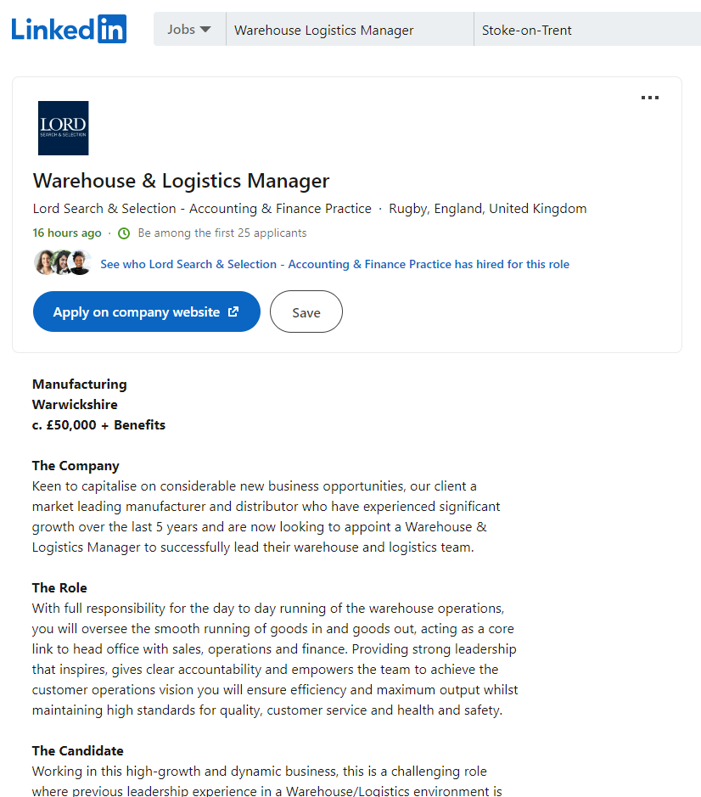

(Practice, 2022)
13/06/2022
Crown House,
The Square, Alvechurch,
Birmingham B48 7LA
Lord Search And Selection Company

Ref: Lord Search And Selection-Warehouse and Logistic Manager

Dear hiring office,
According with the LinkedIn advert of the role for Operational Warehouse manager I am as an experienced Manager working in a fast grow dynamic operational warehouse at DHL Sainsbury’s and in poses of demand skills and skills for work placement certificate, a fit candidate for this position. At my current job I been always ready for challenges, good in building strong relationships with the customers, focus on business grow and team development. My decision of applying to the Lord Search And Selection company to become an operational manager is due to the opportunity to work in a grow successful company where I will enjoy and be able to develop myself and contribute for further growing company in the excitement of the company fast grow dynamic.
Also I want to thank you for this job opportunity and I am wait to hear from you soon.

Kind Regards,
Sanda Bogdan
Sanda Bogdan
Work Experience:
DHL Sainsbury’s Daventry FLT Department Manager 2021-Current

DHL Sainsbury’s Daventry FLT Department operational Support Manager 2020-Current
My role of operational support manager I had to help the manager to complete the daily task at the FLT department. Some of the task constitute in sharing the operational task to the FLT drivers, helping in solving operational problems and in completing the team enquiries.
DHL Sainsbury’s Daventry Warehouse Operative 2018-2020
While I was working as a warehouse operative I had been trained in order to help to the operational duties on the following operational machines : rich truck; ppt; llop.
Tesco Grocery Daventry Warehouse Operative 2016-2018
At this job my role was as a Rich Truck driver, my daily tasks was to loading and unloading the racks, help the Good in department, work with conveyers and move items to different locations.
Skills:
Interpersonal skills Management skills
Problem solving Business Skills
Decision Making M.S. Office
Organization and planning Strategic Thinking
Time management Teamwork skills
Certified with skills for work placement, and experience of two years in the management industry for warehouses shop floor and one year of operational support at Sainsbury’s DHL Daventry, I am focus on developing new ideas and leading high impact projects for the company. I poses strong Management skills and always ready to for challenges.
10 Sandy Lane, Rugby UK, CV21 2UR
 07477255415
 sandabogdan89@gmail.com

Qualifications:
Certificate of higher education skills for workplace and health and social care at University of Wales Trinity Saint David (2021-2023 United Kingdom)
SCF Training rich Truck Licence SCF Training counter balance Truck Licence
SCF Training PPT Truck Licence SCF Training LLOP Truck Licence

References
Practice, L. S. &. S. -. A. &. F., 2022. Warehouse & Logistics Manager. [Online]
Available at: https://uk.linkedin.com/jobs/view/warehouse-logistics-manager-at-lord-search-selection-accounting-finance-practice-3124792580?utm_campaign=google_jobs_apply&utm_source=google_jobs_apply&utm_medium=organic
[Accessed 08 06 2022].

