Daniel Bridgewater
2218703
Generating a program for a specified embedded requirement in C
ACDA4013 (2024)
Contents
Introduction 1
Designing the Software 2
Testing the Software 2
High-level System Flowcharts 4
Conclusion 6
References 6

Introduction
This report aims to document my work on developing software in C for an embedded system while adhering to some behaviour requirements. The system in question is a PIC 18F45K50 microcontroller connected to a bespoke circuit designed by the client, which consists of a 4-position rotary switch, potentiometer, push button, 8 Light Emitting Diodes, a DC motor drivable in both directions, a 4x20 character Liquid Crystal Display, and an RS232 serial terminal (Henceforth referred to as the Virtual Terminal, as the circuit is running in simulation). All components are connected to the PIC microcontroller, which is responsible for coordinating their behaviour.
In brief, these are the requirements:
- Turning the SW1 rotary switch must change the microcontroller’s behaviour to one of the 4 modes as follows:
- Mode A must display the rotation of the potentiometer on a scale of 0-255 on the LEDs in binary, the LCD, and the Virtual Terminal.
- Mode B must spin the motor anti-clockwise if the potentiometer reads less than 75, clockwise if it reads greater than 175, otherwise the motor must stop. The rotation must also be displayed on the LCD.
- Mode C must animate the 8 LEDs in a back-and-forth pattern
- Mode D must spin the motor only when the Button pressed and show the button state on the LCD and Virtual Terminal.
I used a top-down approach to writing the software, where I first studied the requirements to create high-level flowcharts describing the sequence of operation required. This separated the challenge of designing a good system from the challenge of implementing it in C.
The requirements were well-written, leaving absolutely no room for ambiguity regarding the desired behaviour, allowing me to focus primarily on implementing the requested features. Had this not been the case, I would have conversed with the client to ask for clarification on any uncertain points.
Then I used these flowcharts to guide writing the software, which helped ensure it would behave as required. Once I had written the software according to the flowcharts and made sure it conformed to the GNU indentation style to aid readability, I tested it thoroughly. Some mistakes and oversights were discovered, which manifested as incorrect behaviour. I corrected these mistakes, and the software now adheres to all the requirements.

Designing the Software
After reading the requirements, I observed that SW1 determines how the device behaves as there are 4 unique modes of operation, all independent from each other. After first designing the software at a high-level using flowcharts, I built the code around this fact by sectioning each mode off into a subroutine, with the main function continually checking if SW1 has changed. By splitting the code into logical groups, it was much easier to read and reason about than it otherwise would have been.
In general, global variables are bad practice as they can quickly lead to obtuse code and confusing issues which are often hard to troubleshoot. The use of global variables in this project is kept to a minimum by only using them for retaining data when a subroutine ends and using locally scoped variables in all other cases. This also ends up reducing RAM usage since the compiler is smart enough to allocate variables with different scopes into the same memory space when it’s impossible for both to simultaneously contain data. For example, the space used for the pot variable in mode_b() gets safely re-used when mode_c() allocates its mesg[] buffer.
Per the requirements, three of the modes send text to both the LCD and the RS232 serial terminal, but it would be wasteful to duplicate the text in the ROM storage for each printf call. Additionally, Mode A requires using a string format, which ideally should only be performed once as decimal conversions are computationally expensive. The solution to both these problems is using a small string buffer in RAM to temporarily hold the text while it’s being sent to the LCD/serial. Additionally, the string is not duplicated in the source, making the code easier to modify.
Mode C requires animating the LED strip to bounce a single light back and forth. While this could be implemented with arrays, that approach is only strictly necessary when the pattern is random. Instead, I noticed only one LED would be on at once and the light would “move” into the adjacent LED. There are bit-wise shift operators in C and direct translations for these operations in the architecture of most microprocessors, including the PIC[1, Table 24-2] used in this project.

Testing the Software
After following my flowchart to write the software, I systematically tested each future to ensure it behaved as expected, fixing any logic errors I found. This consisted of adjusting the inputs to the PIC chip with as many permutations as possible, such as adjusting the potentiometer to observe appropriate changes on the LCD and Virtual Terminal.
One such logic error I discovered was how Mode D would fail to update the LCD and Virtual Terminal displays after another mode was used, illustrated in Figure 1. This was because edge detection is used to only refresh the displays when the button changes state, which is tracked using the btn_previous global variable. This variable is initially set to 0xff, so the displays are guaranteed to update the first time, but I’d overlooked that this trick only works once. Similar mistakes are a common consequence of global variables, which is why they should be used sparingly. The solution was simply to reset btn_previous to 0xff in main() when the mode changes, on line 33 of main.c.
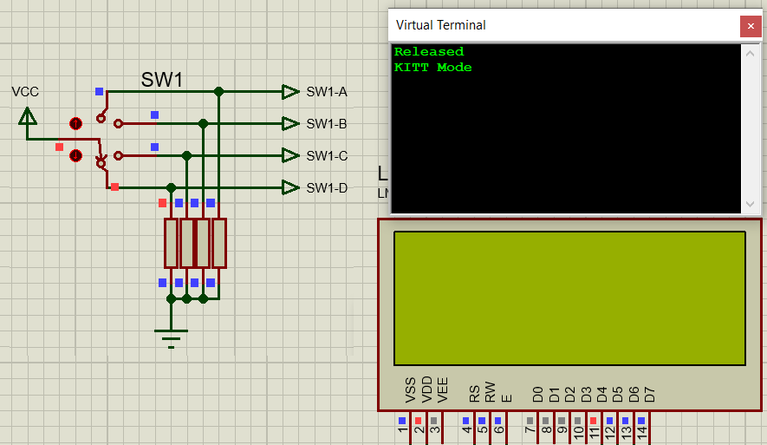
Figure 1: Mode D failure state after SW1 is moved from position D to C, then back to D

Another mistake I discovered was in Modes B and D, where some letters would remain on the LCD when the text was changed. This was because the new text could be shorter than what it was replacing, so the last letters would not be overwritten, such as in Figure 2(A) where “CW” has not removed the last two letters in “STOP”, malforming into “CWOP”. I considered if it would be practical to use the \f control character to first clear the screen, but it would flicker unless I also added logic to only clear the screen when the text changes. Since the user’s experience would be compromised by any amount of flickering, I decided to make all overlapping strings the same length by padding the ends with spaces, see Figure 2(B) and line 103 in main.c.
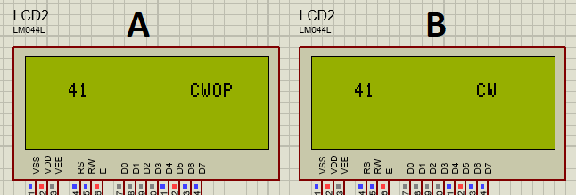
Figure 2: Comparison of outputs without padding (A) and with padding (B)
A similar issue occurred whenever numeric values were displayed, as the length is variable (e.g. changing from 100 to 99 would incorrectly display as 199). The values are 8 bit and can range from 0-255, so the maximum length of a number is 3 digits, which can be communicated to the printf function using the format specifier "%3u". As explained by [2, Sec. B1.2], adding a number before the conversion character specifies the minimum field width and will insert whitespace padding to meet this width.

High-level System Flowcharts
To distinguish between types of actions and make the flowchart easier to read, I have used informal symbols for the Display Text and Delay operations. A legend is included to list all symbol meanings.
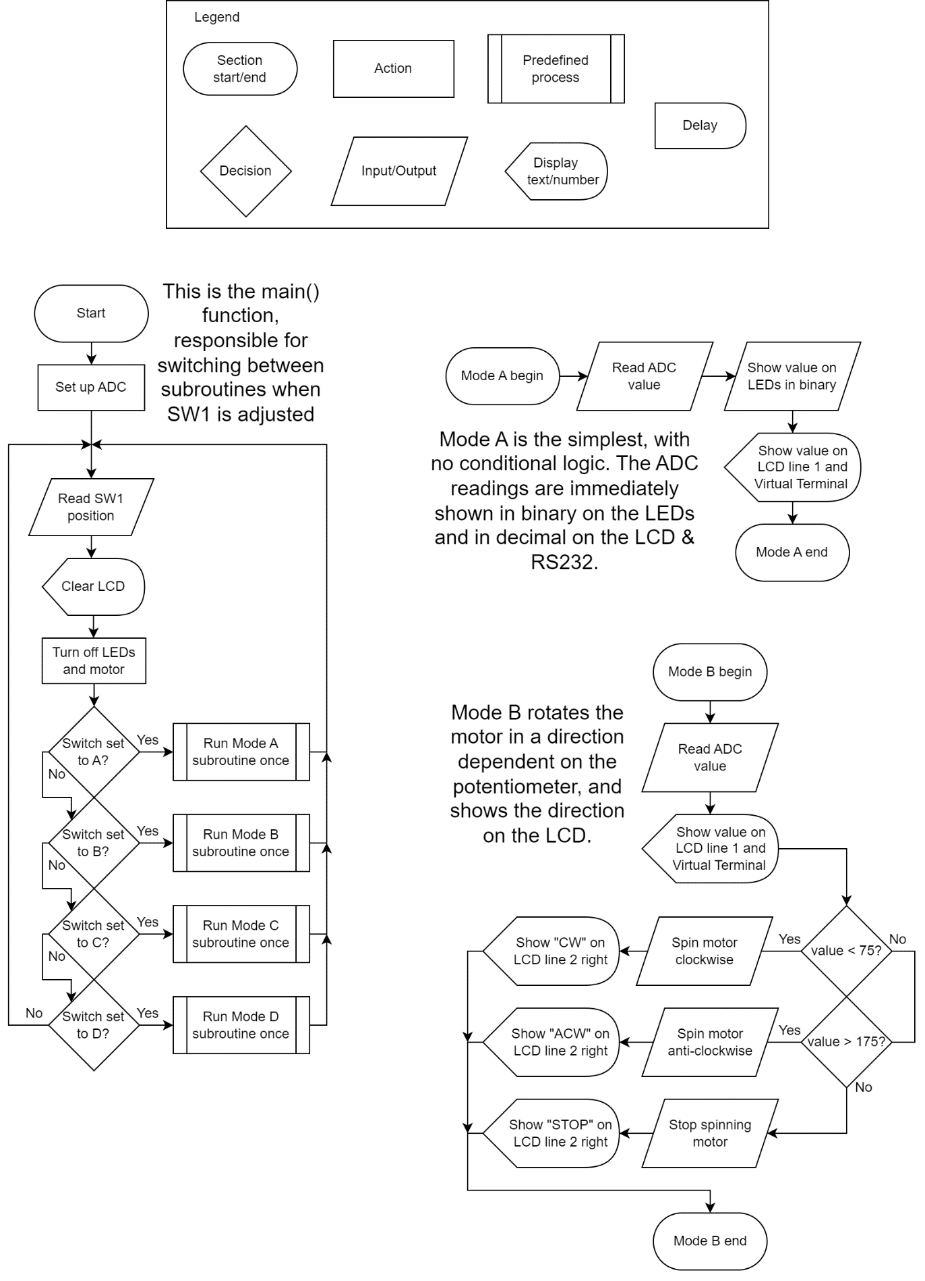
Figure 3: Flowcharts for main(), mode_a(), and mode_b()
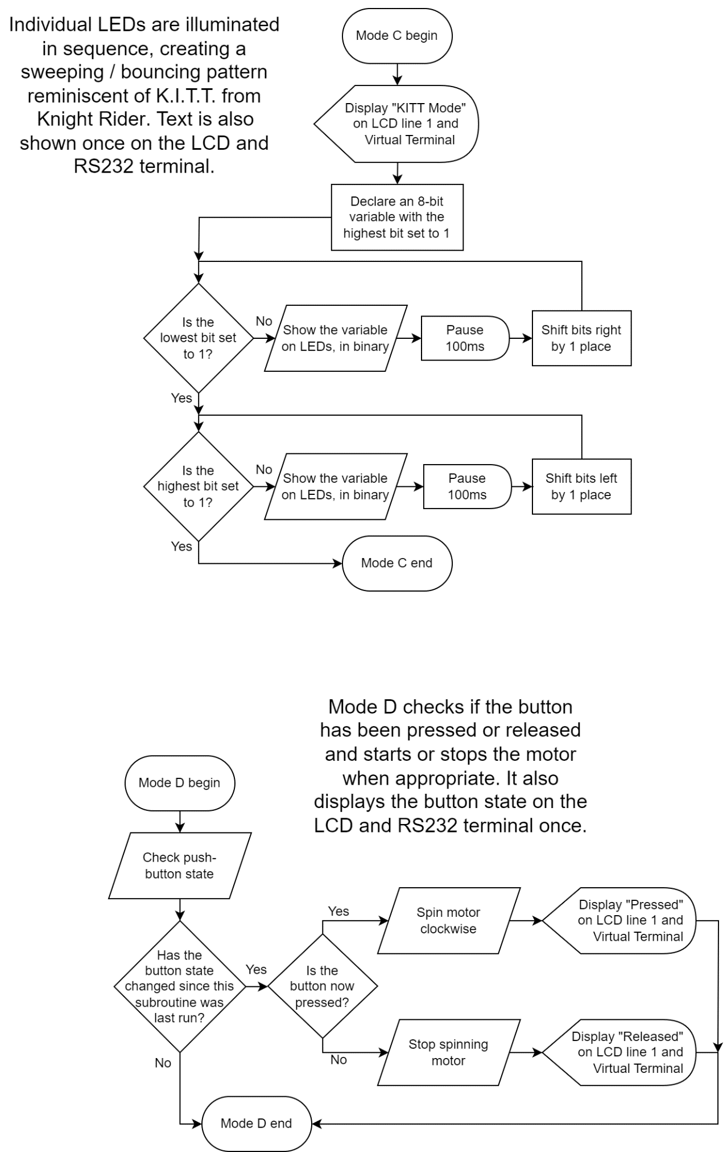
Figure 4: Flowcharts for mode_c() and mode_d()

Conclusion
Using a top-down approach, I successfully implemented every desired feature stated in the requirements while taking appropriate measures to ensure the software runs efficiently, and I have rigorously tested the system to ensure there are no behaviour errors.
This module has taught me how to design and create an embedded software solution according to a client’s requirements by following the top-down principles such first taking time to create logical flowchart diagrams so I could be sure I understood the requirements. Additionally, it taught me how to write software in a manner which is concise, readable, and well-documented with comments explaining why operations are happening along with how they achieve the desired effect.

References
[1] | Microchip, “28/40/44-Pin Flash Microcontrollers with XLP Technology,”  PIC18F45K20 Datasheet, Jun. 2006 [revised Jul. 2015]  https://ww1.microchip.com/downloads/aemDocuments/documents/OTH/ProductDocuments/DataSheets/40001303H.pdf  Accessed: 4th April 2024 @ 14:28
[2] | B. W. Kernighan and D. M. Ritchie, The C Programming Language: 2nd ed,  Englewood Cliffs, N.J.: Prentice-Hall, 1978, p. 243

