 | Student No: | Diana Elena Radu
 | Module Title: | Operation Hotel Facilities
 | Module Code: | BMIH4006
 | Lecturer: | Natalie Brailsford
Placement opportunities provide support to learners in improving their knowledge and skills by experiencing the pressure of responsibilities in the workplace to improve the professional mindset of learners. In the process of my recent hotel placement, I had to spend two weeks in the department of housekeeping which helped me to develop my practical experience and my knowledge about business operations and the changing demands of customers. I have considered Gibb’s Reflective Cycle Model to present my experience in the journal entry.
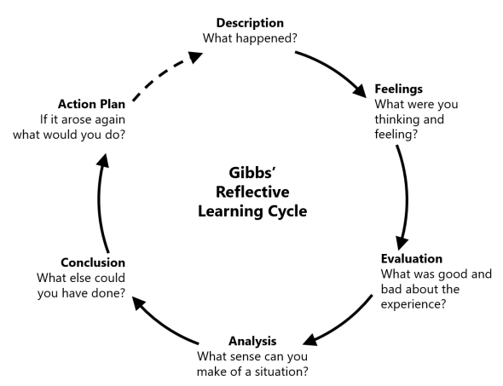
Figure: Gibb’s Reflective Cycle Model
(Source: Harithuddin, 2021)
- Description: In the process of placement, I was responsible for cleaning hotel rooms and public places on the hotel premises as a worker in the housekeeping department. My major responsibilities were changing linens, cleaning bathrooms, crash management and vacuuming as well as stock management for room supplies (Gordon et al., 2019). In this process, I have understood that the department focuses on the demands of customers, quick response, and tight deadlines. I have received training from my supervisor about cleaning procedures and understanding the demands of customers for effective room services as well as improved my teamwork skills with housekeepers to ensure the cleanliness of rooms.
- Feeling: At first, I was very excited by the demanding responsibility for cleanliness in hotel services and I was ready to put my efforts into accomplishing my responsibilities. I have focused on learning different techniques for cleaning hotel rooms and maintaining my efficiency in making every room spotless. I also learnt about behind-the-scenes work in this department to keep customers satisfied and make rooms presentable for them. I developed communication with my senior team members to overcome my professional issues and present my capabilities to accomplish different tasks. I felt a sense of success and accomplishment by fulfilling my roles and responsibilities and satisfying customers.
- Evaluation: In this process of placement, I have understood the significance of time management and teamwork in the housekeeping department which can help me to accomplish my responsibilities in this department. I have focused on collecting feedback and improving my practice in order to achieve cleaning skills. I have understood that it is very important to manage supplies in order to maintain the cleanliness of the hotel and ensure my success in this department (Datta and Singh, 2018). I have also focused on developing my problem-solving skills to provide creative solutions to my homeworkers which can help me to ensure my position in my future professional field.
- Analysis: This placement helped me to understand the way housekeeping is important for guest satisfaction by providing them with well-cleaned rooms and hotel premises to present the quality of customer service and positive experiences of users. I have understood that I face difficulties due to my lack of communication skills which creates challenges in understanding different tasks related to the housekeeping department (Kang et al., 2020). I have also analysed that I need to focus on improving my time management skills because of tight deadlines for room services and stock management in order to achieve success as a successful housekeeping worker in a renowned organisation.
- Conclusion: In this process, I have developed an understanding of the importance of the housekeeping department in the hotel industry and the way it helps to improve the positive experiences of customers. I collected practical knowledge and skills about the roles and responsibilities of housekeeping workers as well as understand the significance of teamwork in this department. However, I need to develop effective strategies to overcome my professional issues and develop effective knowledge about the housekeeping department by improving my skills and knowledge. I need to focus on developing different interpersonal skills which can help me to improve my relationships with my co-workers and ensure my success in my future professional field.
- Action Plan: I have developed some strategies to overcome my skill gaps and improve my understanding of the roles and responsibilities of housekeeping staff.
Required skills | Ways to achieve | Timeline
Communication skills | I will join online classes to improve my communication skills and change my behaviour to present my opinions to my co-workers | 2 months
Time management skills | I will develop a timetable and use some technical tools including Google Calendar and Trello to meet tight deadlines | 4 months
Leadership skills | I will develop listening skills to understand the opinions of my team members and manage teamwork by presenting my empathy towards them | 6 months
Figure: Action Plan
(Source: Learner)

Component Two: Health and Safety Guide

Health and safety guide for the housekeeping department at Premier Inn Hotel
Premier Inn Hotel Group is renowned for its high standard of customer services and housekeeping services across the world which help to satisfy potential customers (Premier Inn, 2024). The organisation also maintain the safety issues of its workers to improve their satisfaction level and improve their efficiency in accomplishing their roles and responsibilities in the organisation. The organisation is committed to maintaining a healthy and safe workplace for its housekeeping workers. It provides medical support to employees and increases awareness about different challenges related to the housekeeping department to maintain the safety measures of workers. There are some major precautions, procedures, equipment, and hazard solutions for this department.
Precautions
- Emphasising using proper protective measures including knee pads, gloves, and safe shoes
- Following safety signs and warnings about using chemicals in room services
- Maintaining security measures while lifting heavy items and two people are responsible for this heavy work to prevent injury
- Reporting any hazard to supervisors of subsections of the housekeeping department
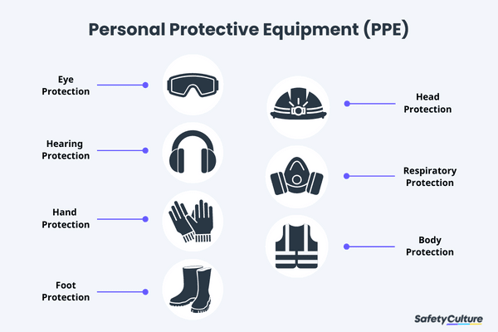
Procedures
- Provide supplies for each room by preparing a cart
- Knock and announcing is important before entering into any room
- Use fresh linens for making beds and replacing towels which are already used
- Clean trash beans, services and mirrors of each room
- Craft bathrooms including floor, walls, sink, and tub
- Vacuum carpet and mop floors
- Restock supplies for guests
- Turn off lights after ensuring cleaned and fresh rooms
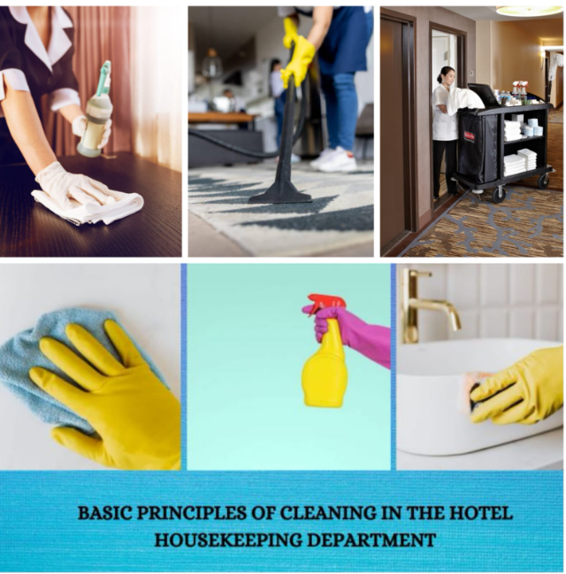
Equipment
- Vacuum
- Mops
- Cleaning cart
- Gloves
- Cleaning chemicals
- Disinfecting wipes
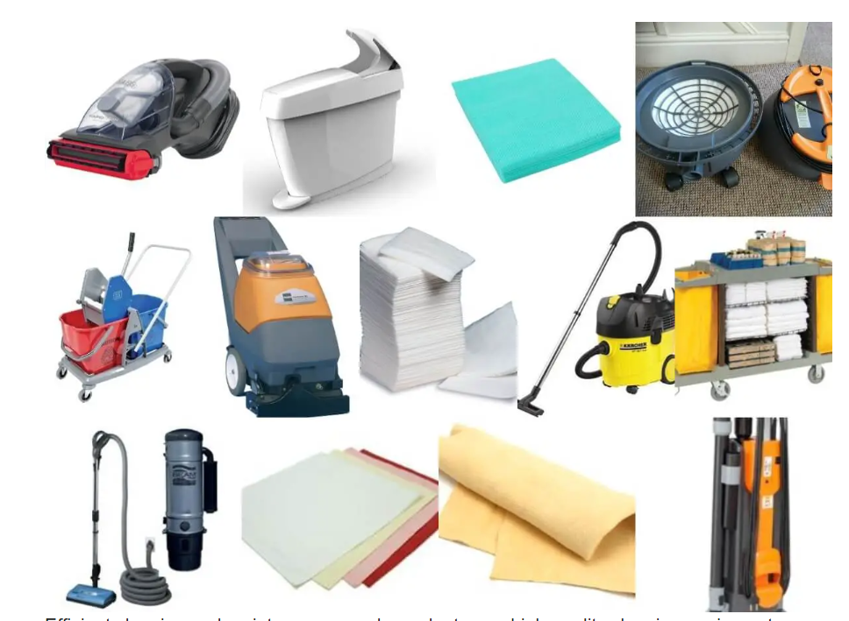
Hazard Mitigation
- Necessity to use wet floor signs while mopping floors
- Need to unplug different electronic appliances while cleaning
- Maintaining awareness and using PPE while using cleaning chemicals
- Report to supervisors if there are any electrical or water issues in rooms
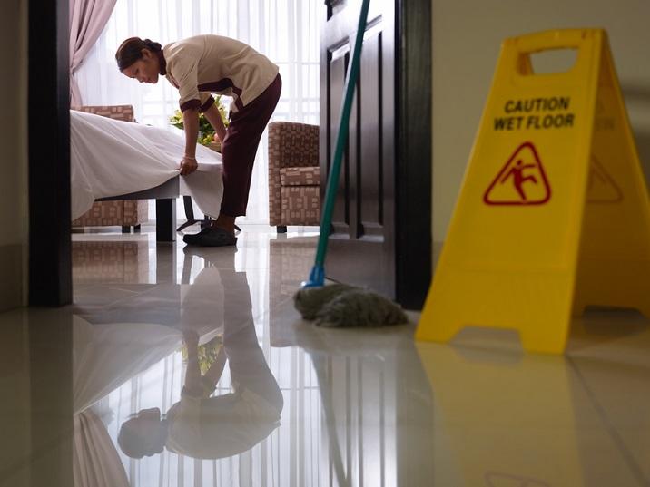
With the help of the guidance and procedures, the housekeeping staff of Premier Inn hotel can improve a safe and hazard-free working environment in the organisation which helps to maintain the reputation of the company in the job market as well as provide positive experiences to customers in this organisation. The managers and staff of the organisation focus on presenting the organisation as the best place for its guests by providing proper room services to them and maintaining the procedure of the housekeeping department which helps to improve its customer care.

Reference List

Gordon, S., Adler, H., Day, J. and Sydnor, S., 2019. Perceived supervisor support: A study of select-service hotel employees. Journal of hospitality and Tourism Management, 38, pp.82-90.
Datta, A. and Singh, R., 2018. Determining the dimensions of organizational climate perceived by the hotel employees. Journal of Hospitality and Tourism Management, 36, pp.40-48.
Kang, H.J.A., Kim, W.G., Choi, H.M. and Li, Y., 2020. How to fuel employees’ prosocial behavior in the hotel service encounter. International Journal of Hospitality Management, 84, p.102333.
Premier Inn, 2024. Top employer: Premier Inn. Available at: https://www.premierinn.com/gb/en/news/2022/top-employer.html (Accessed: 12 February 2024).
Harithuddin, A.S.M., 2021. A first experience of using failure report as a reflective tool in engineering education. International Journal of Emerging Technologies in Learning (Online), 16(18), p.23.

Component 3





