

Changemakers: Creativity and Value Creation
Professions (BMHP5014_LON)

Component 2: Pre-Hospital Support & Safety App
(Poster and Pitch)

Student name: Dan-Matei Voiculescu
Student number: 2411572
Lecturer’s name: Dr. Soban Sadiq

06.07.2026

Table of Content

- Poster……………………………………………………………….....3
- Pitch……………………………………………………………………4
  - Introduction…………………………………………………………4
  - Background…………………………………………………………4
  - Innovation description…………………………………………....5
  - Impact on Health and Social Care……………………………....6
2.5. Social Justice and Equity…………………………………………6
2.6. Public and Stakeholder Involvement……………………………7
2.7. Policies, Legislation and Professional Links………………….7
2.8. Conclusion…………………………………………………………...7
2.9. References……………………………………………………………8

1.Poster

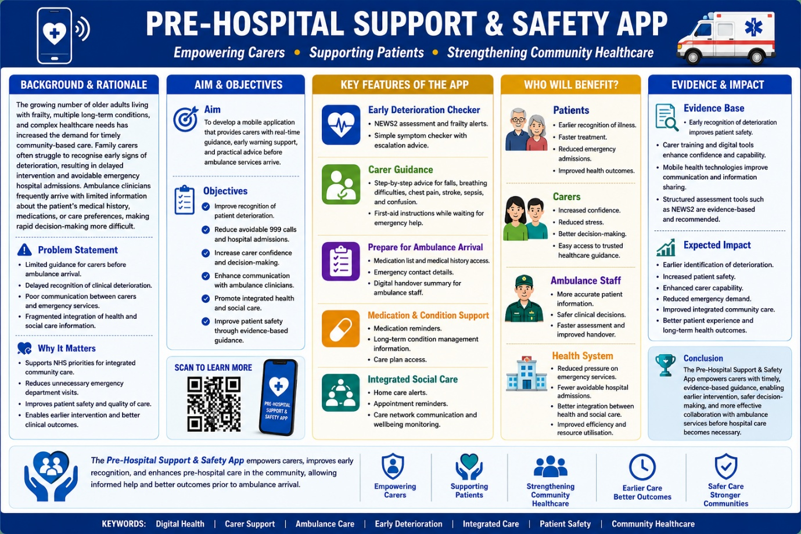

- Pitch

2.1. Introduction
The “Pre-Hospital Support & Safety App” is a digital health innovation designed to enhance patient safety and support carers during periods of clinical uncertainty, both before ambulance services arrive and during routine healthcare interactions such as follow-up treatment or hospital appointments. Digital tools that integrate deterioration monitoring, emergency preparedness and coordinated care, such as pre-hospital support applications reflect a wider shift toward digitally enabled community care for older adults, aligning with evidence showing that clinical decision support systems and remote monitoring can improve safety, continuity and early recognition of deterioration (Hirmas-Adauy et al., 2024; Asthana et al., 2025).
Many older adults and individuals living with frailty or multiple long-term conditions experience deterioration at home, where family carers are often the first to recognise subtle changes in health status (Glasby, 2026). However, carers frequently lack the clinical knowledge, confidence and structured guidance required to make informed decisions, resulting in delayed treatment, avoidable hospital admissions and increased pressure on emergency services (NHS England, 2019).

2.2. Background
The UK’s ageing population presents significant challenges for health and social care systems. Age UK (2023) reports that over 2 million older adults live with frailty, a condition associated with increased vulnerability to deterioration, falls, infections and hospitalisation. Many of these individuals remain at home and rely heavily on informal carers for daily support. Carers UK (2023) estimates 5.8 million unpaid carers, though broader research suggests the true figure may be between 10.5 and 11.9 million, contributing care valued at approximately £162 billion annually. Despite this substantial contribution, carers often receive limited formal training in recognising deterioration or managing urgent situations.
The NHS Long Term Plan emphasises prevention, digital transformation and integrated care as key priorities to reduce avoidable hospital admissions and improve patient outcomes (NHS England, 2019). Furthermore, the Care Act 2014 places a statutory duty on local authorities to promote wellbeing and recognise carers as partners in care. NICE guidance on multimorbidity highlights the importance of coordinated, person-centred care and early identification of deterioration (NICE, 2015). These policy frameworks collectively demonstrate a national commitment to empowering carers, improving communication between services and supporting people to remain safely at home.
Ambulance services frequently attend incidents with limited pre-arrival information, which can delay assessment and treatment. Furthermore, deterioration often occurs outside emergency contexts, such as before outpatient appointments, during follow-up treatment or while awaiting community nurse visits. Caregivers may be unsure whether the symptoms warrant stepping up measures, a consultation with the family doctor, or emergency intervention. A digital solution that supports carers across both emergency and routine care contexts aligns with national priorities and addresses a critical gap in community-based healthcare.

2.3. Innovation Description
The “Pre-Hospital Support & Safety App” is a smartphone application that provides carers with practical, evidence-based guidance during periods of uncertainty. Unlike existing apps that focus primarily on disease management, this innovation integrates clinical decision support, emergency preparedness and care coordination within a single platform. Predictive prevention technologies, including remote monitoring and AI-driven alerts, are seen as essential for shifting care from hospitals to the community (Asthana et al., 2025).
This app supports non-emergency care, enabling carers to monitor symptoms before hospital appointments, prepare structured information for follow-up treatment, and track changes during recovery. Users can securely store medication lists, allergies, medical history, baseline observations, advance care plans and emergency contacts. When an ambulance is called or when attending a GP or hospital appointment, the app generates a concise digital handover summary that can be shared with clinicians, improving continuity of care and reducing delays.
Additional features include medication reminders, personalised care plans, appointment notifications and links to community support services. Integration with NHS digital systems would enable coordinated communication between primary care, community nursing, social care and ambulance services, supporting the NHS ambition of increasing digitally enabled care (NHS England, 2019).

2.4 Impact on Health and Social Care
2.4.1. Patients
Patinets living with frailty, dementia or long-term conditions benefit from earlier recognition of deterioration, faster intervention and improved safety. Timely identification of worsening symptoms may prevent avoidable hospital admissions and support individuals to remain independent within their own homes (Glasby, 2026). This app also enhances the quality of follow-up care by ensuring clinicians receive accurate information during routine appointments.
2.4.2. Carers
Carers gain confidence, reassurance and access to evidence-based clinical guidance. This reduces anxiety, supports wellbeing and recognises carers as essential partners in care, consistent with the Care Act 2014. This app empowers carers to make informed decisions during stressful situations and improves their ability to communicate effectively with healthcare professionals.
2.4.3. Healthcare Professionals
Ambulance clinicians, community nurses, GPs and hospital teams benefit from more accurate pre-arrival and pre-appointment information. This enables faster clinical decision-making, safer handovers and more efficient care pathways. Improved communication reduces duplication and supports integrated care across services.
2.4.4. The NHS
The wider NHS benefits through reduced pressure on emergency and outpatients’ departments, fewer avoidable ambulance call-outs and more efficient use of healthcare resources. Earlier intervention and improved coordination support the NHS Long Term Plan’s priorities of prevention, digital innovation and integrated care (NHS England, 2019).

2.5. Social Justice and Equity
This app promotes equity by improving access to reliable healthcare information regardless of geographical location or socioeconomic background. Features such as multilingual support, accessibility options and simple user interfaces support inclusion and dignity, consistent with the Equality Act 2010.
2.6. Public and Stakeholder Involvement
Successful implementation requires collaboration with patients, carers, healthcare professionals and community organisations through a co-production approach. Carers, older adults and individuals with long-term conditions would participate in focus groups, usability testing and pilot evaluations to ensure this app meets users’ needs.
NHS England, Integrated Care Systems (ICSs), Ambulance trusts, GPs' offices, community nursing teams, local governments, nonprofits including Age UK and digital health developers are among the stakeholders. Stakeholder meetings, social media campaigns, community workshops, public engagement events, and online feedback surveys would guarantee that the app stays person-centered, accessible, and adaptable to dynamic healthcare requirements.

2.7. Policies, Legislation and Professional Links
This innovation aligns with key UK health and social care policies. The Care Act 2014 promotes carers’ wellbeing and emphasises integrated care planning. The Equality Act 2010 ensures equal access for individuals with protected characteristics. Patient information would be managed in accordance with the UK General Data Protection Regulation (UK GDPR) and the Data Protection Act 2018.
Clinical guidance would comply with NICE recommendations for managing multiple long-term conditions and older people with social care needs (NICE, 2015). Healthcare providers would meet the Care Quality Commission (CQC) Fundamental Standards, while nurses and allied health professionals would practise according to the NMC Code (2018) and HCPC Standards of Conduct, Performance and Ethics.

2.7. Conclusion
The “Pre-Hospital Support & Safety App” addresses a significant gap in community healthcare by empowering carers with timely, evidence-based guidance before ambulance arrival and during routine healthcare interactions. The innovation supports early recognition of deterioration, improves communication between carers and healthcare professionals, and strengthens integrated care. By aligning with UK health policies and digital transformation strategies, the application has the potential to improve patient outcomes, reduce unnecessary hospital admissions and contribute to a safer, more sustainable health and social care system.

2.9. References
Asthana, S. et al. (2025) “Harnessing predictive prevention to shift elderly care from hospital to community in England,” BMJ. British medical journal (Clinical research ed.), 389, p. e082873. Available at: https://doi.org/10.1136/bmj-2024-082873.
Care Quality Commission (CQC) (2023) Fundamental standards. London: CQC.
Glasby, J. 2026. Understanding Health and Social Care (Fourth edition). Bristol, UK: Policy Press. https://doi-org.uwtsd.idm.oclc.org/10.56687/9781447379430
Hirmas-Adauy, M. et al. (2026) “Corrigendum: Navigating Through Innovation in Elderly’s Health: A Scoping Review of Digital Health Interventions,” Public health reviews, 47, p. 1609579. Available at: https://doi.org/10.3389/phrs.2026.1609579.
Health and Care Professions Council (2024) Standards of conduct, performance and ethics. London: HCPC. Available at: https://www.hcpc-uk.org/standards/standards-of-conduct-performance-and-ethics (Accessed: 01 August 2026).
HM Government (2014) Care Act 2014. London: The Stationery Office.
National Institute for Health and Care Excellence (NICE) (2016) Social care for older people with multiple long-term conditions (QS132). London: NICE. Available at: https://www.nice.org.uk/guidance/qs132 (Accessed: 01 August 2026).
NHS England (2019) The NHS Long Term Plan. London: NHS England.
NHS England (2021) Personalised Care and Support Plan Standard. London: NHS England.
Nursing and Midwifery Council (2018) The Code: Professional standards of practice and behaviour for nurses, midwives and nursing associates. London: NMC. Available at: https://www.nmc.org.uk/standards/code/ (Accessed: 02 August 2026).
UK Government (2018) Data Protection Act 2018. London: The Stationery Office.

