Name: Curtis Lee Butler

Student Number: 2517431

WORKSHEET 1 – TESTING (Using Variables)

- Original code:
print("Please enter your age:")
age = int(input())
while age <= 16:
print("Not old enough to continue or try again")
age = int(input())
else:
print("Thank you. Move on to next question")

surname = input("Please enter your Surname:")
print(surname)

NINumber = str(input("Please enter your National Insurance Number:"))
print(NINumber)

hoursworked = float(input("Please enter your contracted weekly hours:"))
print(hoursworked)

Contents
Surname 2
National Insurance Number 4
Age 6
Number of working hours per week 8

Surname

Test:
Surname - Enter JONES
Screenshot(s) of output:
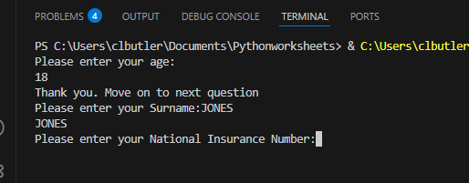
Result: Did the programme behave as expected ie syntactically and logically correct?
YES
Entry of JONES was successful and allowed continuation of the program

Test:
Surname - Leave blank
Screenshot(s) of output:
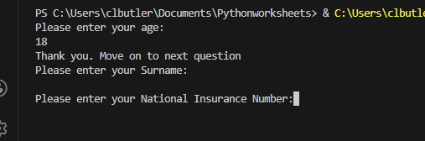
Result: Did the programme behave as expected ie syntactically and logically correct?
NO
When nothing was entered and left blank. Program continued without input. Correct validation would fix this issue

Test:
Surname – Enter A
Screenshot(s) of output:
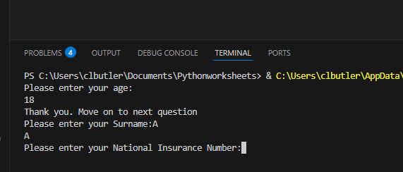
Result: Did the programme behave as expected ie syntactically and logically correct?
NO
Program accepted the entry of A and carried on but A is not a logical surname checks will need to be put into catch this.

Test:
Surname – Enter 123
Screenshot(s) of output:
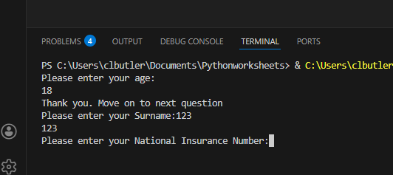
Result: Did the programme behave as expected ie syntactically and logically correct?
NO
The program accepted ‘123’ and continued, even though this is not a valid surname. I did not enforce character‑type validation, so adding this would prevent the issue

National Insurance Number

Test:
National Insurance Number – Enter PE534121B
Screenshot(s) of output:
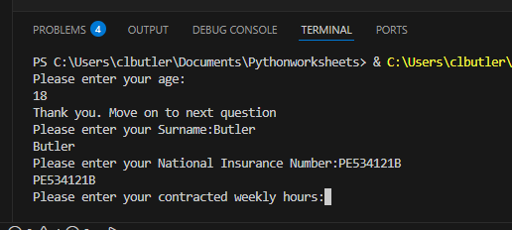
Result: Did the programme behave as expected ie syntactically and logically correct?
YES
Program functioned as expected and continued to the next point of input

Test:
National Insurance Number – Leave Blank
Screenshot(s) of output:
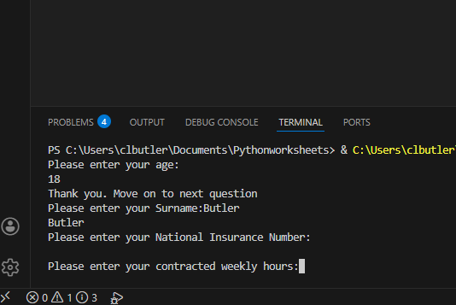
Result: Did the programme behave as expected ie syntactically and logically correct?
NO
When the field was left blank, the program still accepted it and continued. Validation is needed to stop blank inputs

Test:
National Insurance Number - Enter AB11223344556677 (ie too long for National Insurance number format)
Screenshot(s) of output:
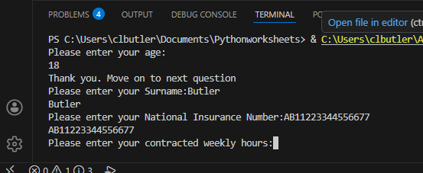
Result: Did the programme behave as expected ie syntactically and logically correct?
NO
When entering AB11223344556677 it was allowed by the program, but it should have not been accepted and caught with validation by having them re-enter correctly.

Test:
National Insurance Number - Enter 22PE4088A (ie wrong format)
Screenshot(s) of output:
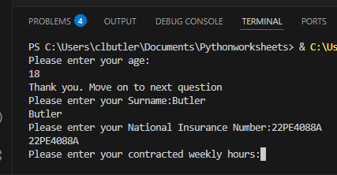
Result: Did the programme behave as expected ie syntactically and logically correct?
NO
The program accepted ‘22PE4088A’, even though this is not a valid NI Number format. Validation should be added to reject incorrect formats.

Age

Test:
Age – Enter 34
Screenshot(s) of output:
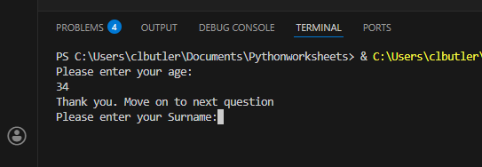
Result: Did the programme behave as expected ie syntactically and logically correct?
YES
Inputted 34 program gave desired response and moved on to the next question

Test:
Age – Enter 150
Screenshot(s) of output:
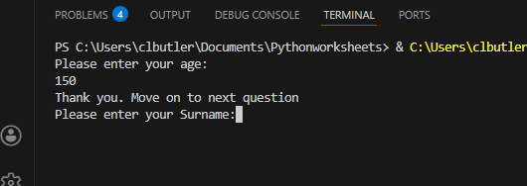
Result: Did the programme behave as expected ie syntactically and logically correct?
NO
Entering ‘150’ was accepted, even though this is far too high to be a realistic age. Validation should be added to reject unrealistic values.

Test:
Age – Enter -4
Screenshot(s) of output:
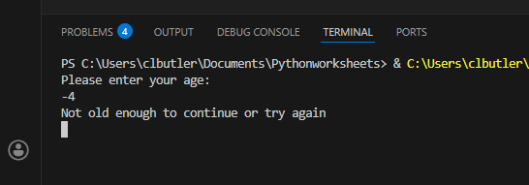

Result: Did the programme behave as expected ie syntactically and logically correct?
YES
Entering ‘-4’ caused the program to reject the value and ask again, which is the expected behaviour from the validation (age <= 16)

Test:
Age – Enter a letter
Screenshot(s) of output:
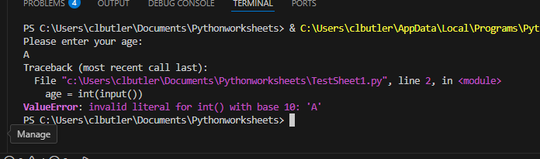
Result: Did the programme behave as expected ie syntactically and logically correct?
NO
Entering ‘A’ caused the program to crash because there were no validation checks for non‑numeric input. This input type should be rejected.

Number of working hours per week

Test:
Number of working hours per week – Enter 37.5
Screenshot(s) of output:
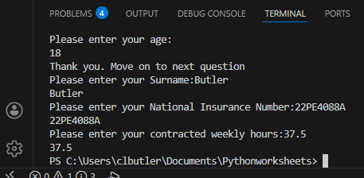
Result: Did the programme behave as expected ie syntactically and logically correct?
YES
Test worked correctly as it matches the correct type of format that has been set.

Test:
Number of working hours per week – Enter 150
Screenshot(s) of output:
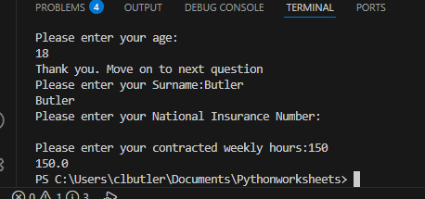
Result: Did the programme behave as expected ie syntactically and logically correct?
NO
The program accepted an unrealistic number of hours, even though this should not be allowed. Validation should be added to prevent impossible working hours.

Test:
Number of working hours per week – Enter 0
Screenshot(s) of output:
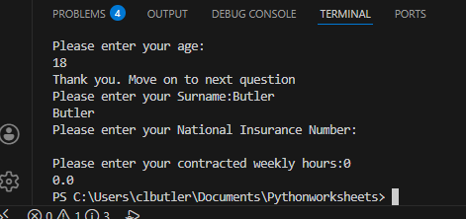
Result: Did the programme behave as expected ie syntactically and logically correct?
YES
The program accepted ‘0’ correctly, as a worker can have a zero‑hour contract. An optional confirmation check could be added to improve user experience.

Test:
Number of working hours per week – Enter -2

Screenshot(s) of output:
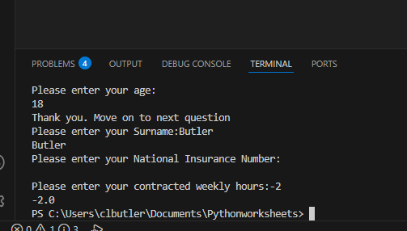
Result: Did the programme behave as expected ie syntactically and logically correct?
NO
The program accepted ‘-2’, even though negative hours are impossible. Validation should be added to prevent negative values and prompt re‑entry.

- Consider the results of the above tests and revisit your code in order to solve the problems. (Note: you may not be able to solve all of them, but solve as many as you can.)

Paste your revised code here:

age_input = input("Please enter your age: ")

# Keep asking until we get valid number
while True:

# Check Is the input a number
if not age_input.isdigit():
print("Error: Please enter numbers only.")
age_input = input("Please enter your age: ")
continue

# Convert to integer now that we know it is numeric
age = int(age_input)

# Check Age too young
if age <= 16:
print("Not old enough to continue. Please try again.")
age_input = input("Please enter your age: ")
continue

# Age too high to be realistic
if age > 120:
print("Error: That age is too high to be realistic. Please try again.")
age_input = input("Please enter your age: ")
continue

# If all checks pass valid age (break used to exit current loop)
break

print("Age accepted. Moving on to the next question.")

surname = input("Please enter your surname:").strip()
while True:
# Check for Blank Input
if surname == "":
print("Error: Surname cannot be left blank.")
surname = input("Please enter your surname:").strip()
continue
# Check that the surname is a reasonable length
if len(surname) <= 3:
print("Error: Surname must be longer than three letters.")
surname = input("Please enter your surname:").strip()
continue
# Remove allowed punctuation and check remaining letters
cleaned = surname.replace("-", "").replace("'", "")

# If ANY numbers or symbols remain, the name is invalid
if not cleaned.isalpha():
print("Error: Surname can only contain letters, hyphens, and apostrophes.")
surname = input("Please enter your surname: ").strip()
continue

# If all checks are passed, break out of the loop
break

print("Surname accepted:", surname)

NINumber = input("Please enter your National Insurance Number: ").strip()

# Keep asking until valid
while True:

# Blank entry
if NINumber == "":
print("Error: National Insurance Number cannot be blank.")
NINumber = input("Please enter your National Insurance Number: ").strip()
continue

# Correct length should be 9 character
if len(NINumber) != 9:
print(
"Error: National Insurance Number must be 9 characters long (e.g., AB123456C)."
)
NINumber = input("Please enter your National Insurance Number: ").strip()
continue

# Split into sections
first_two = NINumber[0:2]
middle_six = NINumber[2:8]
last_char = NINumber[8]

# First two characters must be letters
if not first_two.isalpha():
print("Error: The first two characters must be letters.")
NINumber = input("Please enter your National Insurance Number: ").strip()
continue

# Middle six characters must be digits
if not middle_six.isdigit():
print("Error: Characters 3 to 8 must be numbers.")
NINumber = input("Please enter your National Insurance Number: ").strip()
continue

# Final character must be a letter
if not last_char.isalpha():
print("Error: The last character must be a letter.")
NINumber = input("Please enter your National Insurance Number: ").strip()
continue

# All checks passed
break

print("National Insurance Number accepted:", NINumber)

hours_input = input("Please enter your contracted weekly hours: ").strip()

# Keep asking until valid
while True:

# Check Is the input a number?
try:
hoursworked = float(hours_input)
except ValueError:
print("Error: Please enter a valid number, for example 37.5.")
hours_input = input("Please enter your contracted weekly hours: ").strip()
continue

# Check Negative hours (not possible)
if hoursworked < 0:
print("Error: Hours cannot be negative.")
hours_input = input("Please enter your contracted weekly hours: ").strip()
continue

# Check Unrealistically high (too large)
if hoursworked > 120:
print("Error: That number is too high to be realistic.")
hours_input = input("Please enter your contracted weekly hours: ").strip()
continue

# 0 hours is allowed because zero-hour contracts exist
break

print("Weekly hours accepted:", hoursworked)

# Final Summary to show colledcted data
print("\n--- Summary of Entered Details ---")
print("Surname:", surname)
print("Age:", age)
print("National Insurance Number:", NINumber)
print("Contracted Weekly Hours:", hoursworked)
print("----------------------------------")

