Web Application-ASP C# .NETCORE and MVC

Name: Sai Harsha Jangili
Student number: 1908692
Course: Web Development
Module name: Application Development

Table of Contents
1. Introduction 1
1.1. Abstract 1
1.2. Application Development Concepts 1
2. Requirements 1
3. Design and Implementation 2
3.1. Main design features 2
3.2. Implementation 3
3.2.1. Main models, views, and controllers 4
3.2.2. Screen shots 7
4. Evaluation 9
4.1. Testing 9
5. References 12

Introduction

Abstract
This case study web application is an online e-commerce developed using C# and .netcore_mvc framework. It is integrated with an SQL Server Express LocalDB for storing and managing its data for customers when shopping and placing order [1]. It also stores admin data such as products uploaded to the server. The main audience for the web application are online shoppers. It mainly sales mobile and laptop computers. It is significant since the customer can place an order after shopping. The system get and stores customer’s data for order processing by the system administrator. Nonetheless, the database consists of various relationships such as one to one: user-user_id; one to many: user-orders; many to one: product details-product; many to many: roles-users. The Customer can also search their favourite products as the web application will pull the query from the local database.

Application Development Concepts
Supports for ASP.NET Core 2.2 with Identity is integrated in the web application project. The scripts for putting Identity to the application project created under Areas/Identity. Also, settings for the Identity related services are located in the Areas/Identity/IdentityHostingStartup.cs file in the script folder.

Requirements

- Visual studio Community version; was utilised as the main web Application development environment (IDE).
- Asp.Net MVC 5 ASP.NET MVC 5 is a framework for building scalable, standards-based web applications utilising a well-established design patterns and the power of ASP.NET and the .NET Framework 2.2.
- SQL Server Express LocalDB: The study web application has a back-end server to help it store data such as products on sale and can be accessed by the admin and the front-end web application user. It allows for CRUD functions. Ideally, the server in an SQL, which is available locally on SQL Server Express with Advanced Services. The server also helps the application to share instances. Once installed, LocalDB is an instance of SQL Server Express that can create and open SQL Server databases. The system database files for the database are stored in the local AppData path, which is normally hidden.
- Razor: Entails the applications' mark-up syntax used in ASP.NET to help view and embed server-based code (C# and HTML) into web pages. In case a web page is called, the server executes the server-based code inside the page prior to it returning the page to the web browser. Also, the razor scripts assist the application to run complex tasks, such as accessing the local database.
- JavaScript and JQuery Libraries: Are used for web application views, post data to the server side, handling events, and client side animations. Besides, the JQuery and JavaScript libraries in the developed web application will be utilised to help C# call to ASP.NET Web forms. Particularly the model (data), as well as the view (user interface), and the controller (processes that handle input), also referred to as MVC web service.

- Bootstrap: Bootstrap is a framework to help the application appear intuitive and simpler. It incorporates mark-up language and CSS based structure layouts for typography, structures, catches, tables, route, modals, and images. It equally offers the developer with support for JavaScript modules. In this case, bootstrap have also been utilised to make the web application responsive and interactive.

- HTML: As the application Markup Language

- Web Browser: This app is typically hosted in all modern web-browsers that supports CSS, HTML, and JavaScript, cookies as well.

Ideally this project demonstrates the following
- Design and implement an ASP.NET MVC web application that integrates with a SQL Server Express LocalDB for storing and managing its data
- Use Model, views, and Controller to exchange application’s user interface views, data, and processes that handle events from ASP.NET, C# and JavaScript server
- Develop responsive, dynamic, and interactive website application via .net core framework.

Design and Implementation

Main design features
The application comprise three main areas that is the customer, web admin and identity. Technically, the areas in the developed web application have been logical grouped in a controller, views, and models to assign different functions of application user based on their roles. The identify area will determine ones role after logging in the application. Figure 1 overleaf illustrates the synopsis overleaf.
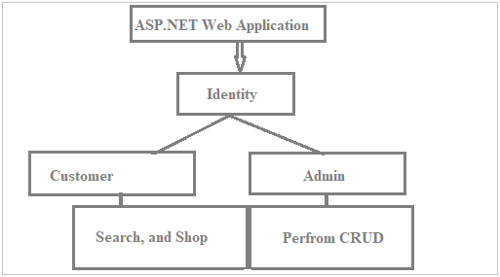
Figure1: main Design

The identity area comprise authentication modules. Customer can read, search, shop products as well as place an order. Admin have access to modules such as create. Read, update, and delete products, users, and other elements.

Implementation
The web application implements the core online shop using functions of the system from the repository pattern with ASP.NET MVC and Entity Framework as illustrated from figure 2 below.
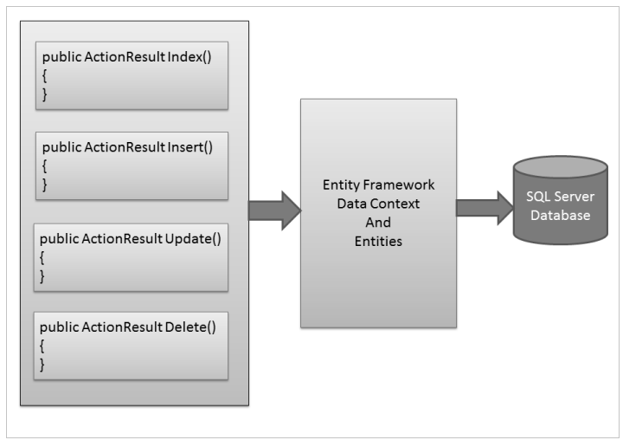
Figure 2: Application Implementation
To get started off with the study application, I developed an ASP.NET MVC 5 web application by selecting the ASP.NET Web Application template in Visual Studio 2015 community. The next step was to install NuGet framework packages, which included Font Awesome, Entity framework for data access of new web application, NuGet copied the entire library files into the application and updated the application reference and config file [2].

Main models, views, and controllers
Models
The application models were Application user identity, user role, product, shopping cart item, product details, and order [3]. The product model include functions to get, set, and display product name, type, its availability, product colour, and tag, image, and price as well as shown in the sneak preview of the following codes;
Listing 1: Sample codes for product model.
public class Products
{ public int Id { get; set; }
[Required]
public string Name { get; set; }
[Required]
public decimal Price { get; set; }
public string Image { get; set; }
[Display(Name = "Product Color")]
public string ProductColor { get; set; } }

On the other hand, the order model also was to fetch, set order place, its details such order number and name, as slightly shown on the code below;
Listing 2: Sample codes for order model.
public class Order
{ public Order()
{OrderDetails=new List<OrderDetails>();}
public int Id { get; set; }
[Display(Name = "Order No")]
public string OrderNo { get; set; }
[Required]

Application user identity was also paramount, as the model determined the user role in the application by guaranteeing them access to the system. Codes below shows a snippet of user identity model the web app utilised
Listing 3: Sample codes for Application User Identity model.
public class ApplicationUser:IdentityUser
{public string FirstName { get; set; }
public string LastName { get; set; }}

General model in the system were used to fetch, set, and display data from the server-side and front-side of the application. On model utilised were; “error view” to display error generated by the user or the application and session user. User role model were created to get and display roles assigned to the admin.
Views
In the application, there were ten shared Razor views [4] as follows
_ViewImports: The cshtml file view is to offer a way to create directives available to Razor pages globally to stopping adding them to pages separately.
_ViewStart. This is a cshtml file view to put common UI logic across the Views in the folder, where it is located. Implying that, the views in a single folder which is having _Viewstart. cshtml will be rendered along with it.
error.cshtml: as a view not found in index1 but in the web. This view will allow the app to show error as the view not found in index1 but in the web.
Index.cshtml, and the _Layout.cshtml master page layout. These two Razor views will be used to bootstrap and configure the web app.
_CookieConsentPartial.cshtml: partial view, from the application user pages of the local variable cookieString is utilised to store the “cookie string”
Partial view: is a cshtml file that renders HTML output within another Mark-up file's rendered output.
_ValidationScriptsPartial: Is a cshtml file view used in the web application "client side validation" (JavaScript) to validate forms before the user sends them according to validation model.
CRUD pages: This views are kept in the controller folder to display pages only to web application admin, who can use them to create, read, update, and delete products, user and other elements. For instance, Create .cshtml files is provide views for user to create new product, new product category and product type. This same applies to edit, delete, and assign cshtml files. Also, user can perform CRUD functions on the product selected in the cart.
Controllers
A controller is in charge of managing the way that a user interacts with an MVC web application. It consists the flow control logic for an ASP.NET MVC application. A controller determines what response to send back to a user when a user makes a browser request [5].

All the controllers are found in the “Areas”. The customer controller resides in the customer folder as well as the admin controllers. Application admin was assigned four essential controllers namely; product, specialtag, product type, and role controllers.

Product controller: C# file comprising functions to handle products in the application by generating responses to the browser request. For example, the controller might return a particular view back to the browser or the product controller might redirect the user to another controller. An example is shown in listing 4.
Listing 4: Sample codes for product controller
{ [Area("Admin")]
public class ProductController : Controller
{ private ApplicationDbContext _db;
private IHostingEnvironment _he;

public ProductController(ApplicationDbContext db,IHostingEnvironment he)
{
_db = db;
_he = he;
}

Role Controller: C# file that contains functions to manage the Roles and user in Identity, for example assign role, edit role, delete role as well as user utilising role and user manager. As shown in the listing 5 below.
Listing 5: Sample role controller
[Area("Admin")]
public class RoleController : Controller
{ RoleManager<IdentityRole> _roleManager;
UserManager<IdentityUser> _userManager; ApplicationDbContext _db;
public RoleController(RoleManager<IdentityRole>roleManager,ApplicationDbContext db, UserManager<IdentityUser> userManager)

In the web application customers have also specific controllers such as user controller, order controller, and Home controller
User Controller: is C# file that contains functions to manage the Roles and user in Identity, for example, identifies customers and give them ability to edit role, delete products, shopping cart and order, utilising user manager [5]. Sample codes are shown in the listing 5 below.

Listing 5: User Controller for Customers

{ [Area("Customer")]
public class UserController : Controller
{ UserManager<IdentityUser> _userManager;
ApplicationDbContext _db;
public UserController(UserManager<IdentityUser>userManager,ApplicationDbContext db)
{ _userManager = userManager;
_db = db;}

Oder Controller: Is utilised to define the all order functions and classes search get product and put it to the shopping cart, checkout [5]. A sample code is shown in the listing 6 overleaf.

Listing 6: Sample codes for Oder controller.
{
[Area("Customer")]
public class OrderController : Controller
{private ApplicationDbContext _db;

public OrderController(ApplicationDbContext db)
{ _db = db;}

//GET Checkout actioin method

public IActionResult Checkout()
{
return View();}

Home Controller: is C# file that contains functions, classes, and methods to control home page. For instace, method named Index(). The URL /Home/Index invokes the HomeController.Index() method. It redirects the customer to home page where products are located [5]. Listing 7 shows a preview of the sample codes for home controller

Listing 7: Home Controller
[Area("Customer")]
public class HomeController : Controller
{private ApplicationDbContext _db;

public HomeController(ApplicationDbContext db)
{_db = db;}
public IActionResult Index(int? page)
{
return View(_db.Products.Include(c=>c.ProductTypes).Include(c=>c.SpecialTag).ToList().ToPagedList(page??1,9));}
public IActionResult Privacy()
{return View();}

Screen shots
Sign up page to authenticate the user in shown in Figure 3. User can Sign up.
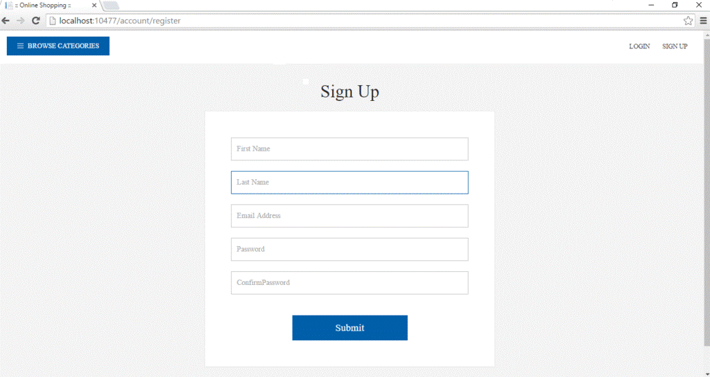
Figure 3: User Sign up Page
User can login if the authenticators is activators in the online shop application. User can login to checkout after placing an order. A sample picture is depicted in Figure 4.
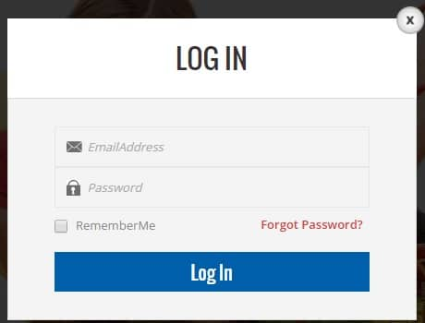
Figure 4: User Login Page
Depending on the products uploaded to the localDB server, the home page will list all items/products being sold on the online shop so that the customer can click on them and add on the shopping cart. Figure 5 shows a sneak preview of products home page for the sample web application.
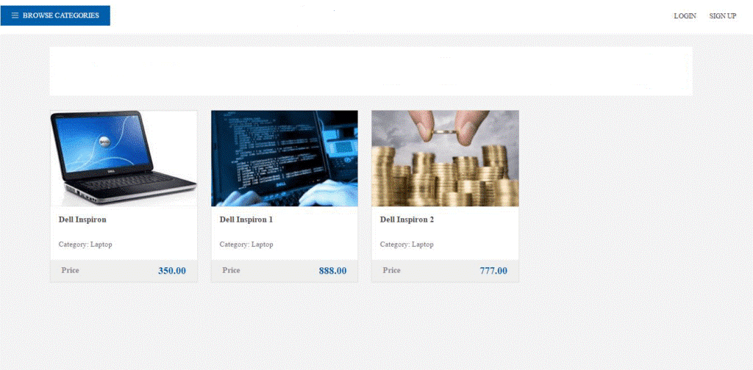
Figure 5: Product Home page
Once the product has been selected, the item is them sent to the shopping cart as shown in Figure 6 overleaf.
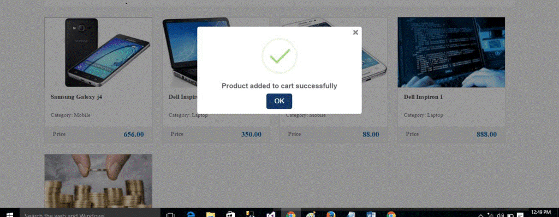
Figure 6: Item added to shopping cart
Once the cart has been filled, the customer can then proceed to cart to perform various functions including CRUD, to read, edit, update, and delete the cart of an item selected in the cart. Figure 7 below shows a slight preview.
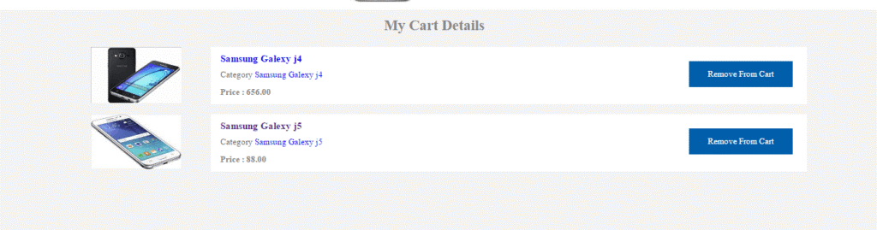
Figure 7: Item added to shopping cart

Evaluation
Web application verification and validation is an essential aspect of software development process. Develop a set of test cases to verify and validate at least two of the core functional requirements or features of the implemented application [7]. The following is a list of some elements that can be typically found in a test case and you should aim to include these in your example test cases

4.1. Testing
Unit testing was undertaken on the controllers for the developed ASP.NET MVC web applications. The unit test determined to test whether or not different controllers returned the right view. Unit testing is the first level testing an ASP.Net project for application functionality. The testing is executed to ensure that the application runs as expected. In ASP.Net, the first task is to create a test project in Visual Studio (1). The test class in Listing 8 contains a piece of sample code used for unit test.
Listing 7: Web application Unit testing
using System;
using Microsoft.VisualStudio.TestTools.UnitTesting;

namespace Onlineshop.Tests
{ [TestClass]
public class UnitTest1
{ [TestMethod]
public void TestMethod1()

public ActionResult Details(int Id)
{

return View("Details");
}

{ } } }

Figure 8 shows a sample results preview generated found the codes to have passed the test from visual studio IDE 2015 Explorer.
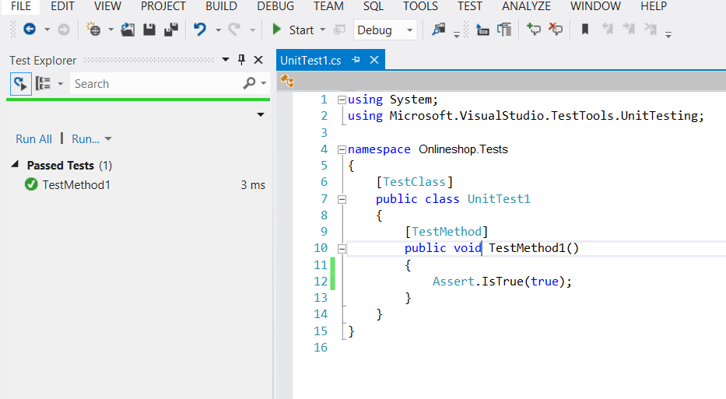
Figure 8: Unit Test

On the other hand, the controller unit test was done on various controllers such as Home, and product controller using codes in listing 8, overleaf and the test results as Figure 9 shows.

Listing 8: Sample code for Web application controller Unit testing
namespace Onlineshop.Tests.Controllers
{ [TestClass]
public class HomeControllerTest
{[TestMethod]
public void Index()
{// Arrange
HomeController controller = new HomeController();
// Act
ViewResult result = controller.Index() as ViewResult;
// Assert
Assert.IsNotNull(result);}
[TestMethod]
public void About()
{
// Arrange
HomeController controller = new HomeController();
// Act
ViewResult result = controller.About() as ViewResult;
// Assert
Assert.AreEqual("Your app description page.", result.ViewBag.Message); }
[TestMethod]
public void Contact(){
// Arrange
HomeController controller = new HomeController();
// Act
ViewResult result = controller.Contact() as ViewResult;
// Assert
Assert.IsNotNull(result);
} }}

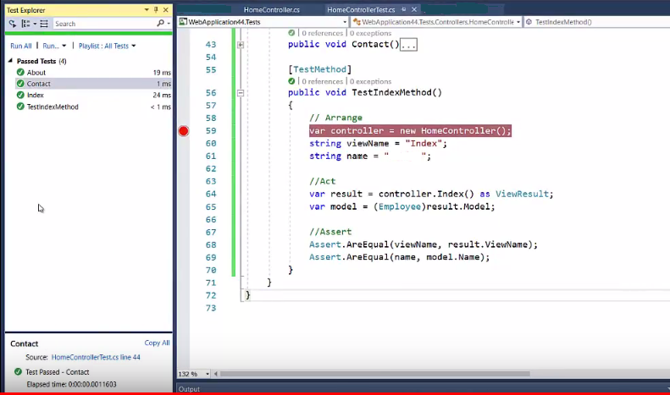
Figure 9: Sample Home Controller Test

References

[1] R. Anderson, "Work with SQL in ASP.NET Core," 2019. [Online]. Available: https://docs.microsoft.com/en-us/aspnet/core/tutorials/first-mvc-app/working-with-sql?view=aspnetcore-3.1&tabs=visual-studio. [Accessed 1 June 2020].

[2] Microsoft, "Install and manage packages in Visual Studio using the NuGet Package Manager," Microsoft, 08 July 2019. [Online]. Available: https://docs.microsoft.com/en-us/nuget/consume-packages/install-use-packages-visual-studio. [Accessed 3 June 2020].

[3] R. A. a. T. Dykstra, "Add a model to an ASP.NET Core MVC app," Microsoft, 13 January 2020. [Online]. Available: https://docs.microsoft.com/en-us/aspnet/core/tutorials/first-mvc-app/adding-model?view=aspnetcore-3.1&tabs=visual-studio. [Accessed 2 June 2020].

[4] R. A. a. R. Nowak, "Introduction to Razor Pages in ASP.NET Core," Microsoft, 20 February 2020. [Online]. Available: https://docs.microsoft.com/en-us/aspnet/core/razor-pages/?view=aspnetcore-3.1&tabs=visual-studio. [Accessed 2 June 2020].

[5] R. Anderson, "Add a controller to an ASP.NET Core MVC app," Microsoft, 08 May 2017. [Online]. Available: https://docs.microsoft.com/en-us/aspnet/core/tutorials/first-mvc-app/adding-controller?view=aspnetcore-3.1&tabs=visual-studio. [Accessed 02 June 2020].

[6] A. Freeman, "Sports Store Completing the Cart," in Pro ASP.NET Core MVC, New York City, Apress, 2016, p. 279.

[7] Jugo I., Kermek D., Meštrović A. (2014) Analysis and Evaluation of Web Application Performance Enhancement Techniques. In: Casteleyn S., Rossi G., Winckler M. (eds) Web Engineering. ICWE 2014. Lecture Notes in Computer Science, vol 8541. Springer, Cham

[8] S. Walther, "Creating Unit Tests for ASP.NET MVC Applications (C#)," 19 08 2008. [Online]. Available: https://docs.microsoft.com/en-us/aspnet/mvc/overview/older-versions-1/unit-testing/creating-unit-tests-for-asp-net-mvc-applications-cs. [Accessed 2 June 2020].

