Problem Solving and Decision Making BMSW4004_BIRM
Florina Madalina Gugoi 211163
Lecturer MD Nazmul Hasan

Introduction
"absenteeism" refers to a worker's unexplained absence from work. An absence is described as 'failure of workers to report for work when they are scheduled to work' by Benefits Interface (Ledesma et al., 2018). There are no exceptions for workers absent from work due to officially recognized holidays, vacations, or authorized leaves of absence granted under the terms of a collective agreement. In Mid Cheshire Hospitals NHS Foundation Trust (MCHT), company managers see absenteeism as the most significant disciplinary issue. Absenteeism is not exclusive to a single region or sector. Because of the downsizing and other lean changes that have taken place in the workplace, this is a huge issue for any company. AIC Insurance recently performed research that found that businesses and the economy lose more than millions annually due to employee absenteeism (Ledesma et al., 2018). Although it was less than a tenth of a percent increase in absenteeism between 2000 and 2012, it was significant. Merrill et al. (2013) argue that one of the greatest ways to generate profits is through boosting the returns on a firm's most valuable asset: its employees. It is one of the most underappreciated ways to save expenditures. For all organizations, controlling absence is essential since the negative impact on efficiency, operations, and cost-effectiveness is substantial. It doesn't matter what the reasons are, and absenteeism is a problem that has to be addressed.

Causes of Absenteeism in Mid-Cheshire
Reasons for the high absenteeism rate in Mid Cheshire Hospitals NHS Foundation Trust (MCHT) may be found here. Commitment is lacking; Employees don't seem to care about the organization's success or even about their jobs (Patton, 2011). There are various reasons for this, including a lack of compensation or a dissatisfying work environment. Their tenure with the organization will influence an employee's dedication to their job and work environment. Employee absenteeism rises due to a lack of repercussions, such as incentives for good attendance or penalties for bad attendance.
Also, employee benefits that allow for a great deal of time off may be exploited by certain employees. Additionally, in other cases, employees may believe that they are treated poorly by management, work in an unfavorable or stressful atmosphere, are overworked, or are subjected to excessive monitoring (Badubi, 2017). Even though a large percentage of employee absences might have been prevented, workers often miss working for 'legitimate' reasons. Domestic troubles (e.g., terrible living circumstances, family conflicts) and their resulting anxieties, societal and religious factors, transportation challenges, or accidents/illnesses are examples of possible causes (Gangai16, 2014)

Fishbone Diagram
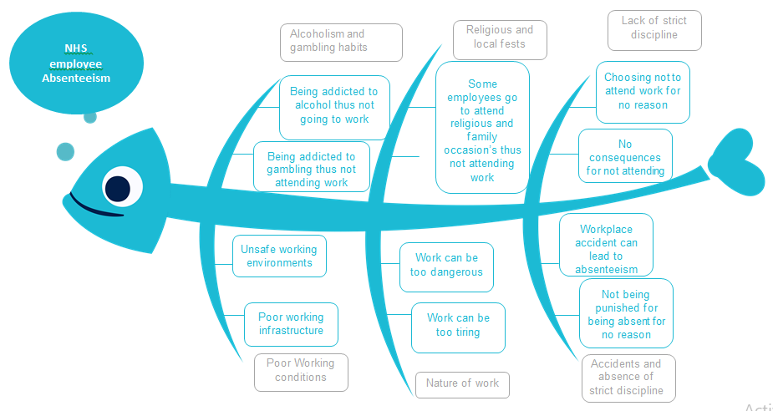
A typical project management problem-solving tool is a fishbone diagram, often known as a "cause and effect" diagram. Kaoru Ishikawa, a professor in Japan, coined the term "Ishikawa diagram" to describe this kind of figure (Liliana, 2016). The reasons for problems in projects may be many, and in some cases, they are intertwined and complex. A fishbone diagram is a useful tool for identifying and resolving these problems.
In this method, you may quickly identify all of the problematic parts of your project and begin working on fixing them more quickly because of the diagrammatic design. This method provides a huge advantage. As a result, it is possible to conduct a more thorough examination by breaking down problems into causes and sub-causes (Liliana, 2016). A more effective and successful approach to issue resolution is assured in this way. The primary issue facing the MID CHESHIRE HOSPITALS NHS FOUNDATION TRUST (MCHT), as seen above, is staff absenteeism. Alcoholism and gambling among employees, religious and local holidays, lack of severe discipline, bad working conditions, nature of labor, accidents, and absence of strict discipline all contribute to this issue. To develop a solution, each of the difficulties must be dealt with separately.

Impact of Absenteeism of Mid-Cheshire
Employees who are often late or leave early put a strain on the rest of the team. In addition to the productivity loss and the costs associated with bringing in a temporary replacement, the additional work they impose on other employees may affect morale. There are four types of costs connected with employee absenteeism, according to Cascio and Boudreau (2010): direct costs of absence itself, indirect costs of handling absence issues, direct costs of replacement personnel, and direct costs of lower production quantity or quality.
Employee benefits and salary are a part of the overall cost of having an absentee employee since they are still being paid when they are not on the clock. Supervisors' time spent advising or reprimanding an absent employee is also included. On the other hand, managing absenteeism concerns includes the expenses connected with the time spent by supervisors dealing with operational challenges created by the absence of a single employee (Cascio and Boudreau, 2010).
Substitute workers' expenses also include overtime payments to achieve delivery deadlines, which are often twice as high as the standard pay rate. (Cascio and Boudreau 2010) A lack of human resource planning also causes the replacement staff to misallocate employee abilities and talents. An enhanced human resource complement is meeting staffing demands. Training and supervision of the replacement staff are also included in these expenditures.
Expenses associated with a decrease in productivity due to casual or replacement staff usage are referred to as "output costs." Machine downtime, product rejections due to quality degradation, increased scrap, loss of efficiency in work teams, malfunction of equipment, and idle machine hours are all consequences of this.

PESTLE Analysis
A range of themes is included in the PEST study's political component, including guidelines and regulations issued by the government and legal requirements for employers. Employees' working and residential circumstances, healthcare standards, and reports from regulatory organizations are also taken into account. An effective Mid Cheshire Hospitals Nhs Foundation Trust (MCHT) relies on racial and ethnic diversity and equality. Including diversity and equality in measures aimed at boosting worker, participation is essential to the rehabilitation of the labor market. Health care workers must be represented fairly to maintain the public's attention long-term (Staufenbiel and König, 2010). Public organizations in the United Kingdom have been urged to ensure that all members are treated equally under the Equality Act. Changing demographics needs diversity, according to the Equality Act. It becomes even more important for the Mid Cheshire Hospitals Nhs Foundation Trust (MCHT) to promote diversity and equality to operate and run well. The Mid Cheshire Hospitals Nhs Foundation Trust (MCHT) must abide by the criteria of the Equality Act and undertake to ensure that its employees and patients are represented fairly and equally.
To ensure that all healthcare facilities meet and exceed national standards, the Care Quality Commission is a governmental body. The commission ensures that hospitals respect the rights of patients and staff and provide high-quality care to those in need of assistance. The inclusion of workers is a critical component of employee engagement to achieve this aim. High absenteeism rates in the Mid Cheshire Hospitals Nhs Foundation Trust (MCHT) may be traced to management's inability to involve personnel in such essential discussions (CQC 2013).
Social factors include, for example, the number of employed and unemployed people, community involvement in health care quality issues, the ratio of social to work time, the size and structure of the population, and employee attitudes toward management and workplace harassment. The Mid Cheshire Hospitals NHS Foundation Trust (MCHT) has received allegations of bullying and harassment from its employees. Fear may cause employees to miss work as a consequence. Workers' views about their employment change after these situations. As a result, their efficiency is diminished because of poor working conditions and management harassment. The Mid Cheshire Hospitals NHS Foundation Trust (MCHT) workers have been accused of having a terrible attitude toward their professions. Social and work time must also be balanced.
The economic section of this study focuses on employment options. The Mid Cheshire Hospitals NHS Foundation Trust (MCHT) workers want to leave the health care system. There's also a section on wages and benefits for workers. Housing problems for. The Mid Cheshire Hospitals NHS Foundation Trust (MCHT) employees have not addressed the organization. The Mid Cheshire Hospitals NHS Foundation Trust (MCHT) workers are dissatisfied since the organization's working circumstances aren't being improved. Employees lack the drive and opportunities to better their lives, which leaves them open to alternative employment opportunities. By negotiating higher wages for staff, the. The Mid Cheshire Hospitals NHS Foundation Trust (MCHT) can keep up with rising living costs. (Staufenbiel and König, 2010) To reduce employee unhappiness and enhance their quality of life, the Mid Cheshire Hospitals NHS Foundation Trust (MCHT) must provide opportunities for professional growth to all of its employees, including those who are already employed. An important part of the government's social justice strategy is ensuring that the impoverished and unemployed access quality healthcare. Consequently, employees will have no incentive to hunt for a new job or skip work.

Solutions to absenteeism at Mid-Cheshire
A problem's root cause is the first step toward fixing it (Kocakulah et al., 2016). On the other hand, absenteeism is a major problem that requires prompt attention. The company should investigate employee absence. It's possible that the work atmosphere isn't conducive. Some employees may be making it difficult for others who aren't in the office to do their jobs. The employee or the management team should investigate this issue and develop a solution. Employers can help their workers improve their interpersonal interactions at work by giving tactics that encourage individuals with comparable interests and dispositions to get to know one other. Employers and managers should convene a meeting with workers to determine what's causing the issue in the first place. If a meeting does not go as planned, questionnaires may gather the necessary information.
To reduce absenteeism, employers should find strategies to engage and excite their employees, so they'll want to come to work. Because of this, the employer must be aware of the distinction between the two roles. Perhaps they substantially impact absenteeism and employee disinterest in the job. Rather than leading and managing, employees should take an active role in becoming servant leaders. Put yourself in the shoes of your coworkers (Kocakulah et al., 2016). Perhaps the lack of drive to come to work results from underpaying. If this is the case, the business should compensate for lost time by paying employees more. Punctual employees may be rewarded, while late or careless are punished. This is a tried-and-true strategy for dealing with time and attendance issues. Companies' most typical rewards and incentives to resolve concerns with time and attendance include gift vouchers, additional leave, special bonuses, and the acknowledgment of workers who fulfill desired attendance requirements (Kocakulah et al., 2016). Treats should be introduced to departments whose members are devoted to delivering on time and budget. On the contrary, the department that performs best is offered a free tour, complimentary lunches, or even money in exchange for their efforts. Absenteeism may also be reduced by returning unused sick leave funds to departing workers, whether at the end of the fiscal year or at the time of their departure.
Setting rigorous restrictions is an alternative solution to the absenteeism issue. When it comes to leaves, there should be a process to follow. When an employee is made aware and accountable for applying for a leave of absence, it only goes through if the proper authorities approve the leave (Kocakulah et al., 2016). Absences or lateness that cannot be explained verbally or properly should be documented in writing. When it comes to compensation increases and promotions, managers should access attendance data. Unplanned absences and tardiness are seen as indiscipline indicators when recorded on a student's attendance record. There is a solid basis for dismissal if the records of absence instances go above the specified point.

Grid Analysis
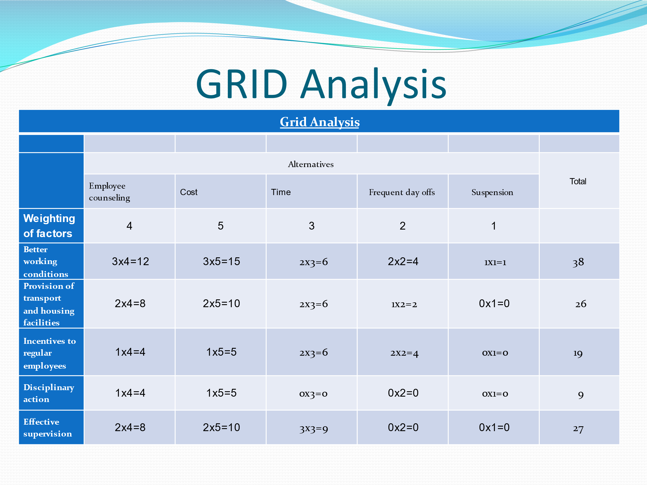
It's the most challenging difficulty for designers, managers, and innovators to make the right selection, especially when there may be more than one alternative to pick from and different considerations to consider. There are many different ways to achieve this aim. Still, one of the most common is to use a Decision Matrix Analysis (also known as the Grid Analysis and Pugh Matrix Analysis). Mid Cheshire Hospitals NHS Foundation Trust (MCHT) solutions may be organized in a grid-like this and the best one selected for the issue at hand. In this case, based on the Grid analysis results, employee counseling and better working conditions seem to be the most appropriate solutions to the problems at hand.

Implementation of the strategies
Changes are needed to the system for controlling absenteeism, and the most recent approaches and models should be used. Due to their increased usage, these models might assist employers in identifying workers who are intentionally misusing the system (Cucchiella et al., 2014). Team members know the game's rules and use them to their advantage. The practice has to be curtailed, and all workers in the company should get training on the importance of punctuality and the consequences of responsible absenteeism.
As a result of creating an Employee Assistance Program (EAP), workers are less likely to be absent from work. A variety of issues, including drug misuse, violence, conflict, and disease, are addressed by counselors in the program (Cucchiella et al., 2014). In Australia, where this kind of program has had great success in resolving employee issues, workers' attendance at work has become more regular. As a result of these other initiatives, workers will discover solutions to difficult instances and go back to work more often.
Every manager's ultimate objective should be to develop long-term goals and plans. In addition to reducing absenteeism, it's important to prevent it. Managers must have outstanding management policies, processes, and abilities (Cucchiella et al., 2014). Establishing a culture of attendance may be tough, but it is critical to guide the workers toward the desired outcomes using their expertise, skills, and charisma. Poor attendance at work not only immediately affects the bottom line, but it may also have a negative impact on other aspects of a person's life (Cucchiella et al., 2014). An employee turnover issue is easy to identify and address in a smaller company. Still, it becomes much more difficult in a big business to manage absenteeism and implement the theories that have been developed. However, a company may achieve minimal absenteeism by using modern tools and adhering to best management practices. The success if these strategies can be measured by looking at the rate of absenteeism at the institution. If the rate is reducing, then it means that the measures are working, if they are not, then it means that the measures are not working thus something else needs to be done.

Conclusion
The organization's culture heavily influences the rules and procedures of an organization. As a result, managers and executives do an excellent job of making sound judgments and instilling the proper culture via their actions and words. There must be a whole corporate commitment to encouraging attendance rather than managing absence if we want to create an attendance-oriented culture If this were to happen, it would be huge because of the negative effects it has on the bottom line as well as the organization's ability to grow its human capital and maintain a competitive edge.

Reference List
Badubi, R.M., 2017. A critical risk analysis of absenteeism in the work place. Marketing, 2(6), pp.32-36.
Bycio, P., 1992. Job performance and absenteeism: A review and meta-analysis. Human relations, 45(2), pp.193-220.
Cascio, W. F. and Boudreau, J. W. (2010). Investing In People Financial Impact of Human Resource Initiatives (2nd ed.) FT Press.
Chirumbolo, A. and Areni, A., 2005. The influence of job insecurity on job performance and absenteeism: the moderating effects of work attitudes. SA Journal of Industrial Psychology, 31(4), pp.65-71.
Cucchiella, F., Gastaldi, M. and Ranieri, L., 2014. Managing absenteeism in the workplace: the case of an Italian multiutility company. Procedia-Social and Behavioral Sciences, 150, pp.1157-1166.
Gangai16, K.N., 2014. Absenteeism at workplace: What are the factors influencing to it?.
Kocakulah, M.C., Kelley, A.G., Mitchell, K.M. and Ruggieri, M.P., 2016. Absenteeism problems and costs: causes, effects and cures. International Business & Economics Research Journal (IBER), 15(3), pp.89-96.
Ledesma, C.R.D., Crespo, H.G. and Castro, A.M.A., 2018. Absenteeism and job performance in nursing professionals from critical areas. Revista Cuidarte, 9(1), pp.1973-1987.
Liliana, L., 2016, November. A new model of Ishikawa diagram for quality assessment. In IOP Conference Series: Materials Science and Engineering (Vol. 161, No. 1, p. 012099). IOP Publishing.
Merrill, R.M., Aldana, S.G., Pope, J.E., Anderson, D.R., Coberley, C.R., Grossmeier, J.J. and Whitmer, R.W., 2013. Self-rated job performance and absenteeism according to employee engagement, health behaviors, and physical health. Journal of occupational and environmental medicine, 55(1), pp.10-18.
Patton, E., 2011. The devil is in the details: Judgments of responsibility and absenteeism from work. Journal of Occupational and Organizational Psychology, 84(4), pp.759-779.
Staufenbiel, T. and König, C.J., 2010. A model for the effects of job insecurity on performance, turnover intention, and absenteeism. Journal of Occupational and Organizational Psychology, 83(1), pp.101-117.

