Nicole Lewis
P150384
Word Count: 2100
Within a given time period, select examples of what could be considered high and low cultural artifacts. Discuss these, taking into consideration the surrounding social, political and historical context.
The focus of the following essay will be to explore and discuss the division of high and low art; a dichotomy that marked the 20th and 21st century, taking into consideration the social, political and historical context around it. Additionally, I will look at the parameters that influenced it, and discuss the interplay between high and low art, whilst providing examples.
When it comes to the circles of academics, high culture has been defined as a “set of cultural products,” which are held by the society in the highest regard (Fortin & Tuchman 1989, pg. 78). The term is relentlessly linked to the elite and ruling classes who have the means and ability to procure such exquisite creations, as well as the aristocracy. Being used mostly, to describe the aesthetically pleasing, connected to “all that is best” in creation, written, or thoughts on the world (William 2015, pg. 28). Some of the arts, preserved by the rich and the educated higher class were fine or historical art, literature and poetry. (squarespace.com)
By the turn of the 20th century, art had started to become far more expressive. There were occurrences of major changes, from wars to progressive economic, and political movements. Therefore, these changes were made apparent in the works of the artists throughout the course of the 20th century. Art was continually being challenged, as nationalism and imperialism changes had begun to spread, these underlying themes were shown within the artist’s work. (MoMA.org).
The transformation in which modern painters and sculptors underwent by reimagining the possibilities in the form of popular culture. Examples of this, are particularly shown in George Braque’s work, Homage to J. S. Bach, 1911, and Pablo Picassos, Still Life with Chair Caning, 1911. Whose work was both considered as being high art. However with the leading onset of industrialization, classic art that was made allowed way for the integration of modern culture. The view proposed by Clement Greenberg believes that Cubism is the first truly 20th century art because “it was the first to accept modern, industrializing world with enthusiasm”. (artnet.com) The uniqueness that cubism brought, using their own identity, on emphasising the normal facts is central to modern art practice.

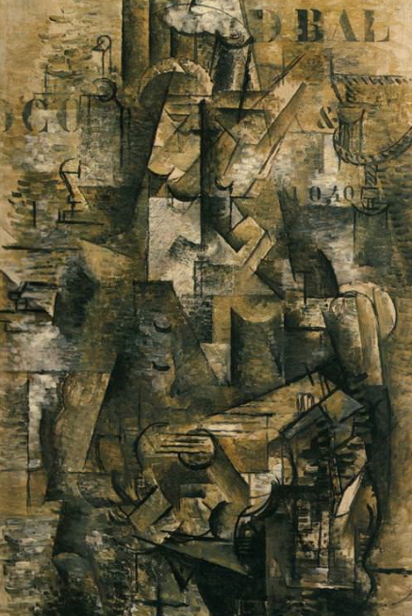

The Portuguese, 1911 by Georges Braque
With the invention of collage, in the beginning of the 20th century, embarked on a radical shift. Using materials such as fragments of newspaper, wallpaper, creating geometric abstracted works, negated the idea of art should be representational. “This split has been damned by elitists who have felt that the only true culture is by definition high, and limited to the enlightened few” (Kirk Varnedoe 1990: 17)
An example of high art is the painting, The Portuguese by George Braque, it highlights a remarkable development in the high art renowned piece of George Braque. Here shows one of his first works of the 20th century, with the incorporation of letters, here he has stencilled the letters “D BAL “, and underneath has roman numerals. His intention, of what first of all shows his incorporation of text that he began adding to normal paintings. (georgesbraque.org) The letters he used were centrally concerned with the words of the modern world, of daily newspapers.

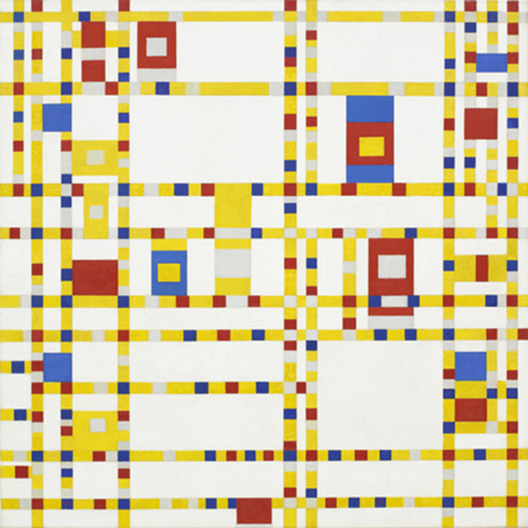

Piet Mondrian Broadway Boogie Woogie 1942–43

Piet Mondrains work is a key example, of the transition that low art had upon high thought of artists. His artistic integrity, lead him to be cherished by all, even those of completely different artistic styles, he was regarded as a classical master. Having escaped to New York, Mondrian was intrigued by the American Jazz, in particular boogie-woogie. Mondrain soon obtained a key position in the international avant-garde, in 1920. He radically simplified, his paintings down to the basic elements. (theartsstory.org) In his piece Broadway Boogie Woogie, it consisted of the fundamental aspects of colour and line, achieving that essence of modernism within his work, the representation of dynamic life. Also of that was expressed in modern jazz, in which he called, in his own work, the "destruction of natural appearance; and construction through continuous opposition of pure means—dynamic rhythm." In his piece the Broadway Boogie Woogie, his canvas is paraded with bright yellow lines that intersect one another. Different coloured squares, which portray the chromatic pulses, as though they are in traffic, blinking with red and blue electric lights, in which beautifully portrays the energy and rhythms of jazz.

The continual blend amongst the two levels was established in the twentieth century. From modern arts embodiment of surrealism, to Dadaism, along with pop art, all of which took control of the art scene. This art displayed a clear contrast to anything that was ever done before. Moreover, leaving both audiences overlapped. Artists that were once considered as low art, conversely, these artists were being marked as high art. Low popular culture, proceeded to amplify as a reputable form of art. Being massively produced were an array of products such as, comic books to billboards, and even gift wrap, making it broadly exposed to the public.
Examples of what is seen as low art are graffiti, comic books and broad domain of advertising. All of sorts that flowered through this era, graffiti that “...had traditionally considered irrelevant” had been revisited. These forms of art, are influenced by uses of conflicts and politics. (Kirk Varnedoe, 1990: 12) “in the cheap reproductions he brushed his way out of the museum, in the brightly coloured commercial posters along the boulevard and in the shop windows of the department stores, in the newspapers and cartoon journals of the morning, stacked up in kiosks along the quai, and even the mean scrawling’s on the walls of the darkened side streets- was an alphabet for art’s new language” (Kirk Varnedoe, 1990: 15)
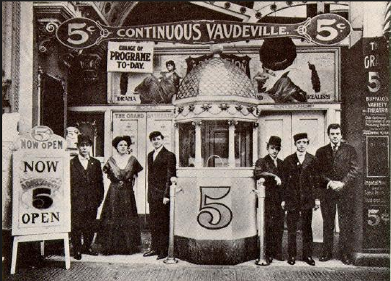

Vaudeville, 1903

One example that is considered to be low cultural art is, Vaudeville. Vaudeville refers to the theatrical assortment entertainment prominent in Canada and United States, from the 1880s to the 1930s. The performances were made in a sequence of different and unrelated acts that were combined collectively in a common bill (Lattari, 2016, p. 72). Various acts comprised of classical and popular dancers, trained animals, dancers, magicians, musicians, jugglers, acrobats, and impersonators. Prior to Vaudeville, the upper class would be found attending operas. The art developed from several sources such as dime museums, burlesque, freak shows and concert saloon. Vaudeville was beyond the usual entertainment since it acted like a reflection of rampant changes of the American life (Soucy and Fischman, 2012, p. 42). The show would consist of “lowbrow” acts that were considered popular entertainment with the further addition of “highbrow” acts of classical musicians (Mortaljourney.com). During the time of Vaudeville, USA was experiencing uncontrolled growth and urbanization, amplified diversity together with upward social mobility. American developed making it the real actualization of the USA dream for the society, patrons, and performers.
The art demonstrates the historical moment when massive immigrants from Europe flocked to America in search of salvation with the new land. Several settlers tried to find luck in the performances which lead the showcasing of foreign themes and varied cultures. Via entertainment and humour, the shows elevated positive exposure to the developing urban immigrant people in USA and African Americans (Massey and Seago, 2017, p. 118). Therefore, the vaudeville modified cultural perceptions of the foreigners promoting acceptance rather than bigotry and racism. Besides, the performance promoted integration and unity among different residents who had the varying ethnic background. A common assumption is that low art, is just for entertainment. Vaudeville produced such a profound impact on popular culture. (mortaljourney.com)
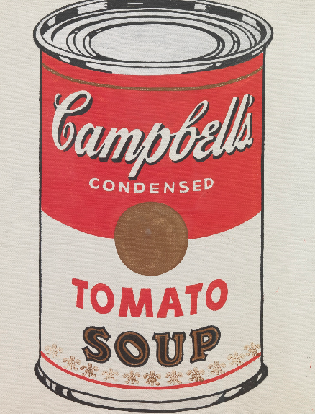
Additionally, Pop culture can be greatly associated with mass culture in the society, or as Theodor Adorno refers to it “the Culture industry” since it’s not established by the masses but it is for the masses (Adorno and Bernstein 2007, pg. 98). Low art has been viewed as an endless cycle of “popular culture.” Low culture is usually criticized by supporters of high culture as being “commoditized.” Herbert J. Gans defines low culture: “...there is no explicit concern with abstract ideas or even with fictional forms of contemporary social problems and issues. ... Low culture emphasizes morality but limits itself to familial and individual problems and [the] values, which apply to such problems.”

A further example is that of Andy Warhol. An artist whom is considered to have removed the barrier between low and high art, transforming pop-culture to be massively revered, and held in galleries with high art works. The effect not only came to light, because of his posturized style, but much so because of both the assumption, and the mainstream culture that it had in achieving eminence. The moral of his work being primarily, the product and the packaging that you see. His work, "Campbell's Soup Can "was an echo of usual magazines and posters of the time period that communicated and emphasized the beauty of a mechanical production. This art work marked a breakthrough, where he started to apply repetition showing reproduction, that arisen from the American commodity culture at the time (Moma.org). By taking art that we see on ordinary wares, and using that picture on a canvas (phaidon.com). He made the union among low and high-class art, amplifying the pop-culture movement. Under the influence of technology, the viewpoint of both society and culture had been revolutionized. Andy Warhol emphasized the importance, of the acceptance of machines, therefore stating it does not in any way give reason to decrease its artistic value. Therefore meaning now, the two cultural vectors intersect during the contemporary. (tate.org).
According to Judith R Blau, professor of sociology at the University of Carolina, (Judith R. Blau, May/June 1986, Society, vol 23 issue 4 p.65) ‘The emphasis in the sociology of culture changed during the 70’s largely as a result of writings by Herbert Gans and Richard Peterson, who stressed that high culture is not intrinsically superior nor popular culture intrinsically inferior’. Therefore suggesting that traditional, and art that was seen as popular, influenced one another, bringing together the divide between low and high art. Theoretician Jozef Kovalcik says “…since the 1960’s high culture was open to popular culture and democratization”
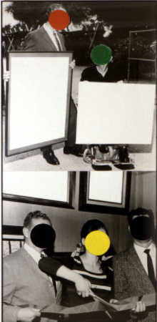

Cutting Ribbon, Man In Wheelchair, Paintings (Version #2), 1988

John Baldessari similarly used the technique of “combining Pop Art's use of mass media imagery with conceptual art’s use of language to create a unique body of work that has become a hallmark of postmodern art” (yourartshop.com). Baldessari's work is a great example of destroying the low and high art boundaries, combining Pop Art’s use of imagery from the mass media with Conceptual art. This included black and white photographs, whilst displaying them in altered configuration. (artnet.com) The viewer is then forced to correlate meaning of each, fragmented movie stars, or fragmented character. To some viewers his work may be suggested as perhaps loathing for mainstream film, his work endorsed characteristics of low art, the characteristics being reproduction and easy (theartstory.org). As he highlighted these early text and image paintings, additionally in his very influential 1980’s photo based works, in which he explored the artistic along with cultural impact on mass media. His painting Cutting Ribbon, Man In Wheelchair, shows his signature technique, by using colourful circles, to look like these people in news paper clippings look as though they had a price sticker stuck on their face. (npr.org)
This approach accommodates the tastes of both new like that of Salvador Dali at the Reina Sofia, or additionally, Marina Abramovic’s retrospective at MoMA, which is aimed at mass audiences however, reinforcing the crossover of what we call high art, streaming into the normal culture, “to oppose an art which generates though and sensations to an art which generates thought and sensation, to an art that produces nothing but the reputation of its premises, that needs a cultural crutch to exist” (Nicolas Bourriaud)

In conclusion, both low and high culture is the necessity of 20th and 21st-century art. The advancement of technology, has expanded culture into lower and wider audiences. Generally, pop culture is adapted easier than high art, often utilizing the overall “look”, as primarily an inspiration, or reflection to the eventual leading of mass product. Whilst, high art continues to insist on communicating that their works are, very intellectual, in which prevent mass consumers from understanding. Although this is not always the case. Ultimately, high and pop culture, are part of the same string, in which two ends of the rope signal their different manifestations of the rope, and are not necessarily the most fundamental. (squarespace.com) In which each artist is confronted with the risk, of watering down the product of interest by appealing to the public and shying away from any kind of complexity. Furthermore, Pop culture is the acceptance, and acceptance in ways can be seen as the reverse of what is seen as high culture. Despite the fact that cultural practices have now developed further, the high and low argument continues to still be prominent. Although, from acknowledging the levelling of these art cultures, in which quantity has changed to quality, the problem of the matter being that culture has become synonymous.

References
Adorno, T. and Bernstein, J. (2007). The culture industry. London [u.a.]: Routledge.
Artspace. (2015). 12 Masterpieces of 21st-Century Painting You Need to Know Now. [online] Available at: https://www.artspace.com/magazine/art_101/book_report/phaidon-twenty-first-century-painting-masterpieces-list-53386 [Accessed 13 Dec. 2017].
Bernárdez, E. (2013). On the cultural character of metaphor. Some reflections on universality and culture specificity in the language and cognition of time, especially in Amerindian languages. Rev. Cogn. Linguist. 11, 1–35.
Birth, K. (2012). Objects of Time: How Things Shape Temporality. New York: Palgrave Macmillan.
Bloom, P. (1996). Intention, history, and artifact concepts. Cognition 60, 1–29. doi: 10.1016/0010-0277(95)00699-0
Boella, G., and van der Torre, L. W. (2004). Regulative and constitutive norms in normative multiagent systems. KR 4, 255–265.
Boivin, N. (2008). Material Cultures, Material Minds: The Role of Things in Human Thought, Society and Evolution. Cambridge: Cambridge University Press.
Bourdieu, P. (1977). Outline of a Theory of Practice, transl. R. Nice (Cambridge: Cambridge University Press).
Bruner, J. S. (1990). Acts of Meaning. Cambridge, MA: Harvard University Press.
Bühler, K. (1990/1934). “Theory of language,” The Representational Function of Language, transl. D. F. Goodwin (Amsterdam: John Benjamins).
Chomsky, N. (2000). The Architecture of Language. Oxford: Oxford University Press.
Clark, A. (2006). Language, embodiment and the cognitive niche. Trends Cogn. Sci. 10, 370–374.
George Braque. (2018). The Portuguese, 1911 by George Braque [online]. Available at: http://www.georgesbraque.org/the-portuguese.jsp. [Accessed on: 19/03/2018].
Hanquinet, L., Savage, M., 2015. Routledge International Handbook of the Sociology of Art and Culture. Taylor and Francis, Milton.
Hultgren, K., 2016. The art of animal drawing: construction, action analysis, caricature. Greenpoint Books, Greenpoint Books.
John Baldessari. (2000). Synopsis. [Online] Available at: cloudhttp://www.theartstory.org/artist-baldessari-john.htm. [Accessed 13 Dec.2017].
John Baldessari. (2017). Brain Cloud. [Online Available at: https://yourartshop-noldenh.com/john-baldessari-brain. [Accessed 13 Dec 2017].

Kirk Varnedoe. (1990). Modern Art, Popular Culture. Museum of Modern Art, N.Y.
Lattari, K., 2016. American Vaudeville. Mammoth Books, DuBois, Pennsylvania. Page 19-42.
McEvilley, T. (1992) Art & Otherness, Crisis in Cultural Identity. New York: McPherson & Company.
National Public Radio. (2013). For John Baldessari, Conceptual Art Means Serious Mischief [online]. Available at: https://www.npr.org/2013/03/11/173745543/for-john-baldessari-conceptual-art-means-serious-mischief. [Accessed on 12/03/2018].
Moma. (2011). Piet Mondrian Broadway, Boogie Woogie [online] Available at:
https://www.moma.org/collection/works/78682. [Accessed on 12/03/2018]
Moma. (2018). George Braque [online] Available at: https://www.moma.org/collection/works/36110. [Accessed on 11/03/2018]

Mortal Journey. (2018). Vaudeville Theater Shows 1900’s [online] Available at:
http://www.mortaljourney.com/2011/03/all-trends/vaudeville-theater-shows.
[Accessed on 11/03/2018].
Moma. (2018). Calendar Exhibitions [online]. Available at: https://www.moma.org/calendar/exhibitions/1517/. [Accessed on 19/03/2018].

Owlcation. (2016). 20th Century Art Movements with Timeline [online]. Available at: https://owlcation.com/humanities/20th-Century-Art-Movements-with-Timeline.
[Accessed on 11/03/2018].
Phaidon. (2016). The Fascinating story behind Andy Warhol's soup cans. [online] Available at: http://uk.phaidon.com/agenda/art/articles/2013/february/22/the-fascinating-story-behind-andy-warhols-soup-cans/. [Accessed 13 Dec 2017]
Pizzino, C., 2016. Arresting development: comics at the boundaries of literature. University of Texas Press, Austin.
Rose, L., 2016. Psychology, art, and antifascism Ernst Kris, E.H. Gombrich, the politics of caricature. Yale University Press, New Haven
Simmel, G. and Levine, D. (2015). Georg Simmel on individuality and social forms. Chicago: The University of Chicago Press.
Tate. (2017). Andy Warhol 1928-1987 [online] Available at: http://www.tate.org.uk/art/artists/andy-warhol-2121. [Accessed on 13 Dec 2017].
Tuchman, G. and Fortin, N. (1989). Edging women out. New Haven (Conn.): Yale University Press.
Williams, R. (2015). Television. Routledge.
YouTube. (2011). Birtwistle - Opera The Minotaur. [online] Available at: https://www.youtube.com/watch?v=tmBuvePA-WE [Accessed 13 Dec. 2017].

