Student: Yanko Yankov
Student number: 2127550
Module: Effective Team Working and Communication
Module code: BMSW4002
Lecturer: Hafiz Rahmani

Executive summary

It is not unusual to see a group of individuals collaborating to achieve their objectives in today's society. Families and instructors inspire us to collaborate with friends and classmates through a variety of approaches when we are still children. Families, educators, and other school administrators begin by emphasizing cooperation and stressing the importance of collaborating together to achieve a common objective, whether it's a sports organization, a school group, or an integrated development environment. Everybody continue to make an effort to interact as they navigate various challenges and different ages. Everyday existence involves communicating in some way. In below work will be covered all aspects, theories and strategies which are able to solve and support Tom’s objectives and targets as per of the Amazon group expansion.

Contents
Executive summary 2
Introduction 4
How to develop an effective team and what team development stages model can be used? 5
Bruce Tuckman's Model 5
Forming 5
Storming 5
Norming 6
Performing 6
Adjourning 7
What team roles are needed to create an effective team? 7
Belbin team roles 8
What are the benefits of teamwork? 9
What are the barriers to effective teamwork identified in this scenario? 9
Conclusion 10
Referencing list 11

Introduction

Team work and communication within the team members are the key essential challenges and highly important tasks to be done daily in each organization. No company can be profitable and sustainably currently with lack of team work and high effective communication. This is the reason there is many theories and methods for improving the team work, improving the communication levels and making sure each daily short terms and long terms objectives are fully achieved. Medium and large companies have higher challenges with this focus and this is the reason they recruit only managers with higher skills and experience when comes to team motivation and management. Team problem solving is other very often challenge which is important part of the daily responsibility and tasks of each manager or team leader. Every problem within the team needs to be solved with quick timely manner and no delay, because this may cause damaging the whole team member performance and results as outcome. Amazon as a global e-commerce giant also have challenges which will be detailed analyzed below, will be provide solutions and effective theories for achieving the company objectives (Lester,2021).

How to develop an effective team and what team development stages model can be used?

Bruce Tuckman's Model
Bruce Tuckman's Model for Team Development is very detailed and useful model which can be used very properly and effectively for the team development and creation. With this model is explained very specific and properly the five stages of the team development for being maximum effective. The defined stages are Forming, Storming, Norming, Performing and Adjourning and there will be detailed explanation for each stage below as showed over the figure one (Pachilova,2021).

Forming
This is the stage when the team is completely new and the team members never met before. At this stage they star to know each other and to start understanding what are their roles and responsibilities. At this stage there is no leaders and each member just start to funding out what is the next steps, daily tasks, the actual inductions and company procedures. This stage is very important, because here is the creation of the team base and the better and smooth is this stage the more results will be delivered from the team in near future (Peachey,2022).

Storming
During the storm stage the team is discovering that team work is not that simple process and that everyone is different as personality, knowledge, skills and social background and this needs to be managed in order to be achieve smooth team work and maximum productivity and results. This stage is very important because here the different characters and personalities learn how to work and collaborate each other and that there is no options for individual work. Here the management need to have strict control in order to ensure that any serious challenges are solved with positive manner and as per the company interest and targets. For example if there is conflict between two or more team members the management need to make sure that the issue is solved, everyone point of view are listen and every member understand that the team work is first priority for the company (Pachilova,2021).

Norming
The norming stage is becoming when the team already knows each other and start behave as team with collaboration and supporting each other daily tasks or challenges. At this stage there is still need of more consistent control from the management, because each member just gets used to it to work as part of the team and focus over the company interests not the individual interest or needs.
At this stage for example the team clearly understand the importance of each member and the contribution of every member to the final target for the company interest. In case there is difficult task the team now knows that everyone need to support and help, because the target is for the team not the individual (Peachey, 2022).
In the Tom’s situation there is need of honest and creative conversation with each member separately one meeting with Mihaela and separate with Spencer in order to find out the details about the issues and challenges and to smartly and effectively offer solutions for both team members for solving the challenges. In case there is still issue and lack of contribution from both team members then there is need of involving Human Recourse manager for investigations and finding the most positive outcome from the situation. The case could be only that those team members needs feels afraid from the changes and that they may lose their job positions so Tom and the HR manager need to find out what is the real actual issue and to suggest to the members options for solution which also can be trainings, developments and this can turn the situation for better team work and more results for the company (Procházková,2022).

Performing
Performing is the stage which period of time the team need to stay and deliver results as maximum level and to produce maximum benefits and profit for the company. Each organization focus to manage and to keep the team at this stage longer time until the job is completed or project is finished. In example where to work will be consistent then the HR needs to manage the team and to ensure they will stay at this stage all the time so there will be consistent results for the company.

Adjourning
This stage is linked to the period where the targets are achieved, project is finished or task completed and the management need to breaking up the team as there is no any work to be done. At this stage could be very helpful to keep the best team members maximum engaged for the future tasks or projects. Many smart managers or owners plan the next project in advance so there is minimum gap between the end of the first project and the start of the next one. This is done with the aim of keeping the best hard working people to do not looking or find other job as this could be again extra expenses for advertising, selection, recruitment and offering process of new employees and the future training for successful completion of the tasks and company profit (Procházková,2022).

Figure 1
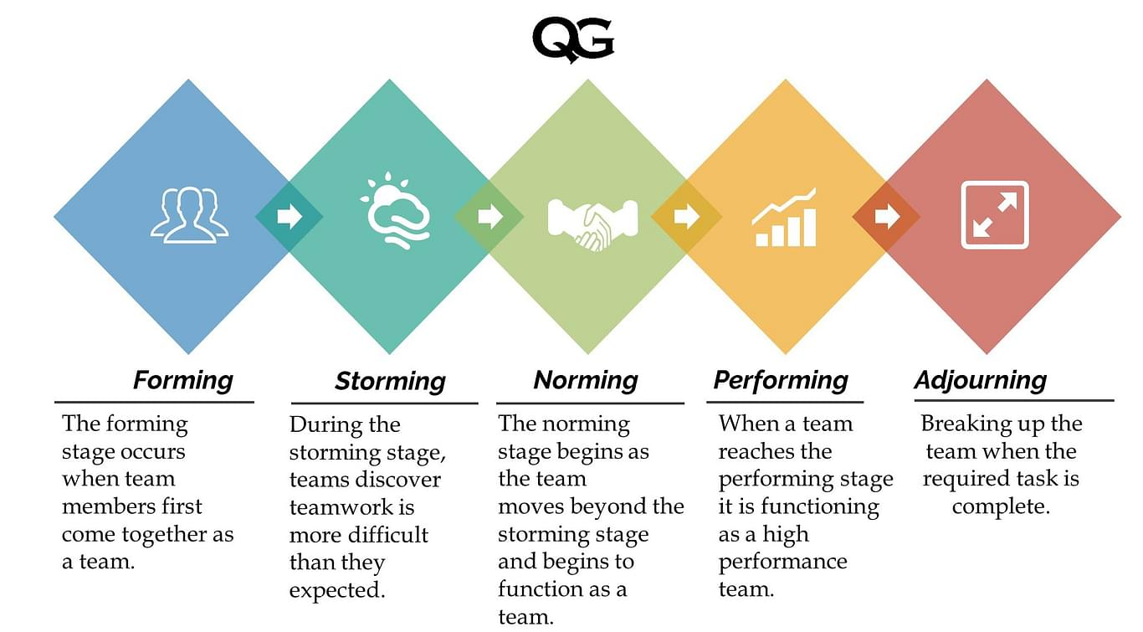
(McMenemy,2022).
What team roles are needed to create an effective team?
Each team needs to have clearly and specific defined job description and specific roles which correspondent to specific responsibilities and tasks every day. This way each individual knows what, when and how need to be completed so at the end the whole team performance need to achieve the set objectives and targets for short and long terms (McMenemy,2022).

Belbin team roles
Individuals in teams frequently take on multiple "team roles," according to Dr. Meredith Belbin, who spent years studying collaboration. He identified nine unique team roles that underpin successful teams and characterized a team role as "a tendency to behave, participate, and interacts with other people in a specific way."
The roles set by Dr. Meredith Belbin are Resource Investigator, Team worker, Coordinator, Shaper, Completer finisher, Implementer, Plant, Specialist and Monitor evaluator. Those roles cover the all average company and business tasks, activities and targets. The most important aspect of this is that the roles must work within maximum collaboration and communication between each of the roles, because this will work for delivering maximum profit and sustainability for the company (Kennedy,2021).
For example in case Tom have specific targets and expectations, but in case they aren’t communicate with the management, team members or with the financial department or accountant then there could be serious losses and missed opportunities as outcome. Definitely also the set objectives will be not achieved due to the miscommunication between the roles within the company.
Figure 2
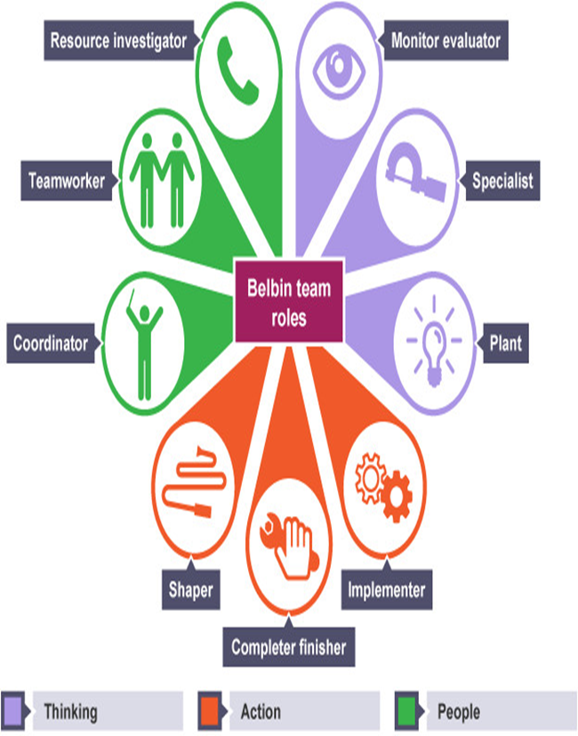
(Bonanno,2021).

What are the benefits of teamwork?
Team work is defined as individuals which working together focused over one main goal or target. Those team members working and helping each other on daily tasks and objectives with them focus that the target needs to be achieved with the group efforts and dedications. Important part of the team work is that everyone helping and supporting each other and even learning one from other so this way the team target will be achieved for sure.
Team work is expected currently from every business from all around the world, because it is proven during the past fifty years that the team work is delivering higher results and profit when comparing with the individual. The Human Resources of every company have the difficult and complex tasks to recruit, select, interview, choice, offer, provide induction, trainings, personal development reviews and when need investigations and disciplinaries, so at the end will be delivered high results and profit from the team for the company (Ford,2021).
What are the barriers to effective teamwork identified in this scenario?
In order to achieve success Tom need asap to create plan and strategy how to manage successfully Mihaela and Spencer situation. In the specific situation Tom need to firstly start conversation one to one with each of them and to investigate what exactly is the problem. Both of them are mostly interested what they will gain so Tom can try to use this and to give them information about future options for promotions, bonuses or pay increase if the project and team targets are fully achieved (Kumah,2021).
In case there is again challenges and both of the employees not cooperate and refusing to do their best for the project then in this situation Tom need to involve Human Resource into the case and to be set official meeting where Mihaela and Spencer are separately invited to attend and to be find and recorded solution where they both will fully support the expansion and the new delivery services. After those meetings in case there is again evidences that they both do not cooperate to the project then the HR manager and Tom need to organize official investigation, disciplinarians or even cancelling their contracts so the company can be able to recruit new one more experienced and more motivated members which to delivered success for the set targets and objectives (Reedy,2021).

Conclusion

From the provided report and solutions is visible that Tom as representing Amazon is able to use different strategies, methods and approaches in order to find best solution for the current situation with the both employees which refusing to support the company expansion and success. Also it is visible how important is the understanding of the communication and team work, because they are critical and very important part of the group and company success. Tom need to use the provided methods for analysis of the situation and to find best possible solution and decision for the Amazon success and maximum profit from the improving and increasing delivery services into the three selected locations.

Referencing list

Anderson, J.E., Lavelle, M. and Reedy, G., 2021. Understanding adaptive teamwork in health care: Progress and future directions. Journal of Health Services Research & Policy, 26(3), pp.208-214.
Gandica, T., Talwar, M., Thungon, S.W., Pyrtuh, E.K.D. and Kumah, E., 2021. Internal Communications In The Time Of A Global Pandemic.
Jankelová, N., Joniaková, Z. and Procházková, K., 2022. The way to business competitiveness: the importance of diversity management and teamwork climate in stabilizing of employees. Journal of Business Economics and Management, 23(3), pp.606-625.
Newman, S.A. and Ford, R.C., 2021. Five Steps to Leading Your Team in the Virtual COVID-19 Workplace. Organizational Dynamics, 50(1), p.100802.
Ostrom, A.L., Field, J.M., Fotheringham, D., Subramony, M., Gustafsson, A., Lemon, K.N., Huang, M.H. and McColl-Kennedy, J.R., 2021. Service research priorities: managing and delivering service in turbulent times. Journal of Service Research, 24(3), pp.329-353.
Paige, J.T., Kerdolff, K.E., Rogers, C.L., Garbee, D.D., Yu, Q., Cao, W., Rusnak, S. and Bonanno, L.S., 2021. Improvement in student-led debriefing analysis after simulation-based team training using a revised teamwork assessment tool. Surgery.
Ploeger-Lyons, N.A. and Keyton, J., 2021. Work Processes in Teams. In The Emerald Handbook of Group and Team Communication Research. Emerald Publishing Limited.
Robinson, E., Ruthven, I. and McMenemy, D., 2022. Delivering services in the new normal: Recording the experiences of UK public library staff during the COVID-19 pandemic. Journal of Librarianship and Information Science, p.09610006221093371.
Sailer, K., Koutsolampros, P. and Pachilova, R., 2021. Differential perceptions of teamwork, focused work and perceived productivity as an effect of desk characteristics within a workplace layout. PloS one, 16(4), p.e0250058.
Saville, J.D., Spain, R.D., Johnston, J.H. and Lester, J.C., 2021, July. Exploration of team communication behaviors from a live training event. In International Conference on Applied Human Factors and Ergonomics (pp. 101-108). Springer, Cham.
Swanson, S., Todd, S., Inoue, Y. and Welty Peachey, J., 2022. Leading for multidimensional sport employee well-being: the role of servant leadership and teamwork. Sport Management Review, pp.1-23.
Wu, C., Song, Y., March, V. and Duthie, E., 2022. Learning from Drivers to Tackle the Amazon Last Mile Routing Research Challenge. arXiv preprint arXiv:2205.04001.
Yu, W., Hassan, A. and Adhikariparajuli, M., 2022. How Did Amazon Achieve CSR and Some Sustainable Development Goals (SDGs)—Climate Change, Circular Economy, Water Resources and Employee Rights during COVID-19?. Journal of Risk and Financial Management, 15(8), p.364.
Zajac, S., Woods, A., Tannenbaum, S., Salas, E. and Holladay, C.L., 2021. Overcoming challenges to teamwork in healthcare: a team effectiveness framework and evidence-based guidance. Frontiers in Communication, 6, p.606445.

