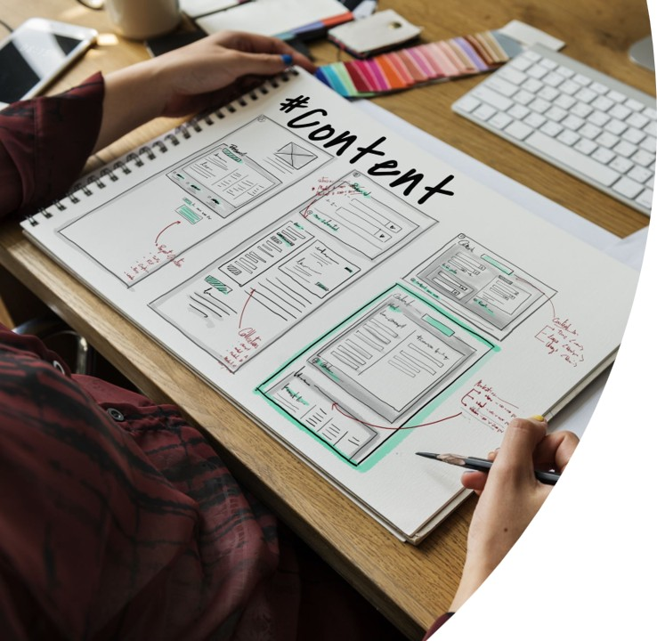  assessment  COMPONENT 2 Professional Development Plan (PDP) |   Oana Stoica  Learning in The Digital Era

Contents
Task 1 – Self-evaluation 2
Task 2 – PDP. 3
Task 3 – Learning to learn summary 7
References 9

Task 1 – Self-evaluation

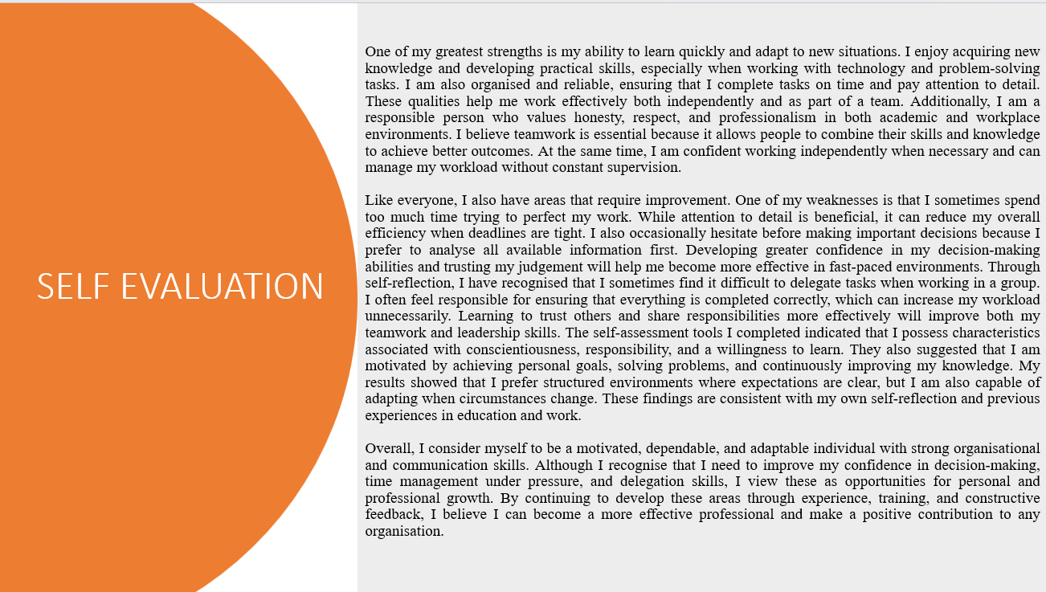
One of my greatest strengths is my ability to learn quickly and adapt to new situations. I enjoy acquiring new knowledge and developing practical skills, especially when working with technology and problem-solving tasks. I am also organised and reliable, ensuring that I complete tasks on time and pay attention to detail. These qualities help me work effectively both independently and as part of a team. Additionally, I am a responsible person who values honesty, respect, and professionalism in both academic and workplace environments. I believe teamwork is essential because it allows people to combine their skills and knowledge to achieve better outcomes. At the same time, I am confident working independently when necessary and can manage my workload without constant supervision.
Like everyone, I also have areas that require improvement. One of my weaknesses is that I sometimes spend too much time trying to perfect my work. While attention to detail is beneficial, it can reduce my overall efficiency when deadlines are tight. I also occasionally hesitate before making important decisions because I prefer to analyse all available information first. Developing greater confidence in my decision-making abilities and trusting my judgement will help me become more effective in fast-paced environments. Through self-reflection, I have recognised that I sometimes find it difficult to delegate tasks when working in a group. I often feel responsible for ensuring that everything is completed correctly, which can increase my workload unnecessarily. Learning to trust others and share responsibilities more effectively will improve both my teamwork and leadership skills. The self-assessment tools I completed indicated that I possess characteristics associated with conscientiousness, responsibility, and a willingness to learn. They also suggested that I am motivated by achieving personal goals, solving problems, and continuously improving my knowledge. My results showed that I prefer structured environments where expectations are clear, but I am also capable of adapting when circumstances change. These findings are consistent with my own self-reflection and previous experiences in education and work.
Overall, I consider myself to be a motivated, dependable, and adaptable individual with strong organisational and communication skills. Although I recognise that I need to improve my confidence in decision-making, time management under pressure, and delegation skills, I view these as opportunities for personal and professional growth. By continuing to develop these areas through experience, training, and constructive feedback, I believe I can become a more effective professional and make a positive contribution to any organisation.

Task 2 – PDP.

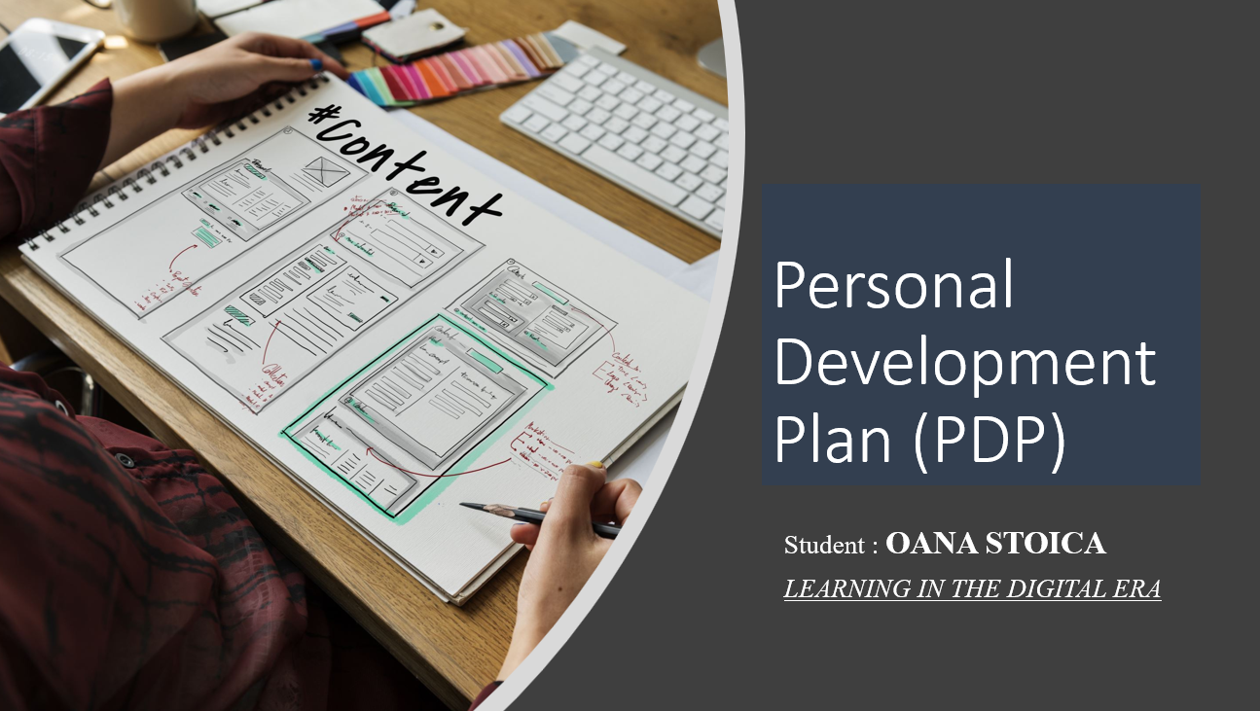
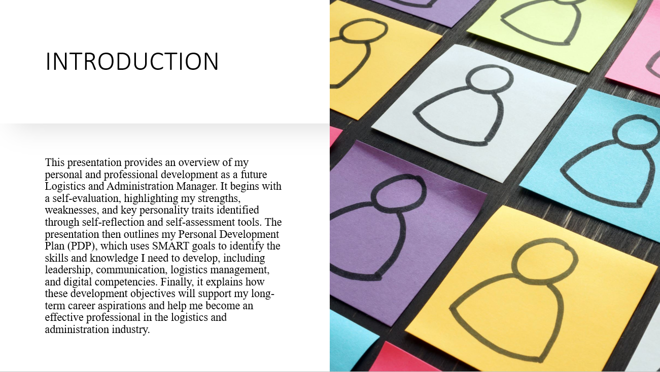
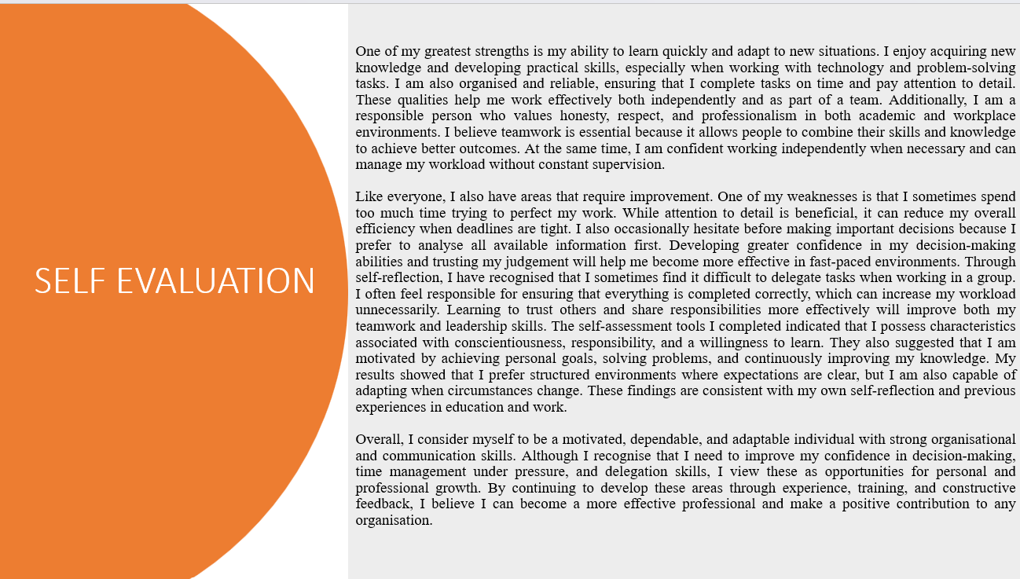
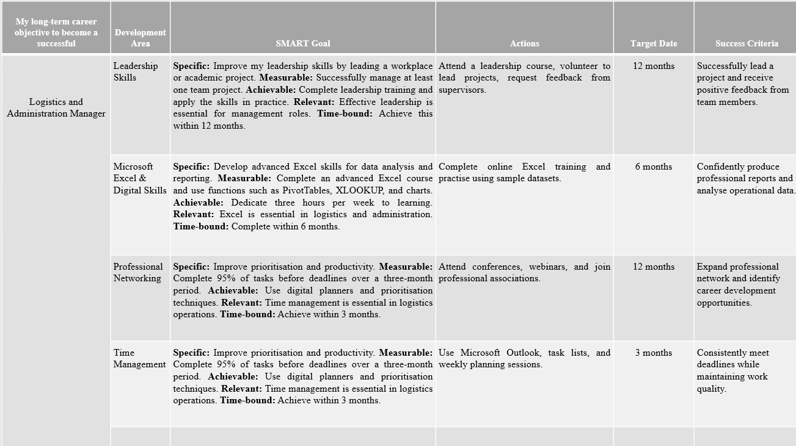
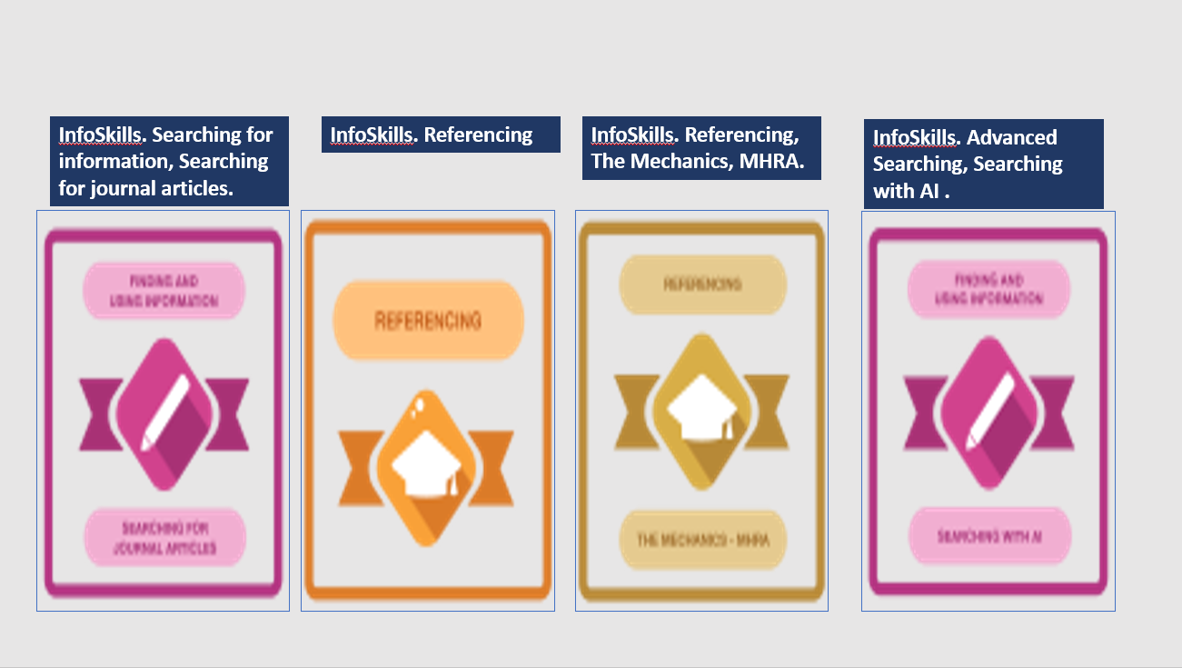
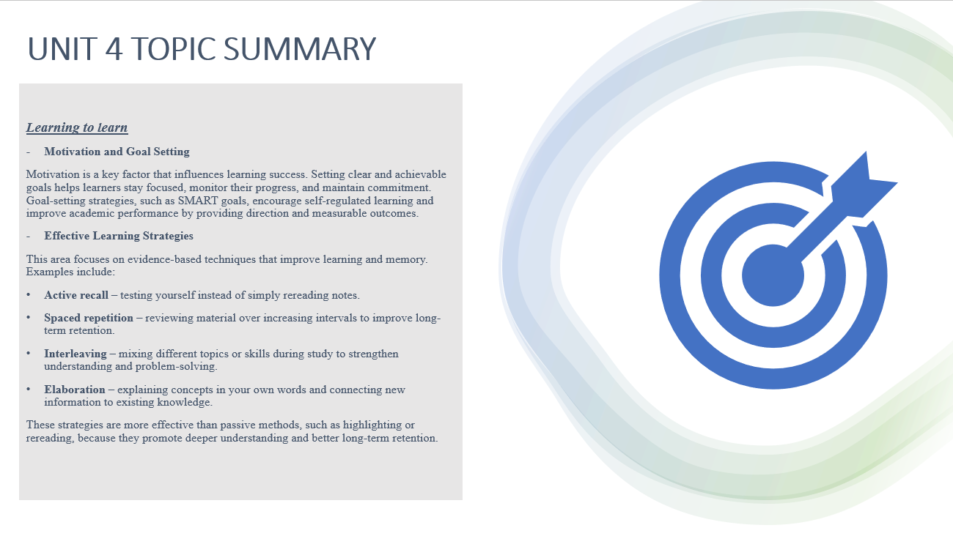
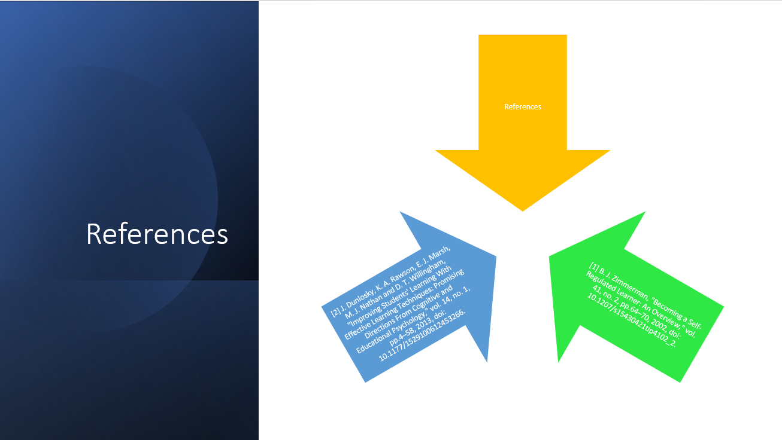

Task 3 – Learning to learn summary

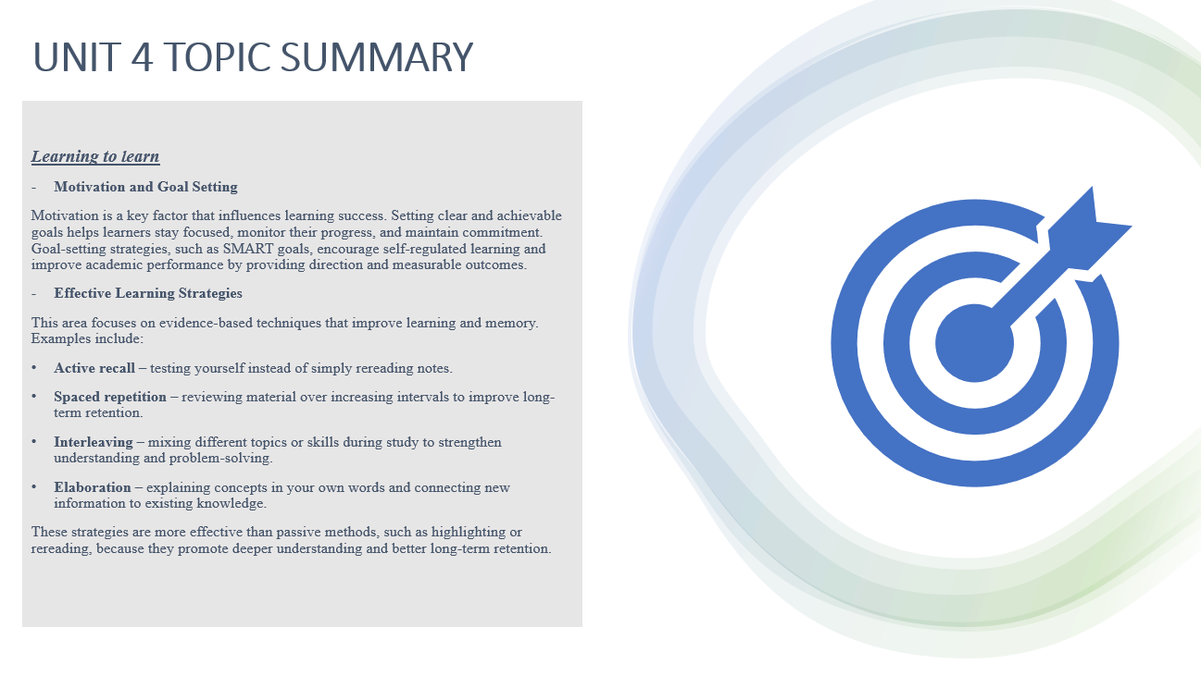
My presentation topic is "Learning to Learn" and two of the principal concepts I could include in my video presentation are:
Effective Learning Strategies
[1]This area focuses on evidence-based techniques [2] that improve learning and memory. Examples include:
- Active recall – testing yourself instead of simply rereading notes.
- Spaced repetition – reviewing material over increasing intervals to improve long-term retention.
- Interleaving – mixing different topics or skills during study to strengthen understanding and problem-solving.
- Elaboration – explaining concepts in your own words and connecting new information to existing knowledge.

Motivation and Goal Setting
Motivation plays a key role in successful learning.[1] Setting clear, realistic goals helps learners stay focused, measure progress, and maintain commitment. Using SMART goals (Specific, Measurable, Achievable, Relevant, and Time-bound) can improve motivation by giving learners a clear direction and sense of achievement as they reach milestones.
In conclusion, learning to learn is an essential skill that enables individuals to become more effective, independent, and lifelong learners. Developing a growth mindset encourages learners to embrace challenges, persist through setbacks, and view mistakes as opportunities for improvement. [1]At the same time, motivation and goal setting help learners maintain focus, monitor their progress, and achieve their learning objectives through structured planning and self-discipline.
Learning Outcomes:
- Understand the importance of a growth mindset in improving learning and resilience.
- Recognise how motivation influences learning success and academic performance.
- Apply effective goal-setting techniques, such as SMART goals, to improve learning outcomes.[3]
- Develop self-regulated learning habits that support continuous personal and professional development.

References

[1] B. J. Zimmerman, "Becoming a Self-Regulated Learner: An Overview," vol. 41, no. 2, pp.64–70, 2002, doi: 10.1207/s15430421tip4102_2.
[2] J. Dunlosky, K. A. Rawson, E. J. Marsh, M. J. Nathan and D. T. Willingham, "Improving Students' Learning With Effective Learning Techniques: Promising Directions From Cognitive and Educational Psychology," vol. 14, no. 1, pp.4–58, 2013, doi: 10.1177/1529100612453266.

