Project Management
LCLM5003

Part A: Poster
Part B: Reflection on Feedback
Part C: Project Management Plan

Student name: Daniel Fratczak
Student ID: 2424154
Table of Contents

Part A: Poster 2
Part B: Reflect critically on the feedback received from tutor and peers 12
Introduction 12
Key strengths 13
Areas for improvement 13
How does feedback inform changes to your final project management plan 14
Conclusion 15
Part C: Project Management Plan 16
1. Introduction 16
2. Project description 17
3. Scope 17
4. Work breakdown structure (WBS) 18
5. Quad Chart 19
6. Gantt Chart 20
7. Stakeholders' involvement 21
8. Allocation of resources 23
9. Risk Analysis 25
10. Conclusion 28
References 29

Part A: Poster
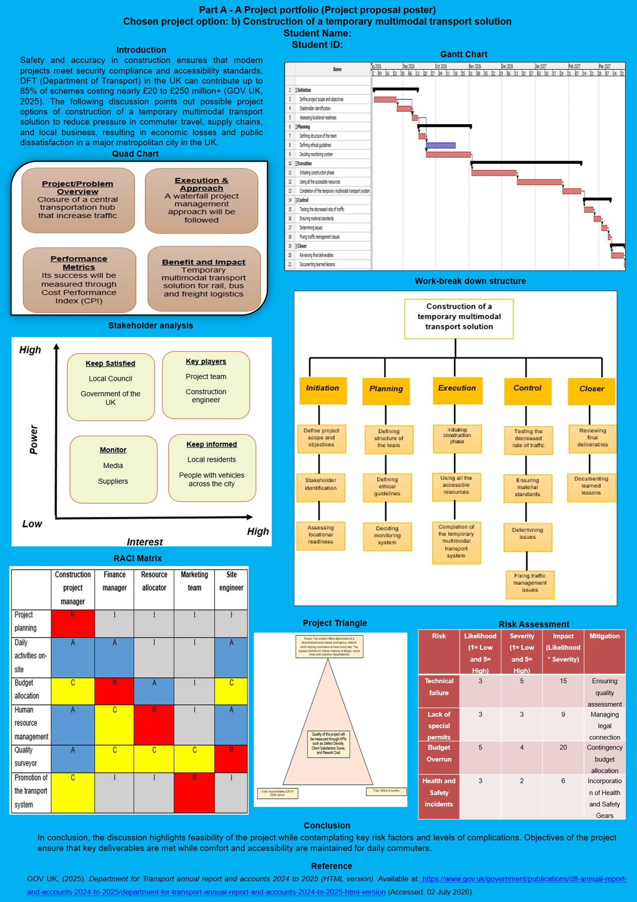

Slide Content
Introduction
Safety and accuracy in construction ensures that modern projects meet security compliance and accessibility standards. DFT (Department of Transport) in the UK can contribute up to 85% of schemes costing nearly £20 to £250 million+ (GOV UK, 2025). The following discussion points out possible project options of construction of a temporary multimodal transport solution to reduce pressure in commuter travel, supply chains, and local business, resulting in economic losses and public dissatisfaction in a major metropolitan city in the UK.

Main Analysis
Project background and rationale
Background
A major metropolitan city in the UK experienced major disruption in November 2025, due to closure of a central transportation hub, which offers key interchange for rail, bus, and freight logistics, due to announcement of an urgent regeneration programme. Creation of foundational safety and accessibility standards in construction prevents cost delays while being compliant with legal standards and safety for commuting travellers (Sarvari et al., 2025).
Rationale
Optimisation of this solution has been proposed as local authorities revealed that the hub was built over 40 years, and no longer meets modern safety standards.
Project aims and objectives
Aim
The aim of the project is to offer construction of a temporary multimodal transport solution that can reduce disruption in commuter travel, supply chains, and local business, resulting in economic losses and public dissatisfaction.
Objectives
- To construct a temporary multimodal transport solution for rail, bus and freight logistics
- To comply with legal and modern safety standards
- To maintain accessibility and commute through project option while primary regeneration programme takes place
- To meet standards of environmental targets and modern urban principles

Scope and boundaries
Scope
The solution offers deployment of a decentralised and phased contingency network while helping commuters to travel every day. The bypass method will reduce chances of delays, scope creep and customer dissatisfaction.
Project Triangle
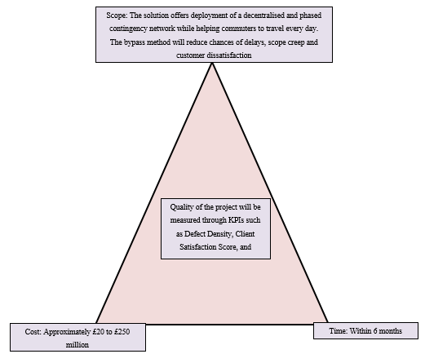
Figure 1: Project Triangle
The above figure highlights that the project can face difficulties while trying to maintain a balance among cost, time, and scope. For instance, while trying to complete the project within estimated budget, the project may not be completed within the forecasted timeline and in order to meet budget and timeline may not be able to fulfil project scope.
Boundaries
The project can experience delays in acquiring temporary licensing permits and noise complaints from surrounding neighbourhoods.
RACI Matrix
R= Responsible
A= Accountable
C= Consulted
I= To Be Informed
 | Construction project manager | Finance manager | Resource allocator | Marketing team | Site engineer
Project planning | R | I | I | I | I
Daily activities on-site | A | A | I | I | A
Budget allocation | C | R | A | I | C
Human resource management | A | C | R | I | A
Quality surveyor | A | C | C | C | R
Promotion of the transport system | C | I | I | R | I
Table 1: RACI Matrix
This RACI matrix evidences which personnel of the project team is responsible, accountable, to be informed and consulted for which task of the project.
Key stakeholders
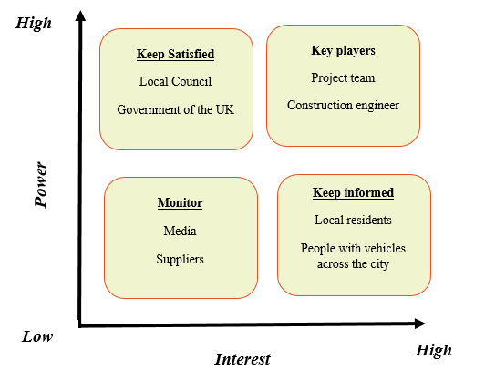
Figure 2: Stakeholder matrix
Involvement of stakeholder holds pivotal importance as they ensure that a construction process meets project scope, procure funding, legal compliance and quality standards (Shah et al., 2023). Key stakeholders in this project are Local council, the government of the UK, project team, construction engineer, media, suppliers, local residents, and People with vehicles across the city.

High-level risks and trade-offs
High-level risks
Assessment of risks before the initiation process in a construction project is essential as it identifies gaps for more strict measures (Salzano et al., 2024). Technical failure and increasing expenditure (budget overrun) are two major issues for the project.
Trade-offs
The project faces difficulties regarding lack of special permits and health and safety incidents risks while trying to maintain environmental targets, digital infrastructure and urban design plans. Deceleration of this process compromises anticipated quality standards of the outcome.
Risk | Likelihood (1= Low and 5= High) | Severity (1= Low and 5= High) | Impact (Likelihood * Severity) | Mitigation
Technical failure | 3 | 5 | 15 | Ensuring quality assessment
Lack of special permits | 3 | 3 | 9 | Managing legal connection
Budget Overrun | 5 | 4 | 20 | Contingency budget allocation
Health and Safety incidents | 3 | 2 | 6 | Incorporation of Health and Safety Gears
Table 2: Risk Matrix
Strategic value of the project
A construction project holds value as a successful outcome offers long-term sustenance of planned outcome and longevity as well (Bennett and Mayouf, 2021). The project holds value as the proposed solution complies with modern urban planning while offering an alternative solution for a respectable length of time.

Work breakdown structure
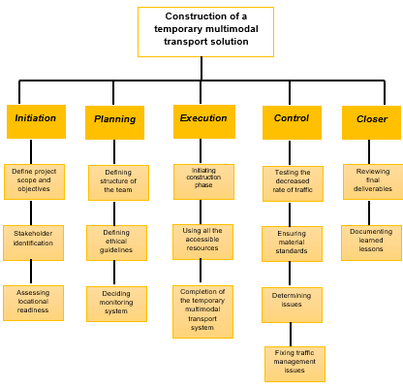
Figure 3: WBS of the project
Quad Chart
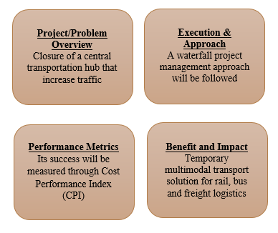
Figure 4: Quad chart of the project
The quad chart shows visually about the problem overview, its execution approach, the performance metrics to be considered for its evaluation and the benefits fostered by the project.
Timeline of the project
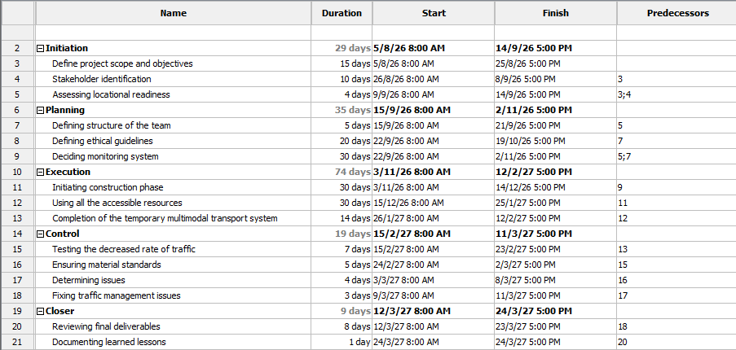
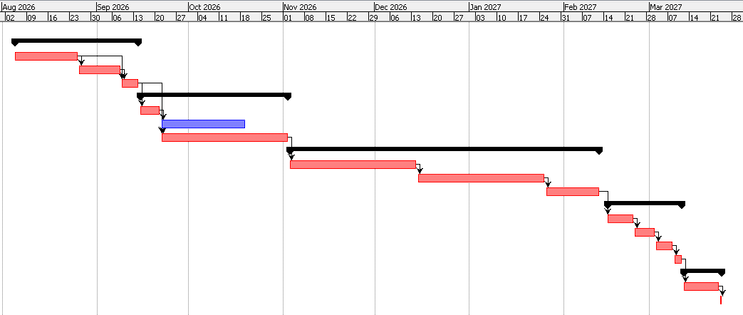
Figure 5: Gantt chart

Conclusion
In conclusion, the discussion highlights feasibility of the project while contemplating key risk factors and levels of complications. Objectives of the project ensure that key deliverables are met while comfort and accessibility are maintained for daily commuters.

Part B: Reflect critically on the feedback received from tutor and peers

Description – What happened?
For Part A, I created a project management plan for a temporary multimodal transport solution to reduce disruption caused by highway maintenance. I also made a poster and presented it to the class. During my presentation, I explained the project aims, stakeholders, risks, and schedule. After I finished, my tutor gave me feedback about my poster and my presentation. The feedback included things I did well and things I need to improve.

Evaluation – What worked well and what did not?
I think my poster was clear and easy to follow. My tutor said my project was well organised and that I had good research and clear project aims. I was happy with this feedback. However, my presentation did not go as well as I wanted. I read too much from my notes instead of speaking from the poster. Because of this, I was not very confident and I did not talk enough to the audience. I now understand that a good presentation is not only about having good information but also about how you present it.

Analysis – Why did this happen?
I think this happened because I was nervous about speaking in front of the class. I was worried that I would forget what to say, so I depended too much on my notes. I knew my project well, but I did not practise my presentation enough before the day. This made me less confident. I learned that practising before a presentation can make a big difference. I also realised that speaking from the poster is better than reading from notes because it helps you connect with the audience.

Application – How will I improve next time?
Next time, I will spend more time practising before my presentation. I will use my poster as a guide instead of reading from my notes. I will also practise speaking clearly and making eye contact with the audience. I believe this will help me feel more confident and improve my presentation skills. I will also use my tutor's feedback to help me do better in future presentations.

Transformation – How has this changed me?
This experience has helped me understand that presenting is an important skill. I now know that I need to prepare not only my project but also my presentation. I feel more confident because I know what I need to improve. In the future, I will practise more, trust my own knowledge, and try to speak naturally instead of reading from notes. This experience has made me a better learner, and I will use what I have learned in my future university work and in my career.

Part C: Project Management Plan

1. Introduction
Project Management concerns the activity of applying relevant tools, techniques, and knowledge to meet the objectives of a project within the defined constraints of time and cost. The current study relates to a project of building a temporary multimodal transport solution for a major metropolitan city in the UK, which is to undergo redevelopment to update its existing system to modern safety standards. The project report discusses the scope, work breakdown structure, quad chart, and the timeline of the project activities using Gantt chart. The detailed assessment of the risk profile and stakeholder merits further inform the project planning process of the multimodal transport solution.

2. Project description
A major city in the UK plans to undergo regeneration, due to the closure of its central transport hub that used to support bus, rail and freight logistics movement. A structural safety assessment revealed that the central hub fails to comply with modern safety and accessibility standards. Moreover, its closure has affected the local businesses, caused supply chain disruptions, and affected commuter travel resulting in economic loss. The redevelopment of the transport hub will reflect alignment with environmental, inclusive urban design and digital infrastructure needs. The project involves conducting several activities to accomplish the redevelopment targets, however in the current study; the focus will be on developing a temporal multimodal transport solution to support transit needs, while the project progresses towards its imperative. The focus during the project is on upholding safety and quality standards to ensure compliance with UK’s construction and built environment norms. The CoMO UK mobility hub details the quality standards that transport projects need to acquire by the DFT (Department of Transport) for gaining relevant accreditations (England, 2026). The present study depicts a roadmap of the activity that can guide the progression of the project with provisions for scheduled completion through informed risk assessment and mitigation.

3. Scope
In scope: The in-scope activities of the project relate to the implementation of decentralised and a phased transport network to help commuter transit. The temporary solution seeks to offer an immediate solution to limit the economic loss and public dissatisfaction caused by the closure of the central hub. The functionality and maintenance of the temporary transit hub falls under the scope of the project.
Out Scope: The aspects that are beyond the project objectives and reflect in the external bounds of the project classify as out-scope. The permanent presence of the heavy civil transport infrastructure, structural overhauls or modification are beyond the scope of the project. Moreover, the current temporary multimodal transport project’s continuity or closure related decisions after the completion of the redevelopment of the central transport hub does not fall within the project’s scope.

4. Work breakdown structure (WBS)
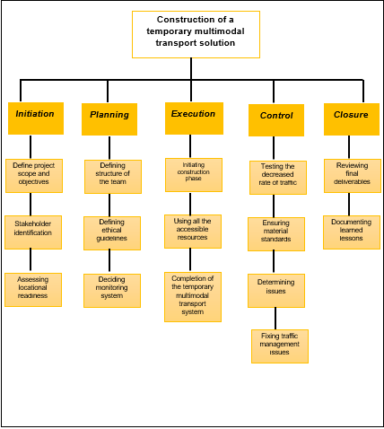
Figure 1: Work breakdown structure
The WBS is a project management tool that breaks down the project activities into smaller and manageable tasks to improve resource allocation and monitoring efficiency. As stated by Oyekunle et al., (2024), the use of reliable measurement tools and efficient techniques of project management enhance the prospects of project success and generate value. The above figure shows the WBS of the temporal multimodal transport project segmented along the lines of the key stages of the project. The project stages relate to initiation, planning, execution, control, and closure with clear depiction of the activities that follow in each stage (Cooke and Williams, 2024). The primary initiation stage involves the activities of defining project scope and objectives, stakeholder identification and assessment of location readiness.
The planning and execution stages depict the avenues of project planning such as team development, while the latter phase involves implementing the project activities. The control process is necessary to monitor the project’s progression, where quality standards and project’s efficiency in fixing traffic management issues are evaluated. The closure of the project follows the premise of reviewing the deliverables and documenting the results to affirm the project’s completion.

5. Quad Chart
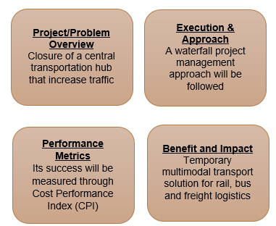
Figure 2: Quad chart
The above image shows a quad chart of the selected temporary multimodal transport project, providing an overview of the imperatives that the project aim to address. The quad chart is a visual representation of the project details to assist the stakeholders in gaining an understanding of the key project details to guide informed decision-making (Kerzner, 2025). The first quadrant represents an overview of the project problem, which relates to the closure of the central transportation hub that led to traffic disruptions. The second quadrant lists the execution approach that the project is to follow that relates to the waterfall method of project management. As mentioned by Leyba et al., (2024), waterfall methodology involves conduction of the project activities in a systematic and sequential manner to ensure optimal monitoring of activities during construction projects and ensure adherence to quality and safety standards.
The third quadrant shows the avenues sought for catering to the performance metrics needs of the project, which is to suffice using cost performance index. As opined by Oyegoke et al., (2022), the purpose of cost control techniques is to ensure that the expenditure on the project responds to the project’s cost and resource constraints, while delivering value for the investment. This necessitates the need for the fourth quadrant where the benefits and impact of the project outcomes list, which relate to an efficient temporary multimodal, transport solution for the public and the businesses.

6. Gantt Chart
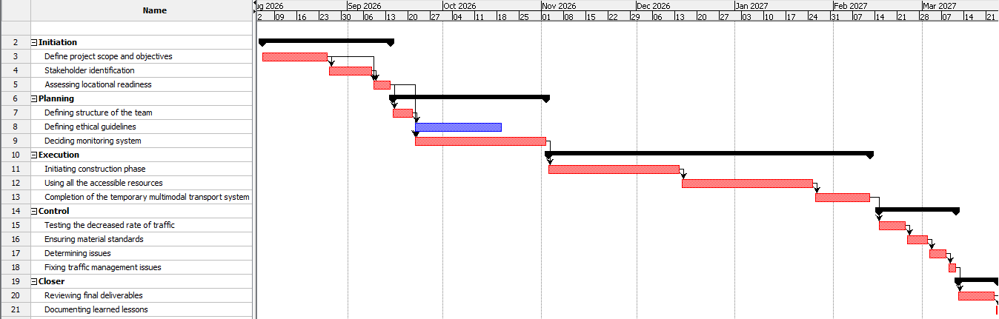
Figure 3: gantt chart or timeline of the project
The above image shows the Gantt chart of the project listing the timelines of each of the activities. The timeline shows the sequential flow of the project activities, where after completion of one stage the project is to advance towards the next stage. The project requires 166 days to accomplish its target objectives and meet its deliverables with activities spanning over the five phases in line with the waterfall method. The longest duration is for the execution stage of the project activity, which requires 74 days involving the tasks of construction phase initiation, use of accessible resources and construction of the temporary multimodal transport system.

7. Stakeholders' involvement
Stakeholder management ensures project success by aligning expectations of team members with project goals and minimising resistance to execute project tasks. In the words of Dugbartey and Kehinde (2025), stakeholder management is involved in defining clear roles to each stakeholder based on their criteria and fostering accountability to meet strategic decision goals. In the temporary multimodal transport solution project, internal stakeholders are the project team (construction project manager, finance manager, resource allocator and marketing team), construction engineer (site engineer) and suppliers. External stakeholders of this project are local council, government of the UK, media, local residents and people with vehicles across the city. According to Wang (2022), internal and external stakeholders influence project progression rates by maintaining workforce stability with tangible and intangible resources. These internal and external stakeholders are responsible for executing the planning, execution and testing tasks within the temporary multimodal transport solution project.
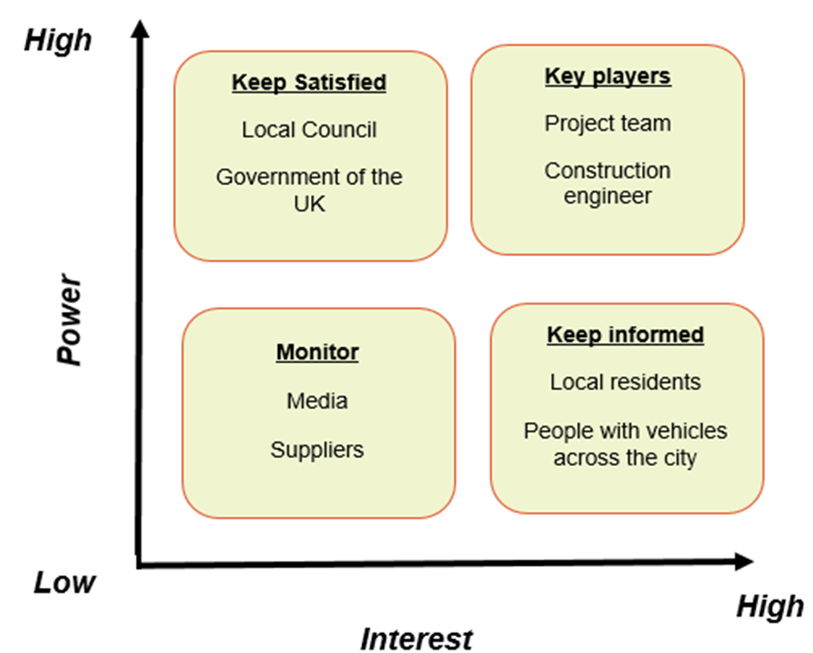
Figure 4: Stakeholder power and interest grid

Stakeholder power-interest matrix is one of the most effective ways to segment each stakeholder based on their roles and responsibilities while executing project tasks in a coordinated manner. Maqbool et al. (2022) stated that the power-interest matrix helps to map out stakeholders and characterise them effectively depending on their capabilities. This matrix enables the project administrator to control project governance and accomplish tasks one by one to reach its objectives and goals. In the context of building a temporary multimodal transport solution project, the stakeholder power-interest matrix has been applied to segment all internal and external stakeholders into four different groups. Local councils and government of the UK belong to the keep-satisfied grid, as these stakeholders are responsible for providing financial and regulatory support to this project. In the monitoring grid, media and suppliers monitor all of the project activities of temporary multimodal transport solution projects and observe key vulnerabilities within the project progression rates. These procedures can guide the project manager to forecast strategic decisions and ensure flexibility in project activity management.
Apart from that, the project team (construction project manager, finance manager, resource allocator and marketing team) and construction engineer (site engineer) are responsible for executing all key events or activities of this project. For this reason, they are categorised into the key players group, as without their involvement, building a temporary multimodal transport solution project cannot reach its destination successfully. These key players are accountable for monitoring the project progression and control each event of this project to ensure flexibility and transparency in project activity scheduling operations. In the words of Hollmann et al. (2022), stakeholder engagement guides project managers to review project operations and focus on external elements to meet project objectives. On the other hand, local residents and people with vehicles are informed about the temporary transport solution so that they can take their routes based on their requirements. For this reason, these external stakeholders are presented in the fourth grid of keep informed groups.

Stakeholder management with internal and external stakeholders improve progression speed and control the project monitoring and tracking management operations. According to Ebekozien et al. (2024), stakeholder integration enables project managers to accomplish, all critical tasks with the engagement of structured project management plans to meet project deliverables. However, sometimes, due to conflict among project team members, the project manager of a temporary transport solution project can face difficulties in organising project activities adequately. Thus, the project manager can introduce conflict management plans to understand key risks in relation to operations or resource management practices. This plan can guide project stakeholders to determine their individual responsibility and maintain project progression rates successfully. In this way, the project authority of this project can also guide their stakeholders with relevant resources to improve their progression speed and ensure flexibility in strategic decision-making processes. Thus, stakeholders of this project can understand the project criteria and execute their assigned tasks in order to achieve project deliverables and objectives.

8. Allocation of resources
Resource allocation is one of the essential tasks within a construction project to meet project deliverables and success. According to Li et al. (2025), resource allocation helps to enhance the speed of actual progression of a project with tangible and intangible resources. For building a temporary multimodal transport solution project, tangible resources are daily on-site activities, quality surveyors and human resource management. On the other hand, intangible resources for this project are project-planning, promotion of the transport system and budget allocation. These tangible and intangible resources can guide the project manager to assign specific tasks and resources to specific stakeholders based on their capabilities. These resources can also assist the project coordinator to avoid extra spending risks and gain better values with tangible resources. RACI matrix is applied to segment each resource with internal stakeholders to enhance the transparency and progression of this project.
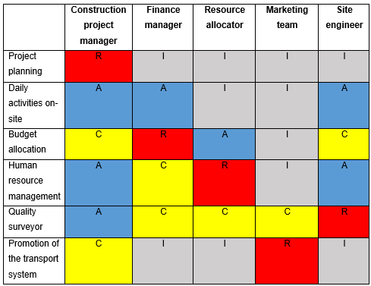
Figure 5: RACI matrix
The project authority uses the RACI matrix to distribute their resources to each stakeholder so that they can take responsibility or accountability to execute each activity. According to Arshad et al. (2023), RACI matrix is designed to assign activities, responsibilities and resources based on stakeholders’ level of expectations while performing the execution phase of a project. From the above matrix, it is understood that the construction project manager takes responsibility in developing project planning where other members are informed about the planning. For daily activities on site, all of the project team members are accountable and informed to handle project tasks and operations in a strategic order.
Activities | Budget (£)
Project planning | £9,400
Daily Activities | £25,000
Human resource operations | £36,000
Construction activities | £75,000
Quality resources | £17,500
Technical resources | £21,500
Total | £184,400
Table 1: Financial Plan

The finance manager is responsible for allocating the budget for this project and the resource allocator stakeholder is responsible for managing human resource-driven tasks. The estimated budget of this project will be £184,400 that is developed by the financial manager. Site manager is also responsible for handling quality surveyor based operations in order to meet project success of the temporary multimodal transport solution project. The marketing team also takes the responsibility to promote their transport system and attract a large number of drivers to take this alternative route. This matrix can guide the project manager to assign specific stakeholders based on their abilities to enhance project performance and control project progression.

9. Risk Analysis
Risk analysis is one of the major constraints in a construction project that is accountable for evaluating key barriers or vulnerabilities of a project. This analysis helps to find suitable solutions and enables the project manager to integrate informed decisions to execute those solutions effectively. According to Shayan et al. (2022), risk analysis helps to enforce key strategic plans based on predicted and unpredicted risks during the execution of a construction project. In the context of building a temporary multimodal transport solution project, the project manager can understand that technical failure, lack of special permits, budget overrun and health and safety incidents can be critical risks that can restrict the flexibility of project progression. These risks can create difficulties for stakeholders to set appropriate budgets and develop regulatory compliance properly due to these vulnerabilities. Thus, the project administrator can respond appropriately to solve these risks with strategic mitigation plans.
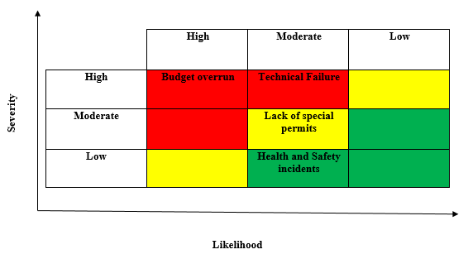
Figure 6: Risk matrix

Risk matrix assists project managers to categorise risks based on two characteristics including likelihood and severity to determine the overall impact on project progression rates. In the words of Guo et al. (2022), risk matrix helps to determine the probability of historical and current data in order to integrate appropriate mitigation strategies. In building a temporary multimodal transport solution project, budget-overrun risk is categorised as high likelihood and high severity level, whereas technical failure is categorised as moderate likelihood and high severity level.
On the other hand, lack of special permits is coordinated as moderate severity and moderate likelihood category and health and safety incidents risk is categorised in low severity and moderate likelihood category. This categorical distribution can guide the project manager to understand the significant impact on project progression rate of building a temporary multimodal transport solution project. This procedure can influence the project coordinator to integrate suitable mitigation strategies to solve these vulnerabilities and enhance project progression rates.
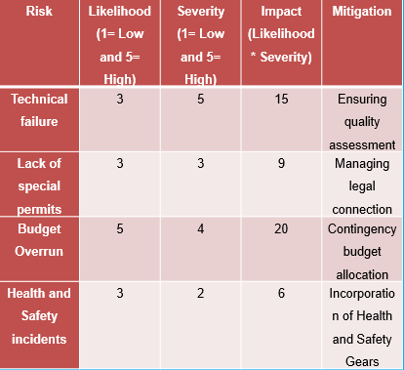
Figure 7: Risk management plan

From the above risk management plan, the project authority can integrate a quality assessment plan for redeveloping technical infrastructure to reduce technical failure risks. Moreover, the project manager can also manage legal connections to minimise the lack of special permit issues and provide appropriate transport solutions to local residents and other people. The project coordinator can also develop consistent budget allocation procedures based on market fluctuations that can enable the financial manager to set appropriate cost and values in resource management plan to avoid budget overrun. In the end, the project manager can also integrate health and safety gears during executing construction operations of building a temporary multimodal transport solution project in order to prevent health and safety incident-based risks. These mitigation plans can guide the project authority to develop strategic project plans, achieve project deliverables, and provide significant transport-driven solutions to their local residents and people.

10. Conclusion
From the above study, it has been concluded that a project management plan guides project managers to determine project stakeholders and resources that are accountable for meeting project objectives and goals. The scope of this project is to implement a decentralised and a phased transport network and reflect in the external bounds of the project classification. Work-breakdown structure and Gantt chart has been created to determine the project timeline. Stakeholder power-interest matrix has been applied to understand stakeholder engagement within the temporary multimodal transport solution project. RACI matrix has been applied to understand resource allocation and risk management plan has been used to solve project-driven vulnerabilities.

References
Part A
Bennett, K. and Mayouf, M., (2021). Value management integration for whole life cycle: post COVID-19 strategy for the UK construction industry. Sustainability, 13(16), p.9274. https://doi.org/10.3390/su13169274
GOV UK, (2025). Department for Transport annual report and accounts 2024 to 2025 (HTML version). Available at: https://www.gov.uk/government/publications/dft-annual-report-and-accounts-2024-to-2025/department-for-transport-annual-report-and-accounts-2024-to-2025-html-version (Accessed: 02 July 2026).
Madden, A., (2023). Belfast’s £200m ‘Grand Central Station’ expected to be completed in 2025. Available at: https://www.belfasttelegraph.co.uk/news/northern-ireland/belfasts-%C2%A3200m-grand-central-station-expected-to-be-completed-in-2025/a/112957583.html (Accessed: 01 July 2026).
Salzano, A., Cascone, S., Zitiello, E.P. and Nicolella, M., (2024). Construction safety and efficiency: integrating building information modeling into risk management and project execution. Sustainability, 16(10), p.4094. https://doi.org/10.3390/su16104094
Sarvari, H., Edwards, D.J., Rillie, I. and Roberts, C., (2025). Barriers, bottlenecks, and challenges in implementing safety I-and safety II-enabled safe systems of working in construction projects: a scoping review. Buildings, 15(3), p.347. https://doi.org/10.3390/buildings15030347
Shah, F.H., Bhatti, O.S. and Ahmed, S., (2023). Project management practices in construction projects and their roles in achieving sustainability—A comprehensive review. Engineering Proceedings, 44(1), p.2. https://doi.org/10.3390/engproc2023044002
Part B
Calafato, R., (2024) Literature in language education: exploring teachers’ beliefs, practices, creativity, and literary competence. Pedagogies: An International Journal, 19(1), pp.80-98. https://doi.org/10.1080/1554480X.2022.2164500
Indeed (2024) Mastering 10 useful academic skills: Tips for development. [online] Indeed Career Guide. Available at: https://in.indeed.com/career-advice/career-development/academic-skills [Accessed 21 July 2026].
Part C
Arshad, M., Saha, S. and Sahu, S.K., (2023). Development of RACI matrix for complete machine lifecycle. International Journal of Industrial Engineering, pp.1-10. https://www.academia.edu/download/99615126/IRJET_V10I277.pdf
Cooke, B. and Williams, P., (2024) Construction planning, programming and control. John Wiley & Sons.
Dugbartey, A.N. and Kehinde, O., (2025). Optimizing project delivery through agile methodologies: Balancing speed, collaboration and stakeholder engagement. World Journal of Advanced Research and Reviews, 25(1), pp.1237-1257. https://doi.org/10.30574/wjarr.2025.25.1.0193
Ebekozien, A., Aigbavboa, C.O. and Ramotshela, M., (2024). A qualitative approach to investigate stakeholders' engagement in construction projects. Benchmarking: An International Journal, 31(3), pp.866-883. DOI 10.1108/BIJ-11-2021-0663
England, H. (2026) Delivering quality: mobility hubs. [online] GOV.UK. Available at: https://www.gov.uk/government/publications/sustainable-placemaking-guidance-for-mobility-hubs/delivering-quality-mobility-hubs-html [Accessed 30 July 2026].
Guo, S., Li, J., He, J., Luo, W. and Chen, B., (2022). A modified risk matrix method for behavioral risk evaluation in the construction industry. Journal of Asian Architecture and Building Engineering, 21(3), pp.1053-1066. https://doi.org/10.1080/13467581.2021.1905647
Hollmann, S., Regierer, B., Bechis, J., Tobin, L. and D’Elia, D., (2022). Ten simple rules on how to develop a stakeholder engagement plan. PLoS Computational Biology, 18(10), pp.1-12. https://doi.org/ 10.1371/journal.pcbi.1010520
Kerzner, H., (2025) Project management: a systems approach to planning, scheduling, and controlling. John Wiley & Sons.
Leyba, A.C.G., Rana, M.Q., Salazar, A.M., Oladinrin, O.T. and Lee, A., (2024) Deploying the hybrid project management methodology framework in major transportation projects in the United Kingdom. Journal of Architectural Engineering Technology, 13(2), pp. 1-9. https://salford-repository.worktribe.com/file/2714805/1/Published%20Version
Li, P., Ren, C. and Lei, Y., (2025). Research on Enhancing Resource Allocation Efficiency on Construction Sites of Building Projects Based on Efficient Calculation Methods. International Journal for Housing Science & Its Applications, 46(3), pp.1-16. https://doi.org/10.70517/ijhsa46329
Maqbool, R., Rashid, Y. and Ashfaq, S., (2022). Renewable energy project success: Internal versus external stakeholders' satisfaction and influences of power‐interest matrix. Sustainable Development, 30(6), pp.1542-1561. DOI: 10.1002/sd.2327
Oyegoke, A.S., Powell, R., Ajayi, S., Godawatte, G.A.G.R. and Akenroye, T., (2022) Factors affecting the selection of effective cost control techniques in the UK construction industry. Journal of Financial Management of Property and Construction, 27(2), pp.141-160. https://www.emerald.com/jfmpc/article/27/2/141/227153
Oyekunle, D.O.T., Abbey, T.I. and Ibeh, F., (2024) Project management dynamics: Shaping success in UK construction projects. Open Journal of Business and Management, 12(4), pp. 2099-2117 https://papers.ssrn.com/sol3/papers.cfm?abstract_id=4862219
Shayan, S., Pyung Kim, K. and Tam, V.W., (2022). Critical success factor analysis for effective risk management at the execution stage of a construction project. International Journal of Construction Management, 22(3), pp.379-386. https://doi.org/10.1080/15623599.2019.1624678
Wang, R., (2022). Organizational commitment in the nonprofit sector and the underlying impact of stakeholders and organizational support. VOLUNTAS: International Journal of Voluntary and Nonprofit Organizations, 33(3), pp.538-549. https://doi.org/10.1007/s11266-021-00336-8

