

Evaluate the use of Nodejs Express and EJS Templates to build reusable stateless web page components that conform to the FHIR Standard

by
Gareth John Williams

Supervisor: Mike Dacey

Project submitted as part of the requirements for the award of

BSc (Hons) Cloud Software Development

26th July 2024

DECLARATION FORM AND FORM OF CONSENT

DECLARATION

I, ............................................Gareth John Williams………………………………… declare that I am the sole author of this Project; that all references cited have been consulted; that I have conducted all work of which this is a record, and that the finished work lies within the prescribed word limits.

This work has not previously been accepted as part of any other degree submission.

FORM OF CONSENT

I ............................................Gareth John Williams……………………………… hereby consent that my Project, submitted in candidature for the BSc (Hons) Cloud Software Development
degree, if successful, may be made available for inter-library loan or photocopying (subject to the law of copyright), and that the title and abstract may be made available to outside organisations.

ABSTRACT

This project explores the use of Node.js, Express, and EJS templates in developing reusable, stateless web page components that adhere to the Fast Healthcare Interoperability Resources (FHIR) standard. The FHIR standard, developed by HL7, is used to aid the exchange of healthcare information across different systems. By leveraging the lightweight and efficient nature of Node.js, along with the robust routing capabilities of Express and the dynamic templating of EJS, this project aims to create modular and maintainable web components that enhance interoperability in healthcare applications.

The research begins with analysis of the FHIR standard, emphasizing its importance in modern healthcare information systems. It examines the challenges of developing web applications, focusing on the need for reusable and stateless components that ensure consistency and efficiency. EJS templates are explored for their ability to generate dynamic HTML content for creating adaptable and reusable web components.

The project implementation phase involves the development of a series of auto-generated web page components designed to conform to FHIR specifications. These components include such record types as patient, appointment scheduling, and medical history tracking, all built using Node.js, Express, and EJS. The stateless nature of these components ensures that they can be seamlessly integrated into various healthcare applications without the need for extensive reconfiguration.

CONTENTS PAGE
Table of Contents
1. DECLARATION FORM AND FORM OF CONSENT 2
2. ABSTRACT 3
3. CONTENTS PAGE 4
4. CHAPTER 1 – INTRODUCTION 7
4.1 Strategic Requirements 8
4.2 What is HL7 and FHIR? 8
4.3 Current Application Approach 9
4.4 Health Organisation Landscape 10
4.5 Initial Aims and objectives 11
4.6 General Project Approach 12
4.7 Report Structure 12
4.8 Summary 12
5. CHAPTER 2 – RESEARCH & REVIEW OF LITERATURE 14
5.1 Review Method 14
5.2 Review Themes 15
5.2.1 FHIR Forms – Existing Solutions 15
5.2.2 Low Code & eForms 15
5.2.3 Development Frameworks and FHIR 15
5.2.4 Frameworks 16
5.2.5 Model Driven Development 16
5.2.6 Templating - Existing Approaches to templating – server side or client side 17
5.3 Review Summary and Key Findings 17
6. CHAPTER 3 – RESEARCH METHODOLOGY 18
6.1 Research Philosophy and Approach 18
6.1.1 Positivism 18
6.1.2 Deductive 18
6.1.3 Methodology – mono-method 18
6.1.4 Experimental Approach 19
6.1.5 Cross-sectional 19
6.2 Hypothesis 20
6.3 Experiment Design 20
6.4 Pre-requisites 21
6.5 Results capture and validation 21
6.6 Sample Test Script 21
7. CHAPTER 4 – DESIGN METHODOLOGY 23
7.1 Agile Approach 23
7.2 Requirements List 23
7.3 Story Mapping 23
7.4 UML 24
7.5 Build Testing Approaches 24
8. CHAPTER 5 – IMPLEMENTATION 25
8.1 Requirements Overview 26
8.2 Design Decisions 26
8.2.1 Design Constraints 26
8.2.2 Why Nodejs? 26
8.2.3 Why EJS why not Angular or React or Vue? 27
8.2.4 Client-side to FHIR 27
8.2.5 Algorithm 27
8.3 Solution Design 29
8.3.1 Design Process 29
8.3.2 Testing 30
8.4 Repository Structure 30
8.5 Deployment 32
8.6 Implementation Challenges 32
9. CHAPTER 6 – EVALUATION 34
9.1 Limitations of the research 35
9.1.1 Resource Constraints 35
9.1.2 Temporal Nature 35
9.1.3 Data Collection 35
10. CHAPTER 7 – CONCLUSIONS AND RECOMMENDATIONS 36
10.1 Suggestions For Further Work 36
11. CHAPTER 8 – REFLECTION 38
11.1 Project Topic 38
11.2 Project Management 38
11.3 Workload 39
11.4 Literature Review 40
11.5 Feedback and Advice 40
11.6 Reflection Summary 40
12. CHAPTER 9 - References 41
13. Appendices 43
13.1 Appendix A – Example Literature Review Data 43
13.2 Appendix B- Requirements 43
13.3 Appendix C - Example Interview Templates 45
13.4 Appendix D – Testing 48

Figure 1 - Health App Example 10
Figure 2 - Initial Aims and Objectives 12
Figure 3 - Research Methodology 19
Figure 4 - Story Map Example [13] 25
Figure 5 - GitHub Repository 26
Figure 6 - GitHub Top programming languages [15] 28
Figure 7 - Class Diagram - GenerateHTMLForm 29
Figure 8 - Iterative Approach 30
Figure 9 - Repository Structure 31
Figure 10 - Web Server Application Folder Structure 32
Figure 11 - Dynamic Menu 32
Figure 12 - Deployment Diagram 33
Figure 13 - EJS Code example 34

Table 1 - Project Approach 13
Table 2 - FHIR Tools 17
Table 3 - Development Tools 26
Table 4 - Evaluation of Objectives 35

CHAPTER 1 – INTRODUCTION
Interoperability is a challenge in software engineering, this is especially true in healthcare where timely and accurate sharing of patient data can be a matter of life or death. Software solutions within healthcare have been designed with front end user focus with little regard to data standards, interoperability or analytics use cases, which has led to additional burden of creating mapping solutions if the data needs to be shared or analysed outside of the source system. These mapping processes can be complex, time consuming and result in misinterpretation and/or ambiguity, in addition, changes to the source system is tightly coupled to the mapping solution which creates additional dependencies as part of development and release management processes. Over time it has become recognised that data is king and the data model needs to be agreed at the beginning of development and not left to a developers preferences which results in proprietary data models.

This project evaluates whether a data-standards approach to health application development at the client side can help efficiency in development of health care solutions. Applications UI tend to be developed in isolation requiring mapping throughout the application stack e.g., from client-side data entry, fields are created then need to be processed to fit a given API specification.

Previous attempts at application tools standardisation involved a forms-based solutions, this approach used such tooling as Microsoft Infopath, open source Orbeon forms, the current trend is Microsoft PowerApps. The issue is that these solutions still use proprietary data models at the point of data capture that require mapping to be able to share or analyse the data. This mapping process can be time consuming.

The forms approach has moved downstream the modelling and standards from being a concern of the application to the messaging or analytics layer often requiring a data-pipeline engineer to understand many applications data models and attempt to map them into a single dataset.

Strategic Requirements
The Welsh Government strategy document “A Healthier Wales” [4] focuses on how public organisations provide services to citizens and patients, and emphasis the need for digital and data services to support the vision.

In 2018 the Welsh Government published a communication to health organisations in Wales entitled “Introduction of HL7 FHIR as a foundational standard in all NHS Wales Bodies” [1] to require the use HL7 FHIR as the primary model for systems interoperability.
The scope of the FHIR was for data sharing only, a key element of this research attempts to look at whether the same standard can be used at the point of data capture. Section 4.2 discusses FHIR in more detail.

“API First” is another architecture principle, the FHIR standard supports this as part of its specification is a RESTful API approach. With other architectural principles such as microservices, modular approach application, API first.

What is HL7 and FHIR?
The IEEE glossary defines the term interoperability as: “The ability of two or more systems or components to exchange information and to use the information that has been exchanged.” [2]

The HL7 homepage provides the following description of itself:
“Founded in 1987, Health Level Seven International (HL7) is a not-for-profit, ANSI-accredited standards developing organization dedicated to providing a comprehensive framework and related standards for the exchange, integration, sharing and retrieval of electronic health information that supports clinical practice and the management, delivery and evaluation of health services.” [3] [3]

The have been several standards published by HL7 that have been adopted by all National Health Service organisations and health system providers within the UK. The current main standard is Fast Health Interoperability Resources (FHIR), commonly known as HL7 FHIR (fire). There are several versions of FHIR, for the purposes of this project R4 will be used as it aligns with the current UK adoption by health organisations.

The FHIR model is defined and published with both an XML and JSON schemas which can be used to create an object model that software designers and developers can use as the basis for applications. A key aspect of FHIR model for this project is that it’s “strongly typed”.

Current Application Approach
The push for concepts such as “User centred design” and “code first” technologies has been misinterpreted or misunderstood to mean either a disregard for the data-model or the data design to be pushed down the road as something to worry about later.

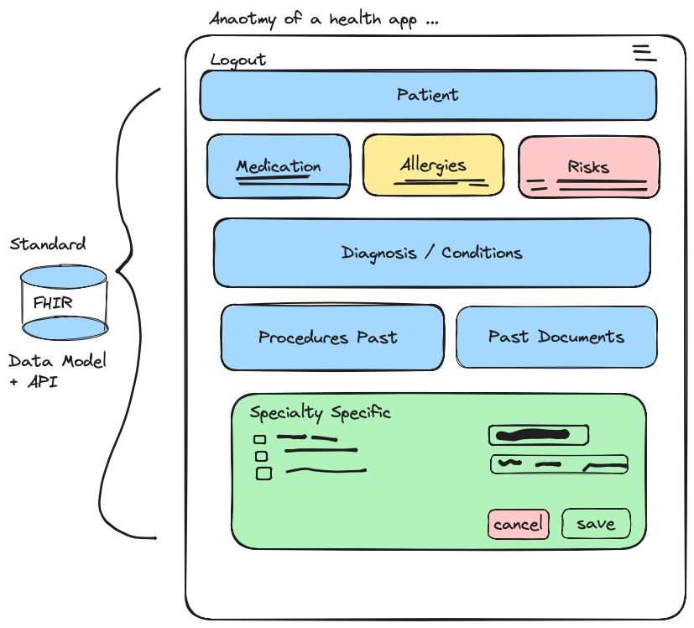
Figure 1 - Health App Example

The mock-up of on a health application user interface in Figure 1, broadly shows how distinct objects such as patient, medication, allergies, risks, diagnosis etc. is repeatable across many health care settings. Each of these objects or blocks could be microservices or distinct components and be used in many health applications in many healthcare settings.
Currently applications have a mix of how UI components are developed, the reason for this are such things as age of tooling, developer preferences, commercial and priorities to “just do it” to get a product out of the door.

Health Organisation Landscape
National Health Services organisations in Wales have a mix of commercial and inhouse written applications with a mix of custom and standard integrations to allow data to be shared between health care providers and healthcare settings. Although figures are not published, it is known that there are over 400 applications in use in healthcare across NHS Wales in various clinical disciplines with a roughly 50-50 split between commercial and in-house developments. The target and scope of this project is the in-house developments.

The architecture, design and implementations of applications mixed, this is because the large number of systems, how some systems have evolved with various conventions and user or developer preferences. Some applications were written over 20 years ago and are now considered to be running “legacy” mode due to the hosting requirements. Another reason for legacy architecture is that switching out health systems is a massive undertaking due to the complexity and clinical safety considerations when building and replacing applications in operational situations.

For inhouse developed solutions, each application stack or architecture used can vary depending on when the system was developed e.g., a database style application with forms tightly coupled to the data model. Organisations develop and deploy application at different speeds in line with their local pressures and strategies.

These legacy issues have meant that proprietary data models have been constructed in each application. This makes it difficult to share data requiring mapping specifications to data models as well as mapping clinical coding systems and reference data.

Initial Aims and objectives
The main aim of this project is to examine whether the use of the FHIR model at the UI build stage can minimise the amount of object mapping both within the application stack and secondary uses of data such as analytics. In addition, it will demonstrate the reusability of components to minimise repeat development processes and avoid the temptation to create proprietary data models.

The project aims and objectives are shown in Figure 2:

- Aim: Evaluate the use of Nodejs, Express and EJS Templates to build reusable stateless web page components that conform to the FHIR Standard​
  - Objective 1: Evaluate existing low-code e-forms products to identify existing solutions, industry trends, and standards​
  - Objective 2: Determine the effectiveness and usability of EJS Templates and FHIR by building example components and combining them to create a usable solution​
  - Objective 3: Critically evaluate the effectiveness of EJS Templates and FHIR as a feasible approach to building reusable stateless web components​

Figure 2 - Initial Aims and Objectives

Objective 1: is an evaluation of existing approaches this will be achieved using interviews and part of the literature review.
Objective 2: will determine the effectiveness and usability of EJS Templates by creating a development framework using a FHIR Server, Nodejs framework and a custom tool to create UI components based on the FHIR data model
Objective 3: The evaluation of the effectiveness will come from the data collected from an experiment described in Chapter 4

General Project Approach
The overall approach to the project is outlined in Table 1, from identifying a project topic through to build and review of results.

Table 1 - Project Approach
Project Stage | Purpose
Initial Requirements | Discussions with work colleagues to identify possible research subjects and problems
Informal Research | A broad search of web materials, interview heads of department
Prototype | To inform feasibility of the topic
Literature Review | Strengthen themes and technical understanding
Research Approach | Decide on philosophy and methodology
Formal Requirements | Build more formal requirements ready for adding to agile backlog
MVP | Agile coding stage to build an MVP
Experiment | Examine usefulness of approach
Results | Evaluate the results
Recommendations | Conclusions and recommendations based on the evidence produced

Report Structure
This report is broken down into the following sections

- Literature Review - The next section will examine the current approaches to solving this issue and investigate whether there are current frameworks that could support or resolve the problem.
- Research Methodology
- Design – Techniques to be used in the design of the solution
- Implementation – description of the build
- Evaluation – outcomes from the use of the build
- Conclusions and Recommendations

Finally, the report will end with a personal reflection on the project.

Summary
In summary, the landscape within health care is mixed with various approaches to application and architectural designs due to the age of applications and preferences of development teams. This means data that needs to be shared or analysed needs effort in the preparation and mapping. This project intends to highlight an approach for new applications to remove or minimise these downstream inefficiencies.

CHAPTER 2 – RESEARCH & REVIEW OF LITERATURE
This chapter is divided in to three sections: an overview of the review method, key themes of the review, and review summary.

Review Method
In addition to interviews and broad internet searches, research and review of existing materials centred around keyword searches of academic databases. The following list describes some of the key themes of the review:

- FHIR and existing approaches - The focus of the search was around FHIR and the existing approached used by developers as part of their build conventions and build tools. Key aspects to identify are whether a similar approach has used previously and identify any short comings.
- Commercial or opensource - Identifying whether there were off-the-shelf solutions available whether commercial or Part of the review was to look for existing solutions such as low-code and forms tooling
- Design patterns - Domain driven development, model driven development was also a key theme examined to ensure any solution is in line with modern development philosophies and methodologies.
- Developer tools and frameworks – an examination of current trends in the developer workspace and application stacks.

As HL7 FHIR is a data driven standard research began with similar paradigms within solutions design, health systems, and industry in general.

Review Themes
The following section describes some of the core themes taken from the literature review that supports the projects aims and objectives and helps inform the hypothesis and the general project approach.

FHIR Forms – Existing Solutions
Although the use of FHIR is a constraint for the project set by the business strategy, it is important to understand if there are any short falls or difficulties using the standard. In the Journal of Critical Care an article by A Brehmer et al, state the importance of the FHIR standard within their work, in their conclusion they state:

“This study demonstrates that utilization of FHIR data and application of analytical capabilities at large scale can serve as an important building block to improve patient care at the local clinic and beyond” [5]

This illustrates the importance using FHIR as the reduces the need for preparation and pre-processing data before analytics can begin, this is one of the main objectives of this project.

Low Code & eForms
A search of “low-code” commercial solutions show that they all use a proprietary data model which defeats the purpose of encouraging the use of FHIR at the point of data capture within UI Models.

Development Frameworks and FHIR
The review from a number of search databases discussed uses of FHIR but not focused on how the schema could be used to aid in application development.
It is important to highlight that this project is utilising the FHIR standard and not examining if it is appropriate to use. This section is looking at how other organisations and business of attempting to use forms approach.

Several online tools are available as shown in Table 2. These were examined for suitability.
Table 2 - FHIR Tools
Tooling
fhirform/README.md at master · E-Health/fhirform · GitHub – java
FHIR Care Records Transfer: UK NHS (pretagov.co.uk) – commercial
Home - Smart Forms v0.1.0 (fhir.org) Radiology Request Form (smartforms.io)
Playground (smartforms.io)

Frameworks
Care should be taken when choosing frameworks, the research highlighted examples of frameworks that were popular, for example in Chapter 2 of the book Frameworks, methodologies and Tools for Developing Rich Internet Applications [6] , Microsoft’s Silverlight framework is one of the options. Silverlight had a browser plugin approach for web components which support ended for in 2021 [7]. This highlights the design consideration around long-term supportability and vendor lock-in, this highlights the importance for applications to be designed in a way to be able to move to different stacks.

When examining papers to compare frameworks, ReactJS, Angular and Vue are amongst the most popular frameworks. Papers such as “Analyzing the difference between ReactJS and AngularJS” by Sharma, Gupta and Singh show how these frameworks are used across industry. However, for this project the approach to be as lightweight as possible and there can be a steep learning curve with both Angular and React, in addition they are client side libraries. The use of EJS for templating will still allow for the use of the larger frameworks and libraries.

Model Driven Development
These approaches seem to be starting at the begging of the development cycle and processes. FHIR is already built upon the domain, in this case healthcare, and provides the data models and workflow. The use of FHIR Profiles describes how these individual data models can be combined to create compositions such as a discharge summary letter than may contain FHIR resources such as Patient, Medication, Observation, Encounter.

Templating - Existing Approaches to templating – server side or client side
The literature search did not find specific papers on templating. In the paper Is the browser the Side for Templating? F. J. Garcia-Izquierdo and R. Izquierdo examine “Browser Side Templating” [8]. The article raises the issue of Rapid prototyping and how client-side driven templating allows designers to work in their own domain, however, a key aspect to this project is to demonstrate that the understanding and use of FHIR throughout the development lifecycle is key and that the templating approach with FHIR at its heart will work for both designers and developers – the prototype used in the experiment shows this to be the case.

Review Summary and Key Findings
The review shows that the original aim and objectives are still valid. There were no existing solutions or attempts could be found as part of the material reviewed.
The review also showed that the proposed combination of FHIR, Nodejs and EJS for templating is still a valid proposal.

CHAPTER 3 – RESEARCH METHODOLOGY

Research Philosophy and Approach
Using the “research onion” [9], as outlined by Saunders et al in the book Research Methods for Business Students, this section of the report describes the chosen research philosophy, methodologies, and approaches, Figure 3 – Research Approach outlines these.
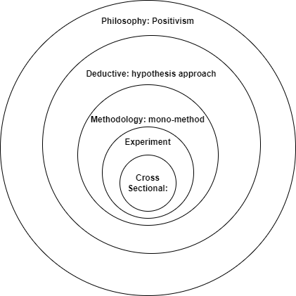
Figure 3 - Research Methodology

Positivism
As the diagram in Figure 3 shows, the chosen epistemology is positivism as this approach is to be objective and strong emphasis to produce quantifiable data. This philosophy also allows for an experimentation method which fits the requirement to test the use of EJS and FHIR.

Deductive
The positivistic philosophy includes a deductive approach which is used to test the theory of the combination of EJS and FHIR using the data collected via experimentation.

Methodology – mono-method
This research project will be using interviews to gather data from the experiment – this also helps with time and resource constraints.

Experimental Approach
The reason for choosing the experimental approach is that the review of literature showed little or no previous examination of the use of EJS and FHIR data model to create server-side rendered web components. In addition, the nature of the research is looking at just one part of a developer’s tools and way-of- working rather than producing a full application solution that can be black-box tested by end users.

Cross-sectional
The experiment data will be cross-sectional – the data collection will be point in time i.e., a single pass of the test script by each participant. Although the participant group is small, it is expected that the data captured is representative of a wider group as the participants are experienced in health application development.

In the context of the "research onion" [9] model developed by Saunders, Lewis, and Thornhill, a "cross-sectional" study refers to a research design where data is collected at a single point in time or over a short period, allowing for a snapshot analysis of a particular phenomenon.

The approach will be to create a protype application them demonstrates the use of EJS, FHIR to create the reusable components.

Hypothesis
A simple hypothesis was developed based on the literature review and interviews with senior development leads within the organisation.

H: The development time for building a healthcare data management application using Node.js, EJS, and FHIR is significantly shorter compared to traditional development methods using .NET, proprietary data models and relational databases.​

H0: Not Supported
H1: Supported
H2: No Significant difference

​

Experiment Design
The following steps will be followed to build data to test the hypothesis
- A short experiment and questionnaire will be used with a group of developers. The questionnaire will discover the experience of each developer e.g., have they used the tools before, are they familiar with FHIR.
- The developer will be given instructions on how to configure the environment and build a simple application using the ejsonfhir approach.
- To validate results, recordings will be taken and reviewed to validate results. Note that these will be desktop recordings and will not include personal identifiable information. Candidate will be provided a pseudo name for the purposes of recording.
- Candidates will be asked whether they are happy to be identified as part of the results.
- For interest of and collaboration, for feedback, the evaluation section of this report will be made available to each candidate.

The experiment approach utilised the key elements of usability testing:
  - Planning
  - Conducting Tests – observations for validation
  - Data Collection – user feedback – compare with observations
  - Analysis and Reporting – findings and suggestions for improvement

Pre-requisites
- Development tools such as Integrated Development Environment and build tools will be out of scope and be expected to be installed and configured as prerequisites.
- A simple Nodejs express web application will be provided as a test harness to display the reusable web components.
- Docker (or other container management) for the FHIR Server container that will provide the store for patient and clinical data.

Results capture and validation
In addition to before and after questionnaire, testers work will also be recorded using Microsoft teams (example shown in Appendix D).

Sample Test Script
Creating a test script for a developer to follow in an experiment involving Node.js and FHIR (Fast Healthcare Interoperability Resources) can help ensure a structured and reproducible process. Below is a template that you can use as a starting point. You can customize it to fit the specifics of your experiment.
Example test script:
Test Script for Node.js and FHIR Experiment
Developer ID:
Script Execution Date:
Pre-requisite script? Y/N
Duration (30mins max):
Project Overview
- Experiment Title: Integration of Node.js with FHIR
- Objective: To evaluate the use of Node.js in handling FHIR resources and APIs for healthcare applications.
- Duration: [Specify the duration of the experiment]
- Participants: [List the developers involved]

Pre-Requisites
1. Environment Setup
- Ensure Node.js is installed. (Node.js version: 14.x or above)
- Install npm (Node Package Manager).
- Install a text editor or IDE (e.g., Visual Studio Code).
- Have access to a FHIR server or a local FHIR server instance (e.g., HAPI FHIR).

2. Required Packages (included in package.json build)
- Express.js .e.g. `npm install express, xpath, xmldom`

3. FHIR Knowledge
- Basic understanding of FHIR resources and how to interact with FHIR APIs.

4. Follow the script.md file as part of the project

CHAPTER 4 – DESIGN METHODOLOGY
This section outlines the design methodologies used in creating the solution and the reasoning behind choosing them.

Agile Approach
As the project is experimental and there’s a certain level of uncertainty in requirements, an agile approach will be used as it allows change and building incrementally but keeps the main goals in mind.

Requirements List
As the main element of the build is a prototype for a backend developer tool, requirements are gathered using a simple numbered list rather than other methods such as User Stories.

Mock requirements were put together for the development of the test harness web application, these requirements broadly follow a simple health-based web application model i.e., adding clinical activity records to a patient care record. Appendix B contains the requirements list.

Story Mapping
In the Journal of Computer Languages, the article The patterns of user experience for sticky-note diagrams in software requirements workshops, Garnder, Blackwell and Church describe the use of “sticky-note diagrams” and state: “The method is widely used in agile software development to capture key software requirements and to translate them into a backlog for development” [12].

The example story map shown in Figure 4 is from Jeff Patton’s internet blog The New User Story Backlog is a Map.
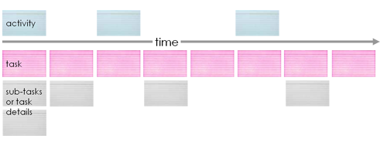
Figure 4 - Story Map Example [13]
The blog describes how flat requirements backlog was ineffective in communicating how a system works. In this project the numbered requirements list will be used to build up a story map to illicit the development tasks. Appendix C contains example of the story maps used in the project.

UML
Where appropriate, UML diagrams will be used to communicate designs and implementation. The Unified Modelling Language specification is provided by the Object Management Group which provides various standards for a “wide range of fields”[13], and is used widely within IT disciplines.

Build Testing Approaches
Although a small project, the discipline of Unit Testing is still used as it can help avoid unexpected changes by highlighting unintended side effects in code. In the paper “A Survey of Unit Testing Practices” Runeson notes of his research results:

“Continuous regression tests are a strength. One company runs automatic tests every night, including automatic results checking. Another company runs regression tests when refactoring the code. It also runs memory tests continuously, ensuring that the basic functionality and characteristics are in place.” [14]

The use of unit testing tools will ensure no unexpected behaviour or bugs are added when coding.

CHAPTER 5 – IMPLEMENTATION
This chapter provides an overview of the implementation of the build for the project. The main development tools used are described in the Table 3. Note that the solution isn’t dependent on VSCode, Docker or Git technologies.

Table 3 - Development Tools
Tools/Components | Purpose
VSCode | General IDE
Git and GitHub | Version control and project repository
Docker Desktop | Container host for Hapi FHIR Server
Nodejs + express | Application framework and packages
Nodejs libraries | A number of packages and utilities such as xpath and dotenv for configuration
Bootstrap Styling | Bootstrap CDN is used for simplicity.

The following screen grab in Figure 5 shows the GitHub repository that has been shared with participants of the experiment. This is a public repository: https://github.com/Slartibartfast2000/ejsOnFHIR.git

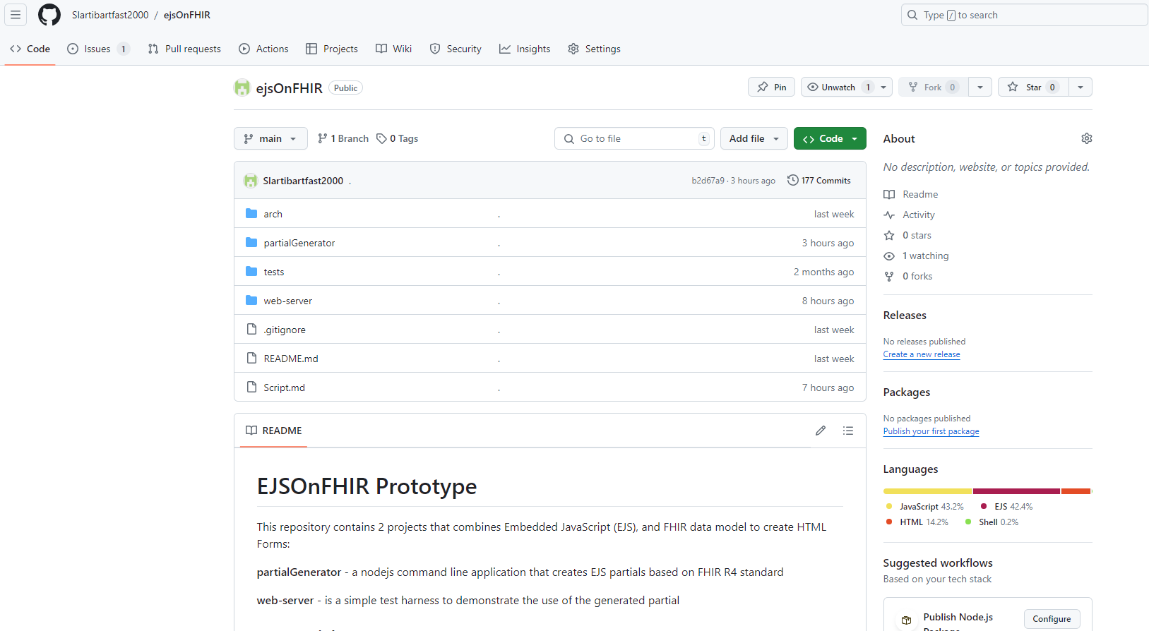
Figure 5 - GitHub Repository
As with most repository conventions a README.md file is added at the root of the solution describing the project.

Requirements Overview
In this particular case, the main requirements are non-functional i.e., they are backend requirements rather than end-user. Some end-user requirements are added just for context and to support the test-harness element of the design. Non-functional requirements were added to by information gathered from interviews. Appendix B has a full list of requirements

Design Decisions
This section highlights some of the key design decisions and tools used in building the experiment.

Design Constraints
The solution is constrained by several organisational and business strategic factors:
- The use of FHIR as the data model i.e., the output of the solution shall be valid FHIR Resources.
- The use of web-based UI components, the organisation policy is to develop using web tools to keep device agnostic rather than thick clients such as Microsoft Windows native win32 applications.
- Opensource tooling
- Long term support – As well as support for individual developers, cyber security is also a key element to the LTS requirement i.e., bugs and vulnerabilities are actively fixed.

Why Nodejs?
The following chart in Figure 6 provided by GitHub [15] from 2023 shows the JavaScript and TypeScript being most popular of programming languages.

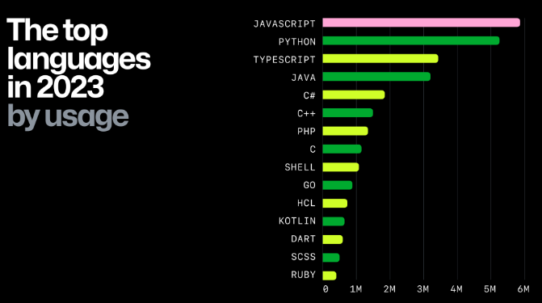
Figure 6 - GitHub Top programming languages [15]
As Nodejs allows for both server-side and client-side use of JavaScript which can make it attractive in only having to support a single language for solutions.
In addition of the main Cloud computing providers such as AWS, Google and Microsoft offer native hosting of Nodejs applications reducing the need for support overheads in containerisation or virtual machines.

Why EJS why not Angular or React or Vue?
One of the aims of the project is to demonstrate that FHIR can be used with HTML and JavaScript without the need for a full-stack framework or client-side libraries.
It is important to note that the use of the lightweight EJS library is to create server-side rendered HTML. It would be just as valid to use any development tool for this purpose.

Client-side to FHIR
It would be possible to send http requests directly to the FHIR RESTful endpoint, however in a real scenario additional workflow or validation may occur server side before sending a request to the FHIR RESTful endpoint.

Algorithm
The main algorithm is within the generateParitial tool of the solution. The algorithm is design to parse the FHIR schema, scan each element and attribute, and generate the EJS Partial based on the parameters provided.

The input parameter to the tool will be FHIR Resource type and the output parameter will be a HTML compliant form based on the resource structure.
- Traverse for a given Resource element
- For each child element of the Resource
  - Build a HTML Input html based on the Resource type

The simple class diagram in Figure 7 shows the GenerateHTMLForm class which takes in three parameters and outputs a string of HTML.

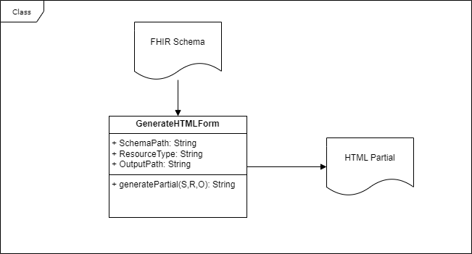
Figure 7 - Class Diagram - GenerateHTMLForm

The parameters are:
SchemaPath – the path and filename of the FHIR Schema.xsd
ResourceType – the Resource type to use to generate the HTML
OutputPath – path and filename to write out the HTML partial
The two artifacts are:
FHIR Schema – the published schema from HL7 International
HTML Partial – the destination file containing the HTML Form partial

Solution Design
The build for the experiment comprises of two NodeJS applications. The partialGenerator to create the EJS partial templates and a test-harness app to host the web controls produced by the experiment.
As the focus of any health application is the Patient, the Patient FHIR Resource and its unique Resource ID is included in the test harness as it is central to the test harness being able to operate.

Design Process
Due to the experimental nature of the project an agile approach was taken due to its iterative and flexible approach.

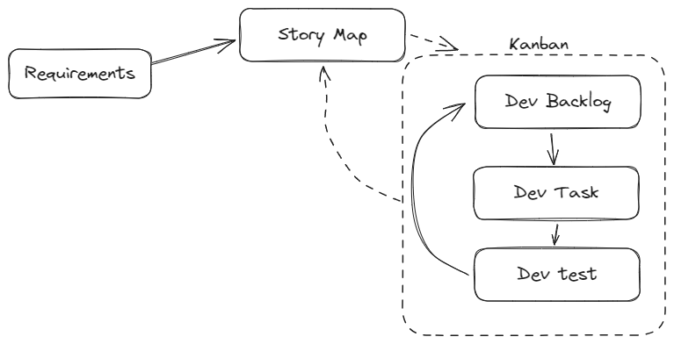
Figure 8 - Iterative Approach

The diagram in Figure 8 describes the broad agile approach. A user story map was created from the raw requirements list (Appendix B). Each story may require splitting in to backlog items for development. A Story Map and Kanban board was then created to keep track of the individual development tasks. For audit and tracking the original requirement id is used throughout.

Specialist software such azure Azure DevOps could have been used to support the development lifecycle, however, due to the short time frame and scope of the project, it was felt that setting up such tools and maintaining them had a high overhead.

Testing
To support the build process, automated testing will be used, although the project will not be using pure test-driven development where the test scripts are written first.

Simple Acceptance Test Scripts were authored to test that the end web component within the UI for simple CRUD tasks:
- Unit testing - do the individual bits of code work?
- System testing - does the system as a whole work?
- Usability testing - does the interface work?
- Acceptance testing - does the user believe that it does what it's supposed to do?

Usability and acceptance testing are combined due to the nature of the project as this is a key part of the experiment.

Repository Structure
The solution repository/folder contains two node projects as shown in Figure 9.
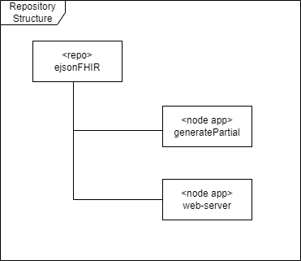
Figure 9 - Repository Structure

The generatePartial is a flat folder structure as the build is fairly small.
The web-server follows a typical Nodejs convention pattern for its folder structure, with the controller, routes and views as the main folders as can be seen in Figure 10:
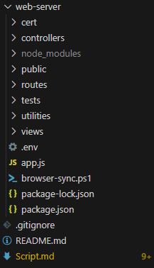
Figure 10 - Web Server Application Folder Structure

A key folder is the web-server/views/dynamicPartials, it is this folder where by default the partialGenerator tool will place the dynamically created HTML forms. In addition, the test harness UI uses the contents of this folder to build the NavBar Resources drop down menu. This is achieved by creating an array of the directory path files, then handing the array to an EJS partial as shown below in Figure 11.
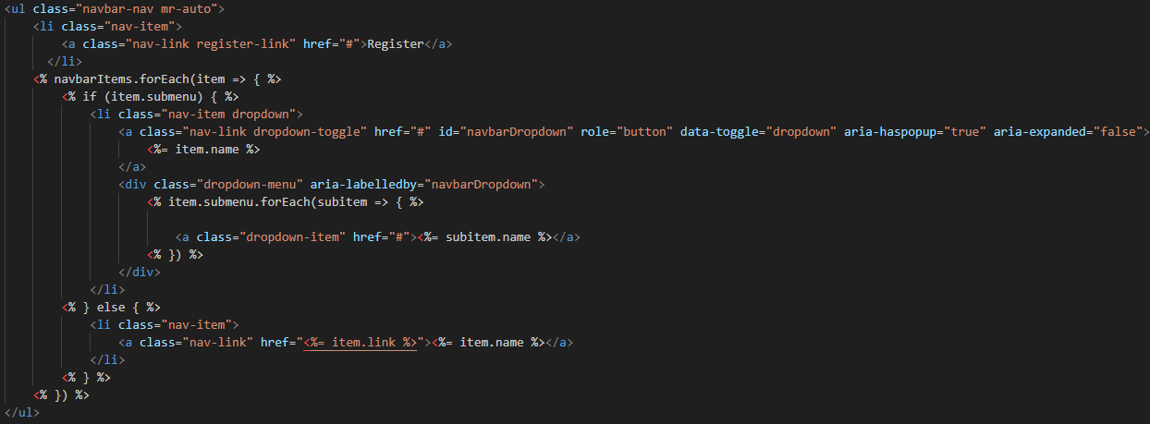
Figure 11 - Dynamic Menu

Deployment
The following deployment diagram in Figure 12 shows the main components for the solution in context with the host.

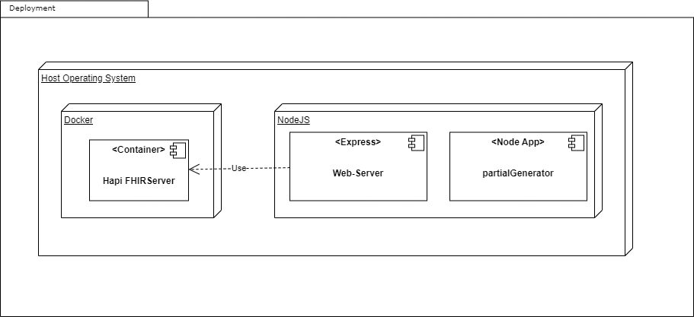
Figure 12 - Deployment Diagram
The diagram shows that for the scope of the project there are three distinct components that are hosted on a single machine. The Hapi FHIRServer is on open-source containerised FHIR compliant server - it is used in this project just to support the build and testing, no alterations have been made. The main developed components are the web-server and partialGenerator.

Implementation Challenges
The main complexity of the solution was the ability to interpret the FHIR Schema and write the correct syntax for the HTML. This took longer than expected.
The code example in Figure 13, shows a switch…case statement that examines the resource type provided by the xml element attributes then builds the appropriate HTML Input tag and attributes.

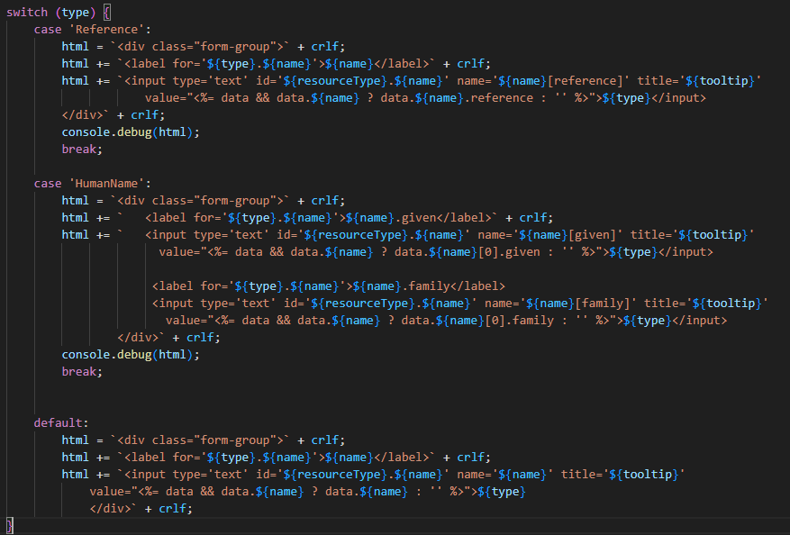
Figure 13 - EJS Code example

As the FHIR specification has many complex types, only a few cases are handled here to demonstrate the capability. It would be expected that future builds would need to cater for far more FHIR types.

CHAPTER 6 – EVALUATION
This section compares the results of the solution against the initial aims and objectives.

The use of the prototype allowed the project to meet the aim of “Evaluate the use of Nodejs, Express and EJS Templates to build reusable stateless web page components that conform to the FHIR Standard​”.

Table 4 shows each objective with comments against each.

Table 4 - Evaluation of Objectives
Objective | Evaluation Comment
- Objective 1: Evaluate existing low-code e-forms products to identify existing solutions, industry trends, and standards​ | The literature review did not find existing solutions to the problem. Commercial products such as low-code forms used proprietary data models which still required mapping to FHIR.
- Objective 2: Determine the effectiveness and usability of EJS Templates and FHIR by building example components and combining them to create a usable solution​ | The build and testing element of the project demonstrated that this objective was met. Testing and comments from staff were complimentary. Although the prototype was basic in functionality, the potential was recognised.
- Objective 3: Critically evaluate the effectiveness of EJS Templates and FHIR as a feasible approach to building reusable stateless web components​ | The complexity of building a node application to automatically build the EJS partial requires detailed technical work upfront, however, once this time is invested, the benefits of being able to use the tooling outweigh the initial cost.

Limitations of the research

Resource Constraints
The main limitation for the research was the low number of participants in using the prototype to be able to build enough data points for formal analysis with only access to 5 Participants. However, it’s important to note that participants were experienced programmers in healthcare applications and the general feedback was positive.

Temporal Nature
As the experiment data capture was cross-sectional, it is limited to a single pointed in time snapshot – this is because of time and resource constraints of participants. It would be useful to repeat the project every 12 months or so and examine whether trends or technologies could change the outcome.

Data Collection
The value of the data collected using interview techniques is found to be subjective. Although participants were timed and videoed, a repeat of the experiment would be required with a wider group of participants would be needed. In addition, look at including developers from outside of healthcare.
Perhaps a slightly different approach to the research methodology to take in to account the participants views as they are experienced developers who have used many tools.

CHAPTER 7 – CONCLUSIONS AND RECOMMENDATIONS
This project has highlighted the inefficiencies of rapidly creating applications without the use of strong data model and constraints. The literature review did not find existing solutions to this problem whether open source or commercial. This influenced the aim of the project to see whether lightweight tools such as Nodejs and templating could be used to solve the problem by ensuring data models are used as part of development.

The project showed that the use of templating within the UI solution (EJS) based on a strongly type data-model (FHIR) could help resolve the inefficiencies by ensuring that data is in a format that is shareable and easily analysed.

There are two main areas that require more attention. The first is the additional acceptance testing. It would have been useful to get input from a UI/UX design person as part of the testing solution.

The second area would be to strengthen the research element to make it more scientific. The outcome was based on interviews which can be open to bias and subjectiveness.

Examine whether the partials created by the tools developed in the experiment could be built into a CI/CD pipeline so that the EJS Partials could be built every day. The HTML fragment created could be used on top of a different technology stack – it doesn’t have to be Nodejs or EJS as the rendering tool server-side. Partials themselves could be taken as the basis for development or when “wireframing” by UI designers.

Suggestions For Further Work
The project showed how the approach could be developed further for use in real world application within healthcare setting:

“This project has demonstrated the basic principles that web-forms based on data standards can improve the efficiency both for front end developers and for the analytics teams in minimising the mapping work by showing that data can be recorded in a structured and interoperable manner. I believe this approach can speed up adoption and help encourage the use of the FHIR standard within application teams across healthcare.” Mark Frayne, UK FHIR Board Member and experiment participant.

In addition, the prototype will be examined to see if can be extended by a developer for a real use case:

“This work could be adopted by a team member to help with the migration of the existing reference data team tools to cloud.” Eugene O’Sullivan, Lead Design Architect and experiment participant.

In addition to real world uses, the experiment showed how EJS and server-side rendering can be used to build web controls that submit FHIR compliant HTML form data. The following is a list of other suggestions:
- Examine whether the EJS partials could be published to a public library for adoption across the wider health and social care application teams.
- Convert the solution into a way-of-working by arranging the adoption of the tools as a standard way of working within healthcare. This will reinforce the use of FHIR as a standard and introduce the use of Nodejs.
- Advertise the experiment publicly and see of the approach can be adopted and contributed to by peer groups, for example publishing to public Git repository. If possible, the experiment be put on a public github site and feedback requested

CHAPTER 8 – REFLECTION
This chapter is a personal reflection on the project and explores how I personally managed specific aspect of the project as well as the project overall to identify areas of personal improvement. In the chapter Understanding Reflective Practice, in the book The Critically Reflective Practitioner, S. Thompson and Neil Thompson state:

“A significant element of reflective practice is the process of drawing out learning from our experience, to be able to distil from our current or recent practice activities useful learning points that will guide our future practice.” [16]

The following sections in this chapter look at reflections and suggestions for improvement on the project topic, project management, and workload.

Project Topic
I consider the topic chosen was a challenging one, this is systems development rather than application development i.e., examining the tools and approach developers take. I believe I would have found it easier to choose a project to simply create an application with end-user requirements for a specific clinical use case. However, I do not feel that this would’ve added value to my place of work where I feel modernisation and looking at how continual improvement in ways-of-working are important.
Although switch to a different project may have helped reduce pressure, I think sticking with the more complex topic shows determination and courage to see a problem through.

Project Management
Although and extensive detailed project plan was created, there were times where the project plan itself became time consuming and cumbersome and began to lose its value and struggle to keep up to date. The project may have benefited from starting with a high-level or summary plan based on the Final Report structure before drilling in to details tasks and resource planning. A more agile approach may have been beneficial not just for development backlogs, but for the project.

I think a more iterative approach to the whole project would have been beneficial, the project began by being too waterfall, e.g. project plan, literature view, research and development. I think many small iterations of each would be a better approach rather than trying to complete as much as possible. I believe this would’ve also helped the “context switching” scenarios.

Workload
Due to the technical complexity of the project and in employment, I felt the pressure of high cognitive load and decreased efficiency. Context switching – the design and development element of the report was complex, ensuring the build tools for the experiment required high concentration to get accurate. Switching between work activities which were complex was extremely difficult. To work around this problem, blocks of time needed to be put aside to be able to focus on one task and do it well. This led to progress be slower than expected and was not originally considered as part of the project plan which in hindsight was optimistic and didn’t take this personal element in to account.

If starting the project again, I think a more agile approach to the whole project and not just the development stage would help manage the context switching, for example, simply take each heading from the example report structure and used them to create backlog epics and then have specific tasks to do within a 2 week window.

The project, especially the experiment design, would have benefited from a team approach to be able to bounce ideas. Perhaps many passes of the experiment may have helped here but time constraints and access to developers were a limitation.

A mistake was made that when lecture modules ended, I found myself simply returning to work 5 days a week – increasing work-load. The “study day” should have been kept in the calendar. I found it important to continue to attend campus – this well help with the context switching as it means focusing on one thing. Being out of the office is a strong signal to colleagues that I am unavailable.

Literature Review
I felt frustrated with the literature review and had difficulties in commencing the literature review especially as personally felt uncertain of the premise of the project, for example should the focus of the review be web-development or frameworks. The initial trawl of research databases was not returning obvious results. Upon reflection I feel this is the reason for choosing the project topic in the first place as the standardised or convention driven development approach for health applications still feels in its infancy.

Feedback and Advice
Throughout the project feedback and advice was freely provided from work and university colleagues whether verbally or in writing. For whatever reason, whether this was related to the context switching problem, the advice was unintentionally ignored. A lesson for me will be to reflect on how I can act on advice straight away rather than take on board but not act upon it.

Reflection Summary
While I found the project topic challenging, I still believe the project topic choice was valuable in terms of my self-learning and in terms of the technologies. In addition, the project informed my work place a correct one, as well as supporting place of work ways of working, it provided evidence that the approach being used within the health industry.
The main personal lesson to take away is time management and ensuring that work is carved up into manageable chunks.
Hopefully elements of this project will be adopted by development teams with my place of work.

CHAPTER 9 - References

[1] | Welsh Government, “A Healthier Wales: long term plan for heath and social care,” 2021. [Online]. Available: https://www.gov.wales/sites/default/files/publications/2021-09/a-healthier-wales-our-plan-for-health-and-social-care.pdf. [Accessed 2024].
[2] | Welsh Government, “Introduction of hl7 fhir in all nhs wales bodies,” 14 06 2023. [Online]. Available: https://www.gov.wales/sites/default/files/publications/2023-06/introduction-of-hl7-fhir-in-all-nhs-wales-bodies_1.pdf. [Accessed 12 06 2024].
[3] | IEEE, “IEEE Standard Glossary of Software Engineering Terminology,” IEEE Std 610.12-1990, pp. 1-84, 1990.
[4] | HL7 International, “Health Level Seven International - Homepage,” 03 06 2024. [Online]. Available: https://www.hl7.org/.
[5] | A. Brehmer, C. Sauer, J. Salazar, K. Herman, M. Kim, J. Keyl, F. Bahnsen, B. Frank, M. Köhrmann, T. Rassaf, A.-A. Mahabadi, B. Hadaschik, C. Darr, K. Herrmann, S. Tan, J. Buer, T. Brenner, C. Reinhardt, F. Nensa, M. Gertz, M. Egger and J. Lkeesiek, “Establishing medical intelligence - leveraging FHIR to improve clinical management,” Journal of Critical Care, vol. 81, 2024.
[6] | V. Y. Rosales-Morales, L. O. Colombo-Mendoza and G. Alor-Hernández, “Alor-Hernández, Giner, Viviana Yarel Rosales-Morales, and Luis Omar Colombo-Mendoza. Frameworks, Methodologies, and Tools for Developing Rich Internet Applications. Hershey, PA: IGI Global, 2015. https://doi-org.ezproxy.uwtsd.ac.uk/10.4018/978-1-4666-6437,” in Frameworks, Methodologies, and Tools for Developing Rich Internet Applications, IGI Global, 2015, pp. 17-35.
[7] | Microsoft, “Silverlight 5,” Microsoft, 2024. [Online]. Available: https://learn.microsoft.com/en-GB/lifecycle/products/silverlight-5. [Accessed 14 07 2024].
[8] | F. J. Garcia-Izquierdo and R. Izquierdo, “Is the Browser the Side for Templating?,” IEEE Internet Computing, vol. 16, no. 1, pp. 61-68, 2012.
[9] | M. N. K. Saunders, P. Lewis and A. Thornhill, Research Methods for Business Students, London: Pearson, 2023.
[10] | H. Gardener, F. Blackwell and L. Church, “The patterns of user experience for sticky-note diagrams in software requirements workshops,” Journal of computer languages, vol. 61, 2020.
[11] | J. Patton, “The New User Story Backlog is a Map,” 08 10 2008. [Online]. Available: https://jpattonassociates.com/the-new-backlog/. [Accessed 03 05 2024].
[12] | Object Management Group, “Mission and Vision,” Object Management Group, 2024. [Online]. Available: https://www.omg.org/about/.
[13] | P. Runeson, “A survey of unit testing practices,” IEEE software, vol. 23, no. 4, pp. 22-29, 2006.
[14] | GitHub, “The state of opensource and AI,” GitHub, 08 11 2023. [Online]. Available: https://github.blog/2023-11-08-the-state-of-open-source-and-ai. [Accessed 03 07 2024].
[15] | S. Thompson and Thompson, Neil, Understanding Reflective Practice, Bloomsbury Publishing Plc, 2023.
[16] | S. E. Efron and R. Ravid, “Structuring and Organizing the Literature Review,” in Writing the Literature Review: A Practical Guide, Guilford, Guilford Publications, 2018-11-14, pp. 121-155.
[17] | D. E. Gray, Doing Research in the Real World, London: SAGE, 2004.
[18] | HL7 International, “Index - FHIR R4.0.1,” HL7 International, 09 07 2024. [Online]. Available: https://hl7.org/fhir/R4/index.html. [Accessed 09 07 2024].
[19] | M. Cohn, User Stories Applied for Agile Software Development, Boston: Pearson Education, Inc., 2009.

Appendices

Appendix A – Example Literature Review Data

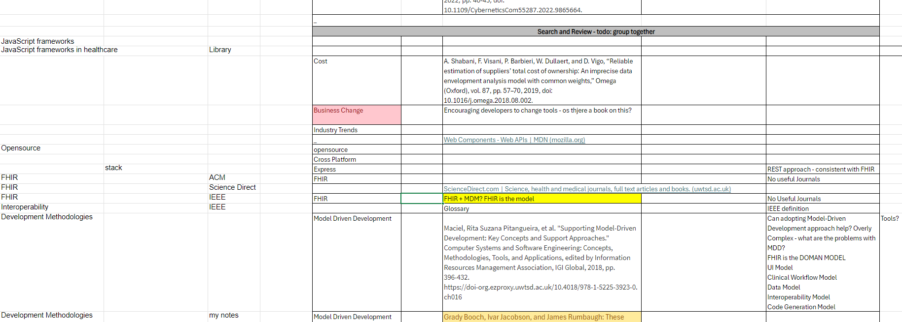
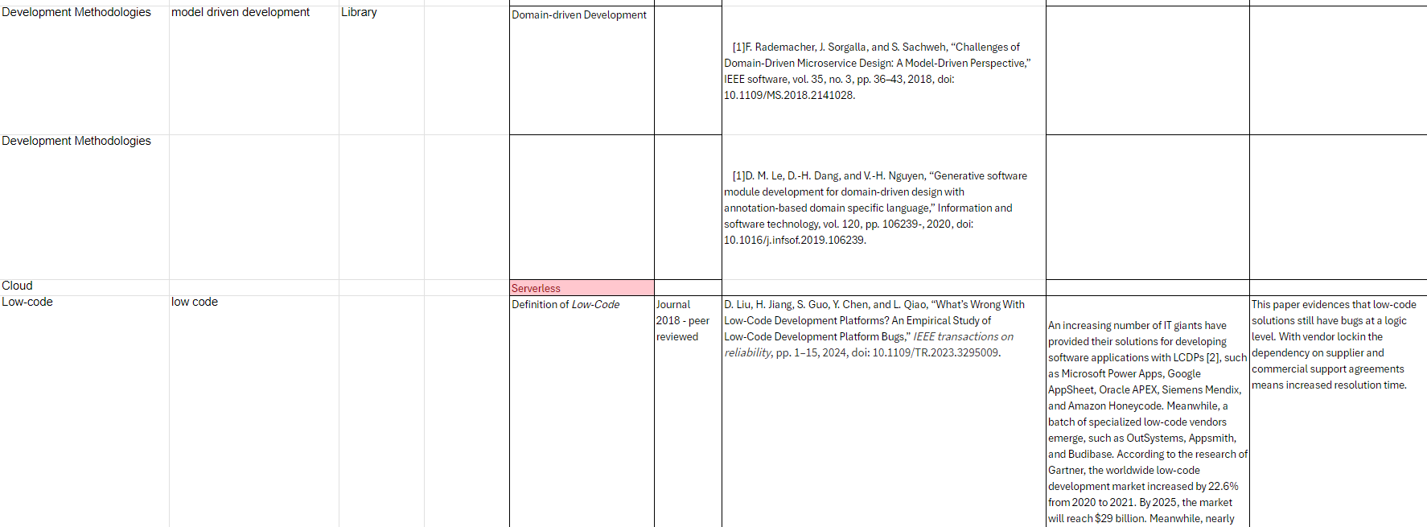

Appendix B- Requirements
Requirements have been separated in to function and nonfunctional and denoted by NF and UR.

No. | Requirement | Source
NF1 | Remove the need to map data from applications for analytics | DHCW Informatics Team
NF2 | Ensure FHIR Standards are used as part of applications design | DHCW Standards Team
NF3 | Cloud hostable
NF4 | web based
NF5 | Familiar programming language
NF5 | UI Designer Requirements | Interview
UR1 | Create a patient record
UR2 | Update a patient record
UR3 | Delete a patient record (or make inactive)
UR4 | Search for a patient record
UR5 | See results from patient Search
UR6 | For a patient enter a new Encounter record

Appendix C - Example Interview Templates

Hi, my name is Gareth Williams am I currently studying for a degree in Cloud Software Development.
The following questions are for research purposes only. No Personal Identifiable information will be shared without prior knowledge and consent.

Question | Choices | Answer
Job Title: |  | Product Manager single Record
Main role: | Principle Developer/Lead Developer/Manager/Product Manager | Chief Product owner for Digital products  Process and People, and budget.  Face of WCP, mobile  WNCR, Critical Care.
Collaboration tools: | TFS / Sharepoint / GitHub / Git /Azure DevOps | Azure DevOps
Backlog Management: | Azure DevOps / Kanban | Requirements  Test scripts  defects
What are the main challenges | Training, support, updates | Taking requirements  Automated testing  Sparing time
Was / is the overall experience positive or negative? | Yes, No
Do you have a roadmap for moving to cloud? | Yes, No | Yes, plan to move.  Architect for Cloud
Does your team use FHIR RESTful APIs or Data model? | Yes, No | Yes, for Requesting Endoscopy, FHIR, bundle.
Have you heard of NodeJS |  | Yes
To What extent? | Journal, Trial, | Jounrel
How receptive is your team to adopting new development stacks or technologies?  What criteria do you consider when evaluating the adoption of a new stack? | 10 = extremely | Cost, usability, ease of learning. Availability of resource, jnrs.
Do you believe that low code approaches are detrimental to keeping highly skilled developers, e.g., do developers feel disenfranchised? |  | No, WEFA, like the fact that boiler plate of WEFA.
Are you familiar with EJS (Embedded JavaScript) as a templating language? How do you perceive the potential benefits of incorporating NodeJS and EJS into your development environment? |  | No
What stack do you currently use? |  | C#, .net , SOAP APIs  Client side Jscript/HTML
What forms tooling do you use? |  | .net WEFA custom – forms, server side rendered.  Data driven
Has the team used low-code tools or forms technologies to help increase  List which tools |  | Orbeon – still got diabetities  System.  Microsoft Forms  Limited  Locking forms – limited user

Appendix D – Testing
Testing was video recorded. The following are screen grabs of a recording.
- Setting up docker and nodejs
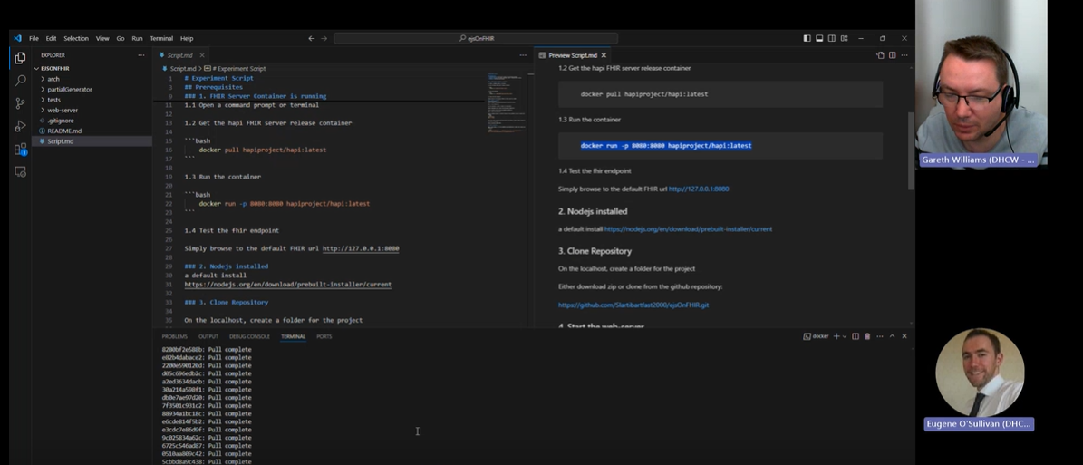

- Running the web-service server

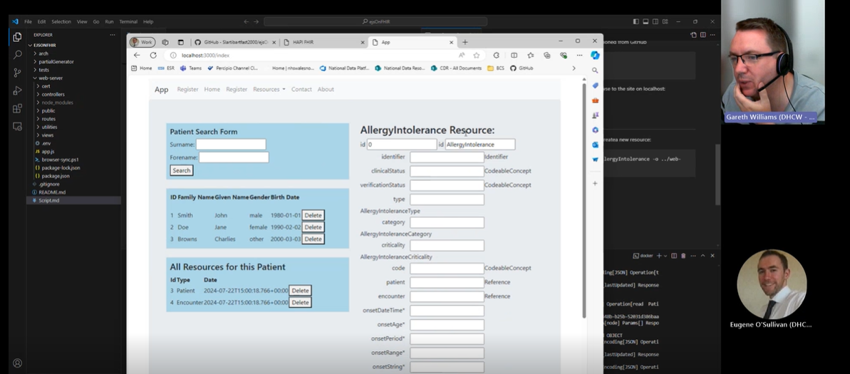

- Using the generatePartial application to create an Organization resource
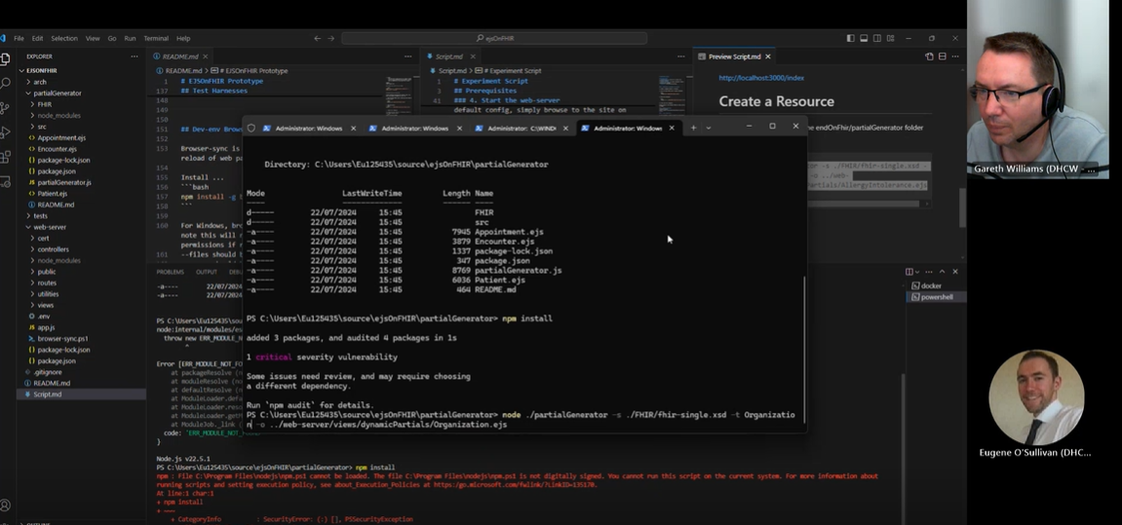

- Using the test web application to view the newly created form

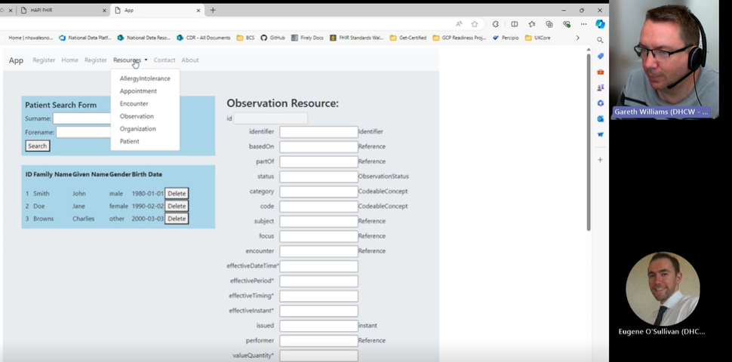
- Creating and updated a new Organization resource


