UNIVERSITY OF WALES TRINITY SAINT DAVID

ACADEMIC AND EMPLOYABILITY SKILLS
Self-Reflective Report

Author: Danciu Bogdan-Florin
Lecturer: Tanja Nathan
Cloud Computing, Term 1

London 2019

Executive summary
The primary purpose of the report is on forming a personal overview describing as a reflective approach towards academic and professional skills learned. The study is based on evaluating the skills and proficiency required for developing a successful PowerPoint presentation. The report further explains the skills and challenges faced during the classroom learning session. Moreover, the study presents a personal reflection of existing skills and the skills that are required to develop. It is Self-evaluation has been depicted in this presentation to evaluate better perspective of the course. The assignment thus helps to discover my strength and weakness in professional and personal skill areas.

Table of Contents
Section 1 4
Personal overview 4
Presentation screenshots 5
Key points learned 6
Section 2 7
Skills required for 7
Self-evaluation 8
Section 3 10
Short-term and long-term goals 10
Action plan for Academic and professional skill need to attain or improve 11
Section 4 12
Backup strategy providing a robust level of data protection 12
All possible disaster scenarios 12
Evaluation of own class-based exercise on crypto wall virus 13
Key points presented in time management lectures 14
Steps to be taken for enhancing productivity and reducing stress 14
Section 5: Conclusion and Evaluation 16
E-portfolio screenshots 16
Conclusion 16
Recommendations 16
Reference 18
Section 6: Appendix 20

Section 1

Personal overview
As a student, I have been working on a project on cloud computing technology and its aspects of data protection. Throughout the activity, I have developed specific IT and academic skills regarding data protection and underwent brainstorming session to enhance my understanding of the subject. I have also developed skills and knowledge on crypto wall virus that was taught as per classroom learning session. I have been present through the classroom program conducted in the subject and have gone through a self-learning process that has allowed me to gain high-end skills and new knowledge on the subject. In the entire course of the learning activity, I have developed a personal and professional skill that has embraced my academic learning in terms of data security and privacy protection. The classroom learning session and self-assessment of my knowledge have helped me in understanding the level of skills and knowledge I have on the subject. Furthermore, there are certain hindrances that I have faced during the due course of the learning activity that was resolved with gained knowledge and skills.
In the entire learning session, I have worked on my existing skills and knowledge that are transferable and have taken responsibility for owns learning session. This has helped me to learn about my own competencies and drawbacks. I have to develop further skills in data analytics and coding of the secured data protection system. The skills thus developed during the entire learning session w\have promoted me in a deeper understanding of cloud computing and data protection.

Presentation screenshots

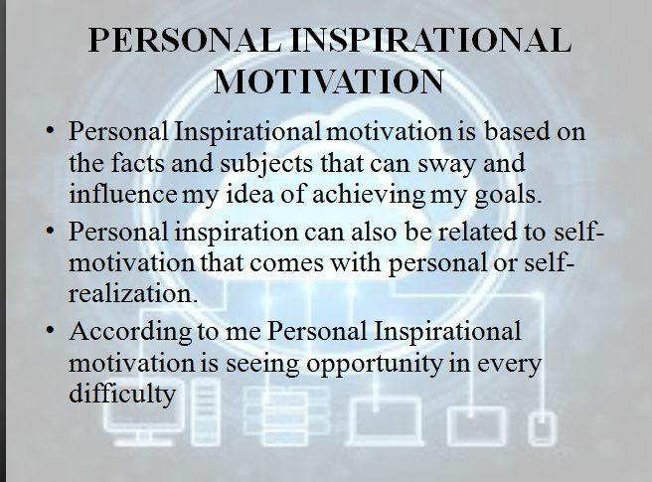
Screenshot 1

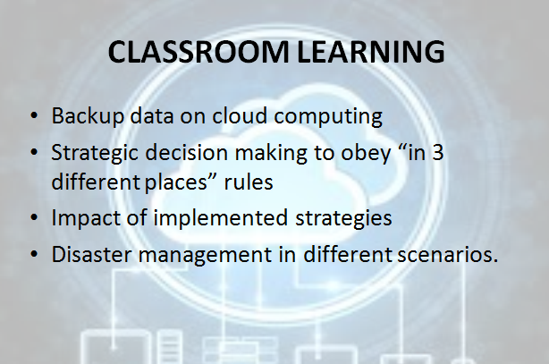

Screenshot 2

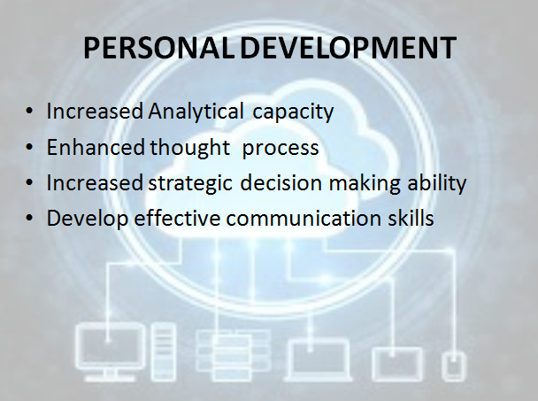
Screenshot 3

Key points learned
The key points that were learned while producing and delivering successful PowerPoint presentation have helped in gaining extra knowledge and opportunity for self-assessment. These points include,
- In terms of producing a PowerPoint presentation regarding my own self proclaimed learning and skills developed, I have gained knowledge about my own strength. I was able to efficiently able to evaluate my personal skills and knowledge that can be utilized as strength during the learning session (Basu et al. 2017).
- I have also learned about my weaknesses that might hinder me in gaining personal inspiration or motivation. In the time of producing the presentation, I was able to identify my limitations and points of improvement.
- Furthermore, while delivering the project, I have gained communication skills and have modified my existing skills of communication. This had allowed me to gain knowledge and more on essential skills like presentation courtesy and ways to approach all the audience and keep them engaged throughout the entire length of presentation.

Section 2

Skills required for
1. Higher Education learning
The skills that are required for achieving successful learning in higher education are
- Adaptive thinking: This skill is vital in case of attending any learning session in higher education. This skill reflects the capability of a student to learn and adapt to the new subjects and topic taught in the classroom.
- Communication skills: It is an important skill that is highly appreciated in the higher education learning program (Barak, and Levenberg, 2016). Communication skills reflect the ability to communicate with other students and professors.
- Collaboration skills: It is essential for higher education students or future employees to develop the skills of teamwork and collaboration. Working in a collaborative environment allows a student to work in a better performative environment, share ideas and therefore deliver a higher quality learning outcome.
- Critical thinking and problem-solving skill: Every student in the higher education learning process is expected to have the ability of critical thinking and must be able to solve any problem using a reasonable and deducible solution.
- Personal management: It is crucial that every student in a HE learning process must have the skills of personnel management.
- Inquiry skills: This skill reflects the ability of a student to raise questions and to be curious about learning more and gaining extra knowledge.
- Creativity and Innovation: One of the essential skills that are expected out of a student in HE learning is to show creativity and deliver an innovative idea.
2. Employability

The skills required or expected for employability are,
- Initiative and enterprise: It is highly expected from employees to take the initiative and take accountability of enterprise. It gives the employee to showcase most of his other skills.
- Planning and organizing: An employee must have the skill of planning and organizing any work or job assigned. The employee must be able to develop strategic planning for the benefit of the business.
- Self-management: Above all skills and job responsibility that are expected from an employee, it is essential to be self-cautious and must be able to manage and control oneself.
- Teamwork: It is essential for an employee to have the skills to work in collaboration or in teams. The employee is expected to have skills of managing or leading team members.
- Communication: Communication skills refer to the ability to communicate or engage in sharing ideas and concerns at the workplace (Boys, 2016). This is very important in the job role of a manager or team leader.
- Technology Skills: To keep up with rapidly advancing technology, an employee must have the skills and knowledge about trending technologies in the field.
- Problem-solving: It is crucial for an employee to have the skills of reasoning and reasoning to solve any problem faced at the workplace.

Self-evaluation

A Self-assessment test was conducted based on the skills and management approach from Mindtools.com. According to the test results, I have scored 56 out of a total 75 marks. The test was based on my personality and skills that I have in terms of attending learning sessions. I have strengths such as,
- Reasoning
- Time management
- Self-assessment and organizing
- Communication skills
My weaknesses are,
- Decision making
- Problem-solving
- Team management skill

Comparison and contrast
Comparing my skills and personality as described in the presentation, my self-evaluation through the online test has revealed a few different and more similarities.
Leadership and Management: I have scored 9 out of 15 points in leadership and management. Though I have ranked myself moderate in terms of leadership, I have misinterpreted my skills of management with leadership (Beghetto, 2016). I have been judged to be on the crossover point of leadership and management, and I am able to build a good team.
Problem Solving and Decision Making: My score in terms of problem-solving and decision making is 7 out of 15. This is where I lacked the most. However, in the presentation, I have mentioned a profound reasoning and problem-solving skills that are required (Cottrell, 2015). According to the test, I lag the understanding and identifying the root cause of the problem. However, once the cause is identified, I will be great at solving the issue with an efficient decision made.
Communication Skills: In comparison to the result of the test and that mentioned in the presentation I have skills in communication and delivering my needs top other. According to the test I am able to resolve most of the issues faced by efficient communication and declaring my ideas and positive beliefs. The result of the test is almost similar to that mentioned in the presentation.
Time Management: As per the result of the test, I am excellent in time management and have proved to be efficient in planning and organizing my job as per time allocated (Assiter, 2017). According to the test results, I am efficient in being productive and work under stressfree conditions.
Personal Mastery: In contrast to skills mentioned in the presentation and as per the result of the online assessment test it is indicative that I am good at self-evaluation and personal mastery.

Section 3

Short-term and long-term goals
Short term goals:
Short term goals allow focusing more on personal development that is highly required in current life situation. These goals include,
- Learning to get along with others and adapt to the situation: It is essential to learn the skill of adapting to the situation in the least possible time that would help me in professional as well as in personal time.
- Becoming more proactive: My next short-term goal is to become proactive and responsive to situations. This would help me in engaging myself more into opportunities to enhance my skills and existing knowledge.
- Releasing the past: It is crucial for me to release the past and focus more into the future. This would help me develop skills that are required to improve my personality instead of holding on to my existing skillset and knowledge.
- Managing stress effectively: Managing the level of stress faced recently should be done as early as possible to gain better control of my mind and work with more proficiency.
- Working on my attitude: I am moderately ranked for my attitude towards learning new things and working as a team. Thus it is imperative for me to develop the skills of a better positive attitude that would be beneficial for me as well as my team members.
Long-term goals:
Long-term goals are required for ensuring a long-term personal development that will help in future career and life development. These goals include,
- Becoming more confident: It is essential and advantageous for me to develop more confidence that would help me in achieving success.
- Improving body language: improving my non-verbal communication is essential in order to connect more with others communicate with confidence and assertiveness (Suleman, 2016). This is a long-term goal that will be developed over a more extended period.
- Developing conflict resolution skills: In order to achieve success in career and life, it is crucial to develop conflict resolution skills. The skill will be developed over a longer p[eriod of time and will reflect successful achievement of career and life goals.
- Increasing willpower: Willpower is the most important in the aspect that mostly influences health and fitness along with career goals. It is essential for me to enhance and attain better willpower in order to attain success in professional and personal life.
- Enhancing decision-making capabilities: As per the results of the personality test conducted in the above sections, I lack decision-making capabilities. I need to develop the skill as a long-term goal to improve my reasoning and critical handling skills.

Action plan for Academic and professional skill need to attain or improve.

The action plan required for improving my academic and personal skill include,

Skills | The time required to develop the skill
Learning to get along with others and adapt to the situation | 2-3 months
Becoming more proactive | 1 month
Releasing the past | 2-3 months
Managing stress effectively | 3-4 months
Team management skill | 4-5 months
Problem-solving | 3-4 months
Developing conflict resolution skills | 2-3 months
Decision making | 1-2 months
Table 1: Action plan for Academic and professional skill need to attain or improve
(Source: Self-developed)

Section 4

Backup strategy providing a robust level of data protection
Through the entire learning process of cloud computing course strategic decision making was one of the essential parts. As strategic decision making represents the ultimate learning outcome of this course, so this has helped me to implement my learning knowledge in practical use. The implemented strategy was developed in order to obey the 3-2-1 rule of computer backup mentioned in the classroom. 3-2-1 backup rules are one of the most accepted and praised approaches in the backup system and approved by many governments because it gives the maximum possibility of data security. The strategy was developed on the context that at least three copies of data would take as back up file and 2 of them will be saved in local storage but in two different mediums. In addition to this rule, at least one copy of the data will be saving in offsite. During my University days, all class notes of my were saved in my personal computer which is using as one of the storage space to save my data and one hard drive to save the same file in an external device. Right now to save the data from my computer I use an online backup process using system automation technique. This will help to upload my saved data in the offsite through the internet. In this way, one data can be saved in three different places. Multiple copies of a single data stipulated by 3-2-1 backup rule will protect me from losing my primary data together with its only backup copy.
On the other hand, sorting data copies in 3 different places ensures that there is no single point of failure. Using this strategy one user can quickly bring a robust data protection level for essential data. This also includes some other data protection such as backup types, critical data areas, storage media, a disaster recovery operation, encryption, etc.

All possible disaster scenarios
In order to identify all possible data loss or disaster scenario, I have identified five different possibilities. I think my backup strategy using cloud computing can recover the entire disaster scenario.
Cybercrime or third-party attack: In present days 48 times it is a cybercrime in data losses or breach as this become easier to initiate and most of the time user are lagging in their security sophistication. This has become easy to inject a virus through an external device and website link through the mail or other ways in the computer and remotely access the targeted computer. There is a high chance of losing important data. Through cloud computing data backup- system and 3-2-1 backup strategy it is impossible to lose all data at a time. There will be two more option to recover data if one storage location is attacked.
Insider threat: insider threat is one of the malicious attacks which is considered as intentional deletion or encryption corruption or theft of sensitive information by someone known. Data vandalism is a real threat in case information or data access in the personal computer is not highly controlled. The 3-2-1 backup rule is highly precocious and data recovery plan for this type of data loss. As usual, all saved data in the personal computer are saved in offsite storage. This strategy does not offer any protection in this scenario but ensures a complete data recovery.
Hardware failure: the risk of hardware failure is one of the unfortunate phenomena in the area of data loss. In a sudden period, one system could, and all the data are removed or formatted from the computer system. Here using 3-2-1 strategy, this could be more relevant concerning data recovery. This strategy gives the best way to recover data at any time anywhere after losing data from the personal computer (Fernandes et al. 2016). Through the cloud, the backup user can quickly recover and protect their data from permanent loss.
Software failure and file Corruption: occasionally some software failures and as a result data and files are deleted and corrupted without warning. In this situation, this mentioned strategy is one of the practical solutions to recover data from an offsite link.
Human error: In present days 25% of data loss takes place due to human error. This disaster scenario is all of the mistakes users make like dropping the computer, accidentally click malicious link misplace devices or delete the file while intended to save.

Evaluation of own class-based exercise on crypto wall virus
In the course of data backup system through cloud computing lecturer has given many examples of disaster scenarios, crypto wall virus is one of them. Trojan horse is one of the classified forms of Crypto wall which is known for masking its viral payload. The infection process has been depicted by the lecturer who is pretty standard for a virus. Moreover, after the host computer holds this virus, it started by establishing a connection of network to random servers (Brouwer, 2016). Using that server, it uploads information of the connection like public IP address, system information, and location including OS. This process can be continued until all the file mismatches with the supporting file types which are being encrypted and copied. Cloud-based storage. This virus could be dangerous for data and files stored in the attached devices. This virus can remove and stop the entire computer system from working. On the other hand, this entire process of removing data from a working computer cannot be easy to recover.
After it is confirmed that this particular virus infects the computer, end-user need to decide if they are interested to pay for ransom and get back their data or they want to lose their data, through cloud computing, one user can secure their data before any virus attack.

Key points presented in time management lectures
In the course of cloud, computing lecturer has discussed time management principles which include a detailed note on how to utilize the time during the study. The principle of time management states that student needs to study the subject matter as soon as possible after a class lecture. It would be more convenient if the student starts studying on the after one hour of the class lecture rather several days later. As lecture notes are fresh in student mind at that time. Also, a student needs to start their assignment when their memory of the assignment is still accurate. One of the exciting parts is odd hours during the day is best for studies. Plan and establishment habits are good for the student so that they can get free time for recreation which makes their mind refreshed to gather more knowledge (Oka et al. 2015).
From the lecture, I got to know that time management refers the process of planning to organize things in a best possible way that one want and need to do so which can be accomplished by him later on. Effective time management is a skill set that can be learned and improved by practice. Furthermore. Time management is essential for students as they need to learn to balance their time wisely in order to be successful. A student should manage their time among the list of commitments like own study time, classes, extracurricular activities and recreation time.

Steps to be taken for enhancing productivity and reducing stress
After this powerful motivational lecture in this course, I have intended to plan for something productive which would help me to be more proactive and reduce my stress level. The first and most important thing on my list is managing time to do more in a day. One of the great reasons for daily stress is completing everything within time, and with perfection, I believe that proper time management is effective stress-revealing technique because it grossly organizes much work within time. After that exercise and a walk will help me to lead a healthy lifestyle (Andersson and Bellgran, 2015). Staying in a positive attitude helps to reduce all the stress and gain more from life. I will try to organize my academic life to deal with stress; it can be achieved by keeping academic notes organized. Track, all the deadlines of assignments, will help to reduce the stress level. Other than that I will stop procrastinating by doing the difficult task at first.

Section 5: Conclusion and Evaluation

E-portfolio screenshots
This section required detailed information about a candidate so we could not deliver the screenshot.

Conclusion
In this coursework of cloud computing, my lecturer has followed some of the subject areas from the AES module. Few of the subject area has been covered in this existing unit which is relevant to the course. In this unit, we have focused on programming, system automation, database, and information management to support data backup. Computer system concept has been followed to support the basic knowledge of the data management system. Data copy and saving formula of a computer system will give a better dimension to the database system. Therefore the lecturer has followed database development or computational mathematics.
On the other hand Information management, assurance and security module has helped to develop the essential knowledge area of saving a file in offsite. In order to establish the idea of technical practice, the lecturer has also focused on professionalism and employability in this course. Some of the subject areas are still untouched in this course which can be followed in the next course.

Recommendations
I have an intention to study some of the remaining modules from the AES module after the current coursework and want to complete those in further studies. Data structures and algorithms using OOPs programming would help me to enhance my programming knowledge and information management system. Secure software development program would help me to increase my technical knowledge.
After completing this course, I have worked on several areas which have become challenges during the course. This entire report I have assessed all my academic and employability aspects and I got to know some of my weakness which I need to look upon for future references and improve my skill sets. During strategic development, I have faced some issues, so I need to work on strategy development and start practicing problem-solving through strategic implementation. On the other hand, this would improve my problem-solving issue as well. In academic practice these skills are fundamental to be successful, so I need to be more focused on these areas. Some of the personal skill sets like effective communication needs to be improved by my side. In the class through interactive intellectual conversation with lecturer and teammates will help to develop this skill. Apart from this, I need to improve my technical knowledge to participate in this communication skill development.

Reference
Andersson, C. and Bellgran, M., 2015. On the complexity of using performance measures: Enhancing sustained production improvement capability by combining OEE and productivity. Journal of Manufacturing Systems, 35, pp.144-154.
Assiter, A., 2017. Transferable skills in higher education. Routledge.
Barak, M. and Levenberg, A., 2016. Flexible thinking in learning: An individual differences measure for learning in technology-enhanced environments. Computers & Education, 99, pp.39-52.
Basu, S., Biswas, G. and Kinnebrew, J.S., 2017. Learner modeling for adaptive scaffolding in a computational thinking-based science learning environment. User Modeling and User-Adapted Interaction, 27(1), pp.5-53.
Beghetto, R.A., 2016. Creative learning: A fresh look. Journal of Cognitive Education and Psychology, 15(1), pp.6-23.
Boys, D., 2016. Towards Creative Learning Spaces?.]
Brouwer, E., 2016. Data Surveillance and Border Control in the EU: Balancing Ef¿ ciency and Legal Protection. In Security Versus Freedom? (pp. 151-168). Routledge.
Cottrell, S., 2015. Skills for success: Personal development and employability. Macmillan International Higher Education.
Danezis, G., Domingo-Ferrer, J., Hansen, M., Hoepman, J.H., Metayer, D.L., Tirtea, R. and Schiffner, S., 2015. Privacy and Data Protection by Design-from policy to engineering. arXiv preprint arXiv:1501.03726.
Douglass, G.K., 2018. Economic returns on investments in higher education. In Investment in Learning (pp. 359-387). Routledge.
Fernandes, E., Paupore, J., Rahmati, A., Simionato, D., Conti, M. and Prakash, A., 2016, August. FlowFence: Practical Data Protection for Emerging IoT Application Frameworks. In USENIX Security Symposium (pp. 531-548).
Mindtools.com, 2018. Available from https://www.mindtools.com/pages/article/get-started.htm accessed on [5/01/2019]
Oka, T., Abe, K., Yamauchi, T., Narumi, T., Ishii, N., Nishimura, S.Y., Sato, T., Tanabe, Y. and Sengoku, M., 2015, September. Roles and effects of a human network of supporting experts out of Niigata University to practical engineering education. In Interactive Collaborative Learning (ICL), 2015 International Conference on (pp. 150-154). IEEE.
Suleman, F., 2016. Employability skills of higher education graduates: Little consensus on a much-discussed subject. Procedia-Social and Behavioral Sciences, 228, pp.169-174.

Section 6: Appendix
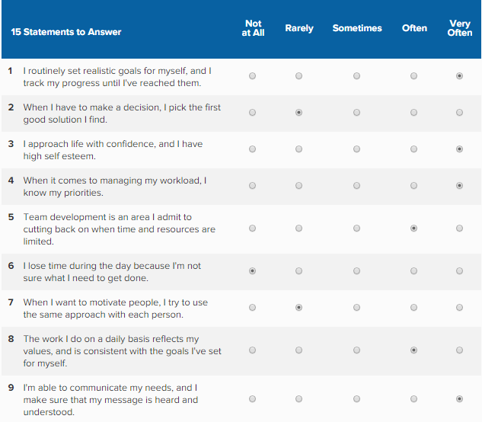
Figure 1: Personality test questions
(Source: mindtools.com, 2019)

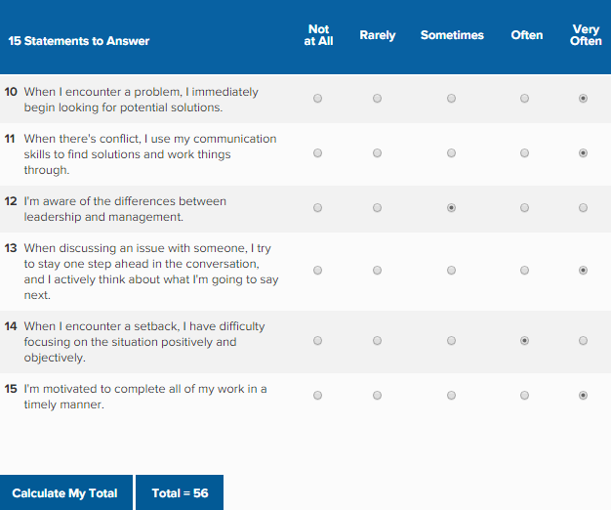
Figure 2: Personality test questions continued
(Source: mindtools.com, 2019)

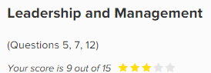
Figure 3: Test Results
(Source: mindtools.com, 2019)

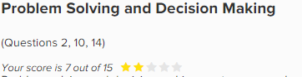
Figure 4: Test Results
(Source: mindtools.com, 2019)

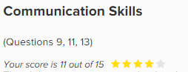
Figure 5: Test Results
(Source: mindtools.com, 2019)

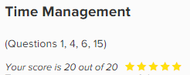
Figure 6: Test Results
(Source: mindtools.com, 2019)

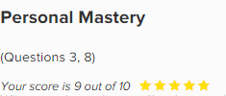
Figure 7: Test Results
(Source: mindtools.com, 2019)

Crypto wall report was not given in this report.

