University of Wales Trinity Saint David

Wales Institute of Science and Art


Kinetic Energy Recovery

Alternative Propulsion Systems (ACHA5010)

Chloe Rees
2218480
October 2024
Table of Contents
1.Introduction 3
2.Vehicle Dynamics and Characteristics 3
2.1 Test Mass 3
2.2 Frontal Area 3
2.3 Rolling Resistance Coefficient 4
2.5 Coefficient of Aerodynamic Drag 5
3.WLTP Cycle 6
3.1 WLTP Kinetic Energy Recovery 6
4.Forces Graphs 7
4.1 All Forces 7
4.2 Total Forces 8
4.3 Power 9
4.4 Traction and Braking Energy 10
4.5 Kinetic Energy Recovery 11
5.Suitable Kinetic Energy Recovery Systems 12
6. System Operations 13
6.1 How the System Operates 13
6.2 KERS Driving feel vs ICE Driving Feel 13
7. Data Findings 14
8. Conclusion 15
References 16
Table of Figures 16

1.Introduction
This report examines the effects of installing a kinetic energy recovery system (KERS) to a passenger vehicle. The study focuses on the data based on a 2022 Hyundai i30N Line 1.5L GDI, due to its compacted design and typical driving routine. The aim of this project is to analyse how to recover energy that would be wasted during braking through a suitable KERS, while also improving efficiency and reducing emissions.
The main objectives include finding key characteristics of the Hyundai I30N Line such as, the test mass, frontal aera, rolling resistance coefficients and aerodynamic drag coefficient. Using these key parameters, the tractive and braking energy can be calculated and then will be analysed over the WLTP cycle. After analysing the data calculated a suitable KERS system will be evaluated on its operational benefits.

2.Vehicle Dynamics and Characteristics
The chosen vehicle is the 2022 Hyundai i30n line 1.5L GDI.

2.1 Test Mass
Using a website that gives specific data on vehicles. It shows that the test mass for the vehicle is 1500kg (Anon., n.d.).

2.2 Frontal Area
The frontal area is a great value to know as it can help to calculate other important data for a vehicle.
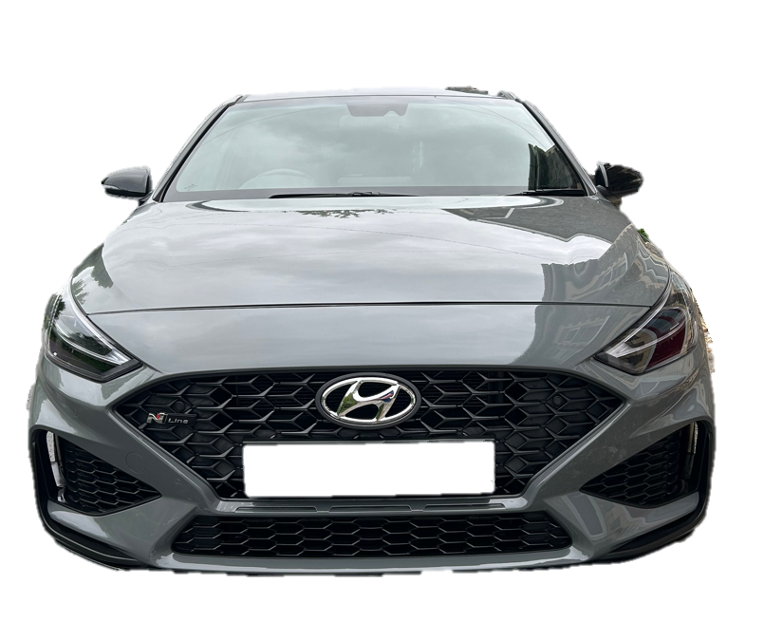

1.4m

1.7m

Figure 1- Hyundai I30N Line.

The Vehicle has a width of 1.7m and a height of 1.4m
$Frontal Area=1.7 × 1.4=2.4m$²

2.3 Rolling Resistance Coefficient
In order to calculate the rolling resistance other calculations must be done first. By doing this it will show how efficient the vehicle is.
Air Density ($ρ$)= 1.223kg/m³
Coefficient of Drag (Cd)= 0.3
Frontal Area (A)= 2.4m²
Velocity (v)= 11.1m/s
Mass= 1250kg
Step 1:
$$Aerodynamic Drag= \frac{1}{2}×ρ×Cd×A×v^{2}$$
Equation 1-Aerodynamic Drag.
$$Aerodynamic Drag= \frac{1}{2}×1.223×0.3×2.4×{11.1}^{2}$$

$$Aerodynamic Drag Losses=54.25N$$

Step 2:
$$Resistive Power=54.25×11.1$$

$$Resistive Power=602.18$$

Step 3:
$$Rolling Resistance Force(Frr)=Total Force-Aero Force$$
Equation 2- Rolling Resistance Force.
$$Frr=602.18-54.25$$

$$Frr=547.93N$$

Step 4:
$$Rolling Resistance Coefficient\left(Crr\right)= \frac{Frr}{Mass × Gravity }$$
Equation 3- Rolling Resistance Coefficient.
$$Crr= \frac{547.93}{1250 × 9.81}$$

$$Crr=0.04$$

2.5 Coefficient of Aerodynamic Drag
Using the same data from the rolling resistance coefficient, it can be used to calculate the coefficient of aerodynamic drag by using the aerodynamic drag value from equation 1. By doing this, it will show how aerodynamic and streamlined the vehicle is.

$$Coefficient of Drag(Cd)=\frac{2×Aerodynamic Drag}{ρ×A×v^{2}}$$
Equation 4- Coefficient of Drag.
$$Cd=\frac{2×54.25}{1.223×2.4×{11.1}^{2}}$$

$$Cd=0.5$$

$$Potential Energy(PE)=m×g×h$$

$$PE=1250×9.81×20$$

$$PE=245kJ$$

$$Work Done(WD)=54.25×500$$

$$WD=27kJ$$

3.WLTP Cycle
The Worldwide Harmonised Light Vehicle Test Procedure or WLTP is the new testing measurement for cars fuel economy, electric driving range and emissions produced after 2017. Before this the New European Driving Cycle or NEDC was used for testing cars since the 1980s. The WLTP is an accurate testing method showing fuel efficiency and emissions and matches it to how cars would be driven in the real world. It also takes into consideration such as rolling resistance and aerodynamic forces, when accelerating and braking (Dale, 2021).

3.1 WLTP Kinetic Energy Recovery
The graph below shows the WLTP acceleration, on the x-axis it shows the total time taken for the acceleration and on the y-axis is the speed in km/h. The graph shows many areas where a kinetic energy system is lost and could be stored and used for extra acceleration. This can be seen mainly in the highlighted braking zones of the graph; this is where kinetic energy can be regenerated into the storage system.
Figure 2- The WLTP Cycle.

4.Forces Graphs

4.1 All Forces
Figure 3- A graph showing all forces on the vehicle.
Figure 3 displays the acceleration force, aerodynamic drag force and rolling resistance forces at the wheel of the vehicle. The acceleration force curve fluctuates significantly as the vehicle is accelerating and reduces very quickly when the vehicle is decelerating or braking very heavily. The aerodynamic forces follow a smooth trend throughout the low-speed section of the cycle, as there isn’t enough speed for the aerodynamics to be effectful. As velocity increases with the time the aerodynamics forces are affected on the vehicle. This can be seen at 1485 seconds into the cycle. The rolling resistance is calculated to be 191.295N which is constant throughout the cycle.

4.2 Total Forces
Figure 4- A graph showing the total forces on the vehicle.
The graph above shows the total forces on the vehicle, this is done by the using the adding the sum of acceleration, aerodynamic and rolling forces. During the low and middle speed section the total forces are lower and less frequent. As velocity increases the total forces at the wheel increases, during the high section the forces are more frequent and the vehicle.

4.3 Power
Figure 5- A graph showing the power during the WLTP cycle.
Figure 5 shows the used and lost power during the WLTP cycle. During acceleration between 10kw to 50kw of power is used to increase speed. As the velocity decreases under breaking the power output also decreases. During breaking this power is lost through mechanical losses and is not absorb and put back into the KERS system.

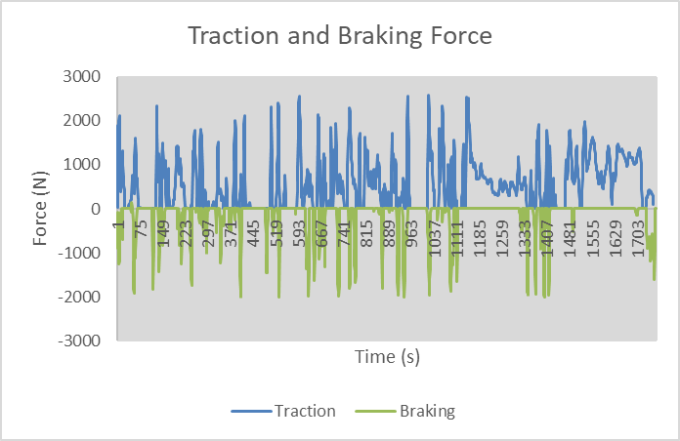
4.4 Traction and Braking Energy
Figure 6- A graph showing the tractive and braking force.
Looking at the graph above it displayed the tractive and braking forces against the WLTP cycle. It can be seen that the maximum amount of tractive force is 2500N at around 1111seconds into the cycle. This happens during the high-speed section of the cycle. During the braking period of the cycle, the maximum amount of force being lost is 2000N also during the high-speed section.

4.5 Kinetic Energy Recovery
Figure 7- A graph showing the lost braking power.
Figure 7 looks at the braking power that has been lost during the WLTP cycle. During the low-speed sections, the power lost is low and only losing 14kW of power. While comparing the low speed to the high-speed sections of the graph, the data shows that just after 885seconds into the cycle the peak amount of lost power is reached, and it shows that it loses 28kW of power during heavy braking. Where Kinetic energy is being lost a KERS system needs to be introduced to absorb this lost energy and stored to improve the car’s efficiency.

5.Suitable Kinetic Energy Recovery Systems
In order to improve the vehicles efficiency a 48V mild hybrid technology can be introduced into the car. Its main purpose is to captures the lost kinetic energy from the braking periods while driving. This system includes a 48V lithium-ion battery that drives a belt integrated starter generator. The 48V hybrid technology improves the vehicles performance significantly, as the vehicle’s velocity decreases the system can capture up to 15kW or 20hp of the lost energy and use it to support the engine and increases its boost by 12kW of power. A smaller battery is also connected to power the main 48V lithium-ion battery, this smaller power unit can also put out 1kWh. Compared to a 12V electrical system the 48V can absorb more lost kinetic energy (Automotive, n.d.).
The 48V KERS system is small thus meaning it doesn’t affect the engine bay space and results in a reduction of weight in the vehicle. The fuel consumption of the vehicle is also improved which results in a lower C02 emissions. By applying this system to the vehicle, the turbo lag is reduced meaning power is driven to the axle and wheels seconds earlier (Valeo, n.d.)

6. System Operations

6.1 How the System Operates
The system operates by where kinetic energy is stored in motion, and then that energy can be used to stop the vehicle gradually (Engineering, 2009).

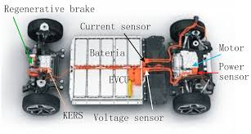

Figure 8-Electric KERS (Armenta-Dé & Cortés, 2023).

6.2 KERS Driving feel vs ICE Driving Feel
When driving a vehicle fitted with a KERS system the driver can feel an instant torque and acceleration compared to a combustion engine, as the build-up of electrical power is almost instantaneously which causes no lag between the throttle and wheels. The weight at the steering wheel can also feel different, as lithium-ion batteries are heavier than an ICE power unit so during cornering and braking the car may feel much heavier and more effort is needed to put the car where you want it to go. Driving a KERS / electric vehicle may increase the drivers impact on the environment as emissions are significantly reduced compared to a vehicle driven by a combustion engine. Noise pollution compared to electric and combustion are also significantly different, as there won’t be any noise produced by the engine however in an electric car the cabin noise may be increased as the car is heavier on its tyres. When braking with a KERS system it can feel weightier as it needs to regenerate a large amount of power therefore the braking may be less sudden but feel heavier under foot (Etengoff, 2024).

7. Data Findings
The evaluation of the calculated data against the WLTP cycle displays significant patters in energy demand and recovery potential. Figure 3 shows the plotting of the acceleration, aerodynamic and rolling resistance forces demonstrated how each resistance fluctuates across the drive cycle. The main force that changed with speed was acceleration, while the aerodynamic forces increased steadily with velocity and becoming more effective at the higher speed section of the cycle. While the rolling resistant stayed at a constant force of 191N.
The power used during acceleration phases peaked at 50kW, and throughout braking phases it revealed many occasions where power could be recovered. This determined that the best KERS system that would be the most efficient for this vehicle is a 48V mild hybrid that was capable of absorbing up to 15kW of power.
Figure 6 shows the difference in tractive and braking energy that was used and lost. Using this data the precise moments of when a KERS system can recover the energy lost.

8. Conclusion
This project successfully showed the benefits of introducing a KERS system into the Hyundai I30N Line. Through the use of vehicle dynamics analysis and simulation of this data against the WTLP cycle, it allowed for identification of where energy is being lost during braking phases of the cycle. Moreover, the analysis of the driver experience differences between an ICE drivetrain and an operational KERS system highlighted differences such as pedal feel, more gradual deceleration, instantaneous torque from electric therefore a much smoother experience while driving an electrified car.
A compact 48V mild hybrid system was analysed as it’s able to capture all the lost power during braking and recycle it to better improve the cars fuel consumption and C02 emissions.
Overall, the findings concluded that modern KERS systems are best to positively effect the vehicles performance and overall environmental look, while reducing weight and costs.

References
Anon., n.d. Parkers. [Online]
Available at: https://www.parkers.co.uk/hyundai/i30/hatchback-2017/15t-gdi-n-line-5d/specs/
Armenta-Dé, C. & Cortés, H., 2023. Analysis of Kinetic Energy Recovery Systems in Electric Vehicles. [Online]
Available at: https://www.mdpi.com/2624-8921/5/2/22
Automotive, S., n.d. What is 48V mild hybrid drive technology. [Online]
Available at: https://www.seg-automotive.com/48v/mild-hybrid-technology/#text_picture_slider_6
Batalha, J., no date. Kinetic Energy Recovery Systems. [Online]
Available at: https://cecas.clemson.edu/cvel/auto/AuE835_Projects_2009/batalha_project.html
Dale, N., 2021. What is WLTP and what does it mean? WLTP Explained. [Online]
Available at: https://www.evanshalshaw.com/blog/what-is-wltp/?srsltid=AfmBOorAgSysV0LBPhQTPGMdvhqBvnh_a04T2ypsfzVVHi9PcFSttfVr&_its=eF5Vj01ugzAQhe8y6xKwDf7hBl30DGjA42DJwZFxyiIKZ-80XXUzi3mfnr73hO_oYQRFWiMO2HjlRdOb2TeOOtd0dvBKukCCFHzAXrES4yXVUxglbWeFdmfCzZ9ykv0g7bRTnkKwp
Etengoff, A., 2024. How does EV driving experience differ from an ICE vehicle?. [Online]
Available at: https://www.evengineeringonline.com/how-does-the-ev-driving-experience-differ-from-an-ice-vehicle/
Valeo, n.d. 48 volts mild hybrid system, the affordable electrication. [Online]
Available at: https://www.valeo.com/en/48-volts-affordable-electrification/

Table of Figures
Figure 1- Hyundai I30N Line. 3
Figure 2- The WLTP Cycle. 6
Figure 3- A graph showing all forces on the vehicle. 7
Figure 4- A graph showing the total forces on the vehicle. 8
Figure 5- A graph showing the power during the WLTP cycle. 9
Figure 6- A graph showing the tractive and braking force. 10
Figure 7- A graph showing the lost braking power. 11
Figure 8-Electric KERS (Armenta-Dé & Cortés, 2023). 13

