University of Wales
Trinity Saint David

Name: Ewelina Halina Serdynska
Student Number: 1922217
Module Title: Workplace Culture and its impact on Organisational Efficiency
Code of the Module: BMSW 5105_LON
Lecturer Name: Olusoyi Ashaye
Executive Summary

The management of a particular business organisation is responsible for developing an ethical culture in their organisation for increasing organisational reputation. In this particular report, in order to discuss the importance of workplace culture and effects on organisational efficiency, Primark has been selected This report has briefly introduced Primark for the key business environmental scanning or analytical tools that have been underpinning in this particular report. The evaluation of the organisational environment has been developed with the help of PESTLE and Porter's five forces analysis. I have explained my learning and skills, which I have acquired while developing the module. Gibbs reflective model has been used for this purpose. The model helps in learning through the bifurcation of a situation into six stages, which are description, feelings, evaluation, analysis, conclusion, and action plan.

Table of Contents
Task 1: “How do broader external environmental factors along with COVID-19 and ethical dilemmas affect organisational culture and its performance?” 4
Introduction 4
Discussion 4
1. “Brief Introduction of the selected organisation” 4
2. “Key business environmental scanning or analytical tools” 4
3. “Evaluation of organisation with its broader environment using PESTLE and Porter’s Five Force Model” 5
4. “Assessment of the workplace culture of the organisation” 10
5. “Critical evaluation of the relationship between the organisation's present culture and its efficiency in achieving financial and non-financial performance and identify two ethical dilemmas in the organisation” 13
6. Conclusion 17
Task 2: Individual Reflective Essay 18
Reference List 23
Appendix 27

Task 1: “How do broader external environmental factors along with COVID-19 and ethical dilemmas affect organisational culture and its performance?”

Introduction
Workplace Culture plays an important role in order to improve the organisational efficiency through developing a collaborating and ethical work culture among the stakeholders. Covid-19 pandemic situation has affected most of the business organisations in terms of poor revenue generation and losing talented employees due to implementing poor organisation cultural policy. In this particular report, in order to discuss the importance of workplace culture and effects on organisational efficiency Primark has been selected which is a reputed retail organisation in the UK. In this report, PESTEL and Porter’s Five Forces Model will be introduced as organisational analysis techniques or tools for Primark. Two ethical dilemmas will be selected based on Primark in the report and dependent upon these two ethical dilemmas recommendations will be provided.

Discussion

1. “Brief Introduction of the selected organisation”
Primark is one of the leading globalised clothing retail business organisations, having their branches around 14 countries. It has been estimated that Primark has a total of 65000 employees in all of their branches operating all over the world (Primark, 2022). The main products of Primark can be listed as “homeware and accessories”, “menswear”, “womenswear”, “Kids wear” and beauty products. They have a total of 400 stores across 14 countries and it has been predicted that their number of stores will increase to 530 by 2026 (Primark, 2022). Primark was founded by Arthur Ryan in the year of 1969 and they have successfully developed their loyal customer base. It has been estimated that their total revenue was 559.3 crores GBP in the year of 2021 (Primark, 2022).

2. “Key business environmental scanning or analytical tools”
In order to analyse the political, economic, social, technological, legal and environmental environment in the UK, PESTLE analysis is important. This particular analytical tool can provide a brief idea regarding the current business environment in the UK by briefing political stability, economic conditions, rules and regulations and customer demands (Shahid, 2022). On the other hand, “Porter’s Five Forces Model'' is important to identify the competitive environment and rivalry in the clothing retail industry in the UK which is beneficial for Primark in terms of developing proper strategies for achieving competitive advantage. “Porter’s Five Forces Model'' will be used as analytical tools by identifying the competitors and threats for Primark.

3. “Evaluation of organisation with its broader environment using PESTLE and Porter’s Five Force Model”
PESTLE Analysis
Political Factor
The fashion industry has a worldwide reputation in the UK. However, there are a few challenges which have taken place because of the Covid-19 pandemic, impact of Brexit, lockdown, and corruption. These challenges have led to political instability in the UK (Theglobaleconomy, 2022).
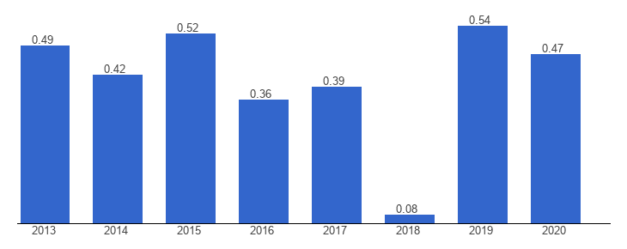
Figure 1: Political Stability Index of UK
(Source: Theglobaleconomy, 2022)
Apart from this, the policies of income tax in the UK have been modified that has initiated support payment with the help of self-employment income support scheme as well as job retention scheme during the Covid-19 pandemic time (GOV, 2022a). Apart from this, due to Covid-19, the supply chain management of Primark has been affected which has led to the delay in supplying raw materials for the production of wearing accessories due to inefficient transportation systems (Sky, 2021).
Economic Factor
The economic aspect in the UK has been segregated under three factors which include the labour cost, rate of inflation and Gross Domestic Product.
“Labour Cost”
Currently, the modern trend in the fashion industry has experienced a constant rise in oversupply and plant obsolescence. Due to the model of linear business of fast fashion, the fashion sector has concentrated on the distribution, quick production and the supply chain apart from designing the products. With the help of the linear model of business, the fashion industry can bring significant and continuous modifications based on current fashion trends and less labour cost (Gazzola et al. 2020). Apart from this, during Covid-19, most of the companies of the fashion industry have relied on local employees that have helped those organisations to attain significant profitability through lower labour cost while manufacturing wearing accessories (Wheeler, 2021). Primark has also taken a similar strategy to decrease the labour price by relying on the local employees.
“Inflation Rate”
According to the recent report of 2022, the inflation rate for clothing and footwear accessories has reached 7% in the UK (Statista, 2022a). In the fashion and clothing industry, the importing price of raw materials involves fabrics, black garments and many more which has grown because of the increment in the price of shipping product’s containers. Due to such a rise of the inflation rate, it has also affected the cost and the expenses of Primark.
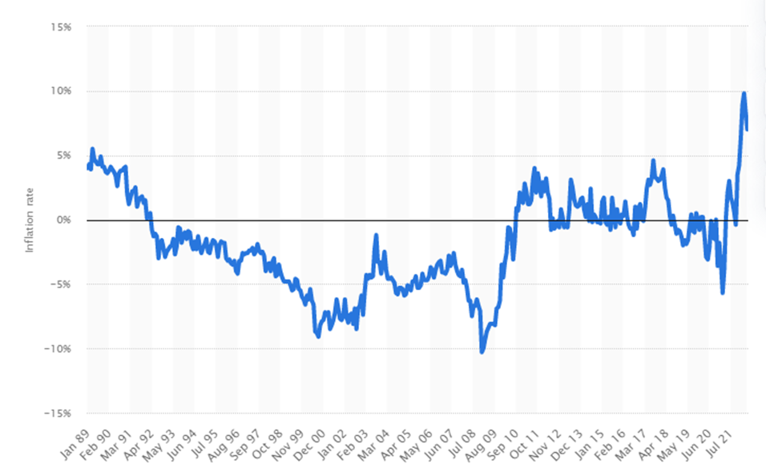
Figure 2: “Inflation rate of footwear and clothing accessories”
(Source: Statista, 2022a)
“GDP”
The current Gross Domestic Product of the UK is 3376 USD (Statista, 2022b). Due to Covid-19 pandemic, the GDP of the country has dropped by a significant number, but since 2021, the GDP is slowly growing and expected to reach 4551.55 USD by the end of 2027 (Statista, 2022b).
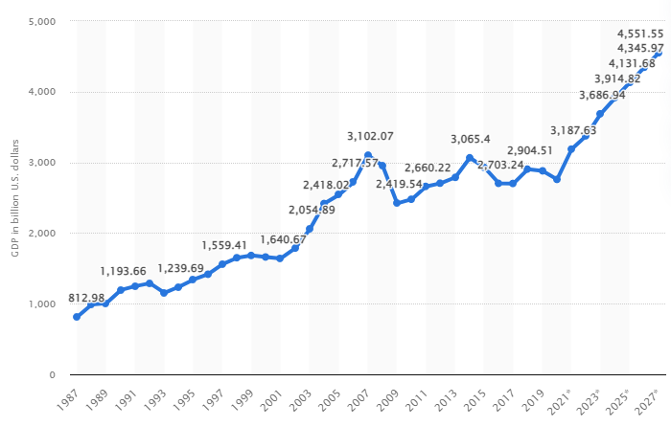
Figure 3: “GDP growth of the UK”
(Source: Statista, 2022b)
Social Factor
The social factor is significantly affected by the factor of immigration in the UK. Employees working in the clothing and footwear industry depend on immigration flexibility to provide the growth in the clothing industry (Fashioncapital, 2022). Apart from this, many fashion companies like Primark rely on the current trends adapted by the clients that reflects on the supply of raw materials based on the design of clothing accessories.
Technological Factor
The fashion sector in the UK has developed their techniques of production and crafting through advanced technologies. Several fashion organisations including Primark have used “Niche quick-response codes” that can be used to deliver the offers of personalised in-store products through QR codes to link with digital shopping (Forbes, 2022). Moreover, the UK government has spent more than £15.3 billion on technological development (ONS, 2022).
Legal Factor
The legal factors in the UK have been influenced by the law of employment, where the “Employment Right Act 1996” can help in offering legal rights to the workers in a company (Legislation, 2022a). According to “Equal Pay Act 1970”, the employees working in the UK can have equal treatment of remuneration irrespective of the cultural background of employees (Legislation, 2022b).
Environmental Factor
Several companies including Primark in the fashion sector in the UK have initiated a few objectives based on environmental sustainability by reducing the usage of plastic and the emission of carbon elements in the production system. Several fashion companies have trained their employees for maintaining a GoGreen environment and provided them by certifying with a GoGreen specialist (British Fashion Council, 2022).
Porter’s Five Force Model
In order to analyse the competitive rivalry “Porter’s Five Force Model” have been used for Primark.
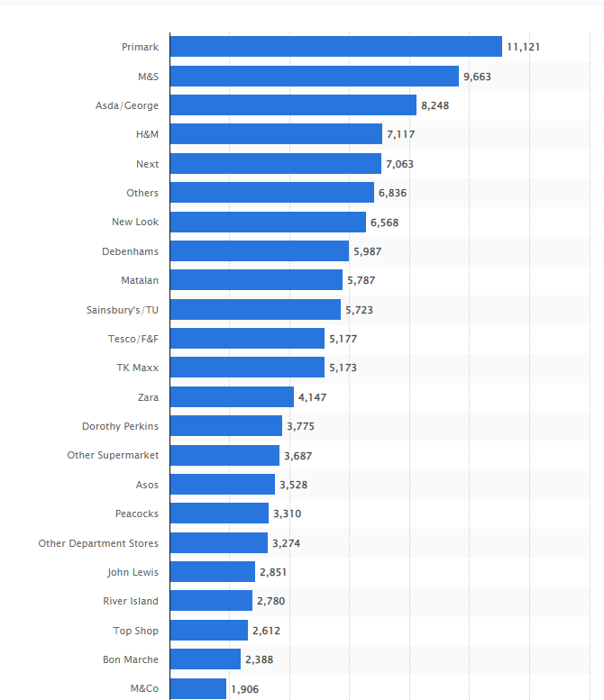
Figure 4: Number of competitors of Primark ranked on customer base in the UK
(Source: Statista, 2022c)
This figure shows the number of competitors of Primark ranked on the customer base in the UK and this has been used in “Porter’s Five Force” analysis for Primark.
Porter’s Five Forces | Measurements | Justification
Threats of new entrants | Low | Primark has developed a wide range of customer base by its different kinds of products such as homeware and accessories”, “menswear”, “womenswear”, “kids wear” and beauty products (Primark, 2022). New entrants will have to invest a lot of money in order to develop this wide range of products. Moreover, additional expenses are associated with maintaining brick-and mortar stores, marketing and selling, innovation and automation. So, threats of new entrants can be considered as low.
Bargaining power of buyers | High | According to the current statistical information it has been estimated that the number of customers of Primark is 11121 which is the highest among all clothing retail organisations in the UK (Statista, 2022c). However, as there are a large number of competitors as popular clothing retail organisations in the UK such as M&S, ASDA, H&M, NEXT Plc so, it can be said that if customers are price sensitive then they can easily shift to another retail clothing organisation (Statista, 2022c).
Threats of substitute products | High | The threat of substitute products is high because the key products of Primark cannot be considered as a unique kind of product. Though they have developed a wide range of clothing and home decoration products, all of those products can be replaced by innovative and unique kinds of sustainable products, which are the new trends in the UK.
Bargaining power of suppliers | Moderate | As per the current statistical information it has been estimated that Primark has only 14 number of suppliers in the UK (Statista, 2022d). This can be considered as a poor number of suppliers and the management of Primark can be regulated and influenced by the bargaining power of suppliers as they have lesser scope for shifting to other suppliers easily. Due to the low number of suppliers, the suppliers can demand an unrealistic price. So, the bargaining power of suppliers can be considered as high for Primark in the UK.
Rivalry among existing competitors | High | It has been observed that the prime competitors of Primark as M&S, ASDA, H&M, NEXT Plc, New Look, and Sainsbury's. The number of customers for M&S has been estimated as 9663 and ASDA is 8248 which is more or less similar to the customer base of Primark (Statista, 2022c). Additionally, the number of customers for H&M and NEXT Plc are more than 7000 (Statista, 2022c). So, it can be said that Primark has a large number of competitors and they have a sufficient number of customer base in the UK. They have gained a large number of customers by smart marketing and innovation. This is the main reason for rivalry among existing competitors in the UK is considered as high.

Table 1: Porter’s Five Force of Primark
(Source: Self-developed)

4. “Assessment of the workplace culture of the organisation”
Culture can be defined as an “assembled effect” and “mediated experience”. According to Anderson (2020), the "assembled effect" portrays how workplace culture is formed and altered through the unanimous effort of both employees and organisations. As the involved functional processes and transformations are lived and experienced, the culture becomes a "mediated experience". Therefore, in order to analyse and bring about a positive change in organisational culture, concepts like the cultural web are required. The six elements within this concept expose the pattern and model of organisational functioning which are critically evaluated to alter practices in the existing culture and bring about a positive transformation for the future culture (Leadershipcentre, 2022).
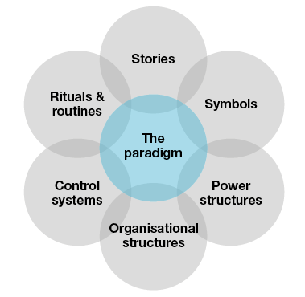
Figure 5: Six elements of the cultural web
(Source: Leadershipcentre, 2022)
Stories: The incidents and instances that employees of an organisation share reflect the extent to which positive culture is integrated. Thus, if the stories reflect positive attitudes, then the culture is healthy and vice versa. In the context of Primark, it can be said that the organisational culture is a mixed one with different outcomes for employees and customers. According to the instances shared by one of Primark's employees, “customers leave their old inner wears in the changing rooms as they wear Primark’s new inner wears and leave the stores” (Mirror, 2021). It has also been mentioned that if the used inner wears reach the shelves by mistake, then the associated personnel will be deemed responsible. However, customers are never charged for this mistake. Thus, while the company acts humbly toward customer mistakes, it does not forgive the mistakes of the employees and the employees are subjected to rebukes (Leadershipcentre, 2022). This shows that the company has not been performing well with respect to managing employee well-being as part of the organisational culture.
Rituals and routines: This represent accepted behaviour and actions of an organisation’s employees and customers according to differing situations. In Primark, the culture of routines and practices is not healthy. Customers expect to enjoy additional services as part of the generosity of the company. For example, one instance shows "a father demanding to havethe size of his 11-year-old daughter’s inner wear determined to facilitate the purchase” (Thesun, 2021). Although the company does not offer fitting service, the father was persistent about it. When expectations were not met, the father lodged a complaint. The instance also shows that employees are flexible to adjust to new situations [Refer to Appendix]. The concerned personnel did not act generously to help out the girl find a fitting inner wear as it was being mentioned that “the next-door M&S offers the inner wear service” (Thesun, 2021). Thus, it shows that simple additional demands of customers are not respected and met by the company’s employees reflecting a negative organisational culture and low performance.
Symbols: These are the visual artefacts that reflect the cultural strength of organisations. When clothing retailers make use of slogans through clothes, it directly reflects how healthy is the cultural treatment of the company's customers. The case of Primark shows a negative treatment of children with much bias toward male children. For example, in February 2022, the girl logo stated, “be kind” while the boy logo stated, “rewrite the rules” (Birminghammail, 2022). Thus, the narrative turned out to be gender-biased where girls were expected to be passive while boys were expected to be active. The situation has led to customer backlash against the company over social media platforms. This shows that the company has wrongly used the clothes as a physical artefact to share a negative cultural image. Thus, the performance of the company is below average with respect to attaching equal importance to children irrespective of gender difference.
Organisational structure: This element represents how an organisation is organised and the extent to which informal lines of power decide the culture. Thus, if an organisation is strictly hierarchical, then the employees have a minimum say and influence in the organisational activities (Child, 2019). Thus, the culture becomes negative as the lower-level employees have no power to contribute toward organisational growth and success. It can be said that Primark has a “hierarchical” organisational structure [Refer to Appendix]. This means that the chain of command is long and there are fewer subordinates (Maalaoui et al. 2020). Thus, it can be said that employees do not enjoy much freedom in the company as they have to constantly seek advice from seniors before deciding to alter the performance style of activity. It can also be concluded that the company does not have any informal line of authority. This means that every decision has to follow the fixed chain of command through the application of the “top-down approach”. Hence, this level of strictness prevents fast decision-making and makes the culture negative. The visible impact is that the decisions are less effective due to linear thinking which directly affects the performance of quality tasks.
Control systems: This element reflects how an organisation controls its employees and activities through multiple means like rewards and employee benefits and quality control. According to Dekker (2018), if an organisation is serious about having detailed yet flexible control, the culture turns out to be positive. In this respect, Primark portrays a positive culture. For example, in 2021, the company adopted a “hybrid working model” to support its employees returning to the office after the end of the pandemic lockdowns. The employees are attending office only 3 days a week and the work schedules are based on individual and team needs (Employeebenefits, 2021). Thus, this flexible practice has allowed employees to enjoy an agreeable amount of work pressure. The practice has led to positive results as the company witnessed an operating profit margin of 10% for the second half of 2021 (Retail-week, 2021).
Power structures: This element involves the use of corporate power by either a few individuals or the whole department of an organisation based on the power division. Ponte (2019) states that the power level and division also decide the freedom to make decisions by organisational members. Since the power within Primark is enjoyed only by “senior officials”, the decision-making is influenced by them. Thus, the culture is negative because most of the members could not contribute to idea generation and decision-making as the decisions are autocratically influenced by the seniors. The situation also reflects that power of influence is enjoyed by a limited number of top-level executives of the company [Refer to Appendix]. Thus, the outcome of decision-making is borne by the entire organisation and its employees according to the influence of the top-level executives. This shows that the performance is not as good as expected due to lack of proper decision-making rationale.

5. “Critical evaluation of the relationship between the organisation's present culture and its efficiency in achieving financial and non-financial performance and identify two ethical dilemmas in the organisation”
Relationship between the present organisational culture and efficacy of Primark to achieve financial and non-financial performance
Primark has been identified to have a hierarchical organisational culture, which states a long chain of commands with a smaller number of organisational subordinates. As per the element of “stories” from the components of the cultural web, it has been noticed that there have been issues regarding changing of lingerie of customers. Primark has no routines and rituals regarding the fitness of lingerie although there has been the inclusion of a report, in which a father has claimed lingerie fitting service for his daughter (Thesun, 2021). Hence, it can be stated that Primark has not followed the basic requirements of customers regarding the fitting service of wearables. The maintenance of the hierarchical structure is responsible for making suitable organisational decisions only through the respective command chain (Mazorodze and Buckley, 2019).
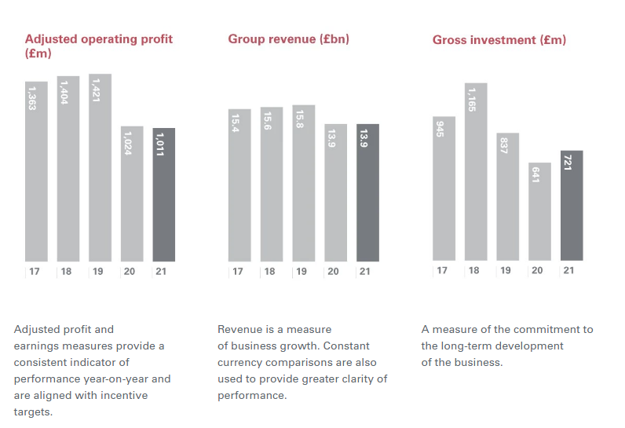
Figure 6: Financial Statement of Primark
(Source: Primark, 2022)
The adaptation of the “hybrid working model” has impacted this organisation for gaining a profit margin in 2021 (Primark, 2022). This working model has immensely ensured its flexible control over the employees by offering them to attend the office thrice a week according to work pressure and team requirements.
“Explanation of the term, Ethical Dilemma and identification of at least two ethical dilemmas in the selected organisation that may or will affect the performance of the organisation”
Explanation of ethical dilemma
Ethical dilemmas can be described by problems in the method of decision-making between two probable options for their acceptability from an ethical perspective. Ethical dilemmas of an organisation are considered to be complex situations, in which the conflict of moral imperatives is faced by employees and organisational managers (Gupta, 2019). Ethical dilemmas are of four major kinds, in which “truth vs loyalty”, “short-term vs long-term”, “individual vs community” and “justice vs mercy” are included. The “truth-vs loyalty” occurs because of the contrast between being honest with organisational values and the promise-keeping of customers (Serrat, 2021). “Short-term vs long-term dilemma” occurs due to the differentiation between short-term goals or satisfaction of customers as per current needs and long-term goals or future possibility of consumers’ interests. The reason for occurring “individual vs community dilemma” is the conflict between pursuing self-interests and pursuing the majority outweighs. The principle of organisational justice regarding sticking to organisational rules and the principle of organisational mercy regarding caring for customers' peculiar requirements create the dilemma of “justice vs mercy” (Ansorge, 2020).
Identification of two ethical dilemmas in Primark that can affect organisational performance
Various ethical issues of Primark have been identified, from which "environmental reporting", "pollution and toxins", "workers' rights", "animal rights", "animal testing", "use of controversial technologies", and “anti-social finance” can be incorporated. Among these ethical dilemmas, the two most important ethical issues can be chosen as “workers’ rights” and “animal rights”.
Workers’ Rights
Primark has assigned a strong policy of supply chain and it has provided the assurance of payment to a living wage. In addition, it has also stated that suppliers have been audited for a minimum of one time per year. Some allegations have been made against Primark regarding is following the promised “code of conduct”. The report of “Christian Initiative Romero (CIR)” has stated that after conducting interviews of 73 employees of Primark, they have not received positive responses from this organisation as per their promises (Ethicalconsumer, 2022). As per the UK report, published in 2019, Primark has been poorly reviewed as it has claimed that not a single worker of this organisation has been paid a living wage as per its ethical promise. This report has also made a recommendation for this organisation to sign legal agreements, by which this kind of ethical dilemma cannot be further practised. It has also failed to deliver minimum wages to the employees as per the article published on “Business & Human Rights website” and it has also cut monthly salaries of the workers for their uniforms provided by the organisation. For this reason, it has been marked down under the “Human Rights category”.

Animal Rights
Primark has been identified as losing a whole mark under the “Animal Rights category”. As this organisation retails leather materials, hence, it has caused ethical dilemmas regarding animal rights. It has also been identified to lose a half-mark for the “animal testing”. It retails various cosmetic brands, which provide no assurance regarding the testing of those products on animals although it has stated that animal testing is strictly prohibited in Primark. According to the “Associated British Foods”, Primark has slaughtered pigs and has sold eggs of hens in its retail stores even after the promise it has made regarding the sale of 100% cage free eggs (Goodonyou, 2022). In addition, this organisation has also been found to sell foie gras, in which geese and ducks are brutally abused with pipes to puncture their throats.
Actions need to be taken for the mitigation of ethical dilemmas with justified point of view
- As per the “Tailored Wages UK report” of 2019, it has been noticed that Primark has been poorly reviewed for the ethical dilemmas regarding its poor management of providing labour wages. This organisation has promised to pay minimum living wages to all of its employees, which has not been kept by Primark according to this UK wages report (Fashionunited, 2017). Therefore, this organisation needs to sign an enforceable agreement and legally-binding agreement with the representatives of organisational workers. Previously, there has been no existence of any legal paper regarding keeping ethical promises of Primark, for this reason, frequent occurrence of ethical dilemmas has occurred. With the help of legal agreements with the employees, this organisation cannot practise any illegal occurrence that hampers human rights.
- According to the “Animal Welfare Act, 2006”, the offences that create unnecessary suffering to animals are said to be illegal as per animal rights (GOV, 2022b). Primark has been claimed to hamper animal rights for not mentioning exact resources of wool and leather. Hence, the strategy needed to be taken by this organisation to mitigate this ethical dilemma can be the proper information of sources of wool and leather that can ensure the fact of non-harming attitudes of this organisation.

6. Conclusion
It can be concluded that Primark is a leading clothing retail organisation and operates their business globally. They have developed a large number of customer bases in the UK. It has been estimated that the number of customers of Primark is 11121 which is the highest among all clothing retail organisations in the UK. However, two major ethical dilemmas have been found associated with Primark such as violation of Workers’ rights and violation of Animal rights. In order to mitigate these challenges two actions can be taken which have been discussed in the above report.

Task 2: Individual Reflective Essay
In this part, I will be explaining my learning and skills, which I have acquired while developing the module. In the context of this, I have used Gibbs's Reflective model to investigate key learnings from the module.
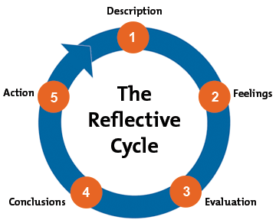
Figure 7: Gibbs's Reflective Model
(Source: Adapted from Adeani et al. 2020)
Description: I have been asked to prepare a report module on workplace culture and its impact on the efficiency of an organisation. I chose the fashion retail brand named Primark to analyse the workplace culture of the company so that the module can serve its purpose of developing my understanding of leadership qualities and management skills for future practices. The topic covers a broad perspective of a company’s management. While going through the case study of Primark, I got to know about how the company does management practices. This made me learn various management skills such as change-management skill, which will help me in my future workplace to adapt changes as per the requirement for accomplishing business goals. Moreover, taking into account the entire module has incorporated into my personality to develop leadership skills. Leadership skills such as decision-making, problem-solving, and interpersonal skills will assist me in my future future business practice of employment requiring, exercising personal responsibility and taking decisive actions in the workplace. According to Abubakar et al. (2019), these abilities enable some positive set of assumptions in an individual that is shared with other people in a workplace for upbringing in a cultural context of the organization.
Feelings: While developing the project, I have found that there is a number of parameters, which need to consider by an organization, especially a multinational company like Primark. Big companies are required to have a strong and structured workplace culture so that they can promote employee performance and engagement. In this way, I have realized the importance of positive and sophisticated organisational workplace culture. In addition, I feel that learning of taking own responsibility will help me in professional as well as personal contexts. In my opinion, one of the most important aspects I learned is the importance of ethical standards. I observed that Primark went through several thick and thin in relation to ethical conduct. Studying ethical responsibilities has made me to fetch more information about ethical practices an organisation can opt for to improve brand value.
Evaluation: By evaluating the procedure of project making, I can say that I faced challenges at the beginning in understanding various practices of an organisation to maintain workplace culture. However, proceeding ahead step by step assisted me in overall professional learning.
I must say that the development process of the module has guided me in many ways to learn crucial leadership and management skills. However, I realised that there are some skill gaps, which I need to improve to brush my acquired leadership qualities for the best possible use. I have worked with more qualitative data from Primark. Therefore, I need to learn data analytical skills in an efficient way. In addition, teamwork, tech support, and innovation are some qualities, which remain untouched in this project. I will be trying to incorporate these skills in my future projects.
Analysis: While doing the self-analysis, I have found that I need to be more critical about my skill gaps. There are several skill gaps which are identified that include lack of data analysis skills, working efficiently in a team and fulfilling the organisational objectives and expectations. Data analysis is one of the most important skill sets required to write a report. While writing the report, I have faced a problem in getting relevant data and information to justify the learning outcomes. I need to work hard on my research ability to acquire the skill of data analysis. At the same time, I have to focus on the right keyword that can help in getting the relevant data and information while doing the data analysis of any particular topic. In the report writing, while giving government data and statistics, it took a long time to get the desired result from the relevant sources. Thus, I need to develop a quick research technique to develop the skill of data analysis.
Apart from this, I need to develop teamwork skills that can help me in working efficiently in a group. Teamwork is very important through which the performance of individual skills can also develop with the help of team members. Apart from this, teamwork can also help in developing a good mutual relationship with the team members.
Conclusion: From the above analytical study, it can be concluded that while writing this report, I have learned and understood several skills which include interpersonal skills, management skills, and leadership skills. With the help of interpersonal skills, I can communicate efficiently. Apart from this, I need to improve my data analysis skills and teamwork skills that can help in working effectively in a group as well as improve my research ability.
Action Plan:
Weaknesses | Objectives to overcome weaknesses | Actions required | Resources | Timeframe
Data Analysis Skills | - Finding relevant data and information from relevant sources.  - Improvement in the research ability.  - Quick research technique. | While searching for any relevant data, it is important to access the information from the Government websites or from the relevant sources of authentic new channels. In order to improve the research ability and the technique to search quickly, it is important to use the right keyword. At the same time, while searching with the right keyword, it is important to put the keywords within the double quotation to get the exact result. | Computer/Laptop/Mobile phone, Internet connection, Books, Journals | 3 to 4 weeks
Teamwork skills | - Growing mutual respect with other team members.  - Building team bonding while working in a group.  - Getting help from team members as well as offering help to team members to solve any query. | While growing mutual respect, it is necessary to give importance to the opinion and views of team members. With the help of interpersonal skills and communication, the team bonding with the team members can be grown. It will help to seek help and provide help in a teamwork. | Project management tool, Attending seminars on developing teamwork skills, YouTube videos on teamwork. | 5 to 6 weeks
Table 2: “Action Plan”
(Source: Self-developed)

Reference List
Abubakar, A.M., Elrehail, H., Alatailat, M.A. and Elçi, A., 2019. Knowledge management, decision-making style and organizational performance. Journal of Innovation & Knowledge, 4(2), pp.104-114.
Adeani, I.S., Febriani, R.B. and Syafryadin, S., 2020. USING GIBBS’REFLECTIVE CYCLE IN MAKING REFLECTIONS OF LITERARY ANALYSIS. Indonesian EFL Journal, 6(2), pp.139-148.
Anderson, B., 2020. Cultural geography III: The concept of ‘culture’. Progress in Human Geography, 44(3), pp.608-617.
Ansorge, D., 2020. Justice and Mercy: Can They Be Reconciled from a Systematic Point of View?. In Mercy and Justice (pp. 123-139). Brill.
Birminghammail, 2022. Primark under fire over slogans on kids' clothes as shoppers demand 'stop'. [online] Birminghammail.co.uk. Available at: <https://www.birminghammail.co.uk/whats-on/shopping/primark-under-fire-over-slogans-23012021> [Accessed 3 June 2022].
British Fashion Council, 2022. [online] Britishfashioncouncil.co.uk. Available at: <https://www.britishfashioncouncil.co.uk/uploads/files/1/NEW%20Fashion%20and%20Environment%20White%20Paper.pdf> [Accessed 20 July 2022].
Child, J., 2019. Hierarchy: A key idea for business and society. Routledge.
Dekker, S., 2018. Just culture: restoring trust and accountability in your organization. CRC press.
Employeebenefits, 2021. Primark implements hybrid working model. [online] Employeebenefits.co.uk. Available at: <https://employeebenefits.co.uk/primark-implements-hybrid-working-model/> [Accessed 5 June 2022].
Ethicalconsumer, 2022. Is Primark ethical? [Online]. Available at: <https://www.ethicalconsumer.org/company-profile/primark> [Accessed on: 25th July, 2022]
Fashioncapital, 2022. Fashion speaks out on immigration. [online] Fashion Capital. Available at: <https://www.fashioncapital.co.uk/industry/16062-fashion-speaks-out-on-immigration/&gt> [Accessed 20 July 2022].
Fashionunited, 2017. Case study on Primark sustainability, ethics, supply chain. [Online]. Available at: <https://fashionunited.uk/primark-sustainability> [Accessed on: 25th July, 2022]
Forbes, 2022. 7 Retail Technologies Worth Watching In 2022. [online] Forbes. Available at: <https://www.forbes.com/sites/bryanpearson/2022/01/11/7-retail-technologies-worth-watching-in-2022/?sh=37c997df4d4f> [Accessed 20 July 2022].
Gazzola, P., Pavione, E., Pezzetti, R. and Grechi, D., 2020. Trends in the fashion industry. The perception of sustainability and circular economy: A gender/generation quantitative approach. Sustainability, 12(7), p.2809.
Goodonyou, 2022. How Ethical Is Primark? [Online]. Available at: <https://goodonyou.eco/how-ethical-is-primark/> [Accessed on: 25th July, 2022]
GOV, 2022a. Income Tax: introduction. [online] GOV.UK. Available at: <https://www.gov.uk/income-tax#:~:text=Most%20people%20in%20the%20UK,if%20you%20qualify%20for%20them> [Accessed 20 July 2022].
GOV, 2022b. Advice and guidance on protecting animal welfare on farms, in transport, at markets and at slaughter. [Online]. Available at: <https://www.gov.uk/guidance/animal-welfare> [Accessed on: 25th July, 2022]
Gupta, R., 2019. Ethics and ethical dilemmas–a practical approach. Vinimaya, 40(1), pp.5-19.
Leadershipcentre, 2022. Cultural Web | Art of change making. [online] Leadershipcentre.org.uk. Available at: <https://www.leadershipcentre.org.uk/artofchangemaking/theory/cultural-web/#:~:text=The%20Cultural%20Web%20is%20a,also%20used%20to%20map%20future> [Accessed 3 June 2022].
Legislation, 2022a. Employment Rights Act 1996. [online] Legislation.gov.uk. Available at: <https://www.legislation.gov.uk/ukpga/1996/18/contents> [Accessed 20 July 2022].
Legislation, 2022b. Equal Pay Act 1970. [online] Legislation.gov.uk. Available at: <https://www.legislation.gov.uk/ukpga/1970/41/enacted> [Accessed 20 July 2022].
Maalaoui, A., Ratten, V., Heilbrunn, S., Brannback, M. and Kraus, S., 2020. Disadvantage entrepreneurship: Decoding a new area of research. European Management Review, 17(3), pp.663-668.
Mazorodze, A.H. and Buckley, S., 2019. Knowledge management in knowledge-intensive organisations: Understanding its benefits, processes, infrastructure and barriers. South African Journal of Information Management, 21(1), pp.1-6.
Mirror, 2021. Ex-Primark worker shares grim changing room horror story that still 'haunts' her. [online] Mirror.co.uk. Available at: <https://www.mirror.co.uk/news/weird-news/ex-primark-worker-shares-grim-24075090> [Accessed 2 June 2022].
ONS, 2022. Research and development expenditure by the UK government [Online] Available at: <https://www.ons.gov.uk/economy/governmentpublicsectorandtaxes/researchanddevelopmentexpenditure/bulletins/ukgovernmentexpenditureonscienceengineeringandtechnology/2020> [Accessed on: 25th July, 2022]
Ponte, S., 2019. Business, power and sustainability in a world of global value chains. Bloomsbury Publishing.
Primark, 2022. About Us [Online] Available at: <https://www.primark.com/en-gb/about-us> [Accessed on: 25th July, 2022]
Retail-week, 2021. Primark profits to exceed last year despite fourth quarter sales hit. [online] Retail-week.com. Available at: <https://www.retail-week.com/fashion/primark-profits-to-exceed-last-year-despite-fourth-quarter-sales-hit/7040568.article?authent=1> [Accessed 2 June 2022].
Serrat, O., 2021. Ethics: My Own Perspective. In Leading Solutions (pp. 49-54). Springer, Singapore.
Shahid, D., 2022. Impact of COVID19 on the Education System in the United States through PESTLE Analysis: A Case Study. Journal of Business and Management Studies, 4(2), pp.477-482.
Sky, 2021. Primark sees supply chain disruption result in limited availability on 'small number of lines'. [online] Sky News. Available at: <https://news.sky.com/story/primark-sees-supply-chain-disruption-result-in-limited-availability-on-small-number-of-lines-12464332> [Accessed 20 July 2022].
Statista, 2022a. Clothing inflation rate UK 2022 | Statista. [online] Statista. Available at: <https://www.statista.com/statistics/318469/clothing-inflation-rate-uk/> [Accessed 20 July 2022].
Statista, 2022b. United Kingdom - Gross domestic product (GDP) 2027 | Statista. [online] Statista. Available at: <https://www.statista.com/statistics/263590/gross-domestic-product-gdp-of-the-united-kingdom/> [Accessed 20 July 2022].
Statista, 2022c. Ladies' clothes stores ranked by number of customers in Great Britain in 2020. [Online] Available at: <https://www.statista.com/statistics/312912/leading-ladies--clothes-stores-in-the-uk/> [Accessed on: 25th July, 2022]
Statista, 2022d. Number of supplier factories of Primark as of October 2021, by country [Online] Available at: <https://www.statista.com/statistics/1102388/number-of-suppliers-of-primark-by-region/> [Accessed on: 25th July, 2022]
Theglobaleconomy, 2022. United Kingdom: Political stability [Online] Available at: <AShttps://www.theglobaleconomy.com/United-Kingdom/wb_political_stability/> [Accessed on: 25th July, 2022]
Thesun, 2021. Ex-Primark workers share horror stories, from finding POO to stolen cards. [online] Thesun.co.uk. Available at: <https://www.thesun.co.uk/fabulous/14717068/ex-primark-employee-customer-horror-story/> [Accessed 3 June 2022].
Wheeler, S., 2021. What Have We Learned about the Corporate Sector in COVID-19?. In Pandemic Legalities (pp. 155-170). Bristol University Press.

Appendix
Q.1 What kind of stories do the Primark employees share?
Q.2 What are the expectations of Primark’s customers when they visit the stores?
Q.3 If a new problem arises, do the Primark employees tend to resolve them by considering exceptions to the existing rules?
Q.4 Do the Primark slogans reflect the positive nature of the company’s culture?
Q.5 Does the hierarchical organisational structure of Primark reflect a negative culture?
Q.6 Is there any informal line of authority which reflects a kind and considerate culture of Primark?
Q.7 Does the company offer work flexibility to employees as part of the altered workplace culture due to the pandemic?
Q.8 Does the company allow employees a certain degree of freedom to bring flexibility into the quality control measures as part of organisational culture?
Q.9 Does Primark senior abuse power and generate a negative outlook of organisational culture?
Q.10 Are the influential decisions made by top-level executives of Primark part of the workplace culture?

