

Module name: Module: Leadership and Management Theory and Practice
Module code: LCBB6022
Lecturer: Dr Piyumika K. Gamage

Student Name: Mihaela Danescu
Student ID: 2315901

Leadership and Management Theory and Practice

This essay is a critical discussion about the role of control in such organisations and a discussion of challenges and mitigation tips that can be applied to effective control.


Figure 1: Controlling
Source - (Hermann, 2023)

Organisational management is composed of a system of functions that are coordinated to direct the activity towards goal achievement. These are usually combined in the P-O-L-C model: Planning, Organising, Leading and Controlling. The framework is still very popular in the management practice and theory as it offers an organised method of comprehending what managers do in the everyday organisational life.
Planning: It is the act of identifying targets, choosing what activities will be done to accomplish the targets, and assigning resources. McDonald's strategically sets the operational objective of new menu offerings and international expansion strategies on a regular basis, and so all outlets are subject to the same standards and resource allocation. This planning directs further organisational activities and preconditions successful control (Mujtaba, 2024).
Organising: It refers to the process of organising resources and activities in order to carry out a plan. This involves the allocation of staff functions, coordination of supply chain systems and the arrangement of kitchen designs at KFC to ensure efficiency in service and quality of service. Organisational structures are also clear, which facilitates communication between employees and managers (IvyPanda, 2020; Aithor, 2024).
Leading: It is defined as guiding and influencing individuals so as to accomplish organisational objectives. At Starbucks, the leadership involves coaching baristas about customer service and also encouraging a positive working culture where employees are motivated to provide quality service. Other theories of motivation that are related to leadership include the Transformational Leadership theory, in which a leader motivates the staff and empowers them to do more than expected (Fragaki, 2017).
Control: The role of control involves managers checking performance, comparing the results with the standards and rectifying deviations. This makes the management cycle complete as planned goals are kept in check. As an illustration, McDonald's has performance dashboards to track sales and service performance at its outlets, and this allows the managers to rectify problems promptly.
Controlling is a central managerial role that keeps the organisational activities consistent with the strategic goals through monitoring the performance and taking corrective measures where needed. In the modern business world, operational efficiency, quality assurance and customer satisfaction depend on effective control. Companies like McDonald's, KFC and Starbucks are global in nature and standardisation, quality and time management are crucial to the competitive advantage and experience with the customers (Taxmann, 2022).
McDonald's has standardised operations in more than 40,000 stores daily, where they serve millions of people, portraying how bureaucratic regulations facilitate uniformity and adherence to the food safety policies across the whole globe. KFC also audits the speed and cleanliness of its services to ensure that the standard is maintained in its global network (KFC Quality Assurance Practices, n.d.)
. The experience of Starbucks in its quest to maintain quality and save on service time by its Green Apron Service model shows that control is key in service provision (Starbucks, 2025).
Management control plays a major role in monitoring organisational operations to ensure that they are in line with the strategic goals, which may include organisational efficiency, customer satisfaction and financial performance. It entails establishing performance standards, assessing the actual performance, comparing the results to the targets and taking corrective action where required. It is particularly important in the context of multinational corporations in the very competitive industries, like the quick-service restaurant (QSR) industry, where companies need to reconcile global standards with local market needs (Ogor and Fidelia, 2022).
In the case of McDonald's, KFC and Starbucks, which are organisations, operational and strategic success is driven by control. McDonald's, which is the most valuable restaurant brand in the world with a brand valuation of about USD -42.6billion in 2026, depends on organised control mechanisms that ensure that its global network of franchises delivers similar standards of service and products. Digital dashboards are regularly used to assess performance measures (sales increase, order accuracy and customer service ratings) of the company and identify deviations at the earliest stage to implement remediation initiatives (Jackman, 2026).
A flagship of Yum! is KFC. Brands rely on the control mechanism in order to take care of its supply chain and quality check-ups in various geographic operations. Brand reputation should be maintained through consistency in food quality and delivery of the services, particularly in areas that present intricate distribution issues. The international outlets are audited regularly, suppliers are assessed, and real-time tracking systems in place to ensure that they meet the specified standards of operation (Kimsanov, 2025).
In the case of Starbucks, control is part of maintaining a consistent level of quality in products and customer experience in the over 37,000 stores spread around the globe. The company has detailed performance-monitoring systems that quantify the skills of baristas, the time taken to process orders and customer reactions. This is where such systems enable managers to assess performance periodically and to act where deviations are noted in time.
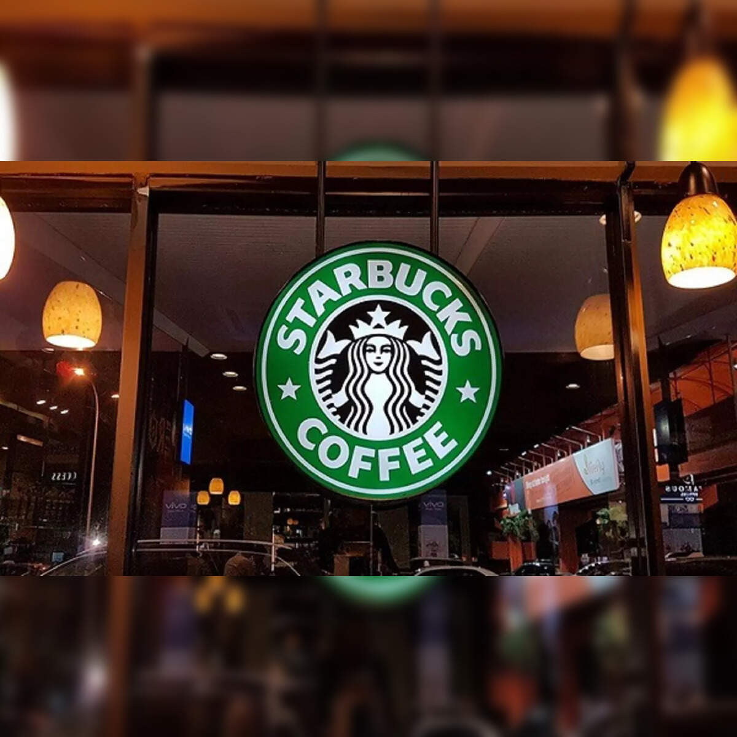
Figure 2: Starbucks
Source - (PTI, 2024)
The global QSR market is also expected to increase greatly within the next decade due to urbanisation and the need for convenience by consumers. The competitiveness and profitability directly depend on the ability to control the operations that are consistent across the large, geographically dispersed networks. In general, control is needed as it offers organised supervision that facilitates strategic objectives, improves efficiency and allows organisations to react well to operational imbalances in volatile business conditions (Mordor, 2025).

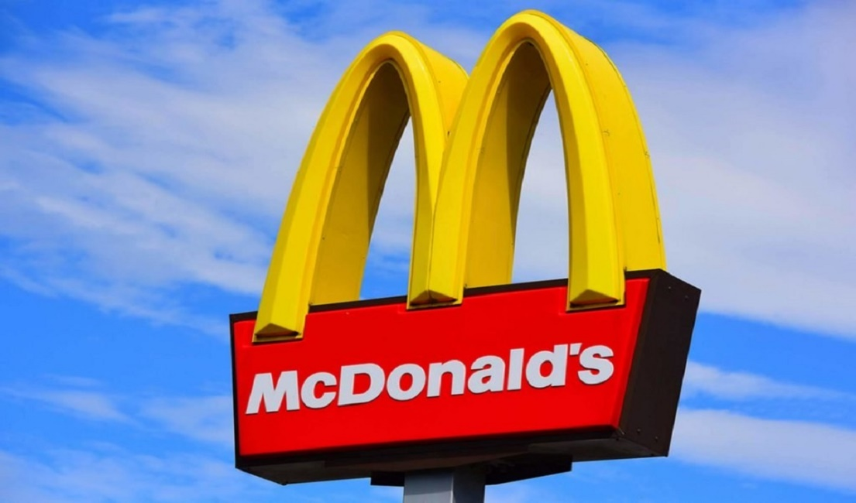
Figure 3: McDonalds
Source - (Getty, 2019)
These functions are combined to form a coherent system; planning gives direction, organising brings alignment of resources, leading creates people, and controlling brings achievement of the goals. It is important to understand how each of the functions is useful in supporting the others, as this is an important aspect in management, and it is congruent with academic theory and practice in business.
Challenges Associated with Controlling
Control is fundamental in big international organisations like McDonald's, KFC and Starbucks, but it is also hard to implement at the same time. Standardisation control, quality control, and time control are three major challenges of successful control. These difficulties have a direct impact on operational performance, customer satisfaction and strategic consistency in very competitive Quick Service Restaurant (QSR) markets that are estimated to grow well beyond USD 875 billion in 2026 all around the world (View, 2026).
Standardisation Control: It helps in making products and services the same anywhere. With its solid presence in the global QSR market, being based on the consistent franchise models and standard operating procedures, McDonald's needs to strike a balance between global and local menu customisations and regulatory demands. Strict control may be tense in other markets where the consumers' tastes are different, and the legal requirements are different. Indicatively, customisation of menus without compromising the brand can water down the standardisation criteria.
Quality Control: It is concerned with the similarity of quality of products and services across outlets. In the case of KFC, which is under the Yum! Product consistency is crucial to the maintenance of customer trust in the Brand's umbrella. Different customer experiences may arise due to variations in supply chain performance, variations in ingredient quality and preparation mistakes depending on the region (Bediako, 2025). Likewise, Starbucks also spends a lot of money on international training programmes to give uniform quality, but even after years of consistent supply chain disruption and inaccurate inventory in early 2026, the challenge of a smooth quality that cuts across thousands of stores is still being felt.
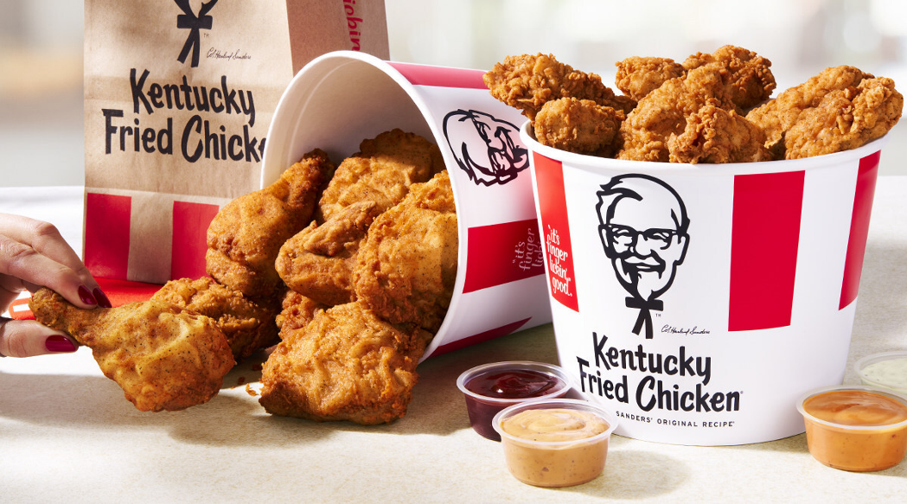
Figure 4: KFC
Source - (KFC, 2025)
Time Control: Time control is associated with efficiency and speed of service, one of the core competitive factors in QSR settings. Consumers are becoming more and more conscious of quick service times: according to industry statistics, up to 95 percent of QSR customers are more concerned with speed. The increased customer satisfaction and sales are directly influenced by longer service times caused by order customisation, complexities of the mobile application, or lack of labour. To address these time pressures, McDonald's and KFC are constantly trying to incorporate digital ordering systems and streamline the performance of the staff (Nadiah Sarah Norazha et al., 2022).
All these challenges, such as standardisation, quality and time, are informed by the magnitude and complexity of global operations, the domestic market forces and changing customer expectations in the QSR business. Organisations should thus embrace an advanced system of control that will always measure performance, detect variances and allow corrective action in real time.
Table 1: Key Controlling Challenges in McDonald’s, KFC and Starbucks
Control Challenge | McDonald’s | KFC | Starbucks
Standardisation Control | Local menu adaptation | Franchise operational differences | Regional variations in service protocols
Quality Control | Supply chain and ingredient variance | Ingredient consistency across regions | Supply chain disruptions and stock shortages
Time Control | Speed vs customisation issues | Service speed during peak hours | Balancing personal service with efficiency

Mitigating Controlling Challenges
McDonald's, KFC and Starbucks find it hard to run global businesses. These barriers are overcome by managers through leadership, technology, process design and performance monitoring. Using relevant management and leadership theories assists in developing mitigation strategies that do not contradict the organisational objectives and enhance efficiency and quality(Payam, 2024; Taylor, 2019; Bartlett and Ghoshal, 2002).
Control for Standardisation: Standardisation provides similarity in products and services between locations. McDonald's develops comprehensive SOPs and international training modules, which facilitate strategic objectives. Franchises adhere to the prescribed food preparation, hygienic and service delivery practices to be uniform across markets. Bureaucratic Management Theory encourages standardised norms and processes in favour of uniformity and accountability. Another area that McDonald's has invested in is performance dashboards to monitor compliance in its operational activities and show the deviations in real time so that managers can take corrective measures before it is too late (Mehrotra and Velamuri, 2021).
Quality Control: The quality ensures that there is quality of the products, food safety, and customer satisfaction throughout the outlets. KFC involves rigorous supplier assessment and centralised quality control to deal with related quality problems. The quality of ingredients and preparation is regularly checked to standards of the brand. Training and performance evaluation enhance quality performance, in line with the Total Quality Management (TQM) philosophy of continuous improvement and participation of the employees. Starbucks uses real-time monitoring and feedback technologies to measure quality indicators such as beverage consistency and service delivery. Investment on innovative supply chain systems enhances inventory and quality of products (Lefevre, 2025).
Control Time: Time control is important in high-speed service areas concerning customer satisfaction and operational efficiency. Starbucks and McDonald's employ mobile ordering apps and digital ordering kiosks to minimise waiting time and enhance traffic during the most active times in line with the 40-per cent trend of 40 per cent of the QSR industry using digital ordering in 2023. According to Contingency Theory, managers respond to external forces by modifying control systems, e.g. customer behaviour and adoption of technology. Forecasting and analytics enhance the scheduling and planning of the staff and demand optimisation, balancing efficiency and quality (Petropoulos et al., 2025).
McDonald's, KFC and Starbucks indicate that standardisation, quality and time management issues can be resolved through regular processes, data-driven surveillance and adaptive leadership. These methods lead to constant improvement and connecting the operations of the whole world to the objectives of the organisations.(Vainnovation, 2023; Wipro, 2022; Berry-AI, 2025).

Table 2: Mitigation Strategies
Control Challenge | Mitigation Strategy | Example Application
Standardisation Control | SOPs, global training, performance dashboards | McDonald’s franchise compliance systems
Quality Control | Supplier audits, real-time quality monitoring, TQM | KFC quality assurance checks
Time Control | Mobile ordering tech, predictive staffing, analytics | Starbucks mobile orders and scheduling

Conclusion
Conclusively, controlling is an important managerial process that helps organisations achieve their strategic goals through consistency, quality, and efficiency. Global companies such as McDonald's, KFC, and Starbucks face the problems of standardisation, quality, and time control, especially because they work in markets which are diverse and competitive. These companies address these issues and guarantee the delivery of consistent services through the implementation of powerful control systems, including SOPs, quality assurance programs, and digital solutions. By adopting leadership theories like the Contingency Theory and the Bureaucratic Management, these businesses will be able to adjust their control mechanisms to suit the interests of the market and the expectations of the customers. An effective management will not only increase the effectiveness of the operations but also create the brand reputation, and the success in the fast-moving QSR industry is a long-term guarantee. Constant self-observation, performance feedback, and technology implementation are the main determinants in overcoming the challenges that arise, whether it is dealing with large-scale global operations.

References
Bediako, K. (2025). KFC’s sustainable competitive advantage in the international franchising. [online] Available at: https://www.aabri.com/SA2018Proceedings/SA18012.pdf [Accessed on 10/04/2026]
Fragaki (2017). Motivation at Starbucks | Alexia Fragaki’s Blog. [online] UBC Blogs. Available at: https://blogs.ubc.ca/alexiafragaki/2017/01/23/motivation-at-starbucks/ [Accessed on 10/04/2026]

Getty (2019). McDonald’s. [online] Tripadvisor. Available at: https://www.tripadvisor.com/Restaurant_Review-g41263-d5104500-Reviews-McDonald_s-Middle_River_Maryland.html [Accessed on 08/04/2026]

Hermann (2023). Spotting the Signs: Understanding Control Issues and Recognizing a Controlling Person. [online] GR8 Relationships. Available at: https://gr8relate.com/spotting-the-sign-understanding-control-issues-and-recognizing-a-controlling-person/ [Accessed on 08/04/2026]
Hospitality Institute (2025). Global restaurant chains: how international brands dominate the food industry. Available at: https://hospitality.institute/bha504/global-restaurant-chains-international-brands-dominate-food-industry/ [Accessed: 20 April 2026].

Jackman, E. (2026). World’s most valuable restaurant brand is known for its fries. Can you guess the chain? [online] Yahoo Finance. Available at: https://finance.yahoo.com/news/world-most-valuable-restaurant-brand-110048156.html [Accessed on 08/04/2026]
KFC (2025). KFC - KFC® Begins its Comeback Era, Issues Come Back Call to Fried Chicken Fans with Free Bucket On Us* Offer | KFC. [online] Kfc.com. Available at: https://global.kfc.com/press-releases/kfc-r-begins-its-comeback-era-issues-come-back-call-to-fried-chicken-fans-with-free-bucket-on-us-offer [Accessed on 08/04/2026]

KFC Quality Assurance Practices (n.d.) Quality Assurance – KFC. kAvailable at: https://kfcfingerlickingood.weebly.com/quality-assurance.html [Accessed: 27 April 2026]
Kimsanov, R. (2025). TQM-Quility improvement in KFC. [online] Scribd. Available at: https://www.scribd.com/document/802570179/TQM-Quility-improvement-in-KFC [Accessed on 08/04/2026]

Lefevre, D.H. (2025). How AI powered automated counting is brewing a better experience at Starbucks. [online] About Starbucks. Available at: https://about.starbucks.com/press/2025/how-ai-powered-automated-counting-is-brewing-a-better-experience-at-starbucks/ [Accessed on 11/04/2026]

Mehrotra, S. and Velamuri, S.R. (2021). Secondary Business Model Innovation in Emerging Economies. Management and Organization Review, pp.1–30. doi: https://doi.org/10.1017/mor.2020.67 [Accessed on 08/04/2026]

Mordor (2025). Quick-Service Restaurant Market Analysis - Industry Report - Trends, Size & Share. [online] www.mordorintelligence.com. Available at: https://www.mordorintelligence.com/industry-reports/quick-service-restaurants-market
Mujtaba, B.G. (2024). McDonald’s Success Strategy and Global Expansion through Customer and Brand Loyalty. [online] ResearchGate. Available at: https://www.researchgate.net/publication/228490432_McDonald [Accessed on 07/04/2026]
Nadiah Sarah Norazha, Mohd, F., Najmi, R. and Mohi, Z. (2022). Influence of quick-service restaurant’s service quality towards customer online review. Journal of Tourism, Hospitality & Culinary Arts, 14(2), 97-129. [online] 14(2). Available at: https://www.researchgate.net/publication/361902820_Influence_of_quick-service_restaurant [Accessed on 08/04/2026]
Ogor, M. and Fidelia, I. (2022). Management control attributes and the organizational performance. International research journal of management, IT and social sciences, 9(4), pp.524–537. doi: https://doi.org/10.21744/irjmis.v9n4.2114 [Accessed on 08/04/2026]
Payam, H. (2024) ‘Understanding management theory: key frameworks for enhancing organizational efficiency, adapting to change, and leading in today’s dynamic environment’, Business Studies Journal, 16(3), pp. 1–13. [Accessed on 08/04/2026]
Petropoulos, F., Akkermans, H., Aksin, O.Z., Ali, I., Babai, M.Z., Barbosa-Povoa, A., Battaïa, O., Besiou, M., Boysen, N., Brammer, S., Brandon-Jones, A., Briskorn, D., Browning, T.R., Buijs, P., Centobelli, P., Chiarini, A., Cousins, P., Cudney, E.A., Davies, A. and Day, S.J. (2025). Operations & supply chain management: principles and practice. International Journal of Production Research, pp.1–184. doi: https://doi.org/10.1080/00207543.2025.2555531 [Accessed on 08/04/2026]

PTI (2024). Starbucks ‘fully committed’ to Indian market, says India JV Tata Starbucks. [online] The Economic Times. Available at: https://economictimes.indiatimes.com/industry/cons-products/food/starbucks-fully-committed-to-indian-market-says-india-jv-tata-starbucks/articleshow/116510840.cms?from=mdr / [Accessed: 10 April 2026].
Starbucks (2025) Starbucks puts human connection at the forefront of new service strategy. Available at: https://www.customerexperiencedive.com/news/starbucks-human-connections-green-apron-service/756210/ [Accessed: 10 April 2026].

Taxmann (2022). Controlling – A Function of Management. [online] Taxmann Blog. Available at: https://www.taxmann.com/post/blog/controlling-a-function-of-management / [Accessed: 09 April 2026].
Vainnovation (2023) McDonald’s success: the lean approach to efficiency & operational excellence. Available at: https://www.vainnovation.co.uk/how-mcdonalds-get-it-right [Accessed: 09 April 2026].
View (2026). Fast Food & Quick Service Restaurant Market To Reach $885.41Bn By 2033. [online] Grandviewresearch.com. Available at: https://www.grandviewresearch.com/press-release/global-fast-food-quick-service-restaurants-market [Accessed on 08/04/2026]

