

Student Name : Akshita Hirpara
University of Wales trinity saint david
Programme : MSc Public Health and Social Care in Practice
Module : Social Epidemiology and Public Health Development
Module code : LCHS7000
Lecturer: Dr Itse Olaoye
Assignment Title: Component 2, Analytical Report
Student ID number: 2528024
Social Epidemiology and Public Health Development

Table of Contents
Task 1: Social Epidemiological Analysis 3
1.1 Introduction 3
1.2 Contextual Background and Underlying Factors 3
1.2.1 Dementia Risks 3
1.2.2 Falls and Fractures Related Injuries 4
1.2.3 Higher Cardiovascular Disease 4
1.2.4 Digital Exclusion 5
1.2.5 Age Discrimination 5
1.2.6 Elder Abuse and Neglect 5
1.3 National Response to Reduce Health Inequalities 6
1.4 Organisations Supporting the Elderly 6
1.5 Conclusion 6
Task 2: Epidemiological Analysis 7
2.1 Introduction 7
2.2 Public Health Approaches (Including Surveillance and Monitoring) 8
2.3 Public Health Impact 10
2.4 Health Needs and Intervention Proposal 10
2.5 Strengths and Weaknesses of The Epidemiological Approach 12
Reference 14

Task 1: Social Epidemiological Analysis
Age and Health Inequalities Issues

1.1 Introduction
The chosen target group for this social epidemiological analysis is the elderly population in the UK, which can be classified as individuals aged 65 years or more (Barton et al. 2024). This population is selected because of the experienced social and health challenges due to a combined effect of growing physiological vulnerabilities with age and exacerbated social and economic vulnerabilities arising out of limited interaction with other people (BGS, 2023). Considering that the elderly population is already expected to have reached 18.5 million in England, while 82% of the elderly population of around 85-year-olds have multiple comorbidity factors and long-term health conditions, their social and health inequalities have the most severe impact on their quality of life as a whole (England NHS, 2025).

1.2 Contextual Background and Underlying Factors

1.2.1 Dementia Risks
Dementia is a significant health risk that the UK has classified for its elderly population since it affects 1 in every 11 individuals aged 65 or above (NHS, 2026). However, its mortality risks are also notable, with 2024 reporting the highest number of deaths among the older population than any other disease, with death rates rising instead of falling (McShane, 2026).
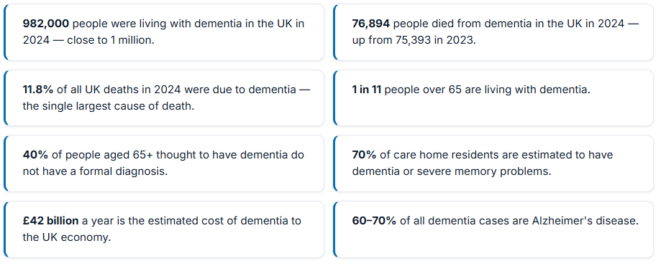
Figure 1: Key Insights on Dementia in the UK
(Source: McShane, 2026)
Especially considering that 2024 statistics on dementia diagnosis and prevalence have reported more than 100,000 individuals not appropriately diagnosed for dementia, while existing cases already cost the UK £42 billion, means interventions are needed for the elderly, which currently are being added outside the NHS 10-year plan to build more coverage and service touchpoints (Bawden, 2024; McShane, 2026; Gov UK, 2022).

1.2.2 Falls and Fractures Related Injuries
Around 36% of elderly people in the UK aged 65 or above have acknowledged falling as a big concern, and 67% of the cases reported between 2019 and 2020 that resulted in hospital admissions were individuals aged 80 or above, indicating that falls, fractures, and other related injuries are a significant cause for concern among the older population (CDDFT NHS, 2026). Statistics indicate that cases for fault-related injuries like hip fracture could double by 2016, with current estimates being around 72,000 cases in England (RCP UK, 2024).
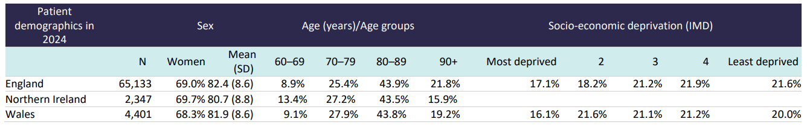
Figure 2: Key Insights on Fracture Injuries among the UK Elderly
(Source: RCP UK, 2024)
Current solutions involving the NICE fracture framework have allocated more resources into fall prevention, physiotherapy and better detection of features, estimating a 25% prevention scope (BGS UK, 2018).

1.2.3 Higher Cardiovascular Disease
Although the overall percentage-wise increase among the UK population reports a 21% increase in heart failure, a 10% increase in atrial fibrillation and so on, Cardiovascular disease has been causing deaths within the UK, especially among individuals aged 75 or below, which is being considered premature death, indicating towards the older population's heightened risks (Blake, 2025; England NHS, 2026a). In order to address this issue, the Long Term plan has targeted better proactivism in primary care settings, with preventative strategies like smoking cessation or appropriate rehabilitation accessibility being given better emphasis (England NHS, 2026b).

1.2.4 Digital Exclusion
Around 2.4 million older adults within the UK are estimated to be digitally excluded due to the limited or almost nonexistent use of digital media and platforms (Age UK, 2025). In fact, the number of older adults using the internet decreased year on year, with a 7% decrease being reported since 2024 (Age UK, 2025). This is exacerbated by 33% suggesting poor IT literacy and 22% suggesting a lack of trust in the Internet (Age UK, 2025). Not only did the Digital Inclusion Action Plan by the UK Government aim to target assisted sessions for improving learning among older adults, but it also helped to mandate essential public services being made available in physical locations to address accessibility issues for the elderly (Gov UK, 2026).

1.2.5 Age Discrimination
Ageism and age related discriminations are rising in prevalence among UK society, as surveys revealed only 20% perceived the cityscape to be acceptable for older people, while individuals even beyond the 60+ age group, with around 50 or over, report negative experiences and outright discrimination due to their age and assumed frailty and vulnerability (Age UK, 2025). Despite anti-discrimination laws, the practices and experiences of age specific discriminations are gaining greater institutional recognition since Piyush from age discrimination-related cases I have observed a 600 per cent increase in the UK, indicating towards a potential solution through an awareness-driven approach (Clemo, 2025).

1.2.6 Elder Abuse and Neglect
Elder abuse and neglect are a rising concern since 63% report experiencing the same, especially within their own home, due to societal isolation and feeling lonely and unsupported (Government Events, 2021). Solutions like the Hourglass helpline or safeguarding mechanisms through the Care Act 2014 have introduced more support systems to help elderly people (Legislation UK, 2014; Wear Hourglass, 2026).

1.3 National Response to Reduce Health Inequalities
National response strategies like the NHS 10-year plan have been proposed for tackling community health care accessibility quite extensively, including care and interventions for the elderly (Gov UK, 2022). The Long Term Plan, on the other hand, utilises “Ageing Well” as a program for addressing frailty and other elderly healthcare inequality issues (Gov UK, 2019). But this also indicates that national interventions are built to tackle elderly care and social welfare, but their methodological weakness lies in reaching the right population at the right time, making community-centric initiatives more vital (Marmot, 2022).

1.4 Organisations Supporting the Elderly
One particular charity or organisation that has been conducting significant interventions and efforts for improving elderly care and in social or health settings is Age UK (Age UK, 2025). The organisation's contributions towards improving accessibility and inclusion of older people in societal settings, along with consistent publications on improving awareness surrounding elderly health inequalities or social inequalities, have provided considerable insights that can support proactive efforts from local communities.

1.5 Conclusion
It appears that health care inequalities are concentrated in the unique physiological and societal challenges of the elderly population, which makes interventions less about treating the health issues and more about systematically identifying solutions for long-term preventative care. As a result, even in the case of societal inequalities faced by older adults, the interventions wrought from national and private institutions have rightly attempted to build awareness and initiatives to tackle the same.

Task 2: Epidemiological Analysis

2.1 Introduction
The clinical definition of type 2 diabetes (T2D) is the process of physiological disruptions to sufficient insulin production, leading to a chronic condition of higher blood glucose levels, which has health consequences in the form of increased heart disease, kidney failure or stroke risks (LeWine, 2024). Although reported cultural and social consequences of TYPE 2 DIABETES are largely linked to cultural stigma or economic liabilities on chronic disease burden, the scope for T2D is far-reaching as a global healthcare challenge with different cultural and social settings introduce different needs for care and intervention systems (Kudale et al., 2025; Li-Geng et al., 2020).
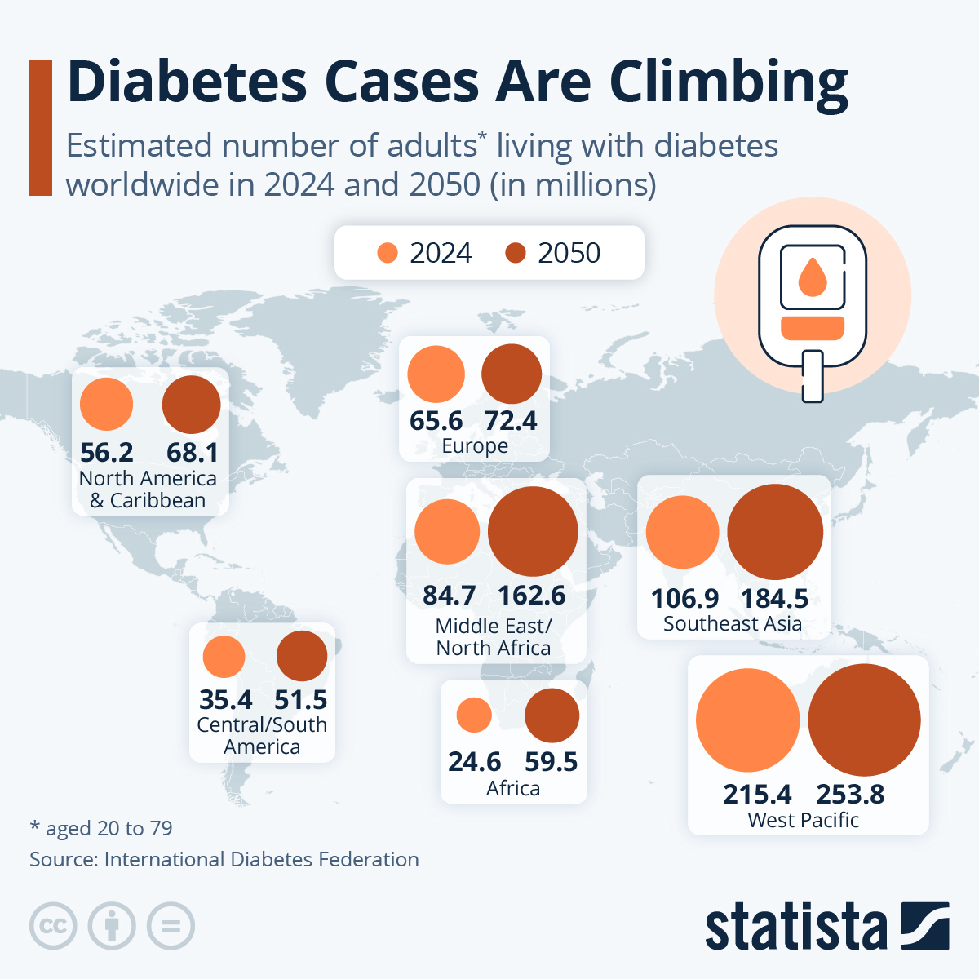
Figure 3: Global Prevalence of Diabetes
(Source: Fleck, 2025)
Despite focusing on the age group of around 18-to 68-year-olds, global-level prevalence records on type 2 diabetes include a larger sample size, which is about 6.28% of the world population, with 15% of the population aged 50 to 69 years being affected by this disease amidst a growing prevalence (See Figure 3) of diabetes across the globe (Khan et al., 2020). Focusing on the national level figures, the UK has reported that out of the 6 million estimated diabetes patients, 90% have type 2 diabetes and intersectionality insights reveal that Indian, Pakistani or Bangladeshi people, along with Chinese, Black and Caribbean people, are more likely to have diabetes than others (Diabetes, 2025). Focusing more specifically on the Tower Hamlets borough of England, one in every ten residents has reported type 2 diabetes, indicating the severe healthcare burden of this disease among the population (Local Gov UK, 2025).

2.2 Public Health Approaches (Including Surveillance and Monitoring)
Considering that Tower Hamlets is a significantly deprived region of England, the population is exposed to significant socioeconomic inequalities that further exacerbate their health risk factors when tackling chronic diseases like type 2 diabetes, which require long-term care (Trust for London, 2021). As a result, investigating the public health measures used for addressing TYPE 2 DIABETES within the adult population of the Borough of Tower Hamlets required due attention specifically towards its containment, management, as well as treatment and reduction strategies.
The national level surveillance and monitoring systems offered a tangible solution for addressing containment and management strategies due to their holistic approaches. For instance, the National Diabetes Audit have reported latest records suggesting more than 2500 reported registrations, with a 53% to 46% male-to-female ratio of TYPE 2 DIABETES cases (Digital NHS UK, 2026a). Additionally, the Quality and Outcomes Framework has also outlined 9 recommended care processes from NICE, stipulating intervention measures helping to promote clear surveillance strategies (Gunn et al., 2021). While the National Diabetes Inpatient Safety Audit focused more on avoidable harm to patients, allowing for the prevention and management areas of focus, Fingertips diabetes profile or the Joint Strategic Needs Assessment have helped build local assessment on early identification of disease patterns in risk-prone areas like the Tower Hamlets (Digital NHS UK, 2026b; Tower Hamlets, 2026).
Although this covers the management control elements, the infrastructural system at ground-level operations for Tower Hamlets remains significantly fragmented, which is why applying the 3P framework helps to better understand how prevention and treatment for type two diabetes is tackled within the borough (Chowdhury and Huda, 2016).
Primary Care Setting (Prevention)
In the primary care setting, prevention strategies receive greater attention as intervention programs like the Diabetes Prevention Program (DPP), offering free 9-month behavioural change or the Path to Remission service program spanning across 12 months receive prominent emphasis for Tower Hamlets Borough (Tower Hamlets Together, 2025). However, due to the referral systems requiring trained healthcare professionals or general physicians with minimal but still present self-referral options, primary care prevention formats in the region have provided modest success (Tower Hamlets Together, 2025).
Secondary (Protection)
At a secondary level, strategies for management of TYPE 2 DIABETES in deprived regions like the Borough of Tower Hamlets prefer to focus more on protection mechanisms by providing further care for the diagnosed. Aside from the direct clinical care provided for protection mechanisms in the form of tablets used for treating and maintaining blood glucose levels, the borough has also adopted the NICE guidelines to ensure management of the diagnosed population is multi dynamic with frequent tests on HbA1c for effective identification every three months along with regular measurements on a 6 month intervals and a long term annual review comprising of both cardiovascular as well as renal, neuropathic other physical examinations (Tower Hamlets Together, 2015; Tower Hamlets Together, 2026).
Tertiary (Promotion)
At a tertiary care level, promotional approaches to managing and building awareness for type 2 diabetes receive more attention. Although social prescribing has seen prominent acknowledgement for the Tower Hamlets borough, awareness and education towards healthy lifestyle and eating habits have predominantly supported early-level engagement, while more robust mental health support programs aimed at supporting psychological disorders that can lead to TYPE 2 DIABETES development are also offered (Tower Hamlets Together, 2015; Calderón-Larrañaga et al., 2023).

2.3 Public Health Impact
In the immediate short term, public health impact resulting from such multilayered intervention programs seems to be moving in the positive direction but still significantly smaller due to operationalised interventions requiring more long-term effectiveness (See Figure 4).
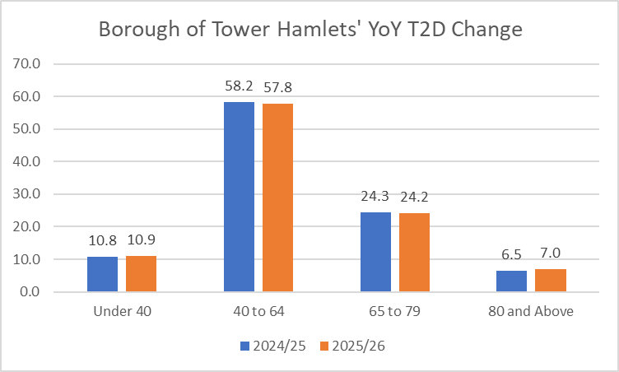
Figure 4: TYPE 2 DIABETES Change in a Single Year
(Source: Self-Created using Data from Digital NHS UK, 2026a)
The long-term effect in this case will be better resource allocation since diabetes complications have already cost the NHS around £6.2 billion between 2021 and 2022, which is already expected to affect the inflating budget of the NHS with up to £18 billion by 2035 in total healthcare expenditure (Endocrinology, 2024).

2.4 Health Needs and Intervention Proposal
It is, however, worth noting that the analysis of the borough of Tower Hamlets and its reported data on TYPE 2 DIABETES seems to imply that the poor social and economic deprivations along with mental health-related challenges are closely associated with risk of diabetes in general. Especially considering the migrant population within the borough having a higher proportion of risks in developing T2D, susceptibility and intervention platforms require ground-level proactivism that established intervention platforms like the fingertips repository will not reflect (Tower Hamlets Together, 2015; Tower Hamlets Together, 2026).
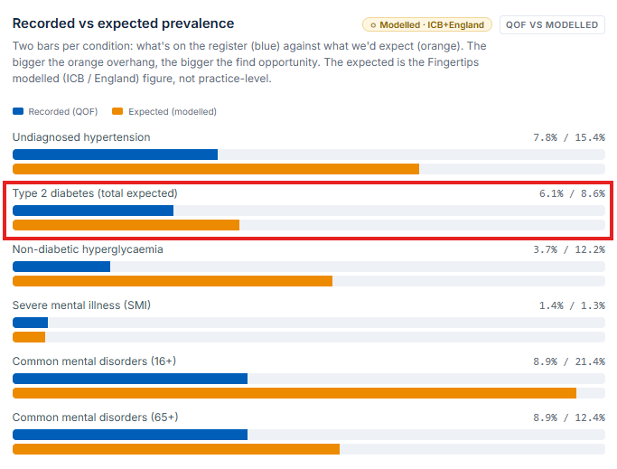
Figure 5: Expected vs Recorded Prevalence
(Source: PCND, 2026)
This gap is actively acknowledged by Figure 5, showcasing ground reality requires an intervention that uses local advocacy, preferably in more culturally sensitive language to build momentum (PCND, 2026).
Hence, the healthcare intervention approach recommended for the borough of Tower Hamlets should be a targeted 12-month intervention plan aimed towards communication, participation, awareness and education and finally long-term prevention (See Figure 6).
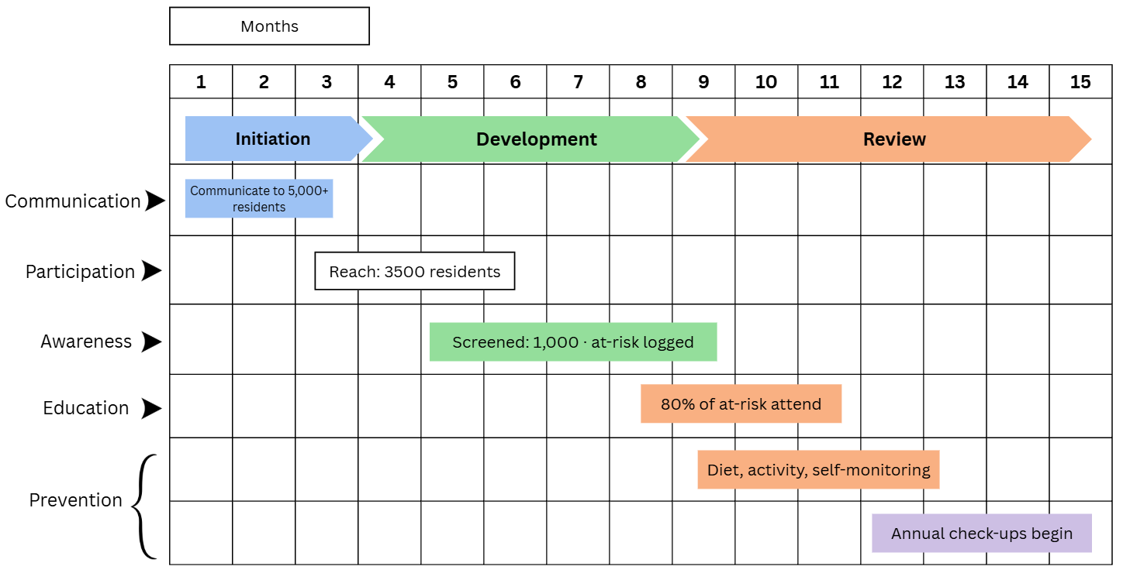
Figure 6: TYPE 2 DIABETES Intervention Plan
(Source: Self-Created in Canva)

2.5 Strengths and Weaknesses of The Epidemiological Approach
It is worth noting that one of the most critical strengths of the national diabetes statistical profile is that it provides universal coverage visibility, which helps to ascertain inequality across specific regional boroughs like Tower Hamlets, but its emphasis on predominantly general physician-recorded diagnoses and registrations means it does not reflect ground reality on TYPE 2 DIABETES cases (PCND, 2026). This means that the expected versus recorded cases, indicating the underlying health challenge for the Tower Hamlets region, may require further self-initiated or robust community-driven screening procedures that do not use traditional mechanisms of surveillance, where participant accessibility gaps could directly translate to feasibility issues. The challenges for managing and tracking health care inequalities among socially and economically deprived regions are not limited to two administrative gaps but also include methodological gaps in clinical diagnosis. For instance, BMI-based obesity values have been acknowledged by Caleyachetty et al. (2021) to be predominantly useful for identifying white European populations' underlying challenges, indicating the predominant risk of migrant populations with different ethnic backgrounds receiving an incorrect assessment and likely explaining their TYPE 2 DIABETES prevalence despite promising screening coverage. Based on this evaluation, the proposed T2D intervention plan targets more proactive mechanisms of awareness and education, such as communication before education or awareness, building curiosity or recommending self-care strategies through local advocacy groups to improve familiarity and accessibility.

Reference
Age UK, (2025). Age UK London Launches Survey to Uncover the Truth About Ageism in London. Available at: https://www.ageuk.org.uk/london/about-us/news/articles/2025/ageism-survey/ (Accessed: August 11, 2026).
Age UK, (2025). Age UK warns 2.4 million digitally excluded older people are at risk of being left behind in an increasingly digital world. Available at: https://www.ageuk.org.uk/latest-press/articles/age-uk-warns-22.4-million-digitally-excluded-older-people-are-at-risk-of-being-left-behind-in-an-increasingly-digital-world/ (Accessed: August 11, 2026).
Barton, C., Sturge, G. and Harker, R. (2024) “The UK’s changing population.” Available at: https://commonslibrary.parliament.uk/the-uks-changing-population/ (Accessed: August 11, 2026).
Bawden, A. (2024) “Up to 100,000 may have undiagnosed forms of dementia in England,” The Guardian, 19 July. Available at: https://www.theguardian.com/society/article/2024/jul/19/up-to-100000-may-have-undiagnosed-forms-of-dementia-in-england (Accessed: August 11, 2026).
BGS UK, (2018). NICEimpact falls and fragility fractures. Available at: https://www.bgs.org.uk/sites/default/files/content/resources/files/2018-08-29/NICE-Impact-falls-and-fragility-fractures.pdf (Accessed: August 11, 2026).
BGS, (2023). Protecting the rights of older people to health and social care. Available at: https://www.bgs.org.uk/policy-and-media/protecting-the-rights-of-older-people-to-health-and-social-care (Accessed: August 11, 2026).
Blake. I., (2025). 'Worst start to a decade for heart health for 50 years' warning as we launch new strategy. Available at: https://www.bhf.org.uk/what-we-do/news-from-the-bhf/news-archive/2025/may/worst-start-to-decade-heart-disease-50-years-bhf-strategy-launch (Accessed: August 11, 2026).
Calderón-Larrañaga, S., Greenhalgh, T., Clinch, M., Robson, J., Dostal, I., Eto, F. and Finer, S., 2023. Unravelling the potential of social prescribing in individual-level type 2 diabetes prevention: a mixed-methods realist evaluation. BMC medicine, 21(1), p.91. https://doi.org/10.1186/s12916-023-02796-9
Caleyachetty, R., Barber, T.M., Mohammed, N.I., Cappuccio, F.P., Hardy, R., Mathur, R., Banerjee, A. and Gill, P., 2021. Ethnicity-specific BMI cutoffs for obesity based on type 2 diabetes risk in England: a population-based cohort study. The lancet Diabetes & endocrinology, 9(7), pp.419-426. https://doi.org/10.1016/S2213-8587(21)00088-7
CDDFT NHS, (2026). Safe Mobility and Falls Prevention. Available at: https://www.cddft.nhs.uk/patients-and-visitors/safe-mobility-falls-prevention (Accessed: August 11, 2026).
Chowdhury, T.A. and Huda, B., 2016. A decade of change in diabetes services in a deprived multiethnic inner city area: diabetes in Tower Hamlets. British Journal of Diabetes, 16(4), pp.188-192. http://dx.doi.org/10.15277/bjd.2016.108
Clemo, F. (2025) Age discrimination payouts jumped 600 per cent last year, analysis finds, PeopleManagement. Available at: https://www.peoplemanagement.co.uk/article/1907766?utm_source=website&utm_medium=social (Accessed: August 11, 2026).
Diabetes, (2025). How many people in the UK have diabetes? Available at: https://www.diabetes.org.uk/about-us/about-the-charity/our-strategy/statistics (Accessed: August 11, 2026).
Digital NHS UK, (2026a). National Diabetes Audit (NDA) 2025-26 quarterly report for England, Integrated Care Board (ICB), Primary Care Network (PCN) and GP practice. Available at: https://digital.nhs.uk/data-and-information/publications/statistical/national-diabetes-audit/core-q4-25-26/national-diabetes-audit-nda-2025-26-quarterly-report-for-england-integrated-care-board-icb-primary-care-network-pcn-and-gp-practice (Accessed: August 11, 2026).
Digital NHS UK, (2026b). National Diabetes Inpatient Safety Audit. Available at: https://digital.nhs.uk/data-and-information/clinical-audits-and-registries/national-diabetes-inpatient-safety-audit (Accessed: August 11, 2026).
Endocrinology, T.L.D., 2024. Diabetes-related complications: a toll too high. The lancet. Diabetes & endocrinology, 12(9), p.601. https://doi.org/10.1016/s2213-8587(24)00246-8
England NHS, (2025). Improving care for older people. Available at: https://www.england.nhs.uk/ourwork/clinical-policy/older-people/improving-care-for-older-people/ (Accessed: August 11, 2026).
England NHS, (2026a). Cardiovascular disease (CVD). Available at: https://www.england.nhs.uk/ourwork/clinical-policy/cvd/ (Accessed: August 11, 2026).
England NHS, (2026b). Cardiovascular disease (CVD) prevention recovery. Available at: https://www.england.nhs.uk/ourwork/clinical-policy/cvd/prevention-recovery/ (Accessed: August 11, 2026).
Fleck, A. (2025) Diabetes Cases Are Climbing, Statista Daily Data. Available at: https://www.statista.com/chart/23491/share-of-adults-with-diabetes-world-region (Accessed: August 11, 2026).
Gov UK, (2019). NHS Long Term Plan launched. Available at: https://www.gov.uk/government/news/nhs-long-term-plan-launched (Accessed: August 11, 2026).
Gov UK, (2022). Health Secretary announces 10-year plan for dementia. Available at: https://www.gov.uk/government/news/health-secretary-announces-10-year-plan-for-dementia (Accessed: August 11, 2026).
Gov UK, (2026). Digital Inclusion Action Plan: One Year On. Available at: https://www.gov.uk/government/publications/digital-inclusion-action-plan-one-year-on/digital-inclusion-action-plan-one-year-on (Accessed: August 11, 2026).
Government Events, (2021). Abuse and Neglect of Older People – What can we do to stop it? Available at: https://www.governmentevents.co.uk/abuse-and-neglect-of-older-people-what-can-we-do-to-stop-it/ (Accessed: August 11, 2026).
Gunn, L.H., Vamos, E.P., Majeed, A., Normahani, P., Jaffer, U., Molina, G., Valabhji, J. and McKay, A.J., 2021. Associations between attainment of incentivized primary care indicators and incident lower limb amputation among those with type 2 diabetes: a population-based historical cohort study. BMJ Open Diabetes Research & Care, 9(1), p.e002069. https://doi.org/10.1136/bmjdrc-2020-002069
Khan, M.A.B., Hashim, M.J., King, J.K., Govender, R.D., Mustafa, H. and Al Kaabi, J., 2020. Epidemiology of type 2 diabetes–global burden of disease and forecasted trends. Journal of epidemiology and global health, 10(1), p.107. https://doi.org/10.2991/jegh.k.191028.001
Kudale, A.M., Ghawat, M.D., Gopale, A.V., Phutane, M.S. and Joseph, S., 2025. Cultural Aspects of Type-2 Diabetes-related Social Stigma: A Cultural Epidemiological Study among General Community Members in Urban Pune, India. Indian Journal of Community Medicine: Official Publication of Indian Association of Preventive & Social Medicine, 50(1), p.234. https://doi.org/10.4103/ijcm.ijcm_894_22
Legislation UK, (2014). Care Act 2014. Available at: https://www.legislation.gov.uk/ukpga/2014/23/part/1/crossheading/safeguarding-adults-at-risk-of-abuse-or-neglect (Accessed: August 11, 2026).
LeWine. H. E., (2024). Type 2 diabetes mellitus. Available at: https://www.health.harvard.edu/diseases-and-conditions/type-2-diabetes-mellitus-a-to-z (Accessed: August 11, 2026).
Li-Geng, T., Kilham, J. and McLeod, K.M., 2020. Cultural influences on dietary self-management of type 2 diabetes in East Asian Americans: a mixed-methods systematic review. Health Equity, 4(1), pp.heq-2019. https://doi.org/10.1089/heq.2019.0087
Local Gov UK, (2025). London Borough of Tower Hamlets: Community-led projects to improve health and reduce the incidence of long-term conditions. Available at: https://www.local.gov.uk/case-studies/london-borough-tower-hamlets-community-led-projects-improve-health-and-reduce (Accessed: August 11, 2026).
Marmot, M., 2022. Public health and health inequalities: a half century of personal involvement. Journal of Public Health, 44(Supplement_1), pp.i23-i27. https://doi.org/10.1093/pubmed/fdac095
McShane. M., (2026). Dementia Statistics UK: The Definitive Guide (2026). Available at: https://onlinecpdacademy.co.uk/blog/dementia-statistics-uk (Accessed: August 11, 2026).
NHS, (2026). What is dementia. Available at: https://www.nhs.uk/conditions/dementia/about-dementia/what-is-dementia/ (Accessed: August 11, 2026).
PCND, (2026). Long-term Conditions & Prevention. Available at: https://www.towerhamlets.gov.uk/Documents/Public-Health/JSNA/Type_2_diabetes.pdf (Accessed: August 11, 2026).
RCP UK, (2024). Room for improvement: hip fracture care in 2024. Available at: https://www.rcp.ac.uk/media/d0fjt0fq/nhfd-2025-annual-report.pdf (Accessed: August 11, 2026).
Tower Hamlets Together, (2015). Tower Hamlets Joint Strategic Needs Assessment. Available at: https://www.towerhamlets.gov.uk/Documents/Public-Health/JSNA/Type_2_diabetes.pdf (Accessed: August 11, 2026).
Tower Hamlets Together, (2025). Service Details for Diabetes Prevention/Programmes for Patients with Diabetes. Available at: https://www.towerhamletstogether.com/files/Final-Service-Details-for-Diabetes-Prevention-March-2025.pdf (Accessed: August 11, 2026).
Tower Hamlets Together, (2026). Tower Hamlets Joint Strategic Needs Assessment. Available at: https://www.towerhamlets.gov.uk/Documents/Public-Health/JSNA/JSNA_Summary.pdf (Accessed: August 11, 2026).
Tower Hamlets, (2026). Joint Strategic Needs Assessment. Available at: https://www.towerhamlets.gov.uk/lgnl/health__social_care/Health-and-adult-social-care/Health-and-wellbeing/joint_strategic_needs_assessme/joint_strategic_needs_assessme.aspx (Accessed: August 11, 2026).
Trust for London, (2021). Tower Hamlets. Available at: https://trustforlondon.org.uk/data/boroughs/tower-hamlets-poverty-and-inequality-indicators/ (Accessed: August 11, 2026).
Wear Hourglass, (2026). Home Page. Available at: https://www.wearehourglass.org/ (Accessed: August 11, 2026).

