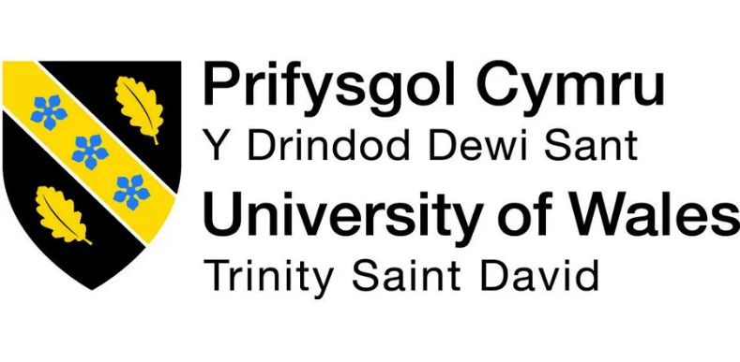

Programme Name: Master of Business Administration
Module Code: LCMB7023
Module Title: Human Capital Management
Title: The Influence of National and International Labor Markets on HRM and IHRM Strategies
Lecturer Name: Ejike Udeogu
Student Name: Sadman Hossain
Student ID: 2505391
Submission Date: 17th October 2025

Table of Contents
List of Figures ii
Introduction 1
1. Question 1: Technology’s Impact on HRM and IHRM 1
1.1 Digital Transformation in HR 2
1.2 Strategic Analytics and Decision Support 3
1.3 Ethical, Legal, and Cultural Challenges 3
2. Question 2: Demographic, Economic & Geopolitical Influences on Talent Management 4
2.1 Demographic Trends 4
2.2 Economic Pressures and Inequality 5
2.3 Geopolitics, Regulation, and Mobility 6
2.4 PESTLE Snapshot 7
3. Question 3: Skills Gaps and Organisational Responses 7
3.1 Causes of Skills Gaps 7
3.2 Organisational Strategies 8
3.3 Policy and Leadership Implications 8
4. Question 4: Reflective Analysis of Learning 8
Conclusion 10
References 10-11

List of Figures
Figure 1: Technology adoption by companies, 2023–2027 (Source: World Economic Forum, 2023) 3
Figure 2: Global population age structure projections, 2020–2050 (Source: United Nations, 2024) 5
Figure 3: Reported labour shortages across sectors, OECD economies (Source: OECD, 2024) 6

Introduction
Human capital happens to be one of the most relevant determinants in ascertaining the long-term competitiveness of organisations in the world today as it is ever evolving and increasingly uncertain. In other words, knowledge, skills and abilities of the employees have finally come to the fore centre stage of organisational success. The systems, means and techniques of attracting people, building their skills and keeping them have reformed considerably through the times. The factors that have strongly impacted such changes include fast technological innovation, demographic changes in various regions and never-ending issues formed by economic and geopolitical volatility.
Since the global labour markets are becoming more interrelated and mobile, the management of people is also assuming a different form. No longer is it regarded as a highly administrative-only role that only entails such activities as staff recruitment, remuneration, or paperwork. Rather, human resource management has become a strategic field of study, which is also formed on evidence, analytics, and dynamism. Generally, decisional capacity, which involves making informed decisions and the capacity to respond to continuous environmental changes, has been an important organisational skill.
This assignment concentrates on four areas that are closely related to this transformation. The first one addresses the issue of how technological advances are transforming both the human resource management (HRM) and the international human resource management (IHRM). Second, it evaluates how the talent management operates in relationship to the demographic, economic and geopolitical changes, especially when it comes to global mobility and long-term workforce planning. Third, it draws the expanding skills gap and looks at the approaches available to organisations to counter it, such as provides Building-Borrow-Buy framework and learning organisation theory. Lastly, it provides a reflective study of what knowledge I have acquired after studying those subjects. All these conversations would offer a decent, overall understanding of how the human capital can be used strategically by organisations in the modern world, which is volatile, uncertain, complex, and ambiguous (VUCA).

Question 1: Technology’s Impact on HRM and IHRM
The technological innovation has essentially changed the way organisations recruit, manage and develop their employees. Data analytics, artificial intelligence (AI) and automation have become part of the HR processes and succeeded in changing the approach of the HR functions in terms of efficiency and role in strategy. The latter changes do not only impact domestic HRM but also IHRM; the active use of technology provides uniformity of all worldwide processes at the same time, which enables accommodating the particular legal and cultural environments (Bondarouk and Brewster, 2016).

Digital Transformation in HR
AI and machine learning are now pervasive in recruitment, selection, and performance management. Tambe, Cappelli and Yakubovich (2019) highlight the opportunities of data-driven HR while warning of inherent complexities, including the difficulty of capturing nuanced human behaviours through data. Applicant tracking systems and predictive algorithms can assess candidates more quickly and objectively, but they must be carefully designed to prevent discrimination. Large organisations such as Unilever and IBM have implemented AI-based hiring systems that analyse speech, micro-expressions, and problem-solving skills, significantly reducing recruitment time while improving diversity outcomes.
Cloud-based HR systems like Workday and SAP SuccessFactors have enhanced HR integration across borders, allowing real-time workforce visibility, streamlined payroll, and performance analytics. For multinational corporations (MNCs), these systems support the balance between global standardisation and local responsiveness-a key challenge in IHRM (Stahl, Björkman and Morris, 2012). Such systems have become particularly vital for managing remote and hybrid teams in the post-pandemic environment, facilitating virtual collaboration and global talent mobility.
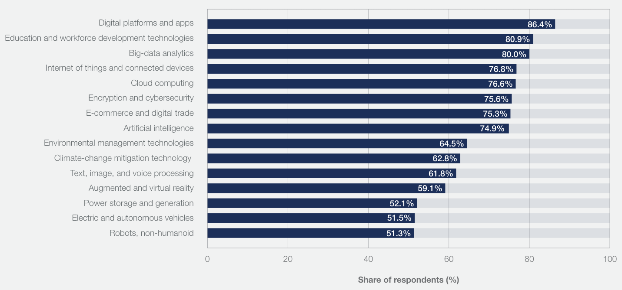
Figure 1: Technology adoption by companies, 2023–2027 (Source: World Economic Forum, 2023)

Strategic Analytics and Decision Support
The increasing use of people analytics enables HR to contribute to strategic decisions. Bersin (2019) notes that advanced analytics link HR metrics with organisational performance indicators such as productivity, retention, and innovation. For example, Google’s Project Oxygen identified key managerial behaviours correlated with team success, leading to targeted leadership development programmes. By using data to forecast turnover, identify high-potential employees, and quantify skill gaps, HR professionals can provide predictive insights that shape long-term strategy. This transformation aligns with Ulrich’s (1997) HR business partner model, which redefines HR as a strategic enabler of business objectives.

Ethical, Legal, and Cultural Challenges
There are also ethical, legal and cultural issues of technology. According to Hunkenschroer and Luetge (2022), the historical data is likely to be manifested in an artificial form and used against a candidate by AI-enabled recruitment systems. Additionally, an open quality can compromise accountability and fairness because it is based on unclear decision-making logic algorithmically. The organisations should therefore adopt ethical AI systems that are transparent, auditable and have human control. Legal risks are also related to data protection laws (e.g., the General Data Protection Regulation published in the EU as GDPR) limiting cross-border data transfer and cross-border profiling use of AI.
The existing cultural differences, also make the use of AI worldwide more complicated. Within the context of collectivism cultures such as Asian ones, the fittingness of a group can score higher than individual merit, conducting the perception of algorithmic tools. Ethical HRM should take into consideration these differences to ensure that there is trust and inclusion in the international workforces.
To conclude, the technological development has contributed to the efficiency of HRM and integration of IHRM, however requiring the emergence of new skills in digital literacy, ethical governance, and making decisions based on the data. Organisations that achieve success will do so by applying technology as an extension of human ability as opposed to a substitution to it.

Question 2: Demographic, Economic & Geopolitical Influences on Talent Management
The global workforce is being reshaped by demographic ageing, economic inequality, and geopolitical disruptions. These trends directly influence how organisations design and implement talent management strategies.

Demographic Trends
The ageing work force in developed economies, along with a fall in the birth rate are reducing prevalence to labour supply and putting strain on pension schemes. According to the reports provided by the Office for National Statistics (2024), the overall activity of older employees in the UK has been on the increase showing tendencies to defer their retirement. Employers should hence consider the use of inclusive age-based approaches where an example is the use of flexible working, staged retirement approaches as well as knowledge-sharing programs. Conversely, emerging economies like India and Nigeria are experiencing youth booms, creating vast but underutilised talent pools. Managing such demographic contrasts requires global organisations to adapt reward, development, and retention strategies to regional contexts (Beardwell and Thompson, 2017).
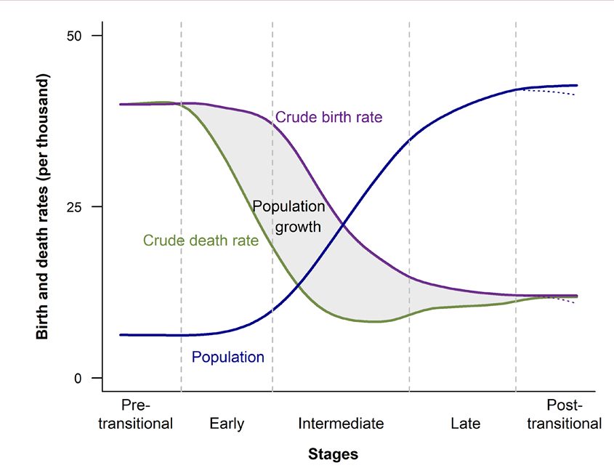
Figure 2: Global population age structure projections, 2020–2050 (Source: United Nations, 2024)
Generational diversity also shapes workplace expectations. Millennials and Generation Z employees prioritise purpose, flexibility, and continuous learning, prompting a shift toward employee experience and sustainability-driven employer branding. Inclusive leadership practices that harness intergenerational collaboration can convert demographic diversity into competitive advantage.

Economic Pressures and Inequality
Economic disparities between and within countries influence both the supply and the expectations of labour. Inflation and stagnating wages intensify retention challenges, while economic downturns reduce investment in training. According to the Department for Education (2025), over two-thirds of UK employers report skills shortages that constrain growth, particularly in digital and engineering sectors. MNCs operating in developing economies must balance competitive compensation with sustainable cost structures, which often leads to regional centres of excellence or outsourcing partnerships.
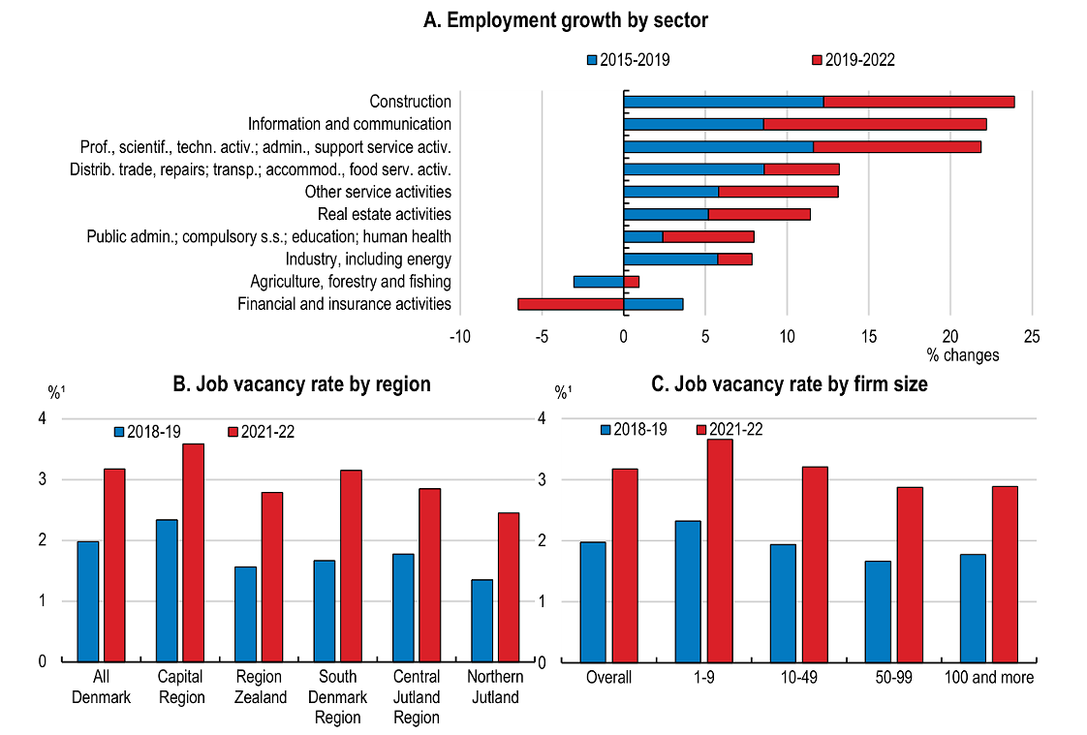
Figure 3: Reported labour shortages across sectors, OECD economies (Source: OECD, 2024)
The growth of the gig economy and non-traditional employment forms adds complexity to talent management. Organisations increasingly rely on freelancers and contractors for agility, but this raises questions about engagement, loyalty, and protection. IHRM must expand beyond permanent employees to consider contingent workforces as part of strategic human capital planning.

Geopolitics, Regulation, and Mobility
Political instability, trade disputes, and restrictive migration policies significantly affect international talent mobility. Events such as Brexit have disrupted labour flows across Europe, forcing firms to localise recruitment. Similarly, geopolitical conflicts and pandemic-related travel restrictions have compelled organisations to adopt hybrid and remote work models, enabling access to a broader global talent pool. Collings, Mellahi and Cascio (2019) describe this as “boundaryless talent management,” where physical borders become less relevant than connectivity and collaboration technologies.
However, global mobility remains constrained by varying labour laws, taxation, and cultural expectations. IHRM professionals must navigate complex regulatory environments to manage expatriate assignments, virtual teams, and international rewards equitably.

PESTLE Snapshot
A brief PESTLE analysis highlights key contextual factors shaping talent management:
Political: Immigration control, trade policy, labour rights.
Economic: Inflation, recession risk, wage competition.
Social: Diversity, inclusion, and generational values.
Technological: Automation and digital skills requirements.
Legal: Data privacy, remote work regulations, employment law.
Environmental: Sustainability commitments and green skill initiatives.
Overall, demographic and geopolitical trends necessitate adaptive, inclusive, and technology-enabled talent strategies. Organisations that develop resilience through scenario planning and ethical global leadership will thrive amid uncertainty.

Question 3: Skills Gaps and Organisational Responses
The widening global skills gap represents a critical threat to productivity and innovation. The World Economic Forum (2023) forecasts that 44% of workers’ core skills will change within the next five years, emphasising digital and analytical capabilities.

Causes of Skills Gaps
The causes of the skills gap are wide-ranging and connected to several factors. One major reason is the speed of technological change. New tools and systems appear faster than schools and universities can update their courses. This often leaves graduates without the right skills for modern industries. Education and training policies in many countries also fall behind what the labour market requires. On top of that, social and economic inequalities make it harder for many people to access training or upskilling. Demographic changes, such as ageing populations and the retirement of skilled workers, make the shortages worse in fields like health care, construction, and IT.

Organisational Strategies
Cappelli (2008) Build–Borrow–Buy framework offers an adaptable model for addressing these challenges. Building internal talent through training and career development fosters loyalty and institutional knowledge. IBM’s “SkillsBuild” initiative, for example, equips employees and external learners with digital and AI competencies. Borrowing skills through strategic partnerships with universities or professional associations allows firms to access new expertise without full-time hiring. Buying talent from the external market provides short-term agility but can drive wage inflation if overused.
Embedding a learning organisation culture (Senge, 1990) reinforces continuous improvement. Such cultures value experimentation, feedback, and collective problem-solving. Modern learning management systems (LMS) support microlearning and self-paced development, making lifelong learning more accessible. For IHRM, aligning these initiatives across global operations ensures consistency in leadership pipelines and future capabilities.

Policy and Leadership Implications
HR executives can be crucial in predicting a future skill requirement by data analytics and scenarios modeling. Combining workforce planning and business strategy enables organisations to be proactive than reactive to change. In cooperation with government programs, thereby external benchmarking can be traced to the Employer Skills Survey, managed by the department of education in the UK (Department for Education, 2025).
In addition, there must be equity in access to learning. Women, elderly employees, and those working in the low-paid industries have obstacles to reskilling. Adequate learning mechanisms that cater to such disparities do not only raise levels of fairness, but also increase the talent pool of the organisation. Association of the performance measure with learning outcomes-i.e. innovation rates or retention- serves to justify investment and instigate accountability.
In conclusion, closing the skills gap requires a systemic approach that integrates learning, technology, and inclusive policy. Organisations that view learning as a strategic capability rather than a support function will sustain competitiveness in the knowledge economy.

Question 4: Reflective Analysis of Learning
The overall experience of this module in management of human capital has been thought-provoking and transformational. Initially, I had a very narrow understanding of HRM as a functional area that is concerned with compliance and operations. My participation in rigorous study of academic theory, empirical research, and group discussion as a leadership ideology in the promotion of organisational success has resulted in a modification in my perceptions between the HR focus as a strategic and an ethical experience.
The issue of the use of technology in HRM was very informative. In my thinking, the first step I made was to consider AI and automation as efficiency tools. Nevertheless, reading articles by Tambe, Cappelli and Yakubovich (2019) and Hunkenschroer and Luetge (2022) helped me realise that the ethical and social aspect of technology adoption is also important. I started to value the fact that HR digital transformation needs to be human-centred, transparent and governed. Such awareness will influence my process of deciding on technology vendors and HR analytics projects in my future career.
The examination of the demographic and geopolitical tendencies broadened my understanding of the world. The Brexit, migration policies worldwide, and working remotely discussions provoked me to think of HR not as a local administrative machine but as a transnational system of coordination balancing the international consistency with local responsiveness. A case study reflection on such organisations as Deloitte and Unilever helped me realise how inclusive leadership and cultural intelligence is the key to successful global HRM.
Examining the global skills gap deepened my awareness of the strategic importance of learning and development. The Build–Borrow–Buy framework and the learning organisation concept helped me conceptualise talent development as a long-term investment rather than a cost. I recognised that addressing skills shortages demands both organisational agility and social responsibility. This resonates with my personal belief that sustainable business performance depends on equitable access to education and meaningful work.
Throughout the module, my academic skills also developed substantially. Engaging critically with peer-reviewed research improved my analytical reading and synthesis abilities. Writing this assignment strengthened my capacity to connect theory with practice and to present arguments coherently using evidence. I also learned the value of reflective practice as a tool for continuous improvement. By questioning my assumptions and analysing feedback, I enhanced my ability to evaluate not only what I learned but how I learned it.
Going forward, I aim to cultivate deeper expertise in people analytics and AI ethics to inform evidence-based HR decision-making. I intend to participate in professional HR networks to stay abreast of emerging trends and policy developments. Most importantly, I plan to embed reflective thinking into my professional routine-periodically assessing my progress, identifying gaps, and seeking feedback. This reflective capability will support my growth as an ethical, adaptive, and strategically minded HR practitioner capable of navigating the evolving global landscape of work.

Conclusion
The global transformation of work is redefining how human capital is managed. Technology is enhancing efficiency but introducing new ethical and cultural dilemmas. Demographic shifts and geopolitical volatility are reshaping labour markets, compelling organisations to design flexible and inclusive talent strategies. Skills gaps demand systemic responses centred on continuous learning and partnership.
This assignment demonstrates that sustainable human capital management lies at the intersection of technology, ethics, and adaptability. The reflective component highlights the personal growth achieved through critical engagement with these complex issues. Ultimately, organisations-and professionals-who embrace lifelong learning and reflective practice will be best positioned to harness the full potential of human capital in an unpredictable world.

References
Beardwell, J. and Thompson, A. (2017) Human Resource Management: A Contemporary Approach. 8th edn. Harlow: Pearson.
Bersin, J. (2019) ‘HR technology in 2020: disruption ahead’. Available at: https://joshbersin.com/2019/08/hr-technology-2020-disruption-ahead/ (Accessed: 11 October 2025).
Bondarouk, T. and Brewster, C. (2016) ‘Conceptualising the future of HRM and technology research’, The International Journal of Human Resource Management, 27(21), pp. 2652–2671. doi:10.1080/09585192.2016.1253457.
Cappelli, P. (2008) Talent on Demand: Managing Talent in an Age of Uncertainty. Boston, MA: Harvard Business Review Press.
Collings, D.G., Mellahi, K. and Cascio, W.F. (2019) ‘Global talent management and performance in multinational enterprises: a multilevel perspective’, Journal of Management, 45(2), pp. 540–566. doi:10.1177/0149206318786439.
Department for Education (2025) Employer skills survey: 2024. Available at: https://www.gov.uk/government/statistics/employer-skills-survey-2024 (Accessed: 11 October 2025).
Hunkenschroer, A.L. and Luetge, C. (2022) ‘Ethics of AI-enabled recruiting and selection: a review and research agenda’, Journal of Business Ethics, 178(4), pp. 977–1007. doi:10.1007/s10551-022-05049-6.
Office for National Statistics (2024) Labour Market Overview, UK: April 2024. Available at: https://www.ons.gov.uk/employmentandlabourmarket/peopleinwork/employmentandemployeetypes/bulletins/uklabourmarket/april2024 (Accessed: 11 October 2025).
Senge, P.M. (1990) The Fifth Discipline: The Art and Practice of the Learning Organization. New York: Doubleday.
Stahl, G.K., Björkman, I. and Morris, S.S. (eds.) (2012) Handbook of Research in International Human Resource Management. 2nd edn. Cheltenham: Edward Elgar.
Tambe, P., Cappelli, P. and Yakubovich, V. (2019) ‘Artificial intelligence in human resources management: challenges and a path forward’, California Management Review, 61(4), pp. 15–42. doi:10.1177/0008125619867910.
Ulrich, D. (1997) Human Resource Champions: The Next Agenda for Adding Value and Delivering Results. Boston, MA: Harvard Business School Press.
World Economic Forum (2023) The Future of Jobs Report 2023. Available at: https://www.weforum.org/reports/the-future-of-jobs-report-2023/ (Accessed: 11 October 2025).

