Module Assignment Submission
Cover Page

Student Name: | Emma Henderson-Wright
Student Number: | 1811453
Module No: | BMMB 7007
Module Title: | Improvement of an HR Priority Area

Date submitted: | 25/03/2022
Time submitted: | 23:30
Statement of Confirmation of Authenticity
By the act of making this submission, the student declares that this is the work of the student named above. Where materials have been used from other sources it has been properly acknowledged. If this statement is untrue, the student acknowledges that an assessment offence has been committed. Proven incidents of plagiarism, collusion or cheating can result in a learner being withdrawn from a
qualification.
Attention is drawn to the Plagiarism, Collusion and Cheating Policy and Unfair Practice policies of the University and ILM.
Permission for ILM to use this script
ILM uses learners’ submissions – on an anonymous basis – for assessment standardisation. By submitting, both the centre and the learner agree that ILM may use this script on condition that identifying information is removed. However, if you are unwilling to allow ILM use this script, please refuse by ticking the box: □

Contents
Executive Summary. 3
Introduction. 3
1.0 Recruitment, Selection and Onboarding. 3
1.1 Benefits for Onboarding. 4
1.2 Organisational Weaknesses. 6
1.3 Organisational Impact. 7
Recommendations. 8
References 9
Appendix 1 10
Appendix 2 11
Appendix 3 12

Executive Summary.

The organisation in this report is a Local Authority primary school, in Bridgend, South Wales. The primary school has two sites an infant and a junior school, with two additional demountable buildings that are additional learning need units. There are forty staff members, mixed gender. The pupils are aged between three and eleven years old, mixed gender. As this is a Local Authority primary school, it is financed and supported by Bridgend County Borough Council. The Local Authority is responsible for budgets and pay (Finance department), repairs (Building and Maintenance department), I. T (Technical department) legalities (Legal department), School meals (Catering department) admissions, wellbeing, grievance, disciplinaries, recruitment and selection (HRM department). The primary school senior leadership team, is responsible for the daily care and education of the pupils, managing their own budget, low level HRM, and highlighting anything such as repairs, legal issues, or recruitment needs to the Local Authority.
The researcher worked in the primary education sector for over ten years and spent many years in this organisation as a unit leader. They have been through the recruitment, selection, and onboarding process themselves as a candidate. They have been involved in the selection process with appointees. As a unit leader, they have unofficially taken on a HRM role, with new employees in their unit, by answering any questions asked, making introductions to other staff members, and showing them important areas of the school. The lack of onboarding available in this busy primary school, has led to a high turnover of staff and a workplace culture of cliques. The recruitment and selection areas are dealt with by the Local Authority HRM department, very successfully. Onboarding has been left to the employees of the school, without any guidance.

Introduction.

During this report the researcher will critically evaluate the HRM priority area of recruitment, selection, and onboarding. The focus will be on onboarding, this is the area that is dealt with by the primary school, it does not have any current processes. Critical evaluation will be conducted on the benefits of onboarding, to individuals and the organisation, the weaknesses, and Impacts. There will be conclusions made in each area, and a final recommendation.

Recruitment, Selection and Onboarding.

According to Taylor (2018) recruitment and selection are often grouped together as one statement, however, they are separate entities and can be used as such. Searle (2009) defines recruitment as the process where an organisation attracts candidates from a pool of talent. Selection is defined as identifying candidates who are suitable for fulfilling an advertised role, within an organisation. The organisation will select and appoint a candidate. Klein et al (2015) define onboarding as integration of new employees into the organisation. There may be explanations of some formal information such as policies and procedures, including Health & Safety. Informal guidance will occur, such as showing new employees where they can find the facilities, their working areas, and making introductions to other staff members.

1.1 Benefits for Onboarding.

Armstrong & Taylor state that once the candidates have been chosen, the organisation will want to nurture their talent pool. People are a vital resource who add value to the organisation. HRM is responsible for the onboarding process. It is vital that this is implemented correctly. The organisation wants the new employee to understand the culture, and the expectations of them. Onboarding must make the new employee feel like they belong there, this is part of the psychological contract. There are benefits of using best practice to the new employee and the organisation. Snell (2006) agrees with Armstrong & Taylor (2020), they state the organisation will want to be welcoming and informative, they have just spent time and money on the recruitment of this employee, who they believe is the correct fit for the organisation. The new employee must have a good experience for them to engage.
According to Karambelkar & Bhattacharya (2017) to ensure the organisation is using best practice for onboarding, they may use a model. A model used for project management and change is the ADKAR model, developed in 2003 by Hatti (2006) Appendix 1. Awareness - Onboarding is a change to the organisation, which will affect existing management, leaders, and employees and any new employees. Making existing staff aware of the impending arrival of a new colleague beforehand, and answering any queries they may have, will help them to feel comfortable and willing to be helpful and friendly to the new employee. The first day should be a momentous occasion and remembered by the new employee for all the right reasons The new employee should be made aware of the organisation’s mission/vision and the culture.
Desire – the new employee may be entering the organisation with mixed emotion. They may feel nervous about whether they have made the right decision. They may be excited and proud of themselves for their success. They will want to know the benefits available to them, such as professional training and development and progression opportunities. They will be interested to know whether there is coaching and mentoring. They may wish to find out if there are any opportunities for socialising. The organisation will be keen to learn what will motivate them.
Knowledge – The new employee must be informed of all legal and safety requirements; the onboarding process must include all relevant policies and procedures. The new employee should have access to all the resources required to expand on their knowledge to be able to perform successfully. Including access to online learning, formal training, coaches, mentors. Training should be delivered promptly and build the confidence of the new employee and enhance their skills or fill any skill gaps.
Ability – the organisation will be excited to see what the new employee is capable of. They will be interested to see how they apply their skills to their position, and how quickly they learn new skills. They should be able to start making connections with colleagues and building relationships, picking up the organisational culture, the way things are done in that organisation.
Reinforcement – Towards the end of the probationary period, the organisation may conduct an appraisal with the new employee. During the appraisal, there will be reinforcement of the employees’ position and the skills and knowledge learnt. An appraisal could involve a reward system or celebration of achievements, which may encourage the new employee to stay motivated. Both parties will be striving to build sustainability.
Kazmi & Naaranano (2013) agrees with Karambelkar & Bhattacharya (2017), that the ADKAR model is suitable to be used for any organisational changes including onboarding. They compare the model to other change models such as Lewin (1944) unfreeze, move, freeze model, however, such models are not as strong for identifying where the barriers may lie. The ADKAR model has specific areas for investigation, allowing the user to go into details in one area at a time, and decide on the competencies and knowledge in that area. Calder (2013) agrees that change models are not one size fits all, there may be certain models that are better for certain situations. The success of a change model will often rely on the individuals involved, they need to be willing for change and updated at every stage. The new employee’s motivation to succeed, take all opportunities offered, and listen to constructive feedback during the onboarding period is vital.
According to Cable et al (2013) employees that receive a comprehensive, successful onboarding experience will fit in, be motivated, engaged, perform well and be loyal. This will benefit the organisation as they will follow their values, beliefs, and attitudes – organisational Behaviour Culture (OBC). They will be motivated and work hard, for themselves, their colleagues, and the organisation. They will be more responsive and please customers and suppliers, leading to a competitive advantage. Bauer (2013) agrees with Cable et al (2013), in their research, organisations with a good onboarding programme had a retention rate in the first year of 91%, those who didn’t only managed to retain 30%. Human capital is a resource, it is expensive to recruit and train people, so it is a benefit to the organisation that they stay and progress well.
Onboarding has been identified as a priority area, mainly because of the benefits to the primary school to retain staff. Staff retention can lead to a competitive advantage in this industry. Parents and caregivers research primary schools in their local area. They ask for recommendations from family, friends, their communities. A primary school recommendation will only be given if the current or previous parents/caregivers are satisfied with the care and education their child has received. The recommender will name staff members and praise them. The teaching staff will have built relationships with both the child/children, and the parent/caregiver. If there is a high turnover of staff, it is not possible to form such bonds.
In conclusion, there are many benefits to the employees and the organisation of having a good onboarding programme. The largest benefit would be to retain staff. Organisations want the best people, they want to recruit them, train them, and keep them. Staff retention can lead to a competitive advantage because of the relationships that are made between the employee and the customers and/or suppliers.

1.2 Organisational Weaknesses.

Byford et al (2017) states that a major mistake for Organisations, is not having any onboarding. They spend vast amounts of money and time, recruiting and selecting the right candidate, hire them, throw them in at the deep end, and then leave them to fail. Starting in a new organisation without any support is a disaster. The organisations culture will be different, the staff, the layout, the facilities, the systems – will be different to what the new employee had in their last organisation. Watkins (2007) agrees with Byford et al (2017) that acculturation is often the driver for onboarding failure. If the employee is left to their own devices, they may not achieve anything, they may also rub up new colleagues the wrong way unintentionally.
HRM deals with people, all people are different, even the same person can be different on any two days, therefore, the onboarding process cannot have a definitive timescale. According to Peretz et al (2015) the onboarding process must give the same opportunities to everyone regardless of their diversity including race, gender, disability. Onboarding can be quite structured, and this can weaken the experience, it is suggested that a personal approach would be more suitable. Inclusion is very important. Online onboarding does not seem to be suitable for everyone. The Covid-19 Pandemic has forced more work from home positions. Luthra (2020) highlights that this is difficult for onboarding because if there is too much interaction, the new employee may feel they are being micro-managed. Not enough interaction may lead to them feeling isolated and not part of the team. It requires balance, frequent contact with the team and ensuring that there are plenty of opportunities for employee voice.
The recruitment and selection process for the primary school is good. The vacancies are on the website Bridgend.Gov (2022). There is a detailed guide on how to register and fill out the application, and information on guaranteed interview scheme, DBS Disclosure Barring Service, Disability Guaranteed Interview Scheme. Each section has a simple overview of what is expected from the applicant, Appendix 2. There is access to the HR fair processing statement Appendix 3. There are job packs available, which include all details including job specification. The interview is multi panel and includes HRM representatives, Primary School head teacher and senior leadership team. The head teacher leads the interview, they are fast at contacting each candidate with the result. If they are appointed, they will report to the primary school’s administration office on the day they start their post.
The local government is a large organisation. This does unfortunately mean that they rely on smaller sites to implement HR practices, this means there are inconsistencies from site to site. HRM practices can often fall to managers, who are not experienced. They will require training in areas themselves, this will take time and money. Once they have a level of knowledge and are responsible for onboarding, they may not have enough time to do it properly themselves. It may get disregarded, or they may delegate certain areas to others; however, this may not guarantee that it has been done correctly.
HRM staff are in the local government office only. There are no HRM staff in a primary school. Onboarding does not exist in any shape. When a new employee, or supply/agency staff arrive at the primary school. They are sent to the relevant room and left. They will need to introduce themselves to any other staff, or if there are no other staff working in that classroom, they would need to read any written instructions that have been left. There are no health/safety/fire instructions given, no introductions made, they are not shown the facilities. Teaching staff must fend for themselves. If there are staff in a classroom, they can be very helpful. There is a policy and procedure book in the office, but that is only accessible if it is asked for. Teaching staff are qualified to teach, they will have been on placements prior to qualifying and will understand how schools work, and what is expected from them.
In conclusion, the weaknesses are due to insufficient onboarding available, particularly in primary schools, where it becomes the responsibility of busy managers. Ensuring that new employees fit well with the culture of the organisation is key.

1.3 Organisational Impact.

Pratiwi et al (2018) state that negatives relating to the onboarding process, may affect the staff turnover of the organisation. Onboarding is the time to highlight a good workplace culture. It will be the responsibility of Managers and leaders, to put their people first, to bring out the best in them. If an employee is not satisfied and do not feel like they belong, they will leave. Organisations cannot afford to lose newly appointed staff because the employee has had a negative first impression of the company. Starting a new position can be daunting and it is imperative that a new employee feels welcome. Jumar & Pandey (2017) agrees that poor onboarding, none, or a quick tour followed by forms to be filled in, will have a negative impact on the new employee. It is the responsibility of HRM to make sure that the new employees experiences within the company match the job advertisement. Graybill et al (2013) discusses a negative personal experience of a first day, they felt like they had made a mistake joining the organisation. They did not receive any introductions, their technology was not ready, they spent the first day bored, alone, and full of regret.
The Local Government uses agency staff to fill some short-term vacancies, and absenteeism. As stated, they are not given any onboarding. The main reason for this would be time. They are there because the children cannot be alone, and a teacher must be present. Zimmerman et al (2013) have researched the negative affect of supply, new or non-permanent staff not having suitable onboarding. They are unable to form connections with permanent employees. This leads to conflicts, either party are not willing to share knowledge, the culture of the organisation is incoherent and there may be disruption. This is not a nice working environment. It is the responsibility or HRM to ensure that employee relations are built and maintained. Conflict will have an impact on the organisation. There may be absenteeism and/or they may feel so strongly they wish to leave the organisation. These negative impacts from lack of onboarding, have a financial cost to the organisation.
In the primary school, the first day was a teacher training day. On arrival to the office, the administrator pointed towards a door and said to go through. This door led to an open hall with approximately 35 people inside, sat on various tables. The head teacher, at the front of the hall, pointed to a table where a few other people were and said sit there. There were no introductions made. It felt very awkward, being asked questions from people with no idea who they were, their job titles or seniority of the primary school. Assumptions were made that they were staff members, however, they may have been governors, parents, or council members. This was not a great start. The first thought was this is a mistake. Graybill et al (2013) felt the same when they had a similar experience. This is not how employees want to feel, or how the employer wants them to feel.
In conclusion, no or poor onboarding can have a negative effect on the organisation. It may affect the new employee, making them feel unwelcome, and as if they don’t belong. It may affect current employees and put a further strain on leadership teams/managers, as they are responsible for implementing onboarding where there is not a HRM team on site. It may escalate to absenteeism and worse case scenario lead to higher turnover of staff. This can have a financial impact on the organisation.

Recommendations.

It will be recommended to the primary school, that on acceptance of an appointment, there should be an employee handbook sent with the contract of employment, for the specific school. This should be a digital copy for environmental reasons. The information inside the handbook, would be a map of the school, with important information such as fire points. Permanent staff basic details, such as their school photograph, name, job title. This would enable new employees to familiarise themselves with important information prior to starting. Due to GDPR legislation, it would not be possible to include important documents, such as policies and procedures, however, it could include the information of where they are stored, so that they will be easily accessible to the new employee when they start. It would be recommended that the handbook was made available to the teaching agencies that supply the school, so they could make it accessible to their staff before they attend on supply.

References

ARMSTRONG, M. and TAYLOR, S., 2020. Armstrong's handbook of human resource management practice. Kogan Page Publishers.
Bridgend.Gov. (2022) – Accessed 12/03/2022.
BYFORD, M., WATKINS, M.D. and TRIANTOGIANNIS, L., 2017. Onboarding isn’t enough. Harvard business review, 95(3), pp. 78-86.
CABLE, D.M., GINO, F. and STAATS, B.R., 2013. Reinventing employee onboarding. MIT Sloan Management Review, 54(3), pp. 23.
CALDER, A.M., 2013. Organizational change: Models for successfully implementing change.
GRAYBILL, J.O., CARPENTER, M.T.H., OFFORD, J., PIORUN, M. and SHAFFER, G., 2013. Employee onboarding: Identification of best practices in ACRL libraries. Library Management, .
KLEIN, H.J., POLIN, B. and LEIGH SUTTON, K., 2015. Specific onboarding practices for the socialization of new employees. International Journal of Selection and Assessment, 23(3), pp. 263-283.
KARAMBELKAR, M. and BHATTACHARYA, S., 2017. Onboarding is a change: Applying change management model ADKAR to onboarding. Human resource management international digest, 25(7), pp. 5-8.
KAZMI, S.A.Z. and NAARANANOJA, M., 2013. Comparative approaches of key change management models - a fine assortment to pick from as per situational needs! Global Science and Technology Forum.
KUMAR, N. and PANDEY, S., 2017. New employee onboarding process in an organization. International Journal of Engineering Development and Research, 5(1), pp. 198-206.
LEWIN, K., 1944. A research approach to leadership problems. The Journal of Educational Sociology, 17(7), pp. 392-398.
LUTHRA, P., 2020. Onboarding while Working-from-Home: Keeping Inclusion at the Heart of It.
PERETZ, H., LEVI, A. and FRIED, Y., 2015. Organizational diversity programs across cultures: effects on absenteeism, turnover, performance and innovation. The International Journal of Human Resource Management, 26(6), pp. 875-903.
PRATIWI, P.Y., FERDIANA, R. and HARTANTO, R., 2018. An analysis of the new employee onboarding process in startup, 2018 10th International Conference on Information Technology and Electrical Engineering (ICITEE) 2018, IEEE, pp. 603-608.
SEARLE, R., 2009. Recruitment and selection. Strategic HRM, , pp. 151.
SNELL, A., 2006. Researching onboarding best practice: Using research to connect onboarding processes with employee satisfaction. Strategic HR review, 5(6), pp. 32-35.
TAYLOR, S., 2018. Resourcing and talent management. Kogan Page Publishers.
WATKINS, M., 2007. Help newly hired executives adapt quickly. Harvard business review, 85(6), pp. 26-30.
ZIMMERMAN, T., GAVRILOVA-AGUILAR, M. and CULLUM, P., 2013. Rethinking human resource strategies: A shift in the treatment of contingent workers. International Journal of Business and Management, 8(7), pp. 28.

Appendix 1

Hiatt (2006).

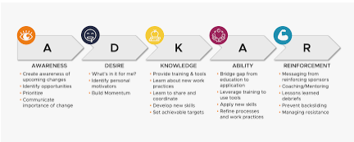

Appendix 2

https://www.bridgend.gov.uk/my-council/jobs/guide-for-applicants/

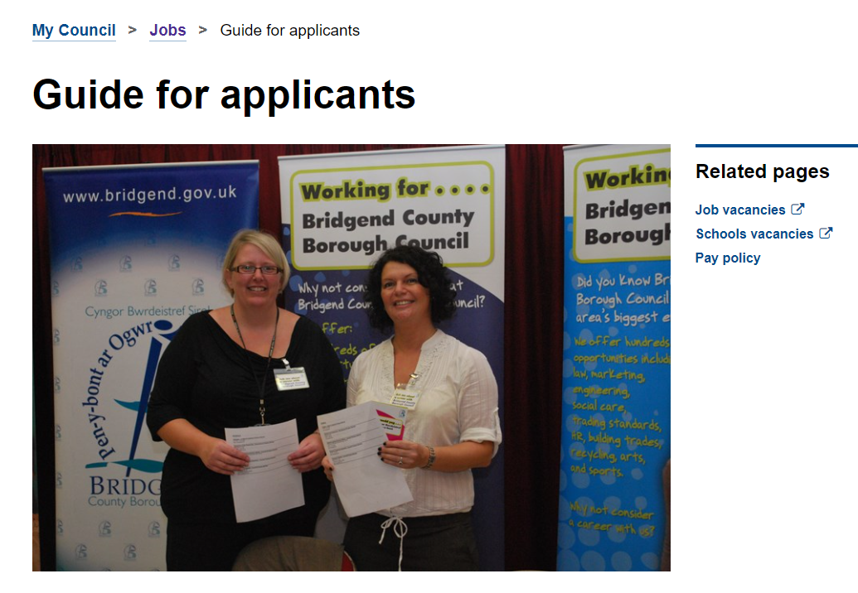

Appendix 3

HR Fair Processing Statement.

