

Programme: Master of Business Administration
Module: Marketing Management
Module Code: LCMB7024
Title: Marketing Environmental Analysis
Word count: 2687
Lecturer: Dian Mayasari
Student Name: Khunti Sneha Sajanbhai
Student ID: 2504970
Submission Date: 24th October
Table of Contents
1. Introduction 4
Task 1: Macro Marketing Environment Analysis 5
1.1 Overview of the Macro Marketing Environment 5
1.2 External Factor 1: Technological Factors 5
1.3 External Factor 2: Socio-Cultural Factors 7
Task 2: Strategic Responses of Pioneers and Followers 8
2.1 Strategic Response to Technological Factors 8
2.2 Strategic Response to Socio-Cultural Factors 10
3. Lessons Learned and Future Implications 13
4. Conclusion 14
References 15

List of Figures
Figure 1: External Factor 1: Technological Factor 6
Figure 2: Leading Grocery Online stores in UK 9

1. Introduction
In the context of business environment analysis, there are two types of business environment, micro and macro, that influence the strategies, growth and expansion of a business. The macro business environment can be defined as the complete, broad economy and the external forces in the market that affect the business (CFI Education, 2025). Many macro-environmental factors affect businesses in the market. The external marketing environment is critically examined through the PESTLE framework, which typically encompasses all the major external factors that influence an organisation's decision-making and future strategies. By understanding the various external market factors, businesses can anticipate, adapt, mitigate risks, and also exploit opportunities (Alawwad, 2024). This environment requires companies to adopt two strategic positions: pioneers and followers. The first action takers, who generally embrace innovation, take risks, and create early competitive advantages, are referred to as pioneers (Christopher, 2021). In contrast, late entrants in the market, who reduce risks by implementing proven and practised strategies, are termed followers.
This business environment report will primarily focus on two external or macro environmental factors: technological and socio-cultural factors, as these factors significantly influence the business and shape its competitiveness across industries. This report will critically analyse the various shifts and changes in these external factors that affect the opportunities and threats faced by pioneers (Tesco) and followers (Sainsbury’s) in the business. It will further evaluate the responses that these pioneers and followers strategically give to maintain competitiveness in the market.

Task 1: Macro Marketing Environment Analysis

1.1 Overview of the Macro Marketing Environment
The macro marketing environment is responsible for shaping industries and influencing competitiveness among organisations, as it represents the broad external factors that affect them. The macro environment operates at a wider level, as it is not controlled by individual firms, unlike the micro environment, which relates to customers, competitors, and suppliers (Svilane, 2023). The analyses of these forces are critical for the strategic management of the market. This is because it enables businesses to implement change, identify potential opportunities, and mitigate the risks of emerging threats and competitors. When organisations fail to recognise shifts in the external environment, they tend to lose their competitiveness. In contrast, those that strategically align their goals and mission with current market trends tend to experience better positioning and long-term security.
The most widely used framework for understanding the external business environment is the PESTLE framework, which encompasses political, economic, social, technological, legal, and environmental factors (CIPD, 2025).

1.2 External Factor 1: Technological Factors
Due to one of the most disruptive forces, technological innovations shape modern industries, which significantly influence the operations, interactions, and competitiveness of organisations (Abuzaid, 2024). The increasing advancements in data analytics, artificial intelligence, e-commerce automation, and augmented reality are responsible for shaping customer preferences, which ultimately compel companies to incorporate emerging digital solutions into their marketing strategies.
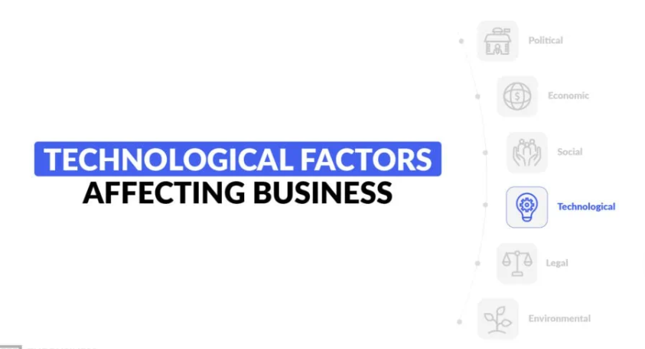
Figure 1: External Factor 1: Technological Factor
(Source: Pereira, 2024)
Opportunities for Pioneers:
The actions taken by pioneering companies gain them an opportunity to create a robust competitive edge in the market. As pioneers, they are typically the early adopters responsible for differentiating brands, attracting digitally advanced customers, and setting industry standards. For example, Tesco's AI-enhanced Clubcard drives loyalty through analytics, positioning the retailer as an innovator in customer relationship management (Shelper, 2024).
Threats for Pioneers:
The cost of innovation, however, is unsafe. Enormous research and development (R&D) can yield no immediate payoff, especially when consumers waste time adopting the technology. Besides, technological solutions may become obsolete in a short period of time (Rosenkranz et al., 2024). To illustrate, some wearable technology products failed to capture merchant attention, and chatbots powered by artificial intelligence were criticised for providing poor user experiences. Therefore, pioneers will encounter a loss of resources and a damaged reputation if the innovation does not perform as anticipated.
Opportunities for Followers:
Believers enjoy watching the successes and failures of pioneers so that they can adopt successful technologies at a lower cost. For instance, Sainsbury has developed its online grocery division, investing in Tesco's e-commerce operations since it learned not to make the same mistakes and still meet consumer demands perfectly (Valentine, 2021). This strategy helps its followers distribute their resources more effectively and minimise risk.
Threats for Followers:
Through these benefits, followers often struggle to meet the innovation challenge, as they feel they are playing catch-up. Potential customers might already be attached to innovative companies that influenced the creation of customer expectations. Followers will have a long-term disadvantage as pioneers build strengths, and the followers are unable to keep pace.

1.3 External Factor 2: Socio-Cultural Factors
The socio-cultural constituents have also assumed a special significance in the development of the marketing strategies because in a contemporary society, consumers have realised that nothing alone will serve in relation to the marketing of products and services that they want. They have high expectations of organisations. Growing demands regarding morals, diversity, inclusiveness, and sustainability are forcing business organisations to embrace practices that would favour wider interests. Customers are assessing the products not only by prices and quality, but also by their position on such ecological issues as climate change, fair trade, representation, and even the attitude to communities (Kubiczek et al., 2024). The ever-changing social values not only pose a threat to organisations, but they also offer a chance in the form of being either the leaders or the followers.
Opportunities for Pioneers
Tesco has been on the frontline in implementing social responsibility into the corporate strategy through its various programmes like “Little Helps Plan” that aim at reducing food waste, promoting healthy meals, and giving back to the community (Tesco PLC, 2021). These practices are representative of the CSR Pyramid by Carroll, where Tesco meets the economic, legal, ethical and philanthropic duties eventually (Homer et al., 2024). The Stakeholder Theory approach has helped Tesco to focus on the value creation for the customers, employees, suppliers and the community at large.
Brand authenticity and emotional attachment to the products are reinforced by Tesco being a committed and responsible company, by doing such things as sourcing responsibly and promoting local producers (Caër, 2025). Its most recent campaigns, one for promoting diversity in marketing and the other promoting food redistribution charities, including FareShare, only improve its social image.
Threats for Pioneers
Being a pioneer, however, has reputational risk. Any gap between what the corporation and the people promise one another may lead to allegations of greenwashing and be further enhanced through the scrutiny of social media. Lacking transparency may break down consumer trust and the brand equity of Tesco (Silkoset and Nygaard, 2025). Therefore, constant monitoring and transparent sustainability reporting are crucial to ensuring credibility.
Opportunities for Followers
Sainsbury, as a follower of Tesco, enjoys the advantage of inspecting the socio-cultural practices of Tesco and implementing practices that work. Its “Plan for Better” initiative is similar to the sustainability objectives of Tesco that aim at minimising waste, carbon neutrality, and sustainability in sourcing (J Sainsbury plc, 2025). This is a proactive implementation which reduces the risk but helps Sainsbury to attract value-conscious but ethically aware consumers.
Threats for Followers
However, when the initiatives of the followers are not authentic, they face the risk of being reactive or insincere. According to the Institutional Theory, this imitation can limit the differentiation (Balzano et al., 2025). Thus, to maintain the consumer trust, Sainsbury should make sure that its activities are not only effective and meaningful but also conveyed properly.

Task 2: Strategic Responses of Pioneers and Followers

2.1 Strategic Response to Technological Factors
The advancements in technology have rapidly transformed the retail industry, pressuring organisations to consistently innovate and adapt to new trends to sustain their competitive edge in the market. Pioneers like Tesco utilise technologies to become a driver of customer engagement and a strategic differentiator. Tesco, through the use of its Clubcard loyalty programme, has made rapid investments in innovation and analytics (Hartfield, 2024). Through the use of artificial intelligence and data analytics, Tesco can predict customer preferences, deliver personalised offers, and optimise its inventory management.
Tesco focuses on differentiating technology-supported customer experiences. Its hi-tech online grocery system and mobile applications offer easy navigation, quick checkout, and home delivery to meet changing customer demands (Agustian et al., 2024). These technologies enable Tesco to provide an easy, integrated shopping experience in-store, which is difficult for competitors to imitate in a short period of time. This aligns with the Generic Strategies proposed by Porter. Tesco's strategy adopted by Tesco is the possession of exquisite technological ability, which creates a value that is difficult to duplicate in the short run by a follower (Acar, 2024).
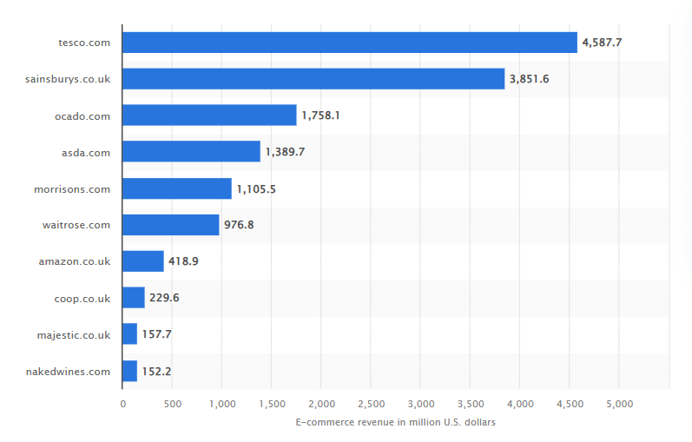
Figure 2: Leading Grocery Online stores in UK
(Source: Statista, 2025)
To mitigate the risks associated with new technology development, Tesco employs a risk management strategy that involves piloting and continuous improvement of its development (Han and Um, 2024). Acceptance efforts, such as automated checkouts and store trials that involve no cashiers, are first implemented on a small scale before being fully introduced into an organisation, and may be altered depending on the reaction of consumers. This is a cyclical technique, making innovations very effective and customer-centred. This is based on Rogers’ Diffusion of innovation theory, where Tesco is positioned as an innovator and early adopter and as such, it enjoys first-mover advantages, but it also involves even more investment and risk (Khamcha Magar, 2025).
On the other hand, more conservative and cost-effective followers, such as Sainsbury, follow this approach. Following established technology, Sainsbury will find it easy to copy innovations by field leaders like Tesco without incurring the expensive R&D costs associated with first-mover innovations. For example, Sainsbury also enhances its reward card (Nectar) by adding certain offers labelled after AI recommendations. Although Tesco does the same, it is still less vulnerable to risks in this manner (Parker, 2025).
Sainsbury also employs benchmarking and adherence in the sense that innovation strategies are reviewed, and factors are included that depict self-evident consumer value (Carassus and Da Ros, 2024). The retailer also possesses strategic advantages, such as coordinating with courier services like Deliveroo, to expand its e-commerce presence without incurring the initial cost of new amenities. Such activities enable Sainsbury to compete effectively and utilise the available technologies. Through the perspective of Diffusion of Innovations, Sainsbury is in the early majority group, avoiding any chance of false innovations that would lead to unnecessary spending of money by acting first. This enables it to adopt a strategy of cost leadership and selective differentiation.

2.2 Strategic Response to Socio-Cultural Factors
Retailers in the UK have been under increasing pressure to compete through socio-cultural influences that require them to source ethically and be an inclusive and environmentally friendly company (Bertola and Colombi, 2024). Both Tesco and Sainsbury’s have realised the importance of integrating the values of transparency and responsibility into their strategic and marketing processes, enabling them to remain relevant and trusted in a society that highly upholds these values. Their strategies, however, vary in intensity and speed. Tesco is the pioneer, and Sainsbury is the adaptive follower with less risky strategies.
Pioneers’ Strategies – Tesco
Being a leading retailer, Tesco does not neglect the incorporation of Corporate Social Responsibility (CSR) into its business strategy by means of such activities as the “Little Helps Plan” that prioritises three aspects, including people, communities, and the planet. This strategy corresponds to the Carroll CSR Pyramid (1991), where Tesco is pursuing its economic objective of making profits, acting legally in accordance with the laws and regulations, keeping its sustainability commitments, and having philanthropic objectives by helping the community.
Tesco plans also correspond to the Triple Bottom Line (TBL) framework of Elkington by balancing on People (based on FareShare partnerships with local farmers and food banks), Planet (reduction of plastic consumption and Net-zero operations), and Profit (to increase brand equity based on ethical branding). Such initiatives support the brand purpose of Tesco, as well as attract morally conscious customers (Jonker, 2025).
For Tesco, the main brand positioning is based on storytelling and open communication. The retailer also issues an annual sustainability report, which shows how it has achieved certain objectives, hence creating a sense of trust in the consumers and reducing any reputational risks. This proactive transparency protects Tesco against possible criticism of greenwashing, which is often a risk faced by the pioneers, like Tesco, that have failed to align their actions to their words (Menzies, 2024). According to the social purpose integrated into the business identity of Tesco, the company has established a good emotional relationship with its customers and has won long-term loyalty.
Followers’ Strategies – Sainsbury’s
Being a follower, Sainsbury implements socio-cultural strategies based on the inspirations of Tesco but with less financial and reputational risks. Similar targets of waste minimisation, carbon emissions, and responsibility in sourcing are reflected in its “Plan for Better” programme, which the company initiated after finding that competitors had positively accepted sustainability measures.
Sainsbury uses institutional learning as the organisation is allowed to observe effective CSR practices of Tesco and implement them only after demonstrating credibility and acceptance of those practices (Mendonça, 2025). The retailer also communicates with sustainability organisations and non-governmental organisations (NGOs) in order to achieve credibility levels and offer affordability to price-sensitive shoppers.
Nevertheless, because of the Institutional Theory, imitating leaders can restrict differentiation. Sainsbury needs to reinforce the realness in the continuity of the company communication and real demonstrative improvement so as not to be seen as reactive and opportunistic. To do this, Sainsbury's invests in transparent reporting and an employee engagement programme to align its social strategies with those of its consumers.
Comparative Insight
Overall, Tesco can be regarded as proactive and values-driven with a high degree of innovation response and brand equity due to its CSR leadership strategy, whereas Sainsbury can be deemed as an adaptive strategy with less risk with more stability and efficiency. These two methods show that socio-cultural responsiveness is the factor that makes a pioneer’s competitiveness by establishing leadership, and makes followers resilient through moderate accommodation (Gupta, 2024).

3. Lessons Learned and Future Implications
The case of Tesco and Sainsbury illustrates that it is highly important to constantly evaluate the macro marketing environment to be aware of any potential opportunities to capitalise on them and to be ready to counter any threats posed by the environment. Socio-cultural and technological influences force companies to be responsive and adaptable to the changing consumer expectations. One major learning is the compromise between innovation and stability. Being the first, Tesco has been experiencing strong growth by investing actively in AI, sustainability, and CSR to influence the market trends and ensure competitive leadership, at the cost of increased expenses and reputation. The follower strategy, on the other hand, implemented by Sainsbury focuses on stability by means of learning, benchmarking, and experimenting with proven innovations with lower risk. The future of marketing will continue to rely more on improvements in technology in AI, automation, and the ethics of data, where companies should combine innovation and responsibility (Şenyapar, 2024). Finding a balance between aggressive adoption of technology and socially responsible practice towards adaptability to changing stakeholder expectations will make the attainment of long-term competitiveness possible.

4. Conclusion
Conclusively, the technological and socio-cultural factor analysis indicates that external macro marketing actors are significant to opportunities and also pose threats to organisations. Consumer loyalty, the image and positioning of brands, as well as socio-cultural shifts, such as Tesco’s ethical approach, are influenced by differentiation opportunities and enhanced customer experiences offered by technological advancements, e.g., Tesco Clubcard powered by AI.
The growth of innovative, proactive pioneers such as Tesco is more strategic (involving more investment and risk), so they have to be leaders in the market. Competitors such as Sainsbury's are strategic followers, grounded in previous trends that are cost-related and efficient in minimising risks and staying competitive. The two methods are both practical: innovators change the market, and the second category maintains stability by taking into consideration the experiences of those who have innovated.
The evaluation of marketing activities demonstrated how the marketing department has contributed to organisations' strategic competitiveness. It has also anticipated and reviewed future developments in marketing by leveraging AI, automation, and data ethics technology.

References
Abuzaid, A.N. (2024) April. AI and business innovation: Analysing disruptive effects on industry dynamics and competitive strategies. In 2024 International Conference on Knowledge Engineering and Communication Systems (ICKECS) (Vol. 1, pp. 1-5). IEEE. https://doi.org/10.1109/ICKECS61492.2024.10617266
Acar, S. (2024) A Review of Porter’s Generic Strategies: Strategy Examples in International Firms. International Social Sciences Studies Journal, 10(11), pp.1902-1918. https://doi.org/10.5281/zenodo.142
Agustian, K., Rosadi, H.Y. and Zen, A. (2024) An integrative analysis of product differentiation strategies and customer experience in enhancing loyalty in the e-commerce industry. Journal of Contemporary Administration and Management (ADMAN), 2(2), pp.561-568. https://doi.org/10.61100/adman.v2i2.206
Alawwad, A. (2024) The influence of external factors on corporate strategy and strategies for adaptation in light of the global challenges. International journal of financial, administrative, and economic sciences, 3(10), pp.91-125. https://doi.org/10.59992/IJFAES.2024.v3n10p3
Balzano, M., Marzi, G. and Turzo, T. (2025) SMEs and institutional theory: major inroads and opportunities ahead. Management Decision, 63(13), pp.1-27. https://doi.org/10.1108/MD-05-2023-0734
Bertola, P. and Colombi, C. (2024) Can fashion be sustainable? Trajectories of change in organizational, products and processes, and socio-cultural contexts. Sustainability: Science, Practice and Policy, 20(1), p.2312682. https://doi.org/10.1080/15487733.2024.2312682
Caër, C. (2025) Branding, Consumer Psychology and Sustainability. https://urn.fi/URN:NBN:fi:amk-2025071523639
Carassus, M. and Da Ros, N. (2024) The Cultivation of an Industry: Navigating Business Challenges and Consumer Trends in Europe’s Emerging Meat Market. https://lup.lub.lu.se/luur/download?func=downloadFile&recordOId=9162544&fileOId=9162735
CFI Education (2025) Macro Environment - Overview, DEPEST Analysis, Factors Available at (Online) <https://corporatefinanceinstitute.com/resources/economics/macro-environment/> (Accessed on 26 September 2025).
Christopher E. (2021) What It Means to Be a Pioneer of Your Industry (and 3 Signs You Might Be One) Available at (Online) <https://www.entrepreneur.com/leadership/what-it-means-to-be-a-pioneer-of-your-industry-and-3-signs/366749> (Accessed on 25 September 2025).
Gupta, R. (2024) Exploring the impact of socio-cultural factors on entrepreneurship development in emerging markets. https://doi.org/10.21203/rs.3.rs-3938479/v1
Han, N. and Um, J. (2024) Risk management strategy for supply chain sustainability and resilience capability. Risk Management, 26(2), p.6. https://doi.org/10.1057/s41283-023-00138-w
Hartfield, T.R. (2024) Overcoming Data Barriers: Strategies for New Entrants to Achieve Differentiation in the UK Food Retail Market. Journal of World Economy, 3(3), pp.68-83. doi:10.56397/JWE.2024.09.08
Homer, S.T., Berezina, E.B. and Gill, C.M.H.D. (2024) The mediating effect of firm familiarity between corporate social responsibility and reputation, trust, and customer satisfaction. Business and Society Review, 129(3), pp.398-423. DOI: 10.1111/basr.12366
J Sainsbury plc (2025) Plan for Better | J Sainsbury plc Available at (Online) <https://corporate.sainsburys.co.uk/sustainability/plan-for-better/> (Accessed on 26 September 2025).
Jonker A. (2025) What Is the Triple Bottom Line (TBL)? | IBM Available at (Online) <https://www.ibm.com/think/topics/triple-bottom-line> (Accessed on 26 September 2025).
Khamcha Magar, R. (2025) Role of Innovation and Research for Designing Sales Promotion Strategies of Bhat-Bhateni Supermarket. https://www.theseus.fi/bitstream/handle/10024/883966/Khamcha_Magar_Roshani.pdf?sequence=2&isAllowed=y
Kubiczek, J., Hadasik, B., Krawczyńska, D., Przedworska, K., Madarász, E.Z. and Ryczko, A. (2024) Perspective of created value in consumer choice: Comparison of economic and ecological dimensions. Sage Open, 14(1), p.21582440241238516. https://doi.org/10.1177/21582440241238516
Mendonça, L.B. (2025) The Impact of Green Human Resource Management Practices on Environmental and Economic Performance in the UK Retail Sector: The Human Resource Perspective (Doctoral dissertation, Dublin, National College of Ireland). https://norma.ncirl.ie/7706/
Menzies, D. (2024) The Big Green Lie-Environmentalism and Consumerism in a Post-Truth Era (Doctoral dissertation, Institute of Art, Design+ Technology). https://illustro-iadt.figshare.com/articles/thesis/The_Big_Green_Lie_-_Environmentalism_and_Consumerism_in_a_Post-Truth_Era/27236499
Parker E. (2025) Sainsbury's announces major Nectar card change to help shoppers save money - Manchester Evening News Available at (Online) <https://www.manchestereveningnews.co.uk/whats-on/shopping/sainsburys-announces-major-nectar-card-32535678> (Accessed on 26 September 2025).
Pereira D. (2024) Technological Factors Affecting Business Available at (Online) <https://businessmodelanalyst.com/technological-factors-affecting-business/> (Accessed on 26 September 2025).
Rosenkranz, S., Staegemann, D., Volk, M. and Turowski, K. (2024) Explaining the business-technological age of legacy information systems. IEEE Access, 12, pp.84579-84611. https://doi.org/10.1109/ACCESS.2024.3414377
Şenyapar, H.N.D. (2024) The future of marketing: The transformative power of artificial intelligence. International Journal of Management and Administration, 8(15), pp.1-19. DOI: 10.29064/ijma.1412272
Shelper P. (2024) Do Loyalty Programs Work? Just ask Tesco - Loyalty & Reward Co Available at (Online) <https://loyaltyrewardco.com/do-loyalty-programs-work-just-ask-tesco/#:~:text=Tesco's%20Clubcard%20Challenges%20cement%20their,a%20way%20to%20collect%20points.> (Accessed on 25 September 2025).
Silkoset, R. and Nygaard, A. (2025) Leveraging blockchain and smart contracts to combat greenwashing in sustainable development. Sustainable Development. https://doi.org/10.1002/sd.3431
Statista (2025) UK: top grocery online stores 2024| Statista Available at (Online) <https://www.statista.com/forecasts/870373/top-online-stores-food-beverages-united-kingdom-ecommercedb?srsltid=AfmBOopiUc1tbodOTzp_6ikiIK5lCohZzQeSnjVCS7T2_dK-iKnuUF9J> (Accessed on 26 September 2025).
Svilane, I. (2023) External Factors of Business Environment and Family Business: Theoretical Review. https://doi.org/10.14311/bit.2023.02.01
Tesco PLC (2021) Tesco Little Helps Plan Available at (Online) <https://www.tescoplc.com/media/757596/lhp-report-2021.pdf> (Accessed on 26 September 2025).
Valentine M. (2021) Sainsbury’s grabs online share with digital marketing push Available at (Online) <https://www.marketingweek.com/sainsburys-digital-marketing-push/> (Accessed on 26 September 2025).

