3/20/2026
Aliu Djalo (2117368)

University of wales trinity saint david

Data Warehousing & Data Mining (ACCA6026)

Assignment 1
Table of Contents:
1. Introduction 1
2. Purpose and Practice of Data Mining 2
3. Dataset Description and Exploration 3
3.1. Dataset Overview: 3
3.2. Attribute Types: 3
3.3. Missing Values: 3
3.4. Exploration of Findings: 3
4. Pre-processing and post-processing 5
4.1. Primary pre-processing 5
4.2. Secondary pre-processing 6
4.3. Post-processing 9
5. Analysis Methods and Results 10
5.1. Introduction to methods chosen: 10
5.2. Classification results: 10
5.3. Clustering results: 14
6. Business Recommendations 18
7. Reflection 19
7.1. Does it work well 19
7.2. Advantages and disadvantages: 19
7.3. What would be done differently 19
8. Conclusion 20

Introduction
This report analyses the Student Performance dataset from the UCI Machine Learning Repository. The dataset includes demographic, social, and academic information about students studying mathematics and Portuguese at two secondary schools in Portugal, covering factors such as age, gender, family background, study habits, school support, attendance, and grades across three assessment periods.
The study has two main goals. First, it uses predictive data mining techniques to estimate students’ final grades based on personal, social, and educational factors. Second, it applies clustering methods to identify groups of students with similar characteristics and performance patterns, which may highlight profiles such as high achievers or students at risk.
Data cleaning and initial exploration were carried out using Microsoft Excel, while predictive modelling and clustering were performed in the Weka data mining platform. Excel was also used to produce visualisations to support the exploration and interpretation of the dataset.

Purpose and Practice of Data Mining
Data mining is the process of examining large datasets to identify meaningful patterns, relationships, trends and insights that can support effective decision making. It integrates techniques from statistics, machine learning and database management to convert raw data into valuable knowledge. The purpose is not merely to store information but to uncover hidden structures and useful insights within complex data. [1]
In modern organisations, data mining is a key part of business analytics. Companies gather vast amounts of data from customers, transactions, operations and digital platforms and mining techniques help them use this data strategically. For example, predictive models can forecast demand, identify customer preferences, detect fraud, optimise pricing and improve efficiency. By relying on evidence from data, organisations can make more accurate decisions instead of depending on intuition. [2]
Data mining also supports segmentation and forecasting. Classification techniques are used to predict future outcomes, while clustering methods group individuals or entities with similar characteristics. This allows organisations to tailor products, services, or interventions to specific groups, improving effectiveness and competitiveness. Additionally, data mining can highlight inefficiencies, reduce costs, manage risks and uncover new opportunities for growth. [3]
Beyond business, data mining is widely used in fields such as healthcare, finance, government, and education. In education, for instance, analysing student data can help identify learning patterns, predict academic performance, and guide targeted support strategies. Overall, data mining transforms large volumes of data into practical insights that enable better decisions across many sectors. [4]

Dataset Description and Exploration

Dataset Overview:
The Student Performance dataset was obtained from the UCI Machine Learning Repository (Cortez and Silva). It includes information about students who are studying Mathematics and Portuguese in two secondary schools in Portugal. The data is split into two parts: one for Mathematics, which contains 395 students, and one for Portuguese, which includes 649 students. Each student is represented by a single record with 33 different attributes, covering areas such as personal details, family background, school-related factors, and academic performance. [5]

Attribute Types:
The variables in the dataset can be grouped into a few key areas. There is basic demographic information, such as the student’s age, gender, and whether they live in an urban or rural area. It also includes details about their family, including their parents’ education and jobs, the size of the family, and the quality of relationships at home.
In terms of school-related factors, the dataset records things like how much time students spend studying, how many classes they have previously failed, whether they receive extra educational support, and how often they are absent. There are also lifestyle factors, including how often students go out, their alcohol consumption during the week and weekends, and whether they have internet access at home.
Finally, the dataset includes three grade variables that measure academic performance over time: G1 (first period), G2 (second period), and G3 (final grade), all scored on a scale from 0 to 20.
The attributes are a mix of numeric variables, such as age and absences, and categorical variables, such as gender and family size.

Missing Values:
One notable characteristic of this dataset is the complete absence of missing values across both files, which simplifies the pre-processing stage considerably. This means no imputation or deletion of incomplete records was required before analysis.

Exploration of Findings:
Initial exploration of the maths dataset revealed several interesting patterns. Analysis of the final grade (G3) distribution showed that the largest group of students (165) achieved grades in the 10–13 pass range, while 38 students received a grade of 0, likely indicating withdrawal or non-submission. Only 18 students achieved distinction (18–20), suggesting high achievement is relatively rare.

Fig 1 – Grade Distribution of Final Grades G3 Maths Dataset.
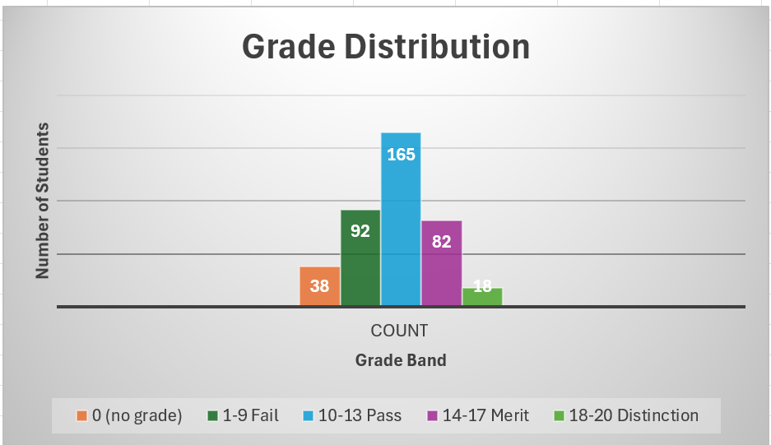

Examination of study time showed a modest positive relationship with final grades, with average G3 rising from 10.05 for students studying less than two hours per week to 11.40 for those studying five to ten hours, suggesting that increased study time has a positive but limited impact on performance.
Figure 2: Average G3 by Study Time on Maths Dataset.
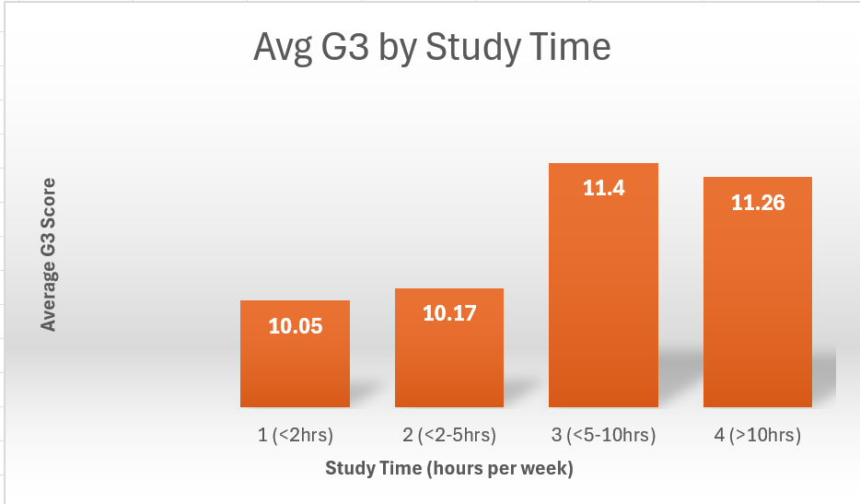

The most striking finding was the relationship between past failures and final grade, students with no previous failures averaged 11.25, while those with three past failures averaged just 5.69, suggesting that academic history is a strong indicator of future performance.
Figure 3: Average G3 by Past Failures on Maths Dataset.
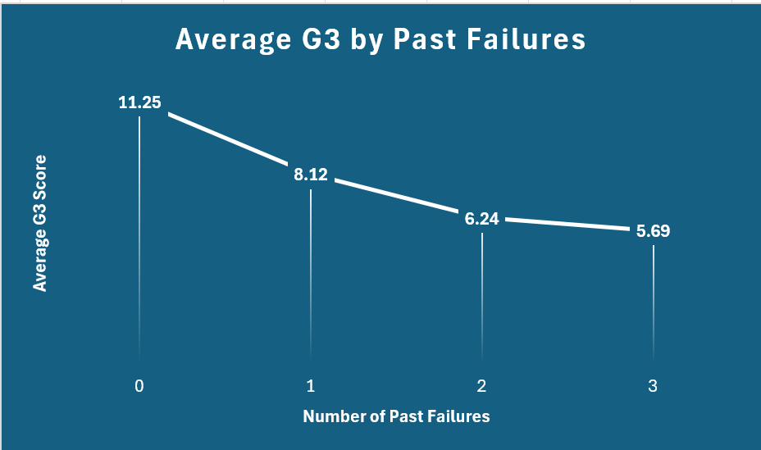

Pre-processing and post-processing

Primary pre-processing
The first step in pre-processing was to combine the mathematic and Portuguese datasets into one file. This was done to make sure that only students who appeared in both subjects were included in the analysis. By merging the datasets, it was possible to work with the same group of students across both courses, which improved consistency and avoided counting the same student twice. The merge was carried out in Microsoft Excel using Power Query, using an inner join. An inner join was chosen instead of an outer join because the aim was to keep only the students present in both datasets, rather than including unmatched records. This approach keeps only the students who appear in both datasets. To match the records accurately, 13 identifying attributes were used, including details such as school, gender, age, family background, and other personal characteristics. These attributes were: school, sex, age, address, famsize, Pstatus, Medu, Fedu, Mjob, Fjob, reason, nursery and internet. These were chosen because they are unlikely to change between subjects and therefore help ensure correct matching.
Grade variables such as G1, G2, and G3 were not used for matching, as they are different for each subject. After merging, the final dataset contained 370 students, reduced from the original 395 mathematics and 649 Portuguese records. This dataset was then used for the later analysis. [6]
Figure 4: Power Query Inner Join Merge Setup.
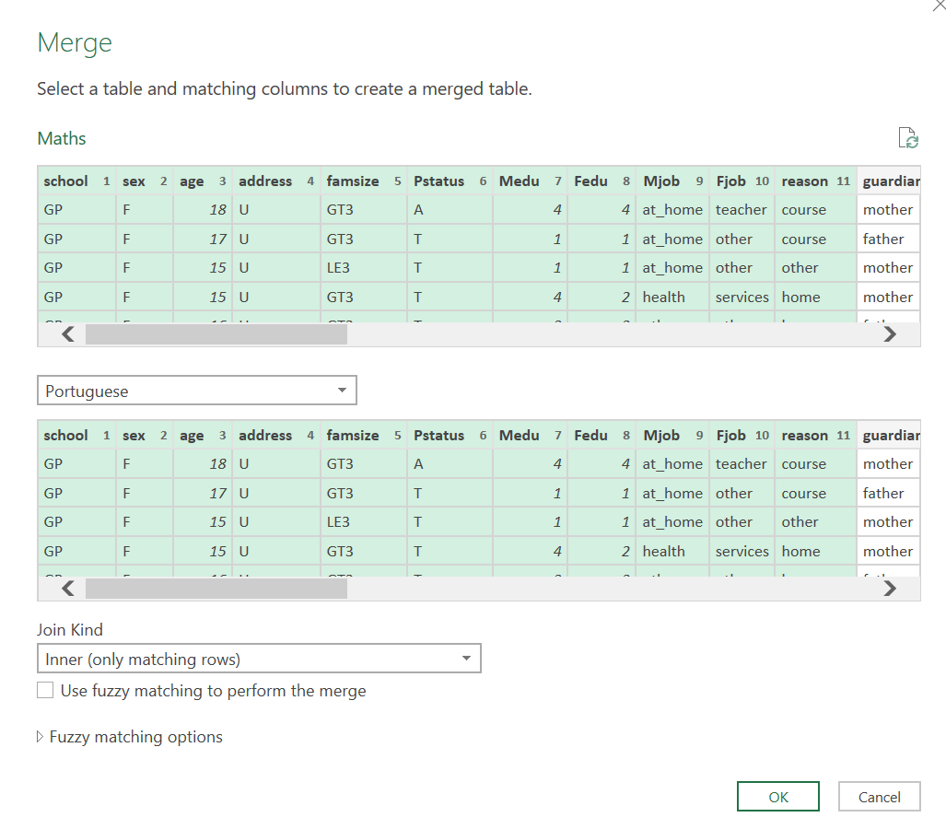

Secondary pre-processing
After merging the datasets, further pre-processing was carried out to prepare separate files for classification and clustering tasks. For the classification analysis, a new variable called G3_band was created by converting the final grade (G3) into categories: No Grade, Fail, Pass, Merit and Distinction. This process, known as discretisation, made it easier to apply classification algorithms and interpret the results. [7]

Figure 5: G3_band Discretisation into Grade Band Categories.
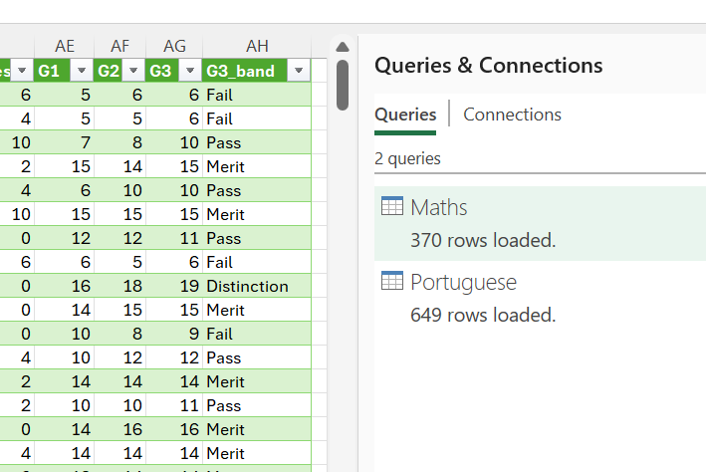

To improve the quality of the model, the earlier grade variables G1 and G2 were removed. These variables are very closely related to the final grade (G3) and keeping them would allow the model to rely heavily on prior grades rather than identifying meaningful patterns in student behaviour. This issue, known as data leakage, can lead to misleadingly high accuracy without providing useful insights. The original G3 variable was also removed, as it had been replaced by the new G3_band classification. [8]
For the clustering analysis, a separate dataset was created by removing all grade-related variables, including G1, G2, G3, and G3_band. This was done because clustering is intended to group students based on their characteristics and behaviours, rather than their academic outcomes. The resulting dataset was saved as student-clustering.csv and used for identifying patterns among students without predefined labels.
An additional dataset, student-regression.csv, was created for linear regression, where the original numeric G3 was kept as the target variable.

Post-processing
After running the analysis in Weka, the results were saved and prepared for reporting. Screenshots were taken of the classification outputs, including the model accuracy, confusion matrix, and decision tree, to clearly show how well the models performed. For clustering, screenshots were captured of the cluster centroids and the distribution of instances across clusters, which helped in understanding the different student groups identified.
Several algorithms were used for comparison, including J48, Random Forest, and Linear Regression. The J48 model was run with both five grade categories and a simpler Pass/Fail version to compare results. Clustering was also carried out using different methods, including Simple K-Means, EM and Hierarchical clustering, with different numbers of clusters tested to explore patterns in the data.
All results were then organised and have been added into the report with clear labels and figures, making the findings easier to present and interpret.

Analysis Methods and Results

Introduction to methods chosen:
A range of algorithms was selected to allow comparison between different approaches to prediction and clustering. For classification, J48, Random Forest, and Linear Regression were used. J48 was chosen because it produces a decision tree, which is easy to visualise and interpret, and works well with both numeric and categorical data [9]. Random Forest was included as it builds multiple decision trees, often leading to higher accuracy and more reliable predictions [10]. Linear Regression was used to predict the exact final grade rather than a category, providing a different perspective on student performance [11]. Using all three methods allowed a more complete comparison of results.
All classification models were evaluated using 10-fold cross-validation, which divides the data into 10 equal parts and tests the model on each part in turn, providing a more reliable measure of accuracy.
For clustering, Simple K-Means, EM, and Hierarchical clustering were selected. Simple K-Means groups students based on similarity and is widely used [12]. EM uses probability to assign students to clusters [13] , while Hierarchical clustering shows how groups are related. Using different methods helped provide a more meaningful analysis of student groupings. [14]

Classification results:
The classification models produced different levels of performance depending on how the target variable was defined. The J48 decision tree using five grade categories (Fail, Pass, Merit, Distinction, No Grade) achieved an accuracy of 40.27%, which is relatively low. This is likely because predicting multiple categories is more complex, and the boundaries between grades can be unclear, making it harder for the model to distinguish between them.
Figure 6: J48 Decision Tree with 5 Class Classification Results
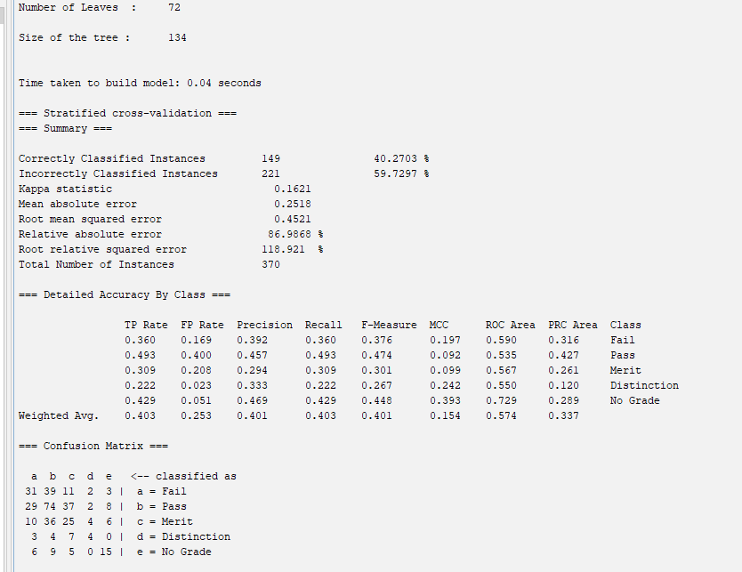

When the problem was simplified to a Pass/Fail classification, the J48 model improved significantly to 67.03% accuracy. This increase is expected, as reducing the number of categories makes the prediction task easier and reduces confusion between similar grade levels.
Figure 7: J48 Decision Tree with Pass/Fail Classification Results
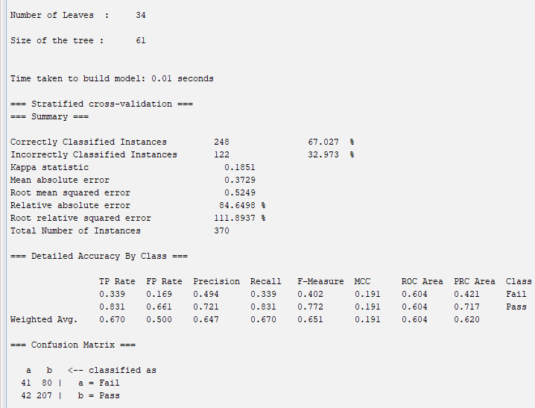
The Random Forest model achieved the highest accuracy at 71.89%, making it the best-performing classifier. This is because it combines multiple decision trees, reducing overfitting and improving overall prediction reliability compared to a single tree like J48.
Figure 8: Random Forest Classification Results
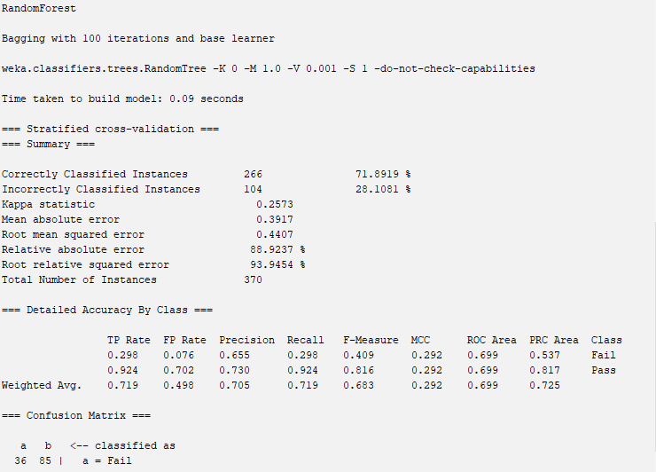
In contrast, Linear Regression produced a relatively weak result, with a correlation of 0.34 between predicted and actual grades. This suggests that the model struggled to accurately predict exact grades, likely due to the complexity of student performance and the influence of many interacting factors.
Figure 9: Linear Regression Results
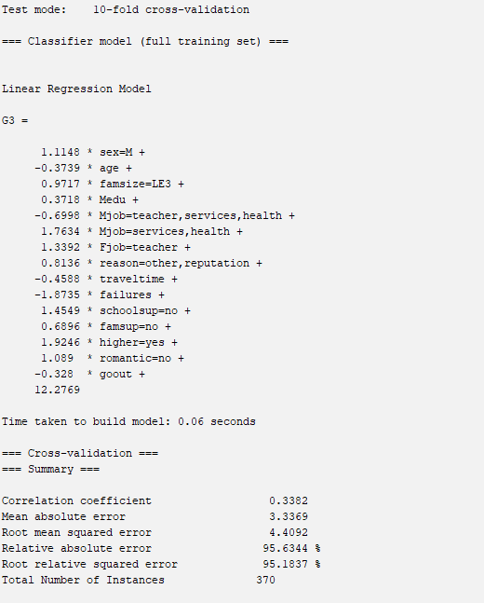

Overall, Random Forest performed best due to its ability to handle complex patterns, while simpler models like J48 and Linear Regression showed more limitations.

Clustering results:
Clustering was used to group students based on their characteristics and behaviours, without using their grades. Different algorithms produced slightly different groupings, but some consistent patterns were identified.
Using Simple K-Means with 3 clusters, three main groups of students were identified. These included more social male students, quieter female students, and a group of more motivated female students. This gave a general overview of how students could be grouped based on behaviour and lifestyle factors.
Figure 10: Simple K-Means Clustering with 3 Clusters
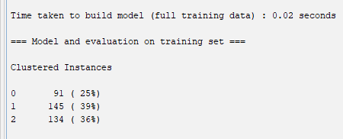

When the number of clusters was increased to 4 using Simple K-Means, the results became more detailed. The additional cluster allowed a clearer separation of students, particularly by gender and behaviour patterns. This provided a more refined understanding of different student types and was more useful for interpretation.
Figure 11: Simple K-Means Clustering with 4 Clusters
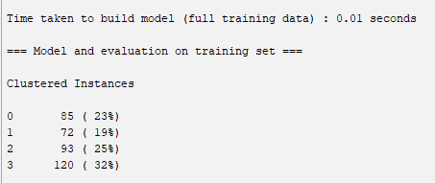

The EM algorithm automatically identified 2 clusters, offering a simpler view of the data. Cluster 0 contained 248 students (67%) with almost no previous failures and lower alcohol consumption, while Cluster 1 contained 122 students (33%) with significantly higher failure rates and alcohol consumption, suggesting a clear at-risk group. This suggests that these variables play a key role in separating students, particularly in identifying those who may be at risk academically.
Figure 12: EM Clustering Results
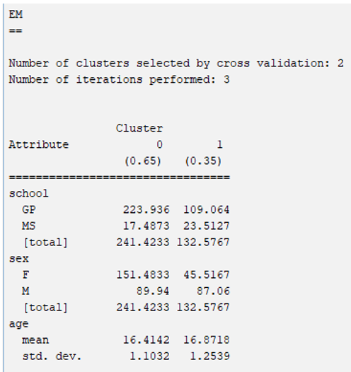
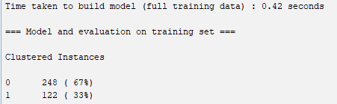

The Hierarchical clustering approach produced 3 clusters, with group sizes of 172 (46%), 141 (38%), and 57 (15%). The structure showed how clusters are related and supported the patterns found in the other methods.

Figure 13: Hierarchical Clustering Dendrogram
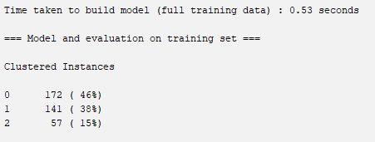
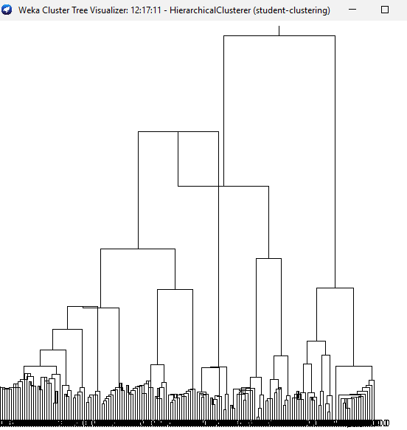

Overall, the Simple K-Means with 4 clusters provided the most useful results, as it offered the best balance between detail and interpretability. However, all methods showed similar patterns, especially in identifying groups of students who may require additional support.

Business Recommendations
Based on the findings, several practical recommendations can be made to help schools improve student performance. One of the most important actions is to identify at-risk students early. The analysis showed that past failures are the strongest predictor of final performance, meaning students who have already struggled are more likely to continue struggling. Schools should monitor these students closely and provide early support before their performance declines further.
The clustering results also highlighted clear student groups with different behaviours. In particular, a group of students with higher failure rates and higher alcohol consumption was identified, suggesting they may need additional academic and pastoral support. In contrast, more motivated students, especially those aiming for higher education, tended to perform better and had lower failure rates. Schools can use this information to target support more effectively, rather than applying the same approach to all students. For example, social male students identified in the clustering analysis may benefit from structured study programmes, while quieter female students may need encouragement and engagement support.
Predictive models such as Random Forest, which achieved an accuracy of 71.89%, could be used as an early warning system. By identifying students who are likely to fail, schools can intervene earlier with tutoring, mentoring, or counselling.
Finally, encouraging positive behaviours such as increased study time and clear academic goals, particularly aspirations for higher education, may also improve outcomes. Overall, combining data-driven insights with targeted support can help schools better support students and improve overall performance.

Reflection

Does it work well
Overall, the analysis worked reasonably well, but there are some limitations. The Random Forest model achieved 71.89% accuracy, which shows it can make useful predictions, although it is not perfect. This means that around one in three predictions could still be incorrect. The clustering methods also worked well, as they identified meaningful groups of students, including clear at-risk profiles. However, the Linear Regression model performed poorly, with a low correlation of 0.34, suggesting it struggled to capture the complexity of student performance.

Advantages and disadvantages:
There are several advantages to this approach. Decision trees such as J48 are easy to understand and explain, and using multiple algorithms allowed for useful comparison. The dataset also contained no missing values, which made pre-processing straightforward. In addition, clustering helped highlight different types of students.
However, there are also some disadvantages. The dataset is relatively small and limited to two schools, so the results may not apply more widely. Analysing the Portuguese dataset separately and comparing results with the mathematics dataset would also provide a more complete picture.

What would be done differently
If repeated, the analysis could be improved by using a larger dataset, testing more algorithms, and applying feature selection to better identify the most important factors. Despite these limitations, the findings provide a useful starting point for schools looking to use data mining to support student outcomes.

Conclusion
This analysis used data mining techniques to predict student performance and identify groups of students with similar characteristics. The Random Forest model performed best, achieving an accuracy of 71.89%. The clustering results also revealed clear student groups, including an at-risk group linked to higher failure rates and alcohol use. These findings show that data mining can be useful in education. Schools can use these insights to identify struggling students earlier, understand different student needs, and provide more targeted support to improve outcomes.

References
[1] Mitch Daniels. "What Is Data Mining?" Purdue University. Accessed: Mar 20 2026. [Online]. Available: https://business.purdue.edu/master-of-business/online-masters-in-business-administration/posts/what-is-data-mining.php
[2] "What is data mining? | Definition, importance, and types." SAP. Accessed: Mar 20 2026. [Online]. Available: https://www.sap.com/uk/products/data-cloud/hana/what-is-data-mining.html
[3] "What is Data Mining? | IBM." IBM. Accessed: Mar 20 2026. [Online]. Available: https://www.ibm.com/think/topics/data-mining
[4] N. Ahmed, R. Ameer, S. Gull, Afrasiyab and Nooruddin, "Data Mining in Healthcare: An Overview of Applications, Techniques, and Challenges," International Journal of Artificial Intelligence & Mathematical Sciences. vol. 3, pp.1–10, May 17 2025, doi: 10.58921/ijaims.v3i1.102. Accessed: Mar 20, 2026. Available at: https://www.researchgate.net/publication/391836969_Data_Mining_in_Healthcare_An_Overview_of_Applications_Techniques_and_Challenges.
[5] "Student Performance - UCI Machine Learning Repository," 11/26 2014, Accessed: Mar 20, 2026. Available at: https://archive.ics.uci.edu/dataset/320/student+performance.
[6] S. Sultana."All About Inner & Outer Joins with Table.Join (Power Query M Language)" ExcelDemy. (-03-262025). Accessed: Mar 20, 20262026, [Blog]. Available at: https://www.exceldemy.com/all-about-inner-outer-joins-with-table-join-power-query-m-language/
[7] Amritha K."Discretization in Data Mining: Techniques & Applications" learninglabb. (-02-112025). Accessed: Mar 20, 20262026, [Blog]. Available at: https://learninglabb.com/discretization-in-data-mining/
[8] M. Shaikh."How to Detect and Prevent Data Leaks in ML Models" Medium. (-03-092025). Accessed: Mar 20, 20262026, [Blog]. Available at: https://medium.com/@musabs2802/how-to-detect-and-prevent-data-leaks-in-ml-models-509cc4d83b9f
[9] N. Khanna."J48 Classification (C4.5 Algorithm) in a Nutshell" Medium. (-08-182021). Accessed: Mar 20, 20262026, [Blog]. Available at: https://medium.com/@nilimakhanna1/j48-classification-c4-5-algorithm-in-a-nutshell-24c50d20658e
[10] "Random Forest Algorithm in Machine Learning." geeksforgeeks. Accessed: Mar 20 2026. [Online]. Available: https://www.geeksforgeeks.org/machine-learning/random-forest-algorithm-in-machine-learning/
[11] Chloe Park. "Linear Regression: Definition, How It Works, and Practical Use Cases - Teachfloor Blog." teachfloor. Accessed: Mar 20 2026. [Online]. Available: https://www.teachfloor.com/blog/linear-regression
[12] J. Frost."What is K Means Clustering? With an Example" Statistics By Jim. (-08-312022). Accessed: Mar 20, 20262026, [Blog]. Available at: https://statisticsbyjim.com/basics/k-means-clustering/
[13] "Expectation-Maximization Algorithm - ML." geeksforgeeks. Accessed: Mar 20 2026. [Online]. Available: https://www.geeksforgeeks.org/machine-learning/ml-expectation-maximization-algorithm/
[14] Austin Chia. "Hierarchical Clustering: Concept Overview With Examples." datacamp. Accessed: Mar 20 2026. [Online]. Available: https://www.datacamp.com/tutorial/hierarchical-clustering

