

Module Name: Managing Enterprise

Module Code: BMSW4011

Assignment Name: Business Plan and Reflection.

Student Name: Devi Raju

Student Number: 2435195

Lecturer: Jaliya De Silva

Deadline: 06/03/2026

Word Count: 1688

AI Acknowledgement:

I confirm that I have not presented any AI generated materials as my own work.

I confirm that I have copies of my drafts, notes, and other resources I used, which I may be asked to prove in evidenc

Business Plan & Individual Reflection:
Table of Contents

Introduction-----------------------------------------------------------------------------------3
Development of the Business Concept------------------------------------------------3
Business Ownership------------------------------------------------------------------------4
Mission statement---------------------------------------------------------------------------4
Aim and Smart Objectives-----------------------------------------------------------------4
Unique Selling Proposition (USP)-------------------------------------------------------5
Physical Resources and Business Location------------------------------------------5
Organisational structure-------------------------------------------------------------------5
Human Resources--------------------------------------------------------------------------5
Marketing and Promotional Activities--------------------------------------------------6
Marketing Research------------------------------------------------------------------------6
Financial Resources (costing and 12-month cash flow forecast) --------------7
SWOT Analysis-----------------------------------------------------------------------------7
Business Viability Conclusion-----------------------------------------------------------7
Individual Reflection----------------------------------------------------------------------17,18.

Business Plan and Reflection:

Business Name:
Nalas Kitchen

Business Type:
Sole Trader

Location:
Bridgend and Delivery Partners (Online)

Owner:
Devi Raju

Business Plan for Nalas Kitchen:

Introduction:
Nalas Kitchen is an Indian restaurant based in Bridgend, offering authentic and high-quality Indian cuisine to both local-residents and the wider surrounding area. The business combines traditional Indian recipes with modern cooking techniques, delivering rich flavours, consistent quality and excellent customer service. In addition to dine in and takeaway services, Nalas Kitchen has established a strong online presence through delivery partners such as Deliveroo and Just Eat, allowing to business to meet the growing demand for convenient, home delivered meals.
The restaurant is committed to use fresh ingredients and carefully selected spices to ensure an authentic dining experience. By leveraging online food delivery platforms, Nalas Kitchen can reach a border customer base, increase sales opportunities and remain competitive in a fast-paced food service market.

Development of the Business Concept:
The business concept of Nalas Kitchen was developed following local’s surveys and marketing research carried out in and around Bridgend area. The business plan is an important tool for developing a clear business idea (Molina, 2003). The research identified a clear gap in the market, as there is currently no restaurant offering truly authentic Indian cuisine in the area. Business plan development helps students gain practical entrepreneurial skills (Wheadon & Duval-Couetil, 2014).
Although there is strong local demand for Indian food, existing outlets do not fully represent traditional flavours, cooking methods or cultural authenticity

Business Ownership:
Nalas Kitchen is a sole trader and family-owned business, managed directly by the owner with full responsibility for operations and finances. As a family-run enterprise, it benefits from strong commitment, shares values, and hands on involvement in all areas, including food preparation, customer services and administration. Owner-managers often use business planning to guide business decisions (Richbell, Watts & Wardle, 2006).
The structure allows for flexible decision-making, lower costs, and consistent quality, while maintaining a personal, customer focused approach. Business success depends on effective management and planning (Skripak & Poff, 2021).

Mission statement:
“To bring the authentic taste of India to Bridgend by serving high-quality, traditional dishes with exceptional service, whether dine in or delivered to your doorstep”. This mission statement reflects Nalas kitchen commitment to bringing authentic Indian cuisine to Bridgend. Mission statements help guide business goals and direction (Berbegal-Mirabent, Mas-Machuca & Guix, 2021).

Aim and Smart Objectives:
The main aim of Nalas Kitchen is to establish itself as Bridgend’s leading Atlantic Indian restaurant by delivering high quality food, excellent customer service and convenient dining options, including dine in an online delivery. Online platforms are changing how businesses operate and reach customers (Langley et al., 2021).

Smart objectives:
1. To achieve customer satisfaction rating of at least 4.5 stars on the Deliveroo and Just Eat within the 1st 12 months of operation.
2. To increase monthly sales by 10% within the 1st year to consistent food quality and effective online marketing.
3. To build a loyal customer base by securing at least 30% repeat customers within 6 months of opening.
4. To maintain food quality and operational efficiency by sourcing fresh ingredients from reliable suppliers on a weekly basis.
Digital innovation creates new challenges and opportunities for businesses (Favoretto et al., 2022).

Unique Selling Proposition (USP):
Nalas Kitchens unique selling proposition is its focus on providing authentic Indian to prepared using fresh ingredients and healthier cooking options. The business emphasis balanced meals with the reduced oil and high-quality spices without compromising traditional flavours. Nutritional awareness with cultural authenticity, alongside dining and online delivery options.

Physical Resources and Business Location:
Nalas kitchen located in Bridgend town centre, close to the bus and train stations offering excellent accessibility and I visibility. The vessels are supported by essential physical resources, dining space, and delivery system to efficient support dining, takeaway and online orders (see Appendix 1). According to Balbontin and Hensher (2021), the process rules play a key role in influencing firm location decisions.

Organisational structure:
Nala’s Kitchen is a family-run business supported by small number of Staff with a simple, efficient structure.

Owner / Founder

Kitchen Lead Service and Front House Admin and Finance.
(Chef) (Family member & outsource staffs) (Family members)

Delivery Partners
With Deliveroo and Just Eat.

Human Resources:
Nalas Kitchen combines family members and train the staff to run daily operations efficiently. Family handle key roles owner/founder kitchen lead, front of house, and Administration. Our team members are trained in food hygiene safety and customer service to ensure consistent quality and a positive experience for dine in and delivery customers. Human resource strategies play an important role in business performance ( Agustian et al., 2023).

Marketing and Promotional Activities:
Nalas Kitchen Promote its business using both local and online methods to attract customers. The restaurant is available online with delivery, which helps reach people who wish to order food online. Also use social media to share updates, special offers and customer reviews. Locally we use flyers, clear signage and word of mouth recommendations to spread awareness. These promotional activities help build a strong reputation and encourage repeat customers within the Bridgend community. (see appendix 2 & appendix 3)

Marketing Research:
I carried out both primary and secondary research before starting Nala’s Kitchen. I conducted a survey with local residents and observed competitors in Bridgend. The results showed strong demand for authentic Indian food and high interest in online delivery. According to McDaniel Jr. (2025), marketing research is essential for understanding consumer behaviour and making informed business decisions. I also reviewed competitor menus, pricing, and online trends. The research helped me decide the menu, pricing, location, and delivery partnerships, confirming that the business idea is realistic and needed. (see appendix 7)

Financial Resources (costs and 12-month cash flow forecast):
The business costs £2,30,769 per year to run, mainly for rent, wages and raw materials. It earns £ 3,34,950 annually, creating a strong profit of £104,181. Income comes from dine-in, take away, delivery, and catering the events. All months show positive cash flow, making the business financially stable and realistic. (see appendix 4, 5 & 6)

SWOT Analysis:
Strengths: Authentic Indian cuisine, family-run service, central location, online delivery available.
Weaknesses: Small initial staff, limited marketing, reliant on local customers.
Opportunities: Rising demand for healthy, authentic food, online delivery growth, catering.
Threats: Local competition, fluctuating ingredient costs, potential drop in consumer spending.
According to Benzaghta et al. (2021), SWOT analysis helps organizations integrate internal and external insights.

Business Viability Conclusion:
Nalas Kitchen is a viable and sustainable business. Market research shows local demand for authentic Indian cuisine, with limited competition in Bridgend. The combination of a prime location, family run business and multiple income source from dine in, take away, and online delivery ensures steady revenue. Financial forecasts demonstrate positive cash flow, manageable costs, and sufficient start-up funding. With clear strengths, growth opportunities, and effective operational planning, Nala’s Kitchen is well-positioned for long-term success.

Appendix 1:
Business Location

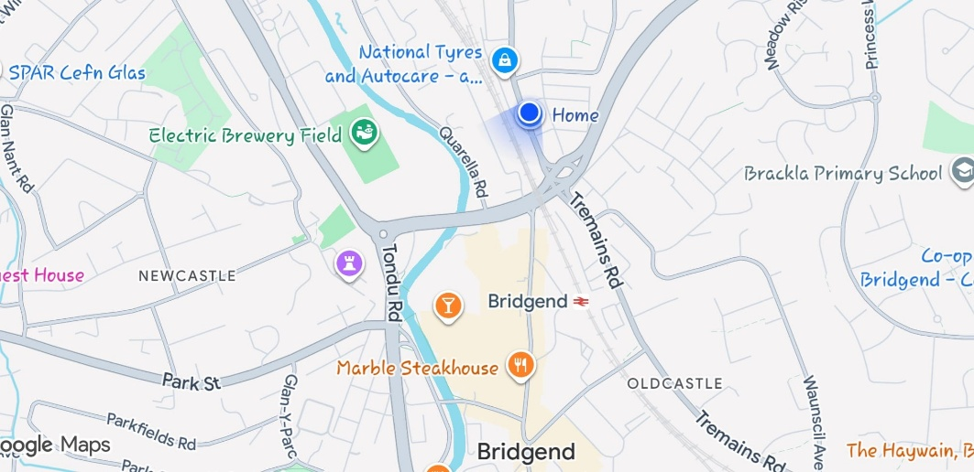

Appendix 2:
Business Card: (Canva)


Appendix 3
Flyers: (Canva)

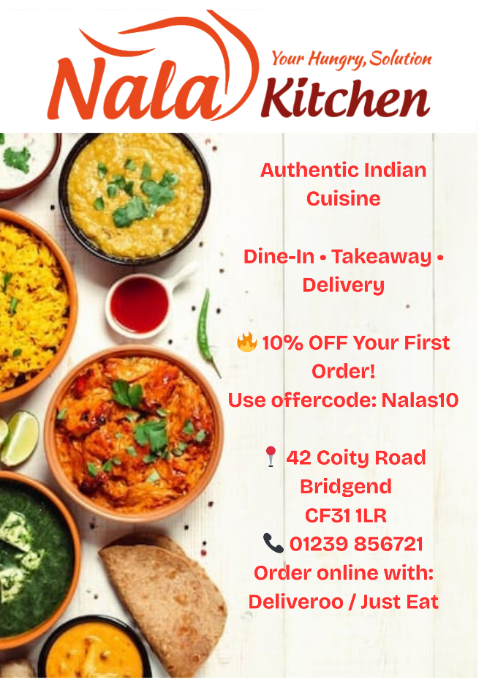

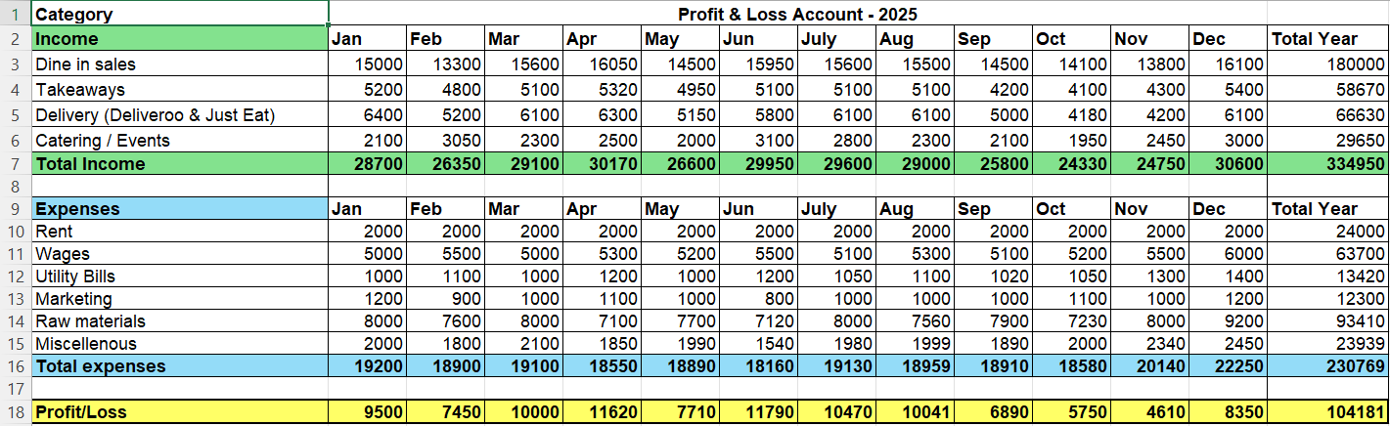
Appendix 4 12-month Cash flow of Nalas Kitchen (Excel)
Appendix 5: Income- Expenses of the year (Excel)

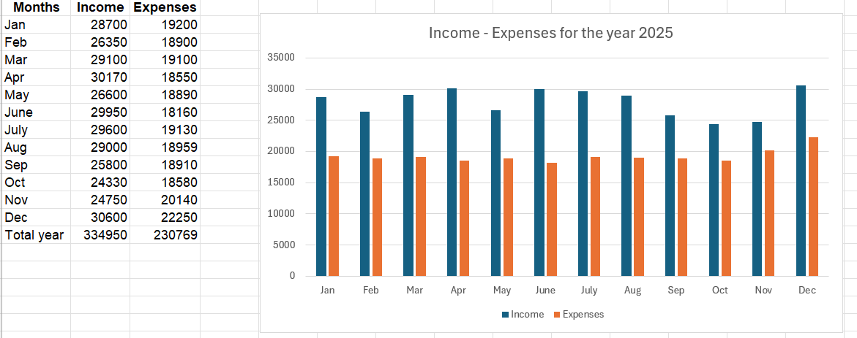
Appendix 6: Restaurant Yearly Budget - Excel.
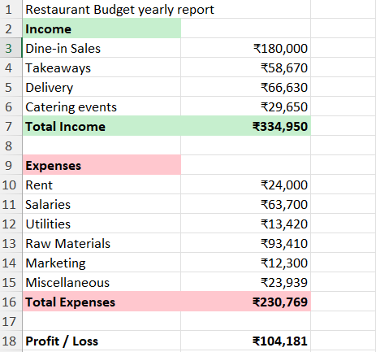

Appendix 7: Marketing Research Survey – (Microsoft forms)

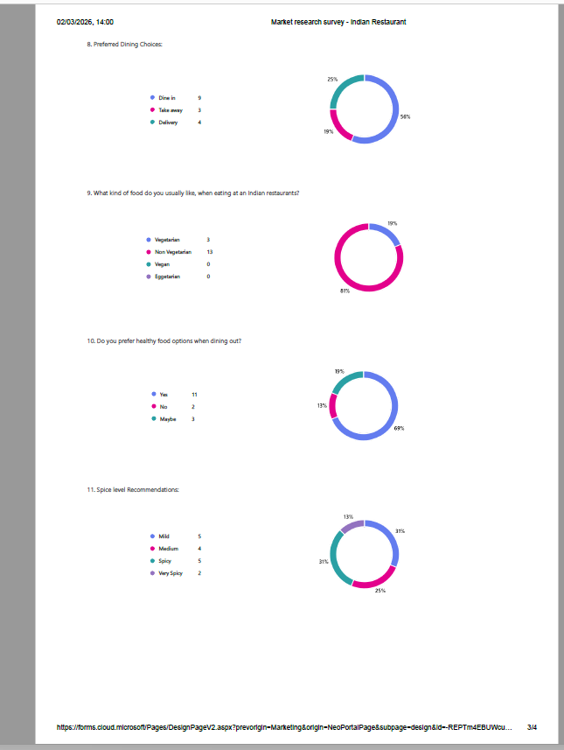

References:
1. Agustian, K., Pohan, A., Zen, A., Wiwin, W. and Malik, A.J., 2023. Human resource management strategies in achieving competitive advantage in business administration. Journal of Contemporary Administration and Management (ADMAN), 1(2), pp.108-117.
Available at: https://journal.literasisainsnusantara.com/index.php/adman/article/download/53/60

2. Andersen, E.S., Grude, K.V. and Haug, T., 2025. Goal directed project management: effective techniques and strategies. Taylor & Francis.
Available at: https://books.google.co.uk/books?hl=en&lr=&id=QLqFEQAAQBAJ&oi=fnd&pg=PP12&dq=business+plan+and+organisational+charts&ots=tRoxLFHwVj&sig=SXVZu9qMO114GAP40O8tZPRgHkA&redir_esc=y#v=onepage&q&f=false

3. Balbontin, C. and Hensher, D.A., 2021. Understanding business location decision making for transport planning: An investigation of the role of process rules in identifying influences on firm location. Journal of Transport Geography, 91, p.102955.
Available at: https://www.sciencedirect.com/science/article/pii/S0966692321000089?casa_token=RcVTXiO4ol0AAAAA:YRfAqS64iwznVfX-_efup--J54xtabJxwn-ivvUx6agmEwxAfgOsxkJuFzbbfnaHO61x5lcaDVo

4. Benzaghta, M.A., Elwalda, A., Mousa, M.M., Erkan, I. and Rahman, M., 2021. SWOT analysis applications: An integrative literature review. Journal of Global Business Insights, 6(1), pp.55-73.
Available at: https://www.academia.edu/download/111456121/viewcontent.pdf

5. Berbegal-Mirabent, J., Mas-Machuca, M. and Guix, P., 2021. Impact of mission statement components on social enterprises’ performance. Review of Managerial Science, 15(3), pp.705-724.
Available at: https://idp.springer.com/authorize/casa?redirect_uri=https://link.springer.com/article/10.1007/s11846-019-00355-2&casa_token=dpIj-XAj-ogAAAAA:AMNpDcvHhyrjWyyud1jKSepYrItcq6xGgXzbqMZrA1EMiUo1jhWxuQ6f6gnBgFCOhzBDGm6OULY5bMn5

6. Favoretto, C., Mendes, G.H.D.S., Filho, M.G., Gouvea de Oliveira, M. and Ganga, G.M.D., 2022. Digital transformation of business model in manufacturing companies: challenges and research agenda. Journal of Business & Industrial Marketing, 37(4), pp.748-767.
Available at : https://www.emerald.com/jbim/article-pdf/37/4/748/2457693/jbim-10-2020-0477.pdf

7. Fitzsimmons, A.B., Qin, Y.S. and Heffron, E.R., 2022. Purpose vs mission vs vision: persuasive appeals and components in corporate statements. Journal of Communication Management, 26(2), pp.207-219.
Available at: https://www.emerald.com/jcom/article-pdf/26/2/207/1299391/jcom-09-2021-0108.pdf

8. Guenther, P., Guenther, M., Ringle, C.M., Zaefarian, G. and Cartwright, S., 2023. Improving PLS-SEM use for business marketing research. Industrial marketing management, 111, pp.127-142.
Available at: https://www.sciencedirect.com/science/article/pii/S0019850123000445

10. Gupta, M., 2022. Business Plan. In Entrepreneurship in India (pp. 57-76). Routledge.
Available at: https://forum.trondao.org/uploads/shorturl/x0gmQHlebTmZlhEMRvX9hVGTxaK.pdf

11. Guenther, P., Guenther, M., Ringle, C.M., Zaefarian, G. and Cartwright, S., 2023. Improving PLS-SEM use for business marketing research. Industrial marketing management, 111, pp.127-142.
Available at: https://www.sciencedirect.com/science/article/pii/S0019850123000445

12. Haapasola, A., 2022. Implementation of a Marketing Plan.
Available at: https://www.theseus.fi/bitstream/handle/10024/745504/Haapasola_Arimo.pdf?sequ
13. Holbeche, L., 2022. Aligning human resources and business strategy. Routledge.
Available at: https://katalog.ub.uni-heidelberg.de/cgi-bin/titel.cgi?katkey=69403952

14. Langley, D.J., Van Doorn, J., Ng, I.C., Stieglitz, S., Lazovik, A. and Boonstra, A., 2021. The Internet of Everything: Smart things and their impact on business models. Journal of Business Research, 122, pp.853-863.
Available at : https://www.sciencedirect.com/science/article/pii/S014829631930801X

15. Molina, A., 2003. Developing the enterprise concept—the business plan. In Handbook on enterprise architecture (pp. 333-369). Berlin, Heidelberg: Springer Berlin Heidelberg.
Available at: https://link.springer.com/chapter/10.1007/978-3-540-24744-9_9

16. McDaniel Jr, C., 2025. Marketing research. John Wiley & Sons.
Available at: https://books.google.co.uk/books?id=8gB_EQAAQBAJ&lpg=PR10&ots=PeGmem9aWR&dq=marketing%20research%20about%20Business&lr&pg=PR10#v=onepage&q&f=false

17. Richbell, S.M., Watts, H.D. and Wardle, P., 2006. Owner-managers and business planning in the small firm. International Small Business Journal, 24(5), pp.496-514.
Available at: https://journals.sagepub.com/doi/pdf/10.1177/0266242606067275?casa_token=6qH3UIPGHOMAAAAA:S2QdXolwpHcVBvFw7YgaRkrRKE87EKd9wE37sUXC1LM8ghvI5N_24Ea9gSAH5vq5f_Fw75PZj7ak
18. Safitri, E.D., Junaedi, S.R.P. and Priono, A., 2023. Swot analysis is used in the startup business development strategy. Startupreneur Business Digital (SABDA Journal), 2(2), pp.136-142.
Available at: https://journal.pandawan.id/sabda/article/download/341/346

19. Shani, A.B. and Coghlan, D., 2021. Action research in business and management: A reflective review. Action research, 19(3), pp.518-541.
Available at: https://journals.sagepub.com/doi/pdf/10.1177/1476750319852147?casa_token=sNaRi3V0R_0AAAAA:LdO7rREQWtyoM5ifLLeHOxHR-xQIx_jeLgstYbxmJ5bqwAnj2R9Xm8Bo6B7KyDS5RldS8f0MAeYM

20. Silverman, D.A. and Smith, R.D., 2024. Strategic planning for public relations. Routledge.
Available at : https://www.taylorfrancis.com/books/mono/10.4324/9781003348467/strategic-planning-public-relations-ronald-smith-deborah-silverman

21. Shaikh, S.A., Memon, M. and Kim, K.S., 2021. A multi-criteria decision-making approach for ideal business location identification. Applied sciences, 11(11), p.4983.
Available at: https://www.mdpi.com/2076-3417/11/11/4983

22. Shanbhag, N. and Pardede, E., 2022. The blitz canvas: a business model innovation framework for software startups. Systems, 10(3), p.58.
Available at: https://www.mdpi.com/2079-8954/10/3/58

23. Skripak, S. and Poff, R., 2021. Fundamentals of business. Virginia Tech Press.
Available at: https://publishing.vt.edu/books/68/files/df98bdb3-ac87-48b8-b518-1608051d1db7.pdf

24. Wheadon, J. and Duval-Couetil, N., 2014. Business plan development activities as a pedagogical tool in entrepreneurship education. The Journal of Engineering Entrepreneurship.
Available at: https://www.academia.edu/download/48233755/JEEN_Business_plan_development.pdf

Individual Reflection:

This semester has given me a clearer understanding of what is involved in creating and assessing a business plan, At the beginning, I believe that a business plas simply about describing an idea of what product I have to sell in my business, However, throughout the lectures and assessments, I learned that it requires details research, financial planning, marketing strategies, critical thinking and evaluation. When developing my business plan for Nalas Kitchen, I had to carefully analyse weather the idea was practical and achievable. Conducting market research was one of the most important steps to know more about restaurant business, I carried out simple surveys and observed competitors in Bridgend area. This helped me understand customer preferences, pricing expectations and demand for authentic Indian food. I realised that making decisions based on real data, is more effective than relying on personal opinion. It also improved my confidence in supporting my ideas with evidence.

Preparing 12-month cash flow forecast was one of the most challenging parts of the assignment. At first, I struggled with estimating costs and predicting income. However, by breaking it down into monthly figures, working through the calculations step by step helped me understand the importance of budgeting, controlling costs, and planning for profit., I gained a better understanding of how Business managing their business. I learned the difference between fixed and variable costs, and how important it is to maintain positive cash flow. This task helped me to understand about financial skills and its shows how financial planning plays an important role in business.

The marketing aspects of the project also taught me valuable lessons, designing a business card, creating a flyer made me think about branding, presentation and customer perception. I understood that marketing is not only promoting products, but about building trust and creating a professional image. I also learned that how online delivery app such as Deliveroo and Just Eat can increase visibility and reach a wider people.

Throughout the semester, lectures on SWOT analysis, target markets, primary, secondary research and competitive advantage helped me think more critically. Instead of focusing on the strengths of my business idea, I learned to consider weakness and possible threats such as competition and rising costs.

Referencing and researching were also important learning experiences. I learned how to use reliable sources and present my information in structured way. This improved the academic quality of my work and strengthened my arguments. Out of the skills I developed, financial planning has had the biggest impact on me. It changed my point of view in business. Market research also had a strong impact on me, because it taught me to focus on customer needs. Understanding income, expenses, and profit has made me more confident in evaluating whether a business idea can succeed in the real world.

Overall, this module has improved my confidence, organisation, angelical thinking, and entrepreneurial mindset. I now feel better prepared to evaluate and develop business ideas in the future.

