

- Student’s name: Petal Charmaine Jones
Training and development needs of HUMAN RESOURCE OFFICER
- Student’s #: 1812740
- Module #: BMSW 5102
- Module Title: Developing Relationship and Workplace Achievement
- Lecturer’s name: Dr. Ze Zook
- BA level 5

Assignment task
- Assume you have been appointed as a trainee Human Resource Officer in the human resource department of a large company in order to develop and understanding of your role as a human resource officer your manager has requested you to:
- Determine appropriate knowledge, skills and behaviours that are required by human resource professional across the department. Please refer to appendix A for an overview of human resource officer responsibilities
- Conduct a personal skill audit for yourself (with the use of appendix B) and identify training and development needs considering the knowledge skills and behaviour you identify in task 1
- Critically assess the potential benefits to the organisation of developing you as a human resource officer through effective training and development.

What is Human Resources (HR)?
- According to Byars and Rue 2006 Human Resource can be characterized as the arrangement of exercises that centers around effective overseeing representatives at all degrees of an association to accomplish hierarchical objectives.
- This is the payroll organisation of the company
- Human resource management can be described as a key, composed and sensible approach to manage the business, progression and thriving of the people working in affiliations. It was defined by Boxall and Purcell (2003) as ‘‘all those activities associated with the management of employment relationships in the firm’’.
What is the Human Resource role?
According to Sang (2016) the role of the HR function can be divided into strategic and operational.
Strategic – arranging and dealing with the HR of the association (for example its staff) to guarantee that the authoritative objectives are met. For example, adjusting the HR and the authoritative objectives. This could mean guaranteeing that the right aptitudes are obvious inside the workforce, decent variety, profession improvement
Operational – supporting line directors, enlistment, determination, preparing, advancement, aggregate haggling (worker's guilds).
Additionally, the role of human resource is working with other department in the organisation to enable managers to implement policies and dealing with employee behaviours.
- Dealing with recruitment and the preparation of new employee handbook
- Hiring
- Training- This is done to enhance the workers skills and knowledge. When this is done it will increase their performances based on what they have learnt.
- Employee Performance Appraisal
- Wages and Employee Management
Human Resource officer responsibilities
- Dealing with payroll and the safe keeping of employee records
- Dealing with departmental issues
- Taking care of different task such as paperwork, staff handbooks company policy
- Give advise on employment laws about how employee goes about knowing their rights
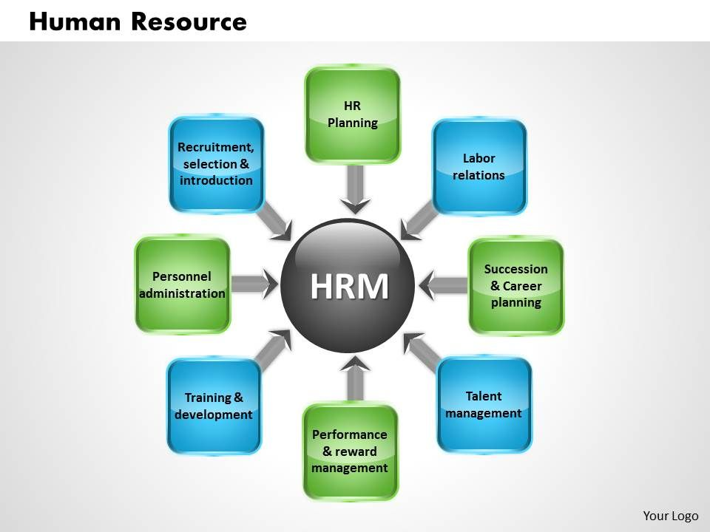
Diagram showing the roles and responsibilities of Human Resource Management

Training skills that needs to be identified as a trainee Human Resource officer at Sainsbury
The type of training skills that needs to be identified are:
- Communication skills- This will enable the passing of information across departments. This is a key skill that all HR officers must have.
- Organisational skills- This will direct you to different departments
- Customer service skills-This will enhance your ability on how to deal with the customers
- Budgeting skills- The knowledge of how to manage and control the expenditure of the organisation
- Training and development skills- further development of career in different departments
- IT and Computer Skills- This includes operating word processing programs and spreadsheets
- Decision Making and Judgment - Considering the relative costs and focal points of potential exercises to pick the most reasonable one.
Knowledge needed for human resource officer
- Administration and management: This will enable line managers and employee on human resource queries. Knowledge of on business and the board standards associated with vital arranging, asset designation, human asset demonstrating, authority strategy, creation techniques and coordination of individuals and assets.
- Government laws: Dealing with policies and the company legislation. A Human resource officer must be aware of the legal codes, agency rules, court procedures, government regulations
- How to Deal with grievance and putting disciplinary procedure in place.
- Human and Personal Resources - Knowledge of norms and procedures for staff selection, decision, getting ready, pay and points of interest, work relations and game plan, and work power information structures.
- Personal and Customer Service- Information on principles and cycles for giving customer and individual organizations. This joins customer needs examination, fulfilling quality rules for organizations, and appraisal of buyer devotion.
- Training and Education - Knowledge of principles and procedures for instructive arrangement and planning design, educating and direction for individuals and social occasions, and the assessment of getting ready effects.
- Computers and Electronics - Knowledge of programming is required. The HR officer must be able to program the computers. They must be aware of the circuit sheets and how they work as well as processors and electronics gear.
Behaviours needed for human resource managers
- Code of conduct- The Code of Conduct traces the obligations, general guidelines of work, direct, conduct and notices anticipated. The motivation behind the Code of Conduct is to build up the desires for the organization and to energize the responsibility, commitment and improvement of each Service Provider in endeavouring to accomplish best practice, a sheltered, solid and strong workplace, and giving a remarkable nature of administration to the organization and its customers.
- Conflict management skills-
Training and Development needs
- The area for training and development are:
- Administration and management
- Dealing with grievances and disciplinary procedures
The potential benefit of Sainsburys developing you as a human resource officer
- Training and Development programs helps employee to acquire skills and knowledge. With the skills and knowledge acquired it will enable me to provide training and development to other staff members in order to save the company time and resource. This will in return speed up the work process in delivering good quality product and services to the customers on time.
- Be more productive in the delivering of high-quality process work this will allow the company to move forward and achieve its objectives and goals with my high degree of knowledge and transferable skills I can look at ways in solving problems in different departments when conflict arises.

References
Armstrong, M., (2006). A Handbook of Human Resource Management Practice.10th ed. Great Britain: Kogan Page
Boxall, P., F., and Purcell, J., (2003). Strategy and Human Resource Management, Basingstoke, Palgrave.
Byars, L. and Rue, L., 2006. Human Resource Management. 8th ed. New York: Mc Graw -Hill, pp.371-383.
CIPD, (2012c). Learning to work. Survey report. London: Chartered Institute of Personnel and Development
Sang, K., 2016. The Human Resource Function. [email].


