In an increasingly globalized world, with the practices of some large companies and their impact on their environment, the trend is toward sustainability. Sustainability for a company corresponds to an approach, a desire to follow practices for the sake of their economic and social environment, but also to preserve the environment, especially today, where it takes more and more space in the development of companies’ strategies. All of these criteria are often combined to form what is called sustainable development. A large company that has often been singled out for some of its practices and strategies considered unethical and anti-environmental is changing the game recently. This company is Apple, the American computer giant. In this report we will analyze and criticize the idea of ​​sustainability through the example of Apple and then we will apply this analysis to the challenges that Apple will face.

The concept of sustainability emerged during the 90s and refers to living and making sure to live in a sustainable environment. The way to arrive at a result like this is to put in place a whole set of well-defined processes and rules that we call sustainable development. A simple definition that can be made of sustainable development is that it corresponds to development that meets the needs of present generations without jeopardizing the needs of future generations. All these new concepts have become more and more important in recent years within companies, especially because of or thanks to the demands of consumers. In the Jasmine Tata and Sameer Prasad’s article (2014) the authors give us a little more information on the introduction of sustainability in companies. Today for companies what is important is to continue to have objectives and satisfactory results, for them and their stakeholders while adopting new strategies that promote sustainable development and sustainability (Labuschagne et al. 2005, 374).

The concept that often comes up when we talk about sustainability for companies is Corporate Social Responsibility (CSR). The idea of CSR is often divided into three parts: profit and results that correspond to the business economy, the people dimension that corresponds to the social and human resources part, and finally the planet component which indicates the preservation of the environment. Thanks to this, CSR can be easily defined as having objectives and results which are competitive and satisfactory for a company, while ensuring the well-being of staff and a working atmosphere and adopting a strategy geared to the respect of the environment. A. Carroll also gave his own vision of CSR through his CSR pyramid. This pyramid is divided into 4 parts that he calls responsibilities. These responsibilities are Economic (make profit), Legal (respect the law), Ethics and Philanthropy (being a good citizen in a company and respectful).

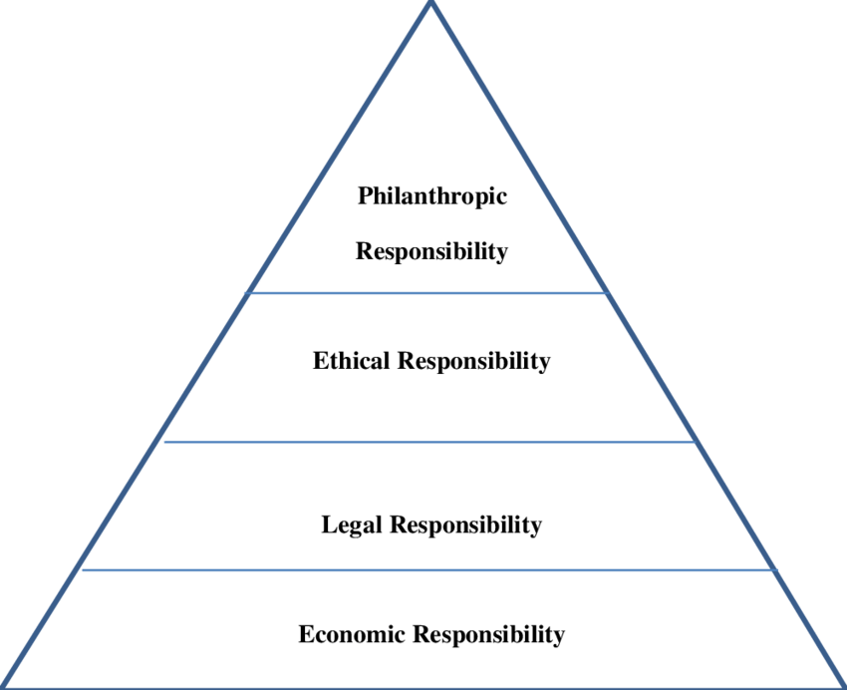

CSR and sustainable development are thus today very closely linked for sustainability. However, we learn in the text of J. Moon (2006) that CSR and sustainable development are two fairly contested notions. The author criticizes the fact that these are rather superficial notions because for him, all companies make sure to be in line with sustainable development and sustainability. No company wants to be blamed for practices that do not respect the environment. For Baumgartner it is a little different. In his article (2010) he says that establishing a sustainable strategy may be clearer than normal. Indeed, if a company wants to implement a sustainable strategy, research will focus on sustainability, the environment which allows to go faster and target faster than we want to implement compared to the sector of business activity. In addition, and to say that the problems related to sustainability and the environment are already identified so the company has yet to achieve. There is also a triple link that exists this time between sustainability, CSR and ethics. This triple link is called "Triple Bottom Line". This Triple Bottom Line includes 3 characteristics: economic, social and environmental. Triple Bottom Line allows, in addition to a CSR strategy to refine the objectives of the company and to be efficient on all aspects. The author John Elkington who wrote a lot of books on the business and specialist of the concept of Triple Bottom Line tells us that this is a very similar approach to CSR because companies, when they implement their strategy have to separate the work into three parts. The first part would be the economic part with profit making. The second would be concerned with the social, i.e. with the people of the company and their well being. Finally the third part of the Triple Bottom Line would look at the environment part and how the company can protect it. This movement has been quite successful when some large companies (Tesco, Nike or Apple for example) have been singled out by consumers and some associations for their unethical and environmentally unfriendly practices. This will lead to an awareness of global corporations to find the image of an environmentally friendly company, the people who work there and its consumers.

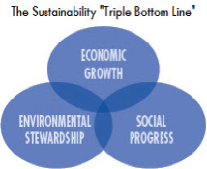

Let's take a look at the company that interests us in this report. This company is Apple. Founded in 1976 by Steve Jobs, Steve Wozniak and Ronald Wayne. Apple is surely one of the most famous companies in the world for its success, its image and the products it produces. Despite its success and the very favorable image that it has around the world, Apple has long been singled out, and still is, by associations and some consumers for some of its practices such as the conditions of work of its employees, the impact on the environment and also its products. Following these events, Apple has decided to change its strategy and go green, that is to say to adopt a strategy and conduct related to sustainability, sustainable development but also ethics. To respect the environment Apple has seen everything, from 2013 with its data centers that are powered by renewable energy (solar and wind), the construction of a solar farm. Apple has also helped and financially supported its partners and subsidiaries to switch to renewable energy since 2015 (J. Johnson, 2016). And in 2017 Apple has installed its new headquarters which is a gem of technologies of course but which wants to be ultra-respectful of the environment, with its solar panels, its 9000 planted trees and its planted vegetation covering 80% of the surface of the building. "Apple is already a leader in innovation and engineering, and we are applying these same talents to become an environmental leader." - Steve Jobs (2007).

Let's now analyze this change of situation that took shape as soon as this statement made by the creator of the company. What the company initially chose to do was to remove certain components of its products such as arsenic or PVC at the end of 2008 (D. Price, 2007). In addition to removing those products that did not have a good reputation for consumers, Apple took a step ahead of its competitors like Dell or HP who used these products years after Apple eradicated them from their production line. This strategy therefore has a double positive effect, that of respecting the environment and therefore of being part of a logic of sustainability, and of moving away from competition and gaining even more customers and market shares. Apple is now even producing CSR reports to show consumers and the world that it is a responsible and green company (C. Moloney, 2017). Indeed in the article that quotes some points of CSR reports that realize Apple shows us that it is a company that has changed. For example for the manufacture that we saw above, with the discontinuation of the use of certain products. But also with the transport of products whose packaging is smaller, it allows to reduce the emissions of gaseous pollutants and to go faster to deliver. Recycling has also taken a big place in Apple, as evidenced by the batteries of MacBook computers that take extremely long compared to other brands, which therefore avoid too often to throw pollutants. Apple also reuses some parts that are still viable for other products.

One of the products that marked a turning point for Apple is the IPhone 7. One of the key innovations of this product is its ability to resist water. Which means that it is a less vulnerable device, as well as its components. This makes it possible to send fewer products to the trash and to pose environmental problems. Another striking thing about this phone is the removal of the traditional plug of headphones to listen to music. From now on the headphones will be wireless or connected by an adapter connected to the charging socket. This innovation has been of great concern to environmental protection associations because they feared that consumers would no longer use conventional headphones and throw them away. But Apple seems to have listened to these fears and decided to create a recycling platform for these old earphones.

However, despite these advances with a new strategy directed towards the respect of the environment and the sustainability, Apple still has a lot of progress to realize on many points and in particular on two very important, which are the work of the children and the phenomenon of addiction to screens. Indeed for years Apple is threatened by several associations for the protection of children (Amnesty International or Unicef) because some subcontractor of the brand as the Taiwanese Foxconn employs hundreds of children in its premises for the assembly of products Apple (J. Garside, 2013) or children exploited in cobalt mines (a component used for the battery of telephones) in the Democratic Republic of Congo (J. Edwards, 2017). The brand defends itself by saying that it was doing everything to prevent its subcontractors from hiring young children for its assembly lines Only Apple continues to work with these companies (often based in China), which degrades greatly its image to consumers.

The other point of progress that Apple must realize, but which obviously concerns here all major brands competing Apple (LG, Samsung, Huawei etc.) is the fight against addiction to multimedia screens. And what could be interesting for Apple here is that to complete its sustainable and sustainable strategy is to fight against this addiction his new fight could allow Apple to become a leader again on a point and get ahead of its competitors.

To conclude on this report, sustainability is therefore a fairly new concept in terms of business strategy but which is still starting to find more and more followers especially with large global companies as we have seen above. This change of mentality is a good thing for the future of the future generations and for the environment, because we are heading towards a future where one day the place of the environment, sustainable development and sustainability will be normal and even major in the strategies put in place by the companies. Apple is one of those companies that has chosen to change the way it does business and put the environment and sustainability at the center of its strategy. However, Apple still has some progress to make, challenges to overcome, especially concerning ethics such as child labor, but also succeed in continuing on the very long-term this strategy which promises to pay for now.

References

R. J. Baumgartner, D. Ebner (2010), “ Corporate sustainability strategies: sustainability profiles and maturity levels“, Sustainable Development; Chichester Vol. 18, Iss. 2.

F. M. Belz, P. Kenneth John, (2009), “ Sustainability marketing: a global perspective“, Sustainability marketing: a global perspective. Chichester: Wiley.

Business Wire, New York (25 May 2012), “Research and Markets: Succeed or Sink: Business Sustainability under Globalisation“.

G. Cook (2017), “ What Samsung can learn from Apple about sustainability“.

L. Dann (2015), “ 5 reasons Apple is becoming a sustainability leader“, edie newsroom.

J. Elkington (1994), “ 5 reasons Apple is becoming a sustainability leader“, Chapter 1.
J. Farrigton, T. Kuhlman (2010), “What is sustainability ?“.

C. Fiennes (2011), “ What the sustainability movement can learn from Apple“, The Guardian Professional Network.

J. Garside (2013), “ Child labour uncovered in Apple's supply chain“.

Hyun-Nam Lee S. (2011), “ Exploring sustainability vals: Sustainability value, lifestyle practices, and stewardship“.

J. Johnson (2016), “Apple’s top 5 sustainability successes“.

Lim Weng M, (2016), “A blueprint for sustainability marketing: Defining its conceptual boundaries for progress“, Marketing Theory; London Vol. 16, Iss. 2.

C. Moloney (2017), “ Is Apple a Sustainable Company?“.

J. Moon (2007), “ The Contribution of Corporate Social Responsibility to Sustainable Development“, International Centre for Corporate Social Responsibility, Nottingham University Business School, UK.

L. Nicholls (2016), “ Greening the Apple: How sustainable is the new iPhone 7 ?“, edie newsroom.

E. Ostrom (2009), “ A General Framework for Analyzing Sustainability of Social-Ecological Systems“.

D. Price (2017), “ Why Apple was bad for the environment (and why that's changing)“.

J. Tata and S. Prasad (2014), “ National cultural values, sustainability beliefs, and organizational initiatives“.

