Leader group: Angelica Costache

CERTIFICATE IN SKILLS FOR THE WORKPLACE
MODULE NAME: Effective Team Working and Communication
Term 2-BMSW4002 (G5)
Lecturer: Ejiro Esohwode

Student name 1 | Ligia Cecilia Codin | ID:1908336
Student name 2 | Andreea Iftime | ID:1906182
Student name 3 | Cristina David | ID:1905357
Student name 4 | Angelica Costache | ID:1818635
Student name 5 | Marilena Tutulan | ID:1908340

- The Benefit of Team Working (student 1)

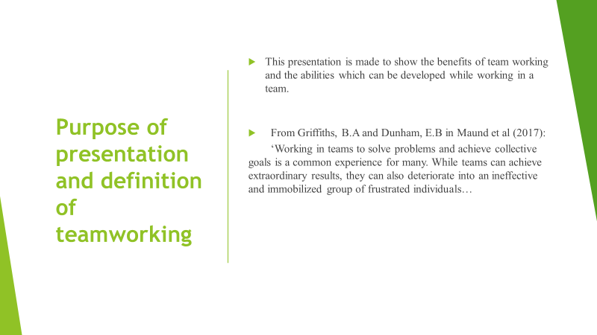
The presentation is crafted to explain organisations how to introduce team working into their companies describing the steps and considerations that need to be taken within an effective team working.

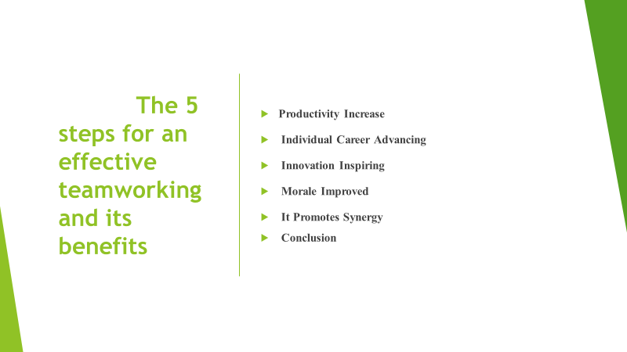

I will now discuss the meaning of the terms used in the slide above.
1) Productivity increasing
Being able to work in a team is simpler for the job to be distributed similarly between the individuals and allocated according to each member’s abilities s and strengths. Productivity will increase faster, more efficiently since tasks are completed where many people are involved.
Team members will support and trust so this will enable each other guidance. This allows them to stay concentrated on the target l and they can finish projects more efficiently. A worried individual with a weighty job on the project, working alone is at danger of becoming clouded and making bad and costly choices.
2) Individual’s career is advanced
By cooperating with others at workplace, other sets of abilities will be discovered and therefore the possibility of learning from others is available. Moreover, this will lead to professional success and the development of individual’s career.
3) Innovation inspiring
Innovation is deﬁned as the development (or the adaptation) and implementation of an idea, which is useful and new to the organization at the time of adoption (van de Ven, 1986; Amabile, 1996; Damanpour & Schneider, 2006).
Two heads are better than one, and this is a reality in the workplace. Teams create innovative and practical answers to problems than anyone working individually.
4) Morale Improved
Since the job is distributed fairly and individuals cooperate, the feeling of a greater sense of accomplishment when the duty is accomplished, and the target is touched that they would not have been able to realise if they worked individually. This combination with a sense of fitting, approvals and trust can drastically improve employee confidence and morale. This is when employees work with dedication and passion.
5) It Promotes Synergy
Synergy is the combined power of a group of things when they are working together that is greater than the total power achieved by each working individually (Cambridge Dictionary).
It can be explained as 1+1=3 also.
Conclusion
Working in a team is beneficial in every workplace because learning from others can improve knowledge and skills and develop individuals for professional success.
- Stages of Team Development (student 2) 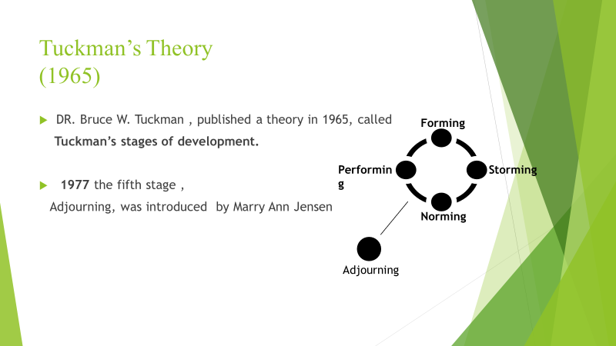
His theory is called “Tuckman stages” and was based on research he conducted on team dynamics. Trust is deeply connected to a successful team performance (Berry 2011 at. al.) In particular, authors such as Tuckman (1965) and Gersick (1988) have developed models that help us comprehend team formation. By breaking this process into its primordial stages, it’s easier for us to understand the evolution of the team. Tuckman believed these stages are very important, for a team to grow and develop, achieve their goals and deliver high quality results. Initially it was four stages model, forming, storming, norming and performing but later, in 1977 a fifth’s stage “Adjourning” was included by Mary Ann Jensen and Dr Bruce Tuckman, both jointly worked on the last stage. Each stage, presenting its own challenge behaviours and feelings for each member of the team.

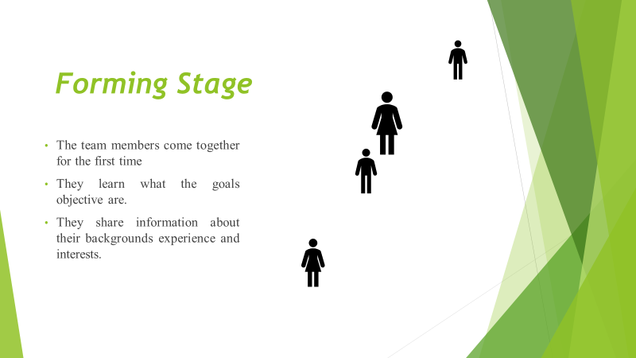
The issue in this stage is, inclusion, because of the awareness of the team members, as they first meet each other.
The members of the team in this stage, are positive, polite few of them can be anxious or others even excited. More than that they share information about their backgrounds, experience and interests. They learn about the project and they will be working on it. It is important for the team leader to be very clear about the team goals and provide clear direction regarding the project.

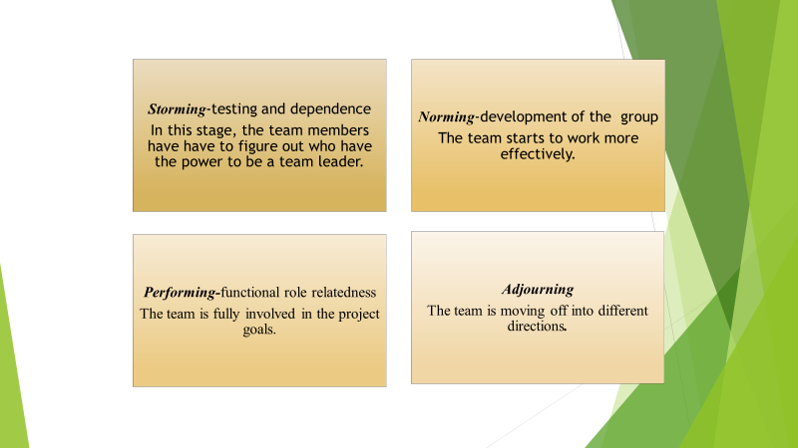

Storming Stage: The named storm is justified here. Storming is the stage where most teams fail. Why do they fail? They have different opinions on what should be done which causes, conflict frustration and resistance. Some teams, if doesn’t manage the conflict, low morale and motivation will be harder for them to get the project completed (J. Guttenberg 2019)
Norming stage: In this stage the behaviour of team members completely changed. The members strength in this stage is cooperation. They respect each other’s opinions and value their differences. The team has also agreed on their team rules, they share information and resolve team conflict.
Performing stage: In this stage, we can see the maximum possible effectiveness on the team. All the issues are resolved, and the team is fully involved in the project goals. They trust each other, are confident and the rely on each other. Their strength is productivity.
Adjourning stage: This stage present, the sad part and the reality of the project life, that it ends... It’s time for the team to celebrate the success and, they could say goodbye to each other. The principal issue in this stage is the completion.
Conclusion: Trust has been declared as being the key component of a successful and effective team.
It regulates the ability of people in the team to interact with each other, influencing as well, the level of information, flow between parties.
- Team Roles (student 3)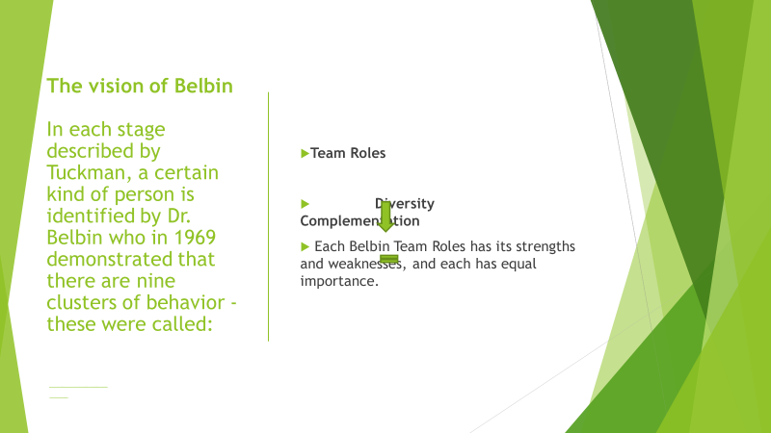
In each stage described by Tuckman, a certain kind of person is identified by Belbin, the famous English researcher who in 1969 discovered that there are nine clusters of behavior - these were called Team roles. Dr. Meredith Belbin firmly believes that the success of a team depends on how balanced its diversity is. For this reason, it suggests that the perfect team, or almost, does exists if we can put these 9 categories of people together (not necessary all the same same time)

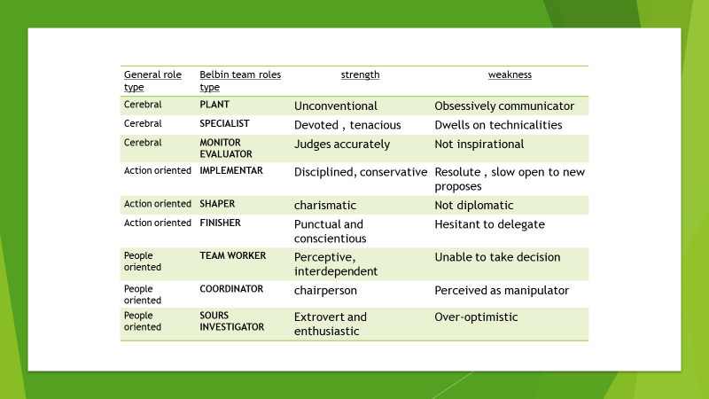
A “PLANT” is that Creative, visionary, and unconventional person who knows how to face problems at any price communicating all this obsessively.
A “SPECIALIST “is that tenacious, self-starting, devoted individual that can share rare skills and performance with all the group, but Contributes only on a narrow front
A “MONITOR EVALUATOR” can be Sober, strategic, and discerning, this team member is perfectly able to see all the options that exist and Judges accurately, but he will not be able to guide and inspire the other colleagues,
An “IMPLEMENTER” is that person very disciplined, dependable, conservative, and the best one who is able to transform ideas into reality, but you can’t expect him to respond quick to new ideas and new proposal. He can also be sometimes very resolute
The best quality of a good “SHAPER” are to be stimulant and charismatic, and his best skills are to be excels under pressure, encouraging and decisive in the face of obstacles he will be absolutely ready to take all the risk at the cost of hurting the other feelings.
A “FINISHER” is that punctual and conscientious person, that one always meticulous and apprehensive. “Perfectionist” could be his first name, but Anxious could be his second one as he think that everything, he does not do with his hands will never be well done therefore he hesitant to delegate
The most of us can identify themselves as a “TEAMWORKER”, because almost all of us can be interdependent, pacific, perceptive and diplomatic we all listen and builds things from nothing. We hate conflict and we are always the mediator in a fight, but also, we lack the strength to take decision
You can recognize a “COORDINATOR” from his Maturity and because he seems to be always confident, he is a good chairperson as he is able to clarifies goals, promotes people, but his best skills is to be a decision-making, and his priorities is to delegates well this is why he can often seems to be manipulative and off loads personal work
I identify myself in a “RESOURCE INVESTIGATOR” as I am kind an extrovert, and enthusiastic woman, my priority is to be communicative and to explores opportunities, but my favorite skills is to build contacts with other. I assume that sometimes I am Over-optimistic, and I Lose interest once initial enthusiasm has passed.
At this point, how many of you can identify themselves in at least one of these descriptions? Or even more than one? Now you know exactly which role suits you most.
- Management of conflicts (student 4)
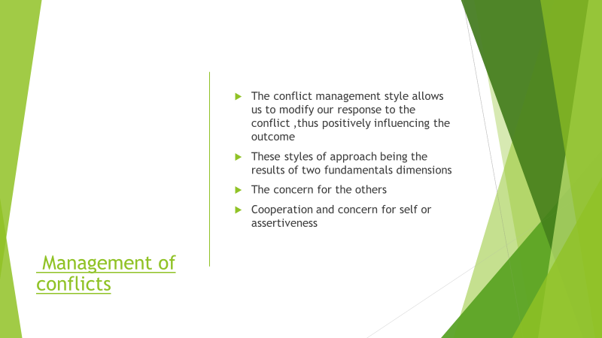

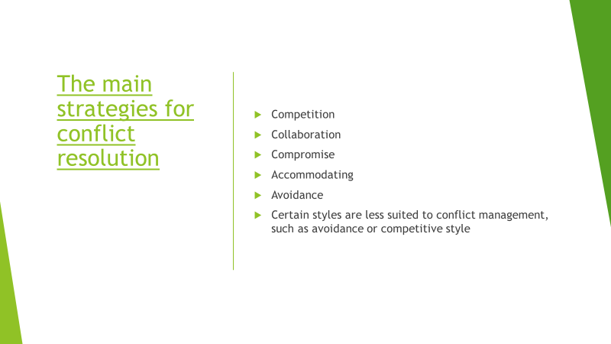

I will start with the conflict’s resolution strategies devised by Thomas and Kilmann.
Competition
There are people whit a competitive style who have a win-lose approach, they know exactly what they want and support with their point of view. It is about power these people being in position by virtue of rank, they are people who act in on assertive way to reach their goals and less interested in the opinions or problems of others.
By collaboration we understand that
we must satisfy the wishes of all those involved in the conflict, respect the position of the other and we will endeavour to maintain a partnership atmosphere in order to fulfil the objective of both sides. In comparation with the competitive style, the collaboration seeks a win-win result.
Compromise
Win-lose-lose and win, by which the side resort to concessions, often we chose the compromise in many situations and we chose to give in to less important chapters to gain greater victories. Compromise is common in situations where it is necessary to negotiate resources or find a temporary solution, often is used as an alternative method of conflict resolution when collaboration or competition have failed. It is not advisable to use the compromise from the beginning as it is a trap only to get rid of responsibilities more easily without trying a collaborative approach.
Accommodation
By accommodation we understand the needs of others and of the relationship with others. Often for their own interests and goals, the people who use this style are very cooperative being very easy to convince, the accommodation is an approach when the goals of the other are important. It is worth remembering that accommodation is not the best method of conflict management. Avoidance
Completely avoiding the situation is not a good choice, otherwise we can use it temporally when we need time to analyse the situation and develop a conflict resolution strategy. This style is also effective in a loaded atmosphere as it allows the people involved in the conflict to calm down.

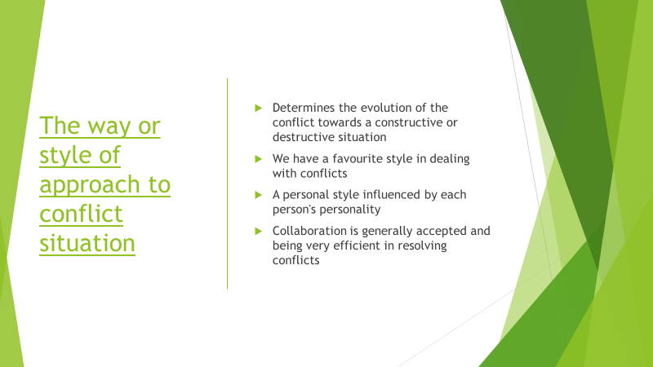

I will finish this work with some important tips in conflict resolution.

Distinction between people and problems
-most of times the conflicts start from the real and justified individuals’ differences, the situation can be debated in a civilized manner without affecting the labour relations.
Listen first, and then talk
-before you defend your point of view you will need to have enough information, active listening is the ability to empathize with the interlocutor and to discover the real interest.
Establish the facts
-by the stability of the observable and measurable elements that will have an impact on the decision taken. Explore options
it is very important to be open through communication and collaboration; it reaches a creative solution.
- Successful Team Development (student 5)
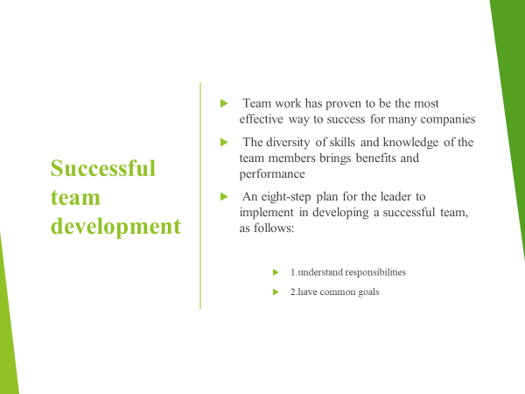

’The essence of a team is shared commitment. Without it, groups perform as individuals; with it, they become a powerful unit of collective performance. This kind of commitment requires a purpose in which team members can believe’. ( Katzenbach and Smith ,2005)
From large corporations to small and medium enterprises, everyone has realized what huge potential teams have in accomplishing tasks and how effective teamwork is when implemented according to the theories and principles presented above. Teamwork brings benefits and performance to the organization due to the diversity of skills and knowledge of team members. A successful team must have a successful leader. The leader must establish clear and effective ways of communicating and monitoring the interaction within the group. To build, develop and maintain a strong and efficient team in the long-term, it requires a collective effort from all those involved in this process.
Human resources consultants recommend 8 steps to follow, necessary in the successful development of a team, as follows:
1.Teams are made up of members with different qualifications and in order to build a successful team the leaders must assign very clearly the role and responsibilities of each one in the team, making sure that each member understood the task received.
2. For a team to be successful, it is necessary for its members to understand, agree with the team's goals and share the same vision. The leader has the responsibility to motivate and maintain a positive energy in the team, to achieve the objectives.

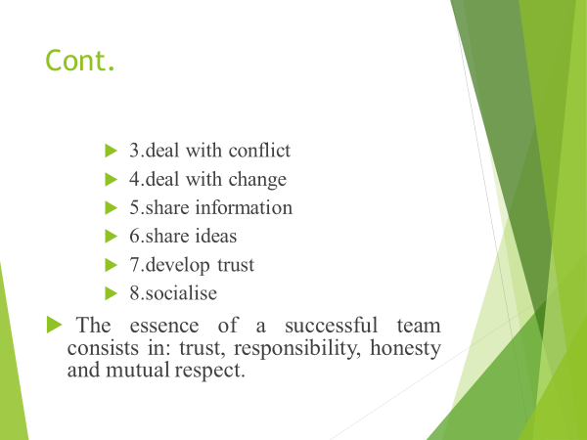
3. When conflicts arise in a team, the leader's responsibility is to take action, identify the facts and find solutions to resolve them. The leader must be a good communicator in resolving a conflict, so that the team's performance is not affected.
4. Unexpected events can occur in an organization that can change the team's plans. The leader must quickly think of a new strategy and coordinate the team so that its performance does not decrease.
5. In order to be successful, a team must be informed correctly and transparently by its leader. The team members must understand each other, know their abilities and needs, in order to perform their tasks successfully.
6. Team members should be encouraged to express their ideas and solutions that bring long-term benefits to the team and thus make it more productive and successful.
7. Trust is one of the essential conditions for a team to function, to be strong and successful. The members of a team must trust each other, for the team to develop beautifully and harmoniously.
8. Within a team, beautiful relationships can be developed, if people meet outside of working hours and spend quality time together. In general, corporations organize team building meetings in order to help employees get to know each other better.
In conclusion, the essence of a successful team consists in: trust, responsibility, honesty and mutual respect.

References

A. Lester (2017), Project Management, Planning and Control, p.369-377
J. Guttenberg (2020), Group Development model and Lean Six Sigma Project Team Outcomes, International Journal of Lean Six Sigma, Database: Emerald
Maund, A., Schriek, M., & Tinkler,P. K. (2017) (Eds.). Certificate in Higher Education: Skills for the Workplace Student Yearbook. London: Sage
Morgan, P. (2017) The business student’s guide to study and employability. London: Sage Publication Ltd
Robbins, S. and Mukerji, D,1994 Managing Organizations New Yorkː Prentice Hall
Tuckman, B. W. (1965) 'Developmental sequence in small groups', Psychological Bulletin, 63, 384-399.

ProofHub (2020) 8 Proven leadership ways to build high-performing teams [blog].13 January. Available at: http://www.blog.proofhub.com (Accessed: 22 April 2020)
https://www.businessballs.com/team-management/tuckman-forming-storming-norming-performing-model/
https://theparticipationcompany.com/2016/06/5-conflictresolution-strategie
https://kilmanndiagnostics.com/overview-thomas-kilmannconflict-mode-instrument-tki

