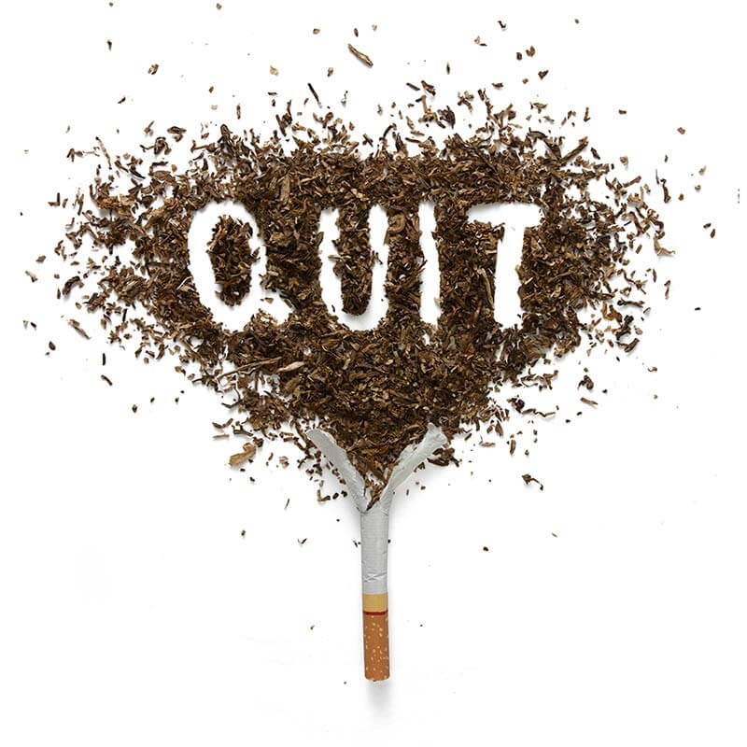
Public Health
:Stop Smoking!
By Franchesca Platt
1708456

Contents Page

Introduction – Page 1
Main body: A Brief History of Smoking – Page 2
Smoking today – page 2
Government initiatives – Page 3
Conclusion
Referances page
Appendix

Introduction

This discussion will be outlining three main initiatives used by the government to help the general public within the United Kingdom (UK) to stop smoking, focusing mainly on England and Wales. Within this discussion comparisons will be made between using the government initiatives or using other methods. This discussion will also give a brief history of smoking, and why it became popular and when, as well as the health implications caused by the addictive drug. It will also outline what has been put in place by the government to help smokers, charities stepping forward, and the methods outlined for smokers to quit.

A Brief History of Smoking

According to science museum.org.uk (2019) smoking had first reached England in 1565, used by the Americans for centuries before the European adventurers bought it back to the United Kingdom. The museum claims that by the 1600’s King James was already growing concerns for the habit. King James is said to have said ‘ smoking is loathsome to the eye, hateful to the nose, harmful to the brain and dangerous to the lungs’. However, despite this demand for it grew, some claiming it had medical properties, and during the Great Plague of 1665-1666 the smoke supposedly protected against disease miasmas. During the worst part of the plague the, the museum displays that smoking was made compulsory at Eaton public school.
By the 1800’s, cigarette smoking was considered eccentric, and pipe smoking became fashionable. During this period, anti-smoking campaigners won the right for the Children’s Act of 1908 to be put in place. This new law meant that children could no longer buy tobacco under the age of 16.
By the end of First World War (1914-1918) posters were being advertised of the soldiers smoking, causing woman to now be appealed to something which was once a male dominated past time. By 1949 the science museum claim that 81% of men and 39% of woman smoked. Smoking was no longer a luxury item, it was part of every day life.

Smoking today

Smoking is one of the biggest avoidable risk factors for cancer. They contain around 4,000 chemicals, some of which include; ammonia, acetone, carbon monoxide, cyanide and arsenic according to Get Self Help (2007). Broken down, the site says Carbon monoxide is a poisonous gas linked with heart disease, stroke and other circulation problems, it claims tar is deposited in the lungs with every breath of a cigarette and can cause cancer and damage your lungs. Benzene is a solvent and is known cause of cancer and is associated with leukaemia. Formaldehyde is a poison used to preserve dead people. It is known to cause cancer, respiratory, skin and gastrointestinal problems, cadmium is a poisonous metal, used in batteries, it can cause liver, kidney and brain damage. And finally ammonia, this can be found in cleaning fluids. Almost all the harm from smoking comes from the inhalation of Tobacco smoke rather than nicotine. Nicotine increases heart rate and blood pressure and can also increase gastric acid secretion leading to peptic ulcers. Asthma.org (2018) also highlights that while smoking, asthma medication isn’t as effective, meaning asthma suffers are at risk of symptoms such as breathlessness, wheezing and coughing, all of which likely to put sufferers at high risk of a life – threatening asthma attack. Along with this the site also claims that if smokers continue to ignore the warning they are at risk of other serious lung conditions such as Chronic Obstructive Pulmonary Disease (COPD). It is said by Action on smoking and health (ASH) (2019) that nicotine is as addictive as heroin and cocaine. Worldwide 1 billion adults, approximately 800 million men and 200 million woman, currently smoke cigarettes. Statistics collected by the Welsh Government (2017) shows that approximately 5,450 deaths each years are caused from smoking related illnesses, causing the National Health Service an estimated £302billion annually. Smoking accounts for one – third of respiratory deaths, over a quarter of cancer deaths and around one – seventh of deaths are sue to cardiovascular disease. Their data showed that in 2016/2017 19% of adults smoked, this being reduced from 2005/2006 when 25% of adults smoked. It is said that tobacco, for both active smokers and environmental smokers causes 3 in 20 (15%) cancer causes in the United Kingdom. In Great Britain alone, the amount of people smoking have decreased between 1974 and 2012 from 18 to 12 males and 13 to 11 females. It is estimated that one in two people born after 1960 in the United Kingdom (UK) will be diagnosed with some form of cancer during their lifetime. Cancer research (2019) have proven that smoking is at a higher rate in more deprived areas, claiming that adults in a routine and manual occupation household start smoking at a younger age, compare to adults in managerial and professional occupational household. Outlife (2018) disagrees however, claiming that people within the LGBTQ+ community are more likely than the rest of the population to smoke, stating that they often start smoking at a younger age, due to social stigma and discriminatory treatment. Truth initiative (2018) backs this by saying they are 2.5 times more likely to smoke. According to the site, tobacco companies have targeted the LGBTQ+ consumers through things like cigarette giveaways and free tobacco merchandise, setting up targeted ‘gay bar nights’ for those in the community. Almost making the issue fashionable and desirable. Smoking causes at least 15 types of cancer; lung cancer, larynx cancer, oesophagus cancer, oral cavity cancer, nasopharyngeal cancer, pharynx cancer, bladder cancer, pancreas cancer, kidney cancer, liver cancer, stomach cancer, bowel cancer, cervical cancer, leukaemia and overran cancer. For this reason the government and the national health service have launched new plans to snub smoking.

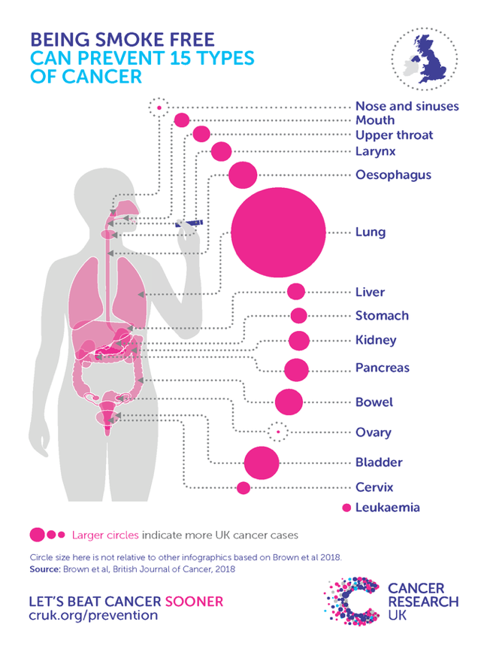
Picture from cancer research.org.uk (2019)

Government initiatives

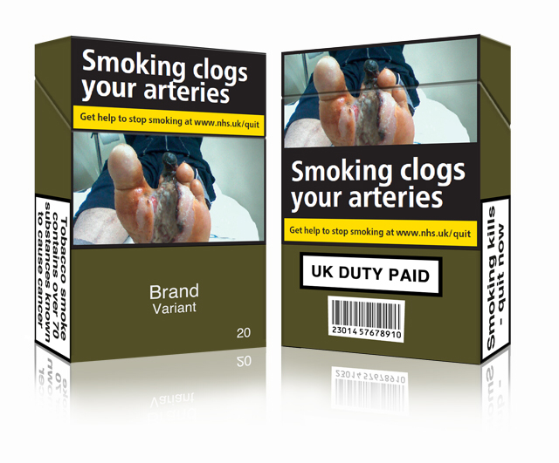
Stop smoking in England and Wales were established in 2000 according to Action on Smoking and Health (2019). According to the site the number of people using the stop smoking services increased year on year, reaching 800,000 users between 2011 and 2012, however statistics have shown that since then, attendance has fallen and quit rates have remained at 50%. The site claims that in their first 10 years of opening the stop smoking service, 20,000 people had achieved what the government had set out. There are several things the government has done to try and prevent people from smoking. One of which is standardising the packets of cigarettes. The UK is the second country in the world to do this, following the lead of Australia. The packaging is no longer an appealing colour, with fancy eye appealing writing it is now black in colour and now contains graphic images of what can happen to the human body should you continue to smoke, many companies also guilting parents into quitting by putting images of children suffering from second hand smoke on the covers, it contains warnings of the consequences and websites in which to help the person quit, as seen above. Picture from Ash.org (2019). The government has also put other strategies in place, for example, smokers are no longer aloud to smoke in public places in Wales, in hospitals, school grounds, public playgrounds and outdoor care settings for children for example, as of 2nd April 2007. Smokers can be fined up to £50, and the premises holder up to £200 according to First Practise Management (2019). In Wales around 6 in 10 smokers want to quit, but struggle to know where to start or how to keep it up. For this reason, the government has set up Nicotine replacement therapies or NRT. NRT works by providing providing smokers with nicotine to help them deal with the withdrawal symptoms after quitting. The withdrawal symptoms according to Boots.com (2019) include; a change in mood swings, such as irritability or feeling down, restlessness or lack of concentration, sleeping difficulties, decreasing heart rate and increased appetite. NRT is avaliable in many forms including lozenges, chewing gum, patches, inhalers and nasal sprays and are easily accessed via the General Practitioner, local pharmacy, high street shops and even some mobile bus clinics. Roycastle (2019) a lung cancer charity, agrees that NRT is the best route to help quit smoking. The national Health Service (NHS) also says that people receiving this treatment are 4 times more likely to stop smoking for good. The NHS also offers 2 types of medicated treatment, these are called Varenicline or Champix and Bupropion or Zyban. Varenicline is a prescription only medication which comes as a course of tablets lasting 12 weeks, (a further 12 weeks are offered should the patient feel the need it at the end of the initial course). This medication works by preventing nicotine from reaching receptors in the brain and by stimulating dopamine production, both of which make nicotine less satisfying. Dopamine is a chemical in the brain that is associated with feelings of pleasure. Varenicline is the most effective form of medicated treatment. Bupropion is again a prescription only medication which comes as a course of tablets lasting around 8 weeks. This medication however, doesn’t contain any nicotine but works by reducing, or entirely alleviating cravings and nicotine withdrawals. Although this medication is safe to use, some patients have found they have experienced side effects from the course. Some of which include; insomnia, dry mouth and headaches, the most serious side effects being seizures but this only occurred in 1 in 1000 people. National Institute for Health Excellence (2019) advises that health professionals have been advised to inform people trying to quit that although the users safety can not be assured, e – cigarettes are likely to be less harmful than cigarettes themselves. Over the years, since the government have put the stop smoking initiatives in place, e – cigarettes have become more and more popular as an alternative way of smoking. However, as of yet, e – cigarettes have not been licensed as a stop smoking aid. According to Boots - counter intelligence (2019) there are 2.9 million regular users of e – cigarettes in the UK.

Conclusion

In conclusion to this, research has shown that although smoking started out as a fashion craze, health implications have become apparent, making more people aware of the dangers of smoking. The initiatives put forward by the government and the health service has shown that, although hard, quitting can be done. ASH (2019) confirms this saying, with the governments initiatives help smokers are more likely to stay an ex- smoker, claiming 53% of people using the serves have remained without a cigarette, compared to only 4% of people who quit unaided. The British Medical Association (2018) researches that it takes 3 months for a smoker to become a non smoker. In 2000, when the initiatives were bought forward to the general public, research shows that it was effective, with over 800,000 people quitting for good. The information gathered shows that for every cigarette smoked after the age of 35-40, 3 months of the individuals life expectancy decreases. This is because the public we’re scare mongered into reality, with statistics like these, taking notice of all that was being told to them. However as the years have gone on, people have become blindsided to what initially was an incentive, despite the increase in price of each packet going up regularly and the graphic images, the warnings have become an everyday thing.

