Module:Learning in the Digital Era
Module code: BMPS4009 & BMPL4007
Assignment Title: Evidence of Learning (E-Portfolio)
Student Name:Rukhsar Tabassum
Student Id:2230738

Summary on the topic of “Preparing for Higher Education”
The following are some of the stated objectives of higher education: To actively pursue and encourage learning. To immerse oneself in the pursuit of truth. Intent on stimulating the economy. In spite of the fact that graduation is supposed to be a time of celebration for completing one's basic education, many adolescents fear it because they do not know what they will do after high school. Before moving forward, it is essential to have a plan in place for attaining one's educational goals. Here are four prerequisites for postsecondary education that every high school senior should be aware of. There are compelling reasons for students to utilise their school's career services and/or guidance counsellors. Such ceremonies are intended to serve as a source of inspiration and guidance as one advances in life (Baker,2018). Juniors and seniors in high school who plan to attend college can seek advice from their school counsellor regarding the courses that will best prepare them for the type of college they wish to attend. The guidance counsellors at their schools can also make recommendations regarding which institutions may be best suited to their personal and financial situations. With the assistance of career services, students can obtain valuable work experience prior to high school graduation (Gunn, & Kapade, 2018). Through these services, they will also receive assistance in creating a polished and professional-looking resume and cover letter (Murtagh,2021). Maintaining genuine connections with high school teachers is essential. Later, students must ask two to four teachers for recommendation letters for college applications. This goes better if the teacher knows the student. More detailed and enthusiastic writing impresses colleges (Thomson,2018). Former teachers, advisors, and bosses can write strong reference letters. These symbols may reveal your work ethic, demeanour, and social skills. These are as effective as academic recommendations. Before applying, list 5–10 people who might write a letter of reference. Give them time to write a good note for you. Preparing for money is best. Most students need financial aid, so choosing early maximizes savings.
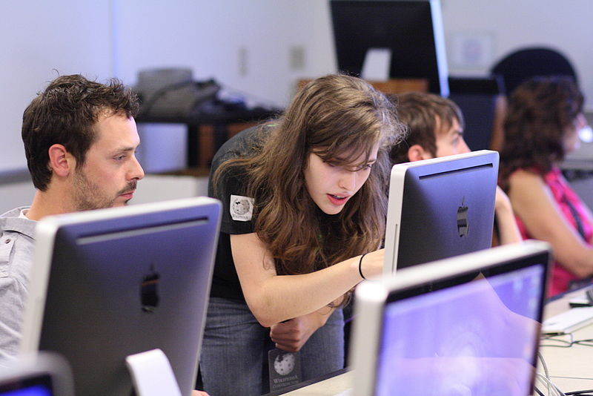

Figure 01: Higher education
Source: (Kaplan, 2021)

A mind map on the topic of “Becoming a Digital Learner”
Your adolescent can become a digital learner by utilising the various online educational resources. Distance education is simultaneously the tide of the future and the present. We offer the following advice from the horse's mouth to students who are committed to excelling in their online classes.
Connection of dots
Students who perform well in online courses are self-motivated and unafraid to exert some independent effort. The hardest aspect is getting your adolescent started, which is why so many families seek my assistance with their digital literacy needs. We offer material broken down into manageable portions for students in National 5 and Higher. During the February vacation, we offer online courses to all students, including Advanced Higher students.
Planning curriculum
If you want to be successful as a digital student, you must develop excellent study habits, including setting goals. One's objectives need not be lofty; they can be as modest as learning to solve one mathematical problem per day or reading and analysing one article per week in English. The most successful digital pupils enjoy adversity and devise novel methods for mastery. Your child can access all the necessary SQA materials from their mobile devices, providing them with a comprehensive and deftly curated collection of lessons to study from any location with an internet connection.
Enrich learning process
Online courses frequently comprise of numerous interconnected components. As opposed to the traditional classroom environment, which consists of a single instructor and a group of students, online education typically employs a variety of teaching methods (Heather, 2021). Your adolescent can also pause and rewind videos, bookmark relevant websites, and access research tools and open windows with ease. My online classroom features high-quality video lessons conducted by a teacher, printable notes, and interactive tests. In addition, during the months of January and February, we offer rigorous classes for candidates at the Higher level.
Produce valuable information
It is essential to teach your adolescent how to store new information in long-term memory if you want them to retain it. The most effective digital learners generate some sort of output in response to the information they have acquired, whether it be a set of flashcards for a topic or a quiz on a previously learned subject. They frequently review the data to ensure its continued accuracy and relevance.
Contribute to success
Finally, digitally savvy students praise the advantages of a multifaceted educational strategy. The educational model of the future will combine traditional classroom instruction with internet resources.
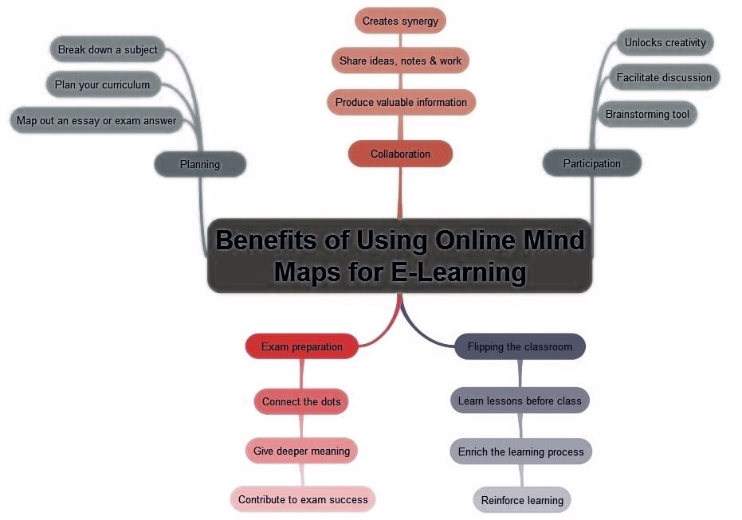

Figure 02: Mind mapping on becoming a digital learner
Source: Author

A two-minute video presentation about your personal identity and how this is shaped by your sense of place, values and beliefs. Explain how these can make you a good team player (as outlined in Unit 2, “Becoming a Team Player”). Again, your work must be supported with credible sources and appropriate Harvard referencing.

Students can use a web-based platform of their choice to create and share their video e.g., OneDrive, Adobe Spark. However, it is suggested that the video is uploaded to YouTube with a link to your work copied and embedded into your report.

A 300-word reflection using Burton’s reflective tool in which you reflect on starting university, getting to grips with online learning and resources, and the process of writing your first assignments.

Your reflection should contain references to at least two information sources, using Harvard referencing.

References
Baker, S., 2018. "Is grade inflation a worldwide trend?", The World University Rankings, Times Higher Education.
Gunn, A.; Kapade, P., 2018. "The university grade inflation debate is going global", University World News.
Heather T.,2021. 5 Ways to Be the Best Digital Learner. My digital lesson.
Kaplan, A., 2021. Higher Education at the Crossroads of Disruption: The University of the 21st Century. Emerald.
Murtagh L.,2021. Enhancing preparation for higher education.pdf. CORE.
Thomson R.2018.“Higher Education" Web of Science (Social Sciences ed.). Journal Citation Reports.

