Introduction to Health and Social Care
Portfolio: Pharmacy Services Poster and Residential Care Homes Essay
Student Name: Shabana Khan
Student ID Number: 2209438
Module Code: LCHS4003
Module Title
Introduction to Health and Social Care

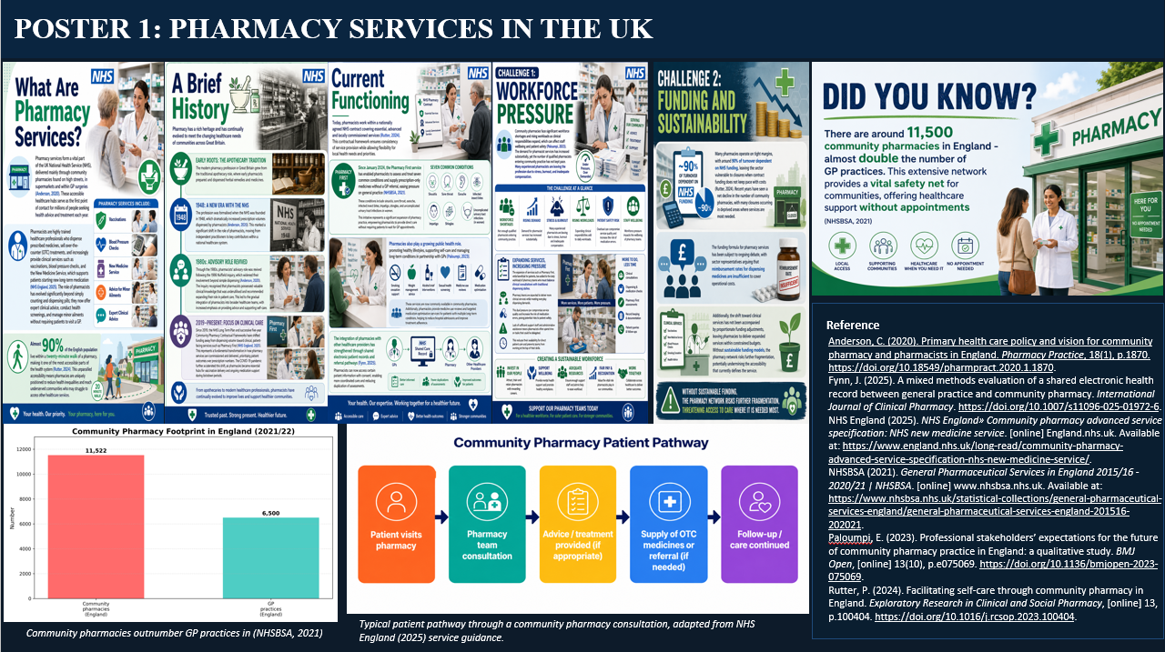

Task 2
Residential Care Homes in the UK
Introduction
Residential care homes are houses where those over the age of 65 and individuals with disabilities who can no longer live on their own, or in some instances still need nursing services, receive housing, personal care, and support (DHSC, 2025). This essay examines the history of residential care homes in the UK, critically reviews their operating systems, and explores their importance in improving the quality of life for care users.
Historical Origins
A history of residential care homes can be seen in the Poor Law, set up in the 19th century, where care was given in a workhouse (Bail, 2022). Such societies were ruthless and had minimal dignity because they had people dwelling in overcrowded conditions. A turning point was when the Poor Law was superseded in 1948 by the National Assistance Act, and the responsibility for the care of in-residence clients was transferred to the local authority. This Act introduced the responsibility for councils to offer accommodation to elderly individuals who were unable to be independent users. In the 1980s and 1990s, reforms to Community Care priorities led to a focus on the least restrictive setting based on the principles of individual choice and independence (NHS England 2022). The 1990s saw the need for a change in focus from institutions and the provision of established care to the needs of individuals or those of a group of people, and the provision of care that is appropriate to those needs; the NHS and Community Care Act 1990 came into place.
Current Functioning
Residential Care Homes are now regulated by a regulatory body, the Care Quality Commission (CQC, 2024), which inspects services to ensure safety and quality. Most residents are provided with individual rooms, but with shared common areas. Funding is provided from continued NHS funding, self-funding of residents, and contributions from the local authority. Under the Care Act (2014), local authorities must do needs assessments and produce a care plan that is tailored to the person's preferences. Funding pressures have increased, including a two-tier pricing system by local authorities for placements funded by them (Foster, 2020). Labour shortages are critical, and attrition is high, along with challenges in hiring qualified workers. During the COVID-19 pandemic, the health service has proved fraught with challenges, and the health system is in need of improved control measures and workforce support (NHS England, 2022).
Significance for Service Users' Quality of Life
Residential care homes offer quality of life through the provision of a safe environment, minimising risks like falls, medication administration, and isolation from others (Bail, 2022). Businesses provide 24-hour assistance, which provides household members and citizens with comfort. Loneliness and depression are prevented by communal dining, organised activities and friendships. By planning for each resident's individual needs, Person-centred care planning helps to allow a resident to remain within their identity, as an autonomous individual and as a man or woman with a goal or function in life. But the benefits of this are unequal for those living in the capital city. Some do not have the best quality of care because of variations in quality, staffing levels are not adequate, and some have financial constraints. Safeguarding needs to be monitored and ongoing (CQC, 2024).
Conclusion
Finally, the residential care home has changed from what was once a bleak Poor Law neglect home into a regulated, person-centred and openly focused service, which can now help the older person and/or person with disabilities to live life to the full and live safely. Supply supports, engages and provides staff with personalised care that helps them improve their quality of life, and certain quality inconsistencies are currently being worked on to improve consistency; however, quality is still variable and workforce is limited, and costs are an issue. There is still a need for future investment and reform in vulnerable people's lives throughout England.
Reference
Bail, K. (2022). Using health information technology in residential aged care homes: An integrative review to identify service and quality outcomes. International Journal of Medical Informatics, 165, p.104824. https://doi.org/10.1016/j.ijmedinf.2022.104824.
Care Act (2014). Care Act 2014. [online] Legislation.gov.uk. Available at: https://www.legislation.gov.uk/ukpga/2014/23/contents.
CQC (2024). The state of health care and adult social care in England 2023/24 - Care Quality Commission. [online] Cqc.org.uk. Available at: https://www.cqc.org.uk/publications/major-report/state-care/2023-2024.
DHSC (2025). Care and Support Statutory Guidance. [online] GOV.UK. Available at: https://www.gov.uk/government/publications/care-act-statutory-guidance/care-and-support-statutory-guidance.
Foster, D. (2020). Adult Social Care Funding (England). commonslibrary.parliament.uk. [online] Available at: https://commonslibrary.parliament.uk/research-briefings/cbp-7903/.
NHS England (2022). What are Integrated Care systems? [online] NHS England. Available at: https://www.england.nhs.uk/integratedcare/what-is-integrated-care/.

