Programs in C and documentation
Software Development
ACCA4017

Author: Geraint Hill
Student Number: 9900497



Table of Contents
Introduction 4
Part A 4
A1 – Question 1 - Variable 4
A2 – Question 2 – For Loop 6
A3 – Question 3 - Array 7
Part B 8
Exercise 1 8
1 Variables 8
1.1 Identify the problem 8
1.2 Annotated Code 8
1.3 Testing 9
1.3.1 Normal Values 9
1.3.2 Normal values (but negative) 9
1.3.3 Boundary values – all values the same 9
1.3.4 Impossible values – letters entered 9
Exercise 2 10
2 Dimensions of Shape 10
2.1 Identify the problem 10
2.2 Annotated Code 11
2.3 Testing 12
2.3.1 Normal Values 12
2.3.2 Normal values (but negative) 13
2.3.3 Area of Triangle greater than Circle 13
2.3.4 Impossible values – letters entered 13
Exercise 3 14
3 Array 14
3.1Identify the problem 14
3.2Annotated Code 15
3.3 Testing 15
3.3.1 Normal Values 16
3.3.2 Normal values (but negative) 16
3.3.3 Boundary values – all values the same 16
3.3.4 Impossible values – letters entered 17
Exercise 4 17
4 Fruit Machine 17
4.1 Identify the problem 18
4.2 Annotated Code 19
4.3 Testing 20
4.3.1 Result display 20
4.3.2 Yes or No answers (Capital letters and lower case) 21
4.3.3 Other than Yes or No answers 21

Introduction

As part of the Software Development module, this assignment has been handed to the author to assess his C Programming ability. In order to demonstrate that his program is working to the specification of the four key exercises, the author used Microsoft Visual Studio to compile his code and provide the console output displayed in this report. This assignment is the author’s own work.

Part A

A1 – Question 1 - Variable

A variable is a location in memory where a value is stored. It is a symbolic name for referencing a stored location for a value. The stored value can be changed during the execution of the program, but the variable name will remain the same throughout. For example, it is like a container in a computer’s memory where various types of information, either pre-defined by the programmer or inputted by the user, is stored.
The four main types of variables that the author is familiar with and has used during the Software Development module and in particular, this assignment are listed below.
characters (a single letter represented by %c) ‘A’;
integers ( a whole number represented by a %d) ‘4’;
strings ( a collection of letters represented by a %s) ‘A’’B’’C’’D’;
floats ( a decimal number represented by a %f) ‘3.14’

Variables are filled with values which represent the type of variable declared. The values within the variables can be constant throughout the lifetime of the program, or as the name variable suggests, can change. Variables aide the programmer to reference information throughout their program, making it easier to reference that variable throughout. For instance if a programmer was writing software for a train company, and needed to repeat code that was for the welsh train station “Llanfairpwllgwyngyllgogerychwyrndrobwllllantysiliogogogoch”, the programmer would not want to type this very long station name every time the program required it, they would simply declare a variable to store the value and then reference the variable instead of the value, in this case a string, that could be input as:
char:longstn[] = Llanfairpwllgwyngyllgogerychwyrndrobwllllantysiliogogogoch;
Every time an instance required the station name to be printed in the program, the programmer will call:
%s, longstn;
Similarly, the value of PI in the sense of the mathematical formulation will not change. PI = 3.1415926535. As this is a decimal number, PI could be declared as a constant (never changes throughout the program). To keep in line with the scope of this question, PI is a float, therefore it will be represented as:
float PI = 3.14
Then to call it:
%f, PI;
Variables’ storage space have to be declared before they are used in the program, otherwise the program will not run and errors will be fed back during the debug phase.
Many of the variables listed below fall outside the scope of the assignment, however the types of variables that are available for programmers to use are, [1]:
Character
Integer
Short
Long
Long long
Unsigned character
Unsigned integer
Unsigned short
Unsigned long
Float
Double
_ Bool

A2 – Question 2 – For Loop

A loop is a control flow in C programming. It is a sequence of instructions that are continually repeated until a certain condition is reached. The for loop, also referred to as a counting loop, sets a limit to the amount of time a code runs. You would want to use a for loop when you know how many times a code needs to repeat. If a program needed to count to 50, the for loop has extra information to do at each iteration compared to manually typing a line of code 50 times calling printf each time until they get to 50, which would be very time consuming. We must note, that as the for loop is taking away the manual work of the programmer, the loops create more strain on the process resource of the computer to start the process, check to see if the condition is met, and repeat. This is fine for a single loop in a program, however more complex programs may require many loops in many functions, that crucially impact resources. The benefit of a for loop is that the code is simplified and structured so it is easier to maintain. Future maintenance to the code is easier because a chain only has to be applied once inside the loop instead of 50 times in case of printf example. The computer could process this in seconds, even milliseconds depending on its processing speed.
A for loop to count to 50 could be inputted like:
for(int i = 1 ; i <=50 ; i ++)
{
printf(“%d”, i);
}
In the above example, the for keyword sets the requirement for a counting loop. The letter i++ in the loop is used as an incrimination operator. Inside the parenthesis sets the expressions, which are separated by the semi colons.

Int i = 1 declares the variable and sets the starting position,
- i-<50 is the binary condition to check, while this condition is met, then execute the instructions within the loop,
- i++ is the incrimination operator that increments the variable after the instructions within the loop have completed executing.
The instructions that are repeated are inside the curly brackets, in this case, it will print 1 – 50 whilst the counting loop (set to 1) starts at 1 and reaches 50.
A loop control variable is usually used to track how often the loop is repeating and in this case the loop control variable is 1. The for loop relies on conditions set by the programmer as to whether the loop should be executed, at what point it starts and finally when the loop should cease.

A3 – Question 3 - Array

An array allows you to store many data values of the same type in one variable, taking away the requirement to repeatedly create variables throughout the programs. Once an array is created you are unable to change the size of an array, and only one data form can be used, i.e. a character or an integer. The values contained in an array are called an element. To create an array, you need to declare it using [] brackets, within the brackets you can set the size of the array, for instance:
array[6]
The above example declares an array consisting of 6 values. Care must be taken when calling an array element. For humans, logically we would assume that within the above array values will be entered into memory slot 1,2,3,4,5,6, in this particular case, to access an element you would need to offset the element by subtracting the memory location by 1. Computers always start their memory count from 0, in relation to the above array[6] the index(memory location) for the array is:
0 = 1
1 = 2
2 = 3
3 = 4
4 = 5
5 = 6
In an array you can manually assign elements to it, or ask for user input which is commonly utilised with a for loop.

Part B

Exercise 1

Variables

In this task, the author was required to create a program that demonstrated his knowledge by declaring three variables and fix them, so no user would be asked to provide the information. The author used his own details to populate the fields. The variables that were required were name, age and height. The variables were declared and assigned a set value. If the user was required to be asked to input the details the author would have used scanf to prompt the user to enter the variable, and the program would store the users input into the variable called.

Identify the problem
- Set name
- Set age
- Set measureOfHeight
- Print name
- Print age
- Print measureOfHeight
- End

Annotated Code

#include <stdio.h>

int main()

{

char name[20] = "G""e""r""a""i""n""t";//declares and sets a string array variable and value
int age = 38;//declares age variable
float measureOfHeight = 1.82;//declares measurment of height variable

printf("Name:: %s\n\n", name);//displays user info
printf("Age:: %d\ years old\n\n", age);//displays user info
printf("Height:: %.2fcm\n\n", measureOfHeight);//displays user info
return 0;
}

Testing

1.3.1 Normal Values
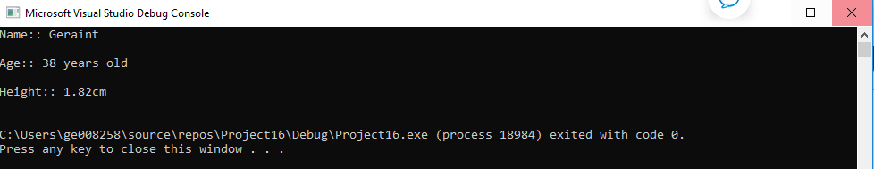
Result: Works correctly and as expected.

1.3.2 Normal values (but negative)
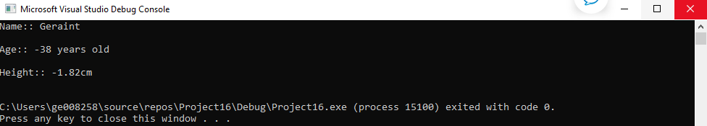

Result: Works correctly and as expected.

1.3.3 Boundary values – all values the same
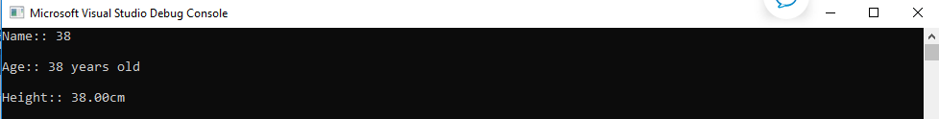
Result: Works correctly. At this stage of the process, integers can still be stored in char variables.

1.3.4 Impossible values – letters entered

Result: Would not run at all. Characters are not allowed to be stored in integer or float variables.
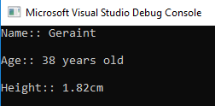
Result: In this scenario a decimal number was input in the age section. The number was rounded to the nearest whole number. If a user wanted to input a more specific age such as 37.5, then the age variable should be changed from an integer to a float.

Exercise 2

Dimensions of Shape

The requirement of this exercise was to get the user to input values that would work out the area of a circle, the area of a triangle and the area of a shaded area of the circle with the triangle embedded in it. The program requires the user to input the radius of the circle first, then the base and height of the triangle, then without further user input, the values given by the user are calculated by the program to display the area of the shaded area. The author created the program in the main function, however, three further functions could have been used to calculate the circle area, triangle area and shaded area, and then return the results in the main. The functions would be declared prototypes, and the main function would be very small compared to the body of each functions, as it would only be used to print the results that the functions returned.

2.1 Identify the problem

# Compute Radius of Circle:
- Set PI = 3.14
- print “Radius of Circle::”
- Get Radius
- Radius = radius * PI
- Print “You entered::radius”
# Compute area of Triangle:
- print “Height of Triangle::”
- Get Height
- Print “You entered::height”
- Print “Base of Triangle::”
- Get Base
- Print “You entered::base”
- Set triarea = height*base / 2
#Compute shaded area of circle
- Set shaded area = circlearea – triarea
- Print shadedarea

2.2 Annotated Code

#include <stdio.h>

int main()

{

float radius; // This section is declaring the variables I will be using in my main function, note all floats//
float circlearea;
float base;
float height;
float triarea;
float PI = 3.14;
float shadedarea;

printf("Radius of Circle::"); //display to user
scanf("%f", &radius); //user input
printf("You entered %f\n\n", radius); //display to user, confirmation of entry

circlearea = (radius * radius)*PI; // sum to work out the area of the circle

printf("The area of your circle is::%.2f\n\n", circlearea); //displays to user and stores into the circlearea variable

printf("Height of Triangle::\n\n"); // display to user
scanf("%f", &height); //user input
printf("You entered %f\n\n", height); //display to user, confirmation of entry

printf("Base of Triangle::\n\n");//display to user
scanf("%f", &base); //user input
printf("You entered %f\n\n", base);//display to user, confirmation of entry

triarea = (base*height) / 2; //sum to work out the area of the triangle
printf("The area of your triangle is::%.2f\n\n", triarea);//displays to user and stores in triarea variable

shadedarea = circlearea - triarea;//sum to calculate the shaded area of the circle

printf("The shaded area is::%.2f", shadedarea);//displays the area of the shaded area, and stores in shadedarea variable, .2f displays the result to two decimal spaces.

}

2.3 Testing

2.3.1 Normal Values

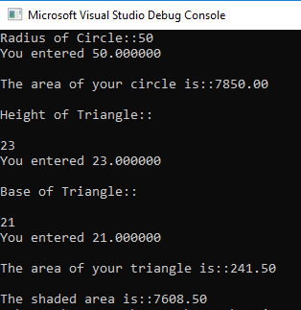
Result: Program runs as expected. Note: The input is a float and so is the result. The result is shown in two decimal spaces, this can be changed in the code as the user requires. If the user wanted to be precise and display the whole of PI for instance, then a double variable should be used.

2.3.2 Normal values (but negative)
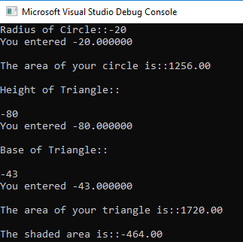
Result: The program treats the negative integers as positive numbers. To avoid negative integers being input, an IF statement can be applied stating that if a’ –‘was preceding a number, the user will not be able to enter a negative number.

2.3.3 Area of Triangle greater than Circle

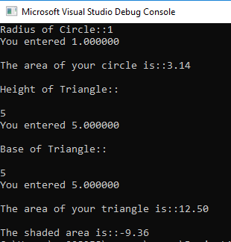
Result: Calculates a negative return, the triangle is based within the circle. An IF statement can be created to state that if the area of the triangle is greater than the circle then the user needs to re-input the information.

2.3.4 Impossible values – letters entered

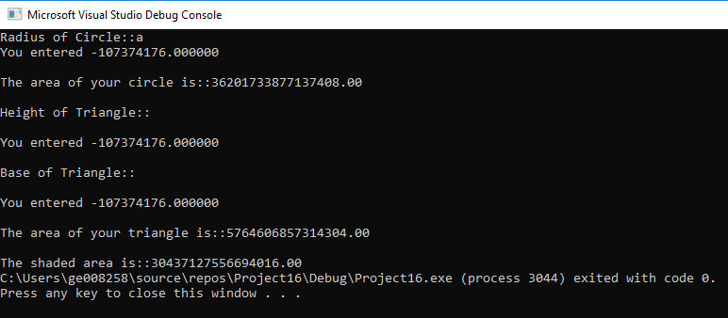
Result: As soon as the user types a character variable, the program runs and crashes, returning a very ambiguous display. An if statement could be issued to advise user that if any value other than a char is issued, to input an integer.

Exercise 3

Array

The author was required to create a program that stored prices in an array, and then calculate the prices before VAT and after VAT. The author used a counting loop to request the information and store in the array. Each of the prices would be stored in the goods array, price 1 would form element 0 of the array and price 5 would be element 4 as explained in PART A. The counting loop was utilised so the coding was more efficient and cleaner. Without the counting loop, the programmer would have to printf and scanf five times, which is inefficient.
The author also explored another avenue that asked the user to enter how many products they wanted to enter, then the loop would count until the number the user inputted was reached. The program worked the same way and calculated the price before and after VAT. However the task was to limit the count to 5.
One issue the author found was that he couldn’t display the ‘£’ sign, and the display in section ‘impossible values’ displays this.

3.1Identify the problem

#Compute price of five products(using a repeat) without VAT applied
- print “Enter the five prices::”
- set goods to array (5)
- set count to 5
- set total to 0
- Set i to 1
- Set VAT to 1.2
- Print Product::
- Repeat 5 times
- Add 1 to i
- Set total to total + value
- Print “The total of your products excluding VAT are::”
#Compute price of five products(using a repeat, with VAT applied
- set totalvat to total*VAT
- print “The total of your products including VAT are::”

3.2Annotated Code
#include <stdio.h>
int main()
{
int goods[5]; // declaring my array called goods, that store 5 values
int count = 5;// this is to form my counting loop maximum limit
float value;// this is the value that the user will input per product
float total = 0;//the total calculated after all product values have been entered, initialised at 0 to start
float totalvat = 0;// the totla calculated after VAT after all product values have been entered, initialised at 0 to start
float VAT = 1.2;// the rate of VAT that will be applied
int i;//to start my counting loop
printf("Enter the five prices::\n\n");//user display

for (int i = 0; i < count; ++i)//setting the conditions for my counting loop

{
printf("Product %d::", i + 1);//asks the user to enter the price, note the i+1 to add the integer to the product after each sequence
scanf("%f", &value);//asks user for input

total = total + value;//calculates the value for all values entered by user

totalvat = total * VAT;//calculates the value for all the values *1.2
}

printf("The total of your products excluding VAT are::%.2f\n\n", total);//displays user info

printf("The total of your products including VAT are::%.2f\n\n", totalvat);//displays user info
return 0;
}

3.3 Testing

3.3.1 Normal Values
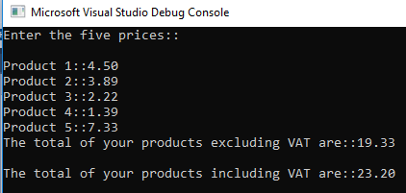
Result: Program runs as expected.

3.3.2 Normal values (but negative)
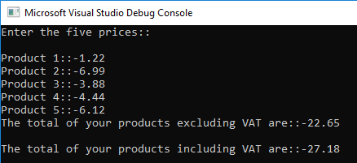
Result: Program runs as expected. Calculates all integers as they are input. The prices need to be positive integers.

3.3.3 Boundary values – all values the same

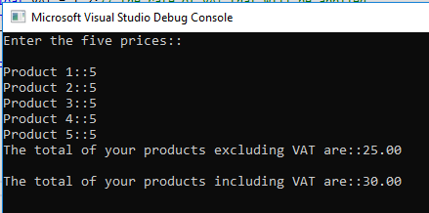
Result: The values are calculated and returned as a float. No issues with all the numbers being the same amounts.

3.3.4 Impossible values – letters entered
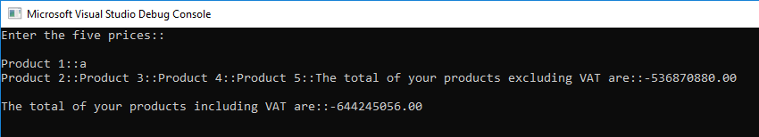
Result: Does not accept characters and returns ambiguous display.
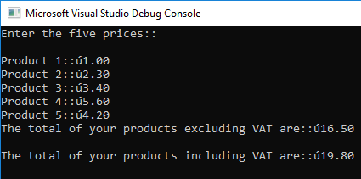
Result: Unable to print ‘£’ symbol.

Exercise 4

Fruit Machine

The requirement of this task was to utilise all the concepts learned throughout the module. The author was required to think logically about how the program was to run, and how and where to use loops and functions. The main aim of the program was to generate three random numbers to replicate a fruit machine game, with the number 5 being the jackpot value. When certain conditions were met, i.e. three ‘5’ in a row, two ‘5’, or three matching numbers, or a no match scenario. The users’ score would be recorded in an accumulative score and when the user ends the session by selecting not to spin again, their total score will be printed. The author found it useful to create a function called spin() to generate the random numbers, calculate the score and return it to the main function. Ideally the author would have created another function called calculatescore, so that he could organise his code further, however after numerous attempts he was unable to get it to work.
The author initially created the program that was not calculating an accumulative score, however further research and many testing attempts enabled an accumulative score version. The author now understands that an initialised value of 0 can be set, and used as a reference to total other values. As soon as this concept was fully understood in the earlier exercise, the calculation for this was relatively straight forward.
The author did venture further out by creating a Boolean value to use in his while loop. The Boolean expression was utilised so the while loop would know whether to continue or end the program.

Identify the problem

#Compute a random set of values and keep user score depending on outcome
- Set spinagain to 1
- Set total to 0
- Set total = spin(totalscore)
- Function Spin(totalscore)
- Set slot1 to rand
- Set slot2 to rand
- Set slot3 to rand
- Set jackpot to 5
- Set jackpotprize to 2000
- Set match2 to 100
- Set bonus to 20
- Set userscore to 0
- Print random numbers
- Main() Function
- Print “Do you want to spin again”
- Get answer
- IF ‘Y’ OR ‘y’ Spin(totalscore)
- While spinagain is 1 Spin(totalscore)
- Print random numbers
- Print “Do you want to spin again”
- Print “Your total is::total”
- If three ‘5’ are matched print “***JACKPOT****”
- If two ‘5’ are matched print “You’ve matched two ‘5’s”
- IF three other numbers are matched print “You’ve matched 3 BONUS!
- While spinagain is 0
- Print “Thank you and Goodbye”
- Print End score is:total

4.2 Annotated Code

#include <stdio.h>
#include <stdlib.h>
#include <time.h>//provides the functionality to generate random numbers, the computer generates these in accordance with time on clock

int spin(int totalscore);

int main()
{
int spinAgain = 1;//this is an example of a _bool, in C this provides an "on" or "true" statement ,0 is "off or "false"
int total = 0; //iinitialises the total variable to 0
char answer;//declares a variable for Y or N

while (spinAgain == 1)//using spin again as 1, to start the while function if Y is pressed
{
total = spin(total);//declares the total variable from the spin function
printf("Your total is::%d\n\n", total);// prints the accrued total figure, that has been cumulated from the spin functiom
printf("Do you want to spin? (Y/N)");//asks user for "true" or "false" statement, and will decide what to do in the while loop
scanf(" %c", &answer);//user input

if (answer != 'Y' && answer != 'y')//if the answer is not equal to y or y the game will exit, as the spinagain variable is now set to "false"
{
printf("Thank you and goodbye\n\n");//user display
printf("END SCORE::%d", total); // displays the wholse culmative score from spin()
spinAgain = 0;//if anything other that y or Y is pressed, this variable is set and quits the game.
}
}
}
int spin(int totalscore)//function that performs the randomly generated numbers and returns the culmative score
{
srand(time(NULL));//
int slot1 = 1 + rand() % 5;//asks slot 1 to generate a random time, 1+ means no 0 is generated and %5 sets wildcard up to number 5
int slot2 = 1 + rand() % 5;
int slot3 = 1 + rand() % 5;
int jackpot = 5; //declares the jackpot figure
int jackpotprize = 2000;//prize 1 as per the assignment spec
int match2 = 100;//prize 2 as per the assignment spec
int bonus = 20;//prize 3 as per the assignment spec
int userscore = 0;//userscore initalises at 0
printf(" %d | %d | %d\n", slot1, slot2, slot3);// displays the randomly generated numbers
{
if (slot1 == jackpot && slot2 == jackpot && slot3 == jackpot)//if all 5,
{
printf("*JACKPOT*, %d points\n\n", jackpotprize);//display that jackpot has been won
totalscore = totalscore + userscore + jackpotprize;//total score, passed to main, totalscore is 0, userscore is 0, jackpotprize is 2000
}
else if (slot1 == jackpot && slot2 == jackpot || slot2 == jackpot && slot3 == jackpot || slot1 == jackpot && slot3 == jackpot)// if two 5's are matched, they win the match2 score
{
printf("You've matched two 5's. %d points\n\n", match2);
totalscore = totalscore + userscore + match2;
}
else if (slot1 == slot2 && slot2 == slot3 && slot1 == slot3)//if 3 numbers are matched they win bonus. As the program gets jackpot condition first three 5's are filtered first
{
printf("You've matched 3, BONUS!%d points\n\n", bonus);
totalscore = totalscore + userscore + bonus;
}
return totalscore;//returns the total score to main
}
}

4.3 Testing

4.3.1 Result display
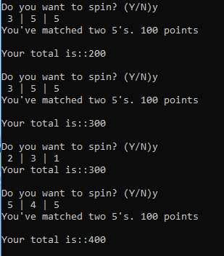
Result: Displays the whole program running and accumulating the score.
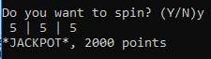
Result: Provides the slot result, Jackpot alert and Jackpot score.
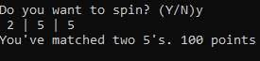
Result: Provides slot result, Match2 5’s and Match2 score.
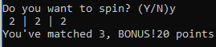
Result: Provides slot result. Bonus of 3 in a row and Bonus score.
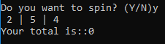
Result: No conditions met, spin again.

4.3.2 Yes or No answers (Capital letters and lower case)
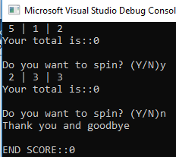
Result: Works as predicted.
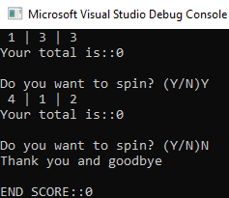
Result: Works as expected.

4.3.3 Other than Yes or No answers

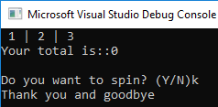
Result: Same as a No, if other than no, then user could be prompted to input a valid answer from options given.
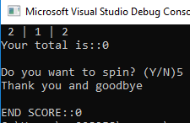
Result: If an integer is selected, it still treats the input as a no, however a condition could also be set, and advise it is an invalid input.

Conclusion
In this assignment we have explored what variables, arrays, and for loops are and how they are used in C programming. We have also created four programs that increase in difficulty. The exercises in Part B were to build an automated program that displayed name, age and height, a program that calculated the area of a shaded area of a circle after asking the user to input their own values for the circle and triangle, thirdly a program to display the prices of 5 objects before and after VAT was applied, and finally a slot machine game.
The assignment covered all the topics that was learned by the author during the study term.

Bibliography
[1] S. Kochan, “How to Work with Variables, Data Types, and Arithmetic Expressions in the C Programming Language | Understanding Data Types and Constants | InformIT,” InformIT, 2014. [Online]. Available: http://www.informit.com/articles/article.aspx?p=2246402. [Accessed: 11-Feb-2019].
[2] Bradley L. Jones, Peter Aitken, Dean Miller, "Sams Teach Yourself C Programming in One Hour a Day Seventh Edition", 2014, Pearson Publishing.

