AI and Machine Learning ACCA6011
Gordon Dickers
Richard Davies

Contents
1– Introduction 3
2 – Program Structure 4
2.1 – Main Menu 4
2.2 – Task 1 5
2.2 – Task 2 6
3 – Algorithms 7
3.1 – Depth First Search 7
3.1.1 – DFS Pseudo Code 7
3.2 – Hill Climbing 9
3.2.1 – Hill Climbing Pseudo Code 9
4 – User Guide 10
4.1 - Main Menu 11
4.1.1– Quit 11
4.2 - Task 1 12
4.2.1 - Automatic Search 12
4.2.2- Pause Menu 12
4.2.2.1 – Continue 12
4.2.2.2 – Quit 12
4.2.2.3– Restart 13
4.2.3- Search for object 13
4.2.4 - Change the maze 14
4.2.5– Quit 15
4.3- Task 2 16
4.3.1- Automatically Solve Assignment Tiles 16
4.3.2- Solve Assignment Tiles for Yourself 16
4.3.3- Automatically Solve Randomised Tiles 16
4.3.4- Solve Randomised Tiles for Yourself 16
4.3.5– Quit 17
5 – Test Schedule 18
5.1 – Main Menu Test 18
5.2 – Task 1 Tests 19
5.3 – Task 2 Tests 20
6 – Program Listing 21
6.1 – Source.cpp 21
6.2 – Headers.h 23
6.3 – MazeFunctions.h 24
6.4 – cMazeClass.cpp 28
6.5 – cMazeClass.h 39
6.6 – 8TileFunctions.h 42
6.7 – cTileMaze.cpp 47
6.8 – cTileMaze.h 73
6.9 – cFileInput.cpp 77
6.10 – cFileInput.h 80
7 - Bibliography 82

1– Introduction
This report will show how the program is laid out using flowcharts, it will than explain the two algorithms used Depth First Search and Heuristic Hill Climbing.
A user guide on how to use the program will follow and then the report will show the test schedule of the program.
Full code listings will be at the end or the report before the bibliography.

2 – Program Structure
For display purposes the program can easily be split into three flow charts.

2.1 – Main Menu
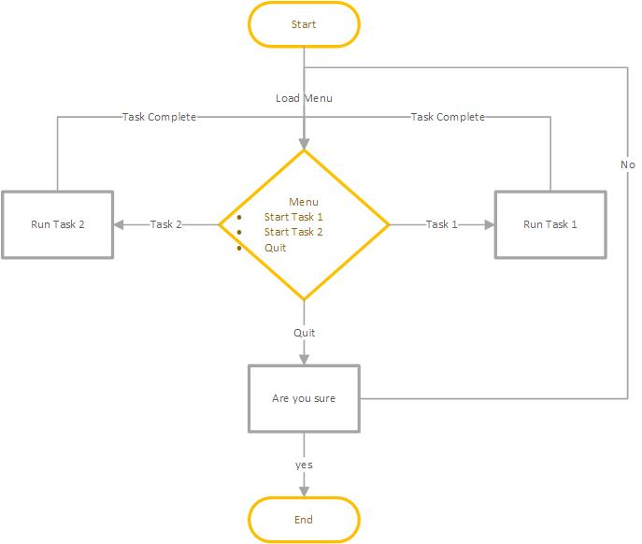
Figure 1 - Flowchart of Main Program Menu
This flowchart depicts the flow of the main menu of the program, which gives the user three choices
- Start Task 1 – this option opens Task 1 section of the program.
- Start Task 2 – this option opens Task 2 section of the program.
- Quit – this option closes the program.

2.2 – Task 1
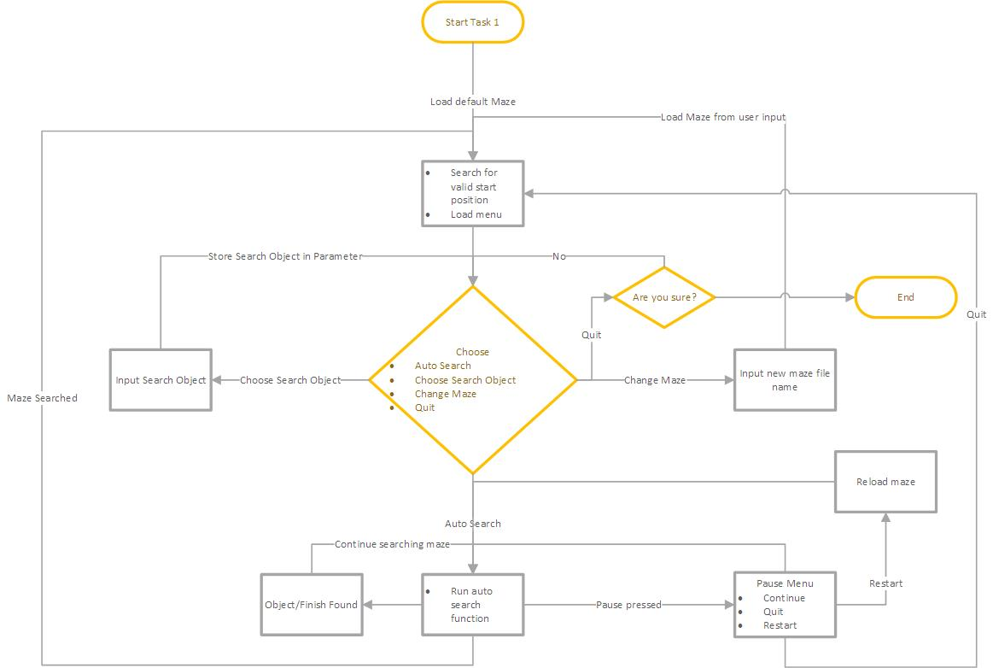
Figure 2 - Flowchart of Task 1
Starting Task 1 loads the task 1 menu which gives the user four choices –
- Auto search the default maze – this option starts the auto search loop.
- Choose a search object – this option allows the user to enter a search object.
- Change the maze – this option allows the user to change the maze by entering the name of a different text file containing a maze.
- Quit – this option exits task 1 and puts the user back to the main program menu.

2.2 – Task 2
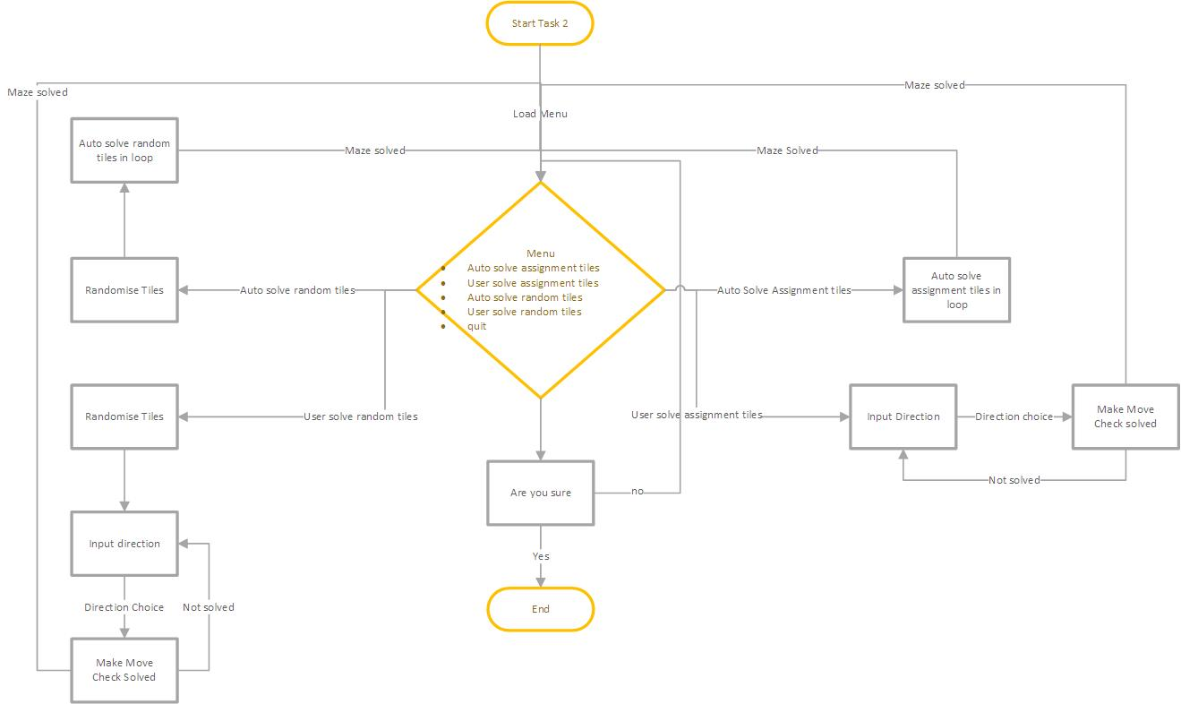
Figure 3 - Flowchart of Task 2
Starting task 2 loads the task 2 menu which gives the user five choices –
- Auto solve assignment tiles – this option starts the auto solve loop using the tiles set for the assignment.
- User solve assignment tiles – this option starts the user solve loop using the tiles set for the assignment.
- Auto solve randomised tiles – this option starts the auto solve loop using randomised tiles.
- User solve randomised tiles – this option starts the user solve loop using randomised tiles.
- Quit – this option exits Task 2 and takes the user back to the main program menu.

3 – Algorithms
The two algorithms used where Depth First Search and Hill Climbing

3.1 – Depth First Search
Depth First Search (DFS) is the name given to the type of search algorithm used in Task 1, a DFS is ‘a method that included a blind search. That is, the search is done by ensuring all [Paths] have been visited’ [1] . At its most basic level, it searched by following a single path to completion while remembering where any branches where, at a dead end it goes back to one of these branches and continues searching that path instead. To show this more clearly, the following is the pseudo code for how it works in the program, It makes up the check tiles function.

3.1.1 – DFS Pseudo Code
While (maze search is true)
If up is a valid movement
Location coordinates equals up coordinates
Push location coordinates onto stack
If right is valid movement
Location coordinates equals right coordinates
Push location coordinates onto stack
If down is valid movement
Location coordinates equals down coordinates
Push location coordinates onto stack
If left is valid movement
Location coordinates equals left coordinates
Push location coordinates onto stack

If up is the finish
Finish location coordinates equals up coordinates
If right is the finish
Finish location coordinates equals right coordinates
If down is the finish
Finish location coordinates equals down coordinates
If left is the finish
Finish location coordinates equals left coordinates

If search object is set
If up is search object
Item location equals up coordinates
Display object found on screen
Show pause menu
If right is search object
Item location equals right coordinates
Display object found on screen
Show pause menu
If down is search object
Item location equals up coordinates
Display object found down screen
Show pause menu
If left is search object
Item location equals left coordinates
Display object found on screen
Show pause menu

If stack is not empty
Agent location equals top of stack
Display location coordinates
Pop coordinates off stack

3.2 – Hill Climbing
Hill climbing is an heuristic function which works by comparing the current layout of a dataset to a solved version of the same dataset, the algorithm then test to see if any changes can be made to make the original dataset closer to the solved version.
‘in each iteration… The best candidate in neighborhood became new solution and their neighboours determine new interval. Algorithm will stop when new candidate is not better than current solution.’ [2]

The following is the Pseudo Code of the in-program implementation and is present in the direction decision function.

3.2.1 – Hill Climbing Pseudo Code
Assign number of incorrect positions to a variable called tiles in wrong position
Set the up down left and right bools to false
Check how many positions are still wrong if the blank space would move up and assign to up position variable
Check how many positions are still wrong if the blank space would move down and assign to down position variable
Check how many positions are still wrong if the blank space would move left and assign to left position variable
Check how many positions are still wrong if the blank space would move right and assign to right position variable

If up position variable < tiles in wrong positions
Up bool = true
Set direction decision to 8

If down position variable < tiles in wrong positions
down bool = true
Set direction decision to 2

If left position variable < tiles in wrong positions
left bool = true
Set direction decision to 4

If right position variable < tiles in wrong positions
right bool = true
Set direction decision to 6

If two movements return the same value and they are the lowest movement
Run the checks again on an offset to that position
Which ever is lowest, set direction decision to that direction

Return direction decision

4 – User Guide
Contents
4 – User Guide 9
4.1 - Main Menu 10
4.1.1– Quit 10
4.2 - Task 1 11
4.2.1 - Automatic Search 11
4.2.2- Pause Menu 11
4.2.2.1 – Continue 11
4.2.2.2 – Quit 11
4.2.2.3– Restart 12
4.2.3- Search for object 12
4.2.4 - Change the maze 13
4.2.5– Quit 14
4.3- Task 2 15
4.3.1- Automatically Solve Assignment Tiles 15
4.3.2- Solve Assignment Tiles for Yourself 15
4.3.3- Automatically Solve Randomised Tiles 15
4.3.4- Solve Randomised Tiles for Yourself 15
4.3.5– Quit 15

4.1 - Main Menu

Upon starting the program, the user will be greeted with the following screen
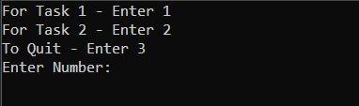
From this screen the user should press the ‘1’ key and press enter to open task 1, or press the ‘2’ key and press enter for task 2.
Entering ‘3’ will quit the program.

4.1.1– Quit
After selecting quit the user will be presenting with another option.
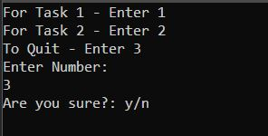
Selecting ‘n’ will keep the user on the menu.
Selecting ‘y’ will exit the program.

- Task 1
The Task 1 initial menu will first appear like the following
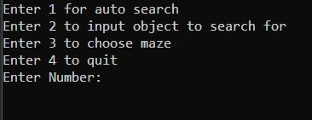

- Automatic Search
Selecting the first option will start the auto search on the default maze (loaded from maze.txt)
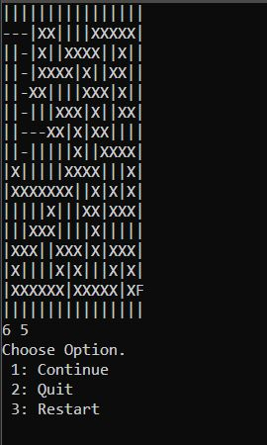
The agents current location is displayd by the coordinates at the bottom of the maze.

4.2.2- Pause Menu
Pressing the ‘space bar’ will pause the search and display this mini menu.

4.2.2.1 – Continue
Selecting continue will close the menu and continue the search.

4.2.2.2 – Quit
Selecting quit will exit the maze and show the initial task 1 menu.

4.2.2.3– Restart
Selecting to restart the maze will reset the maze show the pause menu again.
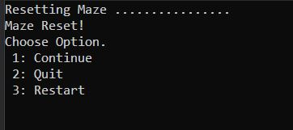

4.2.3- Search for object
Selecting the second option asks the user to input a character to search for in the maze.
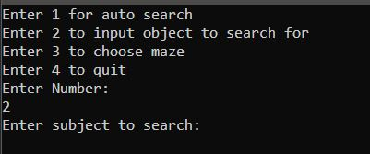
After entering a character, it is displayed in the menu.
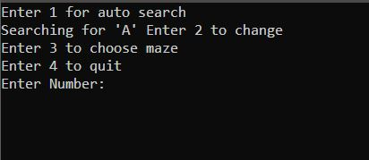
Selecting option ‘1’ now will search the default maze for the object.

4.2.4 - Change the maze
Selecting the third option allows the use to input the name of a new maze.
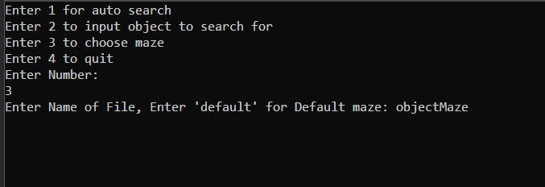
After the new maze has loaded the user is shown the main menu again.
Selecting auto search will now search the new maze, if the search object has been set it will be found if it is present.
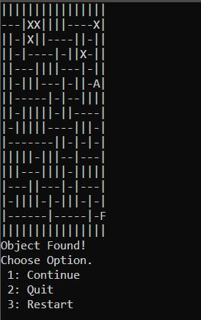

4.2.5– Quit
Selecting quit will require user confirmation
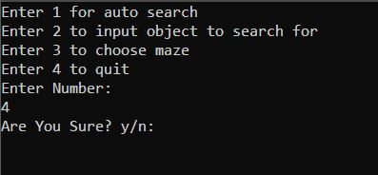

4.3- Task 2
Entering Task 2, the user is shown the following menu
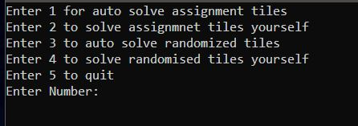

4.3.1- Automatically Solve Assignment Tiles
Selecting option ‘1’ will automatically solve the tile for the assignment.
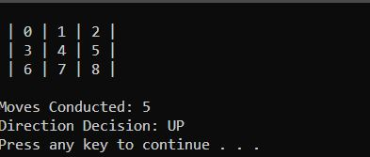

4.3.2- Solve Assignment Tiles for Yourself
Selecting option ‘2’ will require the user to solve the assignment tiles for themselves
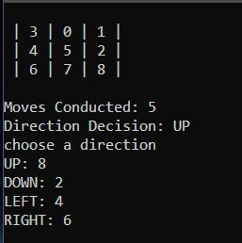
Using the numbers 8,2,4,6, to select which direction to swap the ‘0’ tile

4.3.3- Automatically Solve Randomised Tiles
This option works the same as option 1 with the difference that the tiles are randomised first.
All randomised tiles are solvable.

4.3.4- Solve Randomised Tiles for Yourself
This option works the same as option 2 with the difference that the tiles are randomised first.
All randomised tiles are solvable.

4.3.5– Quit
Option 5 allows the user to quit after confirmation
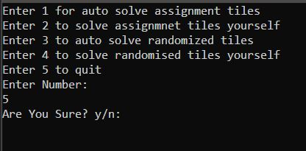

– Test Schedule
The following are the test schedules for the program. They are spilt into the three main areas of the program, main menu, Task 1 and Task 2.

5.1 – Main Menu Test
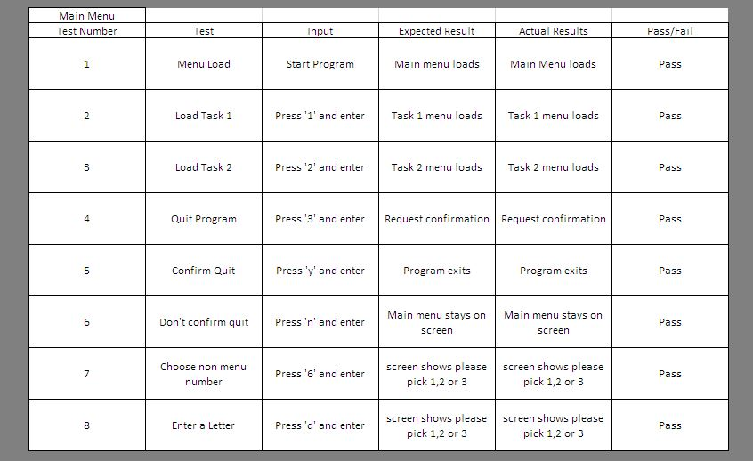
Figure 4 - Main Menu test schedule

5.2 – Task 1 Tests
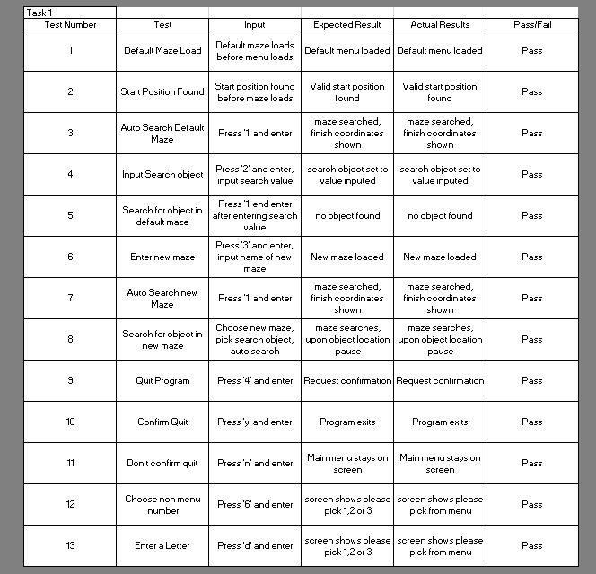
Figure 5 - Task 1 test schedule

5.3 – Task 2 Tests
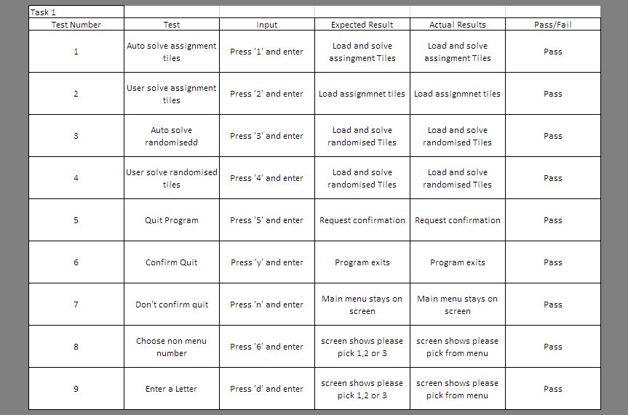
Figure 6 - Task 1 test schedule

– Program Listing
The following is the complete code listing spilt into the various files, the classes are marked with a ‘c’ at the start of the name.

6.1 – Source.cpp
#include "MazeFunctions.h"
#include "8TileFunctions.h"
#include "Headers.h"

using namespace std;

////////////////////////////////////////////
//variables
////////////////////////////////////////////

#pragma region Variables

int taskChoice;
bool quit = false;
char quitChoice;

#pragma endregion

////////////////////////////////////////////
//code main
////////////////////////////////////////////

int main(int argc, char** argv)
{
while (!quit)
{
system("CLS");
cout << "For Task 1 - Enter 1\nFor Task 2 - Enter 2\nTo Quit - Enter 3\nEnter Number: " << endl;
cin >> taskChoice;
switch (taskChoice)
{
case 1://Maze Solver
MazeMenu();
break;
case 2://8 Tile Solver
TileMenu();
break;
case 3://Quit
#pragma region Quit
cout << "Are you sure?: y/n" << endl;
cin >> quitChoice;
if (quitChoice == 'y')
{
quit = true;
}
else
{
quit = false;
}
#pragma endregion
break;
default:
cout << "Enter Either 1,2 or 3!" << endl;
break;
}
}
}

– Headers.h
////////////////////////////////////////////
//Includes for whole program
////////////////////////////////////////////
#include <string>
#include <iostream>
#include <stack>
#include <random>
#include <stdio.h>
#include <Windows.h>
#include <stdlib.h>
#include <time.h>

– MazeFunctions.h
#include "cMazeClass.h"
#include "Headers.h"

/////////////////////////////////////////////
//Variables
////////////////////////////////////////////

#pragma region variables

int menuStyle = 1;
char mazeMenuChoice,
mazeQuit;
string fileName,
menu1 = "Searching for '",
menu2 = "' Enter 2 to change",
searchObject;

#pragma endregion

#pragma region Objects

cMazeClass maze;

#pragma endregion

/////////////////////////////////////////////
//Maze Menu
////////////////////////////////////////////

void MazeMenu()
{
maze.FindStartPosition();
system("CLS");
cout << "Enter 1 for auto search" << endl;
if (menuStyle != 0)
{
cout << "Enter 2 to input object to search for" << endl;
}
else
{
cout << menu1 << searchObject << menu2 << endl;
}
cout << "Enter 3 to choose maze" << endl;
cout << "Enter 4 to quit" << endl;
cout << "Enter Number: " << endl;
cin >> mazeMenuChoice;
switch (mazeMenuChoice)
{
#pragma region auto search
case '1'://initiate auto search
maze.AutoSearch();
MazeMenu();
break;
#pragma endregion
#pragma region input search object
case '2': //enter search object
cout << "Enter subject to search: ";
cin >> searchObject;
maze.setSearchObject(searchObject);
menuStyle = 0;
MazeMenu();
break;
#pragma endregion
#pragma region user input maze file name
case'3'://user choose maze
cout << "Enter Name of File, Enter 'default' for Default maze: ";
cin >> fileName;
if (fileName == "default")
{
maze.LoadDefaultMaze();
}
else
{
maze.LoadInputMaze(fileName);
}
MazeMenu();
break;
#pragma endregion
#pragma region quit
case '4'://quit
cout << "Are You Sure? y/n: ";
cin >> mazeQuit;
switch (mazeQuit)
{
case 'y':
maze.~cMazeClass();
break;
case'n':
break;
default:
cout << "yes (y) or no (n)" << endl;
break;
}
break;
#pragma endregion
default:
system("CLS");
cout << "Please choose form the menu!" << endl;
MazeMenu();
break;
}
}

– cMazeClass.cpp
#include "cMazeClass.h"
#include "Headers.h"

/////////////////////////////////////////////
//Constructor
////////////////////////////////////////////

#pragma region constructor

cMazeClass::cMazeClass()
{
this->LoadDefaultMaze();
}

/////////////////////////////////////////////
//De-Constructor
////////////////////////////////////////////

cMazeClass::~cMazeClass()
{
}

/////////////////////////////////////////////
//Properties
////////////////////////////////////////////
void cMazeClass::setSearchObject(string Value)
{
this->_searchObject = Value;
}
/////////////////////////////////////////////
int cMazeClass::getContinueMaze()
{
return this->_continueMaze;
}
#pragma endregion

/////////////////////////////////////////////
//Method
/////////////////////////////////////////////

#pragma region Methods

/////////////////////////////////////////////
//LOAD DEFAULT MAZE
/////////////////////////////////////////////
void cMazeClass::LoadDefaultMaze()
{
file.ReadDefaultTextFileToArray();
cout << "Default Maze Loading ";

for (int x = 0; x < 16; x++)
{
for (int y = 0; y < 16; y++)
{
this->_maze_array[y][x] = file._file_array[y][x];
this->_temp_maze_array[y][x] = file._file_array[y][x];
}
cout << ".";
Sleep(10);
}
cout << endl << "Default Maze Loaded!" << endl;
}
/////////////////////////////////////////////
//USER LOAD MAZE
/////////////////////////////////////////////
void cMazeClass::LoadInputMaze(string value)
{
file.ReadChosenTextFileToArray(value);
cout << "User Maze Loading ";

for (int x = 0; x < 16; x++)
{
for (int y = 0; y < 16; y++)
{
this->_maze_array[y][x] = file._file_array[y][x];
this->_temp_maze_array[y][x] = file._file_array[y][x];
}
cout << ".";
Sleep(10);
}
cout << endl << "User Maze Loaded!" << endl;
}
/////////////////////////////////////////////
//FIND START POSITIONS
/////////////////////////////////////////////
void cMazeClass::FindStartPosition()
{
///////////////////
//set start position
///////////////////

_validPosition = false;
_searching = true;

cout << "Searching for valid start position ..";

for (int y = 0; y < 16; y++)
{
for (int x = 0; x < 16; x++)
{
if (_maze_array[y][x] == "S")
{
_cursorX = x;
_cursorY = y;
_validPosition = true;
break;
}
cout << ".";
Sleep(10);
}
if (_validPosition == true)
{
cout << endl << "Valid start position found"<<endl;
break;
}
}
}
/////////////////////////////////////////////
//DISPLAY MAZE
/////////////////////////////////////////////
void cMazeClass::DisplayMaze()
{
system("CLS");
_maze_array[_cursorY][_cursorX] = _cursorTile;
for (int y = 0; y < 16; y++)
{
for (int x = 0; x < 16; x++)
{
cout <<_maze_array[y][x];
}
cout << endl;
}
}
/////////////////////////////////////////////
//TILE CHECK
/////////////////////////////////////////////
void cMazeClass::CheckTiles()
{
_validMovement = true;

if (_maze_array[(_cursorY - 1)][_cursorX] == "X") //up
{
location.X = _cursorX;
location.Y = _cursorY - 1;
LocationStack.push(location);
}
if (_maze_array[_cursorY][(_cursorX + 1)] == "X") //right
{
location.X = _cursorX + 1;
location.Y = _cursorY;
LocationStack.push(location);
}
if (_maze_array[_cursorY][(_cursorX - 1)] == "X") //left
{
location.X = _cursorX - 1;
location.Y = _cursorY;
LocationStack.push(location);
}
if (_maze_array[(_cursorY + 1)][_cursorX] == "X") //down
{
location.X = _cursorX;
location.Y = _cursorY + 1;
LocationStack.push(location);
}
//if == "F" at end

if (_maze_array[(_cursorY - 1)][_cursorX] == "F") //up
{
finishLocation.X = _cursorX;
finishLocation.Y = _cursorY - 1;

}
if (_maze_array[_cursorY][(_cursorX + 1)] == "F") //right
{
finishLocation.X = _cursorX + 1;
finishLocation.Y = _cursorY;
}
if (_maze_array[_cursorY][(_cursorX - 1)] == "F") //left
{
finishLocation.X = _cursorX - 1;
finishLocation.Y = _cursorY;
}
if (_maze_array[(_cursorY + 1)][_cursorX] == "F") //down
{
finishLocation.X = _cursorX;
finishLocation.Y = _cursorY + 1;
}
//if == "search object" object found
if (_searchObject != "")
{
if (_maze_array[(_cursorY - 1)][_cursorX] == _searchObject) //up
{
itemLocation.X = _cursorX;
itemLocation.Y = _cursorY - 1;
cout << "Object Found!" << endl;
this->_objectFound = true;
PauseMenu();

}
if (_maze_array[_cursorY][(_cursorX + 1)] == _searchObject) //right
{
itemLocation.X = _cursorX + 1;
itemLocation.Y = _cursorY;
cout << "Object Found!" << endl;
this->_objectFound = true;
PauseMenu();
}
if (_maze_array[_cursorY][(_cursorX - 1)] == _searchObject) //left
{
itemLocation.X = _cursorX - 1;
itemLocation.Y = _cursorY;
cout << "Object Found!" << endl;
this->_objectFound = true;
PauseMenu();
}
if (_maze_array[(_cursorY + 1)][_cursorX] == _searchObject) //down
{
itemLocation.X = _cursorX;
itemLocation.Y = _cursorY + 1;
cout << "Object Found!" << endl;
this->_objectFound = true;
PauseMenu();
}
}
}
/////////////////////////////////////////////
//AUTO SEARCH FUNCTION
/////////////////////////////////////////////
bool cMazeClass::AutoSearch()
{
while (_searching == true)
{
if (GetAsyncKeyState(32) < 0)
{
this->PauseMenu();
}
DisplayMaze();
CheckTiles();
if (LocationStack.empty())
{
cout << "Maze Searched!" << endl;
cout << "Finish Coordinates: " << endl;
cout << "X: " << finishLocation.X << " - Y: " << finishLocation.Y << endl;
system("pause");
system("CLS");
this->LoadDefaultMaze();
this->_searchObject = "";
return false;
}
if (!LocationStack.empty())
{
location = LocationStack.top();
_cursorY = location.Y;
_cursorX = location.X;
cout << location.Y << " " << location.X << endl;
LocationStack.pop();
}
}
}
//PAUSE MENU
/////////////////////////////////////////////
void cMazeClass::PauseMenu()
{
char menuChoice;
cout << "Choose Option.\n 1: Continue \n 2: Quit \n 3: Restart" << endl;
cin >> menuChoice;
switch (menuChoice)
{
case '1':
//Continue
break;
case '2':
//Quit

_searching = false;
RestartSearch();
break;
case '3':
//restart
RestartSearch();
break;
default:
cout << "Please choose from the menu!" << endl;
break;
}
}
/////////////////////////////////////////////
//RESTART SEARCH MID FLOW
/////////////////////////////////////////////
void cMazeClass::RestartSearch()
{
while (!LocationStack.empty())
{
LocationStack.pop();
}
system("CLS");
cout << "Resetting Maze ";

for (int x = 0; x < 16; x++)
{
for (int y = 0; y < 16; y++)
{
this->_maze_array[y][x] = _temp_maze_array[y][x];
}
cout << ".";
}
cout << endl << "Maze Reset!" << endl;
if (_searching)
{
PauseMenu();
}
}

#pragma endregion

– cMazeClass.h
#include "cFileInput.h"
#include "Headers.h"

using namespace std;

class cMazeClass
{
/////////////////////////////////////////////
//Attributes
/////////////////////////////////////////////

#pragma region Attributes
private:
cFileInput file;
string _maze_array[16][16],
_temp_maze_array[16][16];
bool _searching = true,
_validPosition,
_validMovement = true,
_objectFound = false;
int _cursorX,
_cursorY,
_continueMaze = 1;
string _newTile = "X",
_mazeWall = "|",
_cursorTile = "-",
_startTile = "S",
_finishTile = "F",
_searchObject;

struct s_coords
{
int X, Y;
}location;

struct s_searchCoords
{
int X, Y;
}itemLocation;

struct s_finishCoords
{
int X, Y;
}finishLocation;

stack<s_coords>LocationStack;

#pragma endregion

/////////////////////////////////////////////
//Constructor
/////////////////////////////////////////////

#pragma region Constructor

public:
cMazeClass();
~cMazeClass();

#pragma endregion

/////////////////////////////////////////////
//Properties
/////////////////////////////////////////////

#pragma region Properties

void setSearchObject(string Value);
int getContinueMaze();

#pragma endregion

/////////////////////////////////////////////
//Method
/////////////////////////////////////////////

#pragma region Methods
private:
void DisplayMaze();
void CheckTiles();
public:
void LoadDefaultMaze();
void LoadInputMaze(string value);
void FindStartPosition();
bool AutoSearch();
void PauseMenu();
void RestartSearch();
#pragma endregion
};

– 8TileFunctions.h
#include "cTileMaze.h"
#include "Headers.h"

/////////////////////////////////////////////
//Variables
////////////////////////////////////////////

#pragma region variables
char tileMenuChoice,
tileQuit;
int userAssignmentChoice,
userRandomChoice;
#pragma endregion

#pragma region Objects
cTileMaze tile;

#pragma endregion

/////////////////////////////////////////////
//Maze Menu
////////////////////////////////////////////

void TileMenu()
{
tile.SetFailed(false);
tile.SetNumberOfMoves();
system("CLS");
cout << "Enter 1 for auto solve assignment tiles" << endl;
cout << "Enter 2 to solve assignmnet tiles yourself" << endl;
cout << "Enter 3 to auto solve randomized tiles" << endl;
cout << "Enter 4 to solve randomised tiles yourself" << endl;
cout << "Enter 5 to quit" << endl;
cout << "Enter Number: " << endl;
cin >> tileMenuChoice;
switch (tileMenuChoice)
{
#pragma region auto solve assigment
case '1'://auto solve assignment tiles
tile.SetTilesForAssignment();
tile.SetStartPosition();
while (!tile.IsSolved())
{
tile.DisplayTiles();
tile.SwapLiveTiles(tile.DirectionDecision());
tile.DisplayTiles();
}
system("pause");
TileMenu();
break;
#pragma endregion
#pragma region user solve assignment
case'2'://user solve assignment tiles
tile.SetTilesForAssignment();
tile.SetStartPosition();
while (!tile.IsSolved())
{
tile.DisplayTiles();
cout << "choose a direction" << endl;
cout << "UP: 8" << endl << "DOWN: 2" << endl << "LEFT: 4" << endl << "RIGHT: 6" << endl;
cin >> userAssignmentChoice;
tile.SwapLiveTiles(userAssignmentChoice);
tile.DisplayTiles();
}
system("pause");
TileMenu();
break;
#pragma endregion
#pragma region auto solve random
case '3': //auto solve randomise tiles
tile.SetTilesForRand();
tile.SetRandomTiles();
tile.SetStartPosition();
while (!tile.IsSolved())
{
tile.DisplayTiles();
tile.SwapLiveTiles(tile.DirectionDecision());
tile.DisplayTiles();
if (tile.GetFailed())
{
break;
}
}
system("pause");
TileMenu();
break;
#pragma endregion
#pragma region user solve random
case'4'://user solve randomised tiles
tile.SetTilesForRand();
tile.SetRandomTiles();
tile.SetStartPosition();
while (!tile.IsSolved())
{
tile.DisplayTiles();
cout << "choose a direction" << endl;
cout << "UP: 8" << endl << "DOWN: 2" << endl << "LEFT: 4" << endl << "RIGHT: 6" << endl;
cin >> userRandomChoice;
tile.SwapLiveTiles(userRandomChoice);
tile.DisplayTiles();
}
system("pause");
TileMenu();
break;
#pragma endregion
#pragma region quit
case '5'://Quit
cout << "Are You Sure? y/n: ";
cin >> tileQuit;
switch (tileQuit)
{
case 'y':
tile.~cTileMaze();
break;
case'n':
break;
default:
cout << "yes (y) or no (n)" << endl;
break;
}
break;
#pragma endregion
default:
system("CLS");
cout << "Please choose form the menu!" << endl;
TileMenu();
break;
}
}

– cTileMaze.cpp
#include "cTileMaze.h"
#include "Headers.h"

/////////////////////////////////////////////
//Constructor
////////////////////////////////////////////

#pragma region constructor

cTileMaze::cTileMaze()
{
/////////////////////////////////////////////
//tiles in the solved format for reference
/////////////////////////////////////////////
_solvedTiles[0][0] = 0; _solvedTiles[1][0] = 1; _solvedTiles[2][0] = 2;
_solvedTiles[0][1] = 3; _solvedTiles[1][1] = 4; _solvedTiles[2][1] = 5;
_solvedTiles[0][2] = 6; _solvedTiles[1][2] = 7; _solvedTiles[2][2] = 8;
/////////////////////////////////////////////
_numberOfMoves = 0;
srand((unsigned)time(NULL));
}

/////////////////////////////////////////////
//De-Constructor
////////////////////////////////////////////

cTileMaze::~cTileMaze()
{
}
#pragma endregion

/////////////////////////////////////////////
//Properties
////////////////////////////////////////////

#pragma region Properties

void cTileMaze::SetNumberOfMoves()
{
this->_numberOfMoves = 0;
}
void cTileMaze::SetFailed(bool value)
{
this->_failed = value;
}
bool cTileMaze::GetFailed()
{
return this->_failed;
}

#pragma endregion

/////////////////////////////////////////////
//Method
/////////////////////////////////////////////

#pragma region Methods

///////////////////////////////////////////////////////////////////////////
//Set Start Position
///////////////////////////////////////////////////////////////////////////
void cTileMaze::SetStartPosition()
{
for (int x = 0; x < 3; x++)
{
for (int y = 0; y < 3; y++)
{
if (_showTiles[x][y] == 0)
{
_xPosLive = x;
_yPosLive = y;
_xPosCheck = x;
_yPosCheck = y;
}
}
}
_directionDecision = NULL;
}
///////////////////////////////////////////////////////////////////////////
//Set Assignment Tile
///////////////////////////////////////////////////////////////////////////
void cTileMaze::SetTilesForAssignment()
{
/////////////////////////////////////////////
//tiles in order for assignment
/////////////////////////////////////////////
_showTiles[0][0] = 3; _showTiles[1][0] = 0; _showTiles[2][0] = 1;
_showTiles[0][1] = 4; _showTiles[1][1] = 5; _showTiles[2][1] = 2;
_showTiles[0][2] = 6; _showTiles[1][2] = 7; _showTiles[2][2] = 8;
}
///////////////////////////////////////////////////////////////////////////
//Set Assignment Tile
///////////////////////////////////////////////////////////////////////////
void cTileMaze::SetTilesForRand()
{
/////////////////////////////////////////////
//set tiles in order for randomisation
/////////////////////////////////////////////
_showTiles[0][0] = 0; _showTiles[1][0] = 1; _showTiles[2][0] = 2;
_showTiles[0][1] = 3; _showTiles[1][1] = 4; _showTiles[2][1] = 5;
_showTiles[0][2] = 6; _showTiles[1][2] = 7; _showTiles[2][2] = 8;
}
///////////////////////////////////////////////////////////////////////////
//Set Random Tile
///////////////////////////////////////////////////////////////////////////
void cTileMaze::SetRandomTiles()
{
/////////////////////////////////////////////
//TODO: Randomise Tiles
/////////////////////////////////////////////
//random number of moves < 15
int numberOfSwitches = rand() % 15 + 3;
int directionChoice = 0;
while (numberOfSwitches > 0)
{
//random up down left right
int decision = rand() % 100;
//check direction chosen
if (decision >= 0 && decision <= 24 && LiveUp())
{
directionChoice = 8;
}
if (decision >= 25 && decision <= 49 && LiveDown())
{
directionChoice = 2;
}
if (decision >= 50 && decision <= 74 && LiveLeft())
{
directionChoice = 4;
}
if (decision >= 75 && decision <= 100 && LiveRight())
{
directionChoice = 6;
}
//move direction
if (directionChoice != 0)
{
SwapLiveTiles(directionChoice);
numberOfSwitches--;
directionChoice = 0;
}
this->SetNumberOfMoves();
}
}
///////////////////////////////////////////////////////////////////////////
//Set Checking Tile
///////////////////////////////////////////////////////////////////////////
void cTileMaze::SetTilesForChecking()
{
for (int x = 0; x < 3; x++)
{
for (int y = 0; y < 3; y++)
{
_checkTiles[x][y] = _showTiles[x][y];
}
}
}
///////////////////////////////////////////////////////////////////////////
//Check if puzzle is solved
///////////////////////////////////////////////////////////////////////////
bool cTileMaze::IsSolved()
{
int solved1 = 0, solved2 = 0, solved3 = 0,
solved4 = 0, solved5 = 0, solved6 = 0,
solved7 = 0, solved8 = 0, solved9 = 0,
totalSolved = 0;
/////////////////////////////////////////////
if (_showTiles[0][0] == _solvedTiles[0][0]) { solved1 = 1; }
if (_showTiles[0][1] == _solvedTiles[0][1]) { solved2 = 1; }
if (_showTiles[0][2] == _solvedTiles[0][2]) { solved3 = 1; }
/////////////////////////////////////////////
if (_showTiles[1][0] == _solvedTiles[1][0]) { solved4 = 1; }
if (_showTiles[1][1] == _solvedTiles[1][1]) { solved5 = 1; }
if (_showTiles[1][2] == _solvedTiles[1][2]) { solved6 = 1; }
/////////////////////////////////////////////
if (_showTiles[2][0] == _solvedTiles[2][0]) { solved7 = 1; }
if (_showTiles[2][1] == _solvedTiles[2][1]) { solved8 = 1; }
if (_showTiles[2][2] == _solvedTiles[2][2]) { solved9 = 1; }
/////////////////////////////////////////////
totalSolved = solved1 + solved2 + solved3
+ solved4 + solved5 + solved6
+ solved7 + solved8 + solved9;
/////////////////////////////////////////////
if (totalSolved > 8)
{
return true;
}
else
{
return false;
}
}
///////////////////////////////////////////////////////////////////////////
//Check number of incorrect positions
///////////////////////////////////////////////////////////////////////////
int cTileMaze::PositionCheck(int tempTiles[3][3])
{
int value = 0;
for (int x = 0; x < 3; x++)
{
for (int y = 0; y < 3; y++)
{
if (tempTiles[x][y] != _solvedTiles[x][y])
{
value++;
}
}
}
return value;
}
///////////////////////////////////////////////////////////////////////////
//Display Tiles
///////////////////////////////////////////////////////////////////////////
void cTileMaze::DisplayTiles()
{
system("CLS");
cout << endl;
for (int x = 0; x < 3; x++)
{
cout << " | ";
for (int y = 0; y < 3; y++)
{
cout << _showTiles[y][x] << " | ";
}
cout << endl;
}
cout << endl;
cout << "Moves Conducted: " << _numberOfMoves << endl;
if (_numberOfMoves > 10)
{
cout << "FAILED TO SOLVE!" << endl;
this->SetFailed(true);
}
else
{
Sleep(1);
switch (_directionDecision)
{
case(8)://up
cout << "Direction Decision: UP" << endl;
break;
case(2)://down
cout << "Direction Decision: DOWN" << endl;
break;
case(4)://left
cout << "Direction Decision: LEFT" << endl;
break;
case(6)://right
cout << "Direction Decision: RIGHT" << endl;
break;
}
}
}
///////////////////////////////////////////////////////////////////////////
//Check the individual directions are valid
///////////////////////////////////////////////////////////////////////////
bool cTileMaze::CheckUp()//TODO: FIX UP
{
if (_yPosCheck > 0)
{
return true;
}
else
{
return false;
}
}
bool cTileMaze::LiveUp()
{
if (_yPosLive > 0)
{
return true;
}
else
{
return false;
}
}
bool cTileMaze::CheckDown()
{
if (_yPosCheck < 2)
{
return true;
}
else
{
return false;
}
}
bool cTileMaze::LiveDown()
{
if (_yPosLive < 2)
{
return true;
}
else
{
return false;
}
}
bool cTileMaze::CheckLeft()
{
if (_xPosCheck > 0)
{
return true;
}
else
{
return false;
}
}
bool cTileMaze::LiveLeft()
{
if (_xPosLive > 0)
{
return true;
}
else
{
return false;
}
}
bool cTileMaze::CheckRight()
{
if (_xPosCheck < 2)
{
return true;
}
else
{
return false;
}
}
bool cTileMaze::LiveRight()
{
if (_xPosLive < 2)
{
return true;
}
else
{
return false;
}
}
///////////////////////////////////////////////////////////////////////////
//Check positions - with position input for offset
///////////////////////////////////////////////////////////////////////////
int cTileMaze::CountDirectionPositions(int tileValue[3][3], int direction, int xValue, int yValue)
{
SetTilesForChecking();
switch (direction)
{
case(8)://up
if (CheckUp())
{
SwapInputTiles(tileValue, direction, xValue, yValue);
return PositionCheck(tileValue);
}
else
{
return 9;
}
break;
case(2)://down
if (CheckDown())
{
SwapInputTiles(tileValue, direction, xValue, yValue);
return PositionCheck(tileValue);
}
else
{
return 9;
}
break;
case(4)://left
if (CheckLeft())
{
SwapInputTiles(tileValue, direction, xValue, yValue);
return PositionCheck(tileValue);
}
else
{
return 9;
}
break;
case(6)://right
if (CheckRight())
{
SwapInputTiles(tileValue, direction, xValue, yValue);
return PositionCheck(tileValue);
}
else
{
return 9;
}
break;
default:
return 9;
break;
}
}
///////////////////////////////////////////////////////////////////////////
//Swap Tile Functions
///////////////////////////////////////////////////////////////////////////
void cTileMaze::SwapLiveTiles(int Direction)
{
int tempLive;
///////////////////////////////////////////////////////////////////////////
if (LiveUp() & (Direction == 8))//UP
{
tempLive = _showTiles[_xPosLive][_yPosLive - 1];
_showTiles[_xPosLive][_yPosLive - 1] = _showTiles[_xPosLive][_yPosLive];
_showTiles[_xPosLive][_yPosLive] = tempLive;
_yPosLive = _yPosLive - 1;
}
///////////////////////////////////////////////////////////////////////////
if (LiveDown() & (Direction == 2))//DOWN
{
tempLive = _showTiles[_xPosLive][_yPosLive + 1];
_showTiles[_xPosLive][_yPosLive + 1] = _showTiles[_xPosLive][_yPosLive];
_showTiles[_xPosLive][_yPosLive] = tempLive;
_yPosLive = _yPosLive + 1;
}
///////////////////////////////////////////////////////////////////////////
if (LiveLeft() & (Direction == 4))//LEFT
{
tempLive = _showTiles[_xPosLive - 1][_yPosLive];
_showTiles[_xPosLive - 1][_yPosLive] = _showTiles[_xPosLive][_yPosLive];
_showTiles[_xPosLive][_yPosLive] = tempLive;
_xPosLive = _xPosLive - 1;
}
///////////////////////////////////////////////////////////////////////////
if (LiveRight() & (Direction == 6))//RIGHT
{
tempLive = _showTiles[_xPosLive + 1][_yPosLive];
_showTiles[_xPosLive + 1][_yPosLive] = _showTiles[_xPosLive][_yPosLive];
_showTiles[_xPosLive][_yPosLive] = tempLive;
_xPosLive = _xPosLive + 1;
}
//increment number of moves
_numberOfMoves++;
}
///////////////////////////////////////////////////////////////////////////
void cTileMaze::SwapInputTiles(int tilesValue[3][3], int Direction, int xValue, int yValue)
{
int tempInput;
///////////////////////////////////////////////////////////////////////////
if (CheckUp() & (Direction == 8))//UP
{
tempInput = tilesValue[xValue][yValue - 1];
//cout << "up value: " << tempInput << endl;
tilesValue[xValue][yValue - 1] = tilesValue[xValue][yValue];
tilesValue[xValue][yValue] = tempInput;
}
//////////////////////////////////////////////////////////////////////////
if (CheckDown() & (Direction == 2))//DOWN
{
tempInput = tilesValue[xValue][yValue + 1];
//cout << "down value: " << tempInput << endl;
tilesValue[xValue][yValue + 1] = tilesValue[xValue][yValue];
tilesValue[xValue][yValue] = tempInput;
}
///////////////////////////////////////////////////////////////////////////
if (CheckLeft() & (Direction == 4))//LEFT
{
tempInput = tilesValue[xValue - 1][yValue];
//cout << "left value: " << tempInput << endl;
tilesValue[xValue - 1][yValue] = tilesValue[xValue][yValue];
tilesValue[xValue][yValue] = tempInput;
}
///////////////////////////////////////////////////////////////////////////
if (CheckRight() & (Direction == 6))//RIGHT
{
tempInput = tilesValue[xValue + 1][yValue];
//cout << "right value: " << tempInput << endl;
tilesValue[xValue + 1][yValue] = tilesValue[xValue][yValue];
tilesValue[xValue][yValue] = tempInput;
}
}
///////////////////////////////////////////////////////////////////////////
//Pick a direction - Main Logic
///////////////////////////////////////////////////////////////////////////
int cTileMaze::DirectionDecision()
{
Sleep(500);
//////////////////////////////////////
//set variables
//////////////////////////////////////
_directionDecision = 0;
SetStartPosition();
SetTilesForChecking();
_tilesInWrongPosition = PositionCheck(_checkTiles);
_boolUp = false;
_boolDown = false;
_boolLeft = false;
_boolRight = false;
//////////////////////////////////////
//how many positions wrong after movement
_upPos = CountDirectionPositions(_checkTiles, 8, _xPosCheck, _yPosCheck);
_downPos = CountDirectionPositions(_checkTiles, 2, _xPosCheck, _yPosCheck);
_leftPos = CountDirectionPositions(_checkTiles, 4, _xPosCheck, _yPosCheck);
_rightPos = CountDirectionPositions(_checkTiles, 6, _xPosCheck, _yPosCheck);
//////////////////////////////////////
//can we move in a direciton
if (_upPos < _tilesInWrongPosition) { _boolUp = true; _directionDecision = 8; }

if (_downPos < _tilesInWrongPosition) { _boolDown = true; _directionDecision = 2; }

if (_leftPos < _tilesInWrongPosition) { _boolLeft = true; _directionDecision = 4; }

if (_rightPos < _tilesInWrongPosition) { _boolDown = true; _directionDecision = 6; }

//////////////////////////////////////
//if more thean one direction puts tile in correct place
//////////////////////////////////////
//if up and down have the same value
if (_upPos == 1 || _downPos == 1 || _leftPos == 1 || _rightPos == 1)
{

}
else
{
if (_upPos == _downPos && _boolUp && _boolDown)
{
//cout << "up and down" << endl;
//which way leads to a better move
if (CheckUp())
{
//check up
_xPosOffset = _xPosCheck - 1;
_yPosOffset = _yPosCheck;
_upPos = CountDirectionPositions(_checkTiles, 8, _xPosOffset, _yPosOffset);
}
//////////////////////////////////////
if (CheckDown())
{
//check down
_xPosOffset = _xPosCheck + 1;
_yPosOffset = _yPosCheck;
_downPos = CountDirectionPositions(_checkTiles, 2, _xPosOffset, _yPosOffset);
}
//////////////////////////////////////
if (_upPos > _downPos)
{
_directionDecision = 2;
}
else
{
_directionDecision = 8;
}
}
//if up and left have the same value
if (_upPos == _leftPos && _boolUp && _boolLeft)
{
//cout << "up and left" << endl;
//which way leads to a better move
if (CheckUp())
{
//check up
_xPosOffset = _xPosCheck - 1;
_yPosOffset = _yPosCheck;
_upPos = CountDirectionPositions(_checkTiles, 8, _xPosOffset, _yPosOffset);
}
//////////////////////////////////////
if (CheckLeft())
{
//check left
_xPosOffset = _xPosCheck;
_yPosOffset = _yPosCheck - 1;
_leftPos = CountDirectionPositions(_checkTiles, 4, _xPosOffset, _yPosOffset);
}
//////////////////////////////////////
if (_upPos > _leftPos)
{
_directionDecision = 4;
}
else
{
_directionDecision = 8;
}
}
//if up and right have the same value
if (_upPos == _rightPos && _boolUp && _boolDown)
{
//cout << "up and right" << endl;
//which way leads to a better move
if (CheckUp())
{
//check up
_xPosOffset = _xPosCheck - 1;
_yPosOffset = _yPosCheck;
_upPos = CountDirectionPositions(_checkTiles, 8, _xPosOffset, _yPosOffset);
}
//////////////////////////////////////
if (CheckRight())
{
//check right
_xPosOffset = _xPosCheck;
_yPosOffset = _yPosCheck + 1;
_rightPos = CountDirectionPositions(_checkTiles, 6, _xPosOffset, _yPosOffset);
}
//////////////////////////////////////
if (_upPos > _rightPos)
{
_directionDecision = 6;
}
else
{
_directionDecision = 8;
}
}
//if down and left have the same value
if (_downPos == _leftPos && _boolDown && _boolLeft)
{
//which way leads to a better move
//cout << "down and left" << endl;
if (CheckDown())
{
//check down
_xPosOffset = _xPosCheck + 1;
_yPosOffset = _yPosCheck;
_downPos = CountDirectionPositions(_checkTiles, 2, _xPosOffset, _yPosOffset);
}
//////////////////////////////////////
if (CheckLeft())
{
//check left
_xPosOffset = _xPosCheck;
_yPosOffset = _yPosCheck - 1;
_leftPos = CountDirectionPositions(_checkTiles, 4, _xPosOffset, _yPosOffset);
}
//////////////////////////////////////
if (_downPos > _leftPos)
{
_directionDecision = 4;
}
else
{
_directionDecision = 2;
}
}
//if doen and right have the same value
if (_downPos == _rightPos && _boolDown && _boolDown)
{
//cout << "down and right" << endl;
//which way leads to a better move
if (CheckDown())
{
//check down
_xPosOffset = _xPosCheck + 1;
_yPosOffset = _yPosCheck;
_downPos = CountDirectionPositions(_checkTiles, 2, _xPosOffset, _yPosOffset);
}
//////////////////////////////////////
if (CheckRight())
{
//check right
_xPosOffset = _xPosCheck;
_yPosOffset = _yPosCheck + 1;
_rightPos = CountDirectionPositions(_checkTiles, 6, _xPosOffset, _yPosOffset);
}
//////////////////////////////////////
if (_downPos > _rightPos)
{
_directionDecision = 6;
}
else
{
_directionDecision = 2;
}
}
//if left and right have the same value
if (_leftPos == _rightPos && _boolDown && _boolDown)
{
//cout << "left and right" << endl;
//which way leads to a better move
if (CheckLeft())
{
//check left
_xPosOffset = _xPosCheck;
_yPosOffset = _yPosCheck - 1;
_leftPos = CountDirectionPositions(_checkTiles, 4, _xPosOffset, _yPosOffset);
}
//////////////////////////////////////
if (CheckRight())
{
//check right
_xPosOffset = _xPosCheck;
_yPosOffset = _yPosCheck + 1;
_rightPos = CountDirectionPositions(_checkTiles, 6, _xPosOffset, _yPosOffset);
}
//////////////////////////////////////
if (_leftPos > _rightPos)
{
_directionDecision = 6;
}
else
{
_directionDecision = 4;
}
}
}
return _directionDecision;
}
///////////////////////////////////////////////////////////////////////////
//-----------------------------------------------------------------------//
///////////////////////////////////////////////////////////////////////////
//PRINT ALL VARIABLES - PRINT ALL TILES - DEBUGGING
///////////////////////////////////////////////////////////////////////////
void cTileMaze::DEBUG(int choice, int tilesValue[3][3])
{
switch (choice)
{
case(1)://variables
PrintMazeDEBUG();
break;
case(2)://tiles
printMaze(tilesValue);
break;
case(3)://both
PrintMazeDEBUG();
printMaze(tilesValue);
break;
}
}
///////////////////////////////////////////////////////////////////////////
void cTileMaze::PrintMazeDEBUG()
{
cout << "xPos: " << _xPosLive << endl;
cout << "tempxPos: " << _xPosCheck << endl;
cout << "yPos: " << _yPosLive << endl;
cout << "tempyPos: " << _yPosCheck << endl;
cout << "total wrong: " << _tilesInWrongPosition << endl;
cout << "up: " << _upPos << endl;
cout << "down: " << _downPos << endl;
cout << "left: " << _leftPos << endl;
cout << "right: " << _rightPos << endl;
cout << "position: " << _showTiles[_xPosLive][_yPosLive] << endl;
cout << "tmp position: " << _showTiles[_xPosCheck][_yPosCheck] << endl;
}
///////////////////////////////////////////////////////////////////////////
void cTileMaze::printMaze(int tilesValue[3][3])
{
cout << "DisplayTiles(): = " << endl;
cout << _showTiles[0][0] << " " << _showTiles[1][0] << " " << _showTiles[2][0] << endl;
cout << _showTiles[0][1] << " " << _showTiles[1][1] << " " << _showTiles[2][1] << endl;
cout << _showTiles[0][2] << " " << _showTiles[1][2] << " " << _showTiles[2][2] << endl;
cout << endl;
cout << "solved tiles: " << endl;

for (int x = 0; x < 3; x++)
{
for (int y = 0; y < 3; y++)
{
cout << _solvedTiles[y][x] << " | ";
}
cout << endl;
}

cout << endl;
cout << "display tiles: " << endl;
for (int x = 0; x < 3; x++)
{
for (int y = 0; y < 3; y++)
{
cout << _showTiles[y][x] << " | ";
}
cout << endl;
}
cout << endl;
for (int x = 0; x < 3; x++)
{
for (int y = 0; y < 3; y++)
{
cout << tilesValue[y][x] << " | ";
}
cout << endl;
}
system("pause");
}
///////////////////////////////////////////////////////////////////////////
//-----------------------------------------------------------------------//
#pragma endregion

– cTileMaze.h
#include <string>
#include <iostream>
#include <stack>
#include <Windows.h>

using namespace std;

class cTileMaze
{
/////////////////////////////////////////////
//Attributes
/////////////////////////////////////////////

#pragma region Attributes
private:
//tiles
int _solvedTiles[3][3],
_showTiles[3][3],
_assingmentTiles[3][3],
_checkTiles[3][3];
//position
int _xPosLive,
_yPosLive,
_xPosCheck,
_yPosCheck,
_xPosOffset,
_yPosOffset;
//position check for direction
int _upPos,
_downPos,
_leftPos,
_rightPos;
bool _boolUp,
_boolDown,
_boolLeft,
_boolRight,
_failed;
//number of incorrect positions
int _tilesInWrongPosition,
_directionDecision;

int _moveTile,
_numberOfMoves;

#pragma endregion

/////////////////////////////////////////////
//Constructor
/////////////////////////////////////////////

#pragma region Constructor

public:
cTileMaze();
~cTileMaze();

#pragma endregion

/////////////////////////////////////////////
//Properties
/////////////////////////////////////////////

#pragma region Properties
void SetNumberOfMoves();
void SetFailed(bool value);
bool GetFailed();
#pragma endregion

/////////////////////////////////////////////
//Method
/////////////////////////////////////////////

#pragma region Methods
/////////////////////////////////////////////
void DisplayTiles();
void SetStartPosition();
void SetTilesForAssignment();
void SetTilesForRand();
void SetRandomTiles();
/////////////////////////////////////////////
bool IsSolved();
/////////////////////////////////////////////
int DirectionDecision();
/////////////////////////////////////////////
void SwapLiveTiles(int Direction);
void SetTilesForChecking();
/////////////////////////////////////////////
void DEBUG(int choice, int tilesValue[3][3]);
/////////////////////////////////////////////
private:
/////////////////////////////////////////////
void PrintMazeDEBUG();
void printMaze(int tilesValue[3][3]);
/////////////////////////////////////////////
int PositionCheck(int tempTiles[3][3]);
void SwapInputTiles(int tempTiles[3][3], int Direction, int xValue, int yValue);
/////////////////////////////////////////////
int CountDirectionPositions(int tileValue[3][3], int direction, int xValue, int yValue);
/////////////////////////////////////////////
bool CheckUp();
bool LiveUp();
bool CheckDown();
bool LiveDown();
bool CheckLeft();
bool LiveLeft();
bool CheckRight();
bool LiveRight();

#pragma endregion
};

– cFileInput.cpp
#include "cFileInput.h"

/////////////////////////////////////////////
//Constructor
////////////////////////////////////////////

#pragma region constructor

cFileInput::cFileInput()
{
}

/////////////////////////////////////////////
//De -Constructor
////////////////////////////////////////////

cFileInput::~cFileInput()
{
}

#pragma endregion

/////////////////////////////////////////////
//Properties
////////////////////////////////////////////

/////////////////////////////////////////////
//Methods
/////////////////////////////////////////////

#pragma region methods

void cFileInput::ReadDefaultTextFileToArray()
{
FILE *fp = NULL;

fopen_s(&fp, "maze.txt", "r");

if (fp == NULL)
{
cout << "no file found" << endl;
}

ifstream file("maze.txt");

for (int x = 0; x < 16; x++)
{
for (int y = 0; y < 16; y++)
{
file >> this->_file_array[x][y];
}
}

fclose(fp);
}
/////////////////////////////////////////////
void cFileInput::ReadChosenTextFileToArray(string fileNameValue)
{
fileNameValue = fileNameValue + ".txt";
const char * fileName = fileNameValue.c_str();

FILE *fp = NULL;

fopen_s(&fp, fileName, "r");

if (fp == NULL)
{
cout << "no file found" << endl;
}

ifstream file(fileName);

for (int x = 0; x < 16; x++)
{
for (int y = 0; y < 16; y++)
{
file >> this->_file_array[x][y];
}
}

fclose(fp);
}

#pragma endregion

– cFileInput.h

#include <string>
#include <iostream>
#include <iterator>
#include <fstream>
#include <stdlib.h>
#include <string>
#include <stdio.h>

using namespace std;

class cFileInput
{
/////////////////////////////////////////////
//Attributes
/////////////////////////////////////////////

#pragma region Attributes

public:
string _file_array[16][16];

#pragma endregion

/////////////////////////////////////////////
//Constructor
/////////////////////////////////////////////

#pragma region Constructor

public:
cFileInput();
~cFileInput();

#pragma endregion

/////////////////////////////////////////////
//Properties
/////////////////////////////////////////////

#pragma region Properties

#pragma endregion

/////////////////////////////////////////////
//Method
/////////////////////////////////////////////

#pragma region Method

void ReadDefaultTextFileToArray();
void ReadChosenTextFileToArray(string fileNameValue);

#pragma endregion
};

7 - Bibliography

[1] | T. N. N. Sheila Eka Putri, “Implementation and Analysis of Depth-First Search (DFS) Algorithm for Finding the longest path,” Medan, Indonesia, 2011.
[2] | M. G. Ivica Martinjak, “Comparison of heuristic Algorithms in Functions Optimization and Knapsack Problem,” Dugo Selo, Croatia, 2006.

