
Sustainability Practices and Their Effect on Consumer Trust in UK Fashion Retail Industry .
Component 1 – Business Research Proposal
Student Name:Hirsova Livia
Student ID:2238099

Abstract
This research has investigated the business risks associated with green hushing in different companies’ sustainability communication and its implications for stakeholder trust and corporate transparency. Green hushing, the underreporting of sustainability initiatives, can protect firms from reputational risks and may undermine stakeholder confidence. The study adopts a positivist philosophy and a deductive, qualitative approach, using a mono-method. The research objectives are to examine how green hushing manifests in many firms’ sustainability reporting, evaluate stakeholder perceptions, and identify strategies for balancing transparency with reputational protection. Data will be analysed to identify patterns between communication practices and trust levels. The findings will provide practical insights into reputational risk management, regulatory compliance, and competitive advantage in the UK retail sector. Ultimately, the research aims to support in developing transparent yet strategic sustainability communication practices that enhance employee engagement, investor confidence, and long-term performance.
Table of Contents
Defining a Business Problem 4
Research Aim, Objectives and Questions 6
Literature Review 7
Research Methodology 10
Business Relevance & Practical Implications 13
Plan of Work & Time Schedule 14
References 15

Introduction

1.1 Defining a Business Problem
UK Retail Corporate Sustainability Context
UK retailers face the dual threats of stifled consumer perception and tempered investor poise on the lack of incorporation of Corporate Social Responsibility and the Environmental, Social, and Governance frameworks into their business models. Stakeholders are interested in the way a business is run and are involved in the actual actions on sustainability, ethical behaviours, and the business operations reported in its environmental status (Gatti, 2024). In the case of the big UK retailers, a change in the sustainability program. Besides, the announcement of their sustainable procurement policies indicates that the company is concerned about effective environmental management in its operations.
Green houshing as a Strategic Concern
Fashion retailers are highly vulnerable to green hushing and other reputation forecasting that is premised on the perceived performance gaps. Underestimating sustainability activities and achievements, can foster a corporate risk and down grade the corporate reputation. However, in a world where all communication tends toward slack and open reporting, this is the green houshing to which some overzealous companies aspire.
Significance and Emerging Debates
Some negative consequences that can arise from not openly discussing green initiatives, green hushing, are a lack of culture of trust, passive employees, a lack of investment interest, and a lack of transparency (De Novellis et al., 2025). While there has been significant research on greenwashing, green hushing, especially in relation to retail in the United Kingdom, is vastly unexplored. There are gaps that need to be filled, and the steps that will need to be taken are the development of communication strategies that offer accountability while ensuring the strategic discretion of the company.

2. Research Aim, Objectives and Questions
2.1 Research Aim
To find and analyse the potential business risks in relation to the communication of sustainability practices and trust of stakeholders in the transparency of the business activities.
2.2 Research Objectives
- To assess the communication strategies employed by UK fashion retailers and the level of hushing about the hushing of sustainability initiatives.
- To analyse stakeholder reaction and attitude toward the communication of sustainability.
- To develop approaches for implementation and sustain reputation to avoid the negative impacts of non-disclosure in the sustainable communication.
2.3 Research Questions
- What forms of sustainable practices does UK fashion retailers’ have in practice?
- What does green houshing mean in regard to stakeholder trust and engagement?
- What measures can be taken to reduce non-communicated potential reputation damage?

3. Literature Review
3.1 Strategic Corporate Sustainability Communication and CSR Frameworks
According to the present business practice, corporate sustainability communication is a crucial element, as it implies the organisational responsibility, while considering the expectations of Environment, Social and Governance (ESG). The Triple Bottom Line framework by Elkington has stayed among the basics and focuses on the merging of societal, environmental and economic performance in the organisational strategy (Botea-Muntean et al., 2023). ESG reporting comes with measurable elements of evaluating corporate responsibility, enabling investors, regulators and consumers to determine their actions in various dimensions. Fair and regular reporting on sustainability makes the business more legitimate, stakeholders may develop confidence towards the company, and corporate image becomes stronger in more ecologically aware markets, adhering to the regulations and corresponding social demands.
3.2 Greenwashing: Risks and Consequences
Exaggerating or falsely marketing environmental claims is greenwashing and has been studied extensively. Firms engaged in deceptive sustainability communication risk long-lasting reputational harm, loss of customer loyalty and facing regulatory fines. Short-term marketing gain may bring greenwashing, yet it tangles the organisation in ethical, fiscal, and reputational losses. Literature on greenwashing marketing communication has been primitive. Stakeholders' authentication of promotional messages, especially on environmental issues, has increased, which is proving to be the undoing of many.
3.3 New Areas of Study of Greenhushing
Greenhushing is a form of minimisation or skip reporting on a certain aspect of sustainability. It is a recent, sophisticated, and problematic aspect of research. According to the studies of Haigh and Liszka (2024), companies tend to say less or no words about certain environmental achievements and activities to escape examination, diminish regulations, and avoid criticism from the stakeholders and activists. Greenhushing, unlike greenwashing, is not exaggerating, but the problem still applies. Silence or no speech on the subject does not foster disclosure, thereby lessening engagement, losing the value and visibility of the program, and losing trust. This is especially detrimental in cases where stakeholders do not expect slow action when expected by steps to advancement, sustained engagement. In the emerging economic sectors, or in other words, sectors of sophisticated operations coupled with intense gaze from the public, research hints such sectors are even more vulnerable to green hushing, hence the green research presses for more research (Gatti, 2024).
3.4 Corporate Sustainability in UK Retail
The focus on sustainability in the UK retail sector has increased due to growing consumer awareness and regulations. The spectrum of strategies adopted by retailers on energy efficiency, sustainable sourcing and the least amount of waste that are reflected in the CSR report, corporate site and marketing media of the company. Literature on strategic communication indicates that there is a communication gap, which arises between the necessity to build a competitive advantage and responsibility. The literature on green washing has been growing; nevertheless, a dilemma on what is worse, unverified reports, is becoming increasingly questionable, particularly with big retailers whose actions appear to be scrutinised to an unreasonable degree. As per Hilton (2025), the invalidated claims seem to be pervasive, missing a large gap in the literature pertaining to green hushing and retail in the UK. In addition, the interaction of unreported claims and the brand’s long-standing reputation is not sufficiently studied and is a productive area for further research that contributes to the practice and the literature.
3.5 Gaps in the Literature
Although there is an increased understanding of the concept of green hushing, there is still a lack of empirical research. Empirical inquiry into the practices of corporations has remained a slight point of emphasis in current research work, more so on theoretical definitions and speculative commentary. As stated by de Souza Araújo (2024), the current void is specifically in the analysis of green hushing in the retail sector in the UK, where costs are heightened by the availability of visibility and consumer demands. Moreover, there is a lack of research directly affecting underreporting, stakeholder trust, and long-term brand reputation, which future studies should capture as an open research possibility to develop a perspective on both academic and managerial research.
3.6 Conceptual Framework
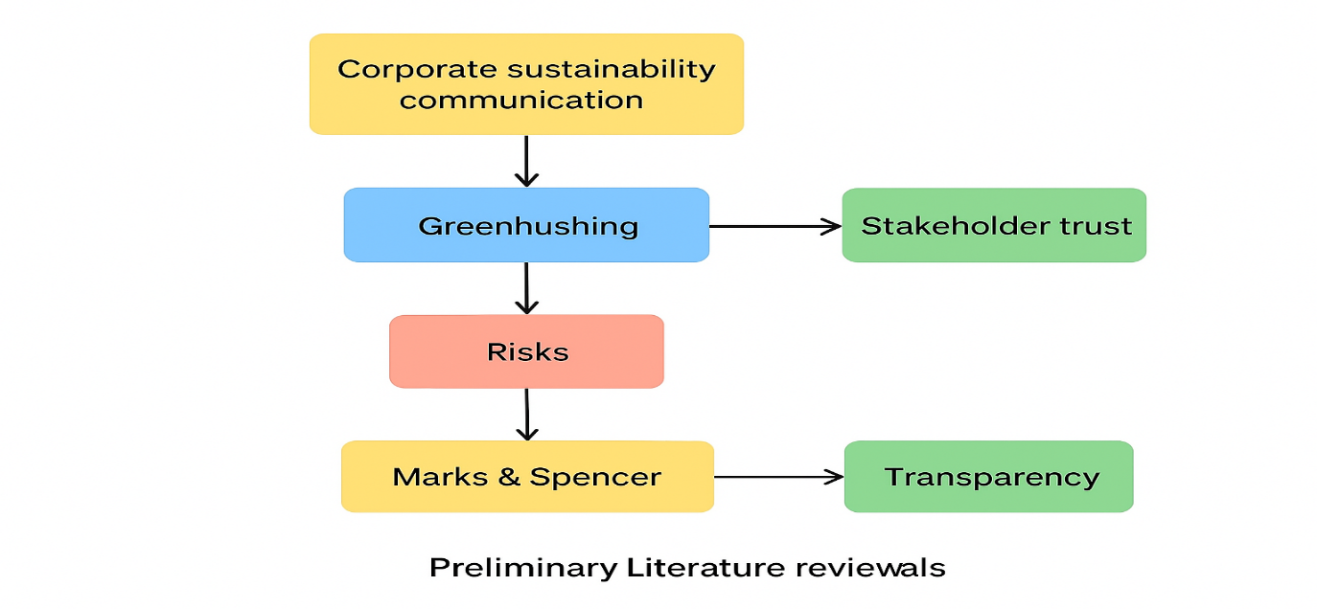
Source: (Author)

4 Research Methodology
Research Onion
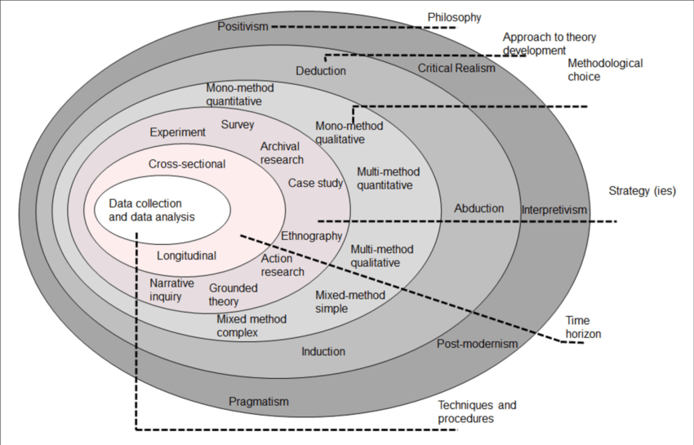
Figure: Research Onion Model
Source: (Mace, 2023)
Saunders describes the research onion as a methodology for designing research. In this study, the researcher describes the philosophy of the research, method, strategy, choice of method, horizon and techniques of data collection. Each layer focuses on the primary subject to ensure the design of the research stays centred on exploring the business risks associated with 'green hushing' and the sustainability communication in an organisation.
4.1 Research Philosophy
The research will adopt the interpretivism philosophy. Through interpretivism, the respondent refers to the social research philosophy that defines the framing of the study to capture reality, in objective, measurable and quantifiable terms and independence of the researcher. The study focuses on different themes perceptions of 'green-hushing' and uses a thematic analysis to capture the data; hence, the interpretivism approach will be used (Saunders et al., 2019). This philosophy is essential to the construction of research instruments structurally, to capture valuable data, and make data-driven findings. This boosts the study's objectivity and reduces potential researcher bias.
4.2 Research approach
This particular study will be conducted based on an inductive framework, where theory comes before data. The inductive approach involves the testing of relevant themes, where the theory is anchored in literature surrounding Green hushing, sustainability disclosure to the public, and stakeholder trust. Regarding the perspectives, a hypothesis such as Green hushing negatively impacts the trust of employees as stakeholders can be formulated (Adams et al., 2017). An inductive approach allows for evidence-based confirmation, refutation of the hypotheses and the provision of the necessary qualitative evidence to enhance the validity of the findings.
4.3 Research Method and Strategy
In this research, a mono-method qualitative approach will be adopted. A thematic analysis is the preferred method of study as it is a resource-efficient way to collect data from different websites, books, journals and scholars that showcased a company's sustainability communication. Other advantages of this method include easy access of data, negligence of sampling, and suitability for qualitative analysis (Crowther and Lancaster, 2009). A qualitative method will enable the researcher to properly understand various aspects regarding green hushing, trust, and transparency. This data will represent through making themes during the data collection period and will align with the current stage of sustainability initiatives. Regarding the time and resource constraints and the exploratory nature of the research, this approach is justified.
4.4 Data Collection
The collection of secondary thematic data will involve. The researcher will made a variety of themes that help to gather qualitative data. This qualitative analysis will aim to collect information on awareness of communication on sustainability, perception of Green hushing and concern about the transparency paradox (Cooper and Schindler, 2014).
4.5 Analysis of Data
Different qualitative data analysis tools will help define the overall trends of the collected data. In order to analyse the relationship between perceptions of trust and green hushing among stakeholders, effective measurements applied (Walliman, 2004). This will help to understand the problem of the degree of consequences perceived regarding the green hushing practice and the problem of how extensively green hushing is practised.
Ethical considerations
Informed consent involves participants being given information relevant to the study and having the option to accept or decline, as well as the indication that they could withdraw at any time. To comply with GDPR, the authors of all the sources should be acknowledged properly. There will be no fabrication or misrepresentation, and all findings will be reported honestly.

4.6 Business Relevance & Practical Implications
Within the competition in the business space, an organisation has a disproportionate need to understand the business risks tied to the 'green' resources 'hushing'. Naturally, the hushing may take place as the business practices become more sustainable. Through hushing, the risk of silence becomes reputational, as stakeholders may perceive the business to be closing the gap on sustainability issues. The lack of visibility might pose a problem, as the external brand image depends on sustainable business practices. This study allows many retailers to comprehend the risks involved with negative visibility green hushing resources as they aim to balance the risks involved with the sustainability uptake within business. The avoidance of reputational damage is essential, as stakeholders, particularly consumers and social equity investors, expect a level of transparency.
These insights will help in understanding the practical side of corporate communications (Mace, 2023). Businesses will gain an understanding of the execution of communications and the assessment of their communications transparency concerning the reputation they will adopt. In particular, the sustainability strategy will report on gaps that can be improved. This will help the company to stave off potential litigation and reputational risks related to "greenwashing" and "green hushing" while also meeting stakeholder expectations and engagement. Regarding the competitive advantage, companies will be positioned to gain the trust of purpose-driven consumers and purpose-driven investors and, hence, can be recognised as a responsible brand, which will solidify their loyalty.
Stakeholders will appreciate reporting that aligns with corporate goals. Accurate reporting that aligns with corporate goals will be appreciated by stakeholders, which will instil motivation and serve as a source of productivity. They will be more inclined to financially support the company due to its robust sustainability (Florent A., 2025).

5. Plan of Work & Time Schedule
Stage | Activity | Duration | Timeline (Weeks) | Gantt Chart Representation
1 | Literature review | 2–3 weeks | Weeks 1–3 | █████████
2 | Design survey questions & ethics approval | 2 weeks | Weeks 4–5 | ██████
3 | Data collection (employee surveys) | 3–4 weeks | Weeks 6–9 | ██████████
4 | Data analysis | 3 weeks | Weeks 10–12 | ███████
5 | Write-up & draft review | 4 weeks | Weeks 13–16 | ████████████
6 | Finalisation, proofreading & submission | 1 week | Week 17 | ███

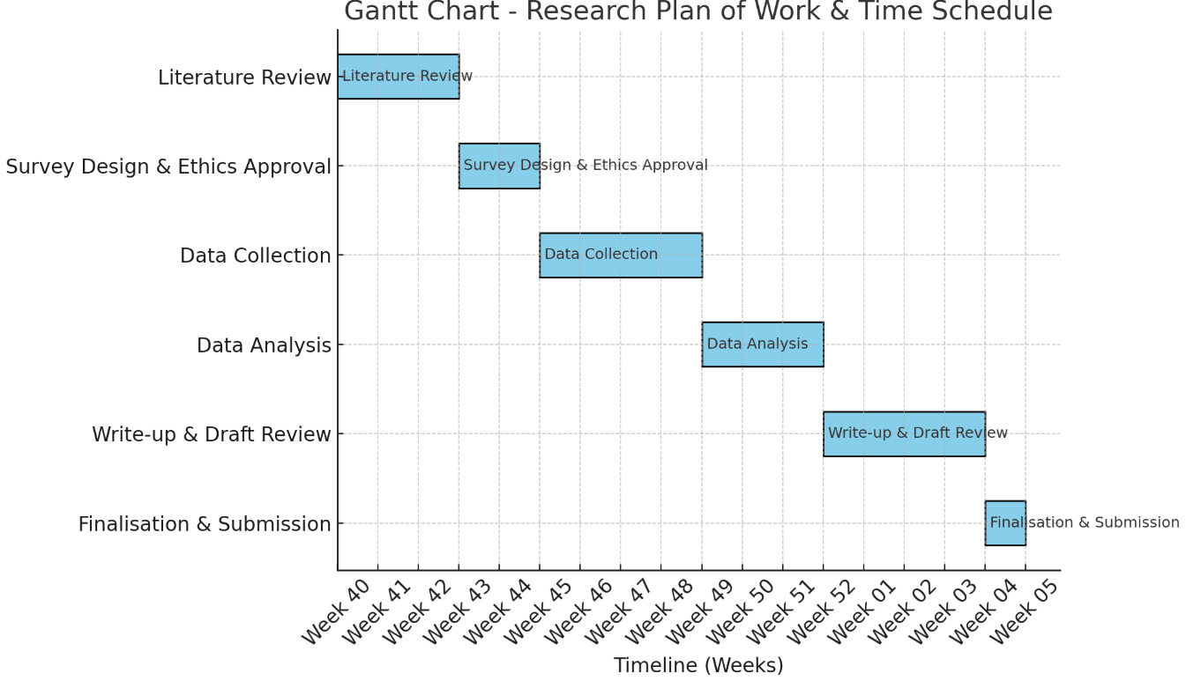
Source-Author

6 References
Adams, J. et al. (2007) Research Methods for Business and Social Science Students. 2 nd Sage Publications,
Botea-Muntean, D.R. and Constantinescu, R., (2023). GREENWASHING AND GREEN HUSHING. AN INTERNET OF THINGS APPROACH TO SUCH STRATEGIES. Romanian Economic and Business Review, 18(4), pp.7-20.
Cooper, D. R., and Schindler P. S. (2014). Business Research Methods. 12 th ed. McGraw Hill
Crowther, D., and Lancaster, G. (2009) Research Methods: A Concise Introduction to Research in Management and Business Consultancy. 2 nd Elsevier Butterworth-Heinemann, Oxford
De Novellis, G., Pedrazzoli, A., Pennetta, D. and Venturelli, V., (2025). Greenwashing, greenhushing, and the path to green banking. Global Finance Journal, p.101147.
de Souza Araújo, C.F., (2024). Untangling The Green Web: Exploring Similarities And Discrepancies Between Greenwashing And Greenhushing. Revista Gênero e Interdisciplinaridade, 5(06), pp.388-409.
Florent A., (2025). Greenhushing: A silence strategy that affects businesses. [Online] Available at: https://www.kabaun.com/en/post/greenhushing-companies [Accessed 29 September 2025].
Gatti, L., (2024). Greenhushing: A Systematic Literature Review. In MIC 2024: Next Generation Challenges: Innovation, Regeneration and Inclusion, Proceedings of the Joint International Conference, Trento, Italy, 5–8 June 2024. Koper, Slovenia: University of Primorska Press.
Haigh, R. and Liszka, S., (2024). Greenwashing and greenhushing: Risks and opportunities from the gap between brand sustainability perceptions and performance. Journal of Brand Strategy, 13(3), pp.229-240.
Hilton, J., (2025). Greenhush and greenwash: a signalling game analysis of strategic environmental disclosure. Environment and Development Economics, pp.1-22.
Mace, M., (2023). What is ‘greenhushing’ and why is it a risk for sustainability professionals?. [Online] Available at: https://www.edie.net/what-is-greenhushing-and-why-is-it-a-risk-for-sustainability-professionals/ [Accessed 30 September 2025].
Saunders, M.N.K., Lewis, P., and Thornhill, A. (2019) Research Methods for Business Students. 8 th, Pearson, Harlow
Walliman N. (2004). Your Research Project, a step-by-step guide for the first-time researcher. Sage Publications.

