

INFORMATION ENGINEERING

By Student:
Anani Y. Mateev

Student Number:
1914594

Course title:
Information Engineering
BSc Cloud Computing

Module Leader:
Suneth Fernando

This is a system, creating on the assumption that the Pizza shop already has
existing working system!
In DFD diagrams we need to explain how the data flows through business
processes and the sequence of them.
By default, I added two business processes in DFD diagram;
-“Making Pizza”
-“Delivering Pizza”
I have not mentioned “chief” and “delivery driver” in my system, because
depends of the existing system – these two entities sometimes are very
complicated and I will not be break good working scheme.
All the new required data store are already included in my diagram!
“Employee” exist in my scheme, because without him the essence of the task
will be unclear!

My DFD diagram:

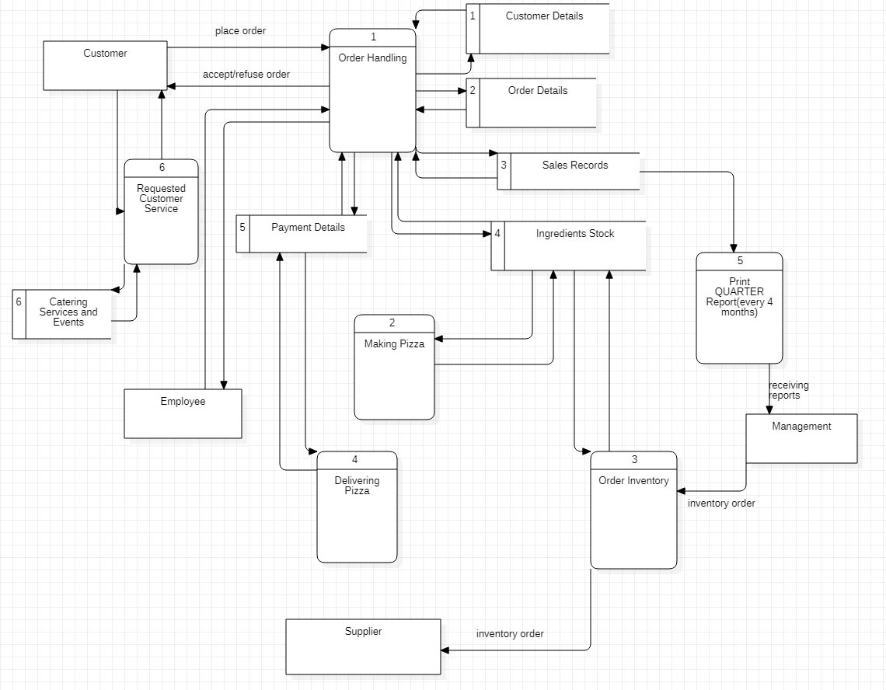

Next part of the task – we have to produce ERD diagram, that means we need
to explain how different modules interact each other – their relationships!

I have produced ERD crowfoot diagram:

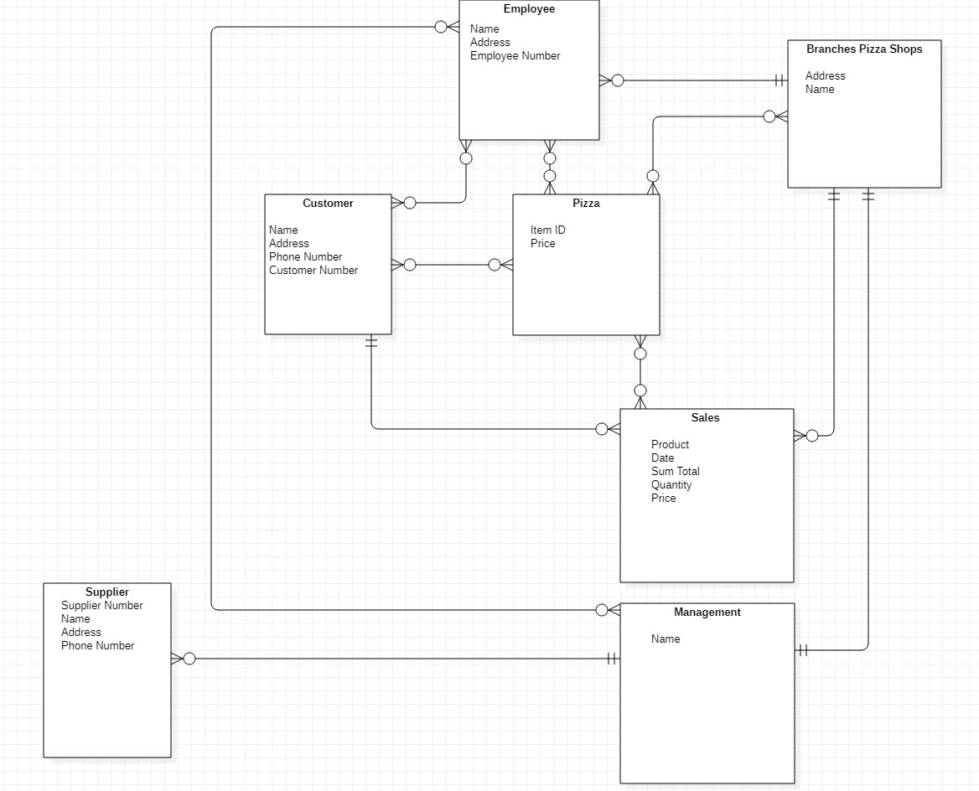

The last diagram we have asked is to demonstrate USE CASE model.
We need to explain all the connections between actors.
In this type I have included the new and very important actor in Pizza
shop – the new branches.

My USE Case Diagram:

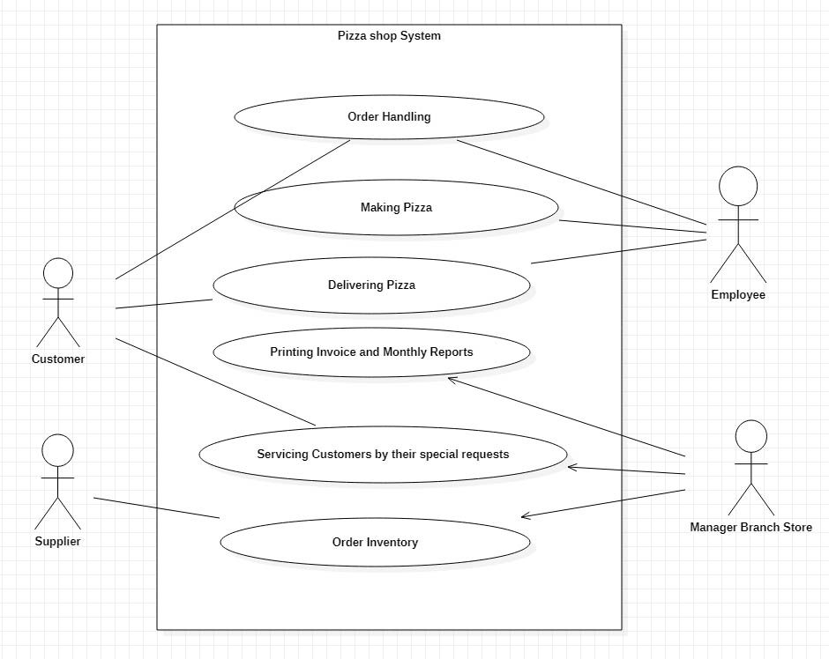

Every system is subject to different changes – because we always have to know
what the client needs exactly!

