Conference Research Paper
Personalisation – Entertainment Options in Dubai’s Luxury Hotels

Andreea Elena Codarcea
2109198

University of Wales Trinity Saint David
BMIH6001
Module Lead : Natalie Brailsford
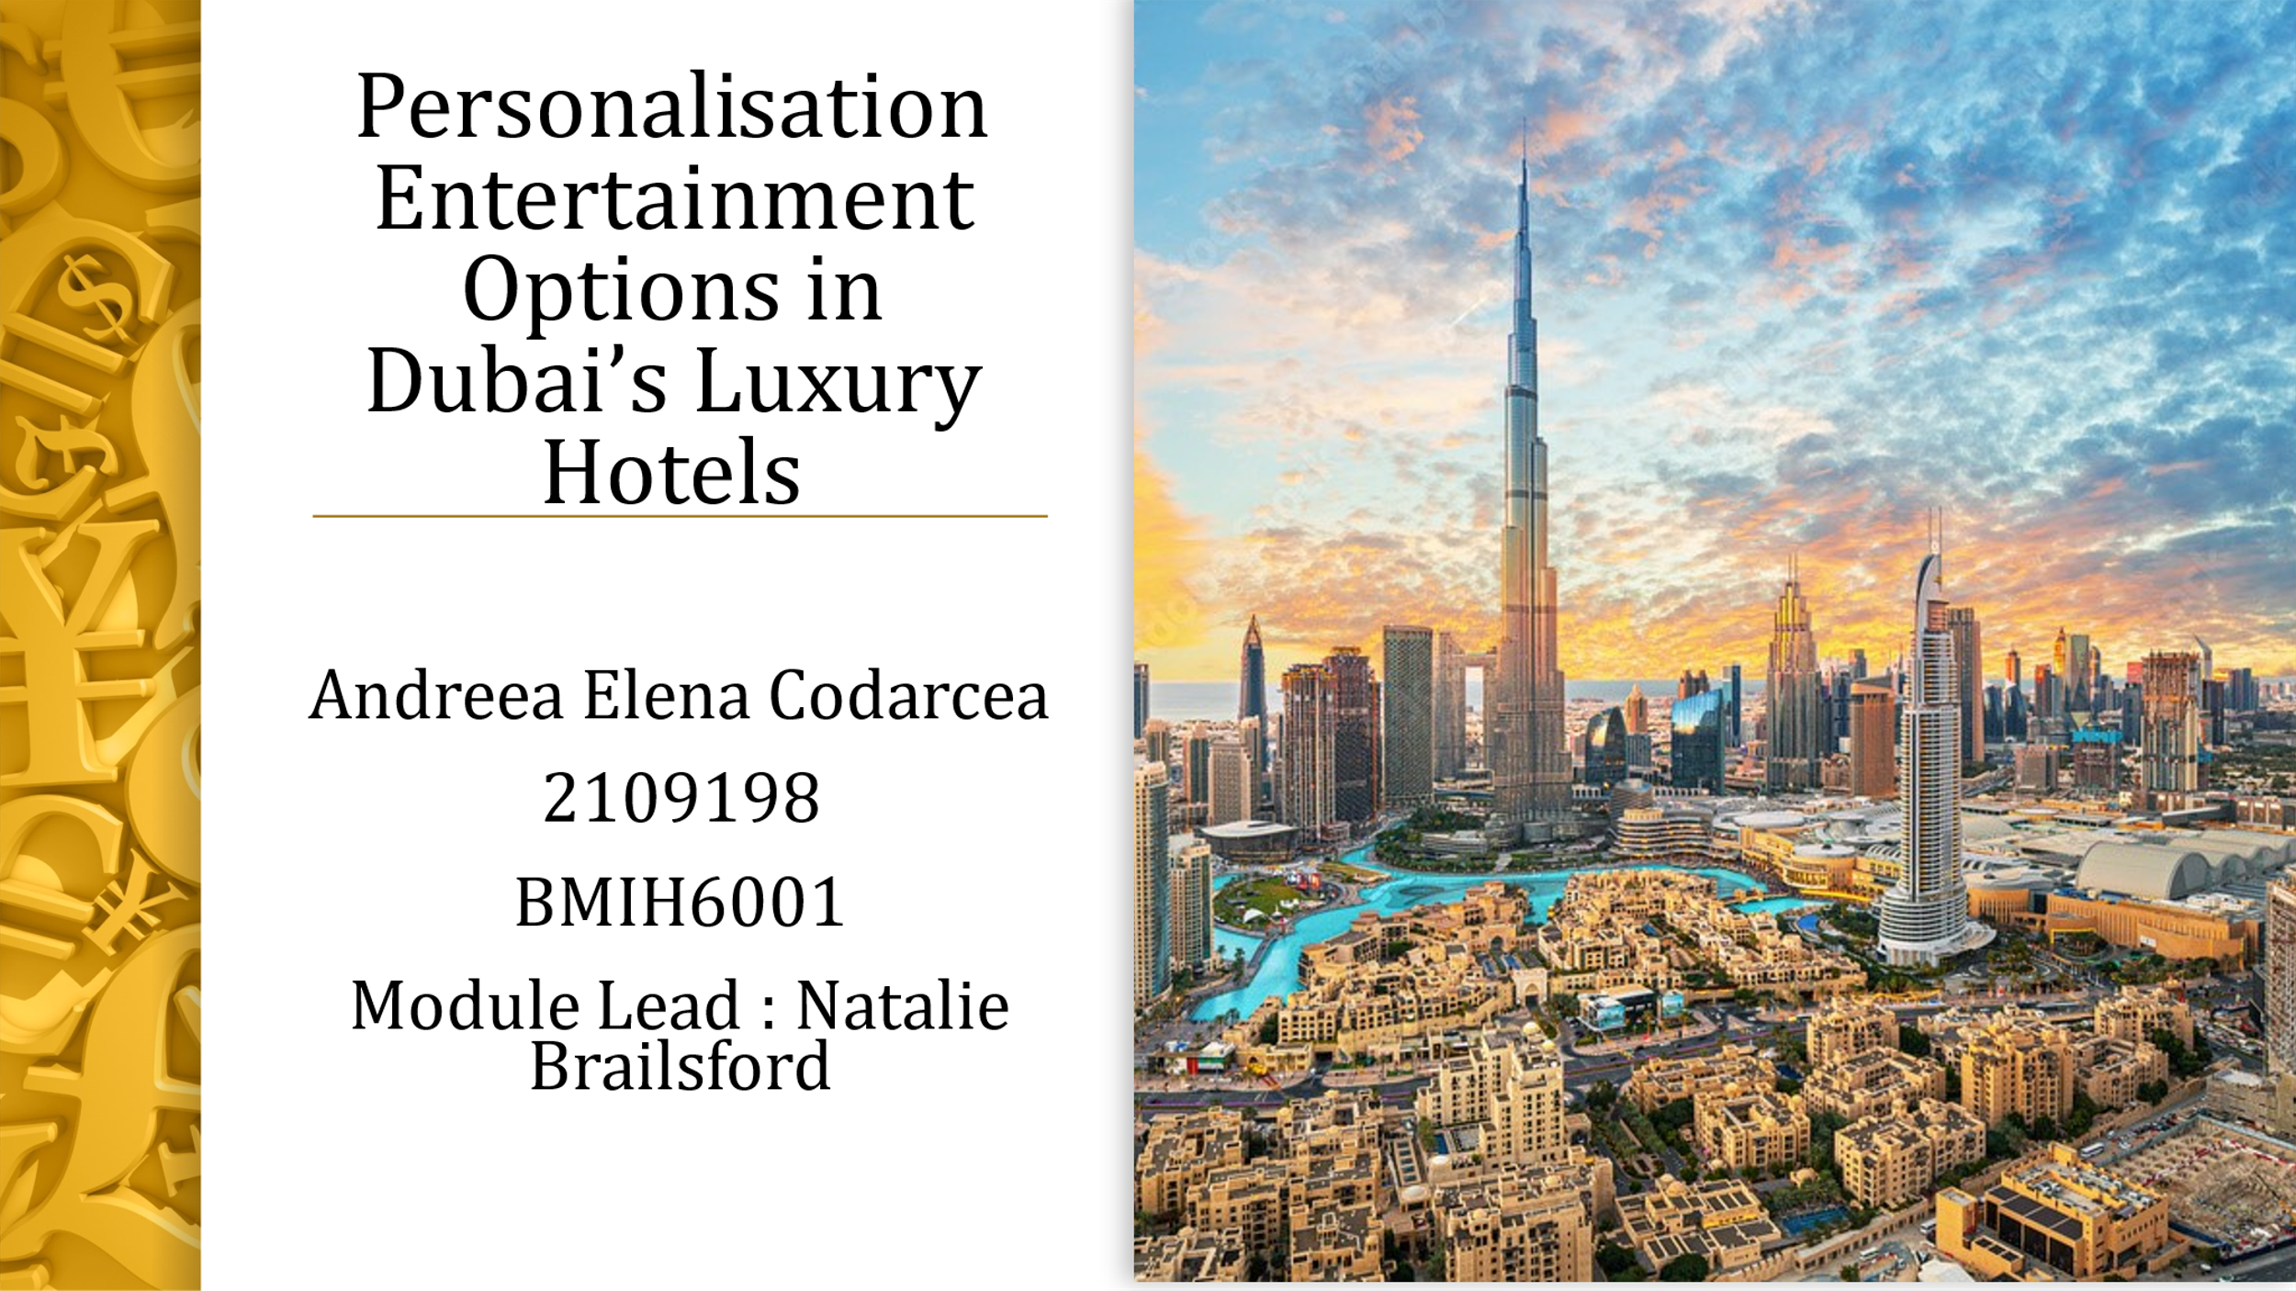
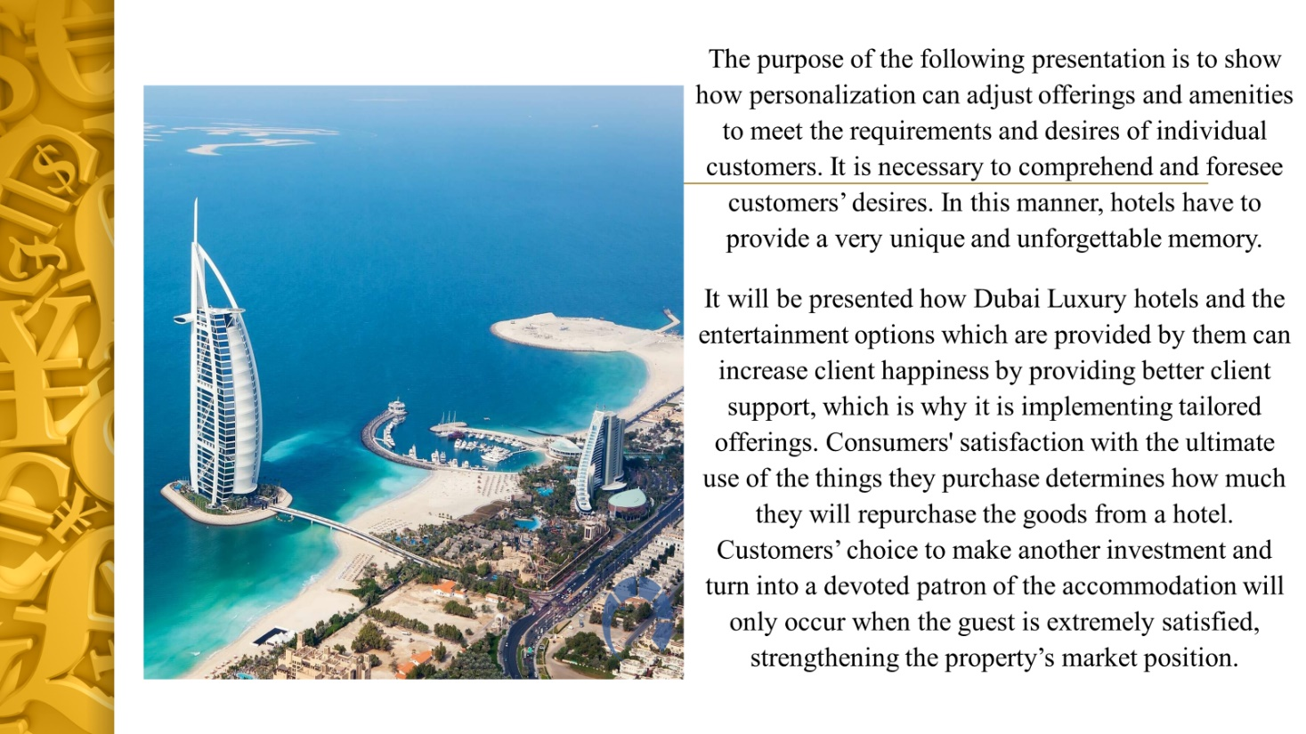
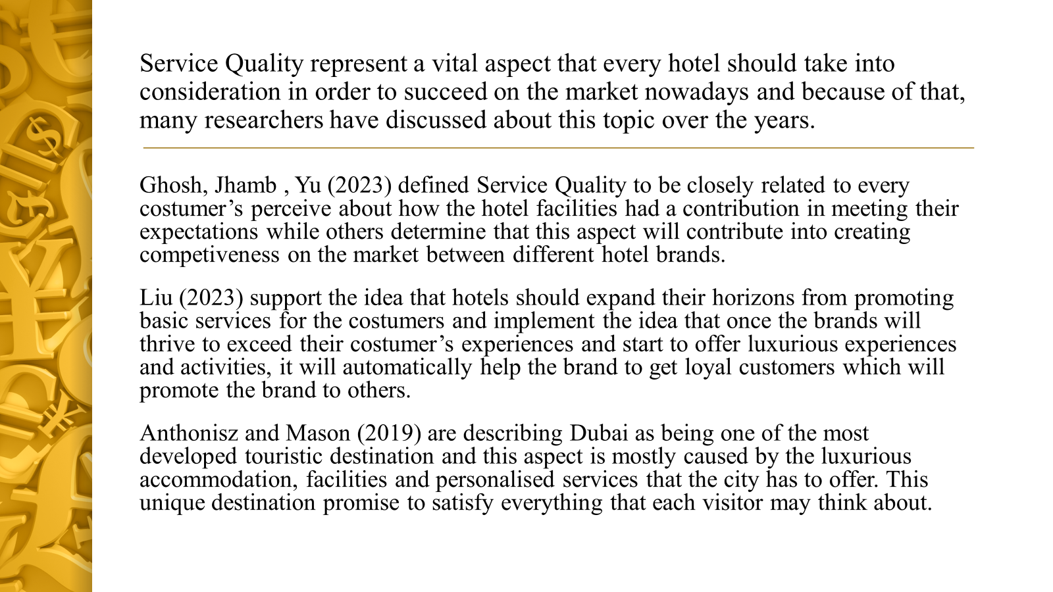
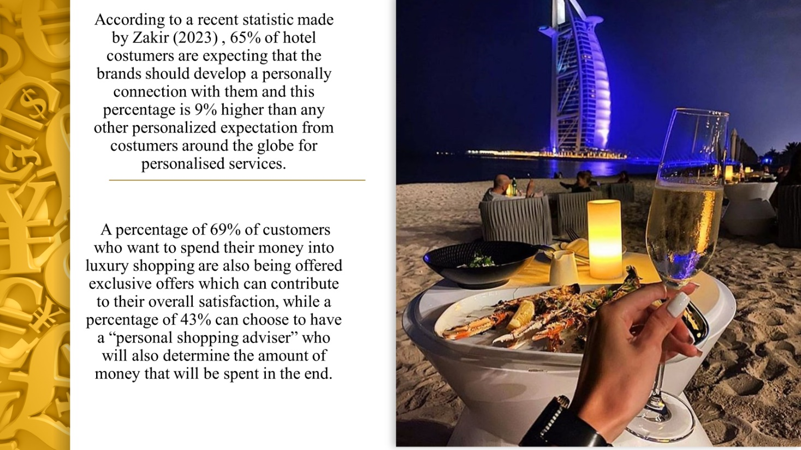
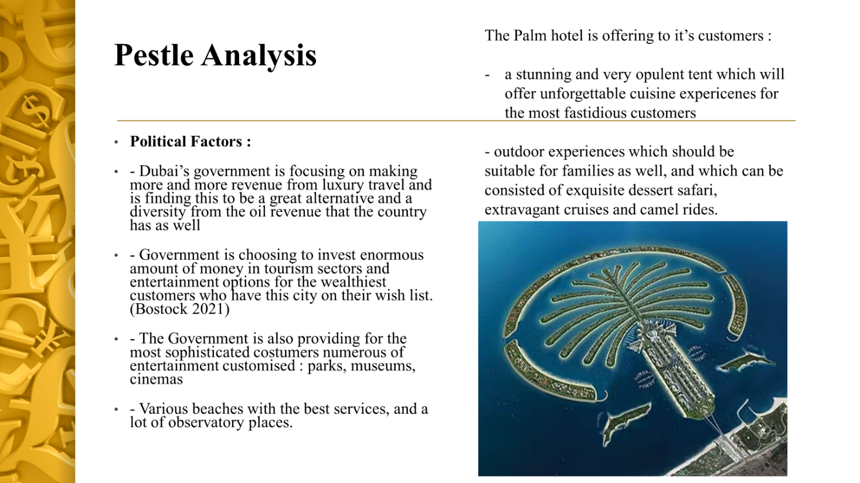

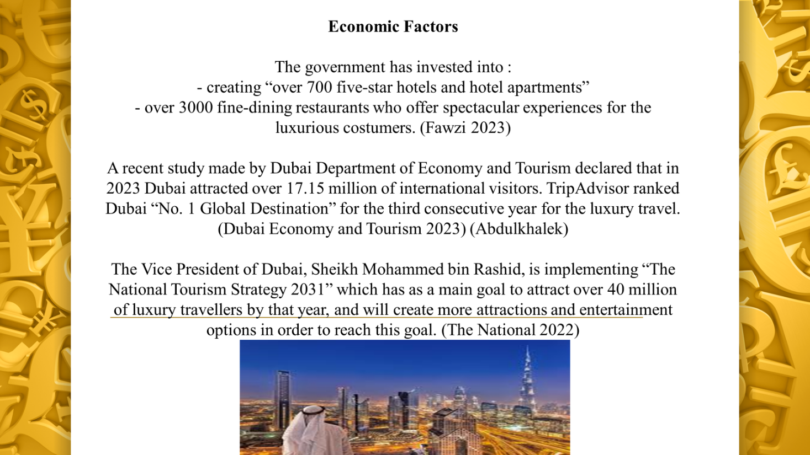
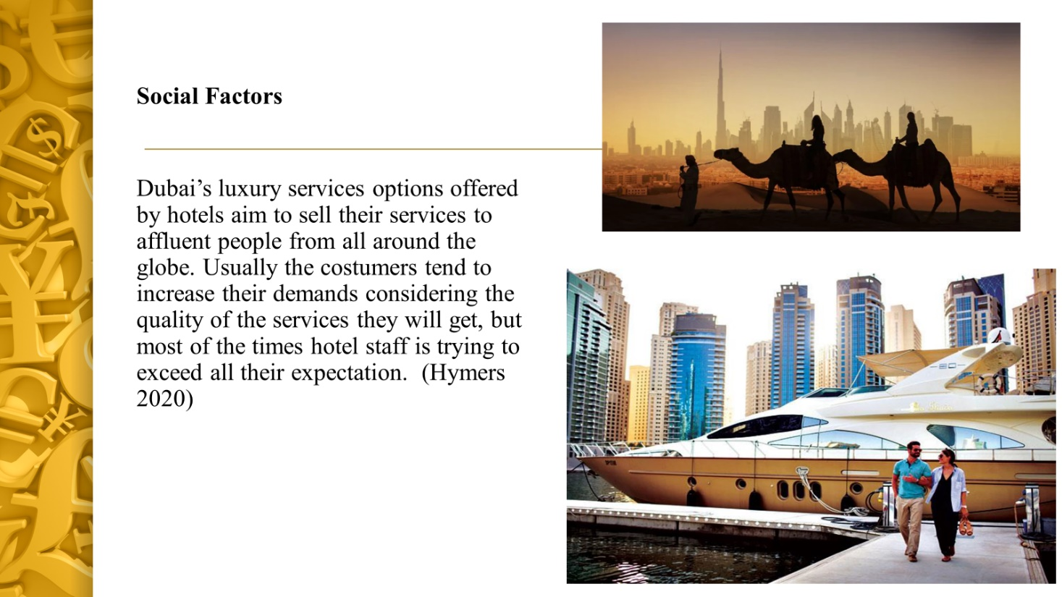

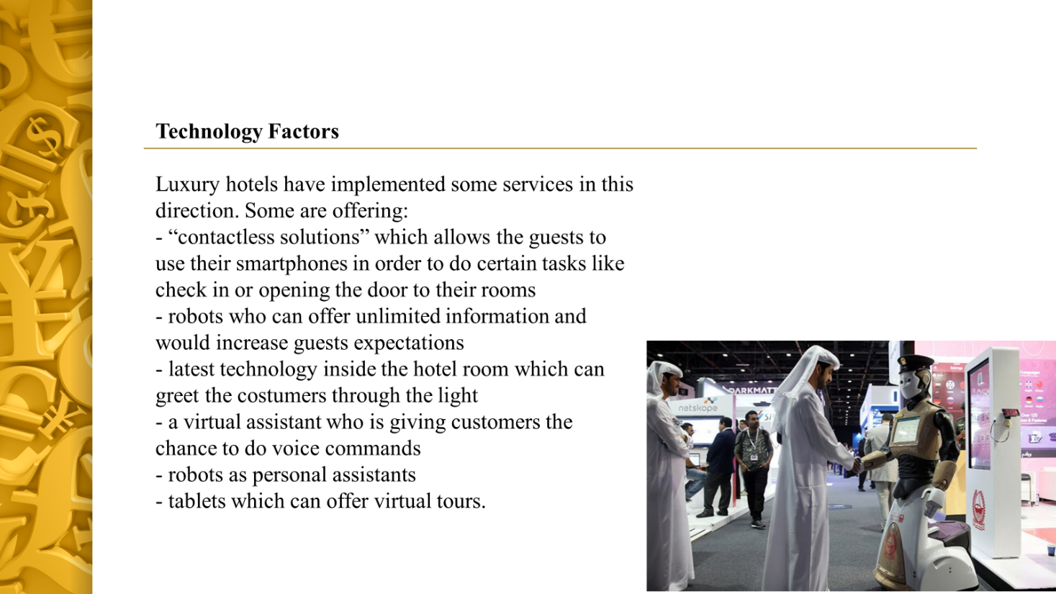

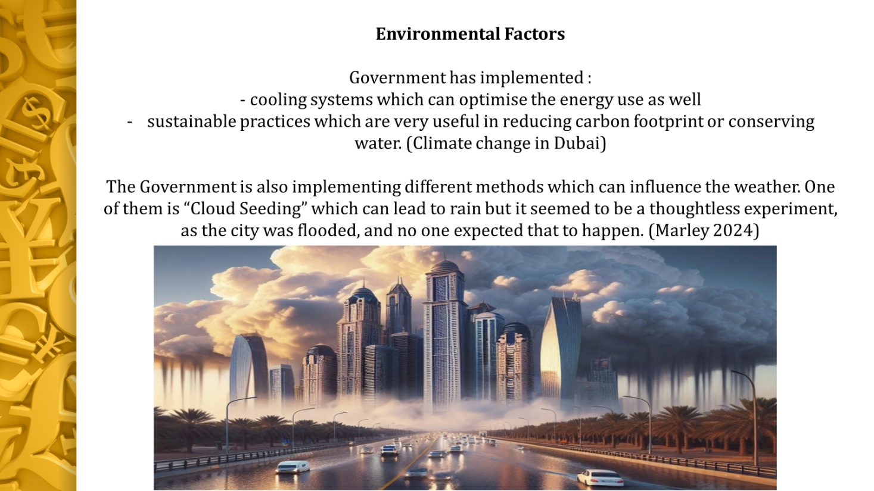

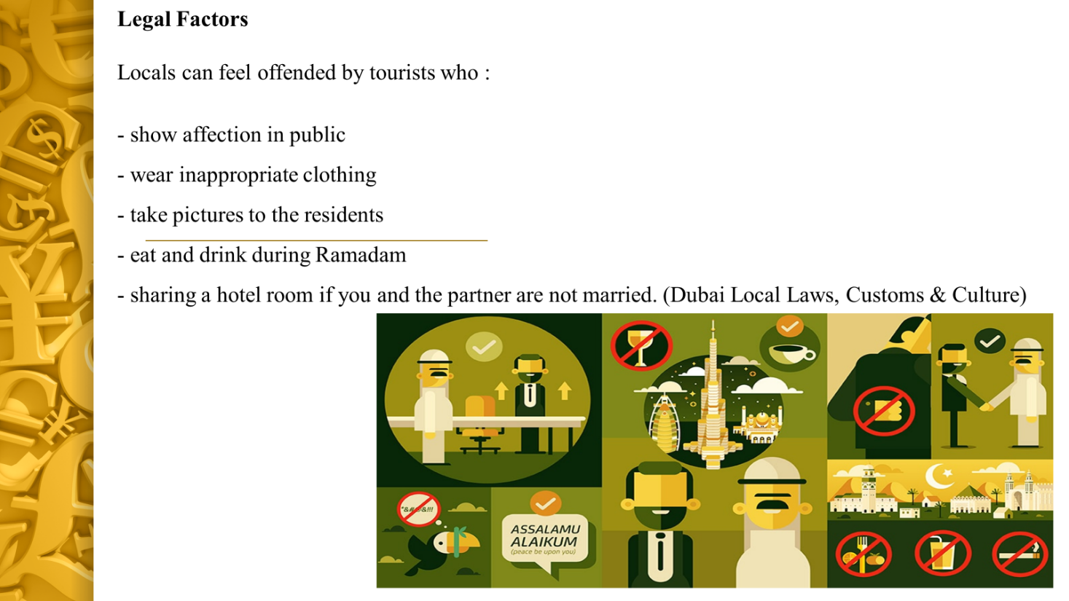
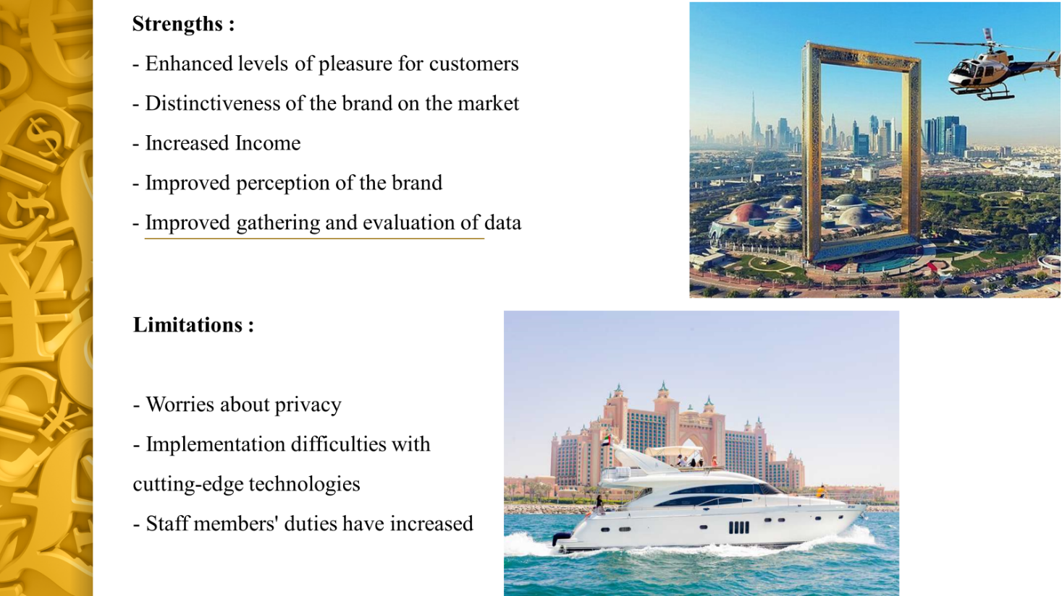
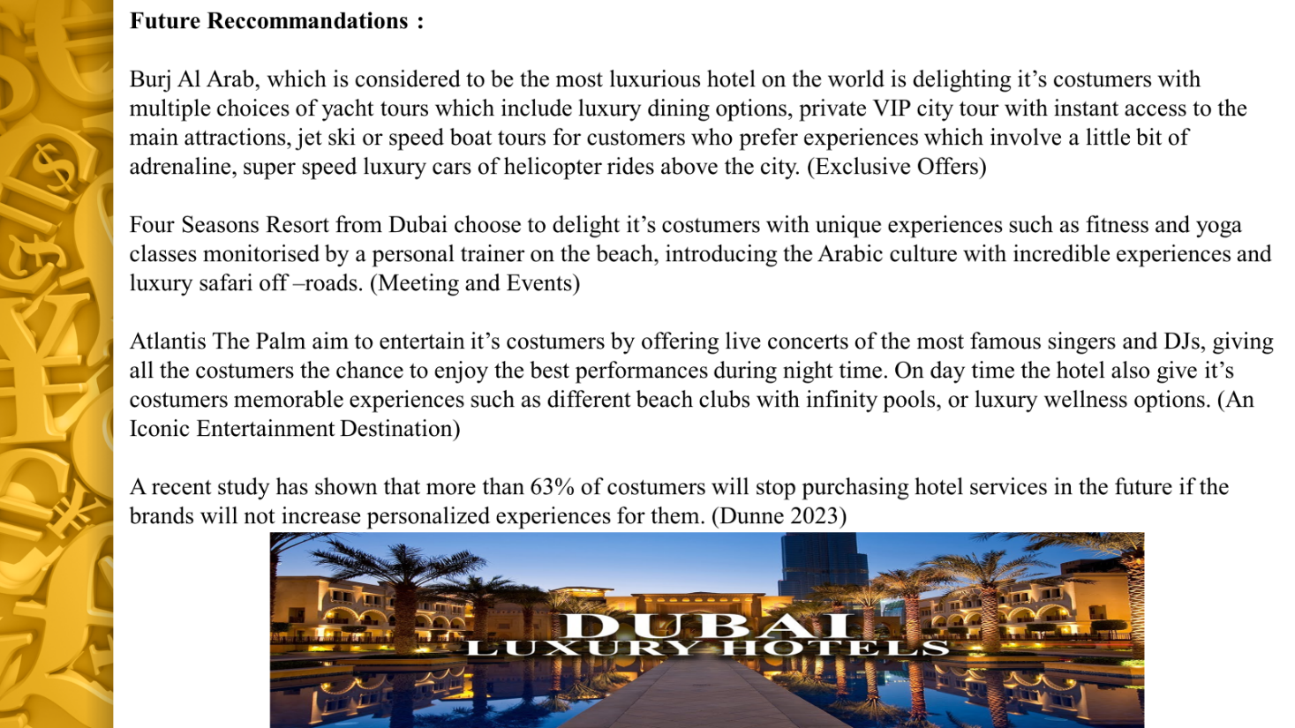

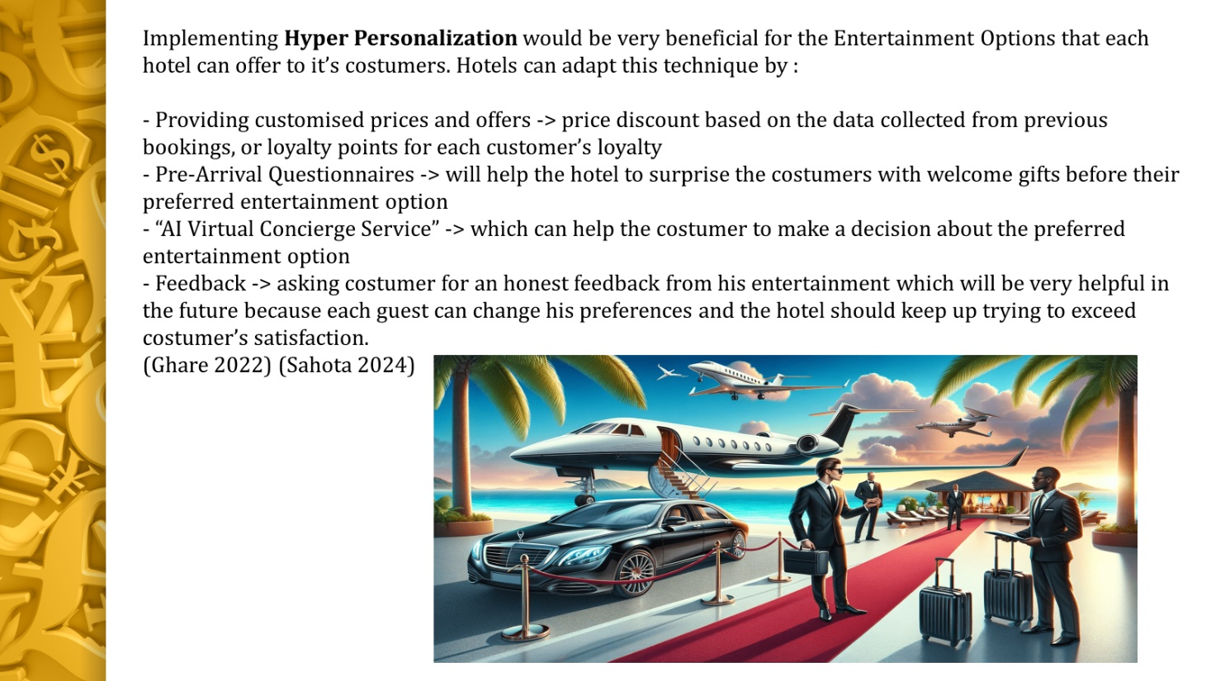

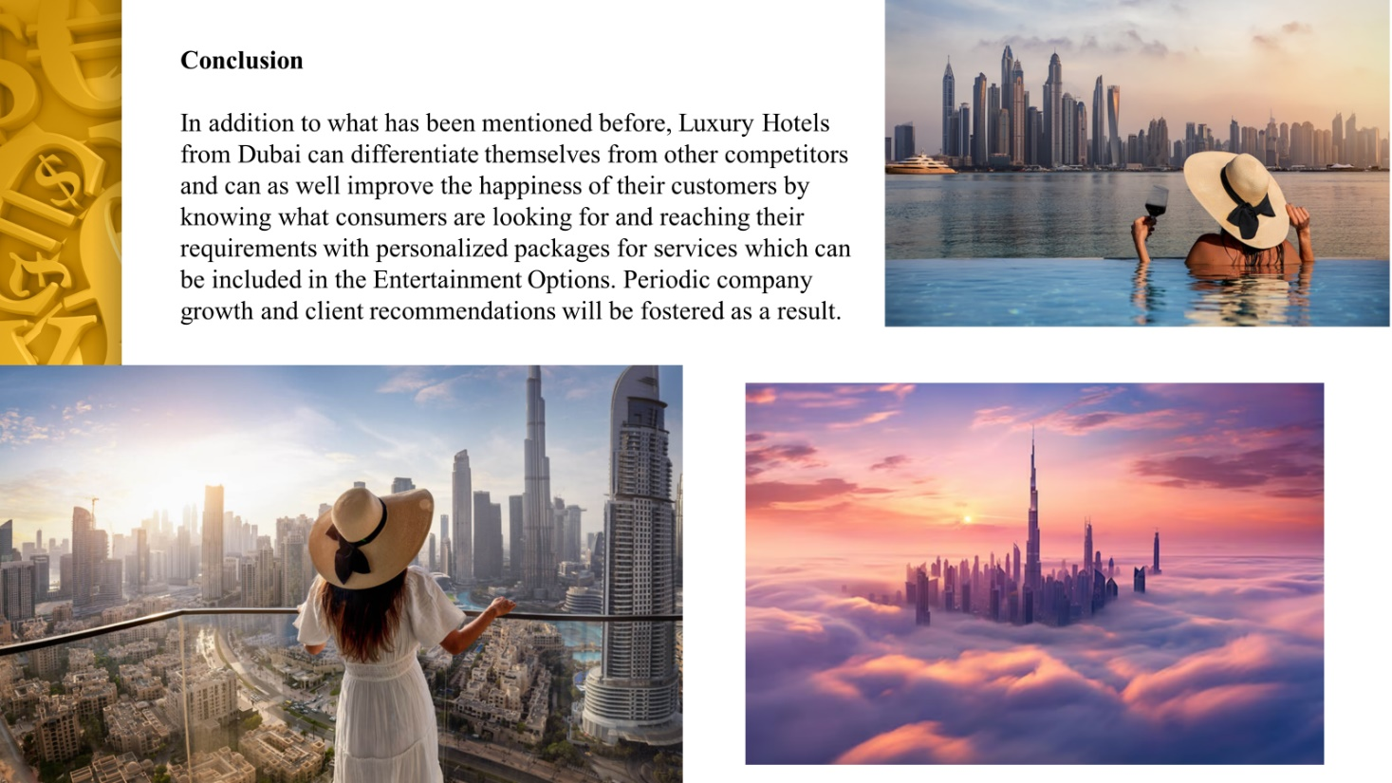
Bibliography :
1. Abdulkhalek (2023) : Why Dubai's luxury travel segment is dazzling . Available at : https://www.khaleejtimes.com/opinion/why-dubais-luxury-travel-segment-is-dazzling . Accessed : 8th of May 2024
2. An Iconic Entertainment Destination . Atlantis Dubai – Explore the Destination. Available at : https://www.atlantis.com/dubai/entertainment . Accessed : 18th of May 2024
3. Anthonisz, Mason (2019) : Reinventing tourism: the Dubai phenomenon . Bingley: Emerald Publishing Limited; Worldwide hospitality and tourism themes, 2019-06, Vol.11 (3), p.279-286
4. Ashkenazi (2024) : The World’s Best Concierge Companies For The Wealthy . Available at : https://www.justluxe.com/lifestyle/leisure/feature-1977043.php . Accessed : 8th of May 2024
5. Bostock (2021) : DUBAI’S GOVERNMENT INVESTMENT IN TOURISM IS PAYING DIVIDENDS FOR HOTEL DEVELOPERS . Available at : https://www.hoteliermagazine.com/dubais-government-investment-in-tourism-is-paying-dividends-for-hotel-developers/?cn-reloaded=1 . Accessed : 2nd of May 2024
6. Climate change in Dubai (2024) : Rising Temperatures : How Dubai is Adapting to Climate Change. Available at : https://blackfeetclimatechange.com/rising-temperatures-2/ . Accessed : 10th of May 2024
7. Davis (2017) : How Leaders Can Adapt To An Environment Of Change . Available at : https://www.forbes.com/sites/forbesagencycouncil/2017/10/12/how-leaders-can-adapt-to-an-environment-of-change/?sh=6c10a1906d20 . Accessed : 2nd of May 2024
8. Dilrabo (2024) : SCIENTIFIC AND PRACTICAL BASES OF CONCEPTS OF SERVICE QUALITY AND EFFICIENCY IN HOTEL BUSINESS , Volume02,Issue02,2024ISSN(E):2993-2777, Published 02.09 2024
9. Dubai Economy and Tourism (2023) : Dubai Hits Record with 17.15M International Tourists in 2023 . Available at : https://www.miragenews.com/dubai-hits-record-with-17-15m-international-1173246/ . Accessed : 5th of May 2024
10. Dubai Hospitality (2023) : Dubai hospitality sector sets the pace for growth . Available at: https://www.zawya.com/en/business/hospitality/dubai-hospitality-sector-sets-the-pace-for-growth-x9zjjqit . Accessed : 21st of May 2024
11. Dubai Local Laws, Customs & Culture . Available at : https://www.bestattravel.co.uk/the-edit/dubai/local-customs-in-dubai/ . Accessed : 15th of May 2024
12. Dunne (2022) : The Future Of Personalization In The Travel Industry . Available at : https://www.forbes.com/sites/danadunne/2022/01/27/the-future-of-personalisation-in-the-travel-industry/?sh=1f2e17233e01 . Accessed : 20th of May 2024
13. Dunne (2023) : The Future Of Personalization In The Travel Industry. Available at : https://www.forbes.com/sites/danadunne/2022/01/27/the-future-of-personalisation-in-the-travel-industry/?sh=dc6abf83e01d . Accessed : 19th of May 2024
14. Exclussive Offers : Jumeirah Burj Al Arab. Available at : https://www.jumeirah.com/en/stay/dubai/burj-al-arab-jumeirah?gad_source=1&gclid=EAIaIQobChMIiJGz3YaGhgMVWS0GAB04lA56EAAYASAAEgLZO_D_BwE&gclsrc=aw.ds . Accessed : 17th of May 2024
15. Fawzi (2023) : What Makes the UAE a Leading Player in the Global Super Luxury Car Market. Available at : https://www.linkedin.com/pulse/what-makes-uae-leading-player-global-super-luxury-car-mohamed-fawzi . Accessed : 4th of May 2024
16. Fromm (2024) : Future Consumer Loyalty Programs Will Increase Personalization . Available at : https://www.forbes.com/sites/jefffromm/2024/01/25/future-consumer-loyalty-programs-will-increase-personalization/?sh=4e0714503380 . Accessed : 19th of May 2024
17. Gasawneh et all (2023) : Impact of Service Quality on Customer Retention . Vol. 24, Iss. 195 . Available at : https://www.proquest.com/openview/7de0996f5986a00319511e668afc2982/1?pq-origsite=gscholar&cbl=1046413
18. Ghare (2022) : How Digital Transformation Can Reshape Guest Experience In The New Pandemic Era . Available at : https://www.forbes.com/sites/forbestechcouncil/2022/02/15/how-digital-transformation-can-reshape-guest-experience-in-the-new-pandemic-era/?sh=16c3d6b73bcb . Accessed : 19th of May 2024
19. Ghosh, Jhamb , Yu (2023) , Measuring service quality perceptions of hotel management institutes on hotel recruiters’ hiring intentions: effect of sacrifice, satisfaction and service value . Pages 469-493 , Published online: 19 Jun 2023 . Available at : https://www.tandfonline.com/doi/abs/10.1080/15313220.2023.2222076
20. Grand Excelsior Hotels Dubai (2024) : How Technology is Transforming Hotels in Dubai? . Available at : https://www.gehotels.com/how-technology-is-transforming-hotels-in-dubai/#:~:text=Hotels%20in%20Dubai%20are%20upgrading,tablets%20for%20controlling%20various%20amenities . Accessed : 10th of May 2024
21. Hymers (2020) : Dubai's best luxury hotels for a 'seven-star' stay, from beach butlers to lavish designer spas . Available at : https://www.telegraph.co.uk/travel/destinations/middle-east/united-arab-emirates/dubai/articles/the-best-luxury-seven-star-hotels-in-dubai/ . Accessed : 10th of May 2024
22. Jein et all (2023) : Luxury hospitality: A systematic literature review and research agenda . Volume 115 . Available at : https://www.sciencedirect.com/science/article/abs/pii/S0278431923001718
23. Kenwood Travel (2022) : TOP LUXURY EXPERIENCES IN DUBAI . Available at : https://kenwoodtravel.co.uk/blog/luxury-experiences-in-dubai/ . Accessed : 16th of May 2024
24. Liu (2023) : Haute Couture Hotels: A Systematic Review on the Practice of Brand Extension by Luxury Fashion Labels into the Hospitality Industry . Available at : https://www.atlantis-press.com/proceedings/icedbc-23/125991329 .
25. Marley (2024) : The weather experiment that really flooded Dubai . Available at : https://theconversation.com/the-weather-experiment-that-really-flooded-dubai-227021 . Accessed : 14th of May 2024
26. Marmol (2015) : PESTLE Analysis, Lemaitre Publishing
27. Meetings and Events : Group Activities. Available at : https://www.fourseasons.com/dubaijb/meetings-and-events/group-activities/ . Accessed 17th of May 2024
28. Milosh (2023) : Evolving Preferences: Understanding Contemporary Luxury Hotel Guests . Available at : https://www.theseus.fi/handle/10024/816941 .
29. Mubashar (2023) : Personalization in Hospitality - The Pros & Cons . Available at : https://www.linkedin.com/pulse/personalization-hospitality-pros-cons-mubashar-allaudin . Accessed : 20th of May 2024
30. Nair (2023) : UAE hotels record 24% increase in revenue to over $7bn in first seven months . Available at : https://www.thenationalnews.com/business/travel-and-tourism/2023/10/08/uae-hotels-record-24-increase-in-revenue-to-over-7bn-in-first-seven-months/ . Accessed : 5th of May 2024
31. Newsroom (2023) : Make your Dubai experience even more memorable this Ramadan . Available at : https://www.dubaitourism.gov.ae/en/newsroom/press-releases/ramadan-activities-in-dubai . Accessed : 3rd of May 2024
32. Raval (2019) : Improving User Experiences In The Hospitality Industry . Available at : https://www.forbes.com/sites/forbestechcouncil/2019/04/22/improving-user-experiences-in-the-hospitality-industry/?sh=5260320c9e22 . Accessed : 21st of May 2024
33. Rizvi (2024) : Mastering The Art Of Personalization In Service-Based Businesses . Available at : https://www.forbes.com/sites/jiawertz/2024/02/14/mastering-the-art-of-personalization-in-service-based-businesses/?sh=170edc6a2cf4 . Accessed : 20th of May 2024
34. Sahota (2024) : AI in Hospitality : Elevating The Hotel Guest Experience Through Innovation. Available at : https://www.forbes.com/sites/neilsahota/2024/03/06/ai-in-hospitality-elevating-the-hotel-guest-experience-through-innovation/?sh=28054ce477d4 . Accessed : 20th of May 2024
35. Sakani (2024) : Dubai’s Luxury Real Estate: How Tourism is Driving the Demand . Available at : https://www.linkedin.com/pulse/dubais-luxury-real-estate-how-tourism-driving-demand-sakanihomes-1thmf#:~:text=Tourists%20from%20around%20the%20world,in%20properties%20in%20the%20city . Accessed : 4th of May 2024
36. Savills (2023) : UAE's leisure and entertainment sector to be invaluable to GDP growth . Available at : https://www.savills.co.uk/blog/article/347543/middle-east-articles/uae-s-leisure-and-entertainment-sector-to-be-invaluable-to-gdp-growth..aspx Accessed : 2nd of May 2024
37. The National (2022) : Sheikh Mohammed launches national tourism strategy to attract 40m hotel guests by 2031 . Available at : https://www.thenationalnews.com/uae/government/2022/11/11/sheikh-mohammed-launches-national-tourism-strategy-to-attract-40m-hotel-guests-by-2031/ . Accessed : 7th of May 2024
38. Zadain (2015) : Tourism shopping and new urban entertainment: A case study of Dubai . Volume 22, Issue 1. Available at : https://journals.sagepub.com/doi/abs/10.1177/1356766715589426
39. Zakir (2023) : Elevating Customer Experience - Personalization in Dubai Travel Marketing . Available at : https://www.linkedin.com/pulse/elevating-customer-experience-personalization-dubai-zakir-7hszf

