

Software Development- Assessment 1
Software Development
ACCA4017
University of Wales Trinity Saint David, Birmingham
Student Name: Cristian-Constantin Paraschiv
Student ID: 2026077

Contents
PART A 3
A1 3
A2 4
PART B (IMPLEMENTATION) 5
Exercise 1. 5
Exercise 2. 5
Exercise 3. 7
References 8

Software Development- Assessment 1

PART A

A1
A list is a data structure which is changeable, mutable, as well as is ordered in a sequence of elements. Each item or a value inside a list is known as an item (Deb, 2021). List completely differs from variable. List is an object whereas variable is reserved memory location that store values. In fact, it can also be explained as that variable is simply a named reference to a value, whereas list consist of various number of named elements of named references. In other words, list consist of number of variables within it. There are various number of ways through which elements of a list can be accessed. As all the list elements of list are written in square brackets. So it works similar as string so for this len() function and square brackets [ ] can be used for accessing elements of list. Other than this, loop can also be used for accessing list elements.
Five main functions of list are:
- For providing total length of list len(list) can be used
Example:
list_1 = [51.39]
list_2 = [56.24, 79.63, 217.11]
print('list_1 length is ', len(list_1))
print('list_2 length is ', len(list_2))
- For returning items from list with max value max(list) function can be used
Example:
prices = [669.16, 547.31, 980.67, 353.91]
price_max = max(prices)
print(price_max)
- For returning items from list with minimum value min(list) function can be used
Example:
prices = [669.16, 547.31, 980.67, 353.91]
price_max = min(prices)
print(price_max)
- For clearing all elements from specific list clear() function can be used
Example:
months = ['January', 'February', 'March']
months.clear()
- For sorting list in ascending order sort() function can be used
Example:
prices = [589.36, 237.81, 230.87, 463.98, 453.42]
prices.sort()
print(prices)

A2
Functions that are defined by oneself for doing certain specific task are known as user defined functions. Built-in functions of any programming language can be used with these user defined functions for development of a function with different requirements that are required by user (Hunt, 2019). These user defined functions can also be used with different parameters as per the need and requirement of the user. These are important in python because it allow programmer to create their own routine and procedure that can be followed by computer. It is extremely important as it directly helps in allowing reusability of codes that can be simply called by programmer for a specify purpose whenever it is required within a program. Anther reason because of which this user defined functionality is important because it directly helps in reducing requirement of writing same code again and again for different inputs. Instead of that, with the help of user defined functions, these functions can be called again and again for different parameters or values which eventually helps in reducing requirement of writing leant repetitive codes.
For example:
myFun(x, y = 50):
print("x: ", x)
print("y: ", y)
myFun(10)

PART B (IMPLEMENTATION)

Exercise 1.

# types of values by using four variables
carMake : str = "Mercedes-Benz" # Various things are tied, bound, or hung using string
Model : str = "2020 v10" # Same as first string
Mileage : float = 723.45 # Because mileage could have a floating point.
Doors : int = 2 # The doors numbers never fluctuating, so we using a integer.
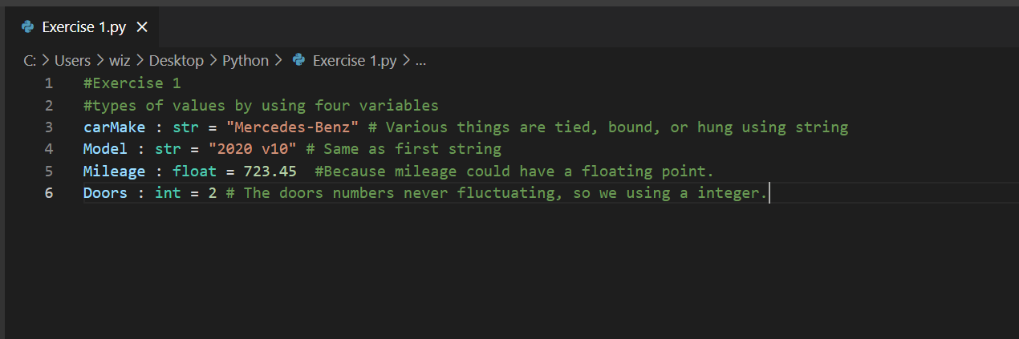

Exercise 2.
#Calculate each of the shaded areas

def circle(radius, pi): # Defined circle with radius and pi with a function
return pi*(radius*radius)
pi = 3.1416 # we define pi value
redValues= float(input("Please enter the Red radius: ")) # Creating variables for the user input
blackValues= float(input("Please enter the Black radius: "))# Creating variables for the user input
blueValues = float(input("Please enter the Blue radius: "))# Creating variables for the user input
redArea = circle(redValues, pi) # defined variable with a function
blackArea = circle(blackValues, pi)# defined variable with a function
blueArea = circle(blueValues, pi)# defined variable with a function
blackArea = (blueArea - redArea)# defined variable with a function
blueArea = blueArea - (redArea + blackArea) # defined variable with a function
print("This is the Red area of the circle " + str(redArea)) # printing what we defined in the functions
print("This is the Black area of the circle " + str(blackArea))# printing what we defined in the functions
print("This is the Blue area of the circle " + str(blueArea))# printing what we defined in the functions
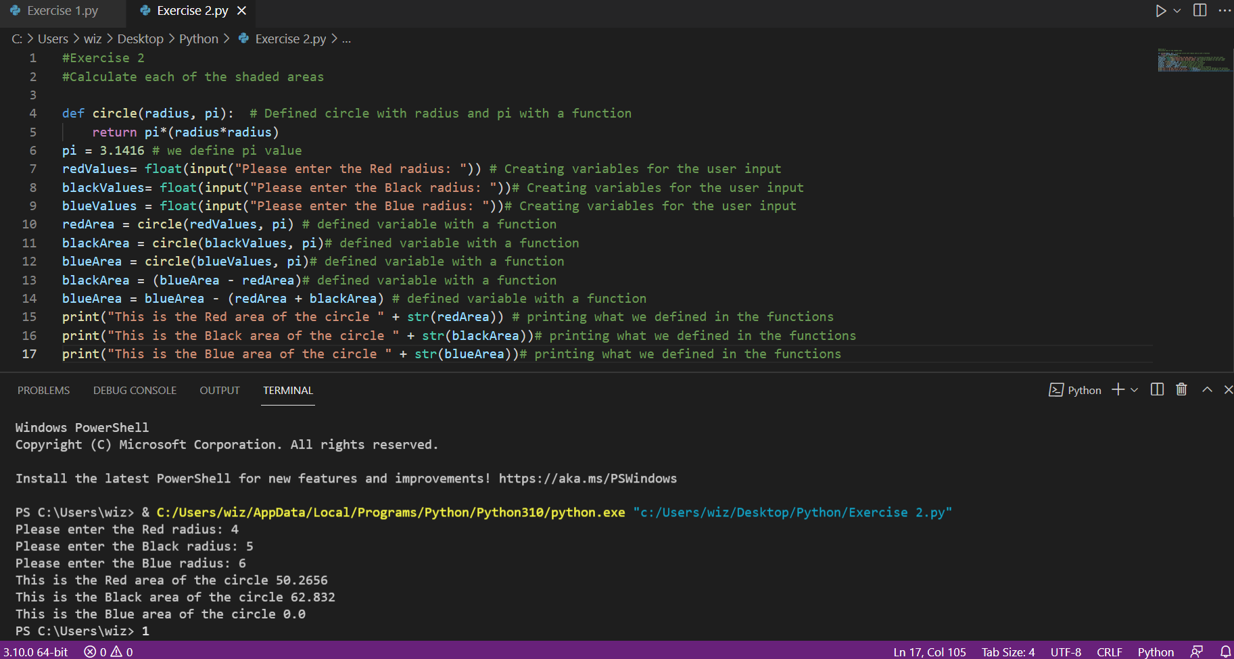

Exercise 3.

import pandas as pd # importing from library the pandas program
import matplotlib.pyplot as plt # importing from library matplotlib program
df = pd.read_csv(r'note.csv') # read the excel note.csv

females = df.query('`Gender`.str.endswith("F")') # define variable females
males = df.query('`Gender`.str.endswith("M")') # define variable males
# using function to define the average
femalesAvg = females['Age'].mean()
malesAvg = males['Age'].mean()
femalesSalaryAvg = females['Salary'].mean()
malesSalaryAvg = males['Salary'].mean()

print("This is the female age avarage: "+str(femalesAvg))
print(" This is the male age avarage: "+str(malesAvg))
print(" This is the female slaray avarage: "+str(femalesSalaryAvg))
print(" This is the males slaray avarage: "+str(malesSalaryAvg))
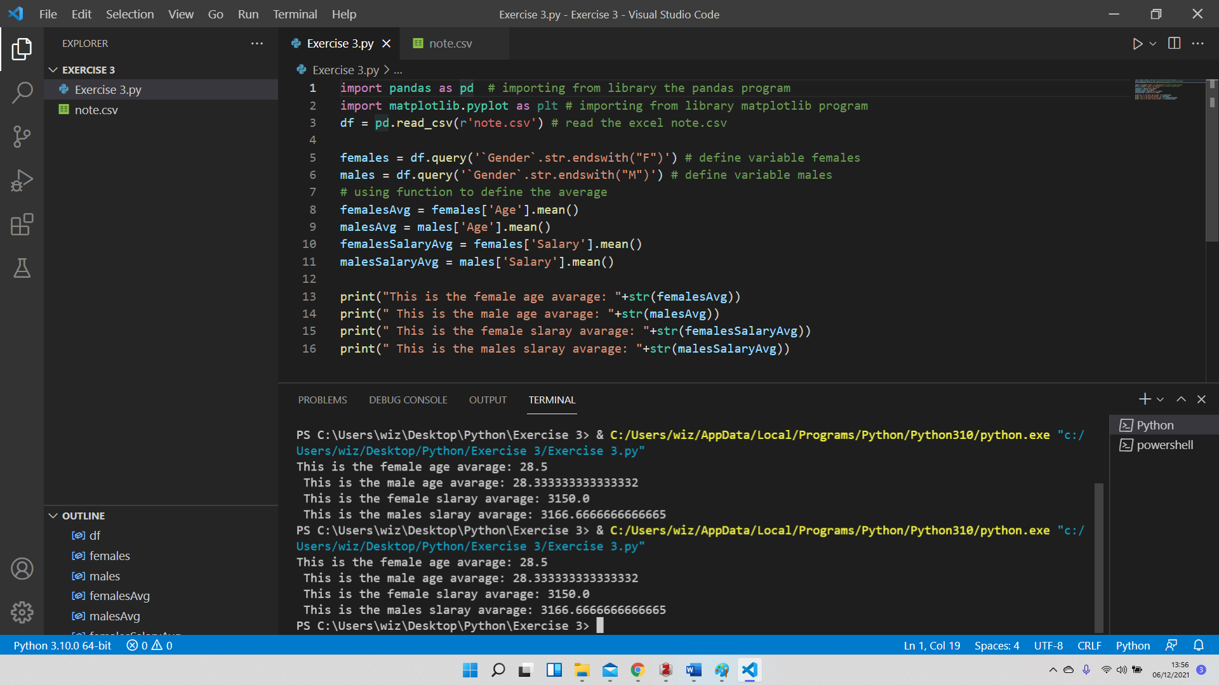

References

Books and journals
Deb, D. (2021) Two useful Python tools - dimpy and tablefile for data analysis applications. preprint. In Review. doi:10.21203/rs.3.rs-1004075/v2.
Hunt, J. (2019) Advanced guide to Python 3 programming. Cham, Switzerland: Springer (Undergraduate topics in computer science). doi:10.1007/978-3-030-25943-3.

