BMSW4002

Table of Contents
Introduction 3
The Three Models of Communication 3
Schramms’ Model 3
Shannon & Weaver’s Model 4
Berlo’s SMCR Model 5
Communication Skills 6
Verbal Communication Skills 6
Clarity 6
Empathy 6
Sincerity 7
Maintaining Eye Contact 7
Non-Verbal Communication 7
Silence 7
Body Language 7
Listening 8
Advantages of Technology in Communication 8
Disadvantages of Technology in Communication 8
Example of Poor Communication 8
Conclusion 9
References 10

Introduction

Two or more persons must successfully communicate and receive each other's messages in order for them to be considered effective communication. When everyone involved in a conversation has the same understanding of the message and is paying close attention to what is being said, this shows that communication is fruitful since it shows the presenter and he or she has indeed been received and understood. In the business world, effective communication occurs when the information exchanged between employees contributes to the success of the company (Fielding, 2006). There are many other skills that are necessary for effective communication, including nonverbal communication, emotional awareness, the ability to understand one's own emotions and those of others, understanding, and the confidence to interact confidently.

The Three Models of Communication

Schramms’ Model
All of the fundamental concepts of communication are included in the Schramm Communication, which is a cyclic model of communication. Understanding and interpreting communication using the Schramm Communication Model has been around for a long time. If you want to know how two people interact when they're arguing over a topic, you can use this tool. Circular communication is based on the idea that information exchange is two-way. (Suter et al., 2009). This indicates that at the very least a correspondent and a recipient exist. At least one additional element is included in the model; the message itself. Typically, communication occurs via the conventional route, with a clear recipient and sender. Additionally, the recipient and sender can be the same person.
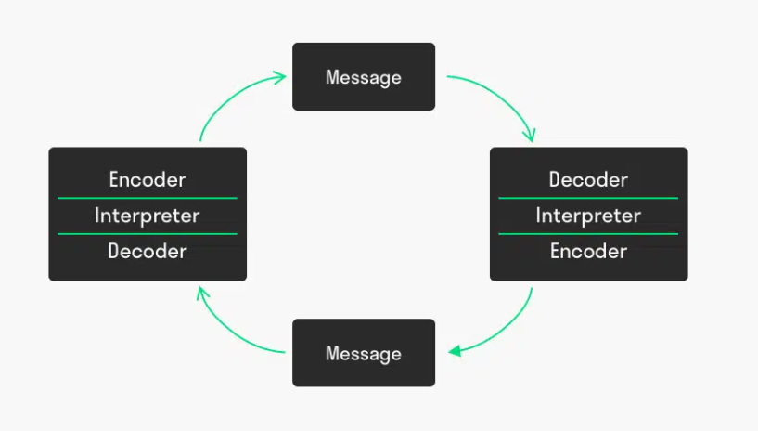
Figure -1: Schramms’ Communication Mode (Lin and Lin, 2020)
It is called intra-personal communication when it occurs between two or more people in the same room. It's the latter that we're referring to here. The Schramm Communication Model is circular in nature, in contrast to most other communication models and theories. As a result, at least two people are required to communicate. To be understood, a communication must be encoded and decoded by both the receiver and the sender. The person or thing who transmitted the communication is known as the sender. The source of the message must be obvious and able to illustrate to the recipient why they should read the message. Because of this, it is crucial that the person sending a message make certain that the data he or she offers is useful, relevant, and accurate. The specific group to whom a message is being sent is known as the communicator's recipient. A number of factors influence the message's decryption by the recipient.

Shannon & Weaver’s Model
This is a more technologically advanced model than some other linear models. The idea applies to interpersonal language, and it continues to have a significant influence on modern social sciences. It serves as the foundation for the majority of contemporary communication theories, and as such is sometimes referred to as "the mother of all models."
The Shannon-Weaver model defines five critical stages in the communication process as follows:
- The sender
- The encoder
- The channel
- The decoder
- The receiver
- Noise (Added later)

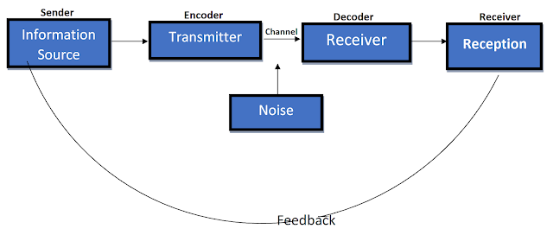
Figure -2: Shannon & Weaver’s Communication Model. (Blythe, 2010)
The sender is the individual, group, or organisation that initially considers the message they wish to deliver. The encoder converts this message to signals. In other ways, this is the method through which we communicate our thoughts. It can be expressed verbally or in writing, or through sign language or body language. Even the use of gifs and emojis is an encoding technique. The channel specifies the method by which the message is transmitted. This could be audio communicated over the radio as part of spoken dialogue, or numerical data transmitted electronically as part of an email or text message. Naturally, based on the medium, the sender and receiver may require communication devices such as phones or computers (Al-Fedaghi, 2012)Once received, the message must be decrypted. This stage outlines how the recipient perceives and translates the message into language. These two options are not mutually exclusive: a machine may be executing this function electrically using binary data or it may be a human brain catching up on all the language data that constitutes a conversation. Finally, the communication reaches the intended recipient, whose brain decodes it as significant. As a group, we all agree that the flow isn't always smooth, and communication is regularly slowed down. Consequently, noise is introduced into the Shannon-Weaver model. Anything that interferes with the model's channel phase is considered noise.

Berlo’s SMCR Model
Communication is made easier by Berlo's SMCR Model of Communication Model components are controlled by a different set of variables for each one. The sender and receiver must be on the same page in order for the message to be delivered successfully. This necessitates excellent communication skills. Additionally, factors such as culture, competence, and attitude are crucial. Some things that are deemed rude in one community may be acceptable in another. There are times when communication isn't as simple as one would like. Disruptions, noise, and an inconsistent process are just some of the things that might get in the way of proper communication (Muyanga and Phiri, 2020). Four components make up Berlo's SMCR Model, each of which describes a unique aspect of communication. The model's multiple components are affected by a variety of factors.
- Sender
- Message
- Channel
- Receiver

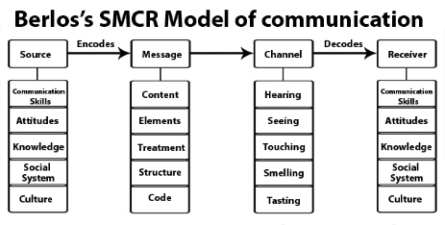
Figure -3: Berlo’s SMCR Communication Model ( Lin and Lin, 2020)

Asynchronous or synchronous communication processes are possible. An asynchronous connection or process is one in which the recipient is in direct communication with the sender. When the transmitter and receiver are not in direct contact, this is thought of as an asynchronous communication process. The disadvantage of asynchronous communication is that neither the sender nor the receiver receives immediate feedback on how the message is communicated. Additionally, it stops the statement from being modified, rendering it unable to fully clarify key points.

Communication Skills

Verbal Communication Skills

Clarity
Everyone benefits from effective communication skills, and clarity is not limited to content and pronunciation. It's about showing concern for the recipient and ensuring they receive the message. Failure to communicate clearly can hurt personal impressions and professional achievement. Your speech, professional opportunities, and relationships will all benefit from effective communication.

Empathy
In the job, being able to read other feelings and emotions is essential. Through it, we may better communicate with one another and our coworkers, clients, and consumers (Fielding, 2006). We may be confident in our ability to gain new technical skills, but we may lack the confidence to improve our interpersonal abilities. Even when it comes to talking about one's own sentiments, many people are embarrassed to do so.

Sincerity
Sincerity contributes to the effectiveness of communication. Sincerity is defined by simple phrases and direct language. When a person is sincere, he may be candid. When a guy is straightforward, he is capable of efficient communication. Being natural also facilitates the creation of a favourable atmosphere.

Maintaining Eye Contact
Eye contact might be imperceptible or even overt. This can be a severe glare when somebody is dissatisfied or a long stare when we notice anything about another person's appearance that is off. It can be a straight gaze when someone is attempting to communicate a critical point. Occasionally, the eyes and body language tell the real story. Maintaining eye contact with the individual demonstrates that he or she is paying attention and listening properly.

Non-Verbal Communication

Silence
In general, silence refers to the absence of all forms of noise. However, in communications, it is interpreted as a lack of speaking (Suter et al., 2009). Thus, the absence of voice does not imply that the individual is incapable of connecting with the other. Silence is an extremely effective mode of communication. The meaning of quiet varies according to circumstance.

Body Language
The human face is incredibly expressive, capable of conveying an infinite number of emotions without speaking a word. And, in contrast to several other nonverbal forms of communication, body language are universal. Happiness, sadness, rage, surprise, fear, and contempt all have universal facial expressions. Consider how the way people sit, move, stand, or carry their heads affects your perceptions of them. Movement conveys a lot of information to the surroundings. This nonverbal communication style encompasses posture, bearing, stance, and subtle gestures. Standing or sitting posture has a significant impact on sentiments and judgments because it provides a nonverbal cue to others about how people feel about them. Nonverbal communication, such as facial expressions, posture while standing or sitting, movements, and eye contact, convey a great deal about somebody.

Listening
When someone hears anything, they are regularly involved in passive listening. They anticipate that their brains will pick up on the key facts and retain them for subsequent recall. However, listening skills are a critical ability for effective communication. It takes practice to develop one's listening ability, but it will enhance one's capacity to link with others and raise one's capacity to retain knowledge.

Advantages of Technology in Communication
When compared to slower methods of communication like postal delivery, the true cost of communication via technology is comparatively low. As technology becomes more standardised and efficient, the price of communicating with it continues to fall. While interacting via technology enables one to locate and provide info to an employee or customer located anywhere. When one needs to communicate with an employee who is out in the field, he may text or email simple and complex information to his smartphone or tablet rather than forcing him to wait until the individual returns to the facility to get it (Bloom, 2014). Technology has simplified the process of documenting and archiving communication. One could save emails and other conversations and search them as required for future use by utilising databases and low-cost storage. Through the use of inexpensive cameras and videoconferencing services, one may conduct live video talks with people in several countries, a much more efficient and cost-effective choice than bringing all participants to a central place to meet.

Disadvantages of Technology in Communication
Technology is a significant source of distraction. With smartphones and tablets, we are constantly inundated with social media notifications, online discussions with pals, and text messages from a neighbour. This distraction can occasionally operate as a "time-waster," lowering productivity and cancelling out any boost in communication output brought about by technological advancements. Personal communication is harmed by the very nature of technology because it is brief and instantaneous and is not designed to convey feelings and emotion in the same way that face to face conversation is. Additionally, because technology is rapid and instant, it affects the accuracy of the elements being conveyed. At times, the tone and content of a digital message are misinterpreted (Sudweeks and Herring, 2001). Email and text messages allow us to communicate in terse, highly edited sentences that lack emotional depth and completely erase the context provided by the body language and tone language. This means that people who only communicate via technology may find it difficult to take part in normal conversation because they lack experience with non-pausable, modifiable, or controlled face-to-face engagement and hence struggle to understand non-verbal signs.

Example of Poor Communication
In my friend’s workplace, there has been an issue of misinterpretation and misunderstanding as there have been white a gap between the message that is conveyed and how it is received. This has created much effective communication and also cause many problems in terms of efficiency and productivity. To overcome the issue, proper interpretation from both parties is required to clear out the gaps that exist. Schramms’ communication model can be an efficient tool that can help to overcome the situation. This indicates that communication must be sent and received by at least two people (Fortunati et al., 2003). Both the sender and the recipient must encode and decode the message for it to be appropriately interpreted.

Conclusion
Multiple models should be used for effective communication since they improve the likelihood of a message being understood. The message is emphasised by the use of many models of communication, which reduces the likelihood of deformation. Good communication not only enables an individual to live a balanced life but also enables them to create strong work ethics, which enables them to build a successful jobs. Simple techniques like leaning forward to show attention in what the speaker has to offer it would go a long way toward building an imposing personality for someone who has learned them. Learning effective ways to communicate not only helps one's career prospects and self-confidence, but it also helps one's social life flourish.

References
Al-Fedaghi, S., 2012. A conceptual foundation for the Shannon-Weaver model of communication. International Journal of Soft Computing, 7(1), pp.12-19.
Bloom, N., Garicano, L., Sadun, R. and Van Reenen, J., 2014. The distinct effects of information technology and communication technology on firm organization. Management Science, 60(12), pp.2859-2885.
Blythe, J., 2010. Trade fairs as communication: a new model. Journal of Business & Industrial Marketing.
Fielding, M., 2006. Effective communication in organisations. Juta and Company Ltd.
Fortunati, L., Katz, J.E. and Riccini, R., 2003. Mediating the human body: technology, communication, and fashion. Routledge.
Lin, X. and Lin, C., 2020. Communication theories applied in mentimeter to improve educational communication and teaching effectiveness. In 4th International Conference on Culture, Education and Economic Development of Modern Society (ICCESE 2020) (pp. 870-875). Atlantis Press.
Muyanga, C.C. and Phiri, J., 2020. Assessment of Effective Communication in International Schools in Developing Countries Based on the Berlo’s SMCR Model. Open Journal of Business and Management, 9(1), pp.448-459.
Sudweeks, F. and Herring, S., 2001. Culture, technology, communication: Towards an intercultural global village. Suny Press.
Suter, E., Arndt, J., Arthur, N., Parboosingh, J., Taylor, E. and Deutschlander, S., 2009. Role understanding and effective communication as core competencies for collaborative practice. Journal of interprofessional care, 23(1), pp.41-51.

