
Student Name | Munwar Hussain
Student ID | 2532062
Programme | CertHE Computing Skills for Workplace
Module | Software Solutions for Business
Module code | ACCA4026
Lecturer | Anum Paracha
Assignment Title | Component 1- Coursework: Portfolio
Word Count | 4113

Table of Contents
Introduction 4
Task 1. E-Commerce Website builders or software solutions 4
1.1 WooCommerce 4
1.2 Wix 5
Task 2. Mind-map of contemporary software applications 6
a. Mind mapping and its benefits in business operations 6
b. Create a mind map of contemporary software applications 8
Task 3. Office Applications 8
a. Four office software solutions for business operations 8
b. Practical demonstration of Two Office Features 16
Task 4. Communication and Collaboration applications 20
a. One contemporary Communication and one Online Collaboration 20
b. One feature of Communication and one feature of a 25
Conclusion 25
References 27

List of Figures
Figure 1: Mind Mapping Example 6
Figure 2: Mind mapping using Mind Meister 8
Figure 3: Statistics of MS Word Users Globally 8
Figure 4: Mail Merge in MS Word 9
Figure 5: Microsoft Document Formatting 10
Figure 6: Track Changes and Comment Feature in MS Word 10
Figure 7: MS Powerpoint 11
Figure 8: Presentation Slide and Templates 12
Figure 9: Presenter View in MS Powerpoint 12
Figure 10: Calculations in MS Excel 13
Figure 11: Pivot Table in MS Excel 14
Figure 12: Example of Excel Data Visualisation 14
Figure 13: Relations in Access Database 15
Figure 14: Microsoft Outlook 20
Figure 15: Number of Office 365 users worldwide 2025 21
Figure 16: Outlook Features 21
Figure 17: Microsoft Teams 23
Figure 18: Microsoft Teams 23

Introduction
In the modern business environment, software applications have become increasingly useful in maintaining organisational efficiency through better communication and improved decision-making processes. According to Gade (2021), having appropriate software in businesses is essential to automate routine tasks and facilitate collaboration, which will minimise manual mistakes and improves actual decision-making. As a result, software in businesses has become crucial to solve complex problems, drive efficiency and innovation to adequately maintain customer engagement and create a competitive advantage (Adewusi et al., 2024).
This report is being processed to explore a range of contemporary software used by modern-day e-commerce businesses to understand their practical usages, strengths and weaknesses, which will help the audience to increase technical proficiency. The report is structured around 4 key sections, beginning with analysing the suitability of two popular e-commerce website builders in modern businesses. Then, in the next two sections, the mind-mapping concept and 4 office applications will be evaluated to understand their significance and practical usage in an organisational context. Lastly, multiple communication and collaboration tools will be examined to assess their impact on workplace interaction and overall organisational productivity.

Task 1. E-Commerce Website builders or software solutions

1.1 WooCommerce
WooCommerce is a free open source e-commerce platform, offering freedom for users to create new online stores through customisation of infinite themes, features and extensions, helping businesses in selling physical or digital goods (WooCommerce, 2026). One of the key benefits of this platform is its flexibility and customisation capability, built on WordPress, which individuals and businesses can use to tailor their product offerings based on customer demands (WooCommerce, 2026a). Moreover, this software offers a payment gateway integration feature, which allows online stores to ensure secure transactions by supporting credit cards, digital wallets and bank transfers (WooCommerce, 2026b). Thus, using these features, businesses can modify their online stores’ functionality and appearance, allowing them to boost customer engagement and satisfaction. Affordability is another key advantage of this tool, as adding this software costs nothing, and there is no need for fees while transactions happen between clients and their customers during sales (WooCommerce, 2026a). This makes WooCommerce the most affordable solution for starting an e-commerce business and effortlessly managing countless orders per day. Lastly, there is scalability, which is a key perk of the tool managing over 1lakh orders on a daily basis, supporting consistent growth (WooCommerce, 2026a).
However, besides the positive sides, there are some limitations of this tool as well, which can negatively impact business growth. For example, unlike Shopify or BigCommerce, the chosen tool is not fully hosted, instead self-hosted, meaning that it requires higher technical knowledge for installation, maintenance and managing security (Sims, 2018). Therefore, without proper IT expertise, managing WooCommerce can be challenging for businesses, as they can face challenges in managing updates and troubleshooting issues, affecting overall business performance.

1.2 Wix
Wix is a type of no-code website builder that allows users to develop professional websites by using customised website templates, drag-and-drop tools and AI-powered design features (WIX, 2026). This software is known for its user-friendly interface, which is centred on the drag-and-drop functionality, allowing users to develop professional websites without any coding experience (WIX, 2026).
One of the key advantages of Wix is its ‘ease of use’ as this software benefits from pixel-perfect customisation of websites with over 2000 pre-designed templates and built-in hosting (Wix, 2026a). Moreover, Wix’s free CRM software helps in automating personalised marketing workflows, triggering actions based on customer behaviours and managing transactions or any price negotiations (Chatham, 2026). These help small to large businesses in accelerating site launch, and get industry-specific functionality across restaurants, portfolios, or e-commerce with minimal technical involvement while ensuring customer satisfaction. Other key benefits involve built-in SEO and Marketing tools, as Wix offers social media integration, email marketing, customisable banners, meta-tags and URL structures (Tomasis, 2026). These advantages aid users in promoting websites and enhancing their search engine rankings to ensure consistent customer engagement and increase product or service adoption.
Despite the advantages, there are limitations as well, which might decrease the efficiency of businesses without proper oversight. For instance, flexibility is restricted in Wix compared to WooCommerce, since it restricts backend customisation. It is not possible for users to switch templates or edit them in a live site; there is a threat of losing present contents, requiring users to start over the website development process (Wix Support, 2026). Moreover, the load times of Wix websites often get delayed due to outdated CMS and high traffic, which can negatively impact SEO rankings of businesses (Arbiv, 2026). Hence, before utilising Wix, users should ensure an up-to-date CMS and lower traffic load to facilitate effective usage of the software.

Task 2. Mind-map of contemporary software applications

a. Mind mapping and its benefits in business operations
Mind Mapping is a powerful approach to arrange complex information and brainstorm ideas, supporting problem-solving about any central topic and its related themes, which are connected through branches (Mind Maps, 2026).
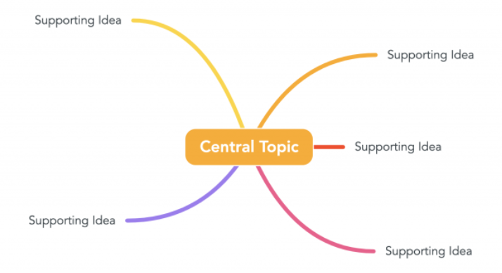
Figure 1: Mind Mapping Example
(Source: Mind Maps, 2026)
More particularly, it refers to a visual, non-linear technique for connecting and organising business ideas and information (Mind Maps, 2026). This is highly crucial for businesses as it simplifies complex business concepts and supports individual thinking by generating new ideas that solve issues effectively. Usually, mind mapping begins with a central idea, then one by one, key branch topics come out of it, which takes the form of a diagram, indicating relationships between the diverse elements, enhancing the problem-solving abilities of organisations.
Mind mapping offers several benefits in business operations, which are discussed below.
Firstly, Dong et al (2021) indicate that mind mapping facilitates creative problem-solving through visual, non-linear structures that map thoughts, enabling innovation. This advantage is particularly useful in strategic planning, developing marketing campaigns and facilitating team collaboration. Secondly, the incorporation of mind mapping amplifies information retention and understanding, especially through its visual organisation of key concepts (Jabade and Nadaf, 2024). This allows business leaders to engage both their logical and creative brain functions, which aids them in breaking down complex business information and generating creative solutions, ultimately strengthening project planning. Thirdly, mind mapping facilitates collaboration of workforces by offering a visually attractive and shared workspace to business entities (Jabade and Nadaf, 2024). Utilising digital mind mapping can help organisational team members to easily map processes, share real-time ideas and pinpoint any possible gaps in decision-making, which enhances organisational productivity (Jabade and Nadaf, 2024). However, the maps in mind mapping often become too complex to understand, becoming messy and often missing the ‘big picture’ (Buzan, 2024). As a consequence of the reduced clarity, team members often struggle to discover crucial insights and the ultimate goal, thereby hindering effective communication and collaboration (Buzan, 2024).
Moreover, from a critical perspective, the mind mapping frequently becomes too time-consuming compared to traditional note-taking or outlining processes, since it involves creating, structuring and organising detailed visual maps (Saxena, 2022). As a result, it delays strategic decision-making, thereby undermining organisational effectiveness. Organisations can easily address these limitations if they set clear objectives before mapping.
Despite the drawbacks, the incorporation of mind mapping is still highly advantageous to businesses since it facilitates innovation and collaborative problem-solving, which can jointly contribute to strategic decision-making.

b. Create a mind map of contemporary software applications
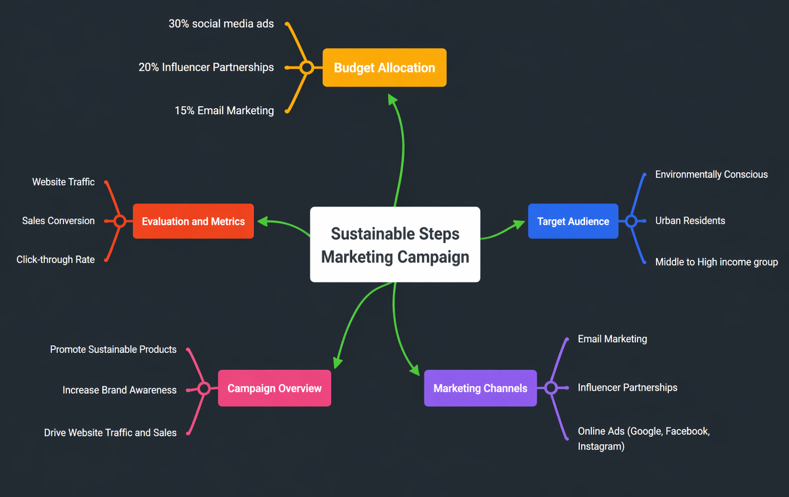
Figure 2: Mind mapping using Mind Meister
(Source: Mind Meister, 2026)

Task 3. Office Applications

a. Four office software solutions for business operations
MS Word
Microsoft Word is commonly known for its word processing software solutions including text manipulation and formatting documents across business operations serving over 1.2 billion users worldwide (DFS, 2026).
Figure 3: Statistics of MS Word Users Globally
(Source: DFS, 2026)
Worldwide, approximately 188,913 verified organisations use MS Word across diverse industries and markets to facilitate formal communication, documentation and reporting processes (Landbase, 2025). Hence, the widespread adoption indicates that this software is enabling a vast range of organisations to create, edit, format and share professional documents on a daily basis and ease business operations.
Features and Benefits
A key feature of MS Word is “Mail Merge”, which allows users to merge information, especially combining a single template document, such as a letter or email, with a structured data source like an Excel spreadsheet and a contact list (Microsoft, 2026).
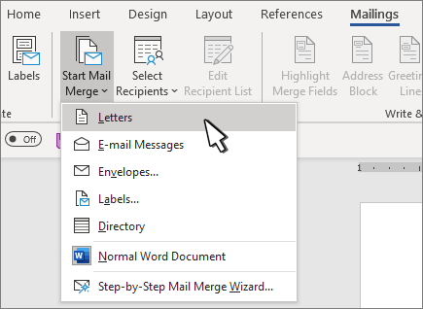
Figure 4: Mail Merge in MS Word
(Source: Microsoft, 2026a)
This feature supposedly benefits businesses to automate bulk creation of personalised emails, envelopes and labels for each recipient or client by reducing risks of manual errors (Microsoft, 2026). Another key feature of MS Word is “text formatting”, as it offers advanced built-in tools to stylise and format large amounts of text, aiding businesses to enhance readability in high-stakes documentations like contracts and reports (Popmintchev, 2025).
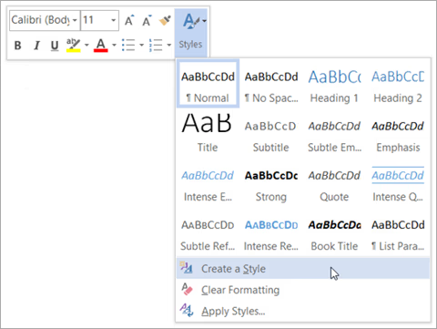
Figure 5: Microsoft Document Formatting
(Source: Microsoft Support, 2026)
This feature is highly advantageous to modern-day businesses as it allows them to maintain a consistent, high-quality presentation in documentation, which is crucial in professional communication (Prakash, 2025). In addition, there is a “Track Changes” and “commenting” feature, which allows multiple users to efficiently track, review and edit documents to make it suitable for professional works, thereby enhancing team collaboration (Baker et al., 2021).
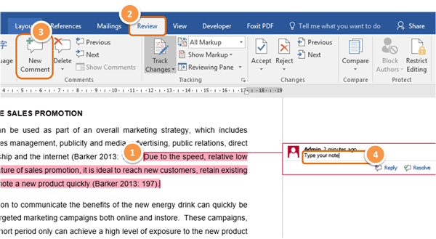
Figure 6: Track Changes and Comment Feature in MS Word
(Source: Test, 2023)
These two features benefit the organisational teams to cooperate and improve work standards, thereby boosting team productivity by reducing chances of errors in preparing professional documents, streamlining operations.
Limitations
Yet, despite the features and their benefits, there are some limitations within MS Word. For instance, complexity and difficulty can occur among inexperienced users in terms of managing advanced features such as referencing tools, mail merge and structured document formatting (Kruse and Rapp, 2023). As a consequence, a lack of MS word experience and knowledge can lead to errors through incorrect usage, contributing to inefficiencies and disrupting workflows. Another limitation can be its compatibility issues in document formats, as the documents shared across different versions or alternative software might not open and often disrupt format and layout (Microsoft Build, 2026). Therefore, businesses must provide proper training to its workers to proficiently use MS features and work with newer versions to avoid compatibility issues.
MS PowerPoint
Microsoft PowerPoint is a robust presentation software that empowers users to generate clean slideshow presentations by adding texts, images, charts and multimedia to efficiently communicate valuable information (Microsoft, 2026b).

Figure 7: MS PowerPoint
(Source: Microsoft, 2026b)
It is mostly used in business meetings, training sessions and sales pitches due to its user-friendly interface and integration, which enhances communication by creating engaging visual representations (Prakash, 2025).
Key Features and Benefits
One of the major features of MS PowerPoint are its “Slide Masters” and “Templates”. This allows organisations to maintain consistent branding across all company presentations such as sales & pitch or fundraising proposals by including attractive colours, fonts and logos into presentations (Microsoft, 2026c).
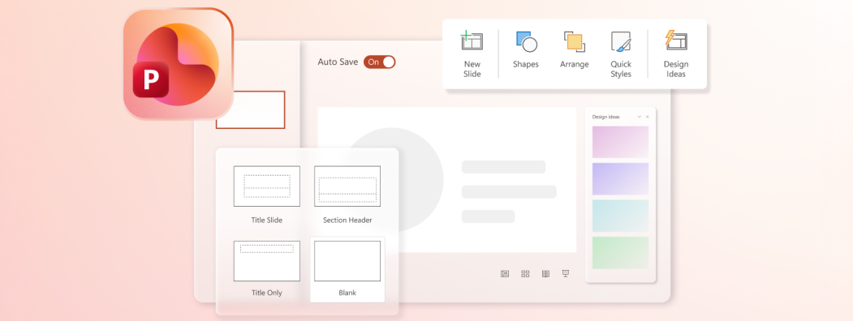
Figure 8: Presentation Slide and Templates
(Source: Microsoft, 2026c)
This feature benefits modern day organisations to consistently maintain a professional and eye-catching format of their presentation works whenever pitching to clients, helping them understand business offerings and values (Microsoft, 2026c). Moreover, organisations further benefitted with these features of MS PowerPoint as it allows them to build strong brand presentations without hiring special designers, which saves employment costs and extra time (Microsoft, 2026c). “Multimedia integration” is another crucial feature of MS PowerPoint, as it facilitates organisational teams to include images, videos, charts and animations into presentations, which makes them more engaging and easier to understand (Doukianou et al., 2021). Therefore, utilisation of this feature helps organisations to attract and convince clients or other business partners towards them, facilitating sales or fundraising.
Additionally, the “presenter view” also serves as a fundamental feature at MS PowerPoint, which allows presenters or business spokespersons to see detailed notes about the presentation slides and follow slide timers (Microsoft Support, 2026a).
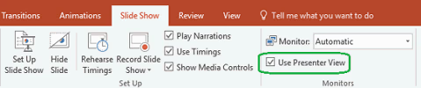
Figure 9: Presenter View in MS PowerPoint
(Source: Microsoft Support, 2026a)
This feature is highly beneficial for business operations as it aids business spokespersons to communicate company offerings and values to clients or other stakeholders through a polished and confident presentation in time (Microsoft Support, 2026a).
Overall, these features jointly help contemporary businesses to enhance communication and increase client retention.
Limitations
Besides the benefits of the software, there are limitations as well. For instance, organisations often become too reliant on presentation slides, which often backfire by making communication inefficient due to poor design or too text-heavy (Green, 2021). This can deliberately reduce communication effectiveness, reducing client engagement by limiting understanding. Moreover, creating attractive professional presentations with more styles, visuals and fonts can become time-consuming, which can delay the outcome, leading to missed market opportunities (Das et al., 2025). Thus, businesses must prioritise clarity in contents before designing slides to avoid communication breakdown.
Overall, despite the limitations, PowerPoint enhances business communication by delivering engaging and appealing organisational presentations.
MS Excel
Microsoft Excel is a great free spreadsheet software application, which makes business data more insightful by allowing users to make them properly organised, calculated and visualised (Microsoft, 2026e). The flexibility and functionality of MS Excel enables organisations to precisely calculate large amounts of numerical data and generate understandable insights that shape and support strategic planning (Okoli et al., 2022). Thus, by doing so this software becomes essential for businesses to drive development of informed decisions essential for growth.
Features and Benefits
One of the fundamental features of MS Excel is its formulas and functions such as IF, VLOOKUP and SUM, which jointly facilitates automated calculation of large datasets (Microsoft Support, 2026b).
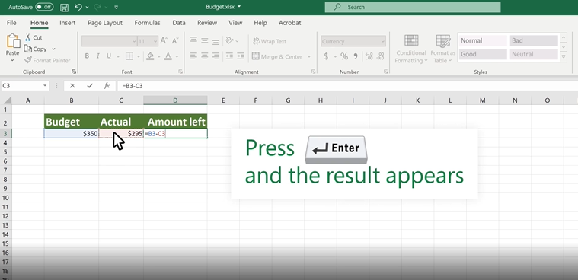
Figure 10: Calculations in MS Excel
(Source: Microsoft Support, 2026b)
Thus, with this feature, businesses get benefitted in calculating budgets, predicting sales and evaluating performance of employees, which optimises resource allocation and improves overall decision-making (Microsoft Support, 2026b). Another key feature of the software is its data analysis capability through ‘Pivot Tables’, which helps in summarising and comparing massive complex datasets and identification of quick trends without any manual calculations (Microsoft Support, 2026c).

Figure 11: Pivot Table in MS Excel
(Source: Microsoft Support, 2026c)
This feature in MS Excel benefits organisations to uncover the market trends, comprehend customer demands and tailor products and services to ensure maximum sales through impactful decision-making (Microsoft Support, 2026c). Additionally, Excel also supports data visualisation, which works as another key feature, enabling businesses to highlight charts and graphs about current market trends, yearly earning and sales volume (Microsoft Support, 2026d).
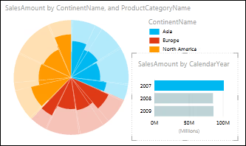
Figure 12: Example of Excel Data Visualisation
(Source: Microsoft Support, 2026d)
This feature contains multiple benefits for businesses as it summarises complex analysis of raw data, offers clear interpretation of trends, enabling businesses to track overall business performance and refine decision-making based on the insights (Al Maruf et al., 2022).
Limitations
However, despite the advantages, the software also has clear limitations. For example, one major drawback is data inaccuracy and errors from manual entries, which can cause miscalculations and lead to inaccurate financial or sales results (Gaoual et al., 2025). Additionally, excel often lacks scalability as it struggles to manage large amounts of datasets, which slow down the analysis process, delaying outcomes and decision-making (Merchant, 2022). Therefore, organisations need to consider using experienced workers and avoid extremely large datasets to maintain accuracy in results.
Overall, regardless of the limitations, MS Excel is still a useful tool for businesses considering its analytical and calculating capability, which enables data-driven decision-making.
MS Access
Microsoft Access is a user-friendly data-base management system (RDBMS), which is designed for storing, organising and managing larger datasets efficiently without any coding skill requirements (Microsoft, 2026f). It is useful for small to medium-sized businesses to manage inventories, track customer data and manage orders, thereby streamlining overall operations in a cost-effective way (Scaler, 2024).
Features and Benefits
‘Relational Database’ is one of the core feature of MS Access, enabling users to design tables and establish relationships between different data tables based on common fields, which prevents potential data duplication and ensure integrity (Microsoft Build, 2026a).
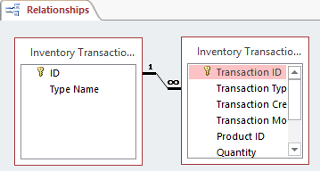
Figure 13: Relations in Access Database
(Source: Microsoft Build, 2026a)
This feature aids businesses to link related data from multiple large tables, which lowers chances of repetition in groups such as multiple customer’s addresses each time they place orders, thereby streamlining customer management (Microsoft Build, 2026a). Moreover, Querying is another important and useful feature, which grants organisational workers to filter, search and manipulate data across diverse tables and retrieve the needed information quickly (Microsoft Support, 2026e). Thus it benefits organisations to identify solutions of complex business concepts without any manual data manipulation.
Limitations
Besides the benefits, the software has several limitations as well, including scalability, as it only supports databases under 2GB file size, which make it unsuitable for high-volume data warehousing (Microsoft Support, 2026f). Moreover, the security features in MS access are quite basic due to lack of robust user-level permissions, making it vulnerable to security breaches and data theft (Microsoft Build, 2021). Therefore, organisations need to ensure multi-user access to manage storage after it exceeds 2 GB and utilise strong encryption to prevent data loss.
Overall, despite the drawbacks, MS Access can be still useful to organisations in organising and managing structured data while lowering data redundancies, making business decisions more accurate.

b. Practical demonstration of Two Office Features
Mail Merge
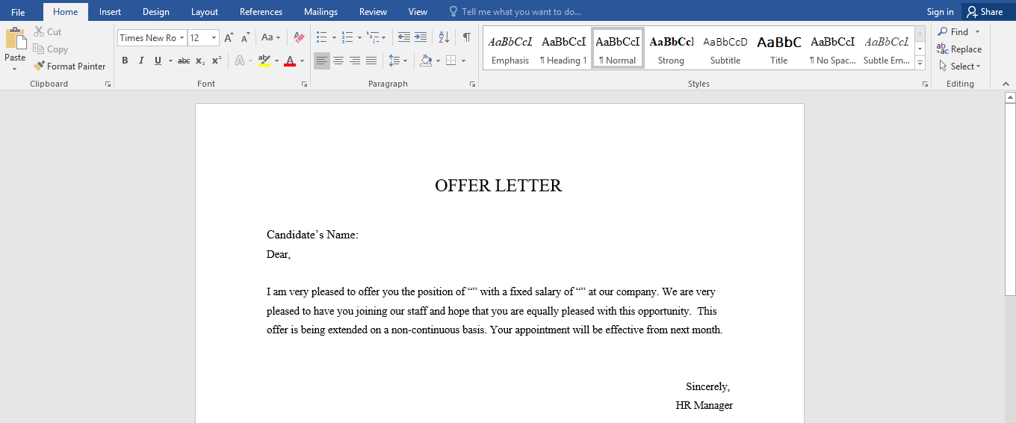
A Letter created in Word before merging it with spreadsheet
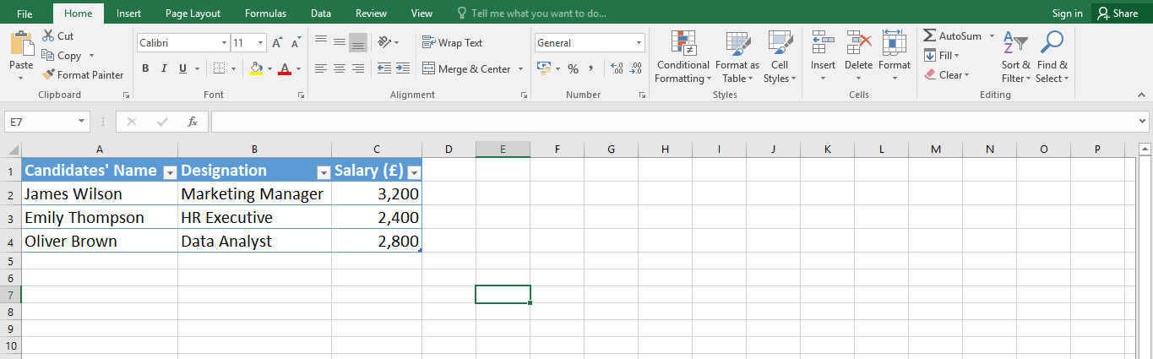
A spreadsheet created to merge with the letter created in MS Word
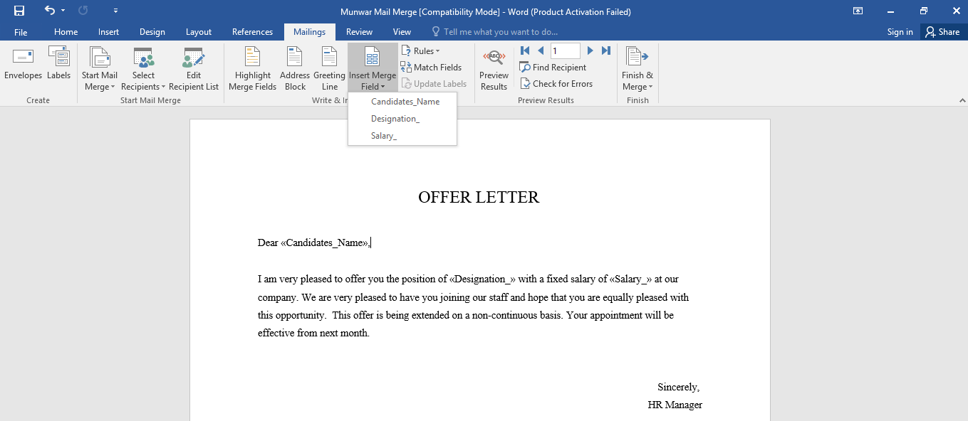
After merging the Excel Spreadsheet to the letter through Mail Merge
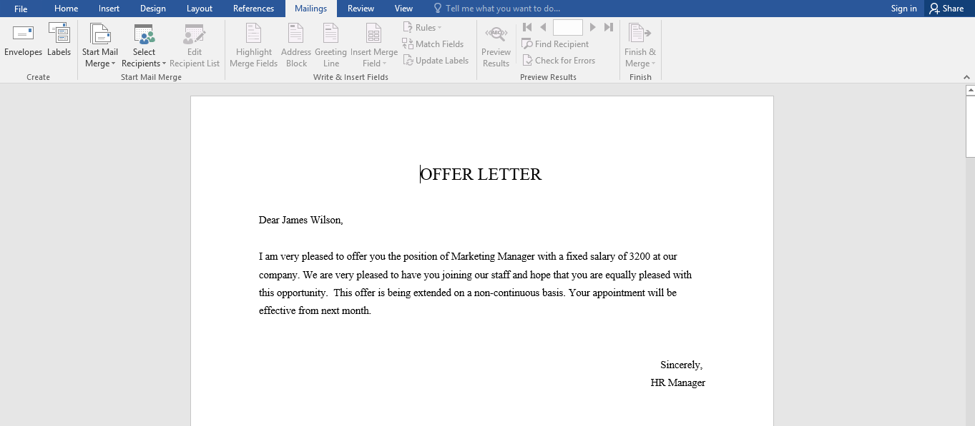
Result 1 after Finishing and Merging both MS Word and MS Excel Spreadsheet

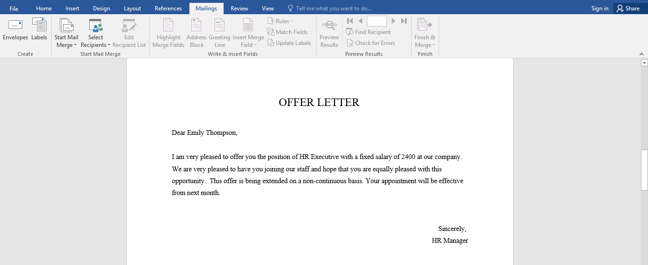
Result 2 after Finishing and Merging both MS Word and MS Excel Spreadsheet
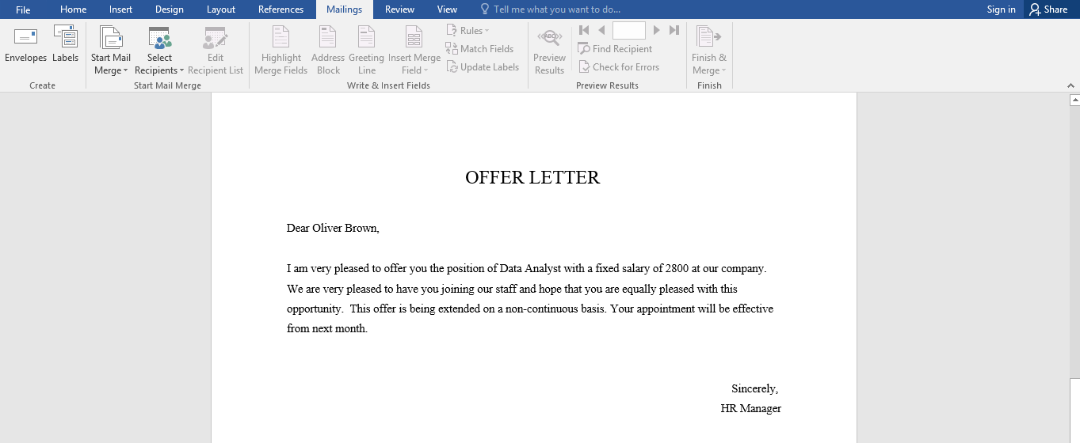
Result 3 after Finishing and Merging both MS Word and MS Excel Spreadsheet
If Statement
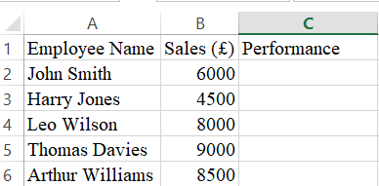
Full table before applying formula
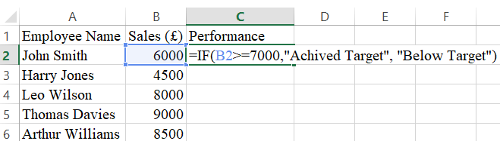
Applying IF function
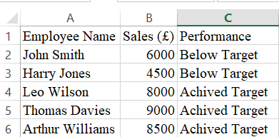
Final Output

Task 4. Communication and Collaboration applications

a. One contemporary Communication and one Online Collaboration
Applications/tools
MS Outlook
Microsoft Outlook is a commonly utilised communication application within the modern corporations, which is designed for managing emails, calendars, contacts and tasks within a single platform.
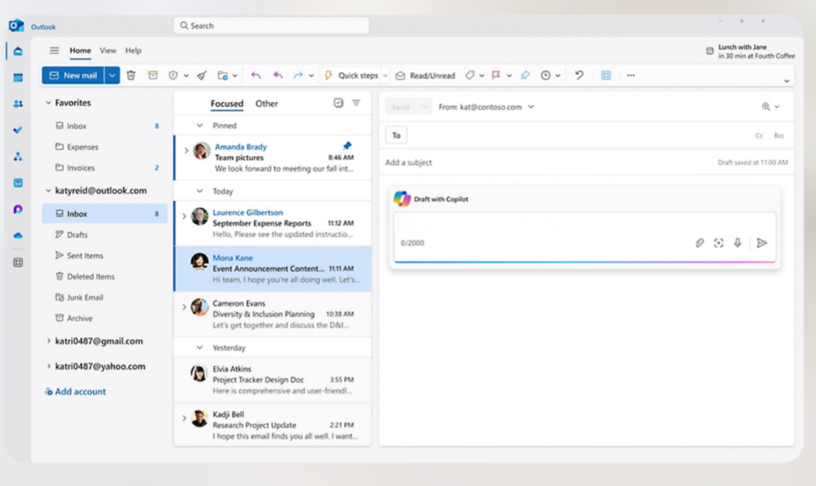
Figure 14: Microsoft Outlook
(Source: Microsoft, 2026)
As a part of the Microsoft 365 ecosystem, this provides support to both internal and external business communication, by making it a necessary tool for maintaining professional interactions and workflow efficiency (Wright and Gills, 2025).
One of the primary features of the Microsoft Outlook is its advanced email management system, which enables the users for sending, receiving, organising and prioritising emails very effectively. Functions, including folders, categories, rules and concentrated inbox mainly helps in filtering the important messages and reducing clutter. This ultimately improves productivity by allowing the employees for managing high volumes of communication efficiently. Additionally, it also offers calendar integration, which enables the users for scheduling meetings, setting reminders and sharing availability with colleagues. This feature is especially valuable in coordinating tasks and managing the time impact fully within the teams (ARYSON, 2026).
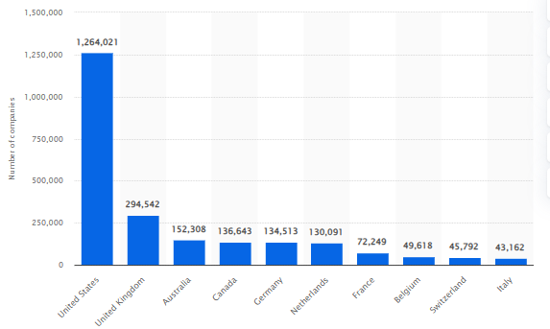
Figure 15: Number of Office 365 users worldwide 2025
(Source: Statista, 2025)
According to the reports, there are approx. 2 million people around the world who use Microsoft 365 daily due to business purposes (Statista, 2025).
Besides that, Microsoft Outlook’s other significant feature is its integration with other Microsoft applications, including Teams, OneDrive, and SharePoint. This enables the users for attaching files directly from the cloud storage and collaborates seamlessly. Moreover, outlooks also involve security features, such as encryption, phishing protection and spam filtering, which are crucial to protect sensitive organisational information and ensure safe communication (Microsoft Learn, 2025).
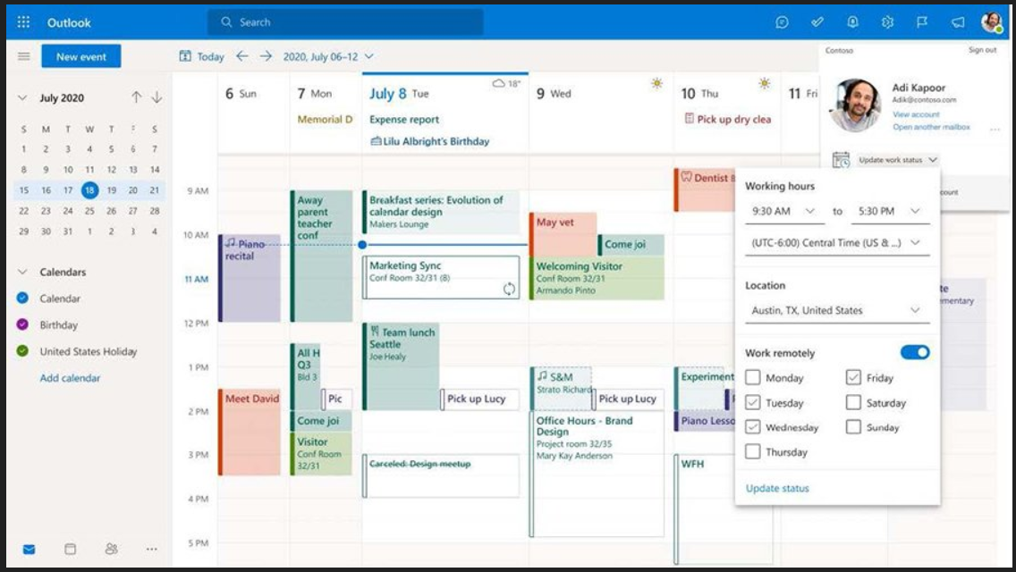
Figure 16: Outlook Features
(Source: Wright and Gills, 2025)
The benefits of the Microsoft Outlook are significant in a particular business context. For example, this application improves professional communication through a structured format to exchange information. Along with that, it also enhances efficiency within the organisation, since communication, task management and scheduling are integrated into one system. In addition, its cloud-based functionality provides support to remote accessibility, by allowing the employees for accessing emails and schedules from different devices and locations, which are necessary within the hybrid working environments (Lambert, 2021).
However, there are multiple limitations associated with Microsoft Outlook. For example, this application can be complicated for the new users, especially because of its wide range of features and options for configuration. Along with that, the application may have performance issues, including slow loading or delays in syncing, particularly during the time of dealing with large mailboxes or unstable internet connections. Moreover, some advanced features often require a paid subscription, which increases operational costs for the small businesses (Microsoft Learn, 2023).
From the critical perspective, while this application is highly impactful for formal and structured communication, it has been seen that it is also less suitable for real-time interaction, where the instant messaging tools can be more efficient. Other than that, over dependency on email communication can also lead to delays in decision-making and overload of information (Microsoft Learn, 2023). Thus, it can be interpreted that corporations often combine the Outlook application with the other platforms for achieving a balanced and comprehensive communication system which provides support to both asynchronous and real-time interactions.
MS Teams
Microsoft Teams is a cloud-based collaboration platform, which is broadly used within the modernistic organisations for supporting teamwork, communication and project coordination. It is also a part of Microsoft 365 environment, and integrates Microsoft tools into a single interface, allowing the employees for collaborating effectively regardless of their physical location (Microsoft Support, 2026).
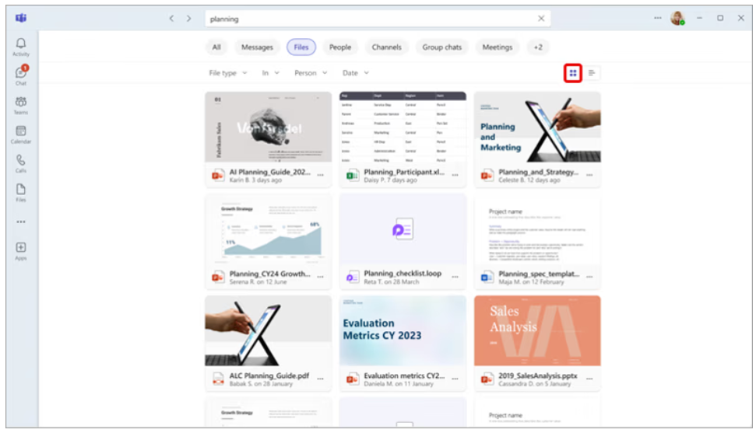
Figure 17: Microsoft Teams
(Source: Microsoft Support, 2026)
One of the core features of Microsoft Teams is its instant messaging and chat functionality, which enables the users for communicating in real time through individual and group conversations. This feature reduces dependency on the traditional email communication and allows faster decision-making. Additionally, this application also offers video conferencing and capabilities of virtual meeting, which helps the organisations in conducting meetings, webinars and training sessions remotely. Other than that, features, such as screen sharing, live captions and recording of meetings, enhances the clarity of communications and ensures impactful knowledge sharing across teams (Microsoft Learn, 2026).
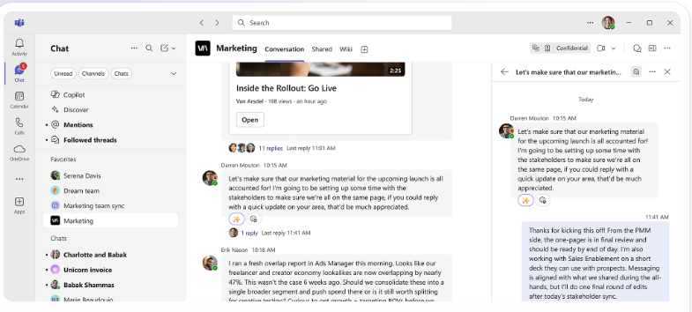
Figure 18: Microsoft Teams
(Source: Microsoft Support, 2026)
Moreover, another important feature is file sharing and co-authoring, where users can upload, share and edit documents collaboratively within the platform. Besides that, implementation with Microsoft Word, Excel and PowerPoint allows multiple users for working on the same document continuously for enhancing efficiency and reducing duplication of the work. Along with that, the Teams also provides channel-based organisation, where employees are enabled for conversation and the files and tasks are grouped under particular projects. This feature mainly helps in maintaining structure and ensuring that the information is easily available for all the team members (Microsoft Support, 2026).
In the context of Microsoft Teams’ benefits, they are significant for the successful business operations as it improves collaboration between the teams through the centralisation of communication and resources within one platform. Moreover, it also enhances productivity as the employees are allowed for accessing chats, documents and meetings without switching among several applications. In addition, this application supports the remote working environments for enabling the organisations for maintaining continuity and collaborating across geographically separated team members (Microsoft Learn, 2026).
Beside these advantages, Microsoft Teams also has some limitations. For example, one major issue is its information overload problem. Since continuous notifications and several channels overwhelm the users, it ultimately reduces concentration. Along with that, it has been seen that the platform relies heavily on a stable internet connection. Thus, poor connectivity may lead to disrupted meetings and communication (Microsoft Learn, 2025a).
Based on the critical perspective, while this application significantly enhances collaboration between teams, its effectiveness relies on proper maintenance and discipline of the users. Without clear communication guidelines, the platform can ultimately lead to confusion and reduced efficiency (Microsoft Learn, 2025a). Thus, it can be stated that the corporations must integrate structured usage of the policies and training for completely leveraging the capabilities of the Microsoft Teams while minimising the possible drawbacks.

b. One feature of Communication and one feature of a Collaboration application
MS Outlook
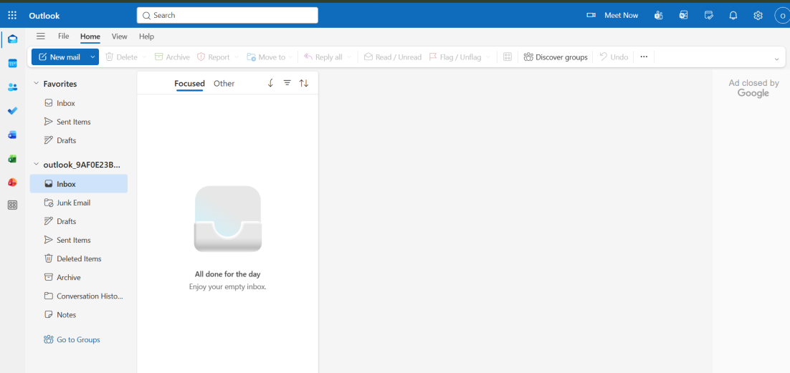
Screenshot of Microsoft Outlook
(Source: Microsoft, 2026a)
Ms Teams
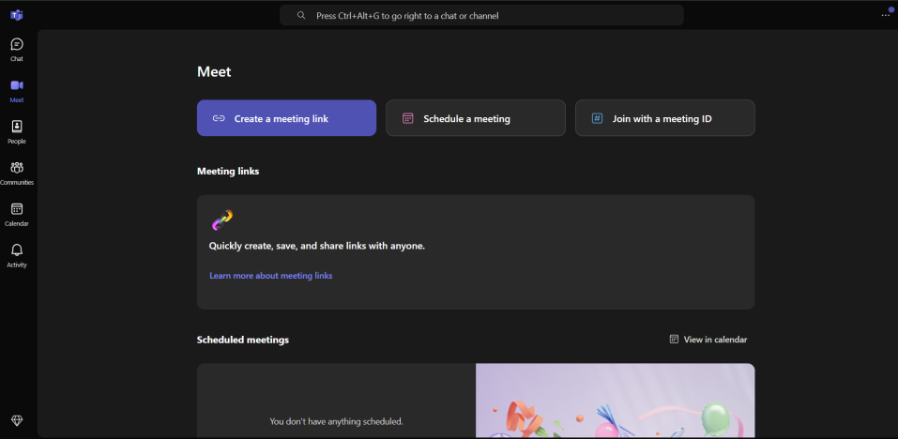
Screenshot of Microsoft Teams
(Source: Microsoft, 2026d)

Conclusion
To sum up the key findings, it can be implied that the software solutions are essential in streamlining modern business processes as they improve efficiency, communication and decision-making. Analysing two e-commerce platforms such as WooCommerce and Wix, it is found that both help organisations to develop scalable, cost effective and highly personalised online stores. Similarly, the exploration of Mind Mapping also highlights how businesses can innovate through enhancing organisational thinking, which allows collaboration among different organisational teams. The practical demonstration further clarifies the concept and its importance in lowering business complexity.
Moreover, the analysis of different office softwares such as MS Word, PowerPoint, Excel and Access, Outlook and Team indicates responsible utilisation of each tool can bring organisational growth through improved data-driven decision-making.

References
Adewusi, A. O., Okoli, U. I., Adaga, E., Olorunsogo, T., Asuzu, O. F., and Daraojimba, D. O. (2024). ‘Business intelligence in the era of big data: A review of analytical tools and competitive advantage’. Computer Science & IT Research Journal, 5(2), 415-431. https://www.researchgate.net/profile/Adebunmi-Adewusi/publication/378208076
Al Maruf, A., Paul, R., Imam, M. H., and Babar, Z. (2022). A Systematic Review of The Role Of SQL And Excel In Data-Driven Business Decision-Making For Aspiring Analysts. American Journal of Scholarly Research and Innovation, 1(01), 249-269. https://researchinnovationjournal.com/index.php/AJSRI/article/download/46/35 (Accessed: 15 April, 2026).
Arbiv, C. (2026). 11 common causes of slow loading websites. Available at: https://www.wix.com/blog/slow-loading-websites (Accessed: 15 April, 2026).
ARYSON. (2026). A Brief About Microsoft Outlook And Its Uses. Available at: https://www.aryson.in/software/outlook/ (Accessed: 15 April, 2026).
Baker, M. J., Nightingale, E. M., and Bills, S. (2021). An editing process for blind or visually impaired editors. IEEE Transactions on Professional Communication, 64(3), 275-287. Available at: https://www.mdpi.com/2078-2489/17/1/46 (Accessed: 15 April, 2026).
Buzan, T. (2024). Mind map mastery: The complete guide to learning and using the most powerful thinking tool in the universe. Jaico Publishing House. https://books.google.com/books
Chatham, A., B. (2026). The 13 most powerful online marketing tools by Wix. Available at: https://www.wix.com/blog/wix-marketing-tools (Accessed: 15 April, 2026).
Das, S., Malik, A., Tripathy, S. K., and Sahoo, M. (2025). How to Improve the Quality of PowerPoint Presentation to Achieve Maximum Learning. Research and Reviews in Pediatrics, 26(2), 31-36. Available at: https://journals.lww.com/rrp/_layouts/15/oaks.journals/downloadpdf.aspx?an=02273274-202505000-00002 (Accessed: 15 April, 2026).
Dong, Y., Zhu, S., and Li, W. (2021). ‘Promoting sustainable creativity: An empirical study on the application of mind mapping tools in graphic design education’. Sustainability, 13(10), 5373. Available at: https://www.mdpi.com/2071-1050/13/10/5373
Doukianou, S., Daylamani-Zad, D., and O’Loingsigh, K. (2021). ‘Implementing an augmented reality and animated infographics application for presentations: effect on audience engagement and efficacy of communication’. Multimedia Tools and Applications, 80(20), 30969-30991. https://link.springer.com/content/pdf/10.1007/s11042-021-10963-4.pdf (Accessed: 15 April, 2026).
Gade, K. R. (2021). ‘Data-driven decision making in a complex world’. Journal of computational innovation, 1(1). Available at: https://researchworkx.com/index.php/jci/article/download/2/2
Gaoual, Y., Aliat, Z., Cherif Chefchaouni, A., Mahyaoui, A., Merhom, O., and Rahali, Y. (2025). Mitigating Risks in Hospital Stock Management: A Structured Method for Validating Excel Files. Hospital Pharmacy, 60(6), 551-560. Available at: https://pmc.ncbi.nlm.nih.gov/articles/PMC12089115/ (Accessed: 15 April, 2026).
Green, E. P. (2021). Healthy presentations: How to craft exceptional lectures in medicine, the health professions, and the biomedical sciences. Springer Nature. https://books.google.com/books (Accessed: 15 April, 2026).
Jabade, M., and Nadaf, H. (2024). ‘Assessing the efficacy of mind mapping as a learning technique to enhance information retrieval in nursing students’. Journal of Education and Health Promotion, 13(1), 371. https://journals.lww.com/jehp/_layouts/15/oaks.journals/downloadpdf.aspx?an=01679914-202409280-00371
Kruse, O., and Rapp, C. (2023). Word processing software: The rise of MS Word. In Digital Writing Technologies in Higher Education: Theory, Research, and Practice (pp. 15-32). Cham: Springer International Publishing. Available at: https://link.springer.com/content/pdf/10.1007/978-3-031-36033-6_2.pdf (Accessed: 15 April, 2026).
Lambert, J. (2021) MOS Study Guide for Microsoft Outlook Exam MO-400. Microsoft Press. Available at: https://books.google.com/books?hl=en&lr=&id=TtfPEAAAQBAJ&oi=fnd&pg=PT8&dq=MS+Outlook+benefits&ots=RB6I-OUId6&sig=Qgl-G6C_RYlBPHAZ50_o6S0RxOQ (Accessed: 15 April, 2026).
Merchant, B. (2022). Microsoft Power BI Performance Best Practices: A comprehensive guide to building consistently fast Power BI solutions. Packt Publishing Ltd. https://books.google.com/books (Accessed: 15 April, 2026).
Microsoft Build, (2026). Word files saved as docx, won't let me open or change file format. Available at: https://learn.microsoft.com/en-us/answers/questions/4955455/word-files-saved-as-docx-wont-let-me-open-or-chang (Accessed: 15 April, 2026).
Microsoft Build. (2021). security concerns with access application. Available at: https://learn.microsoft.com/en-us/answers/questions/5133246/security-concerns-with-access-application (Accessed: 15 April, 2026).
Microsoft Build. (2026a). How to define relationships between tables in an Access database. Available at: https://learn.microsoft.com/en-us/troubleshoot/microsoft-365-apps/access/define-table-relationships (Accessed: 15 April, 2026).
Microsoft Lear. (2025a). Security guide for Microsoft Teams overview. Available at: https://learn.microsoft.com/en-us/microsoftteams/teams-security-guide (Accessed: 15 April, 2026).
Microsoft Learn. (2023). The New Outlook Limitations - Microsoft Q&A. Available at: https://learn.microsoft.com/en-us/answers/questions/4644911/the-new-outlook-limitations (Accessed: 15 April, 2026).
Microsoft Learn. (2025). Overview of OneDrive in Microsoft 365. Available at: https://learn.microsoft.com/en-us/sharepoint/onedrive-overview (Accessed: 15 April, 2026).
Microsoft Learn. (2026). Microsoft Teams service description. Available at: https://learn.microsoft.com/en-us/office365/servicedescriptions/teams-service-description (Accessed: 15 April, 2026).
Microsoft Support. (2026). Customize or create new styles. Available at: https://support.microsoft.com/en-gb/office/customize-or-create-new-styles-d38d6e47-f6fc-48eb-a607-1eb120dec563 (Accessed: 15 April, 2026).
Microsoft Support. (2026). What's new in Microsoft Teams. Available at: https://support.microsoft.com/en-us/office/what-s-new-in-microsoft-teams-d7092a6d-c896-424c-b362-a472d5f105de (Accessed: 15 April, 2026).
Microsoft Support. (2026a). Use Presenter View in PowerPoint. Available at: https://support.microsoft.com/en-au/office/use-presenter-view-in-powerpoint-fe7638e4-76fb-4349-8d81-5eb6679f49d7#:~:text=Try%20it!,From%20Beginning%20or%20press%20F5. (Accessed: 15 April, 2026).
Microsoft Support. (2026b). Overview of formulas in Excel. Available at: https://support.microsoft.com/en-gb/office/overview-of-formulas-in-excel-ecfdc708-9162-49e8-b993-c311f47ca173 (Accessed: 15 April, 2026).
Microsoft Support. (2026c). Create a PivotTable to analyze worksheet data. Available at: https://support.microsoft.com/en-us/office/create-a-pivottable-to-analyze-worksheet-data-a9a84538-bfe9-40a9-a8e9-f99134456576 (Accessed: 15 April, 2026).
Microsoft Support. (2026d). Charts and other visualizations in Power View. Available at: https://support.microsoft.com/en-us/office/charts-and-other-visualizations-in-power-view-141bd462-9853-4973-ac37-842e8345f51e (Accessed: 15 April, 2026).
Microsoft Support. (2026e). Introduction to queries. Available at: https://support.microsoft.com/en-us/office/introduction-to-queries-a9739a09-d3ff-4f36-8ac3-5760249fb65c (Accessed: 15 April, 2026).
Microsoft Support. (2026f). Access specifications. Available at: https://support.microsoft.com/en-us/office/access-specifications-0cf3c66f-9cf2-4e32-9568-98c1025bb47c (Accessed: 15 April, 2026).
Microsoft, (2026b). Microsoft PowerPoint. Available at: https://www.microsoft.com/en-in/microsoft-365/powerpoint (Accessed: 15 April, 2026).
Microsoft. (2026). Use mail merge for bulk email, letters, labels, and envelopes. Available at: https://support.microsoft.com/en-au/office/use-mail-merge-for-bulk-email-letters-labels-and-envelopes-f488ed5b-b849-4c11-9cff-932c49474705 (Accessed: 15 April, 2026).
Microsoft. (2026a). Use mail merge to personalize letters. Available at: https://support.microsoft.com/en-us/office/use-mail-merge-to-personalize-letters-d7686bb1-3077-4af3-926b-8c825e9505a3 (Accessed: 15 April, 2026).
Microsoft. (2026c). How to create on-brand PowerPoint presentation templates. Available at: https://www.microsoft.com/en-us/microsoft-365-life-hacks/presentations/how-to-create-on-brand-powerpoint-presentation-templates (Accessed: 15 April, 2026).
Microsoft. (2026d). Sign In | Microsoft Teams. Available at: https://www.microsoft.com/en-in/microsoft-teams/log-in (Accessed: 15 April, 2026).
Microsoft. (2026e). Microsoft Excel. Available at: https://www.microsoft.com/en-in/microsoft-365/excel (Accessed: 15 April, 2026).
Microsoft. (2026f). Microsoft Access. Available at: https://www.microsoft.com/en-in/microsoft-365/access#:~:text=Microsoft%20Access%20is%20a%20PC%2Donly%20application%20that,create%20apps%20from%20templates%20or%20from%20scratch. (Accessed: 15 April, 2026).
Mind Maps, (2026). What is Mind Mapping? What Are Its Uses?. Available at: https://www.mindmaps.com/what-is-mind-mapping/#:~:text=And%20mind%20maps%20provide%20a,projects%20into%20more%20manageable%20parts. (Accessed: 15 April, 2026).
Mind Meister. (2026). Map. Available at: https://www.mindmeister.com/app/map/3988086500 (Accessed: 15 April, 2026).
Okoli, I., Akinboboye, O., Frempong, D., and Omolayo, O. (2022). Optimizing academic operations with spreadsheet-based forecasting tools and automated course planning systems. International Journal of Multidisciplinary Research and Growth Evaluation, 3(4), 658-674. Available at: https://www.researchgate.net/profile/Olasehinde-Omolayo/publication/393866909 (Accessed: 15 April, 2026).
Popmintchev, D. (2025). Engineering and Scientific Manuscripts with Microsoft Word 2024. Dimitar Popmintchev. https://books.google.com/books (Accessed: 15 April, 2026).
Prakash, V. (2025). Office Tools for Efficient Documentation, Analysis, and Presentation. Addition Publishing House. https://books.google.com/books
Saxena, H. (2022). Enhancing Learning Experience with Augmented Mind Maps. https://researchportal.vub.be/files/94966867/ThesisHimanshiSaxena.pdf
Scaler. (2024). Microsoft Access. Available at: https://www.scaler.com/topics/ms-access/ (Accessed: 15 April, 2026).
Sims, L. (2018). Building Your Online Store With WordPress and WooCommerce: Learn to Leverage the Critical Role E-commerce Plays in Today’s Competitive Marketplace. Apress. https://books.google.com/books (Accessed: 15 April, 2026).
Tomasis, R. (2026). Why use Wix? Top benefits and advantages explained. Available at: https://www.wix.com/blog/why-use-wix (Accessed: 15 April, 2026).
Wix (2026a). Pick the Website Template You Love. Available at: https://www.wix.com/website/templates (Accessed: 15 April, 2026).
Wix Support. (2026). Switching Your Site Template. Available at: https://support.wix.com/en/article/switching-your-site-template (Accessed: 15 April, 2026).
WIX. (2026). What Is Wix? Everything you need to know about the website builder. Available at: https://www.wix.com/blog/what-is-wix (Accessed: 15 April, 2026).
WooCommerce, (2026a). Flexible ecommerce for high-volume stores. Built on WordPress. Available at: https://woocommerce.com/woocommerce-features/#:~:text=Built%20on%20WordPress.,%E2%80%9CI%20love%20Woo. (Accessed: 15 April, 2026).
WooCommerce. (2026). Your business. Your rules. Available at: https://woocommerce.com/woocommerce/ (Accessed: 15 April, 2026).
WooCommerce. (2026b). Results in Official payments. Available at: https://woocommerce.com/product-category/woocommerce-extensions/payment-gateways/?categoryIds=1023&collections=product&page=1 (Accessed: 15 April, 2026).
Wright, G. and Gillis, A. S. (2025). What is Microsoft Outlook?. TechTarget. Available at: https://www.techtarget.com/searchwindowsserver/definition/Microsoft-Outlook (Accessed: 15 April, 2026).

