Dynamic Stress and thermal response investigation for the Steven Impact Test Housing Faceplate.

Physics

Module code ACDB4007

Alex Clarke
2309711@student.uwtsd.ac.uk
Level 4 OME Course
July 2024


Table of Contents
1 Introduction 5
1.1 Steven Test 5
1.2 Johnson Cook model 5
2 Materials 7
2.1 Projectile 7
2.2 Faceplate 7
3 ABAQUS MODELLING 8
3.1 Parts 8
3.2 Parameters 9
3.3 Modelling results at 65 m/s 10
3.3.1 Rear faceplate and side cut response 10
3.3.2 Bolt hole response rear face 12
3.3.3 Velocity of projectile 14
3.3.4 Impact face Thermal response 14
3.4 Modelling results at 130 m/s 14
3.4.1 Rear faceplate and side cut response 14
3.4.2 Bolt hole response rear face 17
3.4.3 Velocity of projectile 18
3.4.4 Impact face Thermal response 18
4 Conclusion & Evaluation 18
5 References 20

Figure 1 Steven Test Assembly including faceplate. 5
Figure 2 Typical stress/ strain curve. 5
Figure 3 Projectile Part in ABAQUS 8
Figure 4 Face plate Part in ABAQUS 9
Figure 5 Assembly in ABAQUS 9
Figure 6 Projectile Velocity loading at 65 m/s 9
Figure 7 Projectile Velocity loading at 130 m/s 10
Figure 8 Assembly Meshing 10
Figure 9 65 m/s Initial impact side cut direct and shear stress. 11
Figure 10 65 m/s Initial impact rear face direct and shear stress 11
Figure 11 65 m/s Initial Midway through model cut direct and shear stress. 11
Figure 12 65 m/s Midway through model rear face direct and shear stress 12
Figure 13 65 m/s End of model side cut direct and shear stress. 12
Figure 14 65 m/s End of model rear face direct and shear stress 12
Figure 15 65 m/s initial impact bolt hole response. 13
Figure 16 65 m/s Midway through model bolt hole response. 13
Figure 17 65 m/s End of model bolt hole response. 13
Figure 18 65 m/s Projectile velocity. 14
Figure 19 65 m/s Thermal response 14
Figure 20 130 m/s Initial impact side cut direct and shear stress. 15
Figure 21 130 m/s Initial impact rear face direct and shear stress 15
Figure 22 130 m/s Midway through model side cut direct and shear stress. 15
Figure 23 130 m/s Midway through model rear face direct and shear stress 16
Figure 24 130 m/s End of model side cut direct and shear stress. 16
Figure 25 130 m/s End of the model rear face direct and shear stress 16
Figure 26 130 m/s initial impact bolt hole response 17
Figure 27 130 m/s Midway through model bolt hole response. 17
Figure 28 130 m/s End of model bolt hole response. 17
Figure 29 130 m/s Projectile velocity 18
Figure 30 130 m/s Thermal response 18

Table 1 AISI-1045 Steel Material properties 7
Table 2 AISI-1045 Steel Johnson Cook properties. 7
Table 3 DC01 Steel Material properties 8
Table 4 DC01 Steel Johnson Cook properties. 8
Table 5 Maximum Stress figures 19

Equation 1 Jonson-Cook Plasticity Model 6
Equation 2 Strain rate and temperature expanded 6
Equation 3 Johnson--Cook Damage model 6

Introduction
The aim of this report is for the learner to carry out Finite Element Analysis (FEA) using the ABAQUS software package to investigate the mechanical (direct and shear stress) and thermal response of the impact of a projectile at multiple velocities (65 and 130 meters per second) into a faceplate used in the Steven test. Sections 1.1 and 1.2 below define what the Steven test is and the Johnson Cook model used for high strain rate impacts within the ABAQUS software.

Steven Test
The Steven test is an impact test used to determine the reaction threshold for a contained explosive sample. A consolidated explosive sample is enclosed in a housing comprised of a back plate (housing), strong ring and face plate, to which a projectile is fired from a gas gun to impact on the faceplate of the housing. For the purpose of this investigation the learner will only be looking at the mechanical and thermal interaction of the projectile impacting the faceplate of the housing assembly highlighted in figure 1, rather than looking at the threshold response of the explosive material. The normal reaction threshold for a HMX based explosive formulation is between 62 and 65 m/s. ^{[1]}
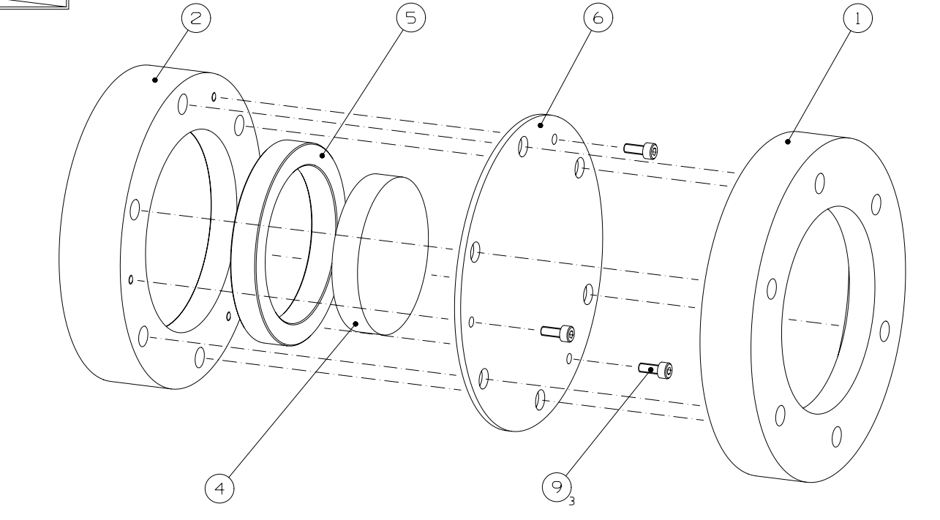
Figure 1 Steven Test Assembly including faceplate.

Johnson Cook model
Stress strain curves of a metal material can be broken down into three main regions and can be seen in figure 2 ^{[2]} Section A-B show the elastic response, B-C show the plastic response and C-D show the damage response of the material. Section C-D’ would be the response of the material if no damage had occurred.
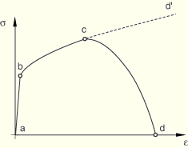
Figure 2 Typical stress/ strain curve.

For the modelling of the Steven test impact the ABAQUS software used the Johnson-Cook Plasticity model and the Johnson-Cook Damage model. These are both used as the model is used for large deformation, high stress, high strain rate and elevated temperatures. The Johnson-Cook Plasticity model (equation 1) shows the flow stress of the material whilst the Johnson-Cook Damage model (equation 3) shows the fracture strain of the material.^{[3]}
Equation 1 Jonson-Cook Plasticity Model
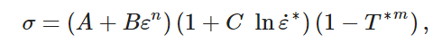
σ is the flow stress of the material.
A is the yield stress.
B is the strain hardening constant
C is the strengthening coefficient of strain rate
M is the thermal softening constant
In the model ἐ* and T* are explained below in equation 2.
Equation 2 Strain rate and temperature expanded.
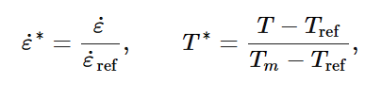
ἐ is the strain rate
ἐ_{ref} is the strain rate reference.
T is the temperature
T_{m} is the melting temperature of the material.
T_{ref} is the reference temperature.
Equation 3 Johnson--Cook Damage model.
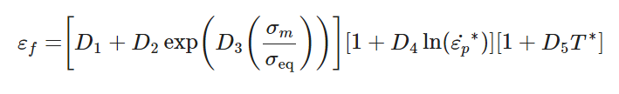
ε_{f} is the fracture strain.
D₁ -D₅ are the damage model constants.
σ_{m} is the mean stress.
σ_{eq} is the equivalent stress.

Materials
A literature review was carried out by the learner to determine the mechanical, thermal and Johnson Cook Plasticity and Damage model properties for each the projectile and the faceplate used in the ABAQUS model. Each source of information has been appropriately referenced in the reference section of this report.

Projectile
As per the drawing for the projectile ^{[4]} the material used for the projectile is carbon Steel to grade 080M40 (EN8/ BS970). During the literature review, the learner determined that they would not be able to find the relevant Johnson Cook parameters for the modelling using ABAQUS. AISI-1045 steel was chosen as an alternative material for modelling purposes as it had similar properties to the 080M40 Carbon steel. Table 1 and 2 show the material and Johnson Cook properties for AISI-1045 steel.
Table 1 AISI-1045 Steel Material properties
Material Properties ^{[5]} | Unit
Density | 7.87 g/cc
Elastic Modulus | 206 GPa
Poisson’s ratio | 0.29
Tensile strength ultimate | 515 MPa
Tensile strength yield | 485 MPa
Elongation at break | 10%
Specific heat capacity | 0.486 J/g °C
Thermal conductivity | 51.9 W/m-K

Table 2 AISI-1045 Steel Johnson Cook properties.
Johnson Cook Model Properties (Optimised model) ^{[6]} | Unit
A | 50.103 MPa
B | 176.091 MPa
n | 0.5176
C | 0.095
m | M
ἐ₀ | 1 s⁻¹
T^{m} | 1520°C
T⁰ | 0°C
Johnson Cook Damage Model Properties ^{[6]} | Unit
D1 | 0.025
D2 | 16.93
D3 | -14.8
D4 | 0.0214
D5 | 0

Faceplate
As per the drawing for the projectile ^{[7]} the material used for the test is Cold Pressed Carbon Steel DC01 (EN 10139 Grade DC01 work hardened (C390) - Low Carbon Steel) Table 3 and 4 show the material and Johnson Cook properties for DC01 steel.

Table 3 DC01 Steel Material properties
Material Properties ^{[8]} | Unit
Density | 7.87 g/cc
Elastic Modulus | 200-215 GPa
Shear Modulus | 82 GPa
Poisson’s ratio | 0.29
Tensile strength ultimate | 270-410 MPa
Tensile strength yield | >=280 MPa
Elongation at break | >=28%
Specific heat capacity | 465 J(kg.K)
Thermal conductivity | 22 W/ (m.K)

Table 4 DC01 Steel Johnson Cook properties.
Johnson Cook Model Properties ^{[9]} | Unit
A | 210 MPa
B | 360.3 MPa
n | 0.275
C | 0.02
m | 0.7
ἐ₀ | 0.0001 s⁻¹
T^{m} | 1792 K
T⁰ | 300 K
Johnson Cook Damage Model Properties ^{[10]} | Unit
D1 | 0.320
D2 | 0.201
D3 | -0.110

ABAQUS MODELLING

Parts
In the ABAQUS software package the learner created the parts for the projectile and the face plate of the Steven test using the dimensions and materials from the provided drawings ^{[4] [7]}. Figures 3, 4 and 5 show the projectile and face place parts along with the final assembly that was to be used during the modelling.
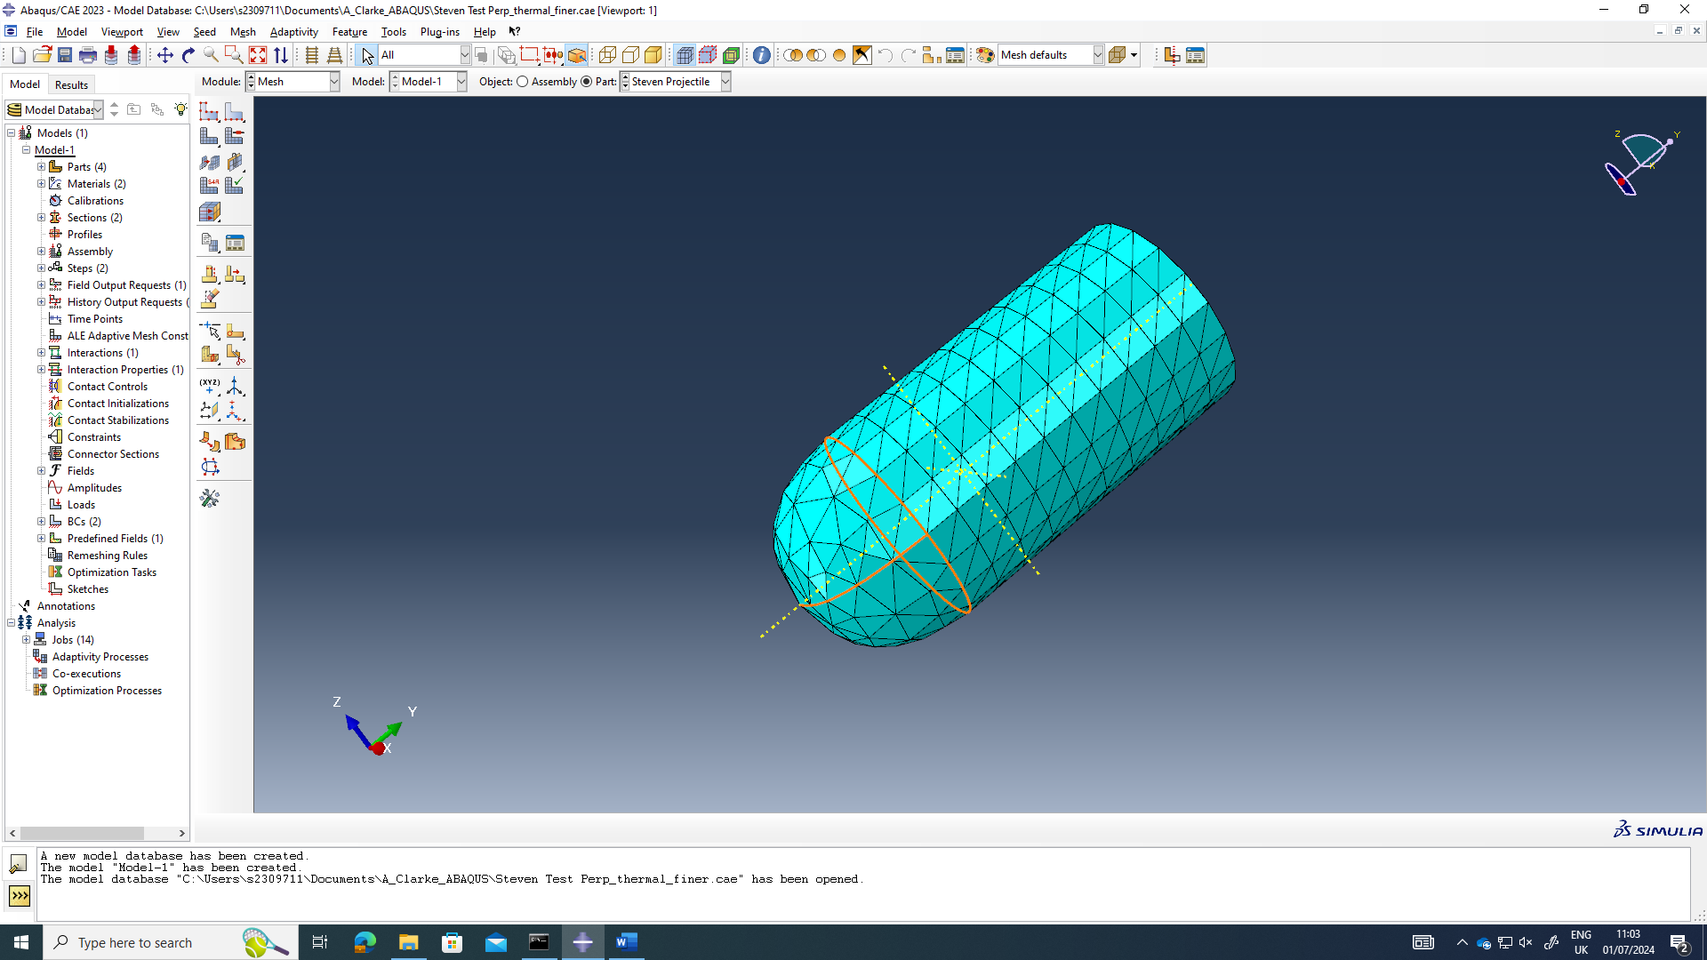
Figure 3 Projectile Part in ABAQUS
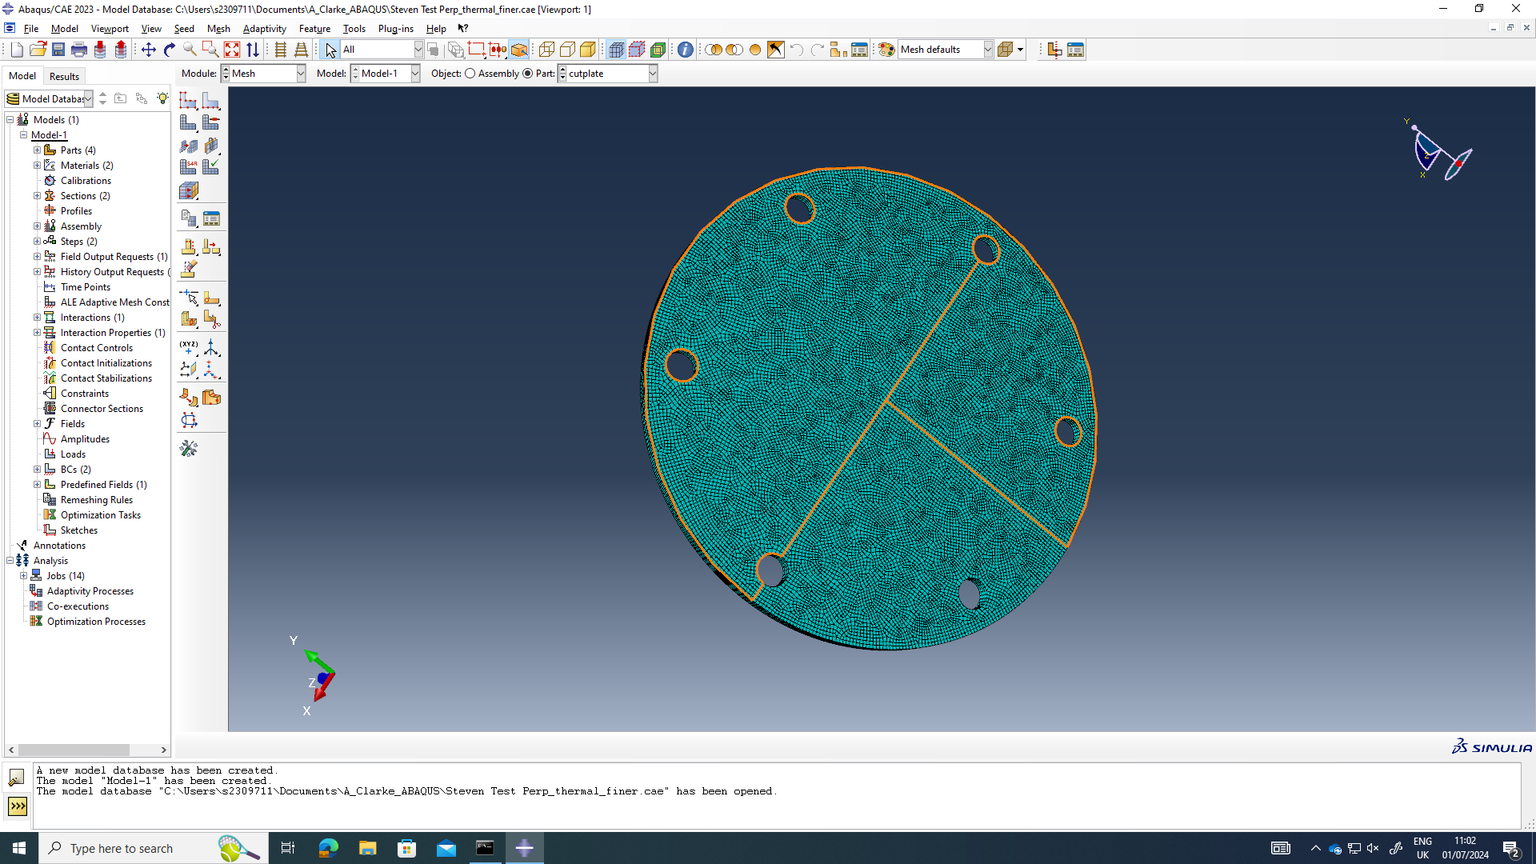
Figure 4 Face plate Part in ABAQUS
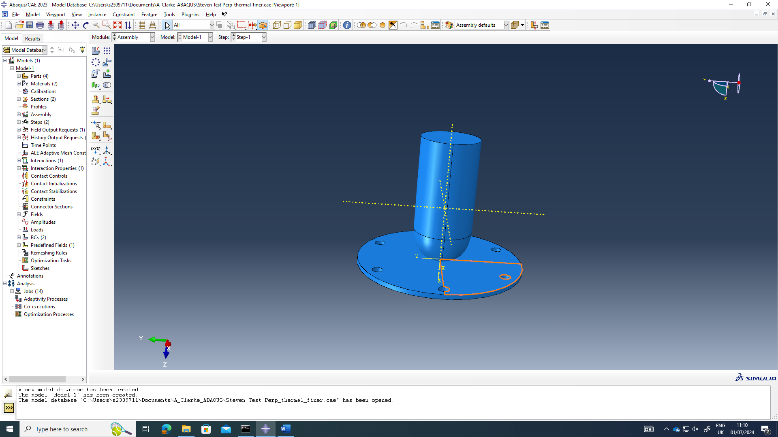
Figure 5 Assembly in ABAQUS

Parameters
As per the requirement set out in the assignment brief, the learner use two different velocities for the projectile during the modelling. Everything else about the modelling including the selected materials properties and dimensions are the same but the two different velocities selected where 65 and 130 meters per second (m/s). Figures 6 and 7 show the orange arrows show velocity loading of the individual nodes in the Z axis direction for the projectile at 65 m/s and 130 m/s.
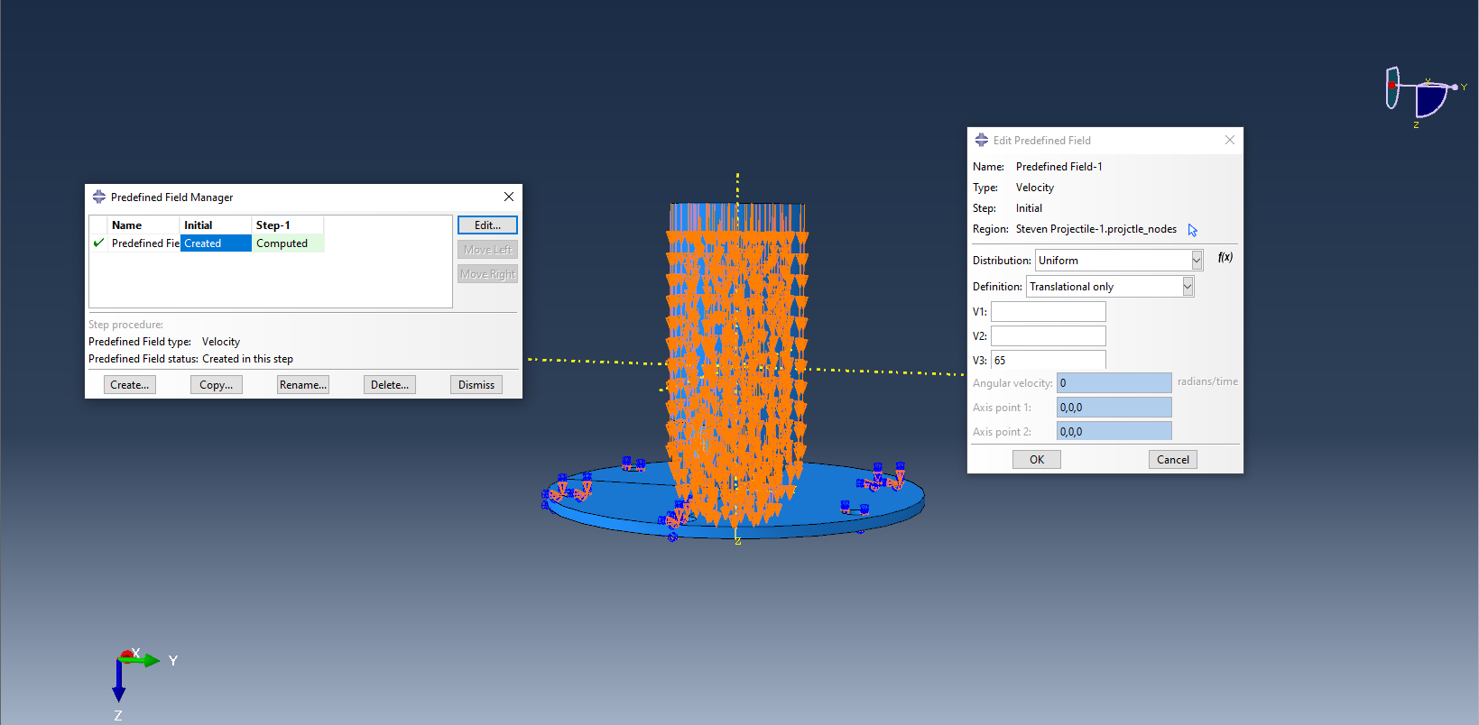
Figure 6 Projectile Velocity loading at 65 m/s

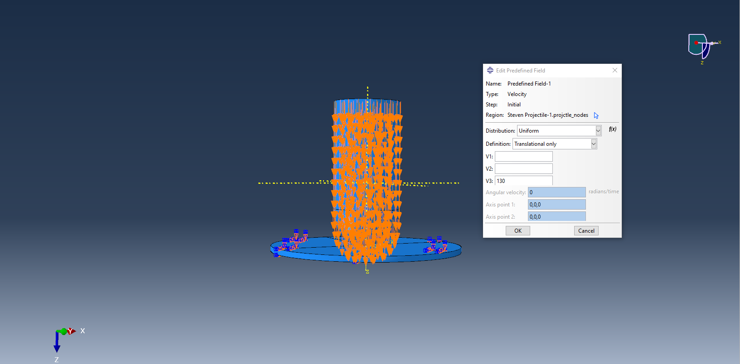
Figure 7 Projectile Velocity loading at 130 m/s
To create the effect of bolts holding the face plate in place, boundary conditions were applied to each of the 6 bolt holes on the face plate. This can be seen in figure 6 and 7 on the blue faceplate section of the assembly. Data capture frequency for the model was set at every 0.001 Milliseconds running for 0.5 Milliseconds.
A finer mesh was applied to the faceplate compared to the projectile. This was because the leaner was more interested in the dynamic stress being applied for this scenario. Figure 8 shows the mesh applied to the assembly.
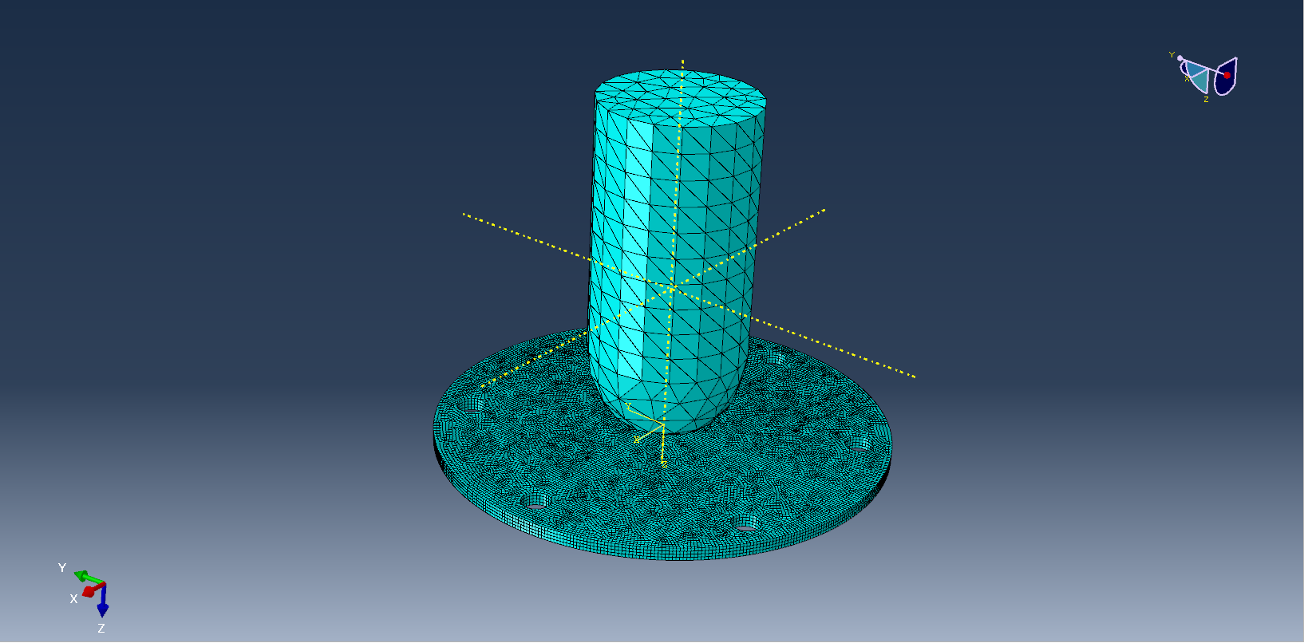
Figure 8 Assembly Meshing

Modelling results at 65 m/s

Rear faceplate and side cut response
Figures 9 and 10 show the initial impact response of the projectile to the face plate with a side cut view and the rear of the face plate. Each figure shoes the direct stress (tension/compression) on the left image and the shear stress of the right image.
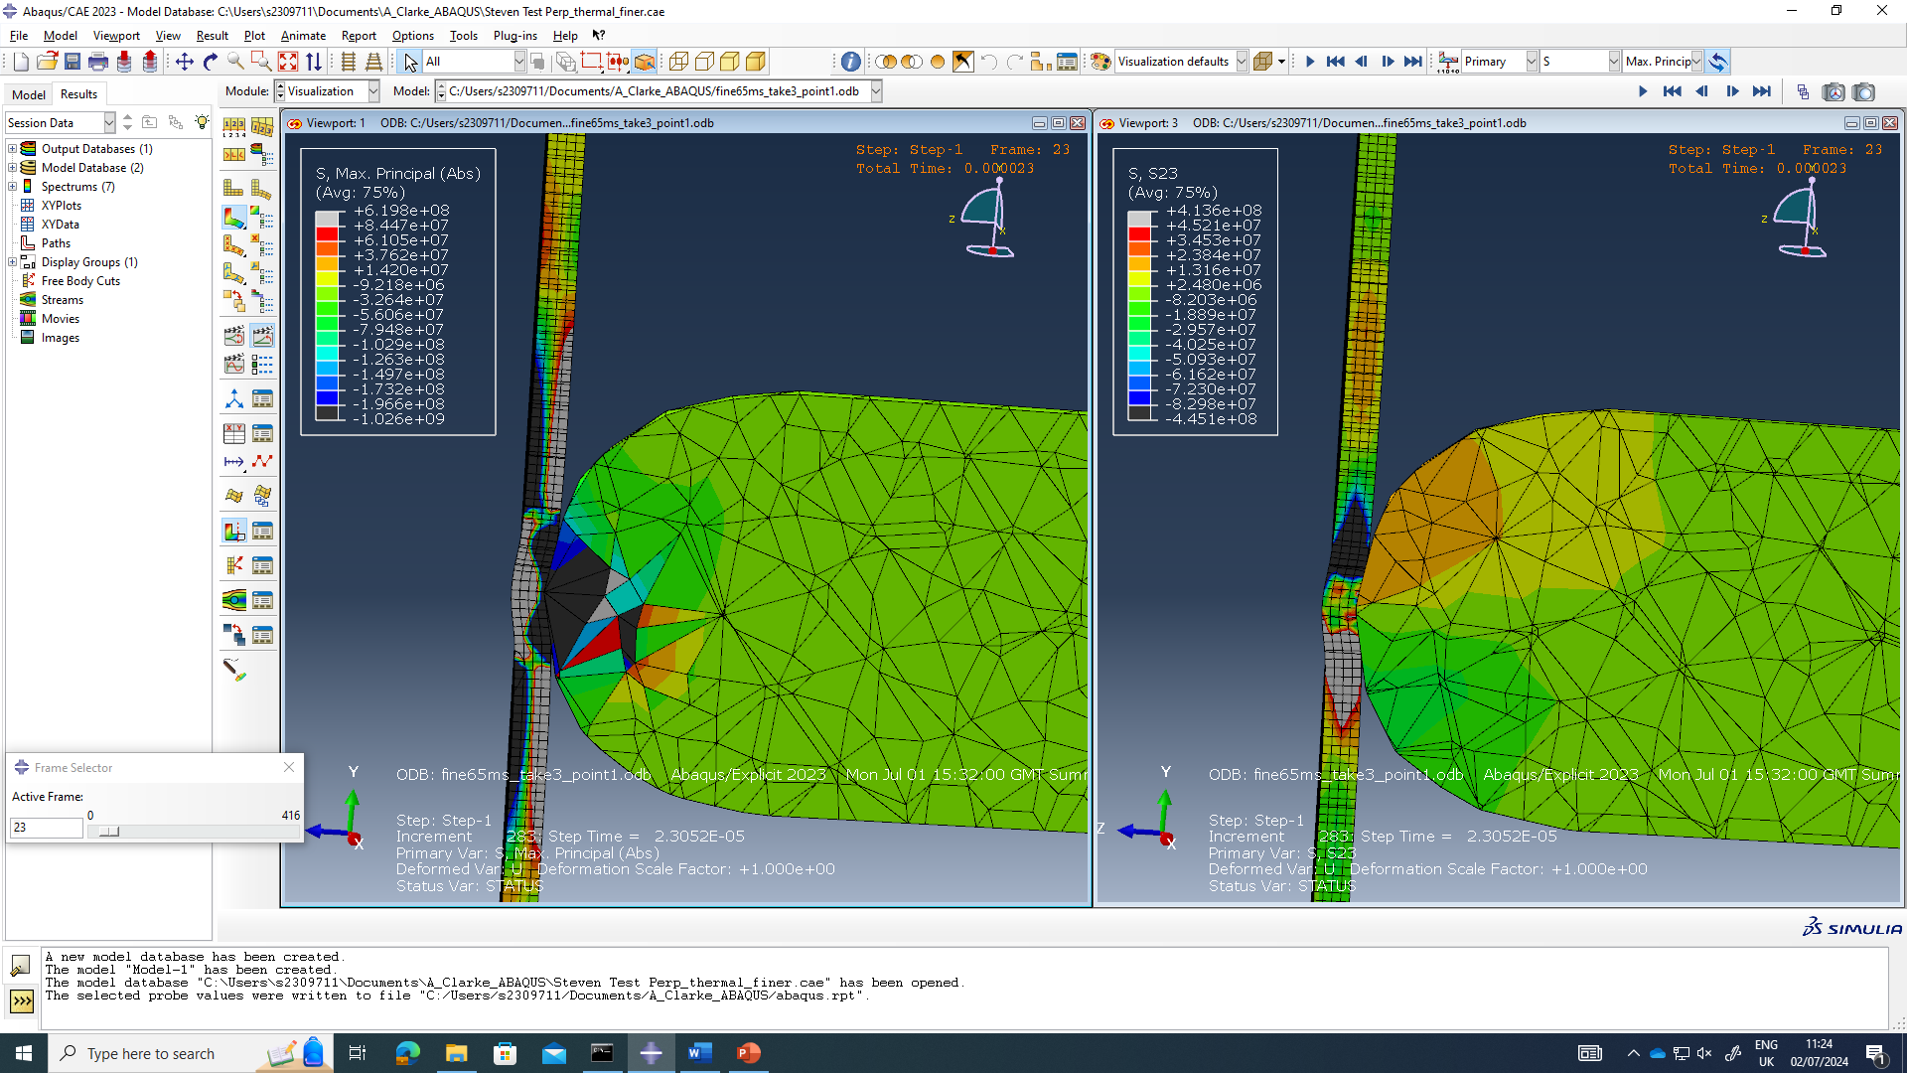
Figure 9 65 m/s Initial impact side cut direct and shear stress.
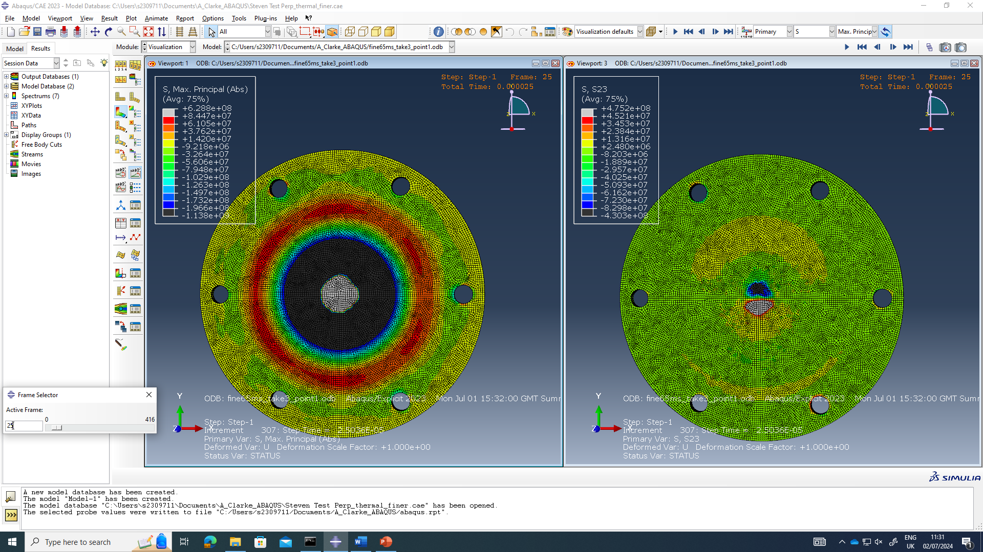
Figure 10 65 m/s Initial impact rear face direct and shear stress
Figures 11 and 12 show the impact response of the projectile to the face plate midway through the model with a side cut view and the rear of the face plate. Each figure shoes the direct stress (tension/compression) on the left image and the shear stress of the right image.
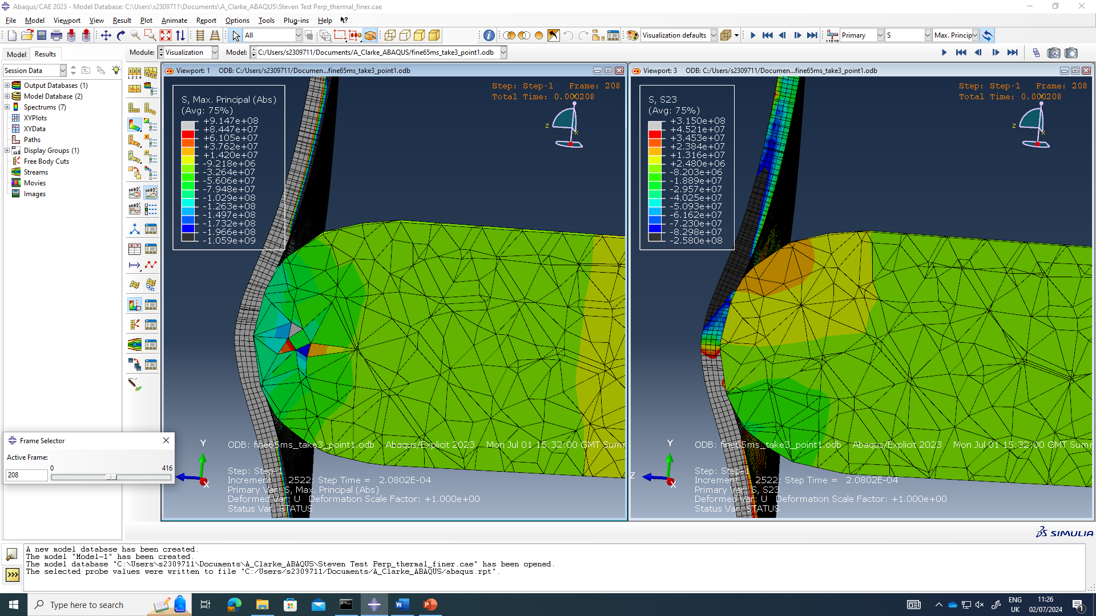
Figure 11 65 m/s Initial Midway through model cut direct and shear stress.
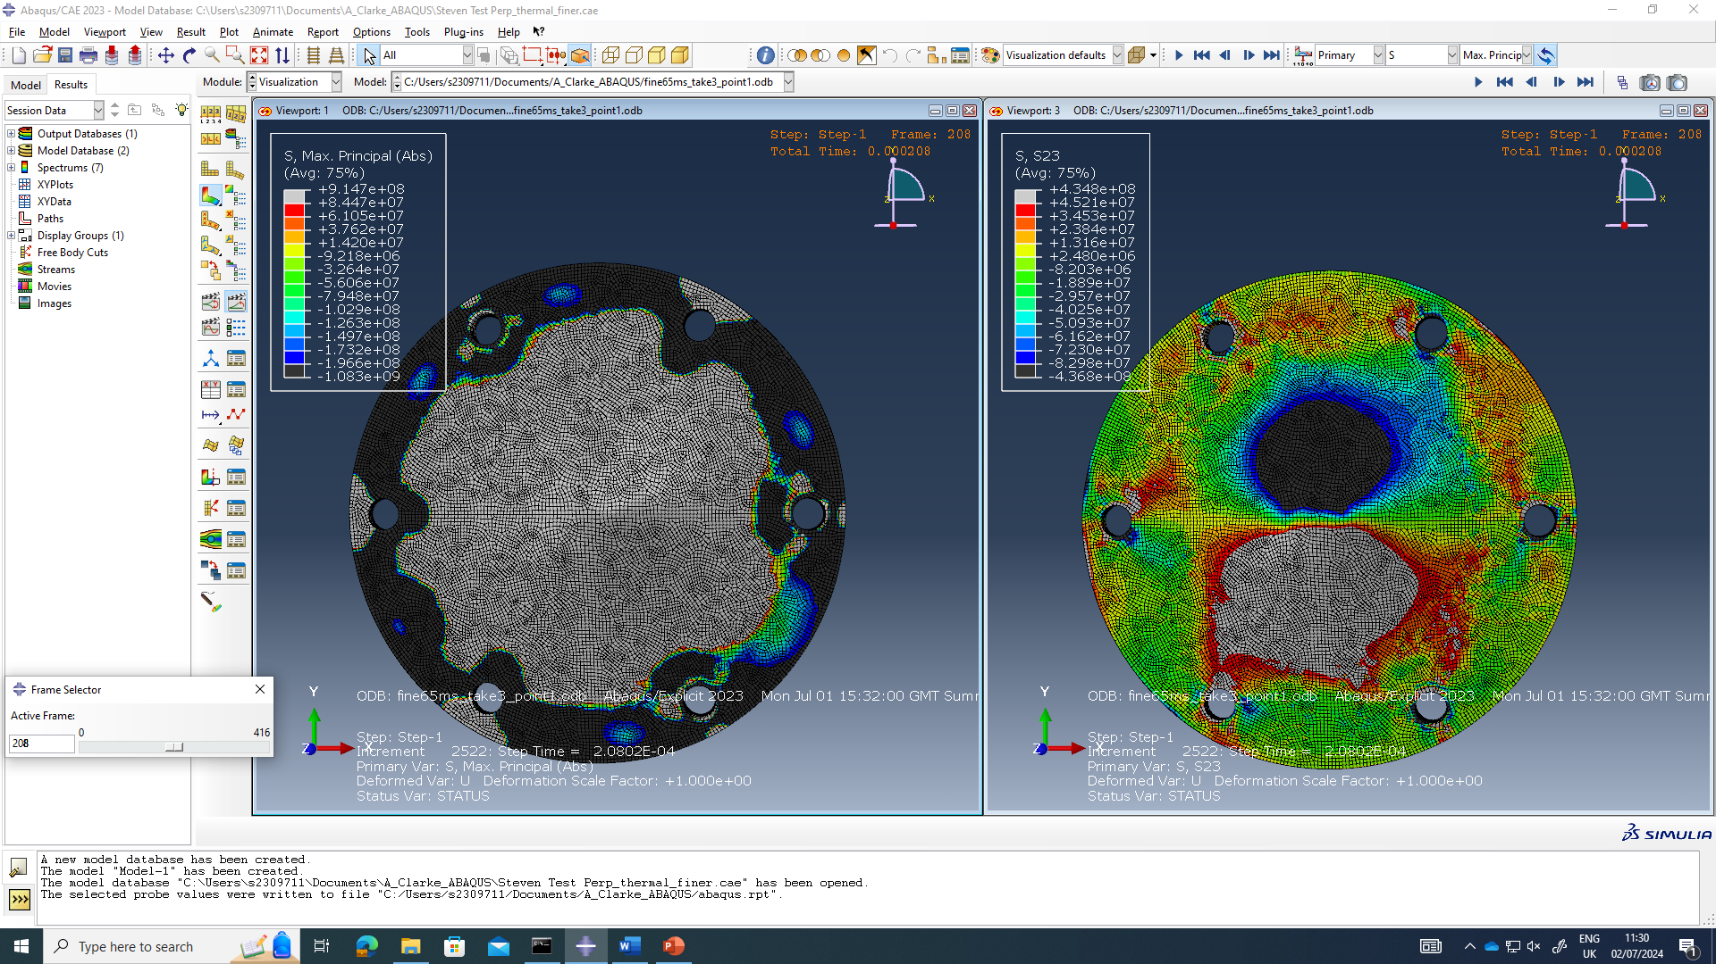
Figure 12 65 m/s Midway through model rear face direct and shear stress
Figures 13 and 14 show the impact response of the projectile to the face plate at the end of the model with a side cut view and the rear of the face plate. Each figure shoes the direct stress (tension/compression) on the left image and the shear stress of the right image.
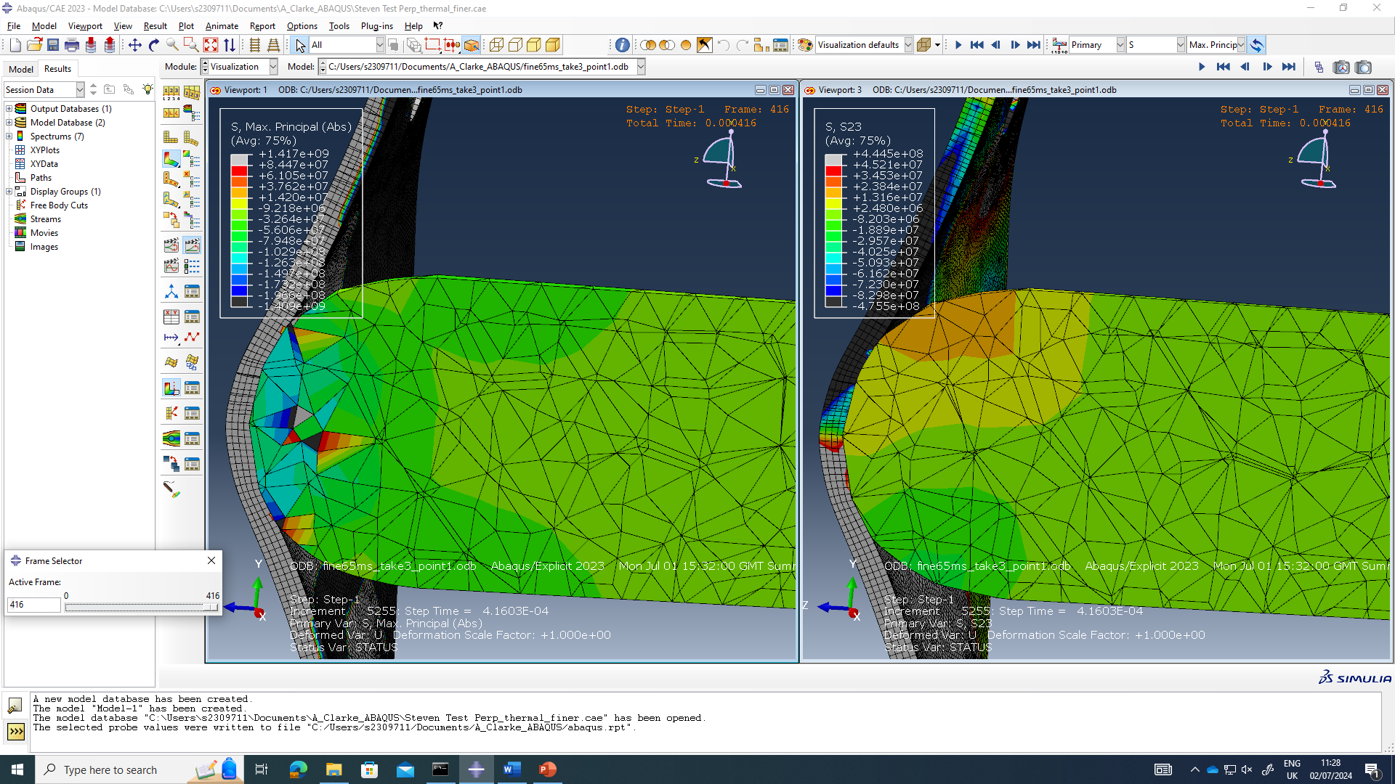
Figure 13 65 m/s End of model side cut direct and shear stress.
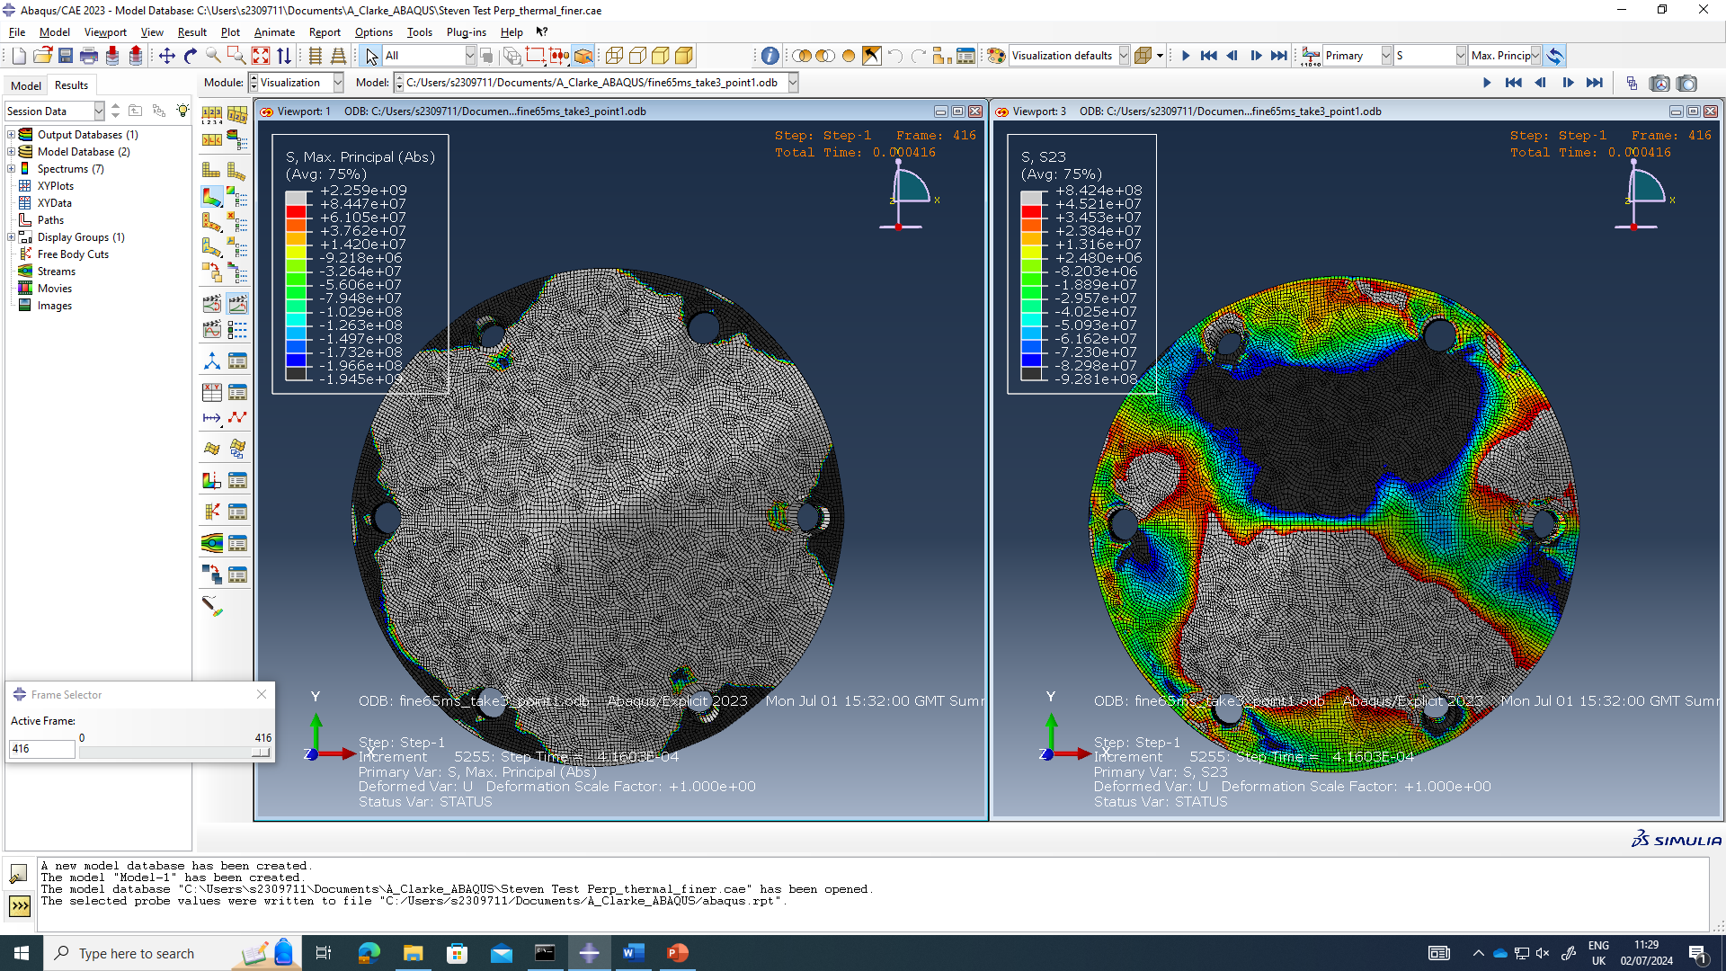
Figure 14 65 m/s End of model rear face direct and shear stress

Bolt hole response rear face
Figures 15, 16 and 16 show the direct stress response on the bolt holes on the rear face of the plate; along with the stress response plotted around the circumference of the inner face of the bolt hole for the initial impact, midway through and the end of the model.
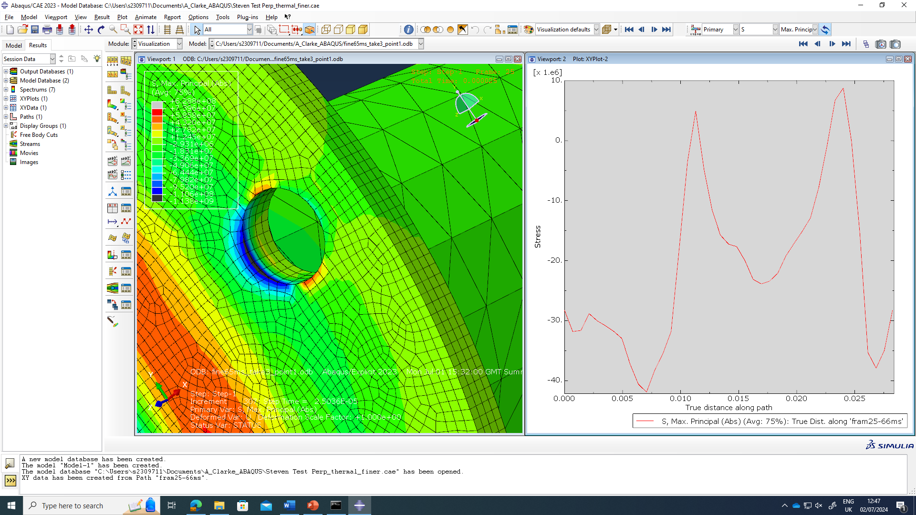
Figure 15 65 m/s initial impact bolt hole response.
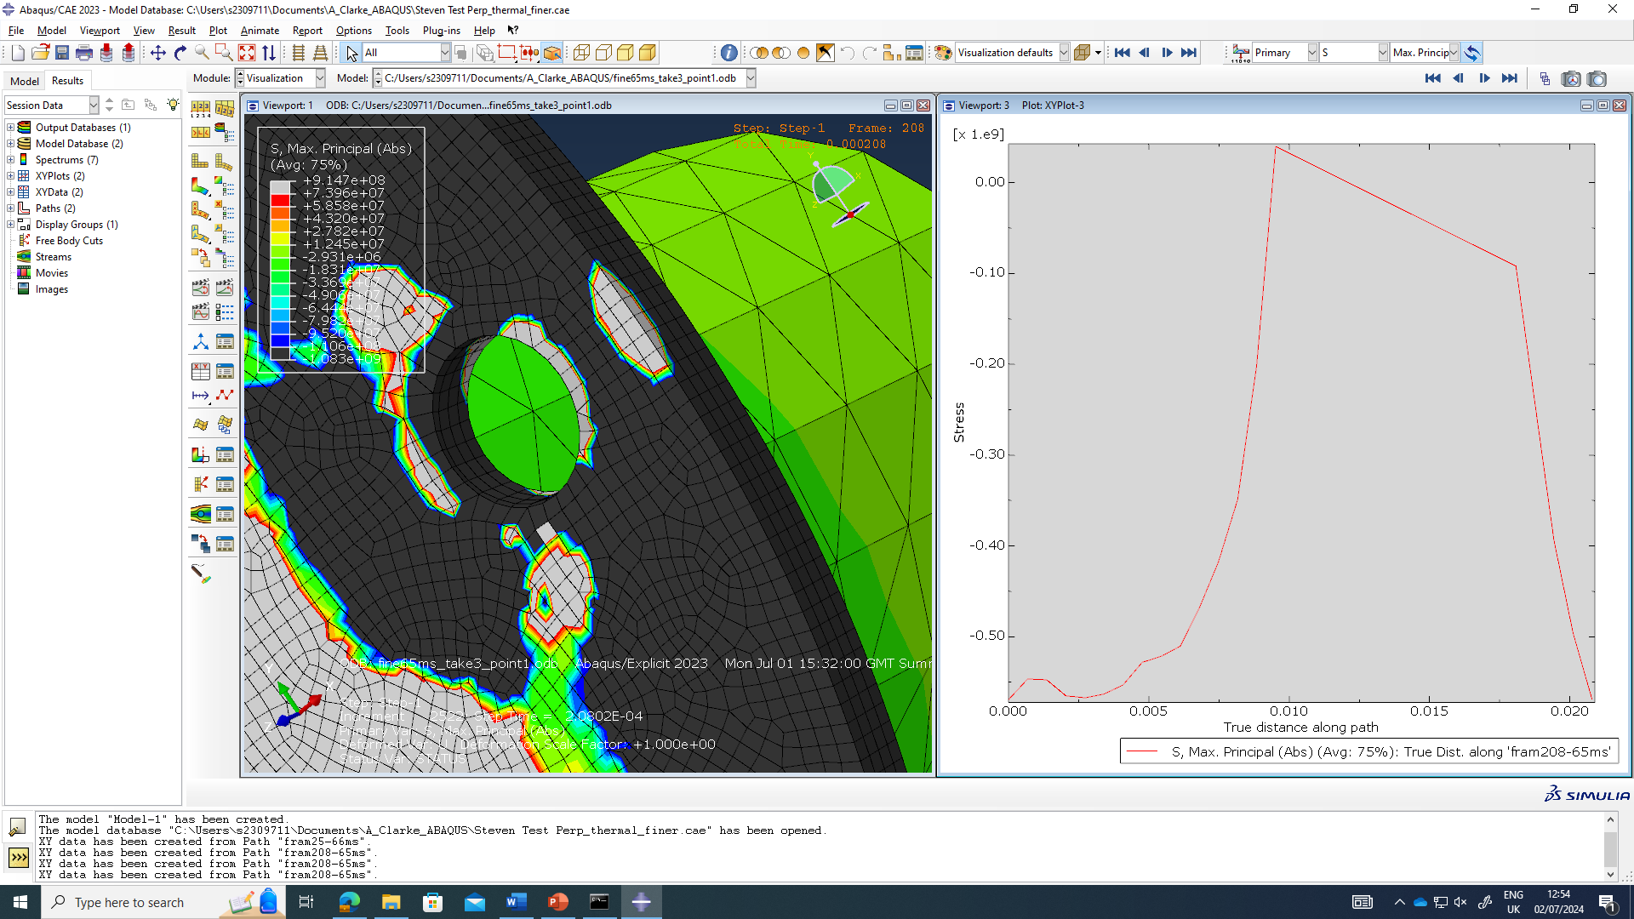
Figure 16 65 m/s Midway through model bolt hole response.
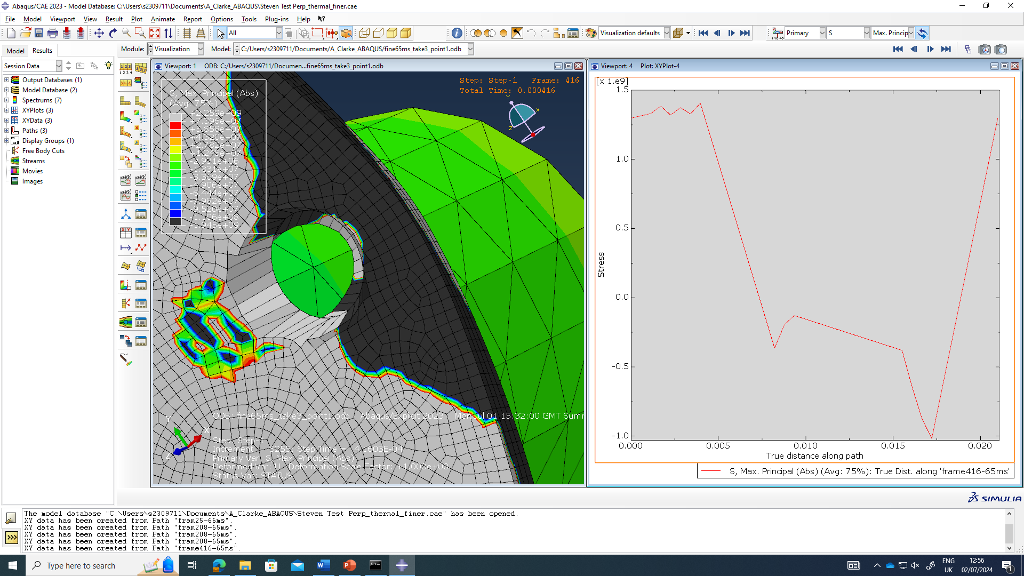
Figure 17 65 m/s End of model bolt hole response.

Velocity of projectile
Figure 18 shoes the reduction in velocity the projectile upon impact with the faceplate.
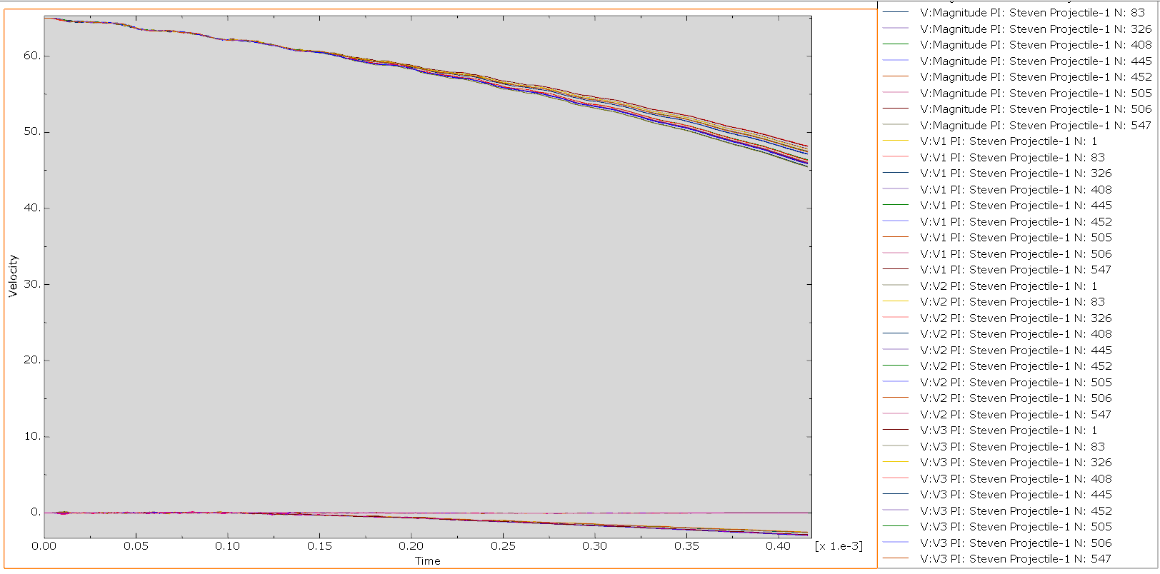
Figure 18 65 m/s Projectile velocity.

Impact face Thermal response
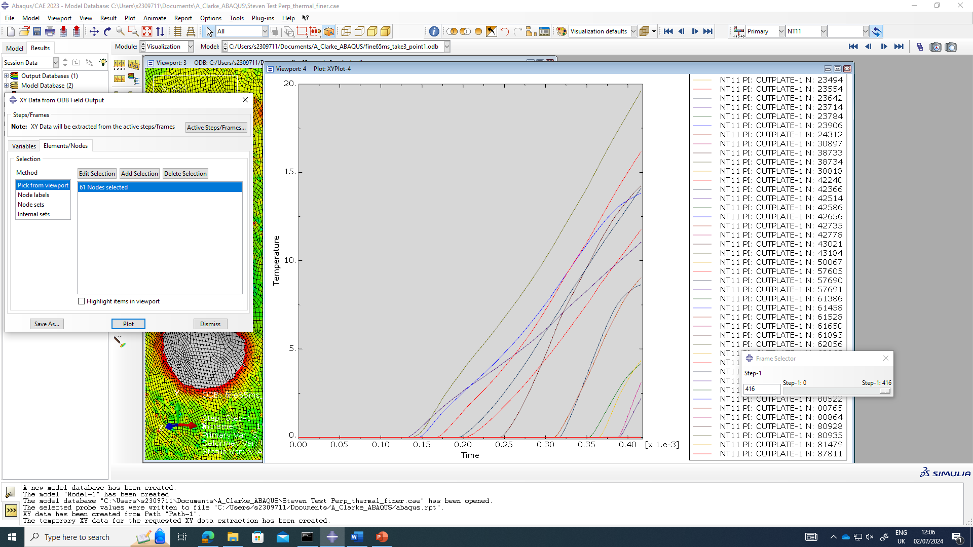
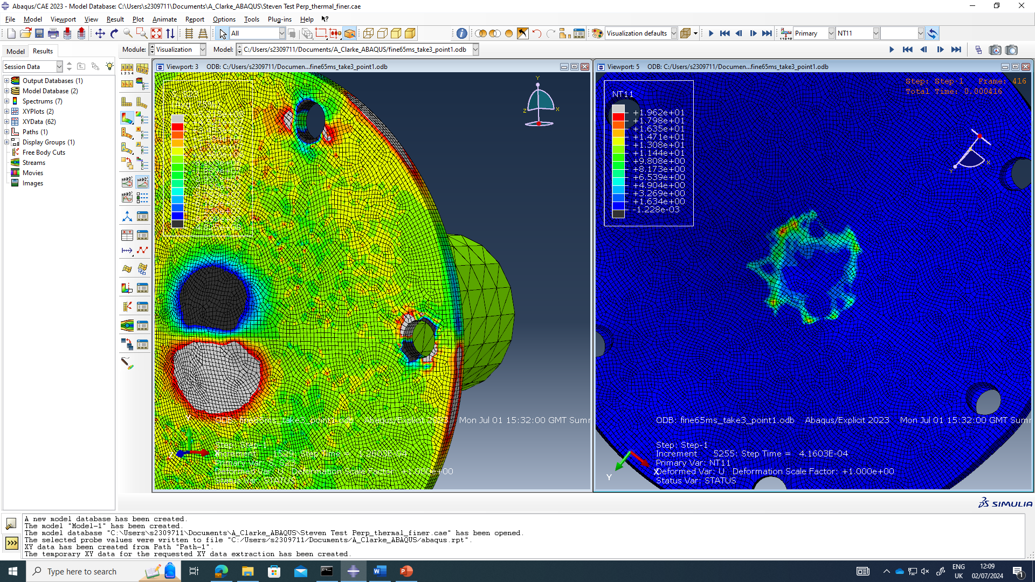
Figure 19 shows the thermal response of the projectile for the impact face of the faceplate, along with a graphical representation of the thermal response on selected nodes in the model mesh.
Figure 19 65 m/s Thermal response

Modelling results at 130 m/s

Rear faceplate and side cut response
Figures 20 and 21 show the initial impact response of the projectile to the face plate with a side cut view and the rear of the face plate. Each figure shoes the direct stress (tension/compression) on the left image and the shear stress of the right image.
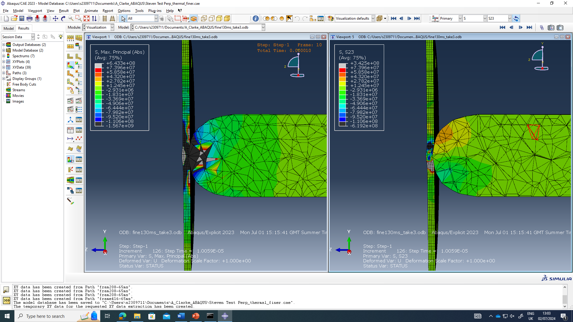
Figure 20 130 m/s Initial impact side cut direct and shear stress.
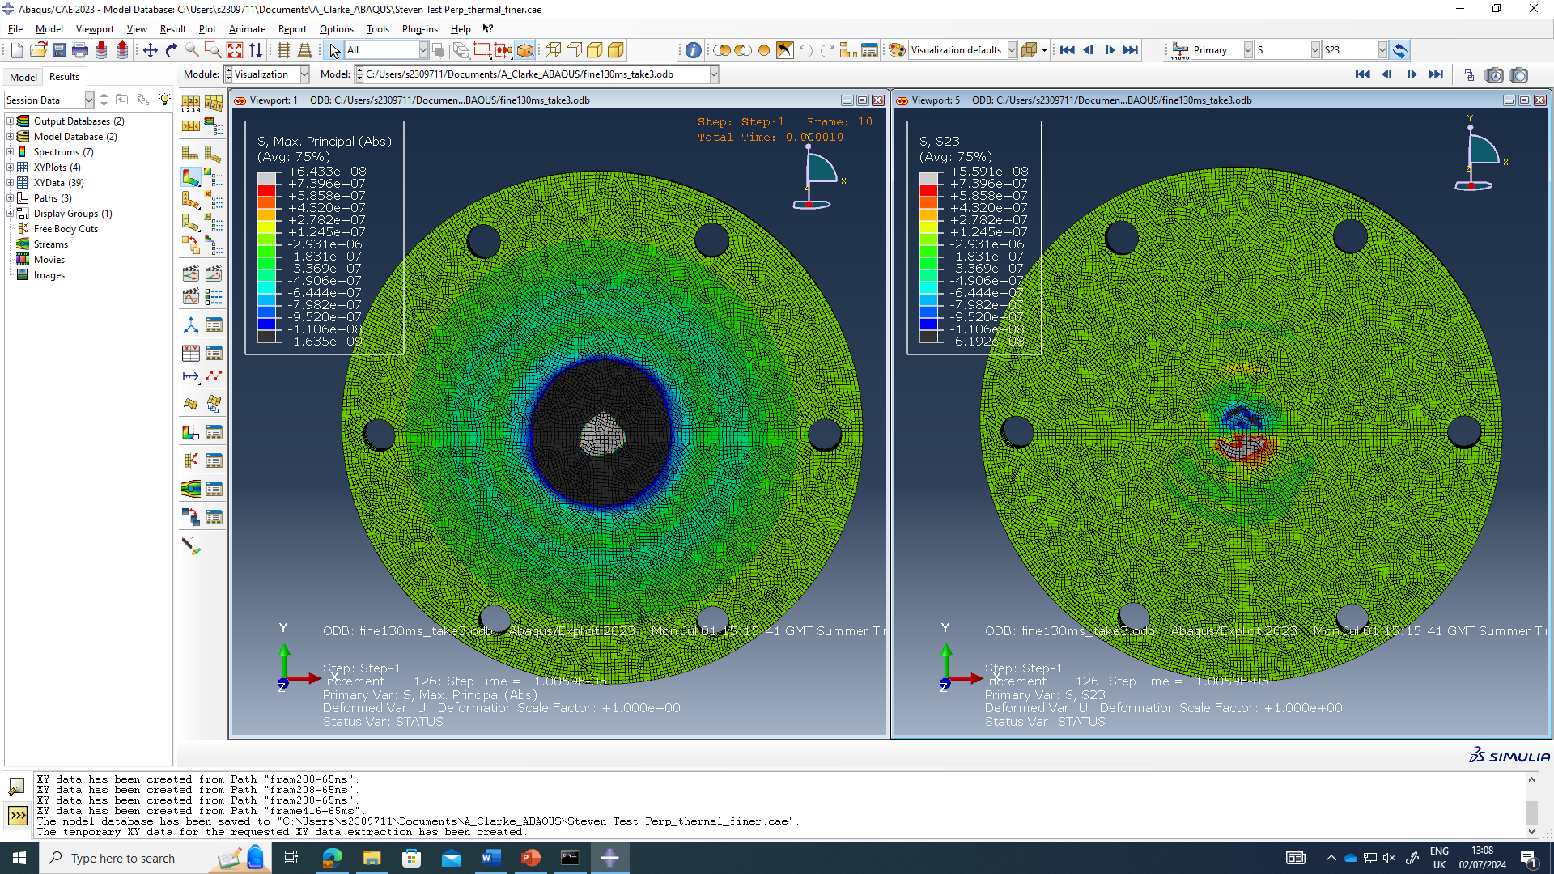
Figure 21 130 m/s Initial impact rear face direct and shear stress
Figures 22 and 23 show the impact response of the projectile to the face plate midway through the model with a side cut view and the rear of the face plate. Each figure shoes the direct stress (tension/compression) on the left image and the shear stress of the right image.
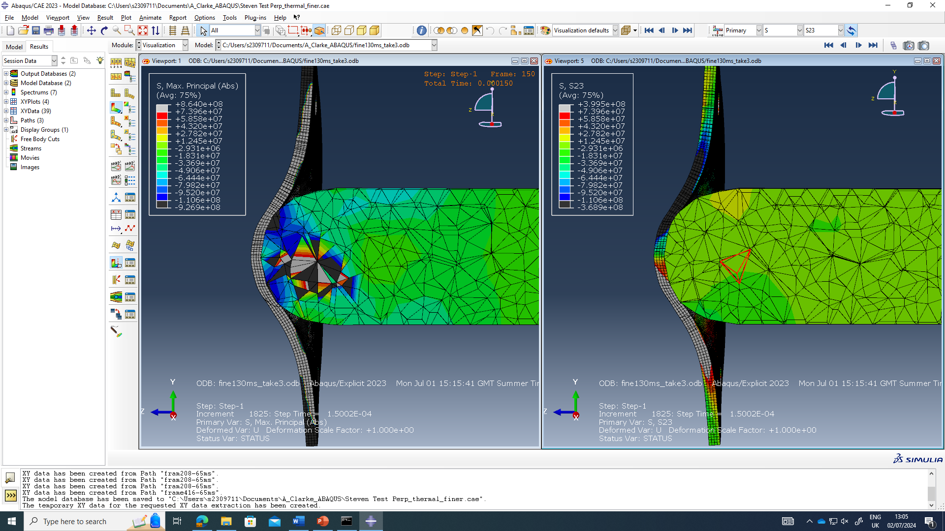
Figure 22 130 m/s Midway through model side cut direct and shear stress.
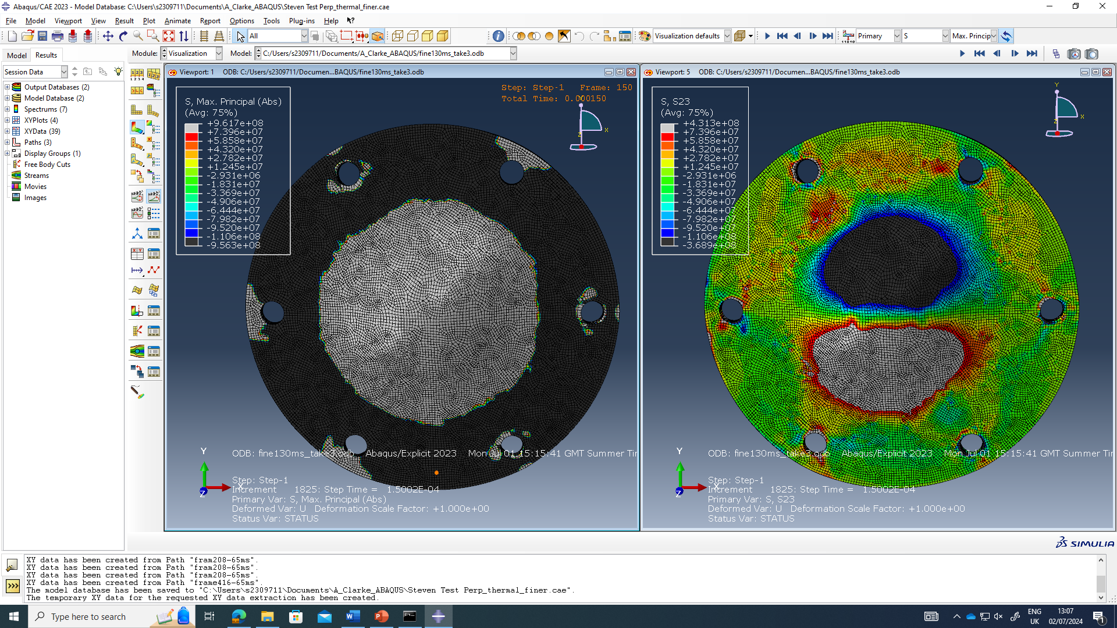
Figure 23 130 m/s Midway through model rear face direct and shear stress
Figures 24 and 25 show the impact response of the projectile to the face plate at the end of the model with a side cut view and the rear of the face plate. Each figure shoes the direct stress (tension/compression) on the left image and the shear stress of the right image.
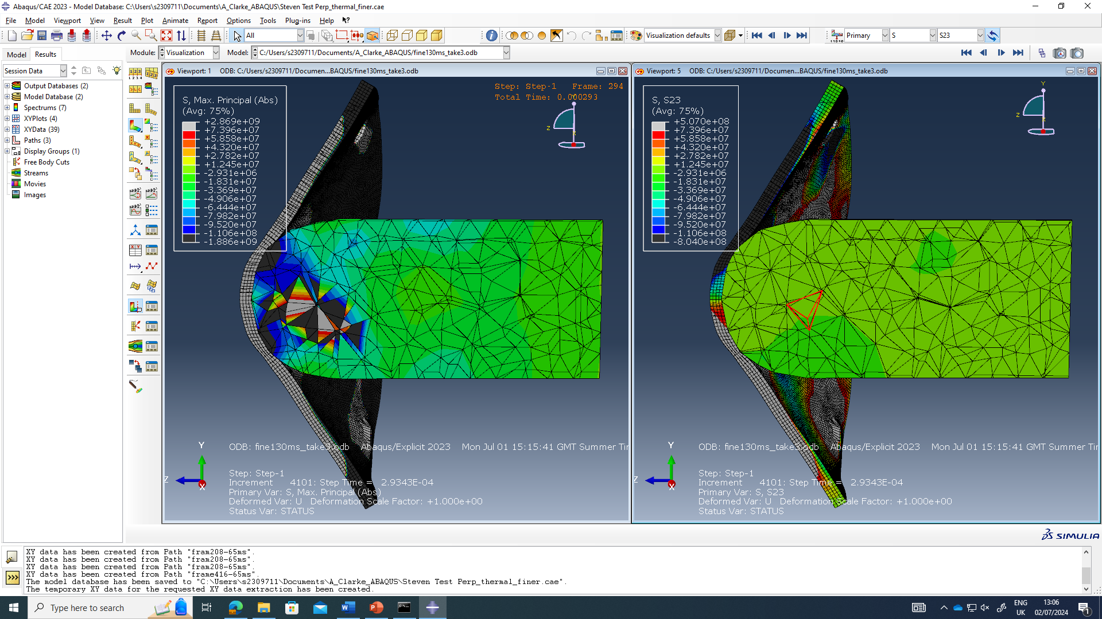
Figure 24 130 m/s End of model side cut direct and shear stress.
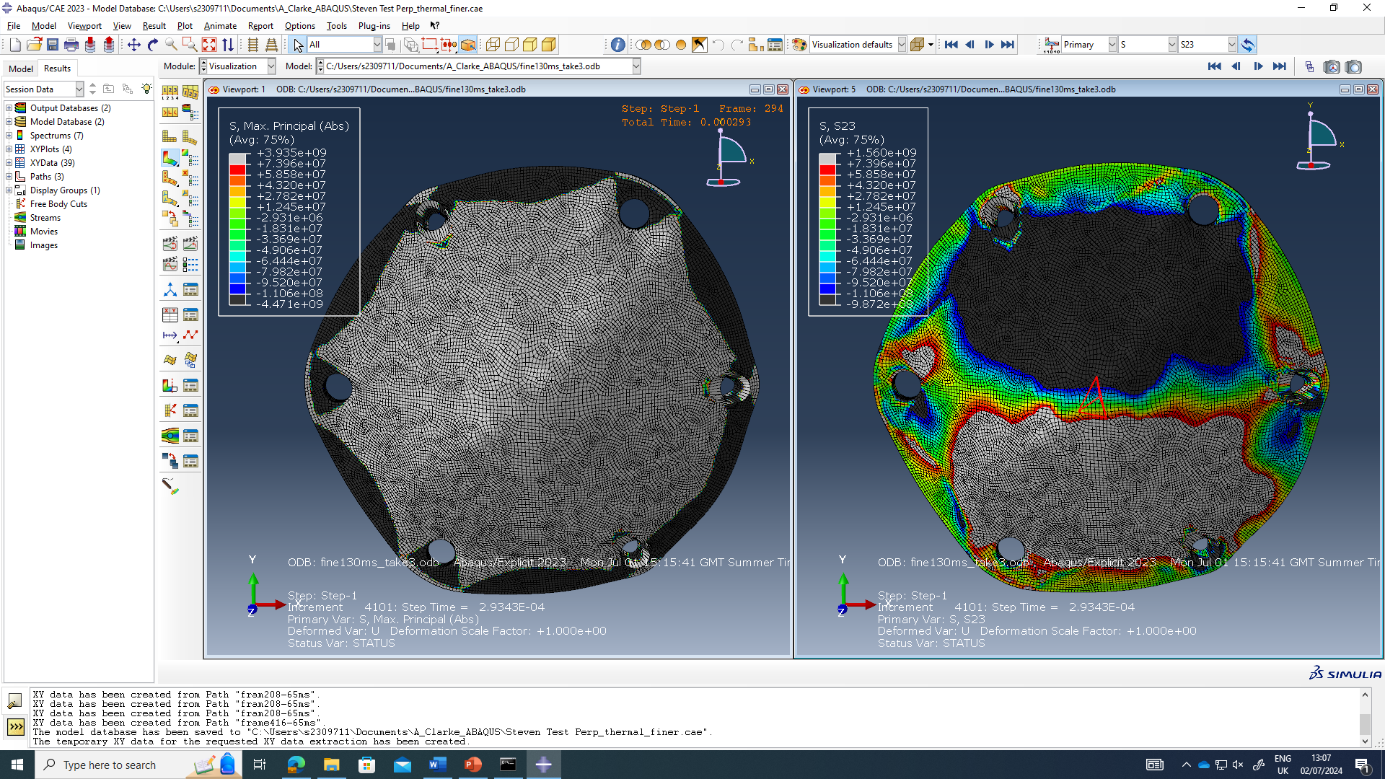
Figure 25 130 m/s End of the model rear face direct and shear stress

Bolt hole response rear face
Figures 26, 27 and 28 show the direct stress response on the bolt holes on the rear face of the plate; along with the stress response plotted around the circumference of the inner face of the bolt hole for the initial impact, midway through and the end of the model.
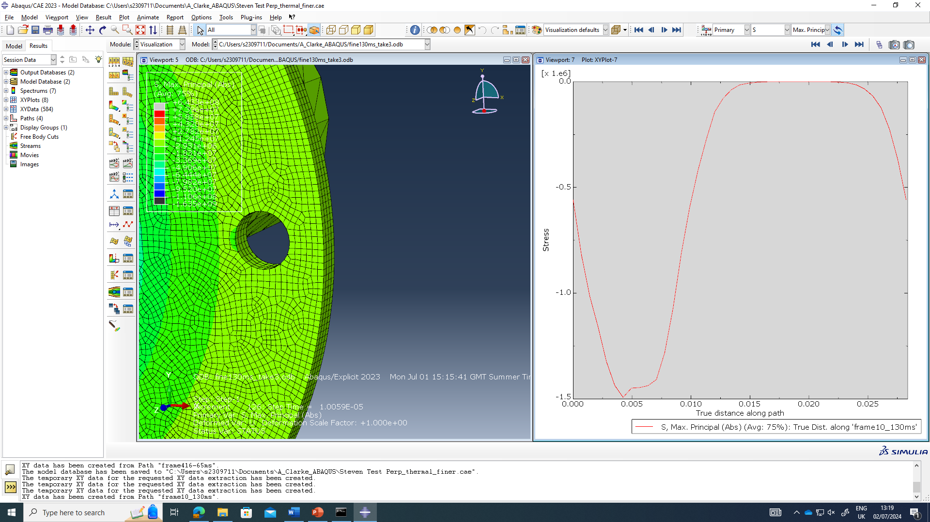
Figure 26 130 m/s initial impact bolt hole response
Figure 27 130 m/s Midway through model bolt hole response.
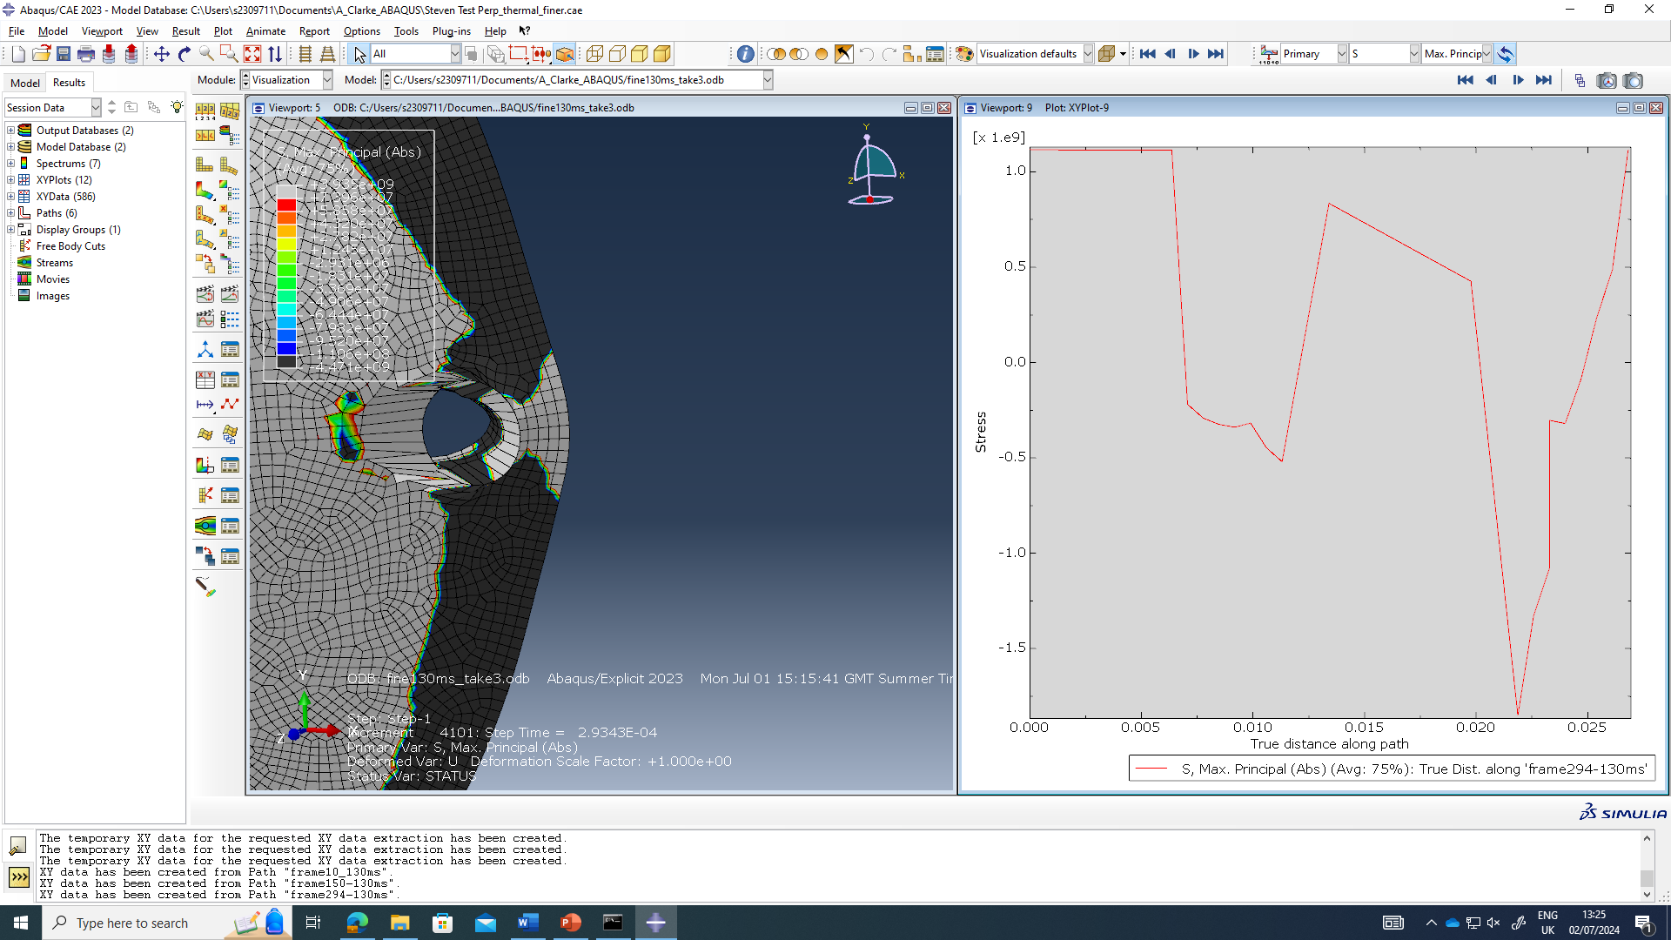
Figure 28 130 m/s End of model bolt hole response.

Velocity of projectile
Figure 29 shoes the reduction in velocity the projectile upon impact with the faceplate.
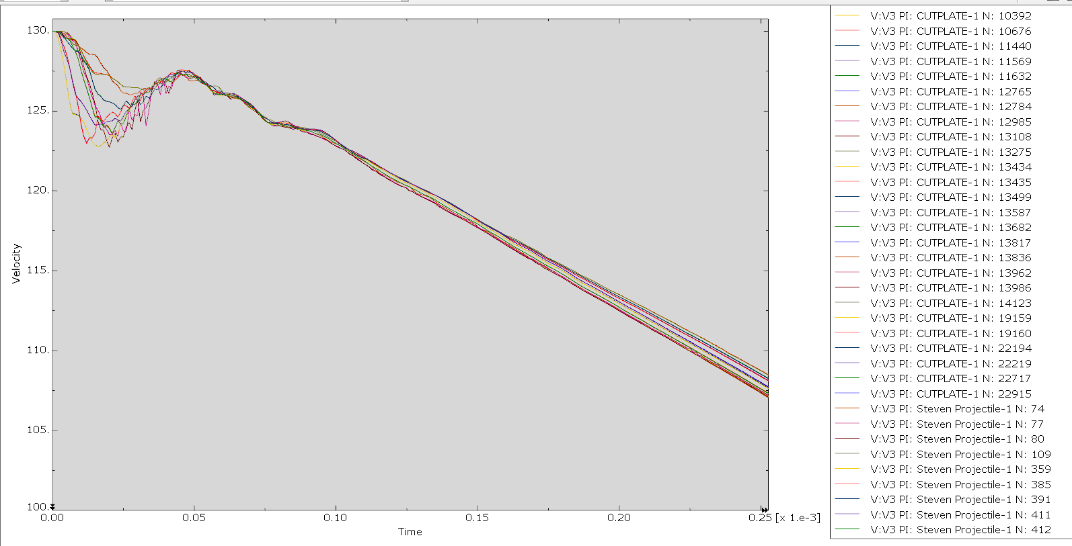
Figure 29 130 m/s Projectile velocity

Impact face Thermal response
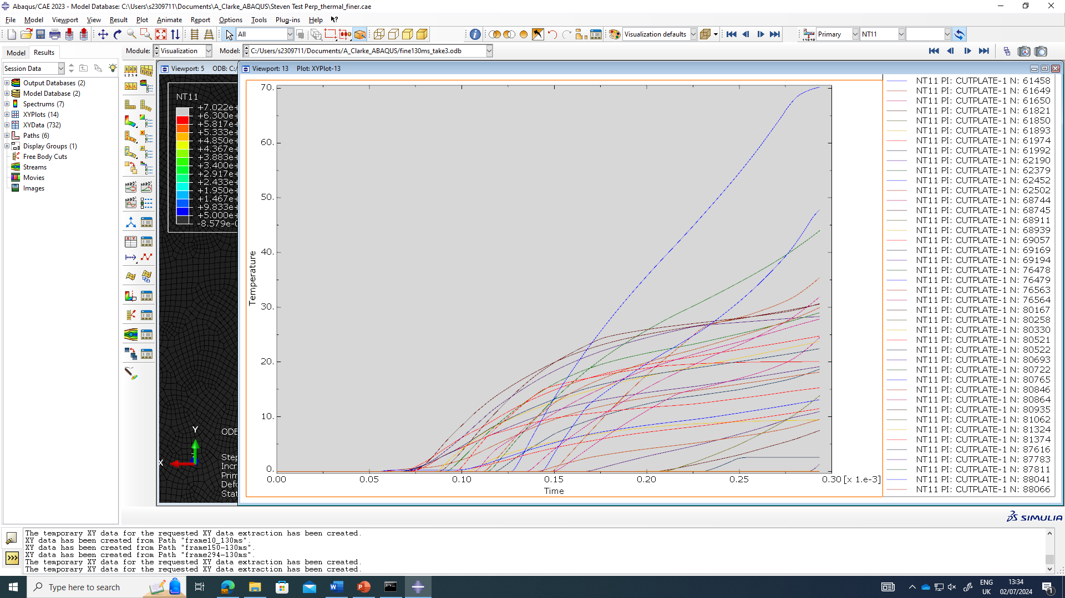
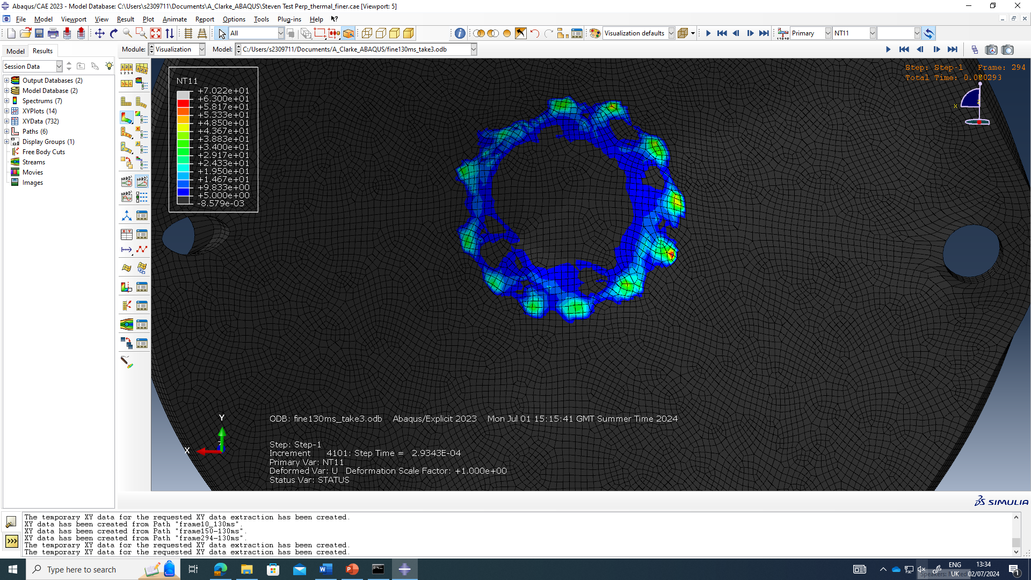
Figure 30 shows the thermal response of the projectile for the impact face of the faceplate, along with a graphical representation of the thermal response on selected nodes in the model mesh.
Figure 30 130 m/s Thermal response

Conclusion & Evaluation
From the data documented in section 3 direct stress wave observed by the learner on each of the impact velocities of 65 and 130 m/s with the initial stress being a wave of compressive stress followed by tensile stress across the face plate. The final dominant stress observed across the face plate was tensile stress which is to be expected from the force of the projectile deforming and stretching the face plate. The bolt holes provided an interesting response with tensile stress forming around the whole circumference of each hole before the compression wave engulfed each of them. Table 5 documents the maximum compressive and tensile stress observed by the learner during the model. Videos of the direct stress waves were created by the learner and are available upon request of the reviewer.
Shear stress was observed by the learner on each of the impact speeds of 65 and 130 m/s. Shear stress was observed in opposite directions above and below the impact point of the projectile on the rear face of the face plate with the evolution of shear stressed being very defined. Table 5 documents the maximum shear stress observed by the learner during the model. Videos of the shear stress waves were created by the learner and are available upon request of the reviewer.
Table 5 Maximum Stress figures
 | Maximum Tensile stress (MPa) | Maximum Compressive stress (MPa) | Maximum + Shear stress (MPa) | Maximum – Shear stress (MPa)
65 m/s | +2259 | -1945 | +529 | -444
130 m/s | +3333 | -2041 | +1071 | -795

The comparison between maximum tensile, compressive and shear stress between the 2 impact velocities of 65 m/s and 130 m/s showed 1.5 times increase in maximum tensile stress, a similar compressive stress and almost a 2 time increase in both the positive and negative shear stress directions for the faster velocity. Upon review of the properties of the face plate material, DC01 Steel, the learner determined compressive and tensile were stress both way above the ultimate yield stress (270-410 MPa) of the face plate indicating that the response was in the plastic and damage region and way past the elastic region.
As expected, the learner observed a decrease in velocity for both projectile velocity upon impact with the face plate as the energy was dissipated through the face plate. The 65 m/s projectile showed a decrease in velocity of approximately 15 m/s with the 130 m/s projectile showing a decrease of approximately 23 m/s.
Both velocity models showed the deformation of the faceplate following impact of the projectile with the 130 m/s showing a much higher level of deformation.
Thermal response was limited for both speeds around 20°C increase for 65 m/s and around 70°C for 120 m/s. Thermal response did not permeate through the whole face place to the rear face but this could have been due to the short model run time. Ideally the learner would have run a longer model to see if the increase in temperature of the metal on the faceplate would reach the other side to have a negative thermal effect causing hot spot formation on the explosive sample that would sit behind it normally in the Steven test.

References
- J.E Reaugh, A. G. Jones, "Mechanical Damage, Ignition, and Burn: Experiment, Model Development and Computer Simulations to Study High-Explosive Violent Response (HEVR)," presented at 14th International Detonation Symposium, Coeur d'Alene ID, United State, April 2011 City of conference, US state or Country, year.
- "Section 19.1.1 Progressive damage and failure" ABAQUS Version 6.6 Documentation. Accessed: July 2024. [Online]. Available: https://classes.engineering.wustl.edu/2009/spring/mase5513/abaqus/docs/v6.6/books/usb/default.htm?startat=pt05ch18s02abm21.html
- Murugesan M, Jung DW. Johnson Cook Material and Failure Model Parameters Estimation of AISI-1045 Medium Carbon Steel for Metal Forming Applications. Materials (Basel). 2019 Feb 18;12(4):609. doi: 10.3390/ma12040609. Erratum in: Materials (Basel). 2020 Dec 16;13(24):E5744. doi: 10.3390/ma13245744. PMID: 30781637; PMCID: PMC6416717.
- Round Nose Projectile, 3DT-334276
- "AISI 1-45 Steel." Matweb.com. Accessed: date. [Online]. Available: https://www.matweb.com/search/DataSheet.aspx?MatGUID=3135b629bdee490aa25f94230424c08a&ckck=1
- M. Murugensan, D. W. Jung, "Johnson Cook Material and Failure Model Parameters Estimations of AISI-1045 Medium Carbon Steel for Metal Forming Applications," Departments of Mechanical Engineering, Jeju National University, Jeju-Do 63243 Korea, February 2019, Accessed: June 2024. [Online]. Available: https://www.mdpi.com/1996-1944/12/4/609
- Steven Test Assembly Drawing Pack, 3DT-3103847
- "EN 10139 Grade DCO01 Work Hardened (C390)." Matmatch.com. Accessed: June 2024. [Online]. Available: https://matmatch.com/materials/minfm36312-en-10139-grade-dc01-work-hardened-c390-
- L. Landi, D. Amici, O. Alunni Boldrini, E. Germani, "Sheets impact simulation for safety guard design: experiments and correlation for FE Explicit models for non-alloy steel," presented at AIAS 2017 International Conference on Stress Analysis, Pisa, Italy, September 2017.
- P. Farahnak, M. Urbanek, J. Džugan, "Investigation study on determination of fracture strain and fracture forming limit curve using different experimental and numerical methods," Journal of Physics, Conf series. Series 896, 2017

