Tomos Blizzard
1402861
BEng Mechanical and Manufacturing Engineering
Dr Rachel Alexander
Group Project
Group Project Assignment B

Contents

1.0 Introduction – Page 3
2.0 Objective – Page 3
3.0 Bruce Tuckman’s Team Building – Page 4
3.1 Meredith Belbin’s Team Roles – Page 5
4.0 Project – Page 7
4.1 Gantt Chart – Page 8
5.0 Team Members – Page 9
6.0 Conclusion – Page 11

- Introduction
This report will take a reflective stance on working together within different teams. This essay will concentrate on working within a team in the workplace.
We will be looking at the team used to complete this project and what improvements could have been made to the team and also the project.
I will also be looking at recognised methodologies which are currently practised within the workplace. This will include Bruce Tuckman’s team building theory and Meredith Belbin’s team role theory.
During this report, I will reflect on a project which was completed to reduce scrap on a machine. This scrap reduction team included 4 members. The members included a project engineer, quality engineer, engineering technician and an operator.
- Objectives
The objective of this report is to show how a team was formed within the workplace to tackle an ongoing scrap issue within the company. It will explain how and why the team was selected for this project. It will also show recognised methods which are used across the world in team selection within the workplace. I will compare the recognised methods against how our team was formed and also how roles and responsibilities were assigned.

- Bruce Tuckman’s team building
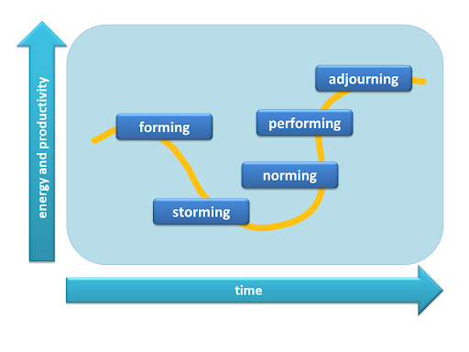
Bruce Tuckman’s theory was developed in 1965. It looks at 5 different aspects which are used when in a team. The 5 steps used are forming, storming, norming, performing and adjourning. These 5 steps are what allows a team to become more productive over time. (The Team Building Company, 2020)
(Coaching Culture at Work, 2020)
The first step is forming. This is where the team is brought together and they are set a task. This step is where the team meet, gather individual information and get to know one another. This is an important stage for the leader of the project.
The next step is storming, this is where the team can begin to fracture. Team members will want to feel valued within the team. Each team member should look to give positive feedback wherever possible to build relationships within the team. This can prevent conflicts.
The third step is norming. When a team gets to the norming stage it is a rounded, well-established team which has been working together for a long time. At this stage, a leader can look to his team for the solutions rather than coming up with the solution by himself.
The penultimate step is performing. This is where the team is working well together. There are plenty of constructive debates held and the team is continually successful in their tasks. They complete their tasks efficiently and step aside for the next member of the team to do the same.
The final part of Tuckman’s theory is adjourning. This is the closure of a project and team. If a team has completed the previous four stages there will be a great bond and experience between this team. (Tuckman's, 2010) (Bonebright, 2010)
3.1 Meredith Belbin’s team roles
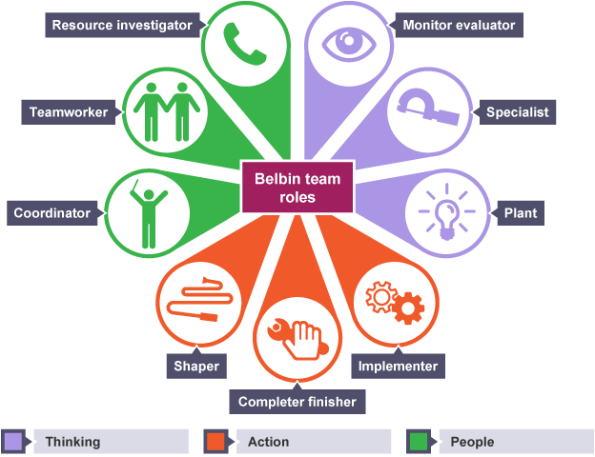
When you look into Belbin’s theory you will find that there are nine team roles. These nine team roles are split into three categories. These three categories are thought orientated, action-orientated and people orientated. A person will generally fall into one of these three categories. (Fisher, 2011)
(Nguyen, 2017)

Monitor Evaluator
A monitor evaluator is very good at looking at ideas brought forward by team members. They will be able to see the positives and negatives within an idea and analyse these before coming to a decision. This person may also come across as detached and a poor motivator.
Specialist
A person who is a specialist is vital to a project. This person will pride themselves on their skills and abilities. They can get caught in the trap and not seeing the bigger picture when undertaking work.
Plant
The plant is the creator of the team. This is the person who will think of innovative ideas within projects. The plant will prefer to separate themselves from the team because they want to complete a job no matter how they do it. Sometimes this can mean failing to comply with rules.
Implementer
An implementer is someone who acts on ideas. These are the people who will turn a great idea into reality. They will also organise work that needs to be completed to get the job done. The issues that may come with this type of person is that they can be slow to accept change and new ideas.
Completer finisher
A completer finisher will be the person who works through fine problems so the task is of the highest quality. This person is likely to worry and find delegating hard. Sometimes this person can be seen to take some aspects of the projects too far when perfecting it.
Shaper
A shaper is a person who will keep the team focused on the task at hand, ensuring they don’t lose any momentum. This person is known to offend peoples feeling and be aggressive when trying to complete a task.
Co-Ordinator
The co-ordinator looks at the team objectives and delegates the workload. Sometimes the coordinator can be seen to delegate too much leaving no work for themselves.
Team Worker
This person brings the team together. This person will see the work required and complete this work for the team. This person will shy away from unpopular decisions as to not upset people within the group.
Resource Investigator
A resource investigator is naturally inquisitive. They will try to find new ideas to bring to the team and also be a very enthusiastic member of the team. Once the initial excitement from the team has worn off this person can lose interest, forgetting to chase people. (Emerald Works, 2016) (Belbin Associates, 2019)

- Project
The project is on a scrap reduction issue which was completed on one of our machines. The machine has run in its current state for 4-5 years. The machine runs well at 80% overall equipment efficiency. Overall equipment efficiency is calculated but multiplying three factors together. These are availability, performance and quality. The company has now decided that the overall standard must be increased from 80% to 85%. (R. Domingo, 2015)
When a brainstorming activity took place the task in question was that the machine starts up and begins making aluminium tubes. It rejects the first 10 tubes as a standard. This was brought in to stop short or long tubes being fed into the machine. Every time this machine stops 10 tubes are rejected into a scrap bin and this reduced our overall equipment efficiency.
Our team looked at doing a study on the 10 tubes being rejected over a shift to see how many of these tubes were out of tolerance. The tube length should be 600mm +/- 0.1mm. This study was used to reduce the number of tubes being rejected. Below is a table to show the results of our study. Every time the machine started up, we took the 10 tubes which were rejected and measured them using a Vernier Caliper. We completed this from 8 am until 5 pm.

As you can see from the chart, majority of the tubes were within specification. The maximum number of tubes which were rejected was 4. From this study, we were able to reduce the number of tubes which were automatically rejected to 5. Even though the data shows the maximum number of tubes was 4, we felt that setting the automatic reject to 5 tubes would be safer when tubes are loaded into the machine. By doing this we have halved the amount of scrap which the machine has been producing.
This scrap reduction has taken the amount of scrap our machine was producing down by 50%. This, in turn, has a positive effect on our quality when looking at the OEE of the machine. This scrap reduction took us to 87% OEE. We achieved our goal which was set at getting the machine OEE to 85% and above.
4.1 Gantt Chart
The Gantt chart below shows the timing plan for the project. This was put together after everyone’s tasks were discussed and agreed. As you can see below, the team was on plan in completing all our tasks up until the 08/02/2020. After this, there was a ten-day delay due to a high-volume order coming in which required the machine to run 24/7. This delayed the project during this period because the changes which needed to be made were on the machine. Due to the team not being able to stop the machine to make the changes we had to put the work on hold. After the large delay everything we completed within its allotted time frame without any further issues.

5.0 Team Members
When the team was considered, there were a variety of roles which were looked at. It was decided that the project engineer would have to lead this task. There would also be a quality engineer present to ensure the quality of the product throughout the changes. A maintenance technician to carry out the changes required on the machine and finally an operator. The operator brings a wealth of knowledge to the team which is specific to the machine being used. He would also operate the machine while the team was making changes.
When looking at the team I will reflect on how Tuckman’s theory and Belbin’s theory is used by the team. During the task, the team was unaware of these theories. The team will look at whether we used these theories in our team, how the team used them and how the team could improve on them.
When looking at Tuckman’s theory of storming, forming, norming, performing and adjourning. The team didn’t use these techniques past storming. As a team, we set out our goals and tasks. Each member went away and gathered the relevant information which was required for the task to be completed effectively. The team had some issues because there was a resistance to change as this machine had run at these settings for such a long time. The team got over this initial stage, we continued to work well as a team and complete the task at hand. Overall, there are still steps that can be taken to use this theory more within our company. Unknowingly the storming stage was used but I believe most teams would complete the same tasks our team did without recognising that they’re using Tuckman’s theory. This task was over a short period. If this theory was going to be used more regular the team would have to be kept together over several projects to get the full potential out of the team.
The project engineer role was to relay all information on this improvement. This role is responsible for making sure all members of the team were clear on what they were doing. The project engineer reports all findings and tasks completed to the senior management team. They would then determine whether this exercise would be rolled out across all products.
The project engineer fell into the Monitor Evaluator and co-ordinator categories. In initial meetings, many ideas were being thrown into the brainstorming activities and it was the project engineers to determine which would give us the best result.

Our quality engineer was in charge of all measurement activities. This included measuring all tubes in a standard way so they were measured correctly and the data was stored within the company system. The SOS (standard operating sheet) was also updated by the quality engineer and finally, the quality of tube was assessed before and after the changes were made. There was no difference between these conditions. (Peter S. Pande, 2000)
As a quality engineer, you naturally have to be stringent in your ways. You have to look into some simple things with massive amounts of detail and I think our quality engineer did that. This put him into the completer finisher category within Belbin’s team roles.
The maintenance technician manufactured and completed all the changes which were required on the machine. This included, programme adjustments on the tube reject system, part manufacturing and all trials.
Our engineering technician brought many good ideas to the brainstorming activities, looking to innovate the way we do things within the company but unfortunately many were too expensive. Our technician also works across the plant daily so had very good working relationships with operators, team leader and maintenance members. Our engineering technician came into the plant and team worker category.
Finally, the operator is the person who was running the machine day in, day out. This person knows what works well and what does on the machine so he was able to bring a wealth of knowledge.
The operator knew of all recurring faults and was able to work the machine better than all of us on the team. He was the specialist of the team. The operator would be completing the trials when required.
Looking back at the team you can see that three key categories were missing when looking at Belbin’s theory. An implementer, resource investigator and shaper. During the project, all team members displayed implementer and resource investigator qualities but nobody completely fitted these categories. The role which was missed out on most was a shaper. During the project, tasks were completed late. This caused us to be 10 days late on the delivery of our project. If we had a shaper within the team, this person would have kept the team on task and also kept the team’s momentum going at the same time. This would have allowed the team to complete the project on time without delay. Looking ahead to the next project, a slightly larger team would rectify these issues and also finding the correct people with these qualities.

6.0 Conclusion
This team was selected by looking at people from different departments within the company who were required when tasks were initially though out. There was no real process or technique used when selecting this team for the scrap reduction task. Looking back this may have been the cause of the team’s issues when completing the tasks. When looking at Tuckman’s theory, the team happened to follow his steps but due to the time the team was together, I feel that we didn’t use his techniques as well as we could have. Keeping this team together for a longer time on a larger project or several smaller ones would have allowed us to develop the relationships which are required when using Tuckman’s theory. The next theory looked at was Belbin’s theory which shows everyone’s roles within the team. These roles are their natural traits and personalities which they have developed in the workplace. In our team, we were missing 3 out of 9 team roles which caused the team to suffer. We were delayed in our project which caused us to finish later than originally agreed. If we had the 3 roles which were missing from our team, I believe we could have rectified this issue and completed the project on time. Overall, I believe this essay shows that the team was successful as the task was completed by reducing the scrap on the machine and increasing the OEE of the machine from 80% to 85%. I do think the team can be improved by implementing Tuckman’s theory and Belbin’s theory when selecting the teams required for the task.

References
Belbin Associates, 2019. Belbin Team Roles. [Online]
Available at: https://www.belbin.com/about/belbin-team-roles/
[Accessed 8 April 2020].
Bonebright, D. A., 2010. 40 years of storming. Human Resources Development International, 13(1), pp. 111-120.
Coaching Culture at Work, 2020. Coaching Culture at Work. [Online]
Available at: http://www.coachingcultureatwork.com/bruce-tuckmans-forming-storming-norming-performing-team-development-model/
[Accessed 8 April 2020].
Cottrell, S., 2005. Critical Thinking Skills. 1st ed. New York: Palgrave MacMillan.
Cottrell, S., 2013. The Study Skills Handbook. 5th ed. New York: Palgrave MacMillan.
Emerald Works, 2016. Belbin Team Roles. [Online]
Available at: https://www.mindtools.com/pages/article/newLDR_83.htm
[Accessed 8 April 2020].
Fisher, S. G., 2011. The Structure of Belbin's team roles. Journal of Occupational and Organizational Psychology, 71(3), pp. 283-288.
.Jones, G.D, 1981. Instrumentation. In: T. Nelson, ed. Engineering & Mechanical Science. United Kingdom: Nelson, pp. 22-23.
Nguyen, M., 2017. DotNet Sharing. [Online]
Available at: https://dotnetsharing.wordpress.com/2017/09/19/learn-belbin-team-roles-through-reflection/
[Accessed 8 April 2020].
Pande, P.S, 2000. The Six Sigma Way. 2nd ed. New York: McGraw-Hill.
Domingo, R., 2015. Sustainability. Overall Equipment Efficiency , 7(10), pp. 9031-9047.
The Team Building Company, 2020. The Team Building Company. [Online]
Available at: https://www.teambuilding.co.uk/theory/Forming-Storming-Norming-Performing.html
[Accessed 8 April 2020].
Tuckman's, B., 2010. Forming, Storming, Norming and Performing Team Development Model. Forming, Storming, Norming and Performing Team Development Model, 1(1), pp. 1,2,3,4.

