
School of International Hotel Management

BA (Hons) International Hotel Management

Marketing Essentials BMIH4005 LEVEL 4

LEVEL 4 ASSESSMENT SPECIFICATION
Student name: | Diana Georgeta Ariton | Student ID number: | 2222495
Programme: | Cert. International Hotel Management
Module: | Marketing Essentials BMIH4005 LEVEL 4
Module code: | BMIH4005 REWORK | Contribution to Overall Module Assessment (%): | 100%
Lecturer: | Chris Wilkin | Internal Verifier: | Jayne Griffith Parry
Assignment Title: | An Essay: A comparison of the marketing methods of two multinational hotel brands. | Word count (or equivalent): | 1,500
Date: | 22.05.2023 | Actual word count | 1649

Table of contents

Introduction.................................................................................................................2
SWOT Analysis of Six Senses....................................................................................2
SWOT Analysis of Holiday Inn....................................................................................3
PESTLE analysis of Six Senses.................................................................................3
PESTLE analysis of Holiday Inn.................................................................................4
Marketing mix..............................................................................................................5
Segmentation, Targeting, and Positioning..................................................................6
Conclusions.................................................................................................................7
References..................................................................................................................8
References..................................................................................................................9
Appendix....................................................................................................................10
Appendix....................................................................................................................11
Appendix....................................................................................................................12
Appendix....................................................................................................................13

Introduction
This account aims to compare the marketing approaches of two hospitality brands, Six Senses and Holiday Inn, both brands under IHG Group umbrella.(IHG, 2022) The hospitality industry is highly competitive, and marketing plays a vital role in gaining a competitive advantage. Marketing is the sum of all processes a business will use to successfully promote, sell, attract, and retain customers. (Jobber & Ellis-Chadwick, 2019) The report intentions are to analyse situational environment, marketing mix, segmentation, targeting, and positioning, as well as marketing communications to identify parallels and variances in the respective marketing approaches. This paper also analyses marketing activities for both brands that are ranked close in the industry.(See appendix 1) Six Senses focuses on a high-end, luxurious experience with a focus on sustainability, while Holiday Inn emphasizes affordability and accessibility. Six Senses product offerings are unique and personalized, while Holiday Inn's offerings are standardized and consistent across locations. (Miler & Peterson, 2020)
SWOT Analysis of Six Senses:
While the brand holds a robust global recognition within the luxury hospitality domain, its high pricing strategy may impede market share acquisition in this sector. The multinational presence consists of twenty-two hotels and resorts situated in various exotic locations around the globe, offering distinctive and tailor-made wellness experiences that set the brand apart from competitors (Six Senses, 2023). However, a limited target market, focused on affluent and health-conscious individuals, circumscribes the brand's presence in metropolitan areas and constrains growth prospects. Nonetheless, growing the brand's footprint in urban and business destinations and devising novel, innovative wellness programs and services may reinforce Six Senses. Various challenges confront Six Senses, including financial downturns affecting luxury hospitality service demand, competition from equivalent luxury hospitality providers, increasing regulations surrounding sustainable practices and eco-tourism, and unpredictable events such as natural disasters or political instability that can impair the brand's properties and operations (Jiang et al., 2022).
SWOT Analysis of Holiday Inn:
The mid-priced hotel sector demonstrates significant brand recognition and a solid reputation. An attractive pricing strategy caters to budget-conscious travellers, while a global presence encompasses numerous urban and tourist locales. A robust loyalty program encourages customer retention (Buttle et al., 2016). However, differentiation within the competitive mid-tier market remains minimal, as does the presence in exotic locations, potentially hindering growth opportunities. Reliance on external booking platforms proves substantial, with limited emphasis on sustainability and ecotourism. Expansion into emerging markets with increasing demand for moderately priced accommodations, enhanced service offerings, and innovative amenities can foster differentiation (Jiang et al., 2022). Collaboration with travel and airline companies can facilitate package deals and discounts, while incorporating sustainable practices and ecotourism initiatives may attract environmentally aware constituents. Nonetheless, growing competition from mid-range hotels and alternative lodging options such as Airbnb persists. Economic fluctuations may influence mid-priced accommodation preferences, and mounting regulatory measures targeting the hospitality sector, encompassing labour legislation and environmental protocols, demand consideration (Kotler et al., 2020).
PESTLE Analysis of Six Senses:
Political instability and regulations may impact the brand's operations in different countries. Political unpredictability and conflicts in some countries may impact the brand's properties and operations. Changes in visa policies and travel restrictions may impact the brand's customer base.
Economic downturns and changes in currency exchange rates may impact the brand's pricing strategy and customer base. Growing demand for luxury hospitality services in emerging markets may present growth opportunities for the brand. (Six Senses, 2021) Variations in the global economy may impact the brand's revenue and profitability.
Socially growing interest in health and wellness among consumers may increase the demand for the brand's services. Cultural differences in different countries may impact the brand's ability to appeal to local customers. Changing demographics and lifestyles may impact the brand's target market and offerings.
Technological innovations may present opportunities for the brand to offer new and innovative services. Changes in consumer behaviour and preferences due to technological advancements may impact the brand's marketing and customer engagement strategies. Dependence on technology for operations and customer services may increase the brand's vulnerability to cyber-attacks and data breaches. (Yetunde, 2022)
Legal changes in labour laws and regulations may impact the brand's operations and costs. Compliance with environmental regulations and sustainability standards may increase the brand's costs.
Environmental awareness combined with energy consumption and waste management are among environmental concern that Six Senses are facing given the management commitment to become more sustainable and environmental aware. (Six Senses, 2021)
PESTLE analysis at Holiday Inn
Political regulations on the hospitality industry, such as taxes and employment laws, could impact the business. (Kotler et al, 2013) Political stability in the countries where Holiday Inn operates could also be a factor affecting the business.
Economic fluctuations in the economy, such as recessions, could affect the demand for hotel accommodations and the overall profitability of Holiday Inn. Currency exchange rates could impact the costs of doing business for Holiday Inn in different regions. (Cong & Thu, 2020)
Social changes in trends and demographics could impact the types of services and amenities that guests expect from hotels. Social media trends and online reviews could affect Holiday Inn's reputation and customer perception. (Mai et al., 2022).
Technological advancements could impact the way that hotels operate and provide services to customers, such as mobile check-in and smart room features. (Stoychev, 2020) Competition from online travel agencies and other booking platforms could also impact Holiday Inn's business.
Legal compliance with various regulations and laws, such as health and safety regulations and data privacy laws, could affect the business operations of Holiday Inn. Litigation and liability issues could also impact the company's reputation and financial stability.
Environmental changes and sustainability practices could affect the business practices of Holiday Inn, such as waste disposal and energy usage. Changing climate patterns could also impact the travel patterns and demand for hotels in certain regions. (Bogren & Sörensson, 2021)
Marketing Mix
Product
Six Senses and Holiday Inn both offer accommodation and hospitality services. Six Senses is a luxury brand that focuses on providing high-end accommodation and wellness experiences. The brand offers its guests luxury villas and suites, spa services, and wellness programs. (Zimmerman & Blythe, 2021) In contrast, Holiday Inn is a mid-priced hotel chain that focuses on providing affordable accommodation and hospitality services. The brand offers standard rooms and suites, restaurant with bar services, meetings, and events facilities.
Price
Six Senses is a premium brand, and its pricing strategy reflects this positioning. The brand's prices are higher than most of its competitors in the luxury hospitality segment. On the other hand, Holiday Inn's pricing strategy is focused on providing affordable accommodation and hospitality services. The brand's prices are lower than most of its competitors in the mid-priced hotel segment. (Chusnaini & Rasyd, 2022)
Place
Six Senses operates in several countries worldwide and has a presence in several tourist destinations. The brand's properties are located in remote locations and exotic destinations. In contrast, Holiday Inn operates in several countries worldwide and has a presence in both tourist and urban locations. (Holbrook, 2018) The brand's properties are in city centres and near tourist attractions.
Promotion
Six Senses and Holiday Inn both utilize various promotional channels to reach their target audiences. (Bogren & Sörensson, 2021) Six Senses' promotional strategy focuses on experiential marketing, and the brand utilizes social media, events, and influencers to showcase its unique offerings (Stoychev, 2020). In contrast, Holiday Inn's promotional strategy focuses on traditional advertising channels, such as television, print, and online advertising.(see appendix 4)
Segmentation, Targeting, and Positioning
Segmentation
Six Senses segments its market based on demographics, psychographics, and geographic variables. Six Senses targets the high-end, luxury segment of the hospitality market, with a focus on eco-conscious travellers and those seeking unique, personalized experiences as the wellness tourism has become a niche market inside the tourism industry (Padma and Ahn, 2020). On the other hand, Holiday Inn segments its market based on demographics and business orientated variables. The brand's target market consists of budget-conscious travellers who prioritize convenience and accessibility. (Gon Kim et al., 2008)
Targeting
Target marketing involves promoting products and services to a specific group of customers who are more likely to be interested in them. Six Senses has also employed target marketing to attract niche customers to its unique offerings. The brand's target most of affluent and health-conscious individuals who are keen to pay for refined accommodation and luxury experiences (Bowie et al., 2016). In contrast, Holiday Inn targets its market by providing affordable accommodation and hospitality services to low-rated seeking travellers.(See appendix 2)
Positioning
Six Senses places itself as a high-end brand that focuses on providing first class accommodation, wellness programs, and spa services to its target market. (Mai et al., 2022)In contrast, Holiday Inn positions itself as a mid-priced hotel chain that provides affordable accommodation and hospitality services to budget-conscious travellers. The brand focuses on providing convenient and straightforward services to its target customers. ( Statista , 2023)
Marketing Communications
Six Senses and Holiday Inn both utilize various marketing communications channels to reach their target audiences. Six Senses' marketing communications strategy focuses on experiential marketing, and the brand utilizes social media, events, and influencers to showcase its unique offerings. (Duarte, 2016) In contrast, Holiday Inn's marketing communications strategy focuses on traditional advertising channels, such as television, print, and online advertising, as well as adds(Yan & Cui, 2016) Both brands utilize email marketing and targeted advertising to reach its target market. (See appendix 3) However both brands focus on creating a strong brand image through social media, experiential marketing, and content marketing. (See appendix 5)

Conclusion
In conclusion, Six Senses and Holiday Inn adapt to distinct market sectors with varying approaches, Six Senses targeting luxury and sustainability, while Holiday Inn aims for affordability and accessibility. Their pricing approaches reflect these divergent focuses, yet both employ promotional tactics to draw in customers. Marketing communications further reveal their different emphases, with Six Senses utilizing experiential and content marketing, and Holiday Inn relying on loyalty programs and bonuses to attract new clientele.

References:

Bogren, M. and Sörensson, A. (2021) “Tourism companies’ sustainability communication – creating legitimacy and value,” Scandinavian Journal of Hospitality and Tourism, 21(5), pp. 475–493. doi: 10.1080/15022250.2021.1974542. (Accessed: April 22, 2023).
Buttle, F., Bowie, D., Brookes, M., & Mariussen, A. (2016). Hospitality Marketing (3rd ed.). Routledge. Available at: https://doi.org/10.4324/9781315682549 (Accessed: April 22, 2023).
Chusnaini, A. and Rasyd, R. (2022) “Social Media Marketing: Social media content, Brand Image, Brand Awareness and purchase intention,” Accounting and Management Journal, 6(2), pp. 46–53. doi: 10.33086/amj.v6i2.3028. (Accessed: April 22, 2023).
Cong, L.C. and Thu, D.A. (2020) “The competitiveness of small and medium enterprises in the tourism sector: The Role of Leadership Competencies,” Journal of Economics and Development, 23(3), pp. 299–316. Available at: https://doi.org/10.1108/jed-06-2020-0080. (Accessed: April 23, 2023).
Duarte Alonso, A. (2016) “Exploring a developing tourism industry: A resource-based view approach,” Tourism Recreation Research, 42(1), pp. 45–58. Available at: https://doi.org/10.1080/02508281.2016.1239332. (Accessed: April 25, 2023).
Gon Kim, W., Jinn-Sun, B. and Jeong Kim, H. (2008) “Multidimensional customer-based Brand Equity and its consequences in midpriced hotels,” Journal of Hospitality & Tourism Research, 32(2), pp. 235–254.https://doi.org/10.1177/1096348007313265 (Accessed: April 24, 2023).
Holbrook, M. B. (2018) Essay on the origins, development, and future of the consumption experience as a concept in marketing and Consumer Research, Qualitative Market Research: An International Journal. Emerald Publishing Limited. Available at: https://www.emerald.com/insight/content/doi/10.1108/QMR-04-2018-0041/full/html (Accessed: April 26, 2023).
IHG, (2022). Company Information. (Online) ihgplc.com Available At: https://www.ihgplc.com/en/about-us (Accessed: April 24, 2023).
Jiang, Y., Zhang, X. and Balaji, M. S. (2022) “Customer-perceived value influence on luxury hotel purchase intention among potential customers,” Tourism Analysis, 27(4), pp. 559–566. doi: 10.3727/108354222x16534530194822. (Accessed: April 26, 2023).
Jobber, D. and Ellis-Chadwick, F. (2019) Principles and practice of marketing (2019), Google Books. McGraw-Hill Education, 9th edition. Available at: https://books.google.com/books/about/Principles_and_Practice_of_Marketing.html?id=HP72sgEACAAJ (Accessed: April 22, 2023).
Kotler, M. et al. (2020) Marketing strategy in the Digital age, 4. Available at: https://doi.org/10.1142/11737. (Accessed: April 22, 2023).
Kotler, P., Armstrong, G., Harris, L.C. and Piercy, N., 2013. Principles of Marketing. 6th European edition. Essex: Pearson Education Limited.
Mai, N.K., Do, T.T. and Tran, P.M. (2022) “How leadership competences foster innovation and high performance: Evidence from tourism industry in Vietnam,” Journal of Hospitality and Tourism Insights. Available at: https://doi.org/10.1108/jhti-02-2022-0083. (Accessed: April 26, 2023).
Miler, D. and Peterson, J.J. (2020) “ Marketing Made Simple: A Step-by-Step StoryBrand Guide for Any Business.,” United States: HarperCollins Leadership... Available at: https://www.google.ie/books/edition/Marketing_Made_Simple/IW6eDwAAQBAJ?hl=en&sa=X&ved=2ahUKEwjh_YXJkd_-AhVCQ0EAHb1cAIQQiqUDegQIAxBD. (Accessed: April 26, 2023).
Padma, P. and Ahn, J., 2020. Guest satisfaction & dissatisfaction in luxury hotels: An application of big data. International Journal of Hospitality Management, 84, p.102318.
Six Senses (2021) Luxury resorts, wellness spas, and Five-star hotels | six senses, mui-2021-annual-report.pdf. Available at: https://www.sixsenses.com/media/13579/mui-2021-annual-report.pdf (Accessed: 21 April 2023).
Six Senses (2023) Luxury lifestyle resort & hotel locations: Six senses, Luxury Lifestyle Resort & Hotel Locations | Six Senses. Available at: https://www.sixsenses.com/en/resorts (Accessed: 22 April 2023).
Statista (2023) Holiday inn hotels gross revenue worldwide 2022, Statista. Available at: https://www.statista.com/statistics/223345/holiday-inn-hotels-revenue/ (Accessed: 21 April 2023).
Stoychev, I. (2020) “Digital and social media marketing strategy,” Digital and Social Media Marketing, pp. 98–120. Available at: https://doi.org/10.4324/9780429280689-7. . (Accessed: April 25, 2023).
Yan, W. and Cui, Z. (2016) “Factors contributing to popularity of loyalty programs,” Cornell Hospitality Quarterly, 57(2), pp. 184–192. doi: 10.1177/1938965516636684. (Accessed: April 27, 2023).
Yetunde, S. B. (2022) Integrated Marketing and digital transformation: An integrated approach, Research Gate. Available at: https://www.researchgate.net/publication/359861411_Integrated_Marketing_and_Digital_Transformation_An_Integrated_Approach(Accessed: April 22, 2023).
Zimmerman, A. and Blythe, J. (2021) “The Future of Business Marketing,” Business to Business Marketing Management, pp. 467–486. Available at: https://doi.org/10.4324/9781003164036-23 .(Accessed: April 24, 2023)

Appendix 1 –Ranking
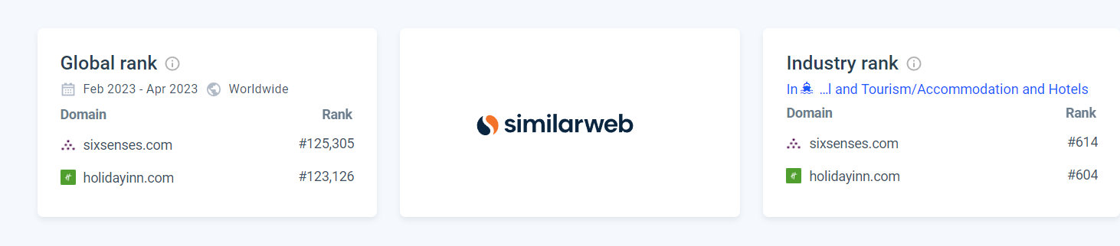
Source- SimilarWeb.com

Appendix 2 – Websites traffic
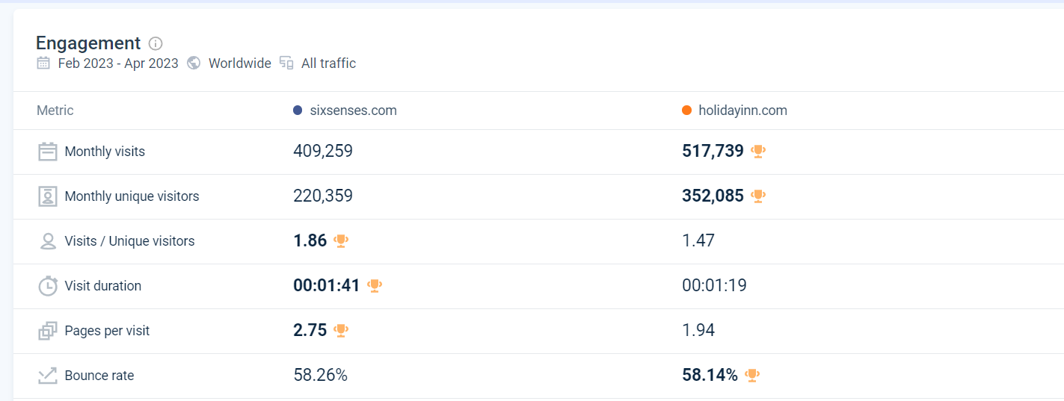
Source: SimilarWeb.com

Appendix 3 – Adds
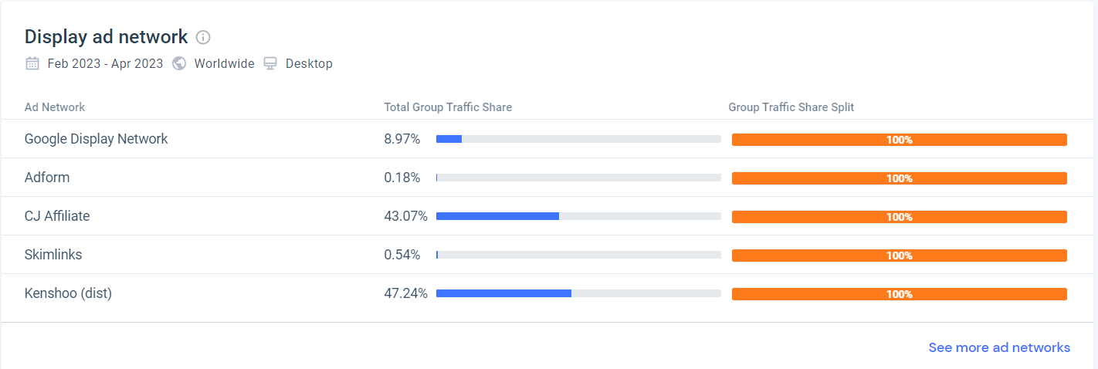
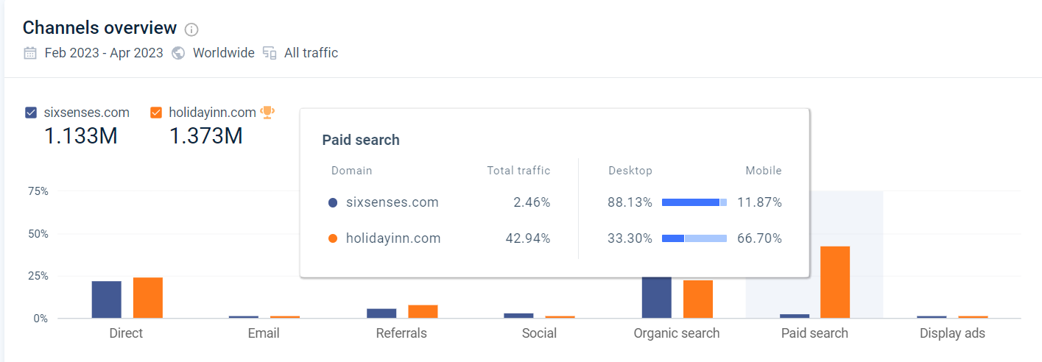
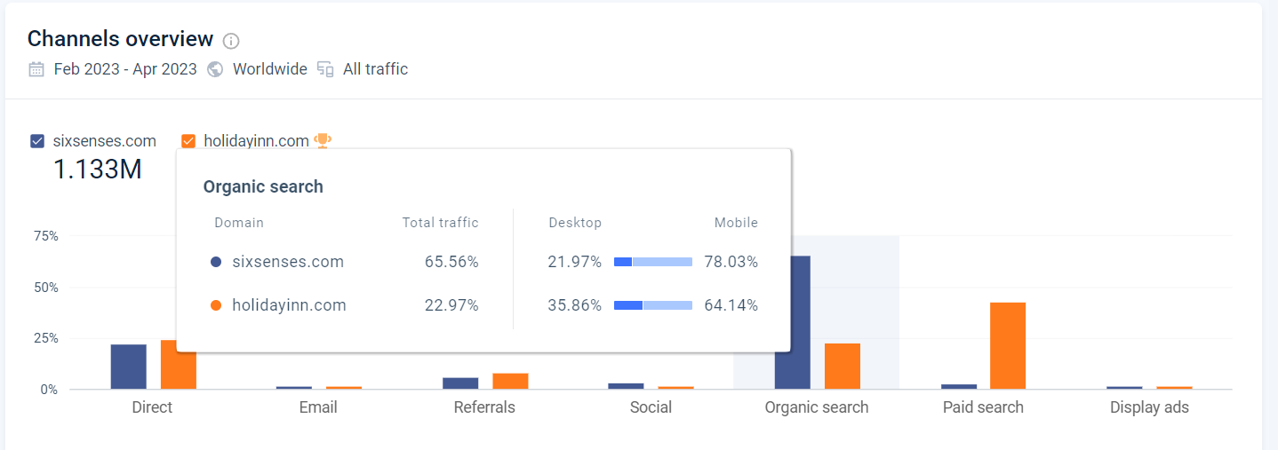
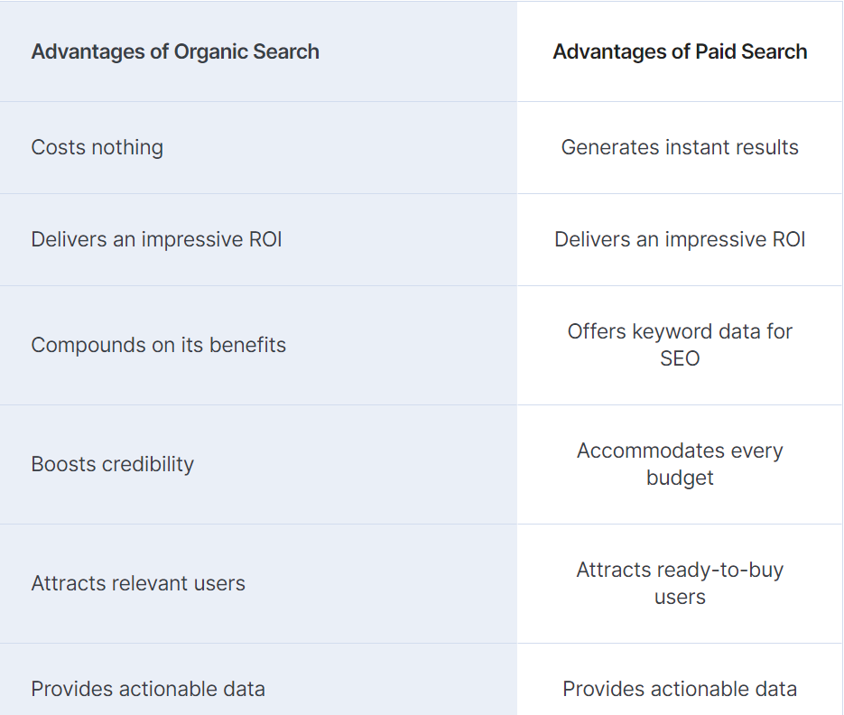
Source: SimilarWeb.com

Appendix 4 - Marketing channels
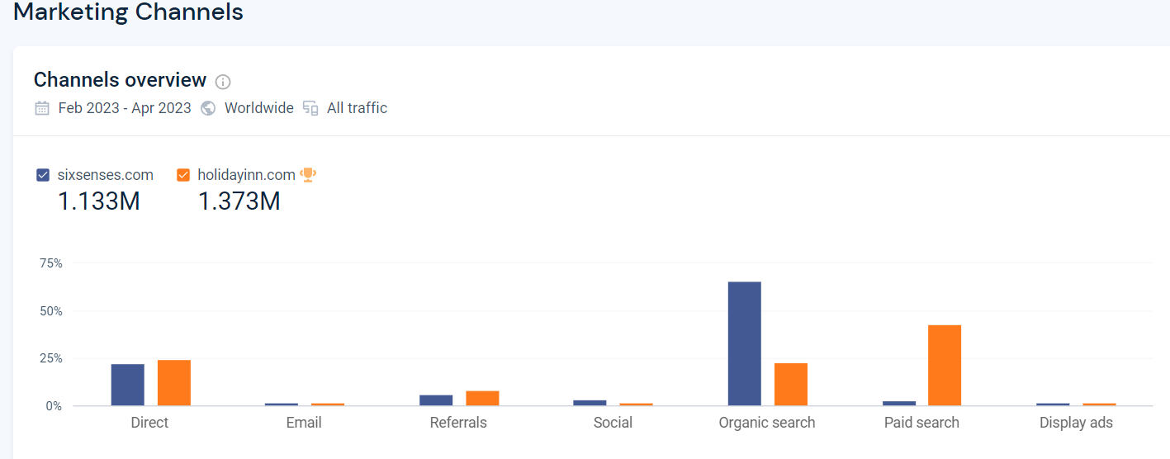
Source: SimilarWeb.com
Appendix 5 – Social media presence
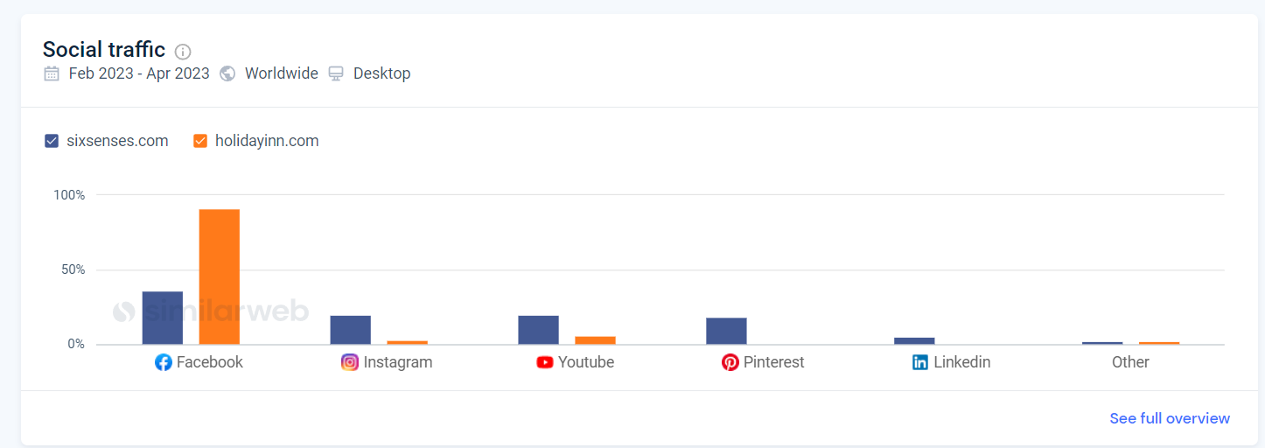
Source: SimilarWeb.com

