
Population Health and Digital Health Promotion LCHS7007_Lon Assessment Component 1 Blogs and Poster
Lecturer: Dr Ping Wu


Tunde Bodi 2114279

Contents

Blog1 2
The impact of using the National Health Service (NHS) application for digital health promotion intervention 2
The concerns of communication between healthcare providers and patients 2
Evidence about the positive effects of using the NHS App 4
Advantages and Disadvantages of the NHS App 4
How to solve disadvantages what steps can be taken regarding the NHS App? 5
Blog 2 6
The impact of using a continuous glucose monitor (GCM) with live notification (real-time information) among people living with diabetes 6
The rising concerns about the continuously increasing number of diabetes diagnoses in the UK 6
Continuous glucose monitors with real-time notification and alarm system 7
The impact of using CGM monitors with real-time alarming systems to address the public health problem and support health promotion 8
References 10
National Health Service (NHS) Application Poster 13

Blog1

The impact of using the National Health Service (NHS) application for digital health promotion intervention

The concerns of communication between healthcare providers and patients

According to the National Institute for Health and Care Research survey, of 2471 patients, about 23% highlighted the issue of getting low-quality care. The main reason is poor communication due to staff shortages causing delays in their treatment plans (NIHR,2019). In another conducted survey among 1000 UK adults who tried to book an appointment with their General Practitioner (GP) service 48% were unable to do so and were not able to get through the reception staff (Money-Kyrle,2021).
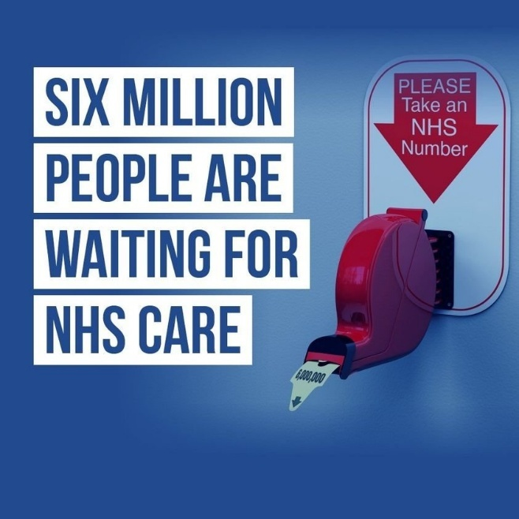
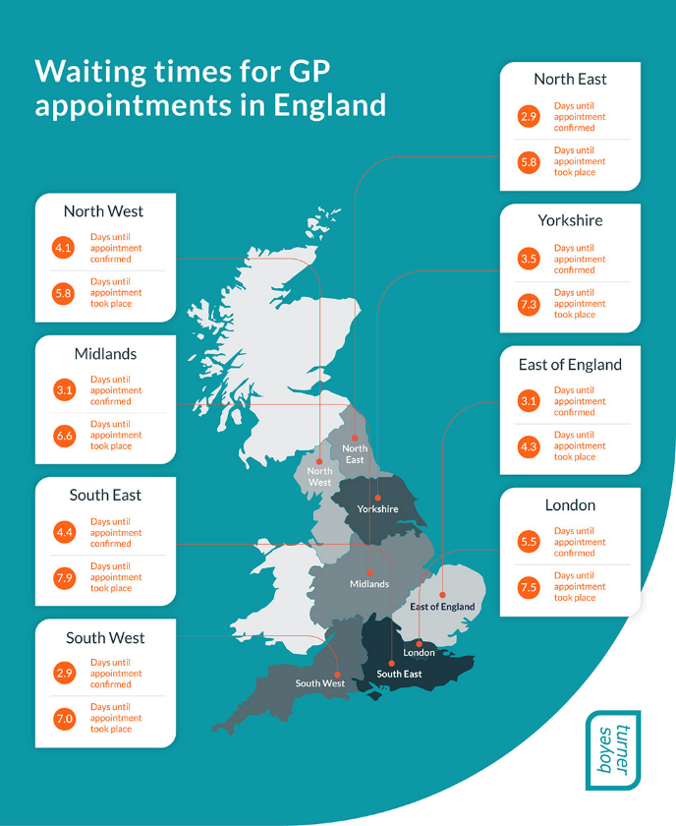
(Peterdowd,2022)
(Boyesturnerclaims,2021)

National Health Service (NHS) App for better patient care and effective quick responses without waiting any longer

The NHS application can make it easier for patients to contact their GP surgeries, and manage their appointments they can also request or cancel appointments and medication through this platform which can be very handful because it can be downloaded on mobile phones and tablets both on Android and iOS (products from Apple) devices so it could be reachable from everyone even if people are on their way and not being at home (Flynn,2022).
Furthermore, the NHS patient portal provides improved patient-provider communication with the built-in electronic messaging system where they also can get more information about their health and ask questions so do not need to wait a long time while they get an answer from health care services (KC et. al,2023).

The NHS application can be used for the following:

- Checking GP medical records
- Ordering repeat prescriptions
- Booking or cancelling appointments
- Checking symptoms using the NHS 111 database which is in alphabetic order for easy findings
- Register to become an organ donor
- Last but not least, sharing the data to help further research conducted inside the healthcare for further improvements (KC et. al,2023).

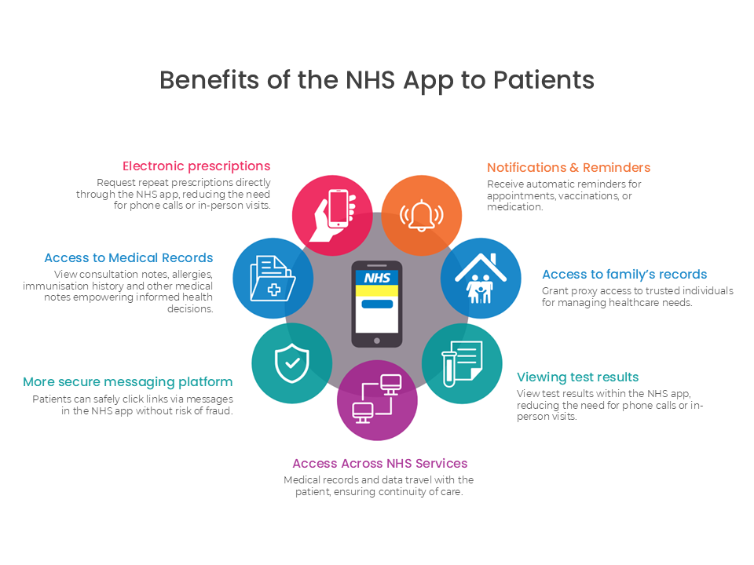

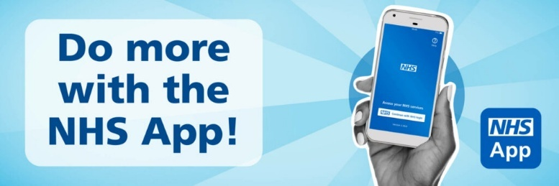

(NHS,2024)
(Thefamilypracticewesterncollege,2025)

Evidence about the positive effects of using the NHS App

The NHS app was launched in January 2019 and between the launch date and December 2023, more than 33 million people downloaded the application furthermore, at the beginning was rapidly increased the number of downloads when NHS introduced the COVID Pass feature which means that patients get access to their jab records related to the COVID and it was necessary on the time of pandemic for accessing different services such as flying in different countries (Reidy et. al,2025).
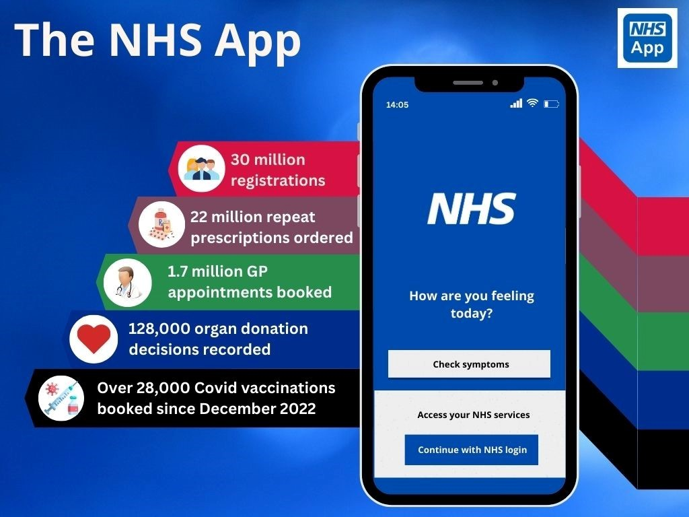

(Warwickhouse,2025)

There is much evidence of how the NHS app makes easier both patient's and health care provider's lives through the many options it can provide for the users and this video made by the NHS and available on YouTube introduces all the benefits it provides:
https://www.youtube.com/watch?v=I-ublmf5wJs&ab_channel=NHSEnglandDigital

Advantages and Disadvantages of the NHS App
There is a growing need for health care services which puts a big pressure on providers and digital technologies such as the NHS App aim so to provide easy quick access for both patients and health care services which positively affects people’s lives however, digital technologies are rapidly evolving and it became available everywhere in healthcare too it brings new complexities and concerns such as keeping private safe and increased the need
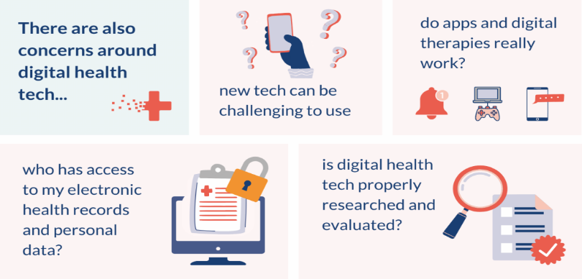
for training and it could cause issues with patients too especially in older generations (Neve et. al,2020).


(NIHR,2022)

(NHS,2025)

How to solve disadvantages what steps can be taken regarding the NHS App?

According to the NHS, the NHS Long Term Plan aim is to solve health inequalities and improve population health and it involves the improvement of their digital services the steps are the following:
- Working on the digital exclusion because they want it to become available and usable for everybody
- Ensuring that all data are kept safe and responding timely to all enquires
- Accelerating preventative programmes by promoting them digitally
- Strengthening the leadership and providing training for the workers for more effective service (NHS,2025).

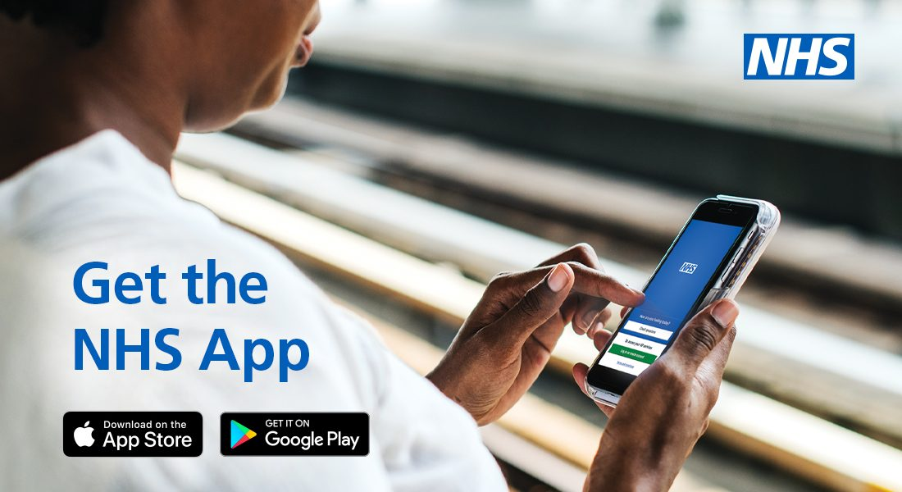
(Crewkernehc,2021)

Blog 2

The impact of using a continuous glucose monitor (GCM) with live notification (real-time information) among people living with diabetes

The rising concerns about the continuously increasing number of diabetes diagnoses in the UK
According to the Diabetes UK data between between 2023 and 2024, there were 4.6 million people diagnosed with diabetes. Still, the estimated number was higher than 5.8 million which means it is an all-time high and unfortunately the numbers are still increasing (Diabetes UK,2025).
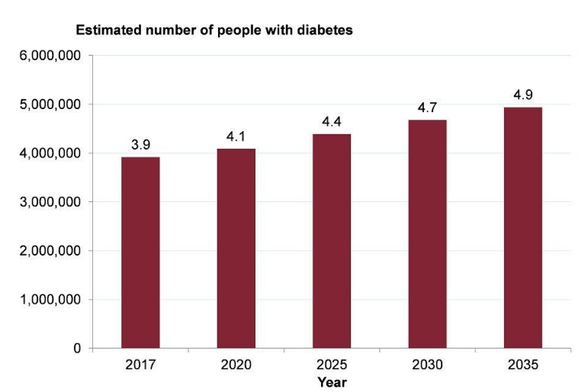
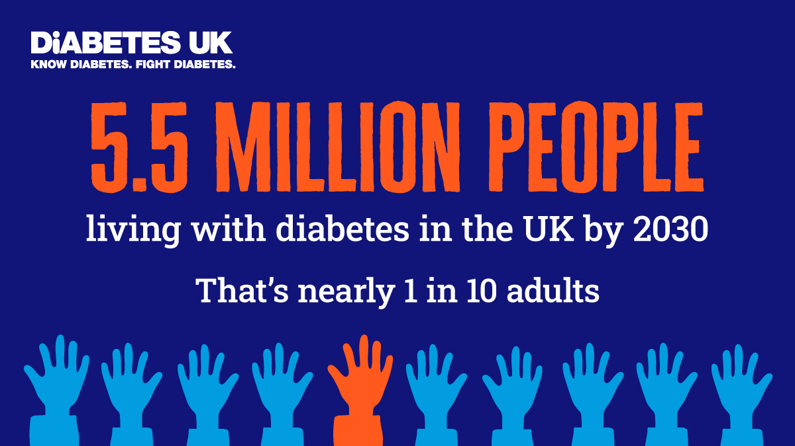

(GOV.UK,2018)
(Mitchell,2025)

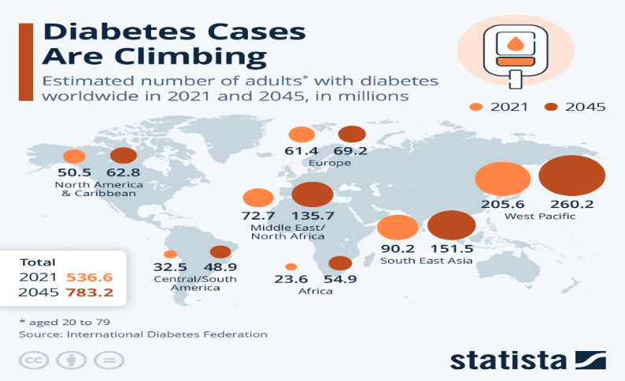
Other data from the international diabetes federation predicts the number of people living with type 2 diabetes will rise globally to 333 million which is 90% of the population furthermore it puts big pressure on healthcare services too because between 6-12% of their expenditure goes to the complication caused by diabetes and this is highlighting the importance of make steps for encouraging people for better health choices with understanding the importance of healthy lifestyle and to this equip them with the right tools and knowledge (Kumar,2018).

(Fleck,2024)

Continuous glucose monitors with real-time notification and alarm system
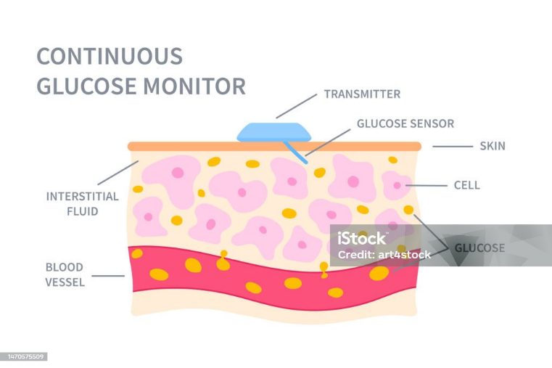

(Istock,2025)

This kind of dive provides real-time and continuous data about how the blood glucose level has changed over time and if it is too high or low alerting the user and if the number gets under or above the critical level it will alert immediately the emergency healthcare service and they can step into to survive the person who got into critical condition and unable to call for help (Usman,2025).
These monitors are small enough to attach to the skin on the arm and synchronize with smartphones or smart watches and many different models are available in the UK such as Freestyle Libre 2, or Dexcom G6 however, only just these new designs will have built alarming system that notifies emergency services in need so this will be more effective and safer like the previous models (Livingstone and Wong-Shin,2025).
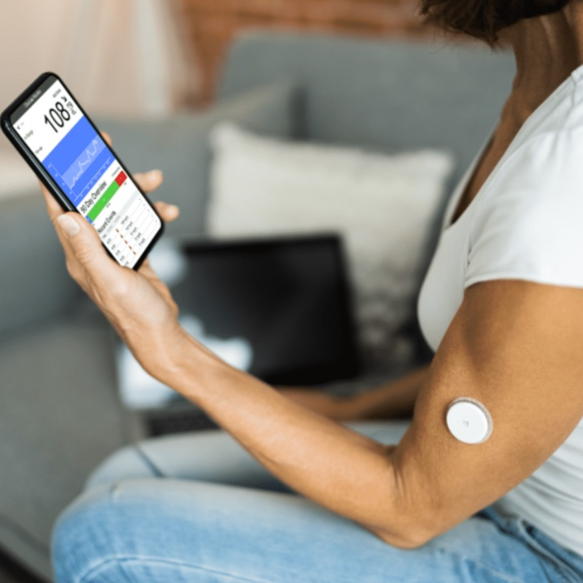

(Thebetternutritionprogram,2025)

The impact of using CGM monitors with real-time alarming systems to address the public health problem and support health promotion

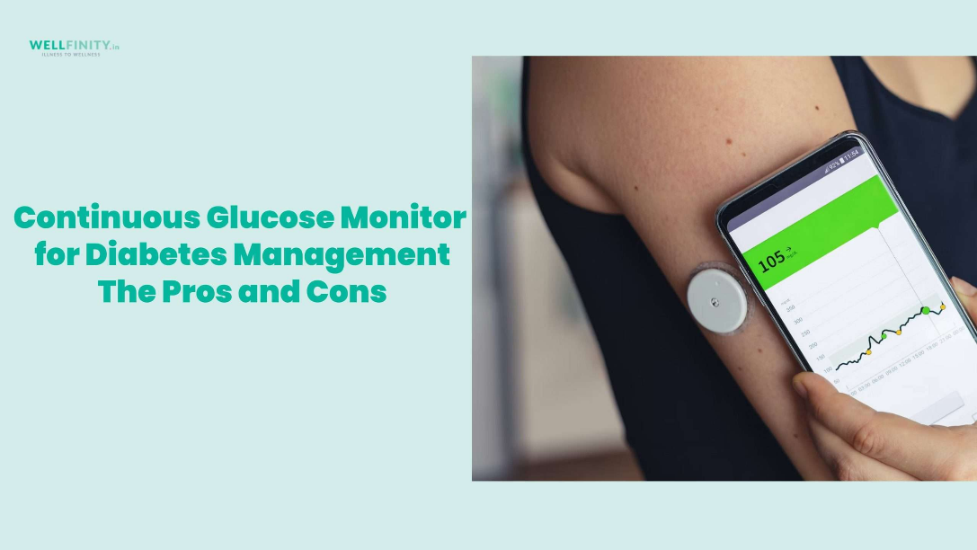

(Wellfinity,2023)

One of the benefits of using these monitors is emowering people with getting real-time information about how the blood sugar level changes can help the user to build up better eating habits also seeing the changes after physical activity can encourage people to increase their activity level and these steps in overall the person lives can be improved also the direct contact to the emergency services can significantly lower the risk of possible complications (Diabetes UK,2025).


(Apticamedical,2025)

To get a better understanding of how these devices work and what kind of benefits they hold there is a video on YouTube made by Diabetes UK:
Using a Freestyle Libre 2 | Matt's Experience | Diabetes UK - YouTube
There are also some disadvantages to this device including
- possible inaccurate reading which could affect the decision related to diabetes management sometimes the device could cause discomfort and feelings
- could cause signal issues while it is trying to contact healthcare services (Oerum,2024).
However, using CGM monitors can be beneficial both to people living with diabetes and for healthcare providers because
- it helps people build up healthy behaviours in their lives and with it can significantly lower the number of people or improve their health living with this condition
- it also could reduce healthcare expenditures occurring from diabetes complications but more trials should be conducted for network and measurement improvements (Holzer et. al,2022).
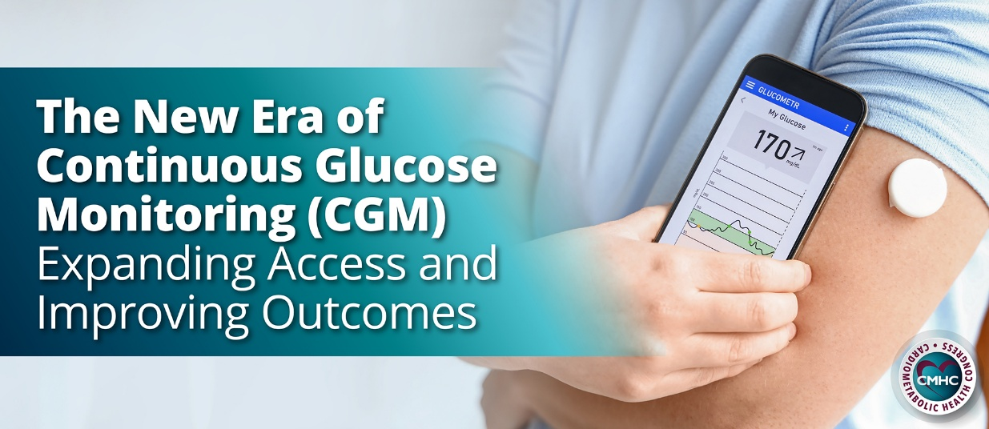

(CMHC,2024)

References

Aptiva Medical (2025) Benefits of Using a Continuous Glucose Monitor [Online]. Available from: https://aptivamedical.com/benefits-of-using-a-continuous-glucose-monitor/ (Accessed: 17 March 2025)
Cardio Metabolic Health (2024) The New Era of Continuous Glucose Monitoring (CGM) Expanding Access and Improving Outcome [Online]. Available from: https://www.cardiometabolichealth.org/the-new-era-of-continuous-glucose-monitoring-cgm-expanding-access-and-improving-outcomes/ (Accessed: 17 March 2025)
Crewkerne Health Care (2021) Using the NHS App [Online]. Available from: https://crewkernehc.co.uk/ppg/using-the-nhs-app/ (Accessed: 14 March 2025)
Diabetes UK (2025) How many people in the UK have diabetes? [Online]. Available from: https://www.diabetes.org.uk/about-us/about-the-charity/our-strategy/statistics (Accessed: 17 March 2025)
Fleck, A. (2024) Diabetes Cases Are Climbing [Online]. Available from: https://www.statista.com/chart/23491/share-of-adults-with-diabetes-world-region/ (Accessed: 17 March 2025)
Flynn, H. (2022) The benefits of downloading – and using – the NHS App [Online]. Available from: https://www.nidderdaleplus.org.uk/the-benefits-of-downloading-and-using-the-nhs-app/#:~:text=The%20app%20makes%20it%20easier%20for%20people%20to,order%20repeat%20prescriptions%20and%20view%20their%20medical%20records. (Accessed: 14 March 2025)
GOV.UK (2018) Chapter 3: trends in morbidity and risk factors [Online]. Available from: https://www.gov.uk/government/publications/health-profile-for-england-2018/chapter-3-trends-in-morbidity-and-risk-factors (Accessed: 17 March 2025)
Holzer, R., Bloch, W. and Brinkmann, C. (2022) Continuous Glucose Monitoring in Healthy Adults – Possible Applications in Health Care, Wellness, and Sports [Online]. Available from: https://pmc.ncbi.nlm.nih.gov/articles/PMC8915088/ (Accessed: 17 March 2025)
Istock (2025) Continuous glucose monitor sensor in skin illustration stock illustration [Online]. Available from: https://www.istockphoto.com/vector/continuous-glucose-monitor-sensor-in-skin-illustration-gm1470575509-501384233 (Accessed: 17 March 2025)
Kc, S., Tewolde, S., Laverty, A.A., Costelloe, C., Papoutsi, C., Reidy, C., Gudgin, B., Shenton, C., Majeed, A., Powell, J. and Greaves, F. (2023) Uptake and adoption of the NHS App in England: an observational study. British Journal of General Practice [Online]. 73(737). doi:https://doi.org/10.3399/BJGP.2022.0150 (Accessed: 14 March 2025)
Kumar, A. (2018) Public Health Issues: Type 2 Diabetes [Online]. Available from: https://www.ukessays.com/essays/biology/publish-health-issues-type-2-diabetes-9624.php (Accessed: 17 March 2025)
Livingston, M. and Wong-Shin, K. (2025) Best Continuous Glucose Monitors of 2025 [Online]. Available from: https://www.cnet.com/health/medical/best-continuous-glucose-monitors/ (Accessed: 17 March 2025)
Mitchell, B. (2025) Spend, save and raise: Raise free donations for Diabetes UK whenever you shop online [Online]. Available from: https://www.savoo.co.uk/charities/diabetes-uk (Accessed: 17 March 2025)
Money-Kyrle, R. (2021) GP Appointment Waiting Times in England [Online]. Available from: https://www.boyesturnerclaims.com/news/gp-appointment-waiting-times-england (Accessed: 14 March 2025)
Neve, G., Fyfe, M., Hayhoe, B. and Kumar, S. (2020) Digital health in primary care: risks and recommendations [Online]. Available from: https://bjgp.org/content/70/701/609 (Accessed: 14 March 2025)
NHS (2024) New NHS App features to support patients and elective recovery [Online]. Available from: https://www.mkuh.nhs.uk/news/new-nhs-app-features-to-support-patients-and-elective-recovery (Accessed: 14 March 2025)
NHS (2025) Digital transformation [Online]. Available from: https://www.england.nhs.uk/digitaltechnology/ (Accessed: 14 March 2025)
NHS (2025) Our approach to reducing healthcare inequalities [Online]. Available from: https://www.england.nhs.uk/about/equality/equality-hub/national-healthcare-inequalities-improvement-programme/our-approach-to-reducing-healthcare-inequalities/ (Accessed: 14 March 2025)
NIHR (2019) Communication problems are top of patients’ concerns about hospital care [Online]. Available from: https://evidence.nihr.ac.uk/alert/communication-problems-are-top-of-patients-concerns-about-hospital-care/ (Accessed: 14 March 2025)
NIHR (2022) What is digital health technology and what can it do for me? [Online]. Available from: https://evidence.nihr.ac.uk/collection/what-is-digital-health-technology/ (Accessed: 14 March 2025)
Oerum, C. (2024) The Pros and Cons of Continuous Glucose Monitoring (CGM) [Online]. Available from: https://diabetesstrong.com/fit-with-diabetes-part-4-the-pros-and-cons-of-cgm/#:~:text=Issues%20with%20CGM%20sensors%20can%20sometimes%20lead%20to,overreliance%20on%20the%20device%20can%20reduce%20personal%20judgment. (Accessed: 17 March 2025)
Peterdowd (2022) NHS Waiting List [Online]. Available from: https://peterdowd.com/peter-dowd-community-work/2022/3/31/nhs-waiting-list (Accessed: 14 March 2025)
Reidy, C., Papoutsi, C., KC, S., Gudgin, B., Laverty, A., Greaves, F. and Powell, J. (2025) Qualitative evaluation of the implementation and national roll-out of the NHS App in England [Online]. Available from: https://bmcmedicine.biomedcentral.com/articles/10.1186/s12916-024-03842-w (Accessed: 14 March 2025)
The Better Nutrition Program (2025) Continuous Glucose Monitor (CGM) [Online]. Available from: https://thebetternutritionprogram.com/product/total-neuropathy-solution/ (Accessed: 17 March 2025)
The Family Practice Western College (2025) NHS APP [Online]. Available from: https://www.thefamilypracticewesterncollege.nhs.uk/nhs-app (Accessed: 14 March 2025)
Usman, S. (2025) Types of Continuous Glucose Monitoring (GCM) Devices for Diabetes and How to Use [Online]. Available from: https://www.semichealth.com/public-health/types-of-continuous-glucose-monitoring-cgm-and-how-to-use (Accessed: 17 March 2025)
Warwick House Medical Practice (2025) Online Access – Patient Access and NHS App [Online]. Available from: https://warwickhouse.org.uk/patient-access/ (Accessed: 14 March 2025)
Wellfinity (2023) The Pros and Cons of using a continuous glucose monitor for diabetes management [Online]. Available from: https://wellfinity.in/diabetes/diabetes-care/continuous-glucose-monitor-pros-cons/ (Accessed: 17 March 2025)

National Health Service (NHS) Application Poster fdgdgfPPPsyerAaAppApplicationApplication
Advantages of using the NHS Application/Health promotion values and principles
- Free for everyone
- Help skip long phone queues and book appointments through the application
- Features like checking test results and requesting repeat prescriptions
- Access to NHS 111 in 24/7
- Make easier communication and connection between patients and health care services (Meek,2021)
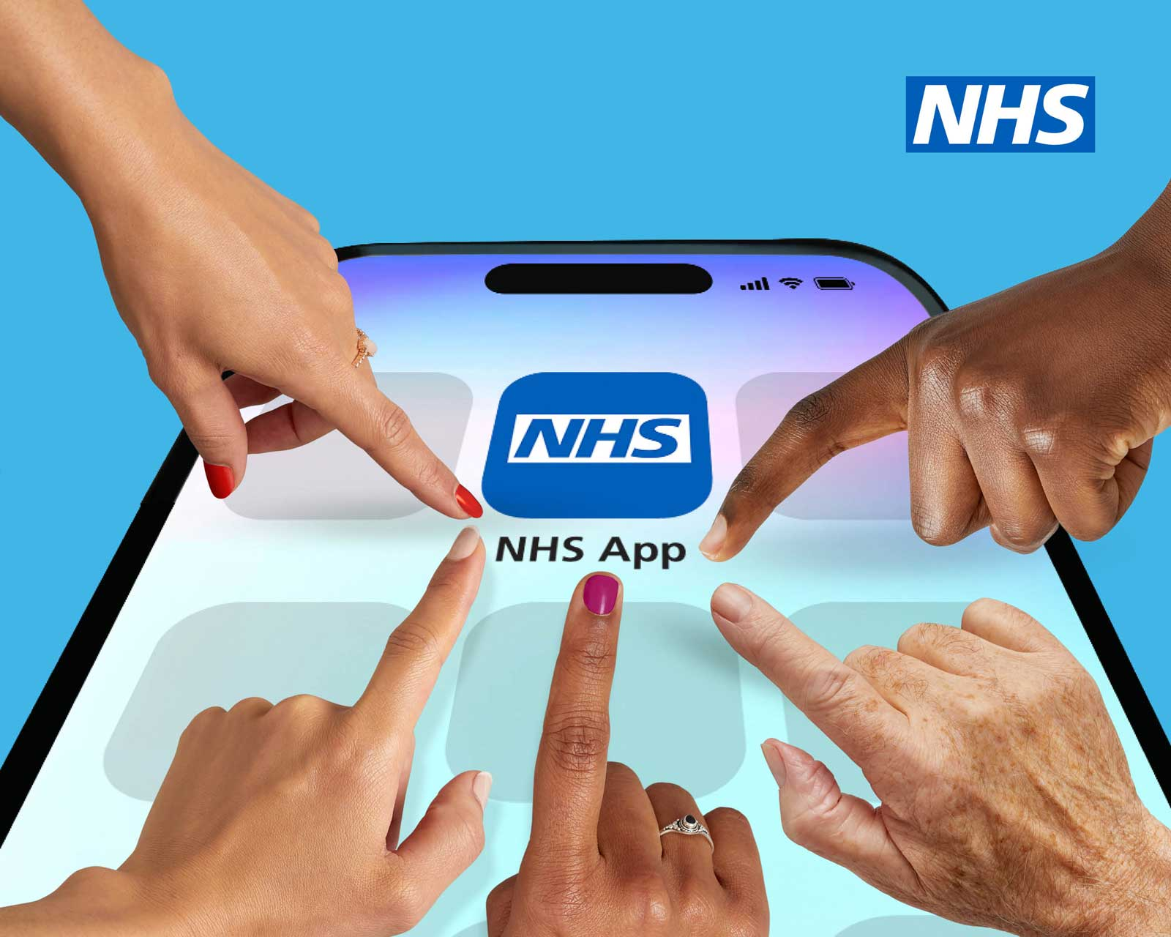
(Centralsurgerysawbo,2025)
Digital and non-digital Health interventions used before
- Contacted patients on phones according to test result
- Adapted video and online consulting services
- Sent appointment reminders
- Patient records have been stored in the General Practices (GP’s) database and could be reached only by calling the GP to get the information (Reidy et. al,2025)


(Maximum Networks,2023)
Background
According to Kings Fund (2025) data 2 in 3 which is 64% of patients and carers had a negative experience with admin in healthcare due to missing or lost test results, missed appointments due to late notification and issues with getting delayed help from health care professionals (Kingsfund,2025).
Furthermore, research data shows that patients who face administrative issues in health care are more likely not to seek care and contact healthcare services in future (Newton,2025).
The NHS app has many benefits both for patients and healthcare providers and helps for easier and timesaver access for everybody (NHS,2025).

(Daily Star,2018)

Health Belief Model of Behaviour Change
It was created in the 1950s by social psychologists Hochbaum, Rosenstock, and Kegels based on their observations. The model aims to help people understand their perceived behaviour regarding their health decisions and what kind of actions they will take (Alyafei and Easton-Carr,2024).
It is built up and based on five concepts, including the person’s beliefs about the likelihood of getting a particular health condition, beliefs about the seriousness of the health condition, perceived barriers and action plans, and beliefs about the effectiveness of the action. Furthermore, the model has been modified over time, adding more factors to it (Nortje,2024).
The health belief model helps predict patients' attitudes and behaviour connected to health issues and it believes that people can make the best decision regarding their health and take the appropriate action these observations are helping healthcare to improve their services to make easier access and easier decisions for the public and the NHS App is the tool which aim was to make this possible for everybody seeking for help or want more information regarding health (ISC Medical, 2018).
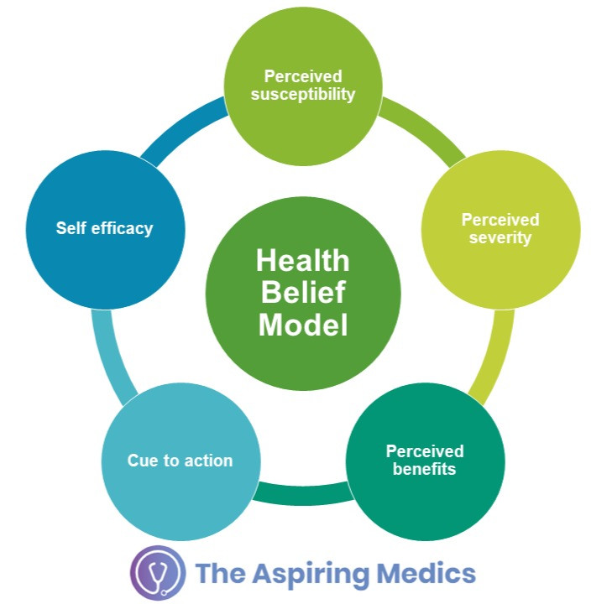
(Treamweskro,2021)
Conclusion
Since the beginning of the NHS App appearance more than 8 million people downloaded and started using it in their daily life at the beginning for proving their COVID-19 vaccination status but later the app got more options which made easier access both for patients and healthcare services check the results, manage prescriptions, book appointments and keep a closer and more frequently connections between them which easer the patient care and manage their conditions (Majeed,2023).
However, there is still more to do with the app because many people still do not have access to it which highlighted the inequality rates among different population groups according to the relevance and access and it is indicated that NHS must further work on the application (Reidy et. al,2023).

References
- Alyafei, A. and Easton-Carr, R. (2024) The Health Belief Model of Behaviour Change [Online]. Available from: https://www.ncbi.nlm.nih.gov/books/NBK606120/ (Accessed: 24 March 2025)
- Central Surgery Sawbo (2025) The NHS App found in 22.6 million pockets across England [Online]. Available from: https://www.centralsurgerysawbo.nhs.uk/the-nhs-app-found-in-22-6-million-pockets-across-england/ (Accessed: 24 March 2025)
- Coruch, H. (2020) Draft NICE guidelines suggest apps can support behavioural change [Online]. Available from: https://www.digitalhealth.net/2020/01/draft-nice-guidelines-suggest-apps-can-support-behavioural-change/ (Accessed: 24 March 2025)
- Designveloper (2025) 5 benefits of Mobile Health Apps in the Future [Online]. Available from: https://www.designveloper.com/guide/benefits-of-mobile-health-apps-in-the-future/ (Accessed: 24 March 2025)
- ISC Medical (2018) The Health Belief Model – A Useful Tool In Understanding Patient Behaviour [Online]. Available from: https://www.medical-interviews.co.uk/blog/health-belief-model-useful-tool-understand-patient-behaviour (Accessed: 24 March 2025)
- Kc S., Reidy C., Laverty AA., Papoutsi C., Powell J., Tewolde S., Costelloe C., Gudgin B., Greaves F. (2023) Adoption and Use of the NHS App in England: a mixed-methods evaluation [Online]. Available from: https://www.phc.ox.ac.uk/publications/1495917 (Accessed: 24 March 2025)
- Majeed, A. (2023) Evaluating the Uptake of the NHS App in England [Online]. Available from: https://blogs.imperial.ac.uk/medical-centre/2023/10/04/evaluating-the-uptake-of-the-nhs-app-in-england/ (Accessed: 24 March 2025)
- Maximum Networks (2023) How GP Practices Can Comply With NHS Mandates to Switch to a Cloud-Based Primary Care Telephone System [Online]. Available from: https://www.maximumnetworks.co.uk/gp-primary-care-telephone-system/ (Accessed: 20 March 2025)
- Meek, N. (2021) NHS app: What is it and what are the benefits of having it? [Online]. Available from: https://www.yorkpress.co.uk/news/19357731.nhs-app-benefits/ (Accessed: 24 March 2025)
- Milne-Ives, M., Lam, C., Velthove, M. and Edward, M. (2020) Mobile Apps for Health Behavior Change: Protocol for a Systematic Review [Online]. Available from: https://pmc.ncbi.nlm.nih.gov/articles/PMC7055785/ (Accessed: 24 March 2025)
- Newton, S. (2025) NHS admin issues putting patients off seeking care, research finds [Online]. Available from: https://www.independent.co.uk/news/uk/home-news/nhs-patients-mencap-healthwatch-england-xray-b2699270.html (Accessed: 20 March 2025)
- NHS (2025) The NHS App – making a difference at every age [Online]. Available from: https://digitalnotts.nhs.uk/the-nhs-app-making-a-difference-at-every-age/ )Accessed: 20 March 2025)
- Nortje, A. (2024) What Is the Health Belief Model? An Updated Look [Online]. Available from: https://positivepsychology.com/health-belief-model/ (Accessed: 24 March 2025)
- Reidy, C., Papoutsi, C., KC, S., Gudgin, B., Laverty, A., Greaves, F. and Powell, J (2025) Qualitative evaluation of the implementation and national roll-out of the NHS App in England [Online]. Available from: https://bmcmedicine.biomedcentral.com/articles/10.1186/s12916-024-03842-w (Accessed: 20 March 2025)
- The Kings Fund (2025) Patients put off seeking care due to ‘dysfunctional’ NHS admin [Online]. Available from: https://www.kingsfund.org.uk/insight-and-analysis/press-releases/patients-put-off-seeking-care-dysfunctional-nhs-admin (Accessed: 20 March 2025)
- Treamweskro (2021) How Does The Health Belief Model Overcome Barriers [Online]. Available from: https://treamweskro.blogspot.com/2021/07/how-does-health-belief-model-overcome.html (Accessed: 24 March 2025)

Expected Outcomes
Encourage people to frequently use the application and the apps the devices using the app collect data about tracked physical activity, and sleep patterns can help improve a person’s well-being and health care can get a better understanding of a patient’s health (Ives et. al,2020)
Digital intervention with the NHS application can make significant changes by helping people to make important steps to improve their lifestyle and it could be beneficial in lowering the risk of developing serious health conditions (Crouch,2020).
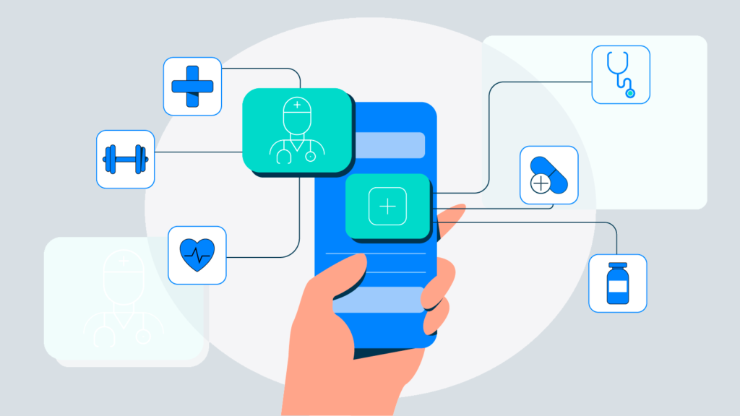
(Designveloper,2025)

