Contextual Studies
Student Name: Hamish Cranstone
Student Number: 1801893
Tutors: Julia Lockheart and Gwen Beynon
Programme of Study: Automotive Design
Module: Ways of Perceiving - ADAD4010
Word Count: 1386

Contrasting Comfort

An exhibition exploring and demonstrating the contrast between comfort and discomfort.

People are always seeking comfort, an emotion that is to be with physical ease and relaxed, without stress (Oxford Dictionaries | English, n.d.). Automotive designers are constantly pushed to explore new ways to make the user feel more comfortable whilst using their vehicles. This paired with the more sophisticated technology and wider range of advanced materials means that nearly everyone’s daily routine has become more convenient and enjoyable.

This exhibitions purpose is to focus on the difference between a comfortable space and that of an uncomfortable one set within a car dealership sales room. It is to be used as a sales piece for an automotive manufacturer to show an exaggerated contrast in comfort from their luxury line of vehicles, to their competitors. There are a select artists and designers that help to convey this desired effect.

Firstly though, what makes a space comfortable? An interior designer named David Wallace who worked to create the interior for cancer care centres across the UK stated in an interview in 2017 that -

“Everything that the visitor to the centre encounters is reassuring, honest, stimulating. There is a place to rest at the entrance - to pause, to be welcomed and to take in the surroundings. The interior is unlike a clinical environment. It feels very domestic - there’s no signage, for example. The textiles are interesting and colourful. The experience is disarming, human.” - (Wallace, 2017).

This shows that one way of creating a comfortable space is to make the area calm and inviting, through methods of creating a warm homely environment. However, for the main room in the exhibition the the complete opposite has been created by curating a space that is as uncomfortable as possible and also showcasing three artists work.

Jun Ong
An architect and artist based in Kuala Lumpur. He has worked with a team to create a very large light installation with a ‘dystopian’ (Oxfordlearnersdictionaries.com, n.d.) feel to it.

Fabrice Le Nézet
A French artist based in London. He has worked with companies such as Ford and Sony but has also created sculptures that create tension.

Ron Mueck
An Australian artist, very well known for his hyperrealistic sculptures. He has created his largest installation that was perfect for this exhibition.

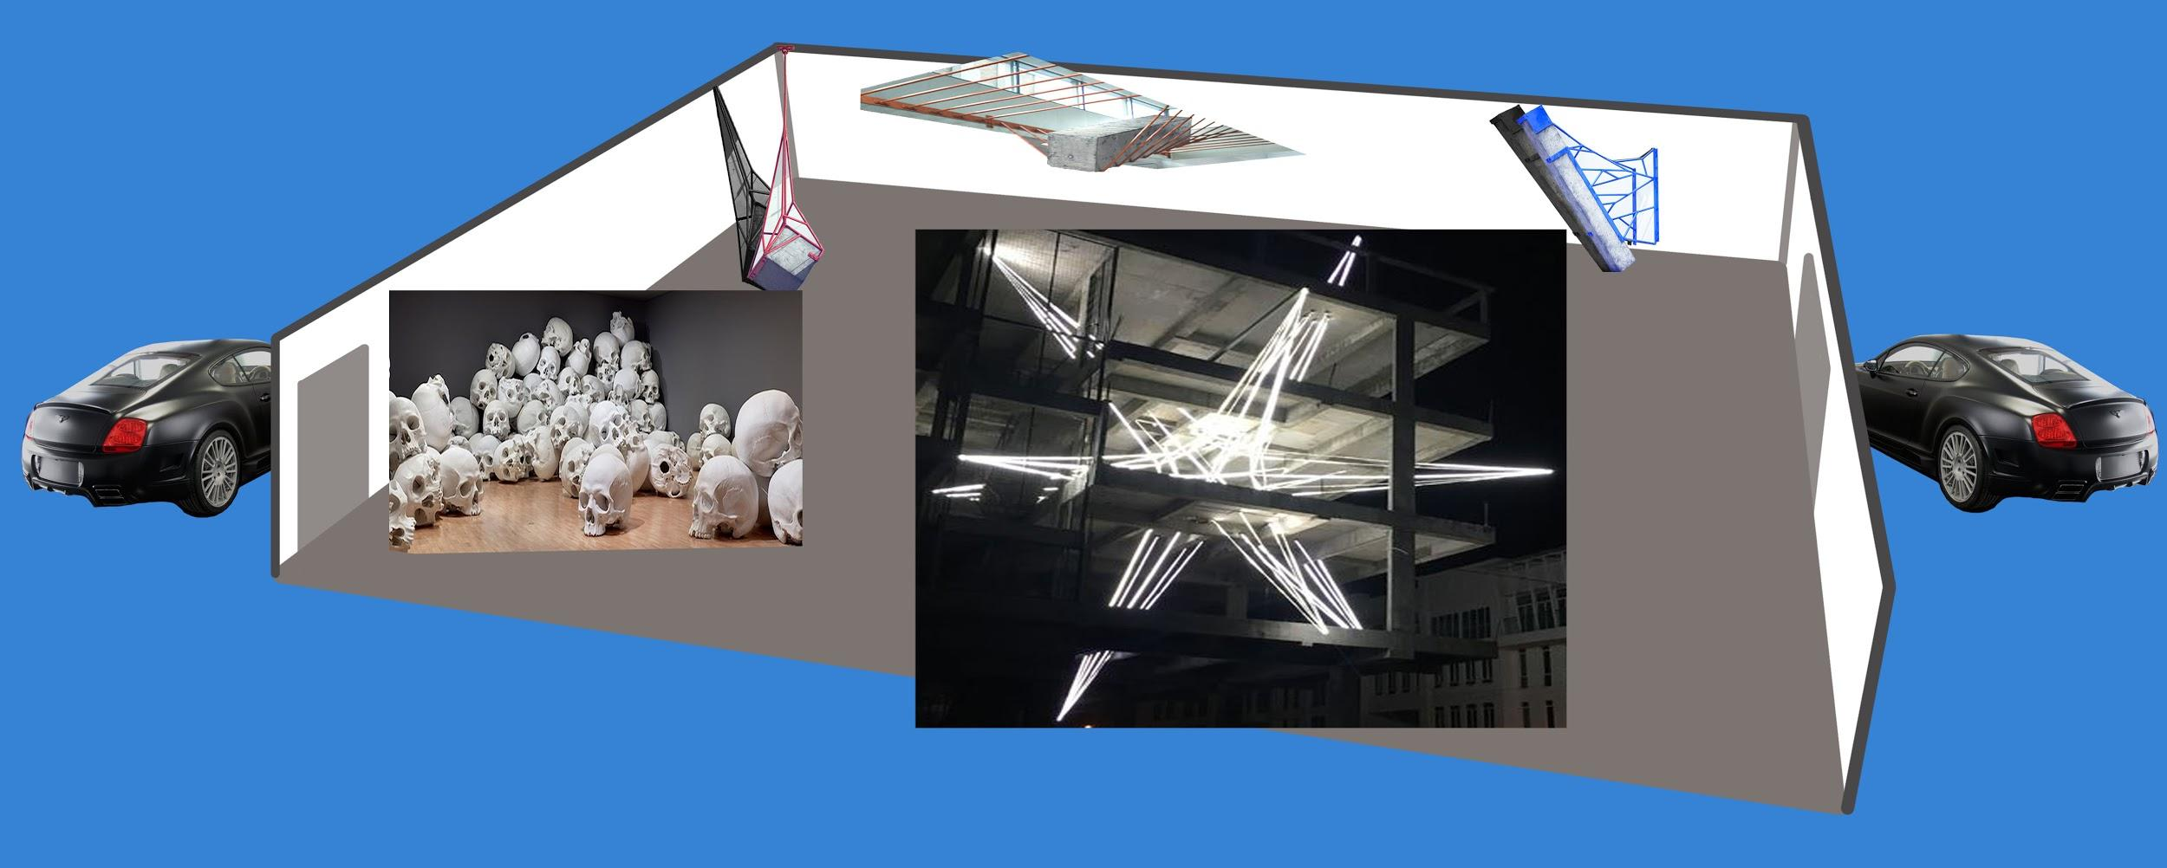
Fig 1. Exhibition Plan - Hamish Cranstone

The exhibition begins unusually, where the spectator is driven to the exhibition room in a luxury vehicle with every optional extra and all the ‘creature comforts’ (Cohen, 2013) that make everything feel inviting. The vehicle has a bright elegant finish with soft leather seats with diamond stitching and a spacious interior, everything is to hand with a modern and stylish layout “...surrounding the front occupants in a seemingly unending ring of handcrafted leather and wood.” (Bentleymotors.com, n.d.) Appealing to the sense of sight, touch and smell. The point of this is to act as a bias for the spectator by making them as comfortable as possible to begin with even though they would be uncertain of what is to come. A large part of ‘discomfort’ (Oxford Dictionaries | English, n.d.) is the fear of the unknown as it is difficult to prepare yourself for.

To enter the single large room of the exhibition the spectators have to enter through blackout doors as the room of the exhibition will only have one light source to create an uneasy atmosphere.

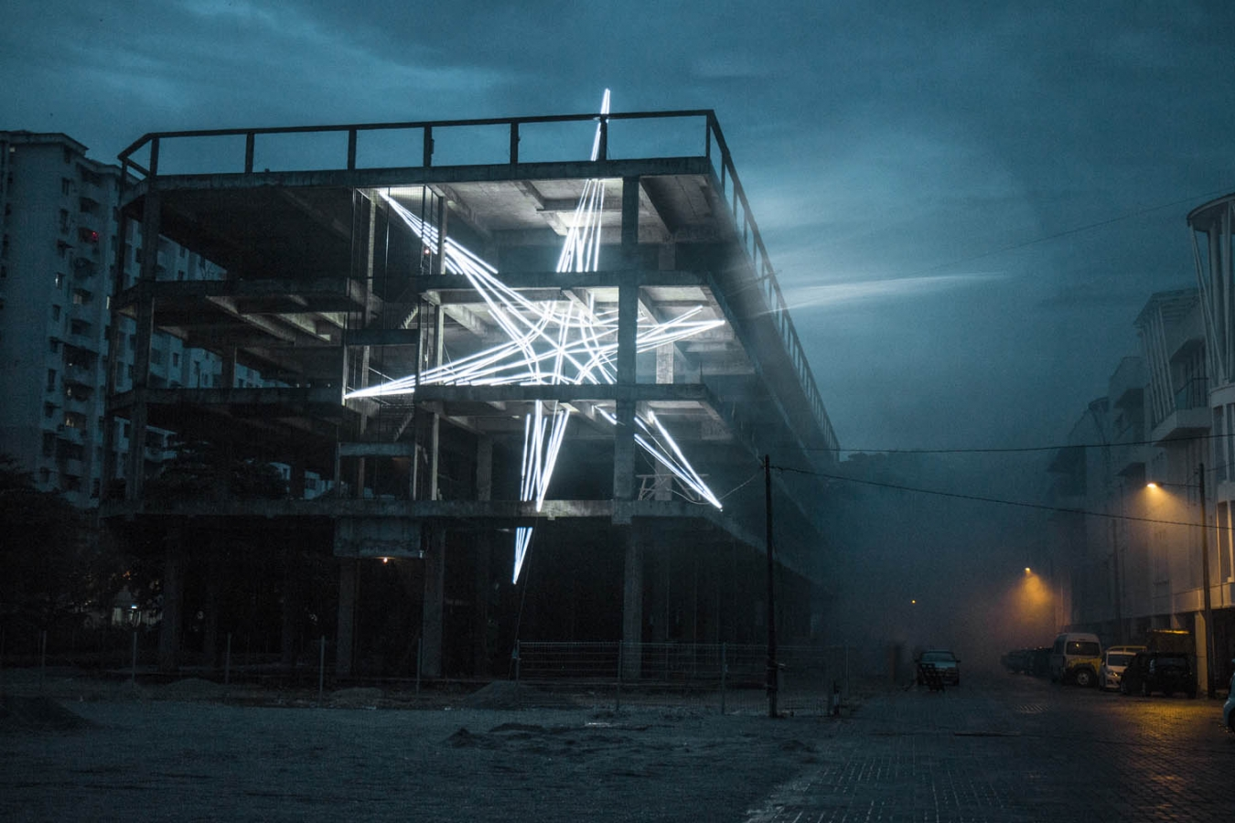
Fig 2. ‘Star’ Lighting Installation by Jun Ong

The first sculpture the spectator will see is this the single light source in the room casting shadows over the other pieces around the exhibition. The sculpture, shown above (figure 1) is called ‘Star’. It is comprised of five hundred meters of steel cables with LED strips.

“Inspired by the notion of “glitch,” a dodecahedron - a 12-sided star-shaped installation appears almost as an error or a temporary irregularity, suddenly finding itself lodged within the concrete superstructure.”(Jun-ong, 2015)

This momentous piece was chosen for the exhibition as it took up a huge amount of space within the centre of the exhibition room. The aim of this is to push the audience to the outside of the room where they would then not have much room to move between it and the rest of the exhibition pieces. This would have made the spectator feel restricted in movement and potentially slightly claustrophobic as the exhibits are within the ‘close phase of personal distance’ - (Hall, 1990).

The use of the ‘proxemics’ (Hall, 1990) has played a large part in this exhibition as understanding how someone's feelings could be effected through the use of space was a key part on how it could create discomfort.

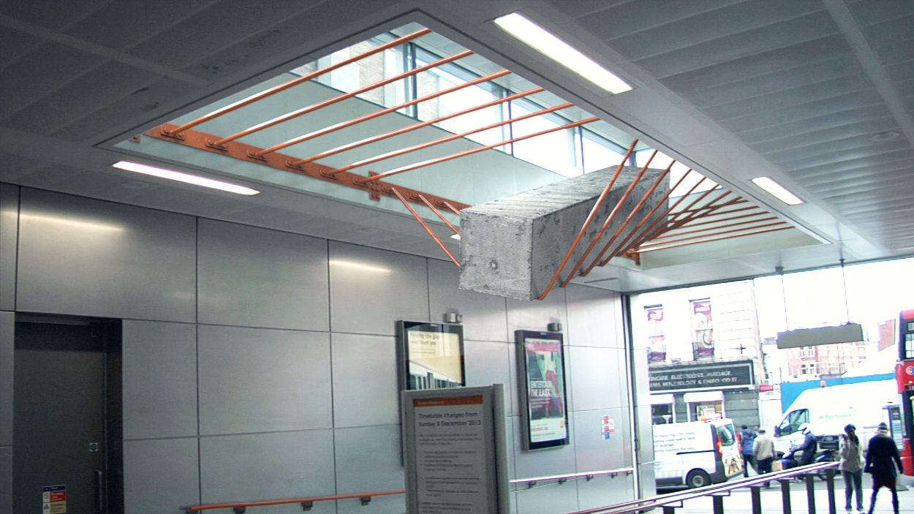
Fig 3. ‘Elasticity’ and ‘Measure’ sculptures by Fabrice le Nézet

The next set of sculptures were created by Fabrice le Nézet. He had created a series of large sculptures that all create tension.

“I worked here on a physical representation of the idea of measure. The objective was to 'materialize' tension in a sense, to make the notions of weight, distance and angle palpable…” - Fabrice le Nézet (2012)

These sculptures were chosen to be included in the exhibition as they will help to create a reaction from the spectator. The sight of seeing such large objects hanging and in some cases, appearing to stretching the frame from which they are held can cause a sense of fear from the possibility of them falling. His sculptures are made of raw materials such as concrete and steel so they are clearly very heavy and in most cases they each weigh over one tonne. The objects will never move, but it is the thought of the possibility of them doing so which was enough to make the spectator feel uneasy to walk around them. This coupled with the little room between the first sculpture gave the audience quite an uncomfortable emotion.

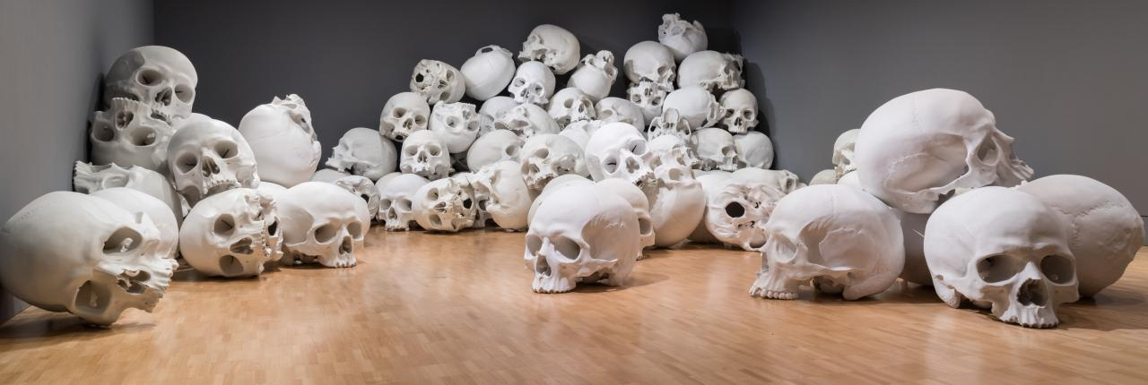
Fig 4. ‘Mass’ - Ron Mueck

The final installment in the exhibition was called ‘Mass’. It is a creation by Ron Mueck, who is better known for creating singular large hyperrealistic sculptures. However, this piece is comprised of one hundred unique hand-cast skulls that are all five feet tall and have a combined weight of five and a half tonnes. They have all been hand placed carefully to create a very ominous creation. This final piece has a dark focus on mortality.

“Over the years I have collected a number skull images from various sources…from Paul Cézanne’s Pyramid of Skulls to Cambodian killing fields or the catacombs of Paris. These have all played a part in the development of Mass.” Ron Mueck (2017)

The thought of death is not a pleasant one and can be seen as the end, so it seemed very fitting to have it as the final piece of the exhibition. As the light from the first exhibit in the centre of the room casts shadows through this final piece, the spectator has need to walk through the collection of skulls to get to the exit door in the corner of the room. The desired effect for this final piece is to invoke unpleasant thoughts as the audience head to the exit.

Once the spectator has left the building they are once again picked up by the luxury vehicle that dropped them off in the beginning, allowing them to feel at ease and reflect on what they have just been through.

In conclusion, the exhibitions main aim of showing the contrast between a comfortable space and that of an uncomfortable one will become very evident to the spectators once they have been through the exhibition. All the pieces work well together as they are all large so play with scale to dwarf the spectator, and even though they may not cause discomfort individually, they will do when presented together in this manner. However, the contrast may not be as apparent to some people depending on their cultural background and beliefs. The use of the luxury vehicle at the start and end acts as a control as the feeling of exquisite quality is universal.
The overall experience of this exhibition was to get people to to understand what makes them comfortable through contrast, however the bias from the automotive manufacturers luxury vehicle will also cause the audience to want to hold onto that comfort from then on.

Bibliography
Bentleymotors.com. (n.d.). New Continental Range | Bentley Motors. [online] Available at: https://www.bentleymotors.com/en/models/new-continental.html#d72daa3cf7e297fab8d3ffb4ae9f16ca [Accessed 3 May 2019].

Cranstone, H. (2019) Exhibition Plan. [Adobe Photoshop CC 2019]

Cohen, A. (2013). Creature Comforts. [online] Positive Psychology News. Available at: https://positivepsychologynews.com/news/aren-cohen/2013112527589 [Accessed 30 Apr. 2019].

Dawling, E. (2017). The hidden, healing power of design. [online] Bbc.com. Available at: http://www.bbc.com/future/story/20171110-the-hidden-healing-power-of-design [Accessed 1 May 2019].

Fabricelenezet.com. (n.d.). www.fabricelenezet.com. [online] Available at: http://www.fabricelenezet.com/ [Accessed 1 May 2019].

Fortescue, E. (2017). Ron Mueck discusses his NGV Triennial installation titled Mass. [online] Artwriter.com.au. Available at: https://www.artwriter.com.au/news/ron-mueck-discusses-his-ngv-triennial-installation-titled-mass/ [Accessed 2 May 2019].

Hall, E. (1990). The Hidden Dimension. New York: Anchor.

Hauserwirth.com. (n.d.). Artists — Ron Mueck - Hauser & Wirth. [online] Available at: https://www.hauserwirth.com/artists/2828-ron-mueck [Accessed 1 May 2019].

Jun-ong.com. (n.d.). Main : JUN ONG. [online] Available at: http://jun-ong.com/ [Accessed 1 May 2019].

Jun-ong.com. (2015). Star : JUN ONG. [online] Available at: http://jun-ong.com/index.php/objects/star/ [Accessed 2 May 2019].

McArthur, J. (2016). Public Access - 6 Ways On How Technology Has Made Our Life Easier. [online] Engadget. Available at: https://www.engadget.com/2016/10/17/6-ways-on-how-technology-has-made-our-life-easier/?guccounter=1&guce_referrer_us=aHR0cHM6Ly93d3cuZ29vZ2xlLmNvbS8&guce_referrer_cs=R-ewUMzHkHaDNVJ_H02JrQ [Accessed 30 Apr. 2019].

Oxford Dictionaries | English. (2019). comfortable | Definition of comfortable in English by Oxford Dictionaries. [online] Available at: https://en.oxforddictionaries.com/definition/comfortable [Accessed 30 Apr. 2019].

Oxford Dictionaries | English. (n.d.). discomfort | Definition of discomfort in English by Oxford Dictionaries. [online] Available at: https://en.oxforddictionaries.com/definition/discomfort [Accessed 30 Apr. 2019].

Oxfordlearnersdictionaries.com. (n.d.). dystopian adjective - Definition, pictures, pronunciation and usage notes | Oxford Advanced Learner's Dictionary at OxfordLearnersDictionaries.com. [online] Available at: https://www.oxfordlearnersdictionaries.com/definition/english/dystopian [Accessed 3 May 2019].

Phaidon. (n.d.). Fabrice Le Nezet gets heavy | Art | Agenda | Phaidon. [online] Available at: https://uk.phaidon.com/agenda/art/articles/2012/june/28/fabrice-le-nezet-gets-heavy/ [Accessed 2 May 2019].

rohayah3 (2018). Lecture 12 Theories of Urban Spatial Design. [online] Slideshare.net. Available at: https://www.slideshare.net/rohayah3/lecture-12-theories-of-urban-spatial-design [Accessed 1 May 2019].

Stewart, J. (2017). 100 Gigantic Skulls Spill Through the Vast Halls of a Museum. [online] My Modern Met. Available at: https://mymodernmet.com/ron-mueck-mass-skull-sculptures/ [Accessed 1 May 2019].

Sheppard, M. (n.d.). Proxemics. [online] Cs.unm.edu. Available at: https://www.cs.unm.edu/~sheppard/proxemics.htm [Accessed 2 May 2019].

Study.com. (n.d.). What is Proxemics? - Definition & Examples - Video & Lesson Transcript | Study.com. [online] Available at: https://study.com/academy/lesson/what-is-proxemics-definition-examples.html [Accessed 2 May 2019].

